ContinuityCore: An In-Process, Engine-Authored Memory for Local LLM Agents
ContinuityCore: An In-Process, Engine-Authored Memory for Local Large-Language-Model Agents
Design, durability, and a measured evaluation across 35B mixture-of-experts models on a consumer Apple-silicon laptop
Andre Borchert
Independent researcher · NVMAI project · Correspondence: [email]
Preprint draft, 7 September 2026. Not yet peer reviewed.
Abstract A coding or writing agent driven by a local language model rediscovers the same facts in every conversation: which decision was settled, which constraint a character or a module must respect, what changed last time. Context windows do not fix this, because the transcript grows without bound and whatever is dropped is dropped by age rather than by importance. We present ContinuityCore, a dependency-free Swift memory engine that runs inside the inference server process, replacing an earlier design built on an external Valkey key–value service. The engine separates two things a conversation conflates — an append-only session log of what happened, and a small, addressed, versioned store of what is true — and assembles a budgeted context block from the latter. Its central design decision is that the engine, not the model, is responsible for writing memory: at session boundaries it asks the model, in a separate tool-free generation, which facts must not be contradicted later, and stores the answer as addressed, supersedable records. We describe the durability model (a journal with a deferred full-flush barrier placed in the pauses between generations so that it never competes with expert streaming from SSD), single-writer locking, per-project placement from the client's declared working directory, and bounded retention. On two multi-session benchmarks — a program ported through three languages and a hundred-chapter novel written over ten sessions — engine-authored memory raises cross-session continuity from 24–52% to 100% on the port and from a 43% model-initiated baseline to 93–98% on the novel, at a cost of roughly one additional generation per session and a resident footprint of about 100 KB. Across three iterated versions the quality is stable within the benchmark's ±6-point noise floor while cost was reduced, and the effect reproduces on a second model quantisation with a cleaner separation (92%→98%). Model-initiated writes through function-calling tools remained near zero on the models tested, which argues for the engine-authored design.
Keywords: long-term memory, LLM agents, context management, mixture of experts, local inference, durability, Apple silicon, evaluation.

1. Introduction
Local inference has reached the point where a 35-billion-parameter mixture-of-experts model runs on a laptop with 24 GB of unified memory by streaming expert weights from SSD, at decode rates of 16–20 tokens per second at 4-bit precision. What such a model still lacks is any memory of the previous conversation. Every agent session starts empty; a project that spans weeks re-litigates in week six a decision made in week two, and a novel loses a character's eye colour by chapter forty. The failure is not a shortage of context length. A transcript grows without bound, so on every call something must be dropped, and a chat history drops whatever sorts oldest — precisely the foundational facts that were stated first.
Two families of remedies exist. Client-side compaction asks the model to summarise the conversation when the window fills; the summary carries initial state well and state transitions badly, because a summariser copies the previous note forward (Section 6.1). Tool-based memory exposes read and write functions to the model and relies on it to decide when a fact is worth storing; on the models we measured, that decision is almost never taken at the moment it must be. This paper reports a third design, which we found to be the one that works: the inference engine itself authors memory at session boundaries, in a separate generation, and stores the result as addressed and versioned facts.
The engine, ContinuityCore, is a Swift package with no dependencies that runs inside the NVMAI inference server on macOS. It replaced an earlier implementation that used the Valkey key–value store as an external service. The reasons for the replacement are practical: a local, single-tenant machine has no use for a network database, the state involved is a few hundred kilobytes, and the store's disk and CPU activity must not collide with an inference engine that is itself streaming gigabytes of expert weights from the same SSD.
The contributions of this paper are:
- A two-store memory architecture — an engine-authored session log and an addressed, versioned fact store with supersession and dispute marking — and its context-assembly budget (Section 3).
- Engine-driven consolidation: a boundary-triggered, tool-free extraction whose prompt design (scoped key listing, values only for mentioned keys, placeholder rejection, incremental distillation) was arrived at by measurement, together with per-project placement derived from the client's declared working directory (Sections 3.5–3.7).
- A durability model for a store co-resident with an SSD-streaming inference engine: page-cache appends, a deferred F_FULLFSYNC barrier taken in the idle moment after a reply, single-writer advisory locking, torn-tail recovery, and bounded retention that expires transcripts but keeps facts (Section 4).
- A benchmark methodology for cross-session continuity with a measured noise floor, and results across three engine versions and several model installs, including an analysis of why model-initiated memory writes fail (Sections 5–6).

2. Background and related work
Context management. Long-context evaluation shows that models use information at the edges of a long prompt more reliably than information in its middle [4], which argues for a small, curated block of durable facts over a large replayed transcript. Retrieval-augmented generation [3] retrieves passages from an external corpus per query; our setting differs in that the corpus is written by the same agent, is tiny, and the cost that matters is the prompt tokens spent on a 35B model at 16 tokens per second.
Agent memory systems. MemGPT [1] treats the context window as main memory and moves content between it and external storage under the model's own control, via function calls. Generative Agents [2] maintain a memory stream with reflection that synthesises higher-level facts. Reflexion [5] stores verbal self-feedback across episodes, and ReAct [6] interleaves reasoning and tool calls. MemoryBank [8] adds a forgetting curve to a retrieval memory. Benchmarks such as LoCoMo [14] and LongMemEval [13] measure long-term conversational memory in chat assistants. The present work differs in two ways. First, the writer is the engine rather than the model: the model is never asked to decide to write, only to answer, at a boundary, what must not be contradicted. Second, the store is versioned with supersession and dispute marking, so a changed fact is a transition rather than an overwrite, which is the property a summariser lacks.
Storage. Valkey [10], the open-source fork of Redis, was the first backend of this system and is a reasonable choice for a multi-process deployment. Log-structured storage [12] and write-ahead logging [11] are the classical basis for the journal used here: an append-only file that is the durable form of in-memory state and is compacted to a checkpoint.
Models. The experiments use three 35B-A3B mixture-of-experts models of the Qwen 3 family [7, 9] — Qwen 3.6, Ornith 1.5 and Qwen-AgentWorld — at 4-bit and 8-bit weight precision, served by NVMAI, an inference engine for Apple silicon that keeps attention and shared weights resident and streams routed experts from SSD through a slot cache. That streaming is the reason the memory store's I/O timing is a design constraint rather than a detail.

3. Design

3.1 Two stores
ContinuityCore separates the two things a conversation conflates. The session log records what happened: tasks, sessions, prompts, replies, memory writes and every assembled context, append-only and engine-authored, so that nobody spends a token recording it. The task memory records what is true: small, addressed, versioned facts written deliberately, and this is the store from which prompts are built. A context assembler turns accumulated state into the block of text a call actually receives, inside a token budget, and a journal persists both stores to a file while RAM remains the source of truth. A façade, ContinuityEngine, owns the four and is a Swift 6 actor, so every operation is serialised without a lock in application code (Figure 1).
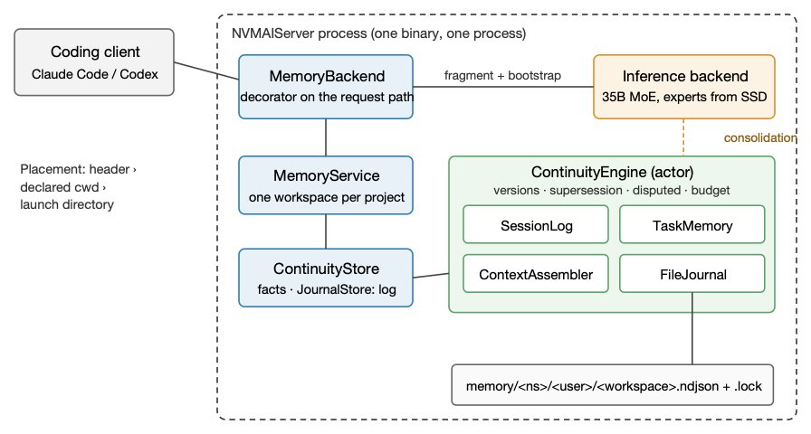
Figure 1. Architecture. Memory is a decorator on the server's request path: on the way in it installs a short system fragment and a bootstrap of facts; on the way out it services memory tool calls (if enabled) and, in the pause after a reply, asks the inference backend to consolidate the session. All memory state lives in a Swift actor in the same process; the only thing outside RAM is one journal file per project.

3.2 Addressing, versions and supersession
A fact lives at namespace.key; the namespace is dotted and hierarchical, the key is not, and the engine never interprets either. It isolates by task and indexes by address, which is what keeps it generic across a coding project (decision.storage, constraint.no_network) and a novel (character.marcus.eyes, state.inn). A write to an existing address does not overwrite: it creates a new version and marks the previous one superseded, so chapter 100 can still answer what chapter 40 believed, and every version records the session and author that wrote it. A write that reverts a value to one the address held earlier is marked .disputed: the contradiction stays visible and flagged rather than silently resolved, because the model is the component best placed to settle it and cannot if the conflict is hidden. .archived retires a fact without destroying it, and a concurrent writer that passes expectedVersion receives a version conflict instead of losing a write.

3.3 Context assembly
The assembler builds the bootstrap block from a ContextBudget: a token ceiling, a priority order of namespaces, and a capped share for recent turns so that one long exchange cannot crowd out durable state. Ordering is priority namespace first, then importance, then recency, with ties going to the older fact so that a foundation outranks last session's status. An included item drags its declared dependencies in with it, so a decision never arrives without the constraint that produced it. The snapshot names what went in and what matched but did not fit; a persistently dropped item is a signal that the budget or priorities are wrong. In the server the bootstrap is bounded twice, by record count (60) and by bytes (16 KiB), each value summarised to 200 characters. The count was raised from 20 after a novel's bible plus its running state passed thirty keys by the fourth session and the character facts were crowded out by state.

3.4 Integration and the two kinds of tools
NVMAI returns tool calls to the client, which executes them; that is right for the client's own coding tools and useless for memory, because no coding client knows about the server's memory. Memory tools are therefore the one kind of function call the engine answers itself, in up to four rounds per request, and a turn that calls a client tool ends the memory loop rather than stranding its result. Throughout this paper "memory tools" means the six memory_* functions (search, get, list, set, append, delete); the client's own tools are never affected by any memory setting. Memory tools are off by default, for reasons Section 6 makes measurable. When a model exhausts its tool rounds it receives one final tool-free generation to answer with what it has, rather than having its preamble returned as the answer — a defect first observed as a 31-token "I need to check the existing memories" where ten chapters should have been.

3.5 Engine-driven consolidation
The store is only as good as what is written into it, and Section 6.1 shows that on the models tested the model-initiated write is the unreliable link. So the engine forces it. When a session has been quiet for a configurable idle time (30 s), or when a new conversation begins in the same workspace before that — a rollover, which is the end-of-conversation signal the API never sends — the engine issues a separate, tool-free request asking what from the session must not be contradicted later: decisions, fixed attributes, rules, current state, and what changed. The answer is a JSON array of addressed facts and is written to memory, reusing an existing key when a fact updates it. This is why the output is facts rather than a note: a later state supersedes the earlier one, where a summary copies "Inn: standing" forward one session after the inn burned.
The prompt's shape was settled by failure. Shown only the names of existing keys, the model re-derived every one from sessions that said nothing about them, wrote not specified over a character's eye colour and confirmed standing for the burned inn. The extraction is now shown the current values of keys the transcript mentions (whole-word match, three characters or more — "inn" must count), the names of keys in namespaces the session touches (capped at 60), and other namespaces as one line with a count. Values shown for mentioned keys stop re-derivation; listing only touched namespaces was the v3 change that removed most of v2's extra cost, because an every-key list grows with the store. A returned fact whose value memory already holds is not rewritten. A long session is distilled incrementally: each consolidation reads only the turns after the last one it distilled, plus one for context. The output cap is 2,000 tokens and the parser is tolerant — a fenced block, a bare object, or an array truncated by the cap are all recovered, and placeholder values (unknown, not specified) are dropped. Consolidation never overlaps a user turn: a generation gate serialises it against the request path, and on a rollover it runs only after the new session's first reply has been returned, so a person never waits for it.

3.6 Placement: which project a session belongs to
A single server serves several projects, and a novel's facts must never appear in a codebase's bootstrap. Every session is placed in a workspace in this order: an explicit X-NVMAI-Workspace header; the working directory the client declared in its system prompt (Claude Code writes a Working directory: line and Codex a <cwd> element on every request); the directory the server was launched from. The workspace identifier is the directory name plus a digest of its full path, so two checkouts of one repository never share memory. Only absolute paths in system messages count, so a user pasting a transcript cannot move their memory, and the home directory, its parent and the filesystem root are refused as workspaces — a server launched from ~ and used for everything would otherwise collect every project into one store.

3.7 Shared personal facts, retention and inspection
A consolidation may mark a fact "global": true — a convention wanted everywhere, a language, a tone. Such facts go to a shared workspace _global under the same user, and every project's bootstrap opens with them under "About this person, in every project". A request cannot name that workspace. Retention (30 days, tunable) expires a project's session log, which is the bulk of the file, and keeps its facts, their history and title, so a novel paused for six weeks returns with its bible; only a cap on the number of project files (100) ever deletes facts, oldest by last write first, and never a project that a server has open. A command-line tool lists, shows, retires and forgets facts, and reads take no lock, so inspection works while a server runs.

4. Durability and coexistence with the inference engine
The design constraint that distinguishes this store from a general-purpose database is the neighbour it lives with. The inference engine keeps attention and shared weights resident and streams routed experts from SSD on every token; exposed expert I/O is 20–37% of a token's time at 4-bit and 8-bit respectively on the reference machine. A store that flushes to disk inline with a request would add its latency to a token, and a full flush on Apple silicon (F_FULLFSYNC, since Darwin's fsync only promises that the write reached the drive's cache) costs tens of milliseconds.
Journal. Both stores persist to one append-only JSON-lines file per project, owner-readable only, inside an owner-only directory. An append is a write(2) into the page cache — microseconds, and all a request ever pays. The durability barrier is taken when appends stop: two seconds after the last one, forced after thirty seconds if they never stop, and at session end, compaction and shutdown (Figure 2). It runs on a utility dispatch queue, never on the cooperative thread pool. The moment after a reply is the one moment the drive is not being asked for expert weights. A process crash loses nothing; a power cut loses at most what arrived since the last idle moment. A torn final line, the normal result of a crash, is dropped on replay rather than stranding every good record behind it. Compaction collapses the file to one checkpoint written to a temporary file and renamed into place, with the directory synchronised, so a crash mid-compaction leaves the old journal intact. The journal is replayed at boot, not on the first request.
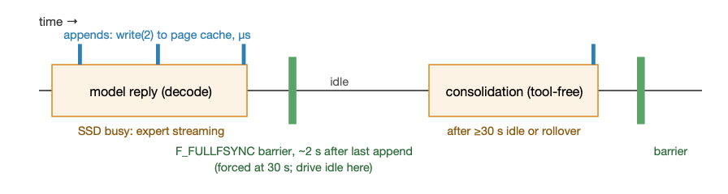
Figure 2. Timing of durability against inference. Appends land in the page cache during a reply; the full-flush barrier is deferred until appends stop, which coincides with the drive being idle. Consolidation is a separate generation gated against the request path, so it never overlaps a user turn.
One writer per workspace. A journal takes an exclusive advisory lock on a .lock sidecar for as long as it is open, so compaction can replace the file without giving the lock up. Without it, two processes on one file would each hold their own copy of the state, see none of the other's writes, and interleave their appends into a braid of two histories. A second server on the same workspace runs without persistence, logs the refusal, and tells the model in its prompt that writes will not outlive the session. The kernel releases the lock however the process exits, so a crash never strands a workspace.
Footprint. There is no RAM ceiling by default, and nothing to defend against: replaying the benchmark journals through the store's own accounting gives the figures in Table 1. Bounds that remain are hygiene rather than budgets — a fact is at most 64 KiB, an address keeps 32 versions, a session keeps 200 turns and a workspace 100 sessions in memory, while the file keeps everything. An optional ceiling (NVMAI_MEMORY_CACHE_MIB) splits three quarters to facts and one to the log; at the cap, facts refuse a write (silently dropping something the model deliberately wrote is worse than declining) and the log evicts its oldest sessions from memory, where they remain on disk.
Table 1. Resident and on-disk footprint measured from the benchmark journals.
Task | Facts held | Resident (facts, history, log) | Journal on disk
Hundred-chapter novel, ten sessions | 93–134 | 96–121 KB | 194–249 KB
Pong in three languages, three sessions | 10–22 | 10–20 KB | 25–45 KB
Failure behaviour and security. Memory never fails a completion: a journal that cannot be opened degrades the session to memory-only with the model told so; a failed write is reported to the model as a tool error and never as success. Keys and scope components are parsed rather than trusted (traversal, separators, globs, control characters and overlong keys are rejected before any store sees them); the model receives logical operations, never commands, and cannot name another workspace; log lines carry operational detail and never memory contents, which a test asserts; and nothing in the memory path opens a socket.

5. Evaluation method
Hardware and models. All measurements ran on one MacBook with an Apple M3 and 24 GB of unified memory, macOS 26.6, with the NVMAI server built in release configuration. Models are 35B-A3B mixture-of-experts checkpoints (about 3B active parameters per token) at 4-bit and 8-bit precision; Qwen 3.6 4-bit is the reference install and decodes at roughly 16 tokens per second with experts streamed from SSD. The harness refuses to start if any source file is newer than the release binary, a guard added after three arms of numbers turned out to be the same arm.
Benchmark A: a program across languages ("pong"). Three separate conversations. Stage 1 asks for a Pong game with two autoplayers in Swift and requires seven numeric rules (field size, win score, ball start, increment and maximum speed, paddle speed) to be chosen and stated as JSON. Stages 2 and 3 ask for the same game in Python and C99, saying only "keep exactly the same rules". Carry-over is the count of rules the later stages reproduce, out of 14. Without memory the model re-picks; some defaults (800×600, first to 11) return by prior, which is why the control scores above zero.
Benchmark B: a hundred-chapter novel ("the book"). Ten conversations of ten chapters each. Session 1 receives the bible: six characters with fixed eye colours, a town where it never rains, a ferry day, three rules. Sessions 2, 4, 6, 8 and 9 introduce a plot event that changes state (the inn burns, a missing brother is found, a confession). Every session ends with a fourteen-question continuity quiz answered as JSON and scored against what is true by then; carry-over is summed over sessions 2–10 (126 questions). Colour words are matched by prefix, since "hazelnut" for "hazel" is not a memory failure; both versions under comparison are always rescored from stored answers by the same pass.
Arms. control / summary: memory off; on the book the harness forces a 200-word note at each boundary and prepends it, which is what a client's own compaction does. auto: memory on, memory tools off, the engine writes by consolidation — the shipped configuration. minimal (set, get, list) and full (six functions) add memory tools. Each arm gets a freshly started server with its own empty memory directory; the server is stopped between arms by its listening process id, and "ready" means a completion returns 200, not that the port is open.
Runs, noise and cost. Three runs per arm with the server's own sampling; at temperature 0 a repeat is the same output. The summary arm runs identical code in every version, so its spread across versions and runs is the benchmark's noise floor: it moved between 84% and 96% over nine runs, i.e. about ±6 points. Differences inside that band are not reported as effects. Cost counts request prompt and completion tokens as the client sees them plus consolidation tokens read from the server log, and model-busy time is request time plus consolidation waits. Every memory-arm score is read together with the server log's counts of bootstraps, consolidations and memory_set calls, so that a score is never attributed to a mechanism that did not run.

6. Results

6.1 The write is the unreliable link
The first evaluation (single runs, temperature 0, Qwen 3.6 4-bit) compared model-initiated memory against forced summarisation on the book (Figure 3). With minimal tools the model stored nothing in session 1, then guessed keys blind — 136 memory_get calls to 2 memory_set across the run — exhausted its tool rounds and, in three sessions, returned a 31-token preamble instead of chapters; its entire memory after ten sessions was one record. With full tools the model made zero writes in session 1 with the bible in front of it, found memory empty in session 2, invented a bible (a brother with brown eyes, rain on Tuesdays, a Thursday ferry) and stored that — which memory then carried faithfully for eight sessions. The forced summary carried the bible to session 10 but lost every transition: the note written after the session in which the inn burned says "Inn: Standing", copied forward from the previous note. Three conclusions followed. The store works: when a fact is written it carries perfectly. The model-initiated write is the unreliable link, and it is the whole result. And a forced boundary extraction beats model-initiated memory two to one while being the worse mechanism, because its advantage is entirely that it is forced. Engine-driven consolidation into the versioned store (v1) combined the forcing with supersession and reached 96%.
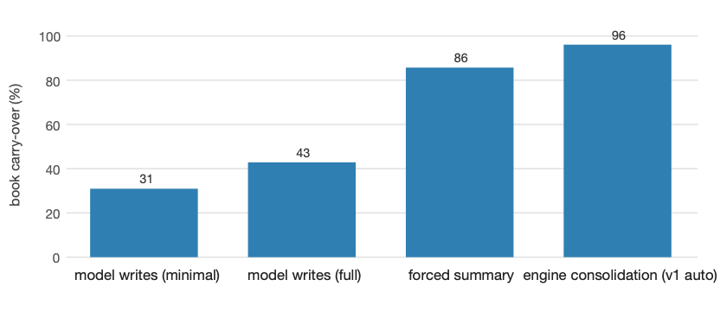
Figure 3. Book carry-over (sessions 2–10) by who writes memory. Model-initiated writes through memory tools (single runs, first evaluation) against a harness-forced summary and the engine-authored consolidation of v1 (mean of three runs). The forcing is what matters; supersession is what the summary lacks.

6.2 Three versions on the reference install
Table 2 and Figures 4–5 give the three engine versions on Qwen 3.6 4-bit, three runs per arm, rescored identically. v2 added the request-ranked bootstrap, reversion marking, values-for-mentioned-keys in the extraction and the 30-second idle trigger; v3 scoped the key listing to touched namespaces, skipped unchanged facts, made consolidation incremental, kept facts through retention and added the shared personal workspace.
Table 2. Book, Qwen 3.6 35B-A3B 4-bit, mean of three runs. Carry-over over sessions 2–10; tokens per run include consolidation; time is model-busy seconds. Noise floor ±6 points (summary arm, unchanged code).
Arm | v1 carry-over | v2 | v3 | v1 tokens · s | v2 tokens · s | v3 tokens · s
summary (memory off) | 96% | 90% | 90% | 19.9k+11.2k · 747 | 20.7k+11.7k · 804 | 21.0k+11.9k · 832
auto (engine writes) | 96% | 95% | 93% | 25.6k+11.1k · 1170 | 28.6k+13.0k · 1404 | 26.5k+12.7k · 1343
minimal (memory tools) | 83% | 89% | 92% | 32.3k+10.9k · 1251 | 30.2k+9.8k · 1198 | 31.6k+11.5k · 1346
full (memory tools) | 83% | 92% | 85% | 40.4k+13.2k · 1791 | 36.0k+11.5k · 1458 | 40.2k+12.1k · 1924
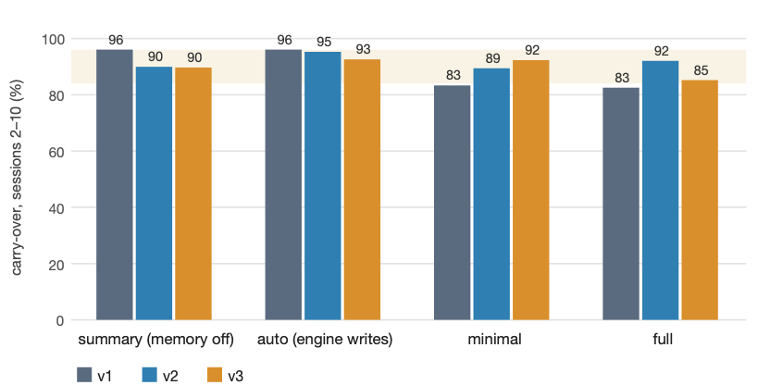
Figure 4. Book carry-over by arm and engine version (mean of three runs each). The shaded band is the spread of the summary arm, which runs identical code in every version, and so is the noise floor of the benchmark. The shipped configuration (auto) is stable inside it; the full-tools arm is the only one that moved outside it, downward, in v3.
The shipped configuration is stable: 96, 95 and 93% are within the band the unchanged baseline itself spans. What changed is cost. v2's every-key listing grew with the store and raised the auto arm's consolidation prompt from 16.7k to 19.2k tokens per run (+15% total); v3's scoped listing brought it back to 18.1k, with the request side also smaller (8.4k against 9.4k), for a net −7% prompt tokens and −4% time against v2 (Figure 5). The floor that remains is structural: ten consolidations per run at 1.5–2k prompt tokens each, and the benchmark's sessions are a single turn long, the worst possible ratio of consolidations to turns. A real session of ten to fifty turns pays the same one consolidation.
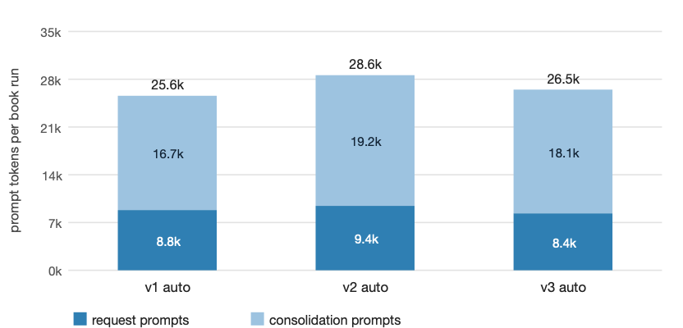
Figure 5. Prompt tokens per book run for the auto arm, split into what the client's requests carry and what the engine's consolidations spend. The extraction prompt is the whole overhead of the feature; v3 removed about half of what v2 had added.
Pong (Table 3, Figure 6) is unambiguous on every version: the control re-picks its rules and lands between 24% and 52% depending on how often defaults return by prior, and every memory arm reproduces all fourteen rule instances in all runs. The cleanest evidence is a non-default value such as paddle_speed: 7 or 400 carried through three conversations. Memory costs 2.9k prompt tokens per run here (three bootstraps and three consolidations) against 0.3k without.
Table 3. Pong, Qwen 3.6 4-bit, mean of three runs. Carry-over is rule instances reproduced in Python and C out of 14.
Arm | v1 | v2 | v3 | v3 tokens · s | Model-initiated writes (v3)
control (memory off) | 24% | 52% | 40% | 0.3k+7.8k · 477 | —
auto | 100% | 100% | 100% | 2.9k+8.4k · 594 | — (engine)
minimal | 100% | 100% | 100% | 5.6k+10.9k · 866 | 0 in 3 runs
full | 100% | 100% | 100% | 7.7k+9.3k · 839 | 4 writes in 2 of 3 runs
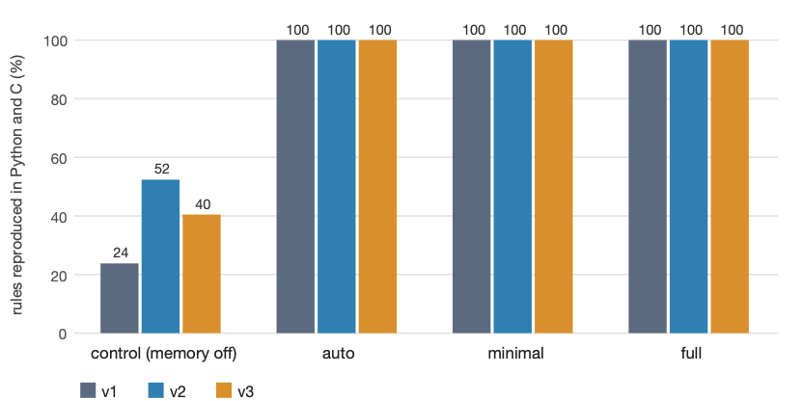
Figure 6. Pong carry-over by arm and version. Every memory arm is at 100% in every run; the control's variation is the rate at which Pong's conventional defaults return by prior.

6.3 Per-session dynamics
Figure 7 shows where the book's baseline loses points. Both arms hold the bible; the summary arm drops after each plot event because the forced note carries the previous state forward and does not apply the transition, and it recovers only partially. Engine-authored memory records the transition as a superseding version, so a state question is answered from the current fact. The residual misses in the auto arm are a mix of synonyms the strict scorer rejects and, on 4-bit, an occasional session in which the model answered from its own draft rather than the bootstrap.
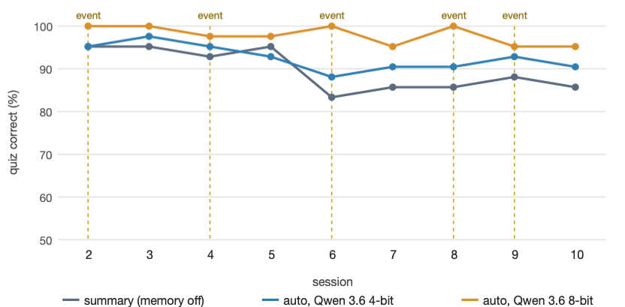
Figure 7. Quiz accuracy per session (mean of three runs) for the memory-off baseline and the shipped configuration on two quantisations of Qwen 3.6. Dashed lines mark sessions that introduce a state change. The baseline's dips follow the events; memory answers state questions from the superseding fact.

6.4 Across installs
The matrix over three models at two precisions was still executing when this draft was written; Table 4 reports what has completed. On Qwen 3.6 8-bit the separation is cleaner than at 4-bit: memory off 92% (runs of 91, 91, 93), memory on 98% (97, 98, 98), every memory run above every baseline run, for +16% prompt tokens and +26% model-busy time; pong moves from 33% to 100%. The 8-bit model writes tighter extractions, so its auto arm uses fewer tokens than the 4-bit auto arm despite the higher precision. Ornith 1.5 4-bit's first run shows a baseline equal to Qwen's (92%) and a memory run at 89% with a smaller consolidation footprint; one run resolves the mechanism, not the rate, so its figure is provisional until its three runs complete.
Table 4. Book carry-over and cost per install, memory off (summary) versus memory on (auto). Mean of three runs unless marked; tokens include consolidation.
Install (all 35B-A3B) | Off | On (auto) | Off tokens · s | On tokens · s | Pong off → on
Qwen 3.6, 4-bit | 90% | 93% | 21.0k+11.9k · 832 | 26.5k+12.7k · 1343 | 40% → 100%
Qwen 3.6, 8-bit | 92% | 98% | 19.9k+11.3k · 1498 | 23.1k+10.4k · 1884 | 33% → 100%
Ornith 1.5, 4-bit (first run only) | 92% | 89% | 21.1k+11.9k · 824 | 27.9k+9.8k · 1144 | pending
Ornith 1.5 8-bit; AgentWorld 4-bit, 8-bit | pending at time of drafting
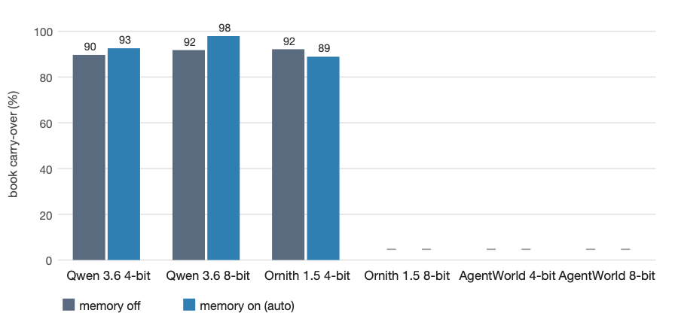
Figure 8. Book carry-over per install, memory off versus on. Installs still executing at the time of drafting are shown as missing; the Ornith 4-bit value is a single run.

6.5 Memory tools
Across the 48 tool-arm runs of v1–v3 on both benchmarks, the model initiated memory writes in two runs, both pong under v3 with full tools: after the Swift stage it stored a prose summary of its decisions and, as a second version, the seven parameters as a structured dictionary, both accurate. In every book run of every version the count was zero; all facts were the engine's. The tools therefore add prompt cost (the six schemas are the largest part of the request prompt in the full arm) and, on the book in v3, a measurable loss (85% against 93% for auto, and +32% time). The one thing they demonstrably provided in the first evaluation — pong's 14/14 through a model-initiated write — the engine now provides without them. They remain available for clients that want them and are off by default.

7. Discussion
Why engine-authored. The two failure modes of model-initiated memory are not tuning problems. A model asked to write a novel writes the novel; the instruction to also store its bible competes with the task and loses. A model that finds memory empty in session 2 has no way to distinguish "nothing was stored" from "nothing is known" and fills the gap. Moving the write to a boundary, in a request whose only task is the extraction, removes the competition, and showing the extraction what memory already holds removes the fabrication. The remaining cost is one generation per session, and the benchmark's one-turn sessions overstate it by an order of magnitude relative to real use.
Why in-process. The Valkey design was correct for a service and wrong for this machine. Every property that a key–value service offers — multi-process access, network reach, unbounded scale — is either unwanted here (nothing in the memory path should be reachable from the network) or unneeded at 100 KB. What the service could not offer is control over when disk I/O happens, and on a machine streaming experts from SSD that timing is the property that matters. The in-process journal also removed a dependency, a daemon, a port, and a class of failure (connection loss mid-session) in exchange for one constraint, one writer per workspace, which is enforced rather than assumed.
What the noise floor teaches. A benchmark whose control arm spans twelve points across nine identical runs cannot resolve a two-point change, and several apparent v1→v2→v3 movements would have been reported as effects without it. The discipline that made the results trustworthy was procedural more than statistical: a freshness guard on the binary, a per-arm fresh server and empty store, readiness defined as a returned completion, server-log counts read next to every score, and both versions rescored by the same pass whenever scoring changed.
Threats to validity. Single machine, one model family, two synthetic tasks, and three runs per arm. The book's quiz is generated from the same bible the model was given, so it tests recall of stated facts and state transitions rather than open-ended coherence. Timing is sensitive to background load — one v2 pong run was excluded when a network extension held a core at 94% — and the 8-bit results have no v2 counterpart. Cross-install results are partial at the time of drafting.

8. Limitations and future work
- Search is lexical. Prefix, tag and importance filters, then a ranked scan of at most 2,000 records. A semantic layer was designed for but not built: it would embed on write and rank by cosine similarity behind the same filters, and it needs an embedding model resident beside a 35B model that is already streaming from SSD, which is a real cost to measure before adopting.
- Session identity is derived. The API is stateless, so a session is the first user message plus the workspace; two conversations opening with the same message in one workspace share a session.
- One process per workspace. Several servers cannot share one memory as they could a database.
- Consolidation cost floor. The extraction prompt is the overhead; further reduction means a smaller extraction model or a cheaper trigger, not a smaller key list.
- Validation gaps. Memory with the client's own tools present in the same turn, other clients' working-directory formats, and long real sessions rather than one-turn benchmark sessions.

9. Conclusion
An agent's memory should be written by the engine that observes the session, not left to a model that is busy doing something else. Doing so inside the inference process, with a versioned store whose writes supersede rather than overwrite, gives a local 35B model continuity across sessions — 100% rule carry-over on a three-language port and 93–98% on a hundred-chapter novel — for one extra generation per session and a footprint of about 100 KB, without a service, a port, or a dependency, and without disturbing an inference engine that shares the disk. The design has been stable across three iterations inside the benchmark's measured noise floor while its cost was reduced, and it reproduces across quantisations of the reference model. The engineering that made these claims checkable — a noise floor from an unchanged control, fresh servers per arm, and scores read only beside the logs of the mechanisms that produced them — is, we think, as transferable as the design.
Data and code availability. The engine (sources/ContinuityCore), the server integration (sources/NVMAIMemory, sources/NVMAIServer/Core/MemoryBackend.swift), the harness (benchmark/memval_run.sh, memory_book.py, memory_value.py) and the per-run result files are in the NVMAI repository at tags memory-v1, memory-v2 and memory-v3. Every figure in this paper is generated from the result files by docs/paper/figures.py.

References
- C. Packer, V. Fang, S. G. Patil, K. Lin, S. Wooders, J. E. Gonzalez. MemGPT: Towards LLMs as Operating Systems. arXiv:2310.08560, 2023.
- J. S. Park, J. C. O'Brien, C. J. Cai, M. R. Morris, P. Liang, M. S. Bernstein. Generative Agents: Interactive Simulacra of Human Behavior. In Proc. UIST, 2023.
- P. Lewis et al. Retrieval-Augmented Generation for Knowledge-Intensive NLP Tasks. In NeurIPS, 2020.
- N. F. Liu, K. Lin, J. Hewitt, A. Paranjape, M. Bevilacqua, F. Petroni, P. Liang. Lost in the Middle: How Language Models Use Long Contexts. TACL 12, 2024.
- N. Shinn, F. Cassano, A. Gopinath, K. Narasimhan, S. Yao. Reflexion: Language Agents with Verbal Reinforcement Learning. In NeurIPS, 2023.
- S. Yao, J. Zhao, D. Yu, N. Du, I. Shafran, K. Narasimhan, Y. Cao. ReAct: Synergizing Reasoning and Acting in Language Models. In ICLR, 2023.
- Qwen Team. Qwen3 Technical Report. arXiv:2505.09388, 2025.
- W. Zhong, L. Guo, Q. Gao, H. Ye, Y. Wang. MemoryBank: Enhancing Large Language Models with Long-Term Memory. In AAAI, 2024.
- W. Fedus, B. Zoph, N. Shazeer. Switch Transformers: Scaling to Trillion Parameter Models with Simple and Efficient Sparsity. JMLR 23, 2022.
- Valkey contributors. Valkey: an open source, high-performance key/value datastore. https://valkey.io, 2024.
- J. Gray, A. Reuter. Transaction Processing: Concepts and Techniques. Morgan Kaufmann, 1992.
- M. Rosenblum, J. K. Ousterhout. The Design and Implementation of a Log-Structured File System. ACM TOCS 10(1), 1992.
- D. Wu et al. LongMemEval: Benchmarking Chat Assistants on Long-Term Interactive Memory. arXiv:2410.10813, 2024.
- A. Maharana, D.-H. Lee, S. Tulyakov, M. Bansal, F. Barbieri, Y. Fang. Evaluating Very Long-Term Conversational Memory of LLM Agents. In ACL, 2024.
Draft note: references were compiled from memory and should be verified against the published records before submission; affiliation, contact and ORCID are placeholders; Table 4 and Figure 8 are to be completed when the six-install matrix finishes.

