
PumpkinCell OS
Computer in Minecraft
CIMC 16-bit CPU Architecture (Cx16)
Software Developer's Manual
Version 1.0
Copyright (c) SyberMCd 2020-2021
Copyright (c) Adam2004yt 2021
Prototype built by:
Adam2004yt
PumpkinCell
SyberMCd
Table of Contents
I. Definitions 4
1.1. Shortcuts 4
1.2. Definitions 5
2. Physical Architecture 5
2.1. Instruction Loader 5
3. Process 5
3.1. CPU Cycle 5
4. Interrupts 6
4.1. Internal Interrupts (Traps, Exceptions) 6
4.2. INT Argument 6
4.2.1. Unspecified (fatal) error (#UE) 6
4.2.2. Page fault (#PF) 7
4.2.3. Reserved (#R4) 7
4.2.4. Cascaded Interrupt (#Q7) 8
4.3. Nesting Interrupt Handlers 8
4.3.1. Raise Interrupt Action 8
4.3.2. IRET Action 8
4.3.3. IRET Fault Action 9
4.4. Interrupt Reference 9
5. Registers 10
5.1. General-Purpose Registers 10
5.2. Control Registers 11
5.2.1. Flags Register 11
5.3. Internal CU Registers 11
6. Virtual Memory 12
6.1. Paging 12
6.2. Enabling / Configuring Paging 13
6.3. Page Directory 13
6.4. Page Table 14
6.5. Page Directory Caching 14
7. CPU Identification 15
7.1. CPUID Instruction 15
7.1.1. AX Register 15
7.1.2. Virtual Memory Capabilities 15
7.1.3. ALU Capabilities 15
8. Assembly 16
8.1. Detailed Description 16
8.1.1. OUT16 a, b → 16-bit Output to Port 16
8.1.2. OUT8 a, b → 8-bit Output to Port 16
8.1.3. IN16 a, b → 16-bit Input from Port 17
8.1.4. IN8 a, b → 8-bit Input from Port 17
8.1.5. MOV a, b → Move Value from 'a' to 'b' 17
8.1.6. J*c a → Jump Conditionally 18
8.1.7. CMP a, b → Compare Values 'a', 'b' 19
8.1.8. PUSH a → Push 'a' to Stack 20
8.1.9. POP a → Pop from Stack to 'a' 20
8.1.10. ADD a, b → Add from 'a' to 'b' 20
8.1.11. SUB a, b → Subtract from 'a' to 'b' 20
8.1.12. MUL a, b → Multiply from 'a' to 'b' 21
8.1.13. DIV a, b → Divide from 'a' to 'b' 21
8.1.14. AND a, b → Byte AND from 'a' to 'b' 21
8.1.15. OR a, b → Byte OR from 'a' to 'b' 22
8.1.16. NEG a → Byte/Logic Negate 'a' 22
8.1.17. RET → Return from Procedure 22
8.1.18. CALL a → Call Procedure 22
8.1.19. CALLA → Call Procedure and Setup Stack Frame 23
8.1.20. LIVT a → Load Interrupt Vector Table 23
8.1.21. HLT a → Halt Processor 23
8.1.22. EXT ... → Extended Operations 24
8.1.23. INT a → Raise Interrupt 24
8.1.24. INC a → Increment a 24
8.1.25. DEC a → Decrement a 24
8.1.26. SHL a, b → Shift Left a by b 25
8.1.27. SHR a, b → Shift Right a by b 25
8.1.28. XOR a, b → Exclusive OR from 'a' to 'b' 25
8.1.29. PGE a → Enable Paging 25
8.1.30. XCHG a, b → Exchange Values 26
8.1.31. CPUID → Processor Identification 26
8.1.32. Other Opcodes 26

Definitions

Shortcuts
- Op - Opcode (Operation Code)
- Mm - Mnemonic (in assembly)
- Args - Arguments (in assembly)
- AddB - Additional Byte (used for storing operation argument)
- CimcC - Instruction representation in CimcC language
- ia – instruction address

Definitions
- Instruction – a well-defined, atomic task done by processor in specified time, called cycle time.
- Register – a small, CPU-internal storage with specified size.
- Virtual memory – the way in which the instructions “sees” the memory address space. It’s mapped to physical memory.

Physical Architecture

Instruction Loader
,-----,
Ack --| |
D0 --| |
D1 --| |
D2 --| |
D3 --| |
D4 --| | [TODO]
D5 --| |
D6 --| |
D7 --| |
Rq --| |
RqOn --| |
'-----'

Process

CPU Cycle
See Control-Unit.mod

Interrupts

Internal Interrupts (Traps, Exceptions)
If an interrupt is called, the registers are placed on stack in the following order:
PUSH16 ip
PUSH16 flags
[PUSH16 arg]
'arg' is a 16-bit value which gives additional, interrupt-specific information about interrupt. If IRET is called, these registers are popped from the stack in the reverse order. The arg must be popped manually by operating system.
[POP16 arg] // done by OS
POP16 flags
POP16 ip
The User Accessible Interrupts can be called using an INT instruction.
The Cascaded Interrupt is reserved for scalability.
See Control-Unit.mod for further information.

INT Argument

Unspecified (fatal) error (#UE)
[0000CODE|RRRRRRRR]
- CODE:
Code | Mnemonic | Meaning
0x0 (0000) | #RUE | Really unexpected error
0x1 (0001) | #IIR | Invalid IRET (interrupt underflow)
0x2 (0010) | #NMI | Non-Maskable Interrupt (Reserved)
0x3 (0011) |  | Reserved
0x4 (0100) |  | Reserved
0x5 (0101) |  | Reserved
0x6 (0110) |  | Reserved
0x7 (0111) |  | Reserved
0x8 (1000) |  | Reserved
0x9 (1001) |  | Reserved
0xA (1010) |  | Reserved
0xB (1011) |  | Reserved
0xC (1100) |  | Reserved
0xD (1101) |  | Reserved
0xE (1110) |  | Reserved
0xF (1111) |  | Reserved
- R: Code-specific argument. If not required, it is 0.

Page fault (#PF)
[XWE0000|9b faulting page]
- XW – (0 - Read, 1 - Write, 2 – Execute (Jump), 3 – Execute) → X – Execute, W – Write
- E – Whether physical page exists

Reserved (#R4)
Argument is ignored and always set to 0.

Cascaded Interrupt (#Q7)
Argument is ignored and always set to 0.

Nesting Interrupt Handlers
Allowed order of nested interrupt handlers: No Interrupt → Interrupt Handler → Exception Handler

Try To Raise (TTR) Interrupt Action
Interrupt source | EF | IIF | Is Raised | Result
Internal | 0 | 0 | YES | Jump to Exception Handler
Internal | 0 | 1 | YES | Jump to Exception Handler
Internal | 1 | 0 | NO | Double fault (crash)
Internal | 1 | 1 | NO | Double fault (crash)
External | 0 | 0 | YES | Jump to Interrupt Handler
External | 0 | 1 | NO | Ignore
External | 1 | 0 | NO | Ignore
External | 1 | 1 | NO | Ignore

IRET Action
EF | IIF | Result
0 | 0 | Raise #UE(#IIR) → Invalid IRET, Interrupt Underflow
0 | 1 | IIF = 0; pop ISR data; jump to Interrupt Handler if raised → Normal IRET
1 | 0 | EF = 0; pop ISR data; jump to Interrupt Handler if raised → Exception IRET
1 | 1 | EF = 0; pop ISR data → Nested Exception IRET

Interrupt Faults
When an exception occures when raising or returning from interrupt (especially if IVT is not set up or invalid, or IRET was called in invalid conditions), the following actions are taken:

Interrupt Raise Fault Action
Interrupt source | EF | IIF | Result
Internal | 0 | 0 | Double fault (crash)
Internal | 0 | 1 | Double fault (crash)
External | 0 | 0 | Jump to Exception Handler → Fault on External Interrupt

IRET Fault Action
EF | IIF | Result
0 | 0 | Double fault (crash) → Interrupt Underflow
0 | 1 | Raise relevant exception → Faulting Normal IRET
1 | 0 | Double fault (crash) → Faulting Exception IRET
1 | 1 | Double fault (crash) → Faulting Nested IRET

Interrupt Vector Table
The IVT (Interrupt Vector Table) stores adresses of routines called when specific interrupt is raised.
The structure of IVT:
0 4 8 16 8+16*size
+----+----+---------+---------+
| Sz | Adresses x Size |
+----+----+-------------------+
Sz – The size of vector table, subtracted by 1. The value range is 0 – 255, which means that the IVT size range is 1 – 256.
Adresses – The interrupt entry adresses, ordered by INT number.

Interrupt Reference
Table 1: Interrupts
No | Id | Arg | Mm | Purpose
0 | INT0 | no | #IM | Invalid Math Operation
1 | INT1 | no | #II | Invalid Instruction
2 | INT2 | yes | #UE | Unspecified (fatal) error
3 | INT3 | yes | #PF | Page fault
4 | INT4 | no | #R3 | Reserved
5 | INT5 | yes | #R4 | Reserved
6 | INT6 | no | #U1 | User Accesible #1
7 | INT7 | no | #U2 | User Accesible #2
All interrupt numbers greater than 7 are device interrupts. The PIC is automatically remapped to add 8 to its internal IRQ number, so that INT8 is equivalent to IRQ0, INT9 to IRQ1 etc.
In result, the CPU can handle up to 248 external interrupts.

Registers

General-Purpose Registers
Table 2: General-purpose registers
Mm | Size | Notes | Layout
ax | 16b | Accumulator | [[-ah-] [-al-]]
bx | 16b | Base | [[-bh-] [-bl-]]
cx | 16b | Counter | [[-ch-] [-cl-]]
dx | 16b | Data | [[-dh-] [-dl-]]
sp | 16b | Stack pointer
bp | 16b | Base pointer

Control Registers
Table 3: Control Registers
Mm | Size | Notes
ip | 16b | Instruction Pointer
flags | 16b | Flags (effectively 8bit)
ivt | 16b | Interrupt Vector Table Pointer

Flags Register
uuuuuuuurEPNZOGI u-unused bytes, r-reserved (do not change!)
I(Interrupt) G(Greater) O(Overflow) Z(Zero) N(In Interrupt) P(Paging) E(In Exception Handler)

Internal CU Registers
These registers are not accesible by user.
Mm | Size | Purpose
addb | 2b | Additional Byte Needed:
  0 (00) | Not Needed | N
  1 (01) | 1 Byte Needed | 1
  2 (10) | 2 Bytes Needed | 2
  3 (11) | Not Checked | -

Virtual Memory

Paging
If PF is set, all instructions uses virtual adresses. They are mapped to physical memory using Memory Management Unit.
The whole physical and virtual memory is divided into 512-byte pages.
Max addressable memory: 65536 B (16-bit address) / 128 pages (7-bit page ID)
Implementation: 8192 B / 16 pages
The virtual address is divided into parts:
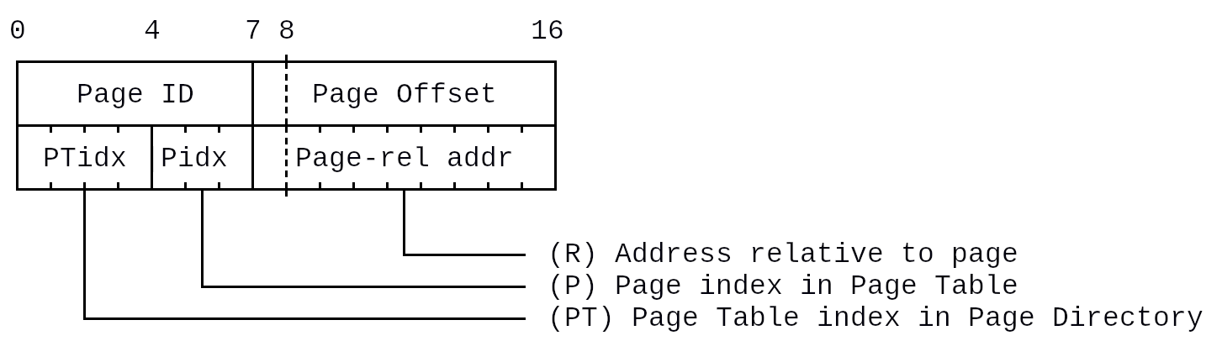
Physical address is calculated using following formula:
Phys = ((Pdaddr[PT].addr)[P]).addr = ((Pdaddr + *(PDaddress * 512 + PToffset * 4)].addr)[PTaddr + Pidx]).addr
Schematic:
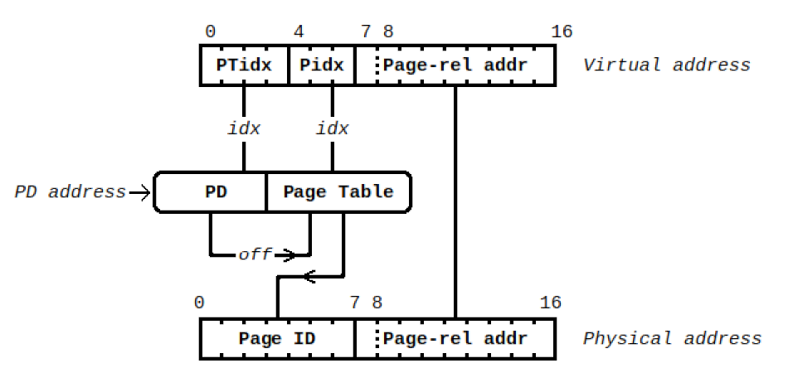
In result, the entire virtual address space is divided into 16 equal parts (each described by one page table). These parts are further divided into 8 equal parts (pages), each described by page table descriptor. This makes implementation using only 2 page tables.

Enabling / Configuring Paging
Paging is set up by calling PGE instruction. The format of argument:
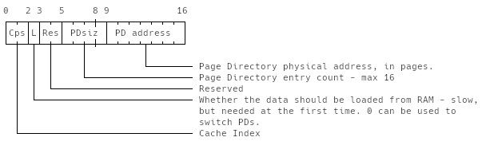

Page Directory
Page Directory has a maximum of 16 entries describing virtual memory divided into a maximum of 16 equal parts. It must be page-aligned. The real number of entries can be specified in PGE instruction (using PDsiz). The maximum size of PD is 16B.
Page Table descriptor in Page Directory:
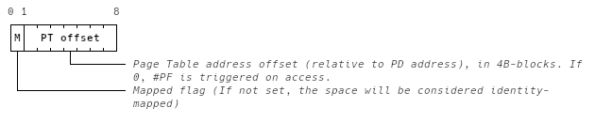
Calculating address of page table descriptor in page directory:
PTaddr = PD address * 512 + PT offset * 4

Page Table
Page Table is pointed by Page Directory entry and has 8 entries. It must be placed in the same page as Page Directory and be 4B-aligned. The resulting size of Page Table is 8B.
Page descriptor in Page Table:
0 1 8
+-+-+-+-+-+-+-+-#
|P|Page physical|
+-+-+-+-+-+-+-+-#
| '-------- Page Table physical address, in pages.
'---------------- Present (should NOT trigger #PF when accessed)
Calculating address of page descriptor in page table:
Paddr = PTaddr + PIdx
Calculating resulting physical address:
Phys = Page physical * 512

Page Directory Caching
When a program calls PGE, the Page Directory is loaded from RAM to cache specified by Cache Index (PDCI). The cache stores max. 4 page directories with their corresponding page tables.
Page Directory Cache size: 4 PDs * 16 PT descr * 1B/descr = 4x16x1B = 64B (16B)
Page Table Cache size: 4 PDs * 16 PTs * 8 Page descr * 1B/descr = 4x16x8x1B = 256B (64B)
Total size: 320B
Cache can be switched using PGE instruction, if L = 0.

CPU Identification

CPUID Instruction
The CPUID instruction sets registries to CPU-specific information.

AX Register
[NMMM AAAA:VVVV vvvv]
- ‘N’ – Has revision number in bx
- ‘M’ – Virtual Memory Capabilities
- ‘A’ – ALU Capabilities
- ‘V’ – Architecture major version (0x0 for cx8, 0x4 for cx16, 0x8 for cx32, 0xc for cx64)
- ‘v’ – Architecture minor version (0x0 for cx16 Initial Release)

Virtual Memory Capabilities
[RRR]
- ‘R’ – Reserved

ALU Capabilities
[1ISF]
- ‘1’ – Always set
- ‘I’ – 64-bit SIMD. Reserved for now.
- ‘S’ – 32-bit SIMD. Reserved for now.
- ‘F’ – Floating Point Coprocessor (FPC) implemented. Reserved for now.

Assembly

Detailed Description

Other Opcodes
Opcodes not listed here are all reserved. If they are called, an Invalid Instruction trap is triggered.
Alphabetical Index
Accumulator 10
Base 10
Base pointer 10
Counter 10
Data 10
Flags 11
Instruction 4
Invalid 26
Instruction Pointer 11
Interrupt 6
Argument 6
Cascaded 8
Internal 6
Nesting 8
Page fault 7
Raising 8
Vector Table 11, 23
Paging 12, 25
caching 14
Page Directory 13
Page Table 14
5. Registers 10
General-Purpose 10
Stack 6
pointer 10
Stack pointer 10
Virtual Memory 12, 25

