**Calculator Program Documentation**

**Overview**

The calculator program is a simple command-line application written in C++. It allows users to perform basic arithmetic operations such as addition, subtraction, multiplication, and division. The program prompts the user for an expression, evaluates it, and displays the result. The user can exit the program by entering the "exit" command.

**Prerequisites**

To run the calculator program, you need to have a C++ compiler installed on your system. The program is compatible with C++11 or later versions.

**File Structure**

* The calculator program consists of a single source code file:
* calculator.cpp: Contains the main code for the calculator program.

**Compilation and Execution**

* To compile and run the calculator program, follow these steps:
* Save the calculator.cpp file to your computer.
* Open a terminal or command prompt.
* Navigate to the directory where you saved the calculator.cpp file.
* Compile the program using a C++ compiler. For example, if you are using the GCC compiler, run the following command:



* After successful compilation, run the program by executing the generated executable file. Use the following command:



**Usage**

* Once the calculator program is running, it will display a prompt to enter an expression or the "exit" command. Here's an example interaction:

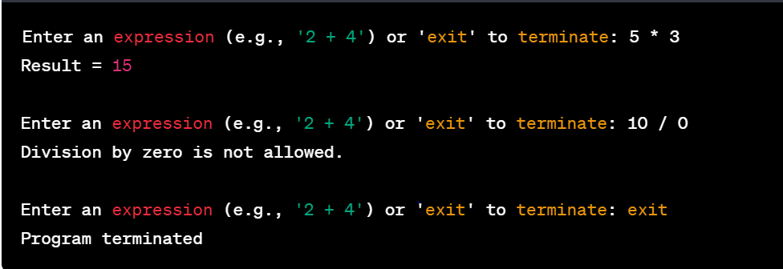

* The program accepts expressions in the format operand operator operand, where operand can be any floating-point number, and operator can be one of the following: + (addition), - (subtraction), * (multiplication), or / (division).
* If the entered expression is invalid or contains an unsupported operator, an appropriate error message will be displayed, and the program will prompt for a new expression.

**Class: Calculator**

* The Calculator class encapsulates the arithmetic operations performed by the calculator program. It provides the following methods:
* float add(float a, float b): Performs addition of two floating-point numbers (a and b) and returns the result.
* float subtract(float a, float b): Performs subtraction of two floating-point numbers (a minus b) and returns the result.
* float multiply(float a, float b): Performs multiplication of two floating-point numbers (a and b) and returns the result.
* float divide(float a, float b): Performs division of two floating-point numbers (a divided by b) and returns the result. If division by zero is attempted, an appropriate error message will be displayed.

**Main Function**

The main() function serves as the entry point for the calculator program. It performs the following steps:

Creates an instance of the Calculator class.

Enters a loop to prompt the user for an expression.

Reads the user's input and checks if the "exit" command is entered. If so, the program terminates.

Parses the expression into two operands and an operator using the stringstream class.

Performs the corresponding arithmetic operation based on the operator and the Calculator class methods.

Displays the result of the calculation.

Repeats the loop to accept new expressions or the exit command.

**Error Handling**

The calculator program handles several error cases to ensure correct execution:

If the user enters an invalid expression (not in the format operand operator operand), an appropriate error message is displayed.

If the user attempts to divide by zero, a specific error message is shown, and the program prompts for a new expression.

If the user enters an invalid operator, an error message is displayed, and the program prompts for a new expression.

**Educational Use**

You are free to use this calculator program for educational purposes, such as learning about basic C++ programming concepts, command-line input/output, parsing expressions, and error handling. You can modify and experiment with the code to enhance its functionality or add new features.

However, please note that this program is intended as a simple example and may not cover all possible edge cases or advanced features typically found in professional calculator applications.

**Conclusion**

The calculator program provides a basic framework for performing arithmetic calculations from the command line. Its simple structure and easy-to-understand code make it a suitable educational resource for beginners learning C++ programming.

If you have any further questions or need assistance, please feel free to reach out. Enjoy exploring and learning with the calculator program!