CSE 598 Capstone Project Proposal
Individual proposal with a runnable, reproducible, and testable baseline. Length target: 1 to 2 pages.
Basic Information
Student name | Puneet Kumar Bokka
Project title | Project Janus: Adversarial Shadow-World Architecture (ASWA)
Repository / notebook link | Local project folder: Agentic AI (push to course repo or GitHub and replace this line before submit)
Configuration location | examples/readme.md (also README.md for web demo instructions)
Section 1. Problem Definition
Task. Build ASWA, a closed-loop defensive system for enterprise operations tooling. Live production (the Light World) is never attacked directly. Instead the system discovers risk inside an isolated Shadow-World twin and returns only validated defenses through the Janus Gate. Another person can judge success by whether unsafe actions are blocked in production after deploy, while secrets and attack payloads never leave the twin.
ASWA runs four operational steps:
1) Duplicate. Mirror and sanitize live telemetry into a Shadow-World twin via the Reality Mirroring Engine.
2) Attack. Run Adversarial Synthesis Agents only inside the twin for exactly N steps.
3) Learn. Log successful shadow breaks or observed production risks and design countermeasures.
4) Deploy. Validate defenses in the Janus Gate, install approved patches in production, and hard-block ASA payload export.
User, interfaces, and predicates.
- Intended user. Security or platform engineer protecting automated or agentic ops tooling where mistakes can leak data or move money.
- Input. Production state, telemetry (may include secrets), horizon N, and an explicit policy set.
- Output. Sanitized twin, confined attack report, designed countermeasures, Gate decisions, and installed defensive patches.
- Success. Secrets redacted. ASA confined to twin. Each confirmed risk yields a countermeasure. Only validated defenses install. Post-deploy unsafe probes return 403.
- Failure. Secret leakage, ASA payload escape, unvalidated deploy, or confirmed risk with no defensive response.
Section 2. Motivation and Project Scope
Static pen-tests go stale as systems change, while continuous red-teaming of live production is operationally unsafe. ASWA is worth building because it provides continuous adversarial pressure without placing attack execution in production. An agentic design is appropriate because ASWA is a multi-component workflow with conflicting incentives: faithful sanitized mirroring (RME), aggressive shadow probing (ASA), and conservative one-way export control (Janus Gate). This is feasible for a semester project because the Light World can be a local FastAPI simulator, while the architectural invariants remain meaningful and evaluable.
In scope this semester.
- Acme Ops Light World (FastAPI) with tickets, ACLs, restricted files, email, and payments.
- RME sanitization and twin hydration, plus an ASA tabular learner over a closed simulator action catalog for horizon N.
- Learn stage plus Janus Gate validation and install, a localhost web console with multiple use cases, and an offline CLI baseline.
Out of scope.
- Real exploit development, memory-injection tooling, or weaponized payloads.
- Production-scale Kafka/gRPC fabrics, hardware/hypervisor airgaps, and attacks on third-party systems.
Section 3. Runnable Baseline
Baseline type: tool-use / workflow baseline with a rule-based policy world and a small tabular ASA learner. It is intentionally simple, but it fully runs the Duplicate -> Attack -> Learn -> Deploy loop and is therefore a reasonable starting point for later LLM/RL upgrades.
What the baseline uses.
- Python 3.10+ standard library for the core ASWA loop.
- Optional web demo stack: fastapi, uvicorn, httpx (requirements.txt).
- No external model API key is required for the graded baseline.
What the baseline does, step by step.
1) Load input. Read telemetry and N from examples/test_unsafe.json (CLI) or live Acme Ops telemetry (web).
2) Duplicate. aswa/rme.py clones state, redacts secrets, sanitizes restricted content, and hydrates the twin.
3) Attack. aswa/asa.py runs a Q-learner for N shadow steps over a closed action catalog and records policy violations.
4) Learn. aswa/learn.py logs vulnerabilities and designs countermeasures (firewall, DLP, payment, workflow rules).
5) Deploy. aswa/janus_gate.py validates defenses and blocks attack-trace export. webapp.py can install approved patches into production.
Implementation files.
- run_baseline.py, aswa/rme.py, aswa/asa.py, aswa/learn.py, aswa/janus_gate.py, aswa/pipeline.py, aswa/world.py
- Web surface: run_web.py, webapp.py, web/, production/app.py
- Config and examples: examples/readme.md, examples/test_unsafe.json, examples/test_safe.json
Section 4. Test Case and Baseline Output
Concrete test case.
- Sample input file. examples/test_unsafe.json
- Sample input content. Telemetry includes a secret token, contractor identity jane@vendor.com, and a touch of restricted file q4_salary.xlsx. Horizon N = 3.
- Expected behavior. Twin is hydrated with secrets redacted. ASA finds shadow policy breaks. Learn designs defenses. Janus Gate deploys patches. payload_escaped=false. Production remains free of ASA side effects.
Actual baseline output (screenshot). Command used: python run_baseline.py --input examples/test_unsafe.json
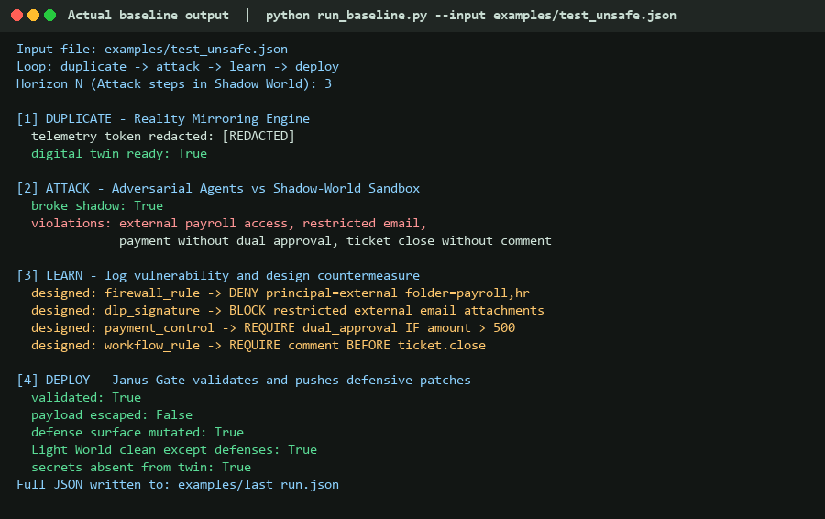
Figure 1. Actual console output from the runnable baseline on examples/test_unsafe.json.
- End-to-end Duplicate -> Attack -> Learn -> Deploy completed successfully on a concrete input.
- payload_escaped stayed False. Light World remained clean except installed defenses. Full JSON written to examples/last_run.json.
What did not work yet.
- ASA actions are closed-catalog probes, not open-ended strategy discovery.
- Learn still maps known violations to template defenses rather than fully generative policy compilation.
- Twin fidelity is intentionally simplified versus production-scale streaming architectures.
Section 5. Reproducibility and Run Instructions
Dependencies and installation.
1) Runtime. Python 3.10+.
2) Install. python -m pip install -r requirements.txt
3) API keys. None required for the baseline. Local demo token (web only): Bearer prod-secret-abc
4) Exact CLI command. python run_baseline.py --input examples/test_unsafe.json
5) Exact web command. python run_web.py then open http://127.0.0.1:8765
6) Input location. examples/test_unsafe.json (and other examples/*.json use cases)
7) Output location. Console printout, examples/last_run.json, and web UI Light/Shadow panels
8) Known limitations. Windows console may show encoding quirks. No cloud services required. Web demo needs free local ports (default 8765).
- Docs. More detail: examples/readme.md and README.md
Section 6. Initial Evaluation Plan
Future improved systems will be compared against this baseline on the same labeled use-case suite. Evidence of improvement is higher defensive coverage and better Learn/Gate quality without weakening containment.
Primary criteria.
- Safety/reliability: payload-escape rate = 0 and secret-leak rate = 0.
- Correctness: post-deploy block rate on known unsafe probes.
- Completeness: Learn recall when Attack succeeds or production risk is observed.
Secondary criteria.
- Latency of the full loop, ASA episodes-to-break, false-deploy or over-refusal rate, and optional later cost if LLM components are added.
Section 7. Limitations and Next Steps
Known weaknesses and expected failure cases.
- Toy twin can drift from any richer future connectors. Paraphrased or novel action types outside the ASA catalog may be missed.
- Template defenses may be incomplete for complex multi-step social-engineering patterns.
- Over-broad Gate rules could later block some safe workflows if not refined.
Next phase, risks, and needs.
- Next build. Build richer Acme scenarios, stronger ASA exploration within the closed contract, and more expressive Gate policy signatures.
- Optional extension. Optional LLM assistance for countermeasure wording, without relaxing containment.
- Risks. Shadow-fidelity gaps, ASA variance, and over-refusal if defenses become too coarse.
- Help / data / infra needed. A larger labeled telemetry and use-case set. Later one model API key only if LLM roles are added.

