**FACE RECOGNITION SYSTEM**

A REPORT ON PROJECT BASED LEARNING

(SEMESTER-IV)

*Submitted by*

**TANISHA KUMTHEKAR (23246)**

**AVINASH MAHARNAVAR (23248)**

**ATHARVA NAGMOTI (23253)**

**SHRADDHA PAWAR (23260)**

**ADITYA POKHARNA (23262)**

**SECOND YEAR ENGINEERING**

**Society for Computer Technology and Research’s**

  **PUNE INSTITUTE OF COMPUTER TECHNOLOGY**

**DHANKAWADI PUNE – 43**

**ACADEMIC YEAR: 2021 – 2022**

## **CERTIFICATE**

This is to certify that the report entitled

**Project Name**

**FACE RECOGNITION SYSTEM**

**Submitted by**

|  |  |
| --- | --- |
| **TANISHA KUMTHEKAR (23246)**  **AVINASH MAHARNAVAR (23248)**  **ATHARVA NAGMOTI (23253)**  **SHRADDHA PAWAR (23260)**  **ADITYA POKHARNA (23262)** |  |
|  |  |
|  |  |

is a bonafide work carried out by them under the supervision of **Prof. K. Sultanpure** and it is approved for the partial fulfillment of the requirement of **Audit Course for SE** for the award of the Degree of Bachelor of Engineering (Information Technology)

|  |  |
| --- | --- |
| **Prof. K. Sultanpure** | **Dr. A. S. Ghotkar** |
| PBL Coordinator | Head of Department |
|  |  |
|  |  |
|  |  |
| Place- PICT, Pune.  Date- 05 May 2022 |  |

**ABSTRACT**

A face recognition system is an AI based system which will be used to mark the attendance of the students, faculties and staff. While the main objective of the project is to reduce the physical contact of a person with the machine to avoid infection. For that we thought to design a face recognition attendance system that will use artificial intelligence to recognize the face of a person and mark his/her attendance. Such a product has already been developed. But according to our survey it has some limitations of accuracy. So, our motive is to develop a product with more accuracy and more advanced features. We aspire to provide a high intelligence face recognition module which would not just make the attendance system easy but would also render some additional high-quality features which would reduce human dependency. Stepping into the world of 4th Technological revolution with a strong knowledge is our ultimate focus.

## **INDEX**

|  |  |  |
| --- | --- | --- |
| Chapter Number | Title | Page Number |
| **1** | **INTRODUCTION** | 6 |
| 1.1 | Background | 6 |
| 1.2 | Relevance | 6 |
| 1.3 | Motivation | 6 |
| **2** | **AIM AND OBJECTIVE** | 7 |
| **3** | **LITERATURE SURVEY** | 8 |
| 3.1 | Existing System | 8 |
| 3.2 | Limitation of the existing Systems | 8 |
| **4** | **SYSTEM ARCHITECTURE /WORKFLOW DIAGRAM** | 9 |
| **5** | **EXPERIMENTATION RESULTS** | 11 |
| **6** | **FUTURE SCOPE** | 13 |
| **7** | **CONCLUSION** | 14 |
| **8** | **REFERENCE** | 15 |

Chapter 1

**INTRODUCTION**

* 1. **Background-**

Fingerprint scanning systems are almost the standard for attendance systems but recent struggle with the pandemic has brought forth the issue with systems that require physical contact. Hence, we need a device which will reduce the physical contact of a person with the machine to avoid infection. For that we thought to design a High Intelligence Face Recognition and Attendance System that will use artificial intelligence in particular the concepts of Computer Vision. Which recognizes the face of the person and marks his attendance along with the time at which attendance was marked and storing the attendance data into excel sheet.

**1.2 Relevance**-

Face recognition system is expected to accurately map the face-print, the input and compare it with the database stored with the system. And provide the correct output by matching the face with the dataset and recognizing the face. To increase the accuracy of the system we used a pre-trained model named (face recognition) which has an accuracy over 99 percent.

### **1.3 Motivation-**

1)Additive to traditional security systems.

2) Creating an automatic face recognizer system which will help the college faculty to reduce the human dependency for the attendance and the time can be utilized for more efficient work.

3) Seeing the rise in the field of Artificial Intelligence we wanted to take an initiative to contribute to the automation process and take a stepping stone towards AI and in particular computer vision.

Chapter 2

**Objectives**

* System should be able to recognize the input i.e., face and mark the attendance
* Accurate mapping of the input and comparison with the database
* System should be user friendly, i.e., easily accessible to any person with basic knowledge of computers.
* The system should be able to mark the attendance with the information of the student that is, name, roll no. and the time at which the student has marked his attendance.
* The system should be fast enough to accept the input and insert the data into the database within a few seconds.
* Accurate mapping of the input and comparison with the database.
* System should be user friendly, i.e., easily accessible to any person with basic knowledge of computers.
* The design of the system should be such that it would be time efficient and can handle large set of data.
* The system should be implementable with potential of business module in school, colleges, banks and companies
* To keep a watch on the employees, staff and customers to avoid any mis happening.

Chapter 3

**LITERATURE SURVEY**

# **3.1 EXISTING SYSTEM -**

- Face recognition biometrics is the science of programming a computer to recognize a human face. When a person is enrolled in a face recognition system, a video camera takes a series of snapshots of the face and then represents it by a unique holistic code.

- When someone has their face verified by the computer, it captures their current appearance and compares it with the facial codes already stored in the system.

- the faces match, the person receives authorization; otherwise, the person will not be identified. The existing face recognition system identifies only static face images that almost exactly match with one of the images stored in the database.

- When the current image captured almost exactly matches with one of the images stored then the person is identified and granted access.

- When the current image of a person is considerably different, say, in terms of facial expression from the images of that person which are already stored in the database the system does not recognize the person and hence access will be denied

# **3.2 LIMITATIONS OF THE EXISTING SYSTEM-**

# The existing or traditional face recognition system has some limitations which can be overcome by adopting new methods of face recognition:

- The existing system cannot tolerate variations in the new face image. It requires the new image to be almost exactly matching with one of the images in the database which will otherwise result in denial of access for the individual.

- The performance level of the existing system is not appreciable

Chapter 4

**SYSTEM ARCHITECTURE/ WORKFLOW DIAGRAM**

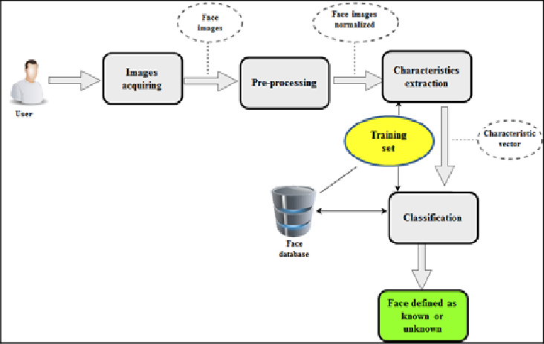

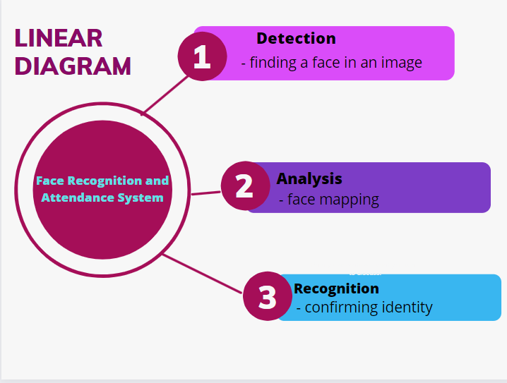

Chapter 5

**EXPERIMENTATION RESULTS**

Our FRS is distributed into 3 program files as displayed below. Namely:

1. webcam.py to manipulate the function related to webcam

2. simple_facerec.py which stores the main code of FRS regarding mapping and comparing of databases.

3.Attendance.csv file is the location where the attendance is marked.

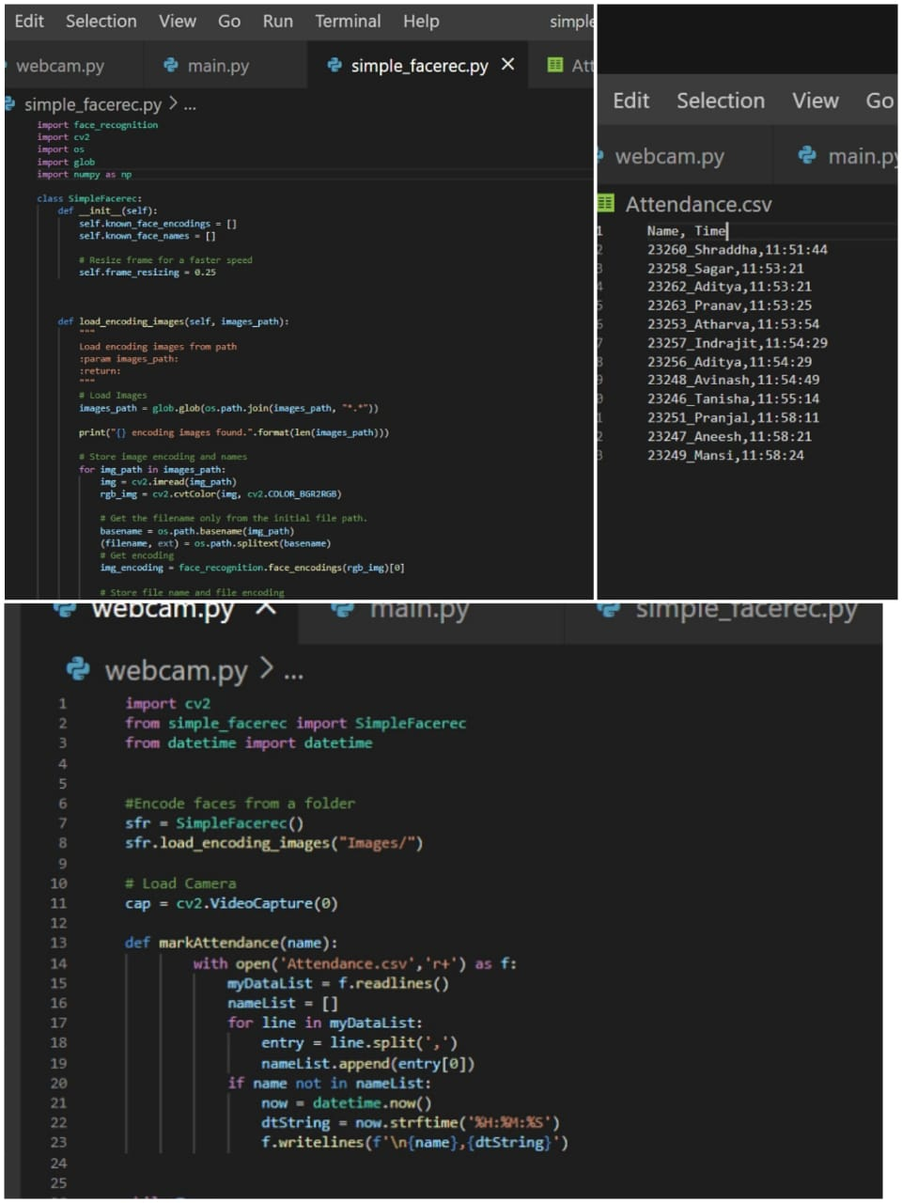

As shown in the diagram below, the window appears on your device screen to capture the face and it displays the name of a person with one rectangular window around the face. 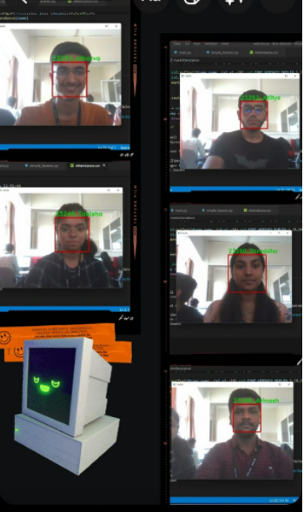

In this way the FRS works.

Chapter 6

**FUTURE SCOPE**

Just like these days we rely on our fingerprints as our identity, a time will come when our faces will be our identity cards. Today, one of the fields that uses face recognition the most is the security system. Facial recognition is a very effective tool that can help law enforcers recognize criminals and software companies are leveraging the technology to help users access their technology. This technology can be further developed to be used in other avenues such as ATMs, accessing confidential files, or other sensitive materials. This can make other security measures such as passwords and keys obsolete. So in the future, FR technology may be considered as the best alternative for any other types of biometric security systems.

Chapter 7

**CONCLUSION**

Thus, the proposed face recognition system has been implemented. It accurately identifies input face images of an individual which differ from the set of images of that person already stored in the database thus serving as an effective method of recognizing new face images

Hence when a new image is fed into the system for recognition the main features are extracted and computed to find the distance between the input image and the stored images. Thus, some variations in the new face image to be recognized can be tolerated. When the new image of a person differs from the images of that person stored in the database, the system will be able to recognize the new face and identify who the person is. Face recognition implemented successfully hoping for scalability in near future.

Chapter 8

**REFERENCES**

* Youtube playlist of Edureka: Creating Face Detector and Motion Detector using OpenCV: https://youtu.be/-ZrDjwXZGxI
* [Face recognition using OpenCV and Python: A beginner's guide- SuperDataScience | Machine Learning | AI](https://www.superdatascience.com/blogs/opencv-face-recognition).
* Visual Studio Code –<https://code.visualstudio.com/download>
* Learn OpenCV Course Full tutorial with Python: https://youtu.be/oXlwWbU8l2o