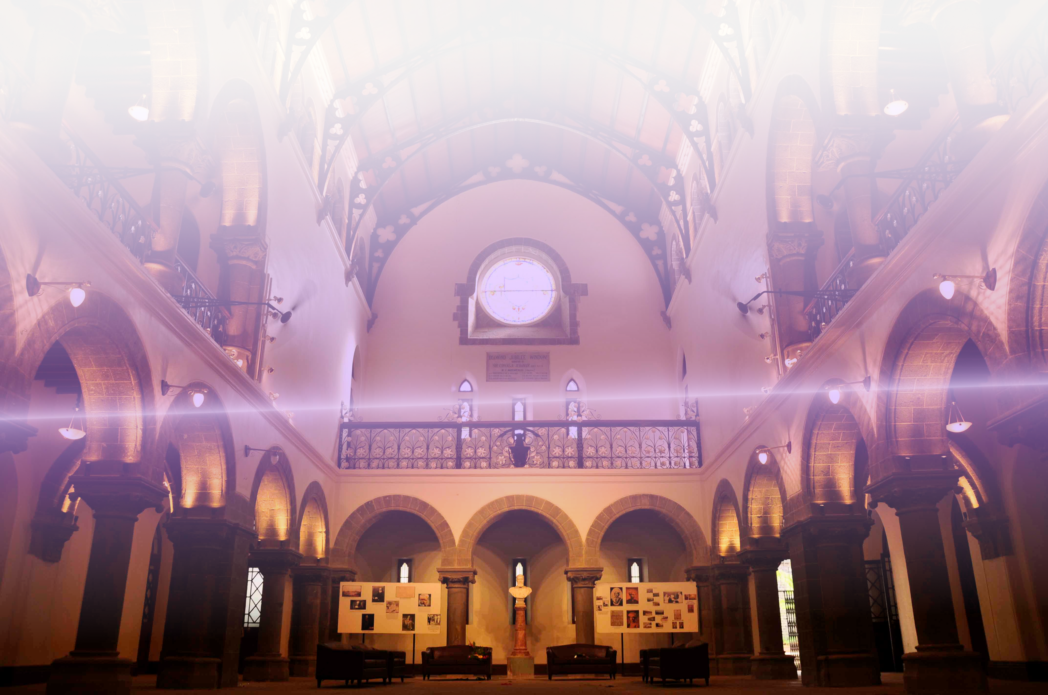

Sponsorship Brochure

Mini Debian Conference Pune
College of Engineering, Pune, India, 30th & 31th July 2016

“MiniDebConf Pune 2016” is a smaller version of Debian Conference which focuses on Debian as a Free and Open Source Software by conducting talks and workshops. The conference will provide a platform for advances in not only Debian but various Free Software projects as well.

We are proud to be hosting the conference this year at College of Engineering, Pune scheduled on 30 and 31st July 2016

We invite you to join us and support this event!

This brochure contains information on sponsorship opportunities for “MiniDebConf 16, Pune”. We can also be reached at minidebconfpune@openmailbox.org to answer any queries you may have.

Hello from the Organisers!

Thank you for your interest in MiniDebconf 16, Pune, organised by the Debian India Community.

In the brochure you are currently reading, we aim to provide you with all the information regarding sponsorship of our conference. We also take a moment to explain the nature of the Debian Project and the important role that mini DebConfs play in development of Free Software.

We invite you to sponsor our conference at a level of your choice, which meets your budget and matches the level of visibility you would like to reach among our participants and in the media.

In this brochure, we describe the benefits associated with each of these levels, as well as giving a few ideas about the additional exposure that’s possible through sponsoring individual components of our conference, including the possibility of advertising your job openings and engaging in direct dialogue with our participants.

Mini DebConf 16 is organised on a non-profit basis, and all the organisers work as volunteers without compensation.

Your contribution makes it possible for us promote Debian and Free Software (Open Source) technologies to the academic and professional audience, motivate them to contribute to the movement of open knowledge, and also helps us bring together a large number of Debian contributors to work together, help each other, learn from each other, and forge friendships that facilitate the remote collaboration our project sees during the remainder of the year.

We would like to thank you in advance for your support. If you have any questions or ideas to discuss, we look forward to reading your message at minidebconfpune@openmailbox.org and to working with you!

— The MiniDebConf '16, Pune Team

Debian, The Free Operating System
Debian is an operating system consisting entirely of Free and Open Source Software. The Debian project is dedicated to being 100% free software and to being a responsible “citizen” of the Free and Open Source Software ecosystem. Our priorities are Free Software and our users and our strict guidelines serve as an example for many other projects.

Debian is Universal, Debian is Choice
Debian is known for its adherence to the Unix and Free Software philosophies, and for its extensiveness — the current release includes over 45,000 software packages for more than ten computer architectures, ranging from the more common Intel 32-bit and 64-bit architectures to ARM (cellphones and tablets) and the IBM S/390 (mainframes). Besides the well-known Linux kernel, it also supports the FreeBSD kernel and GNU/Hurd.

A Large, Distributed and Non-profit Project
The Debian Project’s key strengths are its volunteer base, its dedication to the Debian Social Contract, and its commitment to providing the best Universal Operating System. Debian is produced by over a million active developers spread across the globe, many of whom volunteer in their spare time.

Debian is an independent non-profit organisation not under the influence of a commercial entity. Debian’s dedication to Free Software, its non-profit nature, and its open development model make it unique among Free Software distributions.

A Pillar for Free Software
Debian’s high quality standards and its strict adherence to policy makes it a preferred choice for derivatives. Currently, over 130 actively developed operating systems build on Debian, including the popular Ubuntu distribution. More specialised derivatives range from grml (optimised for sys admins) to Tails (optimised for privacy). Debian runs in hundreds of schools thanks to SkoleLinux, powers gaming platforms with SteamOS, and its derivatives have been deployed by public institutions such as Indian courts of justice. The Debian Project takes pride in being built upon by all, and we work actively with the teams behind derivative distributions to maximise the gains for all.

Impact of Debian on other Software projects
The Debian Project is widely considered one of the most successful and influential open source projects in the world: over 1,000 volunteer programmers are currently involved in Debian development, and the formative document of the Open Source movement itself, the Open Source Definition, was originally a Debian position statement.

We would encourage support from any software project which benefits from Debian in any way possible as sponsors.

Our Accounting Partners

Swathantra Malyalam Computing


Swathanthra Malayalam Computing (SMC) is a free software collective engaged in development, localization, standardization and popularization of various Free and Open Source Software in Malayalam language. "എന്റെ കമ്പ്യൂട്ടറിനു് എന്റെ ഭാഷ" is the slogan of the organization, which translates to "My language for/on My Computer".

SMC is perhaps the largest language technology developer community in India and collaborates very closely with government and industry, and serves as an advisory to govermental/semi-govermental organizations that determine the future of Malayalam language on computing devices.

SMC would be acting as the holding agency for funds and handling the accounts for us.

All cheque/DD payment by sponsors shall be made in favour of “Swathanthra Malayalam Computing” payable at Thrissur, Kerala.
For bank transfer, the account details of Swathanthra Malayalam Computing are :
Name of Account : Swathanthra Malayalam Computing
Account Number : 0084053000046718
Name of Bank : South Indian Bank
Name of Branch : Thrissur Main Branch
IFSC Code : SIBL0000084

Contact us for any clarifications or more details.

Sponsorship and Privileges

Platinum Sponsor :- Rs. 1,00,000 /-

Deliverables by Team Debconf-Pune :-

Promotional Deliverables

- Company's corporate logo will appear on the website specifying ‘Platinum Sponsor’.
- Company's logo on all posters and brochures of the event.
- Company's standees /banners will be put up at each event venue. The standees/banners (Maximum 3) will have to be provided by the Company . Size of each standee / banner should not be more than 6x3 feet.
- Company's logo will be displayed on the conference stage back drop. These banners will be made by the event organizers.
- E-certificates with Company's logo given to participants for this event.
- Special flex posters (upto 3, maximum size of 6'x3') exclusively with Company's logo can be displayed at vantage points on the campus (to be provided provided by the Company).
- Special brochures / flyers (provided by the company) will be provided with delegate kit (if provided).
- Company's logo will appear on delegate kit of the conference (if provided).

Marketing Deliverables

- Company's logo will appear on a 10 minute presentation made by the organizers for on-campus promotion.

Deliverables by Company :-

- Company will contribute a sum of Rs. 1,00,000/- addressed to “Swathanthra Malyalam Computing”.

Gold Sponsor :- Rs. 75,000 /-

Deliverables by Team Debconf-Pune :-

Promotional Deliverables

- Company's corporate logo will appear on the website specifying ‘Gold Sponsor’.
- Company's logo on all posters and brochures of the event.
- Company's standees /banners will be put up at each event venue. The standees/banners (Maximum 2) will have to be provided by the Company . Size of each standee / banner should not be more than 6x3 feet.
- Company's logo will be displayed on the conference stage back drop. These banners will be made by the event organizers.
- E-certificates with Company's logo given to participants for this event.
- Special flex posters (upto 2, maximum size of 6'x3') exclusively with Company's logo can be displayed at vantage points on the campus (to be provided provided by the Company).
- Company's logo will appear on delegate kit of the conference (if provided).

Marketing Deliverables

- Company's logo will appear on a 10 minute presentation made by the organizers for on-campus promotion.

Deliverables by Company :-

- Company will contributute a sum of Rs. 75,000/- addressed to “Swathanthra Malyalam Computing”.

Silver Sponsor :- Rs. 50,000 /-

Deliverables by Team Debconf-Pune :-

Promotional Deliverables

- Company's corporate logo will appear on the website specifying ‘Silver Sponsor’.
- Company's logo on all posters and brochures of the event.
- Company's standees /banners will be put up at each event venue. The standees/banners (Maximum 1) will have to be provided by the Company . Size of each standee / banner should not be more than 6x3 feet.
- Company's logo will be displayed on the conference stage back drop. These banners will be made by the event organizers.
- Special flex posters (upto 1, maximum size of 6'x3') exclusively with Company's logo can be displayed at vantage points on the campus (to be provided provided by the Company).
- Company's logo will appear on delegate kit of the conference (if provided).

Marketing Deliverables

- Company's logo will appear on a 10 minute presentation made by the organizers for on-campus promotion.

Deliverables by Company :-

- Company will contribute a sum of Rs. 50,000/- addressed to “Swathanthra Malyalam Computing”.

Bronze Sponsor :- Rs. 25,000 /-

Deliverables by Team Debconf-Pune :-

Promotional Deliverables
- Company's corporate logo will appear on the website specifying ‘Bronze Sponsor’.
- Company's logo on all posters and brochures of the event.
- Company's logo will be displayed on the conference stage back drop. These banners will be made by the event organizers.
- Special flex posters (upto 1, maximum size of 6'x3') exclusively with Company's logo can be displayed at vantage points on the campus (to be provided provided by the Company).

Marketing

- Company's logo will appear on a 10 minute presentation made by the organizers for on-campus promotion.

Deliverables by Company :-

- Company will provide a sum of Rs. 25,000/- addressed to team “Swathanthra Malyalam Computing”.

Sponsor :- Rs. 10,000 /-

Deliverables by Team Debconf-Pune :-

Promotional Deliverables

- Company's logo will appear as a sponsor on the website .
- Company's logo will appear on delegate kit of the conference (if provided).

Deliverables by Company :-

- Company will contribute a sum of Rs. 10,000/- addressed to “Swathanthra Malyalam Computing”.

Stalls

Open space for stalls with tables and chairs will be provided to Silver Sponsor and above with the pre-condition that no commercial activity can take place. The Stalls are to only share information about your product. The product, idea and implementation has to be a FOSS and available under some copyleft license.

If you have any special request that you would like to accommodate as a sponsor, feel free to reach out to us.

E-mail: minidebconfpune@openmailbox.org

Looking forward for your participation and support

Team mini Deb Conf Pune 2016

Sandeep K Y
+91 94059 49639

Raju Vindane
+91 90963 31084

