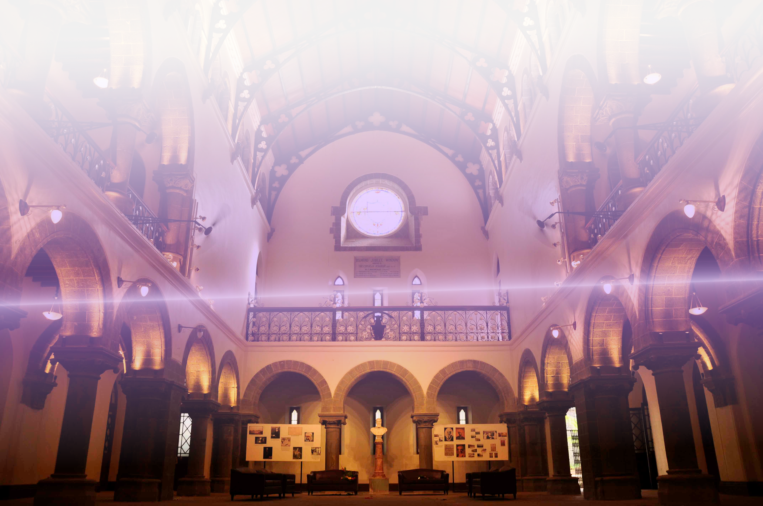

Sponsorship Brochure

Mini Debian Conference Pune
College of Engineering, Pune, India, 30th & 31th July 2016

“MiniDebConf Pune 2016” is a smaller version of Debian Conference which focuses on Debian as a Free and Open Source Organization by conducting talks and workshops. The conference will provide a working environment which will lead to advances in not only Debian, but Free Software as a whole.

We are proud to be hosting the conference this year at College of Engineering, Pune scheduled on 30 and 31st July 2016

It is a global event which usually has participants from different places within and outside the country.

We invite you to join us and support this event!

This brochure contains information on sponsorship opportunities for “MiniDebConf 16, Pune”. We are also standing by at: minidebconfpune@openmailbox.org to answer any queries you may have.

Hello from the Organisers!

Thank you for your interest in MiniDebconf 16, Pune, organised by the Debian India Community.

In the brochure you are currently reading, we aim to provide you with all the information regarding sponsorship of our conference. We also take a moment to explain the nature of the Debian Project and the important role that mini DebConfs play in development of Free Software.

We invite you to sponsor our conference at a level of your choice, which meets your budget and matches the level of visibility you would like to reach among our participants and in the media.

In this brochure, we describe the benefits associated with each of these levels, as well as giving a few ideas about the additional exposure that’s possible through sponsoring individual components of our conference, including the possibility of advertising your job openings and engaging in direct dialogue with our participants.

Mini DebConf 16 is organised on a non-profit basis, and all the organisers work as volunteers without compensation.

Your contribution makes it possible for us to bring together a large number of Debian contributors from to work together, help each other, learn from each other, and forge friendships that facilitate the remote collaboration our project sees during the remainder of the year.

We would like to thank you in advance for your support. If you have any questions or ideas to discuss, we look forward to reading your message at minidebconfpune@openmailbox.org and to working with you!

— The MiniDebConf '16, Pune Team

Debian, The Free Operating System
Debian is an operating system consisting entirely of Free and Open Source Software. The Debian project is dedicated to 100% free and to being a responsible “citizen” of the Free and Open Source Software ecosystem. Our priorities are Free Software and our users and our strict guidelines serve as an example for many other projects.

Debian is Universal, Debian is Choice
Debian is known for its adherence to the Unix and Free Software philosophies, and for its extensiveness — the current release includes over 45,000 software packages for more than ten computer architectures, ranging from the more common Intel 32-bit and 64-bit architectures to ARM (cellphones and tablets) and the IBM S/390 (mainframes). Besides the well-known Linux kernel, it also supports the FreeBSD kernel and GNU/Hurd.

A Large, Distributed and Non-profit Project
The Debian Project’s key strengths are its volunteer base, its dedication to the Debian Social Contract, and its commitment to providing the best Universal Operating System. Debian is produced by over a million active developers spread across the globe, many of whom volunteer in their spare time.

Debian is an independent non-profit organisation not under the influence of a commercial entity. Debian’s dedication to Free Software, its non-profit nature, and its open development model make it unique among Free Software distributions.

A Pillar for Free Software
Debian’s high quality standards and its strict adherence to policy makes it a preferred choice for derivatives. Currently, over 130 actively developed operating systems build on Debian, including the popular Ubuntu distribution. More specialised derivatives range from grml (optimised for sys admins) to Tails (optimised for privacy). Debian runs in hundreds of schools thanks to SkoleLinux, powers gaming platforms with SteamOS, and its derivatives have been deployed by public institutions such as Indian courts of justice. The Debian Project takes pride in being built upon by all, and we work actively with the teams behind derivative distributions to maximise the gains for all.

Impact of Debian on othe Software projects
The Debian Project is widely considered one of the most successful and influential open source projects in the world: over 1,000 volunteer programmers are currently involved in Debian development, and the formative document of the Open Source movement itself, the Open Source Definition, was originally a Debian position statement.

We would encourage support from any software project which benefits from Debian in any way possible as sponsors.

Our Accounting Partners

Swantantra Malyalam Computing


Swathanthra Malayalam Computing (SMC) is a free software collective engaged in development, localization, standardization and popularization of various Free and Open Source Softwares in Malayalam language. "എന്റെ കമ്പ്യൂട്ടറിനു് എന്റെ ഭാഷ" is the slogan of the organization, which translates to "My language for/on My Computer".

SMC is perhaps the largest language technology developer community in India and collaborates very closely with government and industry, and serves as an advisory to govermental/semi-govermental organizations that determine the future of Malayalam language on computing devices.

SMC would be handling the accounts for us.

All cheque/DD payment shall be made in favour of “Swathanthra Malayalam Computing” payable at Thrissur.
For bank transfer, the account details of Swathanthra Malayalam Computing are :
Name of Account : Swathanthra Malayalam Computing
Account Number : 0084053000046718
Name of Bank : South Indian Bank
Name of Branch : Thrissur Main Branch
IFSC Code : SIBL0000084

Contact us for any clarifications or more details.

Sponsorship and Privileges

Platinum Sponsor :- Rs. 1,00,000 /-

Deliverables by Team Debconf-Pune :-

Promotional Deliverables

- <Company Name>'s corporate logo will appear on the website specifying ‘Platinum Sponsor’.
- <Company Name>'s logo will appear on delegate kit of the conference (if provided).
- <Company Name>'s logo on all posters and brochures of the event.
- <Company Name>'s logo on event booths.
- <Company Name>'s logo will be displayed on the conference stage back drop.
- Special brochures / flyers containing <Company Name> logo will be provided with delegate kit.
- E-certificates with <Company Name>'s logo given to participants for this event.
- Special flex posters exclusively for <Company Name> can be displayed at vantage points on the campus (if provided).

Marketing Deliverables

- <Company Name>'s logo will appear on a 10 minute presentation for on-campus promotion
- Post conference details will be posted on the website which will bear complete details

Deliverables by <Company Name> :-

- <Company Name> will contribute a sum of Rs. 1,00,000/- addressed to “Swatantra Malyalam Computing”.

Gold Sponsor :- Rs. 75,000 /-

Deliverables by Team Debconf-Pune :-

Promotional Deliverables

- <Company Name>'s logo will appear on the website specifying ‘Gold sponsor’.
- <Company Name>'s logo will appear on delegate kit of the conference (if provided).
- <Company Name>'s logo on all posters and brochures of the event.
- <Company Name>'s logo on event booths.
- <Company Name>'s logo displayed on the conference stage back drop.
- Special brochures / flyers containing <Company Name>'s logo will be provided with delegate kit.
- E-certificates with <Company Name>'s logo given to participants for this event.

Marketing Deliverables

- <Company Name>'s logo will appear on a 10 minute presentation for on-campus promotion.
- Post conference details will be posted on the website which will bear complete details.

Deliverables by <Company Name> :-

- <Company Name> will contributute a sum of Rs. 75,000/- addressed to “Swatantra Malyalam Computing”.

Silver Sponsor :- Rs. 50,000 /-

Deliverables by Team Debconf-Pune :-

Promotional Deliverables

- <Company Name>'s logo will appear on the website specifying ‘Silver Sponsor’.
- <Company Name>'s logo will appear on delegate kit of the conference.
- <Company Name>'s logo on all posters and brochures of the event.
- <Company Name>'s logo on event booths.
- <Company Name>'s logo displayed on the conference stage back drop.
- <Company Name>'s logo will appear on delegate kit of the conference (if provided).

Marketing Deliverables

- <Company Name>'s logo will appear on a 10 minute presentation for in-campus promotion.

Deliverables by <Company Name> :-

- <Company Name> will contribute a sum of Rs. 50,000/- addressed to “Swatantra Malyalam Computing”.

Bronze Sponsor :- Rs. 25,000 /-

Deliverables by Team Debconf-Pune :-

Promotional Deliverables

- <Company Name>'s logo will appear on the website specifying ‘Bronze Sponsor’.
- <Company Name>'s logo will appear on delegate kit of the conference.
- <Company Name>'s logo on all posters and brochures of the event.
- <Company Name>'s logo on event booths.
- <Company Name>'s logo displayed on the conference stage back drop.
- <Company Name>'s logo will appear on delegate kit of the conference (if provided).

Marketing

- <Company Name>'s logo will appear on a 10 minute presentation for in-campus promotion.

Deliverables by <Company Name> :-

- <Company Name> will provide a sum of Rs. 25,000/- addressed to team “Swatantra Malyalam Computing”.

Sponsor :- Rs. 10,000 /-

Deliverables by Team Debconf-Pune :-

Promotional Deliverables

- <Company Name>'s logo would appear as a sponsor on the website .
- <Company Name>'s logo will appear on delegate kit of the conference (if provided).

Deliverables by <Company Name> :-

- <Company Name> will contribute a sum of Rs. 10,000/- addressed to “Swatantra Malyalam Computing”.

Stalls

Space for Stalls will be provided to Silver Sponsor and above with the pre-condition that no commercial activity can take place. The Stalls are to only share information about your product and the product, idea and implementation has to be on FOSS ideals and under some copyleft license (Space will be provided for 10-12 Stalls Only on FIFO basis).

Feel free to reach out to us for any clarifications.

E-mail: minidebconfpune@openmailbox.org

Looking forward for your participation and support

Team mini Deb Conf Pune 2016

Sandeep K Y
+919405949639

Raju Vindane
+919096331084

