Air Ticket Reservation System
Software Requirements Document
V 1.0


Table of Contents
1.0 Introduction 3
1.1 About this document 3
1.1.1 Purpose & Scope of the document 3
1.1.2 Intended Audience 3
1.2 About the Software System 3
1.2.1 Purpose 3
1.2.2 Scope of the system 4
1.2.3 Exclusions 5
1.2.4 System Perspective 5
1.2.5 System diagram 5
1.2.6 Architecture diagram 5
1.2.7 System Environment 7
1.2.8 User Characteristics 7
1.2.9 Impact of the System 8
1.2.10 Assumptions, Dependencies, Risks / Constraints 8
1.2.11 Design Constraints 8
2.0 System Requirements 9
2.1 Functional Requirements 9
2.1.1 ARS – Register Customer 9
2.1.2 ARS - Search Flight Page 10
2.1.3 ARS – Ticket Booking 12
2.1.4 ARS – Edit Profile 15
2.1.5 ARS - Cancel Ticket 17
2.2 Nonfunctional Requirements 18
2.2.1 UI Requirements: Inn 18
2.2.2 Performance Requirements: Pnn 19
2.2.3 Installation, Deployment & Operational Requirements: Onn 19
2.2.4 Maintainability & Portability Requirements: MPnn 19
2.2.5 Security Requirements Snn: 19
3.0 Requirements / Use Case Summary Table 20
4.0 Make /Buy analysis 20
4.1 Reusable components 20
5.0 Annexure 21
6.0 Change Log 21

Introduction

About this document

Purpose & Scope of the document
The purpose of the software requirements document is to systematically capture requirements for the project and the system “Air Ticket System” to be developed. Both functional and non-functional requirements are captured in this document. It also serves as the input for the project scoping
The scope of this document is limited to addressing the requirements from a user, quality, and non-functional perspective. It is recommended that design aspects are not added in this document

Intended Audience
Project Team

About the Software System
The client would like to develop an independent application Air Ticket Reservation System (ARS) application. ARS is basically a system that helps customers to get access to various operations such as air ticket search, booking and cancellation after getting themselves registered. There are few important modules in the system which is discussed below.
The following section will cover aspects related to Air Ticket Reservation System.

Purpose
Air Ticket Reservation System (ARS). ARS is basically a system that helps customers to manage the flight tickets booking mechanism. The following are the few important modules in the system
- Customer Registration
- Search Flight
- Ticket Booking
- Edit Profile
- Cancel Ticket

Scope of the system
The scope of the system is explained through its modules as follows
- Application should have single login page. Login page should be the welcome page for the application. And also customer is only the application user
- None of the application features can be accessed without login
- The welcome page should have links to the following modules.
  - Customer Registration module – This module is used for registering the details of the customer into the system
  - Search Flight module - This module is used by the customers to search the system for flights based on different parameters.
  - Ticket Booking module- This module is used by the customers to book tickets into the system for different flights.
  - Edit Profile module - This module is used for updating the Customer profile details into the system
  - Cancel Ticket module - This module is used by the customer to cancel his/her ticket and update the same into the system
- There should be logout feature. Once logged out should come to the welcome page again or design a logout page from where re-login can be done.
Use Case Diagram
Air Ticket Reservation System

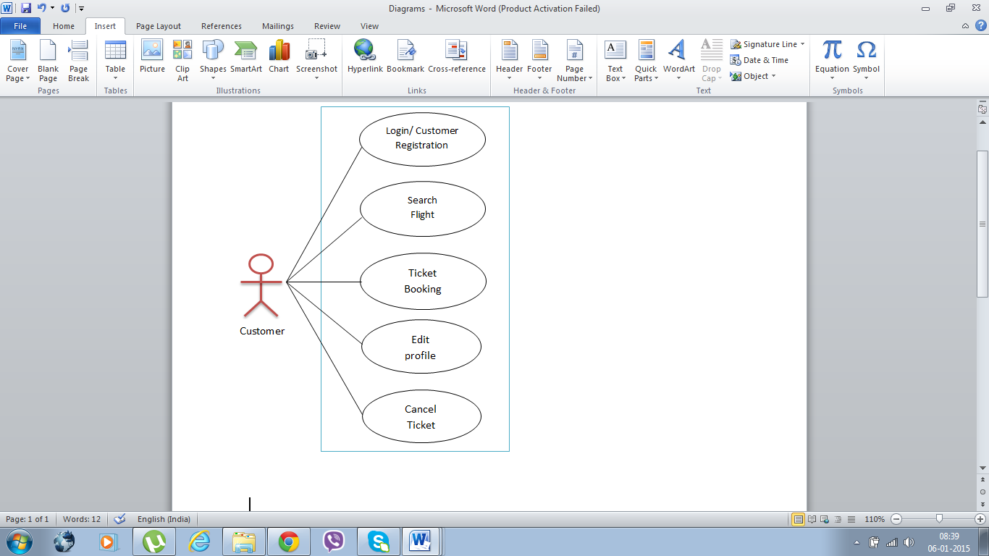

Exclusions
The system will operate only on the modules discussed above and will not include any additional functionality.

System Perspective
The ARS is an independent software system developed to manage the activities like customer registration, search flights, booking tickets etc. using the Java/ Dotnet architecture.

System diagram
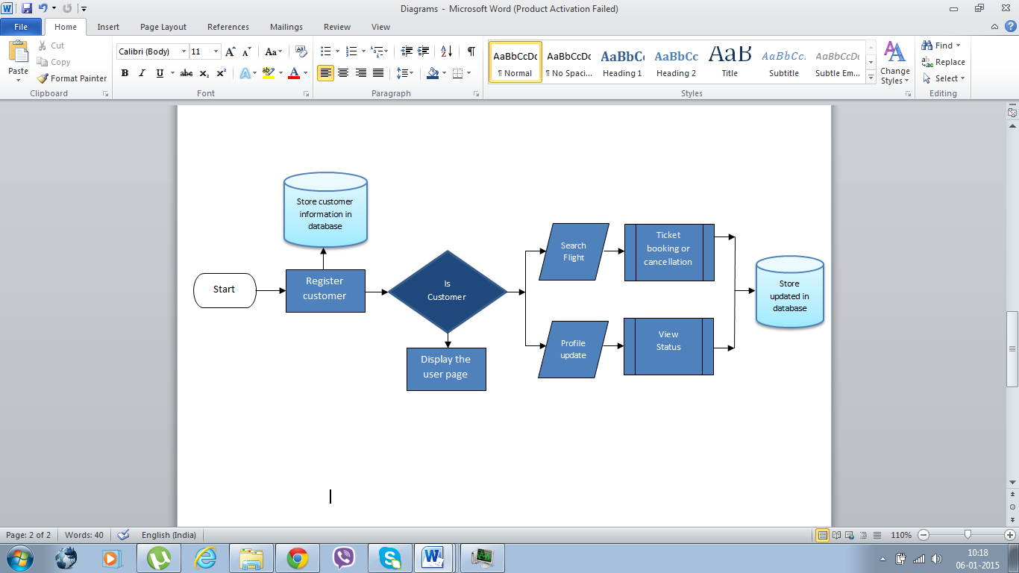

Architecture diagram

Physical Architecture:
A physical architecture is an arrangement of physical elements, (system elements and physical interfaces) that provides the designed solution for a product, service, or enterprise. It is intended to satisfy logical architecture elements and system requirements. Auto Identification Process follows a three layered architecture namely presentation layer, business logic layer and data access layer.
- Presentation Tier is the tier in which the users interact with an application. Presentation Tier contents Shared UI code, Code Behind and Designers used to represent information to user.
- Business Tier is mainly working as the bridge between Data Tier and Presentation Tier. All the Data passes through the Business Tier before passing to the presentation Tier. Business Tier is the sum of Business Logic Layer, Data Access Layer and Value Object and other components used to add business logic.
- Data Tier is basically the server which stores all the application’s data. Data tier contents Database Tables, XML Files and other means of storing Application Data.
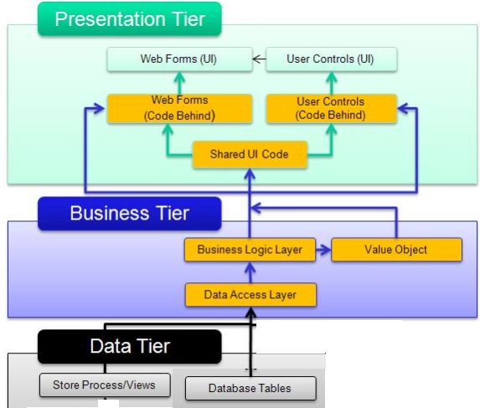

Logical Architecture:
The Logical Architecture defines the Processes (the activities and functions) that are required to provide the required User Services. Many different Processes must work together and share information to provide a User Service. The Processes can be implemented via software, hardware, or firmware. The Logical Architecture is independent of technologies and implementations

3-Layered Architecture Logical Diagram
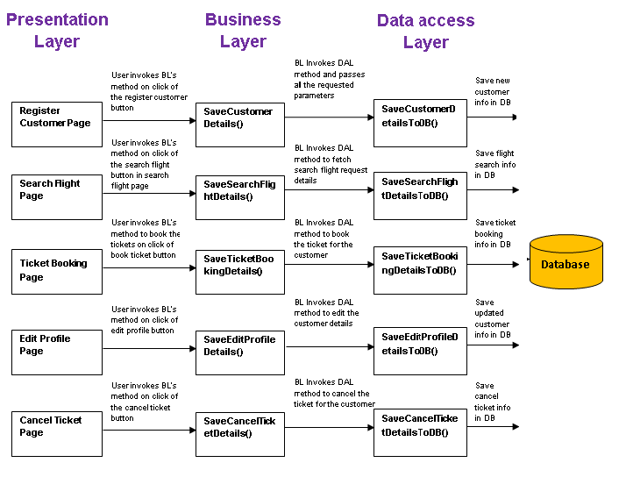

System Environment
The ARS application will be operated from the client server with parallel processor support. When a user connects to the Web Server, the Web Server will interact with the Database after processing the business logic to transfer data to and from a database.
- Java/J2EE or .NET Framework application deployment.
- My Sql/Sql server database for data storage

User Characteristics
The application should be user friendly; hence the user should not need any software and hardware knowledge. The user may be new to the client products having never used them before.
The types of users likely to use the system are as follows,
- Client
- Delivery Assurance Group, Process Engineering group
- Developers, testers, other associates in the project

Impact of the System
This is a new product which is developed for internal users. Expected impact of the product is to automate existing manual processes in order to make them more efficient and cost effective.

Assumptions, Dependencies, Risks / Constraints
Assumptions:
1. The customers must possess prior knowledge on ARS operations undertaken offline.
2. The air ticket reservation system application should be designed in such a way that it’s a user friendly application.
3. While making the user registration it should display SSN types with the already preloaded values from the database
Dependencies:
If there is any similar Identification process required for other applications of the same client, this system should be able to accommodate such a reusability dependency.
Risks:
If there is any failure in ticket booking/cancellation processes, the system should be able to handle such a financial risk.

Design Constraints
Application should have single login feature. Login functionality should be the welcome feature for the application.
Only customer can access the application.
None of the application features can be accessed without login.

System Requirements

Functional Requirements

ARS – Register Customer

Air Ticket Reservation System  Req-2.1.1 | ARS - Register Customer
When the users enter the following link http://localhost:8080/AirTicketReservationProcess in the browser, Home page appears which will have a short welcome message; a brief introduction to the purpose of the Air Ticket Reservation System, the user can choose appropriate options.
Under home page, we need below interface and Home page Interface Requirements

Customer registration page should have basic attributes/fields as mentioned in UI Interface Screen section.

At any given point of time, the user can Deselect/Reset all or can go to home page by the clicking home.
UI Interface Screen | Name - It updates the name of the User  Email - It provides the email Id of the user  Password - It provides the password required  DOB - It provides the DOB of the user in dd-mm-yyyy Format  Address - It provides the address of the customer  Phone - It provides the phone number  Gender - It provides the Gender  SSN Type - It provides the SSN type  SSN Number - It provides the SSN number
Trigger | User triggers the functionality once he/she updates the details into the system
Pre-Conditions / Assumptions | While making the registration it should display SSN types with the already preloaded values from the database
Post Conditions | On successful registration it should display the success message “Registration is successful“.
Success End Condition | Once the registration is successful it would display success message separately.
Failed End Condition | The system should throw an error message if any one or more of the validations fail. The error messages and error codes need to be identified during design. The validation and business rules are mentioned in the business rules section.
Steps & Actions | System should display “Register new user option.”  Once user goes for the “Register New User” System should request the user update all the necessary details for the registration.  System needs to populate the SSN Type with the prepopulated values.  All the necessary validation should be done.  System needs to generate the search id and store the user details.  Identify the SSN_MASTER table storing the SSN types supported by the ARS system.
Business Rules & Validations | All fields are mandatory.  Name should not contain special characters, numbers.  Password must have atleast one special character.  Email Id that is registered once could not be used again for registration with another customer.  SSN number should be unique in the system.  If the same SSN Number exists system should show message like “User already exists in the system.”

ARS - Search Flight Page

Air Ticket Reservation System  Req-2.1.2 | ARS – Search Flight
ARS Search Flight page should have basic attributes/fields as mentioned in UI Interface Screen section.
At any given point of time, the user can Deselect/Reset all or can go to home page by the clicking home.
UI Interface Screen | While making a search the following details needed to be updated,  Leaving from - It denotes the city from which the flight is taking off.  Going to - It denotes the city up to the city where it is going.  Password - It provides the password required.  DOB - It provides the DOB of the user in dd-mm-yyyy Format.  Address - It provides the address of the customer.  Phone - It provides the phone number.  This should capture the following fields  Leaving form –flight take off.  Going to- flight arrival.  Departure Date-flight departure date.  Departure Time –flight departure time.  Seat to book – Number of seat to book.  Show Flights – Submit Button used to search the flight.  In the Search Result Screen,  The search result should be displayed in a tabular format as shown in the below table:  Leaving from - It denotes the city from which the flight is taking off.  Going to - It denotes the city up to the city where it is going.  Password - It provides the password required.  DOB - It provides the DOB of the user in  dd-mm-yyyy format.  Address - It provides the address of the customer.  Phone - It provides the phone number.
  Flight | Airlines Name | Departs From | Departure Time | Arrives | Arrival Time | Fare
  F_191 | Air India | Kolkata | 6:50 | Delhi | 7:30 | 2030
Trigger | Customers triggers the functionality once he/she submits the details into the system
Pre-Conditions / Assumptions | While making a search, all the locations should be populated from the database
Post Conditions | All matching profiles should be displayed in the search result and the searched data should be fed into the Search_Temp_Master table.
Success End Condition | Display the search result in the once the searching is completed
Failed End Condition | The system should throw an error message if any one or more of the validations (refer to EOD1) fail. The error messages and error codes need to be identified during design. The validation and business rules are mentioned in the business rules section
Steps & Actions | System should display all the necessary fields.  System need to populate the locations field.  All the necessary validation should be done.  System needs to store search result in the search_temp_master.  Identify the FLIGHT_MASTER table storing the flight details, AIRLINES_MASTER table storing the airline details and LOCATION_MASTER table storing the locations.
Business Rules & Validations | Leaving from and Going To location cannot be same.  Departure date should be future date only.  Departure Date cannot be more than one date.  Departure Date should be in the format dd-mon-yy.  Departure Time should be in the format HH:MM.  Departure Time cannot be more than 24 hours.  Departure Time should be in number.  Seat to be booked should be in number.  Seat to be booked cannot be more than 20.  Available seats must be greater than equals to the seat to be booked for that departure date.  After clicking on the “Show flights” button:  Load the search items in the system.  If the flight is not available then the system throws an exception.

ARS – Ticket Booking
Air Ticket Reservation System  Req-2.1.3 | ARS – Ticket Booking
The Ticket Booking page should have basic attributes/fields as mentioned in UI Interface Screen section.
UI Interface Screen | Home Screen:  On searching the flight the following details needed to be updated,  Leaving from - It denotes the city from which the flight is taking off.  Going to - It denotes the city up to the city where it is going...  Password - It provides the password required  DOB - It provides the DOB of the user in  dd-mm-yyyy Format.  Address - It provides the address of the customer.  Phone - It provides the phone number  Number Of Passengers - It provides the total number of passengers travelling.  Note: Once the details are being updated the user can go for the search result.  For the search result the following details needed to be updated:  Flight Number - The flight number would be updated  Flight Franchise - The Flight Franchise Name would be updated  From_Location - It would display the starting location name  To_Location - It would display the ending location name  Start Time - It would display the flight start time  End Time - It would display the flight reaching time  Fare - It denotes the flight fare  In the Pro-forma Invoice Details the following fields needed to be updated:  Customer Name - The flight number would be updated  Airline name - The Flight Franchise Name would be updated  Leaving From - It would display the starting location name  Going To - It would display the ending location name  Number Of Passengers - It would display the total number of passengers  Date Of Journey - It would display the Date of Journey.  Departure Time - It denotes the flight departure time  Booking Date - It denoted the ticket booking date.  Total Price - It denotes the total Price of the ticket  Note: Once all the details have been updated the User can go for the Confirmation. Once confirmed, the booking ID would be generated.  Final invoice details would capture the details below:  Customer Name - The flight number would be updated.  Booking ID - The Booking ID would be updated.  Airline name - The Flight Franchise Name would be updated.  Leaving From - It would display the starting location name.  Going To - It would display the ending location name.  Number Of Passengers - It would display the total number of passengers.  Date Of Journey - It would display the Date of Journey.  Departure Time - It denotes the flight departure time  Booking Date - It denoted the ticket booking date.  Total Price - It denotes the total Price of the ticket.
Trigger | Customer triggers the functionality once he/she submits the details into the system.
Pre-Conditions / Assumptions | There should be at least one search result depending on the search criteria
Post Conditions | Booking details should be displayed in the invoice details and the booking data should be store into the system.
Success End Condition | If booking successful produces the invoice, display the invoice details.
Failed End Condition | The system should throw an error message if any one or more of the validations (refer to EOD1) fail. The error messages and error codes need to be identified during design. The validation and business rules are mentioned in the business rules section.
Steps & Actions | Registered user logs in to the system.  Search for flight with Source and destination location, departure time and date and required seats.  System needs to render the flights depending on search criteria.  All the necessary validation should be done.  User will select one of the flights and proceed for booking.  Booking will generate a pro-forma invoice with all the booking information.  System needs to generate the booking id and store the booking details once confirm the pro-forma invoice.  Reduce the available seats for the booked flight for the departure date.  Identify the table for storing the booking details and generate the invoice of booking.  Clear all the data of SEARCH_TEMP_MASTER table.
Business Rules & Validations | Email id and password fields cannot be blank.  Email Id must be contains @ and . symbol.  Password must be containing alpha numeric values.  Leaving from and Going To location cannot be same.  Departure date should be future date only.  Departure Date cannot be more than one date.  Departure Date should be in the format dd-mm-yyyy.  Departure Time should be in the format HH:MM.  Departure Time cannot be more than 24 hours.  Departure Time should be in number.  Number of passengers should be in number.  Number of passengers cannot be more than 20.  Available seats must be greater than equals to the seat to be booked for that departure date.  After clicking the booking button :  Generate the booking id.  Load the booking id and booking details in the system.  Generate Invoice.

ARS – Edit Profile
Air Ticket Reservation System  Req-2.1.4 | ARS – Edit Profile
This use case will be used by the customer to edit their profile into the system. The Edit Profile page should have basic attributes/fields as mentioned in UI Interface Screen section.
UI Interface Screen | While making a login the customer needs to update the following details:  This should capture the following fields,  Email ID - User needed to update the Email ID.  Password - User needed to update the Password.  Once the details is been updated the user can update the data in the system through login. User has also an option for flushing the data for reentering. Once it is updated a customer ID would be generated by the system to the user.  When the Customer wants to edit the details they need to update the details below:  CID - It denotes the User Id  C_Name - It denotes the customer name  DOB - It denotes the Customer Date of Birth  EMAIL - It denotes the customer email id  PASSWORD - It denotes the password  PHONE NO - It denotes the Customer Phone number  ADDRESS - It denotes the address of the customer  GENDER - It denotes the Gender of the customer  Once it is updated the customer can update the details in the system. Customer can also have the option for resetting the data.
Trigger | Customer triggers the functionality once he/she submits the details into the system.
Pre-Conditions / Assumptions | While editing, all the details of the Customer should be populated from the database
Post Conditions | Customer editable data should be updated
Success End Condition | If the search produces results, display the profile details. On successful update of the user profile show message as “<Customer Name>’s profile updated successfully”.
Failed End Condition | The system should throw an error message if any one or more of the validations (refer to EOD) fail. The error messages and error codes need to be identified during design. The validation and business rules are mentioned in the business rules section.
Steps & Actions | Registered user logs in to the system.  Clicks on the edit profile link.  System should display all the necessary fields in the screen.  Customer details should be automatically populated from the system and only editable fields are eligible for modification.  System needs to store the altered Customer details into the system.
Business Rules & Validations | Login Customer  email should be in valid format  Email Id Cannot Be Left Blank  Password should match the criteria.  Password Cannot Be Left Blank.  If email id or password should exist in the system.  Edit Customer CID Should be automatically populated from the system and must not be editable  Customer Name should be automatically populated from the system, and while editing it must not contain any number and any special character if violated then system should throw Exception.  Customer name cannot be left blank  Date of Birth should be automatically populated from the system, and should be in the format dd-mm-yyyy.  Date of Birth cannot be left blank.  E-mail should be automatically populated from the system, and should be a valid email format.  Email id cannot be left blank,  Password should be automatically populated from the system, and while editing it, must be max 10 min 6 characters must be alphanumeric and at least one special character otherwise system should throw Exception.  Password cannot be left blank.  Phone No must be automatically populated from the system and while editing it must not contain anything other than numeric value, and must not exceed 10 values, otherwise system should throw Exception.  Phone number cannot be left blank.  Address cannot exceed more than 100 characters.  Address cannot be left blank.

ARS - Cancel Ticket
Air Ticket Reservation System  Req-2.1.5 | ARS – Cancel Ticket
This use case will be used by customer to cancel his/her ticket and update the same into the system. The customer should have the booking id to be searched from the system.
UI Interface Screen | While the order cancellation the following details needed to be updated:  This should capture the following fields,  Booking ID - It would display the Booking ID  Once all the value is updated the user can go for the cancellation. The cancellation charge & the refund amount can be found from the database & it would be updated in the system accordingly.  For confirming the order of cancellation the following details needed to be updated:  This should display the following fields,  Booking ID - It represents the booking ID  Booking Date - It represents the booking date  Journey Date - It represents the date of Journey  From - It denotes the start location  To - It denotes the end location  Total Fare - It represents the total air fare  Cancellation Charge - It represents the cancellation charge  Refund Amount - It represents the refund amount  Note: Once all the details are being updated the user can go for the cancellation.
Trigger | Customer triggers the functionality once he/she receives the booking id.
Pre-Conditions / Assumptions | The customer should have the booking id to be searched from the system.
Post Conditions | The booking details will be retrieved from the database, calculate the cancellation charge and refundable amount and will update the same into the system.
Success End Condition | Display the cancellation charge, refundable amount including booking details and on confirmation update the same into the system.
Failed End Condition | The system should throw an error message if one of the validations is wrong. The error message and error code needs to be identified during design. The validation and business rules are mentioned in the business rules section
Steps & Actions | Registered user should login to the system.  Clicks on Cancel Booking option.  Provide the booking id.  System should display all the necessary field details.  Calculate the cancellation charge. If cancellation is done before10 days and above10% will be deducted, before 5 days 20% and before 1 day 50% will be deducted from the total fare.  Calculate the refundable amount:  RefundableAmount=TotalFare – CancellationCharge  Available seats should be updated accordingly
Business Rules & Validations | When booking id blank, system should display appropriate error message.  When booking id not found into the system, system should display appropriate error message.  When cancellation is done on the same day of journey, system should display appropriate error message.  When the booking is already cancelled, the system should display appropriate error message.  When cancellation is done after the journey date, system should display appropriate error message.

Nonfunctional Requirements

UI Requirements: Inn
- The front end should be user-friendly and pleasant
- Any error message or exception displayed to the user should be user-readable (and not technical)
- All entered values should be validated
- The UI screens are designed with any theme color along with the logo of the company.
- Exceptions should not be shown on console.
- No debug message should come on console.
- All the errors and exceptions should be logged to log file.
- Log file path should be configurable.
- Database connections should be configurable.
- It should not be hard coded.
- Requirements involving UI features should be taken care in console accordingly

Performance Requirements: Pnn
- All front-end pages should be served up in less than 5 seconds post click when up to 1000 users are on the application concurrently.
- Since it’s a financial operations application, transactions should be safe and fast.

Installation, Deployment & Operational Requirements: Onn
- Application Java and J2EE deployment with My SQL database or SQL Server database for persistence
Or
Application .NET Framework deployment with SQL Server database for persistence
- This system must be up 24X7

Maintainability & Portability Requirements: MPnn
- If the allocated memory space for the existing application needs to be increased then it should be possible without any impact to performance

Security Requirements Snn:
- No unauthorized users should be able to log on to the system
- User Id/Login Id should have combination of letter and numeric values, none of the special characters are allowed (#,@,$,%,&).
- Validate the user id/login id and password, accordingly to the user it will redirect to the appropriate page.

Requirements / Use Case Summary Table
Business Requirement ID | Software Requirements ID | Short Description | Requirement Provider (Originator) | Priority | Complexity | Requirement type | Remarks
BR001 | SR001 | Register Customer | Client | High | Medium | UI screen & backend processing | -
BR002 | SR002 | Search Flight | Client | Medium | Medium | UI screen & backend processing | -
BR003 | SR003 | Ticket Booking | Client | High | Medium | UI screen & backend processing | -
BR004 | SR004 | Edit Profile | Client | Medium | Medium | UI screen & backend processing | -
BR005 | SR005 | Cancel Ticket | Client | High | High | UI screen & backend processing | -

Make /Buy analysis

Reusable components
The ARS can be made reusable as such to handle various reservation management processes.

Annexure
NA

Change Log
Please note that this table needs to be maintained even if a Configuration Management tool is used.
Version Number | Changes made
V1.0 | First version developed by Sharika V on Dec 29 2014.
V1.1 | <If the change details are not explicitly documented in the table below, reference should be provided here>
V1.1 | Page no | Changed by | Effective date | Changes effected
V1.2 | <If the change details are not explicitly documented in the table below, reference should be provided here>
V1.2 | Page no | Changed by | Effective date | Changes effected

