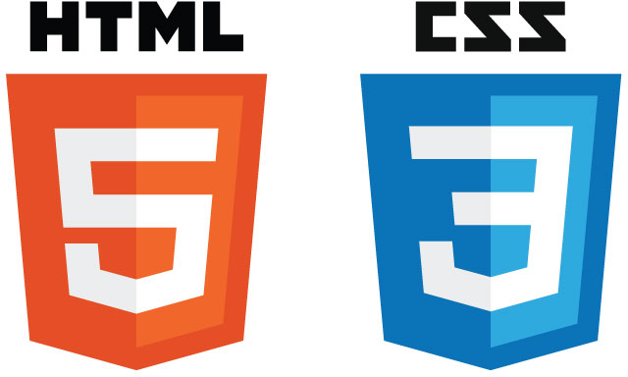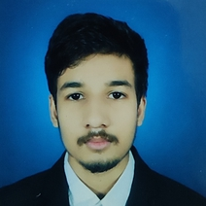

**EDUCATION**

Bachelors in Computer Science Engineering | Chandigarh University, Gharuan

*Session: 2019-2023 | Score: 7.82 CGPA*

Intermediate (CBSE) |Bridgeford School, Ranchi

*Session: 2018-2019 | Percentage: 71.2%*

Matriculation (CBSE) | Bridgeford School, Ranchi

*Session: 2016-2017 | Percentage: 95%*

**TRAINING & PROJECTS**

**HIGHRADIUS | TRAINEE**

February 20229 – May 2022

* Built a data-driven and AI-enabled FinTech B2B Cloud Application.
* Developed and integrated ML model and Chatbot along with Analytics in the UI.
* Tech Stack: Java, MySQL, React.JS, Python, Highcharts, Crossfilter, DialogFlow.

**INTERNSHALA | SUMMER TRAINING**

July 2021 – August 2021

* Built a JAR file for Temperature Converter Tool app
* Built Connect4 Game.

**ACADEMIC ACHIEVEMENTS**

* Certificate of Introduction to Soft Computing, IIT Kharagpur

**CERTIFICATIONS & AWARDS**

* Introduction to Cybersecurity Tools & Cyber Attacks, Coursera
* C++ for C Programmers, Coursera
* R Programming, Coursera
* Python Data Structures, Coursera
* Programming for Everybody (Python), Coursera
* Core Java, Internshala
* Introduction to Data Science in Python, Coursera

**EXTRA CURRICULAR & CO-CURRICULAR ACHIEVEMENTS**

* Qualified for Regional Mathematics Olympiad (RMO)

**Puneet Singh**

Address: Ranchi, Jharkhand - 834003

E-mail: *19bcs2594@cuchd.in*

Phone: +91 9142847400

LinkedIn: [linkedin.com/in/puneet-singh-a306b1194/](https://www.linkedin.com/in/puneet-singh-a306b1194/)

**PROFESSIONAL SUMMARY**

As a beginner in the field of Information Technology, I strive to associate myself with an organization where I can utilize my skills in the best possible manner, which further gives me an opportunity to grow in my career journey while contributing to the development of the organization.

**TECHNICAL COMPETENCIES**

C++ | JAVA | PYTHON | HTML | CSS

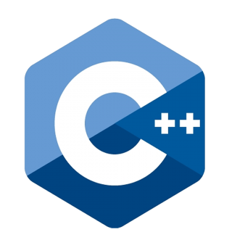 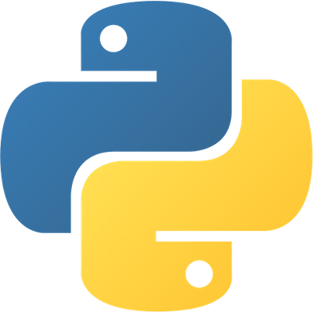

**INTERPERSONAL SKILLS**

Communication **|** Lea**d**e**r**ship **|** Problem – Solving **|** Teamwork

**INTERESTS & HOBBIES**

Mathematical research **|** Crypto currencies **|** Automobiles

**LANGUAGES KNOWN**

English **|** Hindi

**PERSONAL DETAILS**

Mother’s Name: Mrs. Munmun Singh

Father’s Name: Mr. Prabhat Kumar

D.O.B.: 17 March 2002