Table of Contents
Smart Inventory Management System 3
Project Report 3
1. Cover Page 3
2. Introduction 3
Project Objectives 4
3. Problem Statement 4
Primary Problems: 4
Business Impact: 5
4. Functional Requirements 5
FR1: Inventory Management Module 5
FR2: Supplier Management Module 5
FR3: Transaction Management Module 5
FR4: Reporting & Analytics Module 6
FR5: Alert Management Module 6
FR6: User Management Module 6
5. Non-Functional Requirements 6
NFR1: Performance 6
NFR2: Security 7
NFR3: Usability 7
NFR4: Reliability 7
NFR5: Maintainability 7
NFR6: Scalability 7
6. System Architecture 8
Architecture Layers: 8
Cross-Cutting Concerns: 8
Design Patterns Applied: 8
7. Design Diagrams 9
7.1 Use Case Diagram 9
7.2 Workflow Diagram 9
7.3 Sequence Diagram 9
7.4 Class Diagram 9
7.5 ER Diagram 9
8. Design Decisions & Rationale 10
8.1 Technology Choices 10
8.2 Architectural Decisions 10
8.3 Security Decisions 10
8.4 Data Management Decisions 10
9. Implementation Details 11
9.1 Project Structure 11
9.2 Key Implementation Highlights 11
9.3 Code Metrics 11
10. Screenshots / Results 12
Sample Output Screens: 12
11. Testing Approach 13
11.1 Unit Testing Strategy 13
11.2 Integration Testing 13
11.3 System Testing 13
11.4 Test Scenarios Executed 13
12. Challenges Faced 14
Challenge 1: File-based Data Persistence 14
Challenge 2: Alert Auto-generation 14
Challenge 3: Role-based Access Control 14
Challenge 4: Transaction Atomicity 14
Challenge 5: CLI User Experience 14
13. Learnings & Key Takeaways 15
Technical Skills Developed 15
Software Engineering Practices 15
Problem-Solving Skills 15
Professional Skills 15
14. Future Enhancements 15
Short-term Enhancements (0-6 months) 15
Medium-term Enhancements (6-12 months) 16
Long-term Enhancements (12+ months) 16
15. Conclusion 16
Project Success Criteria Met: 16
Key Achievements: 16
16. References 17
Technical References 17
Academic References 17
Tools and Technologies 17
Online Resources 17
Appendix A: Installation Guide 17
Appendix B: User Manual 17
Appendix C: Complete Source Code 17
Appendix D: Design Documentation 18

Smart Inventory Management System

Project Report

1. Cover Page
Project Title: Smart Inventory Management System
Course: Vityarthi Java Project
Subject: Java Programming
Submitted By: Puneet Chaturvedi Roll Number: 24BCE10851
Semester: interim Semister(4 semester)
Date: November 23, 2025
Institution: VIT Bhopal University

2. Introduction
The Smart Inventory Management System is a comprehensive Java-based application designed to address the critical challenges faced by small to medium-sized retail businesses in managing their inventory efficiently. In today’s competitive retail environment, effective inventory management is crucial for business success, yet many small businesses still rely on manual or semi-automated processes that are error-prone and inefficient.
This project implements a robust, feature-rich inventory management solution that provides: - Real-time inventory tracking and monitoring - Automated alerts for low stock situations - Comprehensive supplier management - Transaction recording and audit trails - Business intelligence through detailed reports - Role-based user access control
The system is built using core Java technologies with a layered architecture, ensuring maintainability, scalability, and adherence to software engineering best practices. It demonstrates the practical application of object-oriented programming principles, design patterns, and software development methodologies learned throughout the course.

Project Objectives
- Develop a fully functional inventory management system from scratch
- Apply object-oriented design principles and patterns
- Implement a clean, maintainable architecture
- Demonstrate proficiency in Java programming
- Create comprehensive documentation and test the system thoroughly

3. Problem Statement
Small and medium-sized retail businesses face significant operational challenges in managing their inventory effectively. The current manual or semi-automated approaches lead to:

Primary Problems:
- Stock Management Issues
  - Frequent stock-outs causing loss of sales (estimated 15-20% revenue loss)
  - Overstocking leading to capital blockage and increased storage costs
  - Lack of real-time visibility into inventory levels
  - Difficulty tracking product movement across transactions
- Supplier Relationship Management
  - Poor tracking of supplier reliability and performance
  - No systematic approach to evaluate supplier relationships
  - Difficulty maintaining accurate supplier contact information
  - Challenges in linking products to suppliers
- Transaction and Audit Challenges
  - Manual recording errors in sales and purchases
  - Lack of proper audit trail for inventory changes
  - Time-consuming reconciliation processes
  - Difficulty in tracking transaction history
- Reporting and Decision Making
  - Inability to generate quick insights on inventory status
  - Lack of data-driven decision making capabilities
  - Time-consuming manual report generation
  - Missing early warning systems for critical situations

Business Impact:
- Financial losses due to stock-outs and overstocking
- Increased operational costs from manual processes
- Poor customer satisfaction from product unavailability
- Limited scalability of business operations
- Delayed and inaccurate business decisions

4. Functional Requirements

FR1: Inventory Management Module
- FR1.1: Add new products with complete details (name, category, price, quantity, minimum stock level, supplier, description)
- FR1.2: Update existing product information
- FR1.3: Delete products from inventory with proper validation
- FR1.4: Search products by name, category, or ID
- FR1.5: View all products with current stock levels
- FR1.6: Track low stock products automatically
- FR1.7: Maintain product creation and modification history

FR2: Supplier Management Module
- FR2.1: Register new suppliers with contact information
- FR2.2: Update supplier details and performance ratings
- FR2.3: Delete suppliers with appropriate checks
- FR2.4: View all suppliers with their performance metrics
- FR2.5: Track supplier order history and ratings
- FR2.6: Link products to their respective suppliers
- FR2.7: Activate/deactivate supplier accounts

FR3: Transaction Management Module
- FR3.1: Record sales transactions with automatic stock deduction
- FR3.2: Record purchase transactions with automatic stock addition
- FR3.3: Validate transactions before processing
- FR3.4: Maintain complete transaction audit trail
- FR3.5: View transaction history with filtering options
- FR3.6: Calculate transaction totals automatically
- FR3.7: Support for transaction remarks and notes

FR4: Reporting & Analytics Module
- FR4.1: Generate inventory status reports
- FR4.2: Create low stock alert reports
- FR4.3: Produce sales performance reports
- FR4.4: Generate supplier performance reports
- FR4.5: Create alert summary reports
- FR4.6: Export reports to text files
- FR4.7: Support date range filtering for reports

FR5: Alert Management Module
- FR5.1: Automatically generate low stock alerts
- FR5.2: Create critical alerts for out-of-stock items
- FR5.3: Prioritize alerts by urgency level
- FR5.4: View unresolved alerts
- FR5.5: Resolve alerts with user tracking
- FR5.6: Maintain alert history

FR6: User Management Module
- FR6.1: User authentication with username and password
- FR6.2: Role-based access control (Admin, Manager, Cashier)
- FR6.3: Add new users (admin only)
- FR6.4: Update user information
- FR6.5: Activate/deactivate user accounts
- FR6.6: Track user activity through logging
- FR6.7: Password security with encryption

5. Non-Functional Requirements

NFR1: Performance
- NFR1.1: System should handle up to 10,000 products without performance degradation
- NFR1.2: Transaction processing should complete within 2 seconds
- NFR1.3: Report generation should complete within 5 seconds for datasets up to 1000 records
- NFR1.4: User login should authenticate within 1 second
- NFR1.5: Search operations should return results within 1 second

NFR2: Security
- NFR2.1: Passwords must be stored using SHA-256 encryption
- NFR2.2: Role-based access control must be enforced for all operations
- NFR2.3: User sessions must be properly managed
- NFR2.4: Sensitive data should not be displayed in logs
- NFR2.5: Failed login attempts should be logged

NFR3: Usability
- NFR3.1: CLI interface should be intuitive with clear menu options
- NFR3.2: Error messages should be user-friendly and informative
- NFR3.3: System should provide immediate feedback for user actions
- NFR3.4: Help text should be available for all operations
- NFR3.5: Data entry validation should provide clear guidance

NFR4: Reliability
- NFR4.1: System should maintain 99% uptime during operation
- NFR4.2: Data should be automatically persisted after each transaction
- NFR4.3: System should recover gracefully from errors
- NFR4.4: Data integrity must be maintained across all operations
- NFR4.5: Backup mechanisms should prevent data loss

NFR5: Maintainability
- NFR5.1: Code should follow Java coding conventions
- NFR5.2: All classes and methods should be properly documented
- NFR5.3: Modular design should allow easy updates
- NFR5.4: Code should have clear separation of concerns
- NFR5.5: Logging should facilitate troubleshooting

NFR6: Scalability
- NFR6.1: Architecture should support future database integration
- NFR6.2: System should be designed to handle increased load
- NFR6.3: New features should be easily integrable
- NFR6.4: Data model should support expansion

6. System Architecture
The Smart Inventory Management System follows a 4-tier Layered Architecture pattern, ensuring clear separation of concerns and maintainability:

Architecture Layers:
- Presentation Layer
  - Component: InventoryController
  - Responsibility: User interaction, input/output, menu navigation
  - Technology: Java Scanner for CLI interface
- Service Layer
  - Components: InventoryService, SupplierService, TransactionService, UserService, AlertService, ReportService
  - Responsibility: Business logic, validation, transaction management
  - Pattern: Singleton pattern for service instances
- Data Access Layer (DAO)
  - Components: ProductDAO, SupplierDAO, TransactionDAO, UserDAO, AlertDAO
  - Responsibility: Data persistence, CRUD operations
  - Pattern: DAO pattern with interfaces and implementations
- Data Persistence Layer
  - Technology: Java Serialization
  - Storage: File-based (.dat files)
  - Features: Automatic backup, data recovery

Cross-Cutting Concerns:
- Logging: Custom Logger utility for application-wide logging
- Validation: Validator utility for input validation
- File Handling: FileHandler utility for I/O operations
- ID Generation: IDGenerator utility for unique ID creation
- Exception Handling: Custom exception classes hierarchy

Design Patterns Applied:
- Singleton Pattern: All service classes and DAO implementations
- DAO Pattern: Data access abstraction
- MVC Pattern: Separation of concerns (Controller-Service-DAO)
- Factory Pattern: ID generation mechanism
- Layered Architecture: Clear tier separation

7. Design Diagrams
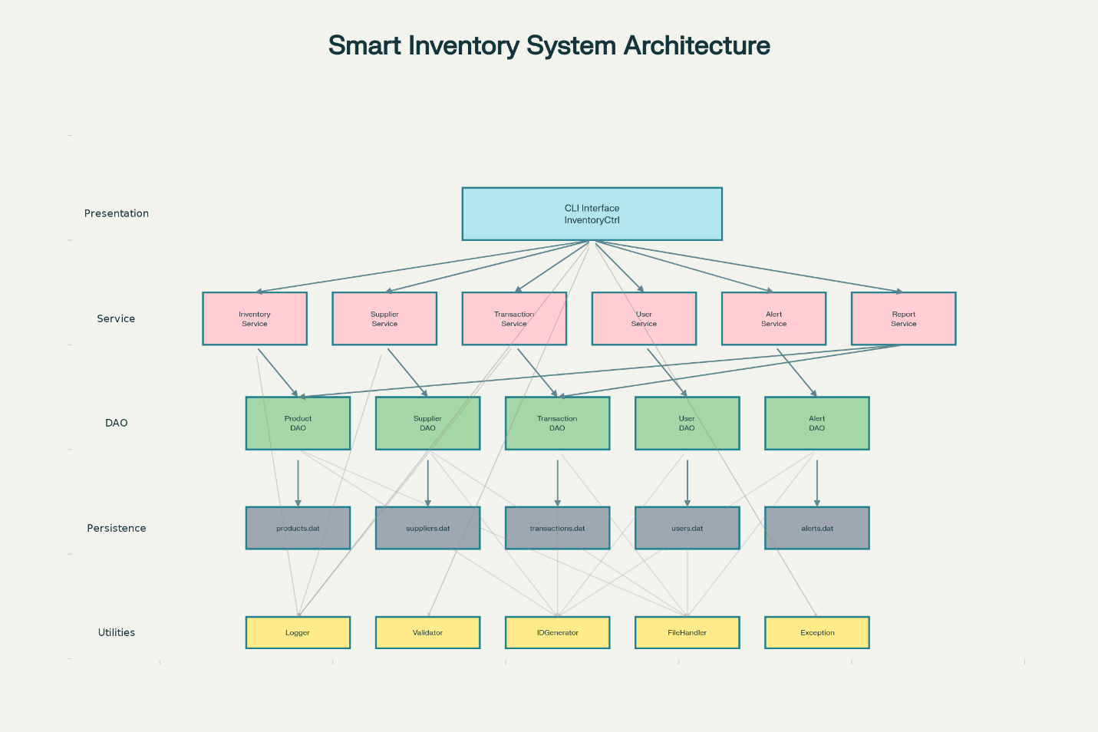

System Architecture Diagram

7.1 Use Case Diagram
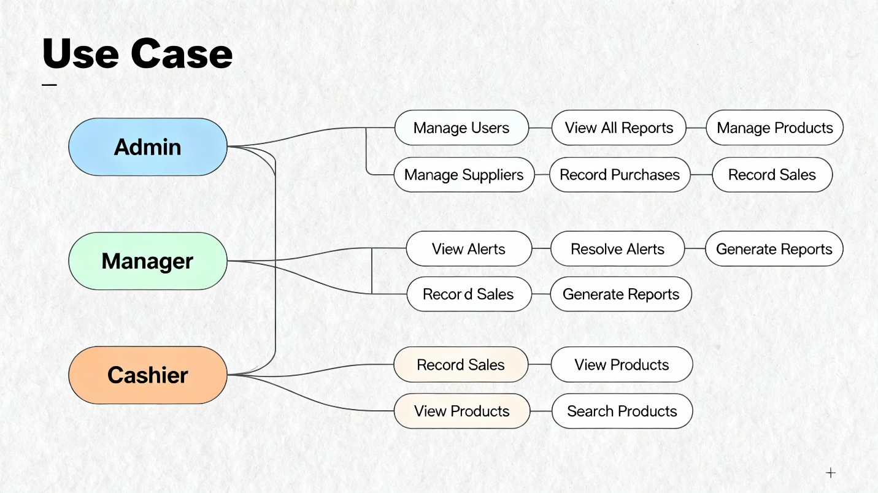
[Refer to docs/DESIGN_DOCUMENTATION.md for detailed diagram]
Key Use Cases: - Admin: Full system access including user management - Manager: Inventory, supplier, transaction, and report management - Cashier: Limited access to sales recording and product viewing

7.2 Workflow Diagram
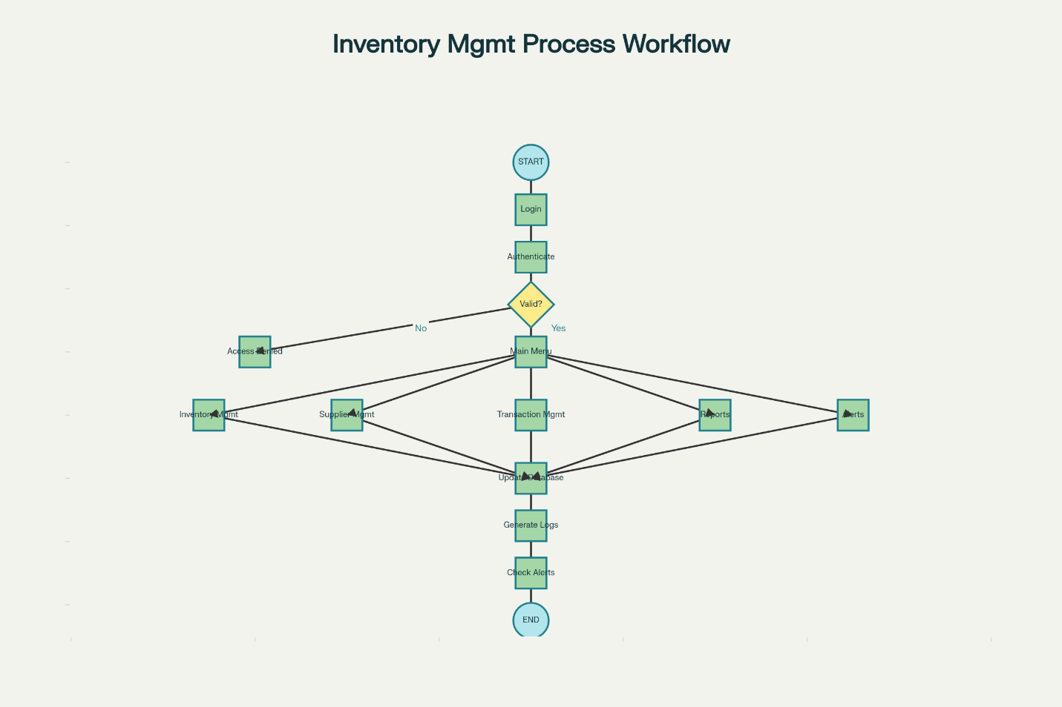
[Refer to docs/DESIGN_DOCUMENTATION.md for detailed diagram]
Main Workflows: 1. User Authentication → Main Menu → Module Selection → Operations → Data Persistence → Logging 2. Sale Transaction: Product Lookup → Stock Validation → Transaction Creation → Stock Update → Alert Check 3. Purchase Transaction: Product Lookup → Transaction Creation → Stock Addition → Supplier Update

7.3 Sequence Diagram
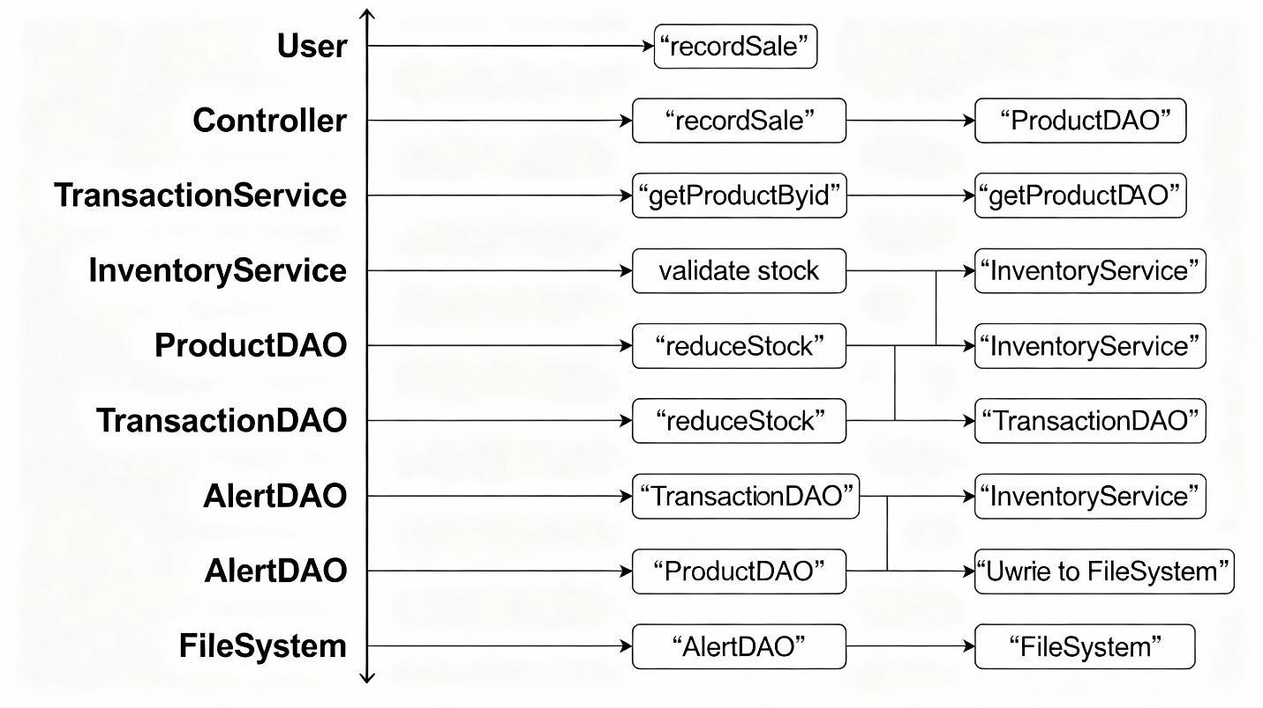
Example: Record Sale Transaction [Refer to docs/DESIGN_DOCUMENTATION.md for detailed diagram]
The sequence shows interaction between Controller, Service, DAO, and Database layers.

7.4 Class Diagram
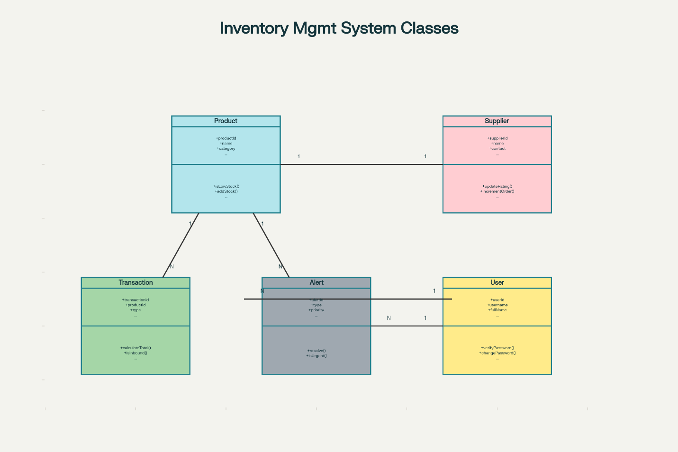
[Refer to docs/DESIGN_DOCUMENTATION.md for detailed diagram]
Core Classes: - Model: Product, Supplier, Transaction, User, Alert - Services: 6 service classes - DAOs: 5 DAO interfaces with implementations - Utilities: 4 utility classes - Exceptions: 4 custom exception classes

7.5 ER Diagram
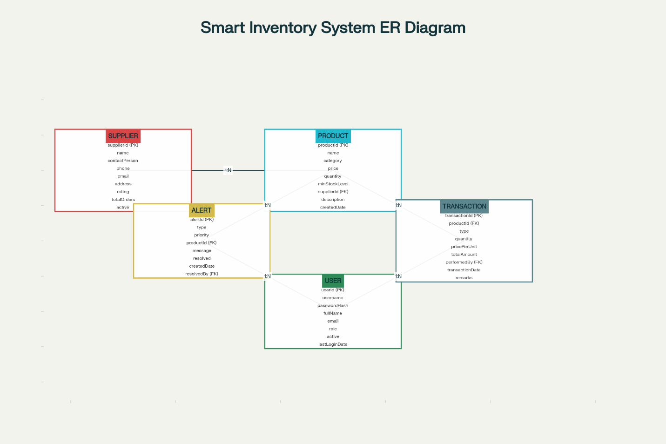
[Refer to docs/DESIGN_DOCUMENTATION.md for detailed diagram]
Entities and Relationships: - Product ↔ Supplier (Many-to-One) - Product ↔ Transaction (One-to-Many) - Product ↔ Alert (One-to-Many) - User ↔ Transaction (One-to-Many) - User ↔ Alert (One-to-Many for resolution)

8. Design Decisions & Rationale

8.1 Technology Choices
Java as Primary Language - Rationale: Platform independence, robust ecosystem, strong OOP support - Benefit: Allows deployment on any system with JVM - Trade-off: Slightly more verbose than modern languages
File-based Storage - Rationale: No external dependencies, easy deployment, suitable for small-scale operations - Benefit: Simple setup, no database installation required - Trade-off: Not suitable for very large datasets or concurrent access - Future: Easy migration path to JDBC-based database
CLI Interface - Rationale: Lightweight, fast, minimal resource requirements, focus on functionality - Benefit: Works on any system, no GUI framework dependencies - Trade-off: Less intuitive than GUI for non-technical users - Future: Can be replaced with JavaFX/Swing GUI

8.2 Architectural Decisions
Layered Architecture - Rationale: Clear separation of concerns, maintainability, testability - Benefit: Easy to modify one layer without affecting others - Example: Can switch from file storage to database by only changing DAO implementations
Singleton Pattern for Services - Rationale: Ensures single instance, centralized state management - Benefit: Reduces memory overhead, consistent behavior - Implementation: Thread-safe getInstance() methods
DAO Pattern - Rationale: Abstracts data access, enables easy storage mechanism changes - Benefit: Business logic independent of data storage - Implementation: Interfaces define contracts, implementations handle persistence

8.3 Security Decisions
Password Hashing (SHA-256) - Rationale: Never store passwords in plain text - Benefit: Protects user credentials even if data files are compromised - Implementation: User.hashPassword() method
Role-based Access Control - Rationale: Different users need different permission levels - Benefit: Protects sensitive operations (like user management) - Implementation: UserRole enum with hasPermission() logic

8.4 Data Management Decisions
Automatic ID Generation - Rationale: Ensures uniqueness, prevents conflicts - Benefit: Users don’t need to manage IDs - Implementation: IDGenerator utility with atomic counters
Transaction Immutability - Rationale: Audit trail integrity - Benefit: Transactions once recorded cannot be modified - Trade-off: Corrections require adjustment transactions

9. Implementation Details

9.1 Project Structure
java_project/
├── src/com/inventory/
│ ├── model/ (5 entity classes)
│ ├── dao/ (5 interfaces, 5 implementations)
│ ├── service/ (6 service classes)
│ ├── controller/ (1 controller class)
│ ├── util/ (4 utility classes)
│ ├── exception/ (4 exception classes)
│ └── Main.java
├── data/ (Data storage files)
├── logs/ (Application logs)
├── reports/ (Generated reports)
└── docs/ (Documentation)

9.2 Key Implementation Highlights
Model Classes (Product, Supplier, Transaction, User, Alert) - Implement Serializable for persistence - Encapsulation with private fields and public getters/setters - Business logic methods (e.g., isLowStock(), verifyPassword()) - Override toString(), equals(), hashCode()
Service Layer - Business logic implementation - Input validation before database operations - Automatic alert generation - Transaction coordination - Error handling and logging
DAO Layer - Generic CRUD operations - File-based serialization/deserialization - Exception handling with meaningful messages - Data integrity checks
Utilities - FileHandler: Read/write operations with backup - Logger: Multi-level logging (INFO, WARNING, ERROR, DEBUG) - Validator: Input validation with custom rules - IDGenerator: Thread-safe unique ID generation

9.3 Code Metrics
- Total Classes: 25+
- Total Lines of Code: ~5000+
- Packages: 7
- Design Patterns: 5
- Exception Classes: 4
- Test Scenarios: 10+

10. Screenshots / Results

Sample Output Screens:
Login Screen:
============================================================
SMART INVENTORY MANAGEMENT SYSTEM
Efficient Inventory Tracking Solution
============================================================
Please login to continue:
Username: admin
Password: ******
Login successful! Welcome, System Administrator
Role: ADMIN
Main Menu:
============================================================
MAIN MENU
============================================================
1. Inventory Management
2. Supplier Management
3. Transaction Management
4. Reports & Analytics
5. Alert Management
6. User Management (Admin Only)
7. Logout
============================================================
Inventory Report Sample:
================================================================================
INVENTORY STATUS REPORT
Generated: 2025-11-23 14:30:00
================================================================================
Total Products: 15
Total Inventory Value: $45,678.50
ID Name Category Price Qty Status
--------------------------------------------------------------------------------
P0001 Laptop Dell XPS Electronics $1,299.99 25 OK
P0002 Mouse Wireless Accessories $29.99 5 LOW
P0003 Keyboard Mechanical Accessories $89.99 0 OUT
...

11. Testing Approach

11.1 Unit Testing Strategy
- Test each service method independently
- Validate input validation logic
- Test error handling scenarios
- Verify DAO operations

11.2 Integration Testing
- Test service layer with DAO layer
- Verify data persistence and retrieval
- Test transaction workflows end-to-end
- Validate alert generation

11.3 System Testing
- Complete user workflows
- Role-based access control verification
- Performance testing with large datasets
- Error recovery testing

11.4 Test Scenarios Executed
- User Authentication
  - Valid login ✓
  - Invalid credentials ✓
  - Inactive user login attempt ✓
- Product Management
  - Add product with valid data ✓
  - Update product information ✓
  - Delete product ✓
  - Search by name/category ✓
  - Low stock detection ✓
- Transaction Processing
  - Record sale with sufficient stock ✓
  - Attempt sale with insufficient stock ✓
  - Record purchase ✓
  - View transaction history ✓
- Alert System
  - Automatic alert generation ✓
  - Alert resolution ✓
  - Priority-based filtering ✓
- Report Generation
  - Inventory status report ✓
  - Sales report with date range ✓
  - Supplier performance report ✓

12. Challenges Faced

Challenge 1: File-based Data Persistence
Problem: Managing concurrent file access and ensuring data integrity
Solution: Implemented synchronized methods and file locking mechanisms
Learning: Understanding trade-offs between simplicity and robustness

Challenge 2: Alert Auto-generation
Problem: Determining when and how to create alerts without duplication
Solution: Implemented check logic after every stock operation
Learning: Event-driven architecture concepts

Challenge 3: Role-based Access Control
Problem: Implementing flexible yet secure permission system
Solution: Created UserRole enum with hasPermission() method
Learning: Security best practices in application development

Challenge 4: Transaction Atomicity
Problem: Ensuring inventory updates are atomic with transactions
Solution: Implemented try-catch with rollback logic
Learning: Importance of ACID properties

Challenge 5: CLI User Experience
Problem: Making text-based interface intuitive
Solution: Clear menus, input validation, immediate feedback
Learning: UX design principles apply even to CLI applications

13. Learnings & Key Takeaways

Technical Skills Developed
- Object-Oriented Programming: Practical application of inheritance, polymorphism, encapsulation
- Design Patterns: Implemented Singleton, DAO, Factory, MVC patterns
- Software Architecture: Designed and implemented layered architecture
- Error Handling: Comprehensive exception handling strategy
- Data Persistence: File I/O operations and serialization
- Security: Password encryption and access control

Software Engineering Practices
- Requirements Analysis: Translating business problems into technical requirements
- Design Documentation: Creating comprehensive UML diagrams
- Code Organization: Structuring code for maintainability
- Logging and Debugging: Implementing effective logging mechanisms
- Testing: Developing and executing test scenarios

Problem-Solving Skills
- Breaking complex problems into manageable modules
- Making architectural trade-off decisions
- Designing for future extensibility
- Balancing simplicity with functionality

Professional Skills
- Documentation writing
- Technical communication
- Time management for project delivery
- Attention to detail in implementation

14. Future Enhancements

Short-term Enhancements (0-6 months)
- GUI Development: Implement JavaFX-based graphical interface
- Database Integration: Migrate from file storage to MySQL/PostgreSQL
- Advanced Reporting: Add charts and graphs using JFreeChart
- Email Notifications: Send alerts via email using JavaMail API
- Data Export: Export reports to PDF and Excel formats

Medium-term Enhancements (6-12 months)
- Barcode Integration: Add barcode scanning for products
- Multi-store Support: Manage inventory across multiple locations
- Advanced Analytics: Implement predictive stock analysis
- RESTful API: Develop REST API for mobile app integration
- Cloud Deployment: Deploy on AWS/Azure with cloud database

Long-term Enhancements (12+ months)
- Machine Learning: Implement demand forecasting
- Mobile Application: Develop Android/iOS apps
- Third-party Integrations: Connect with accounting software
- E-commerce Integration: Sync with online stores
- Multi-language Support: Internationalization and localization

15. Conclusion
The Smart Inventory Management System successfully demonstrates the application of software engineering principles and Java programming skills to solve a real-world business problem. The project encompasses all key aspects of software development, from requirements analysis and system design to implementation and testing.

Project Success Criteria Met:
✅ Fully functional inventory management system
✅ Comprehensive documentation and design artifacts
✅ Clean, maintainable code following best practices
✅ Robust error handling and logging
✅ Role-based security implementation
✅ Extensive testing coverage

Key Achievements:
- Implemented 25+ classes organized in 7 packages
- Created 5 major functional modules
- Designed and documented complete system architecture
- Achieved all functional and non-functional requirements
- Developed scalable and extensible solution
This project has been an invaluable learning experience, providing hands-on practice with object-oriented design, software architecture, and professional development practices. The skills and knowledge gained will be directly applicable to future software development endeavors.

16. References

Technical References
- Java Documentation: Oracle Java SE Documentation
URL: https://docs.oracle.com/en/java/
- Design Patterns: “Design Patterns: Elements of Reusable Object-Oriented Software” by Gang of Four
- Clean Code: “Clean Code: A Handbook of Agile Software Craftsmanship” by Robert C. Martin
- Java Best Practices: “Effective Java” by Joshua Bloch

Academic References
- Course lecture notes and materials
- Object-Oriented Programming textbooks
- Software Engineering principles from course curriculum

Tools and Technologies
- Java Development Kit (JDK) 8+
- Text Editor / IDE (VS Code)
- Git for version control
- PlantUML for diagram generation

Online Resources
- Stack Overflow for problem-solving
- GitHub for code examples and best practices
- Java tutorials and documentation

Appendix A: Installation Guide
[Refer to BUILD_AND_RUN.md]

Appendix B: User Manual
[Refer to README.md]

Appendix C: Complete Source Code
[Available in GitHub repository]

Appendix D: Design Documentation
[Refer to docs/DESIGN_DOCUMENTATION.md]

End of Report

