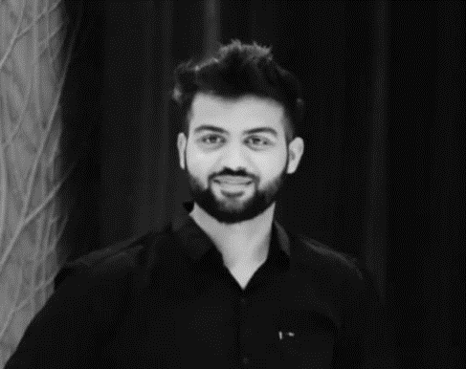

**Puneet Alwani**

**** 8769611262**

linkedin.com/in/puneet-alwani-57a238218/



**PROFESSIONAL SUMMARY**

Talented Graduate Developer with a strong academic background and an experience of more than 2 years in building innovative, responsive user interfaces using Mern Stack Technologies and familiar with JAVA Full Stack Technologies. Strong knowledge of database design, implementation and optimization using MySQL and MongoDB. Able to work harmoniously with other members of the Team. Possesses great analytical and problem-solving skills.

**TECHNICAL COMPETENCIES**

C++ | HTML5 | CSS3 | JavaScript | Bootstrap | REACTJS | NODE JS | JAVA| SPRING BOOT |SQL| Docker| MongoDB | AWS | Generative AI| GitHub Copilot.

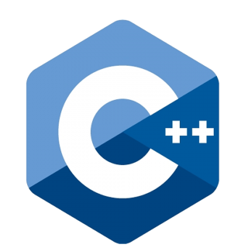

**INTERPERSONAL SKILLS**

Teamwork **|** Coordination **|** Hardworking | Dedicated | Punctual

**LANGUAGES KNOWN**

English **|** Hindi

**PROFESSIONAL EXPERIENCE**

Programmer Analyst

Cognizant Technology Solutions |Sept 2023 – Present| Client- BRG

* Developed and Designed React application for client project with collaboration with backend team.
* Migrated React frontend modules to micro frontend architecture for improved scalability and maintainability.
* Get certified as Generative AI Code Assistant and certified by GitHub Copilot training.

Programmer Analyst Trainee

Cognizant Technology Solutions |Sept 2022 – Aug 2023| Telstra Account

* Worked on their Ecommerce platform in an agile environment.
* Utilized the MEAN stack to enhance and maintain our platform.
* Documented code changes, conducting code peer reviews and participated in product demos.

Mern Stack Development Intern

Cognizant Technology Solutions |Feb 2022 – Aug 2022|

* Trained as a Developer on Mern stack technologies (HTML8, CSS3, JavaScript, ReactJS, NodeJS, Express and MongoDB).
* Designed innovative, responsive web-based interfaces in the project “Job Portal”.

**EDUCATION**

BTech in Computer Science Engineering | Swami Keshvanand Institute of Technology (Jaipur)

*Session: 2018-2022 | Score: 8.84 CGPA*

12th Board (CBSE) | Rawat Public School, Pratap Nagar (Jaipur)

*Session: 2016-2017 | Percentage: 80%*

10th Board (CBSE) | Rawat Public School, Pratap Nagar (Jaipur)

*Session: 2014-2015 | Score: 10 CGPA*

**PROJECTS**

* **Ecommerce App -** Designed backend using JAVA, spring, Rest API, Docker, MySQL, AWS in which one should add, modify, delete etc. the product that they want to sell on the UI interface portal.
* **Job Portal (Applicant and Recruiter) –** Designed using ReactJS, JavaScript, NodeJS, MongoDB in which there are two logins, applicant who apply for job and recruiter who recruit applicants.

**CERTIFICATIONS & ACHIEVEMENTS**

* GitHub Copilot- JAVA certified. - May 2024
* Gen AI fundamentals (Foundation) – Nov 2023
* Developing responsive Web (Udemy) - Jan 2023
* ReactJS course certified (Udemy). – Aug 2022
* Certified and Hands on ChatGPT Course (Cognizant Learn).