**INDEX**

|  |  |  |  |  |
| --- | --- | --- | --- | --- |
| **S. No.** | **DATE** | **NAME OF THE EXERCISE** | **PAGE NO.** | **SIGN** |
| 1 | 07/07/23 | To prepare an activity named ‘Formation of Team’ in MS Project for discussing and planning of a project. | 3 – 6 |  |
| 2 | 21/07/23 | To select a real-world software project, perform planning for the project and implement the planning on MS Project. | 7 – 12 |  |
| 3 | 28/07/23 | To prepare the resource sheet for the planned real-world software project, allocate resources to the tasks and create the network diagram | 13 – 21 |  |
| 4 | 04/08/23 | To develop and present a comprehensive Gantt chart for the planned real-world project. | 22 – 25 |  |
| 5 | 11/08/23 | To establish task precedence for the planned real-world project on MS Project. | 26 – 28 |  |
| 6 | 18/08/23 | To allocate resources using the resource sheet and perform cost factoring | 29 – 31 |  |
| 7 | 25/08/23 | To demonstrate unlinking, splitting and merging on the real-world project. | 32 – 34 |  |
| 8 | 15/09/23 | To add milestones and checkpoints to the real-world project. | 35 – 39 |  |
| 9 | 22/09/23 | To add detailed notes for each resource used for the real-world project on MS Project. | 40 – 43 |  |
| 10 | 29/09/23 | To utilize MS Project workspace to baseline the project and review the critical path, focusing on formatting and printing the project plan for effective communication and analysis. | 44 – 46 |  |
| 11 | 06/10/23 | To track progress effectively within a project using MS Project. | 47 - 48 |  |

**Experiment 1**

**Date:** 07/07/2023

**Aim:** To prepare an activity, ‘Team Formation’ in MS Project for the purpose of team formation for a project.

**Problem Statement:**

In MS Project, prepare an activity ‘Team Formation’ for the purpose of team formation for a project.

* The team should consist of 4-5 members
* There should be time allotted to lunch each day
* There should be activities to check team-spirit and team-bonding
* A report needs to be given to Project manager on the final day

**Description:**

There are various steps involved which were crucial for this activity:

**a) Scope of the Project:**

Significance:

Defining the project scope is essential to establish the boundaries, objectives, and constraints of the project. It provides a clear understanding of what is included and what is not, setting expectations and preventing scope creep.

What to Do:

This step involves gathering requirements, understanding project goals, determining constraints (e.g., budget, time), and defining the project's technical and functional boundaries.

**b) Evaluation of Skill Set:**

Significance:

Assessing technical and non-technical skills is crucial for building a balanced and efficient team. It ensures that the team possesses the necessary competencies to successfully execute the project.

What to Do:

Evaluate team members based on technical skills related to the project (e.g., Web Dev, AI/ML, communication) and non-technical skills (e.g., communication, organization, time management) through assessments or interviews.

**c) Formation of Team:**

Significance:

Forming a team involves choosing the right individuals based on skill assessments, team dynamics, and readiness to work together. A cohesive and well-suited team is essential for project success.

What to Do:

Analyse the skill evaluation data and consider team members' relationships, willingness to collaborate, and overall team spirit to form a cohesive team of 4-5 members.

**d) Allocation of Roles to Each Member:**

Significance:

Assigning roles ensures that each team member knows their responsibilities, maximizing efficiency and productivity. It aligns individual skills with project requirements.

What to Do:

Conduct daily meetings (10:00 AM - 12:00 PM over 3 days) to discuss team members' skills and preferences, and then allocate roles based on a consensus reached during the discussions.

**e) Choosing Team Leader:**

Significance:

Selecting an effective team leader is crucial for maintaining focus, resolving conflicts, and ensuring project progress. Leadership skills and the ability to guide the team are key factors.

What to Do:

Evaluate each team member's proficiency, leadership skills, and conduct a voting process to choose the most suitable individual as the team leader.

**f) Meeting Organized by Team Leader with Team Members:**

Significance:

This meeting, led by the chosen team leader, aims to align the team, establish communication channels, and set expectations for the project. It lays the foundation for coordinated teamwork.

What to Do:

The team leader organizes a meeting (½ day) to introduce the project, clarify roles, set communication protocols, and foster a collaborative team environment. The meeting also prepares the team for reporting to the manager.

**g) Reporting to the Manager:**

Significance:

Reporting to the manager at the end signifies accountability, transparency, and enables managers to track progress and provide necessary guidance.

What to Do:

Team members collectively prepare and present a comprehensive report (2 hours: 3:00 PM - 5:00 PM) to the manager, outlining the team formation process, allocated roles, and the overall project plan.

**Output:**

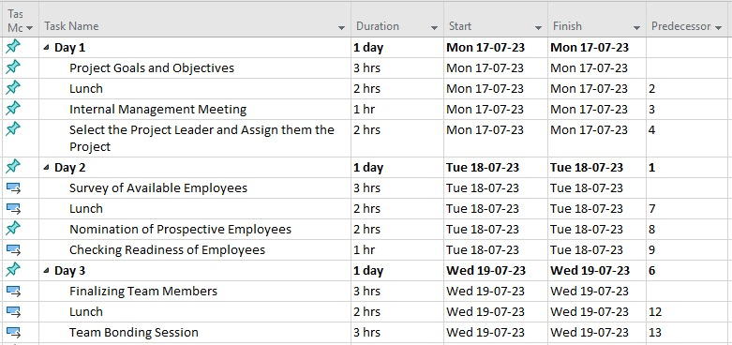

Figure 1: Days 1 to 3 of the team building process

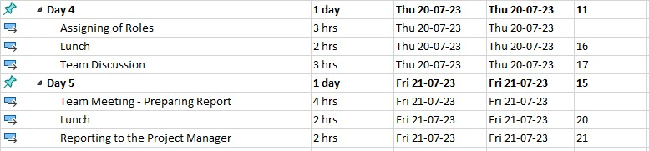

Figure 2: Days 4 and 5 of the team building process

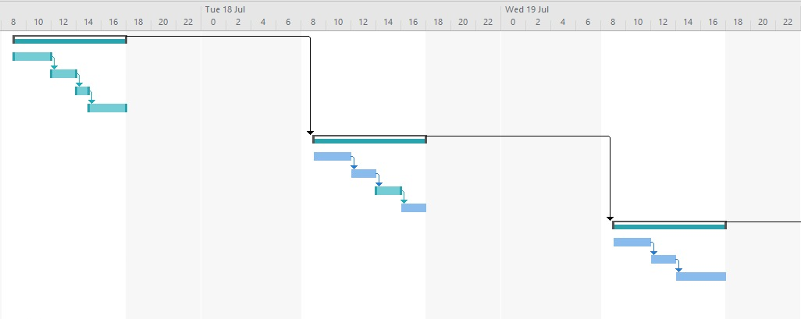

Figure 3: Gantt Chart for the team building process [1]

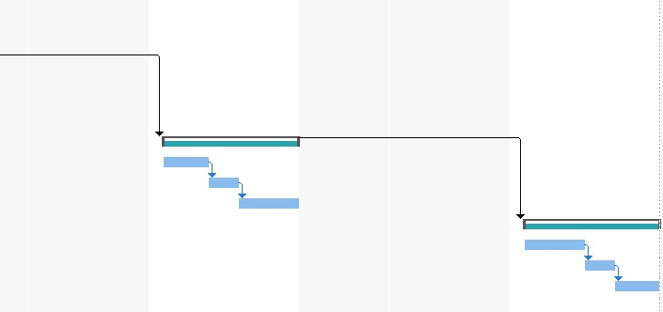

Figure 4: Gantt Chart for the team building process [2]

**Result:**

The "Team Formation" activity’s successful completion is evidence of effective project management and tactical team development. A cohesive and competent team was ensured by the organised technique, which included skill evaluation, role allocation, and leadership selection.

**Evaluation:**

|  |  |  |  |
| --- | --- | --- | --- |
| Marking Criteria | | | |
| Criteria | Total Marks | Marks Obtained | Comments |
| Concept (A) | 2 |  |  |
| Implementation  (B) | 2 |  |  |
| Performance (C) | 2 |  |  |
| Total | 6 |  |  |

**Experiment 2**

**Date:** 21/07/2023

**Aim:** To select a real-world software project, perform planning for it, and implement it on MS Project

**Selected Project Title:** Sentiment Analysis of Tweets

**Description:**

**Step 0: Select the Project**

Sentiment analysis of tweets

**Step 1: Identify Project Scope and Objectives**

1.1. Identify objectives - Implementing a sentiment analysis system on tweets to prevent hate speech and false information.

1.2. Establish a project authority - The management team of the organization will oversee the project’s progress and implement corrective measures whenever necessary.

1.3. Stakeholder analysis –

* External Stakeholders: The company that outsourced us this project.
* Internal Stakeholders: Project Leaders, Project Managers, Product Owner, Team Leads, Team members.

1.4. Establish methods of communication with all parties -

* First party: These are the people who would be directly working on the project to establish communication between these members and the second party which includes managers and leaders. Emails and standard project tracking and planning tools such as Jira would be used.
* Second party: These are members who are not directly involved in the development of the project but are responsible for completing the project on time which includes project leaders and managers, for establishing communication between these and the first party we would be using Emails and standard recurring meetings. To establish communication between these and 3rd party we would be using Emails and occasional meetings.
* Third party: These members are external to the project and to establish communication between these and the second party we would be using official mails and occasional meetings.

**Step 2: Identify Project Infrastructure**

* **Software Requirements**

Frontend Requirements: HTML, CSS, JavaScript and a Frontend framework React.js would be used to create the user interface of the application.

Backend Requirements: Python and Django would be used for server-side development.

For the database, we would be using MySQL.

DevOps Requirements: We would be deploying our servers on Lambda to save cost.

We would be deploying our database servers on Amazon RDS.

For the user-facing part of the application, we would be deploying the static site on S3 and would be using CloudFront to distribute the content.

* **Material Requirements**

All the concerned hardware requirements.

* **Team Requirements**

Frontend Developers, Backend Developers, DevOps Engineers, Database Administrators, Business Analysts, Software Testers.

**Step 3: Analyse Project Characteristics**

1. The project would be product-driven.
2. The predictions of the sentiments should be accurate and therefore an external NLP library would be used.
3. The project should be scalable therefore distributed deployment would be used.
4. The system should be extremely secure and the data related to tweets should be saved securely in the database.
5. The system should be seamlessly integrated with the twitter API.
6. Proper user authentication and access control is required.
7. The user experience (UX) should be smooth and convenient.
8. Proper change management and version control is required in the project.

**Step 4: Identify Project Products & Activities**

The product is a Sentiment analysis system that seamlessly integrates with the Twitter API to analyse the tweets and predict their sentiments to prevent hate speech and false information.

Project Activities:

1. Requirements gathering and analysis
2. Designing the front-end
   1. Wire-framing
3. Designing the back-end
   1. Designing the database schema
   2. Designing the API architecture
   3. Designing the Cloud Architecture
4. Implementing the front-end using React.js
5. Implementing the back-end
6. Testing
   1. Alpha testing
   2. Beta testing

**Step 5: Estimate Effort for Each Activity**

1. Requirements gathering and analysis would approximately take 3 days and requires 2 Business Analysts.
2. Designing the front-end
   1. Wire-framing activities would take approximately 4 days and require 1 Front-end developer.
3. Designing the back-end
   1. Designing database schema would take 5 days and would require 2 DBAs.
   2. Designing API architectures would require approx. 3 days and 2 Backend Engineers.
   3. Architecting the cloud would take 2 days and a DevOps Engineer.
4. Front-end implementation would take 5 days and 2 Front-end developers.
5. Implementing the back-end.
   1. Creating tables in MySQL would take 3 days and would require 2 DBAs.
   2. API implementation would take 4 days and require 2 Back-end Engineers.
   3. Installing and integrating the required libraries would take 1 day and 2 Backend Engineers.
   4. Implementing the required cloud architecture would take 5 days and 1 DevOps Engineer.
6. Testing
   1. Alpha testing would be completed in a week and would require the complete team.
   2. Beta testing would be completed in 2 weeks and would require a Software Tester who will assist the client.

**Step 6: Identify Activity Risks**

1. The client may not approve the created user interface.
2. Improper change management and version conflict between dependencies.
3. Breach of sensitive user information and tweets due to broken access controls.
4. The installed NLP libraries may not deliver the required accuracy and hence we may be required to implement our own NLP logic.
5. AWS changing its infrastructure and software stack may affect what type of libraries and dependencies we can run.
6. Testing may get delayed due to recurring bugs.
7. Exiting of a team member during the project.
8. Rising AWS costs.
9. Changing business objectives of the important stakeholders.
10. Twitter’s policy changes may affect the integration of the project with the Twitter API.
11. Changes in any legislature may prevent the system from storing and analysing tweets.
12. Version changes in the NLP library may prevent its proper integration with other dependencies.
13. Database schema if not adequately designed will make the queries highly inefficient and may degrade user experience.
14. Vulnerabilities in 3rd party frontend or backend libraries may lead to a security breach.

**Step 7: Allocate Resources**

Allocate the necessary resources

**Step 8: Review/Publicize plan**

The developed plan will be evaluated by the important stakeholders and the tasks would be allocated to the concerned team members.

**Step 9: Execute the Plan**

Plan the project’s execution

**Step 10: Lower-Level Planning**

* Requirements gathering and analysis

1. The Business Analysts would take the user requirements on the first day.
2. The Business Analysts would prepare the SRS for the client on the second day.
3. The SRS would be shown to the client on the third day where the feedback from the client would be taken and the SRS would be finalized.

* Designing the front-end

The wire-framing for the front-end would be done by using Figma according the UI requirements mentioned in the SRS.

* Designing the back-end

1. The database schema would be designed on db.io.
2. Design documents for API architecture would be created.
3. Design documents for cloud architecture would be created.

* Implementing the front-end using React.js

The frontend would be implemented using the React framework with some third-party libraries to provide modern application features such as top loading bar and infinite scroll.

* Implementing the back-end

1. Creating the required tables in MySQL.
2. Implementing the APIs using Django.
3. Installing the required libraries and integrating them with the APIs.
4. Provisioning and deploying the database and application servers on RDS and EC2, respectively.
5. Provisioning S3 and CloudFront services for the user-facing part of our application.

* Testing

1. The Alpha testing would be done by the inhouse development team using Shake and BrowserStack.
2. The Beta testing would be done by using the same tools except at client’s own system and environment.

**Output:**

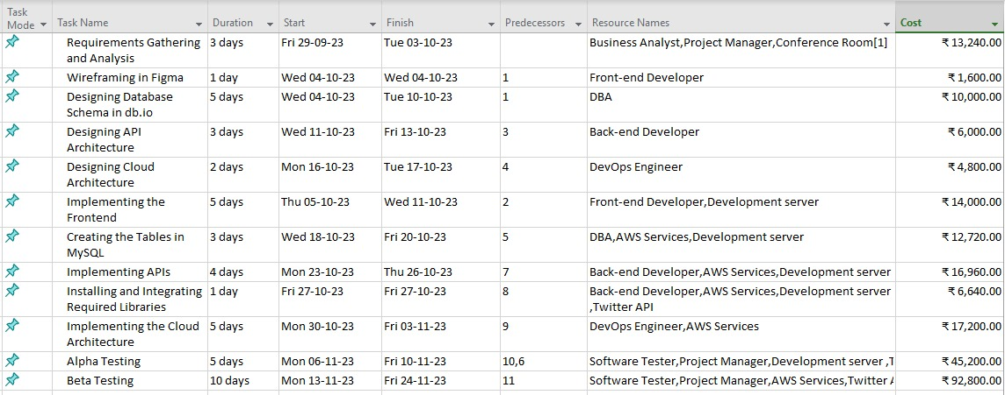

Figure 5: Task Sheet

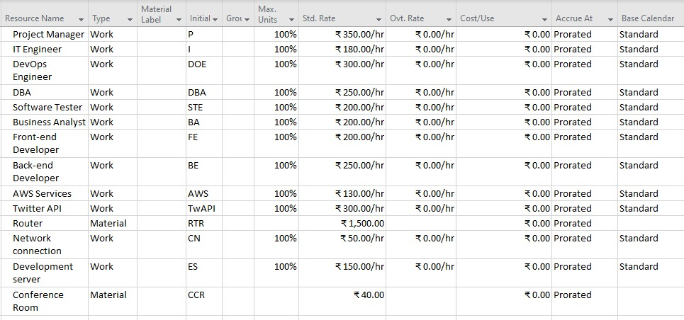

Figure 6: Resource Sheet

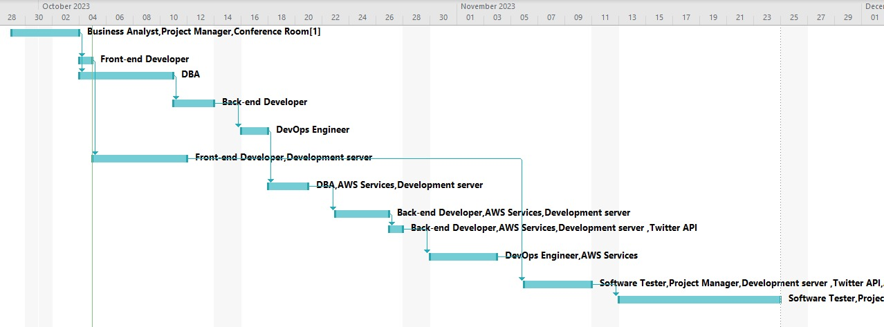

Figure 7: Gantt Chart

**Result:**

We were able to select our real-world project *(Sentiment Analysis of Tweets)*, performed planning for it, and implement it on MS Project.

**Evaluation:**

|  |  |  |  |
| --- | --- | --- | --- |
| Marking Criteria | | | |
| Criteria | Total Marks | Marks Obtained | Comments |
| Concept (A) | 2 |  |  |
| Implementation  (B) | 2 |  |  |
| Performance (C) | 2 |  |  |
| Total | 6 |  |  |

**Experiment 3**

**Date:** 28/07/2023

**Aim:** To prepare the resource sheet for the planned real-world software project, allocate resources to the tasks and create the network diagram

**Procedure:**

Creating a resource sheet and a network diagram for a real-world software project involves careful planning and organization. The step-by-step procedure that helped us allocate resources to tasks and create a network diagram for our project *(Sentiment Analysis of Tweets)* is as follows:

1. **Understanding Project Requirements:** Familiarizing ourselves with the requirements, goals, and constraints related to the project, and understanding its features, functionality, and the desired outcome.
2. **Defining Tasks and Milestones:** Breaking down the project into smaller tasks and milestones. These tasks should be SMART, i.e., specific, measurable, achievable, relevant, and time-bound. Division of tasks is based on the project phases, such as planning, design, development, testing, and deployment.
3. **Estimating Task Durations:** Working with the project team to estimate the duration and effort required for each task. The complexity of the task, skills of the team members, and any dependencies between tasks are considered.
4. **Allocating Resources:** Identifying the team members who will be responsible for each task based on their skills, availability, and expertise, and allocating appropriate resources to each task to ensure successful completion.
5. **Creating a Resource Sheet:** Preparing a resource sheet that includes the following information for each task:
   * Task name
   * Task description
   * Assigned resource(s)
   * Start date
   * End date
   * Task duration
   * Dependencies (if any)
6. **Determining Task Dependencies:** Identifying task dependencies to establish the order in which tasks should be completed. Some tasks may be dependent on others and cannot start until their prerequisites are completed.
7. **Constructing a Network Diagram:** Using the task dependencies and task durations to create a network diagram. This diagram is a graphical representation of the project's tasks and their interdependencies, and helps in visualizing the project flow and identifying the critical path.
8. **Identifying the Critical Path:** The critical path is the longest path through the network diagram and represents the shortest time in which the project can be completed. Identifying tasks on the critical path is crucial, as any delay in these will result in a delay in the overall project.
9. **Reviewing and Adjust:** Reviewing the resource sheet and network diagram with the project team to ensure accuracy and feasibility, and making the necessary changes based on feedback and constraints.
10. **Optimizing Resource Allocation:** Optimizing the resource allocation to balance workload and ensure that each team member's skills are effectively utilized.
11. **Finalizing the Resource Sheet and Network Diagram:** Once it is reviewed and optimized, finalizing the resource sheet and network diagram for use throughout the project.

RESOURCES AND THEIR COSTS

**Human Resources:**

* **Project Manager**
  + Role: Oversees project planning, execution, and delivery
  + Estimated Cost: Rs. 180,000 per month
* **Business Analyst**
  + Role: Assess how the project is performing and helps in improvements
  + Estimated Cost: Rs. 60,000 per month
* **UI/UX Designer**
  + Role: Designs the user interface and user experience
  + Estimated Cost: Rs. 60,000 per month
* **Frontend Developer**
  + Role: Builds the frontend of the website (the user-facing parts)
  + Estimated Cost: Rs. 75,000 per month
* **Backend Developer**
  + Role: Builds the backend of the website (for example, the APIs)
  + Estimated Cost: Rs. 90,000 per month
* **Database Administrator (DBA)**
  + Role: Manages the database
  + Estimated Cost: Rs. 60,000 per month
* **Data Engineer**
  + Role: Builds systems that collect, validate, and prepare high-quality data
  + Estimated Cost: Rs. 75,000 per month
* **ML Engineer**
  + Role: Develops and builds self-running (AI) systems to automate predictive models
  + Estimated Cost: Rs. 60,000 per month
* **Systems Administrator (Sysadmin)**
  + Role: Manages server infrastructure and deployment
  + Estimated Cost: Rs. 90,000 per month
* **DevOps Engineer**
  + Role: Builds infrastructure and tools so that software can be developed and released
  + Estimated Cost: Rs. 90,000 per month
* **Security Analyst**
  + Role: Monitors the networks for security breaches
  + Estimated Cost: Rs. 60,000 per month
* **Software Tester**
  + Role: Tests the functional and non-functional requirements of the software
  + Estimated Cost: Rs. 45,000 per month

**Material Resources:**

* **Cloud Hosting Services (AWS)**
  + Estimated Cost: Rs. 100,000 per month
* **Twitter API**
  + Estimated Cost: Rs. 1 per month
* **Miscellaneous Expenses (covers miscellaneous project expenses)**
  + Estimated Cost: Rs. 30,000 per month
* **Maintenance and Updates (Includes bug fixes, security patches, and new features)**
  + Estimated Cost: For this component, the costs can vary significantly, but they can be expected to be between Rs. 5,000 and Rs. 10,000

RESOURCE ALLOCATION FOR EACH TASK

**Task 0: Select Project**

Subtask 0.1: Define Project Objectives (1-2 weeks)

**Resources:**

* Project Manager (1)

Subtask 0.2: Establish Project Stakeholders (1 week)

**Resources:**

* Project Manager (1)

Subtask 0.3: Assess Project Feasibility (2-3 weeks)

**Resources:**

* + - Project Manager (1)
    - Front and Backend Developers (3)
    - ML Engineer (1)
    - Database Administrator (1)

Subtask 0.4: Obtain Project Approval (2-3 weeks)

**Resources:**

* + - Project Manager (1)

**Task 1: Identify Project Scope and Objectives**

Subtask 1.1: Define Project Scope (2-4 weeks)

**Resources:**

* + - Project Manager (1)
    - All the members of the team for collaborative brainstorming, which will be followed by documentation

Subtask 1.2: Establish Project Objectives (2-3 weeks)

**Resources:**

* Project Manager (1)
* All the members of the team for discussions and planning sessions

Subtask 1.3: Document Scope Statement (2 weeks)

**Resources:**

* Project Manager (1)
* Business Analyst (2)
* Project management software (e.g., Microsoft Project) for efficient documentation and collaboration

**Task 2: Identify Project Infrastructure**

Subtask 2.1: Evaluate Hardware Requirements (2-3 weeks)

**Resources:**

* Project Manager (1)
* System Administrator (1)
* Hardware assessment tools and equipment to evaluate the existing hardware and identify further needs

Subtask 2.2: Evaluate Software Requirements (2-3 weeks)

**Resources:**

* Project Manager (1)
* Frontend and Backend Developers (3)
* PCs with the software needed for development and testing.

Subtask 2.3: Procure or Set Up Infrastructure (4-6 weeks)

**Resources:**

* Project Manager (1)
* System Administrator (1)
* Procurement documentation and contracts for purchasing hardware or setting up server infrastructure

**Task 3: Analyse Project Characteristics**

Subtask 3.1: Conduct Market Research (4-6 weeks)

**Resources:**

* Project Manager (1)
* Marketing and PR Specialist (1)

**Material Resource:**

* Market research tools and software for data collection and analysis.

Subtask 3.2: Analyse Competitor Offerings (3-4 weeks)

**Resources:**

* Project Manager (1)
* Marketing and PR Specialist (1)
* Access to competitor analysis tools and databases.

Subtask 3.3: Identify Target Audience (2-3 weeks)

**Resources:**

* Project Manager (1)
* Marketing and PR Specialist (1)
* Customer segmentation tools and software for audience analysis.

**Task 4: Identify the Product and Activities**

Subtask 4.1: Define Project Deliverables (2-3 weeks)

**Resources:**

* Project Manager (1)
* UI/UX Designer (1)
* Design and prototyping software (e.g., Figma)

Subtask 4.2: Break Down Deliverables into Activities (4-6 weeks)

**Resources:**

* Project Manager (1)
* Frontend and Backend Developers (3)
* Project management software (e.g., MS Project) for task breakdown and tracking

**ACTIVITIES**

* **Activity 1: Requirement Gathering**

**Resources:**

* Business Analyst (2)
* Project Manager (1)
* Requirement gathering templates and tools
* **Activity 2: Designing the frontend (Wireframing)**

**Resources:**

* UI/UX Designer (1-2)
* Design and wireframing software (e.g., Figma, Adobe XD, …)
* **Activity 3: Designing the backend (3 Sub-activities: Designing the DB schema, the API architecture, and the Cloud architecture)**

**Resources:**

* Frontend Developers (2)
* **Activity 4: Implementing the frontend**

**Resources:**

* Frontend Developers (2)
* **Activity 5: Implementing the backend (4 Sub-activities: Creating tables in the database, Implementing the APIs using Django, Installing the required libraries and integrating them with the APIs, and Implementing the cloud architecture by provisioning and deploying the required services)**

**Resources:**

* Back-End Developers (2-3)
* DevOps Engineer
* **Activity 6: Testing (Alpha testing and Beta testing)**

**Resources:**

* Quality Assurance (QA) Engineer (1)
* Testing tools and devices for different browsers and platforms
* **Activity 7: Security Implementation Resources:**
* Security Specialist (1)
* Backend Developer (1)
* Security tools and software for data protection and encryption
* **Activity 8: User Training and Documentation Resources:**
* Technical Writer (1)
* Documentation tools and software
* **Activity 9: User Feedback and Iterative Updates Resources:**
* Project Manager (1)
* User Experience (UX) Researcher (1)
* Feedback collection tools and software
* **Activity 10: Maintenance and Support Resources:**
* Support Team (2)
* Monitoring and support tools for continuous operation and updates

**Task 9: Execute Plan**

Subtask 9.1: Begin Executing the Activities

**Resources:**

* Project Manager (1)
* Relevant personnel depending on the ongoing activity

Subtask 9.2: Monitor Progress

**Resources:**

* Project Manager (1)
* Team leads (1 for each activity)

Subtask 9.3: Manage the Required Changes

**Resources:**

* Project Manager (1)
* Change Control Board (consisting of key stakeholders)

Subtask 9.4: Ensure Quality Control

**Resources:**

* QA Engineers (1)
* Relevant personnel depending on the ongoing activity

**Task 10: Lower-Level Planning**

Subtask 10.1: Detailed Activity Planning (4-6 weeks)

**Resources:**

* Project Manager (1)
* Team leads (1 for each activity)

Subtask 10.2: Allocate Resources for Lower-Level Tasks (Iterative)

**Resources:**

* Project Manager (1)
* Relevant team leads (based on ongoing allocation needs)

Subtask 10.3: Update and Review Detailed Plans (Ongoing throughout the project)

**Resources:**

* Project Manager (1)
* Team leads (1 for each activity)

**Description:**

METHODOLOGY FOR RESOURCE DEFINITION AND ALLOCATION

1. **Project Analysis:**

* Understanding Project Scope: A thorough understanding of project goals, objectives, and scope is crucial to identify the types and quantity of resources needed.
* Activity Breakdown: Detailed breakdown of project activities to identify the specific tasks and their requirements.

1. **Expertise Identification:**

* Skills and Roles Identification: Identify the necessary skills and roles required to execute each task or activity.
* Profiling Team Members: Evaluate the existing team's skill sets and allocate tasks based on expertise.

1. **Resource Cataloging:**

* Resource Types: Categorize resources into professional (e.g., developers, project managers) and materialistic (e.g., software, hardware).
* Quantifying Resources: Determine the quantity of each resource needed based on task complexity and estimated effort.

1. **Resource Allocation:**

* Matching Skills and Tasks: Match the required skills for a task with the available expertise within the team.
* Optimizing Utilization: Allocate resources efficiently to ensure optimal utilization and productivity.

**Output:**

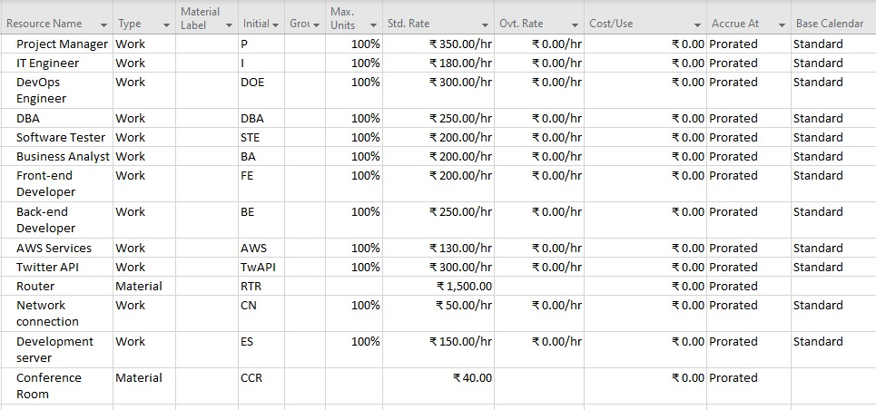

Figure 8: Resource Sheet

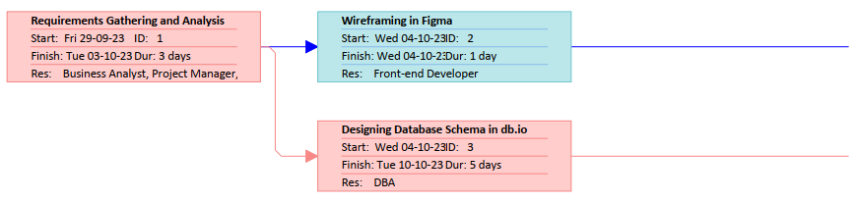

Figure 9: Network Diagram [1]

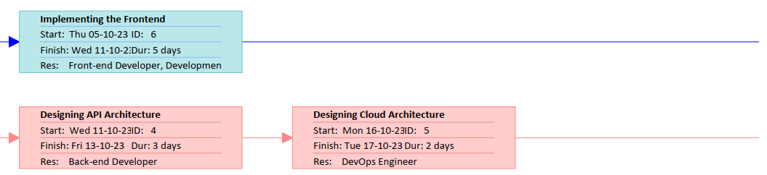

Figure 10: Network Diagram [2]

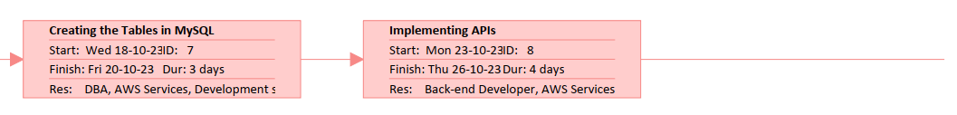

Figure 11: Network Diagram [3]

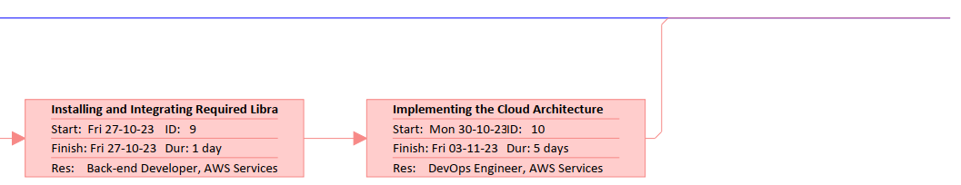

Figure 12: Network Diagram [4]

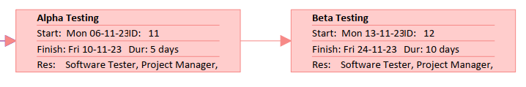

Figure 13: Network Diagram [5]

**Result:**

The resource sheet for the project was successfully created, and we were also able to allocate resources to the tasks and create the network diagram.

**Evaluation:**

|  |  |  |  |
| --- | --- | --- | --- |
| Marking Criteria | | | |
| Criteria | Total Marks | Marks Obtained | Comments |
| Concept (A) | 2 |  |  |
| Implementation  (B) | 2 |  |  |
| Performance (C) | 2 |  |  |
| Total | 6 |  |  |

**Experiment 4**

**Date:** 04/08/2023

**Aim:** To develop and present a comprehensive Gantt Chart for the planned real-world project.

**Description:**

A Gantt chart is a graphical representation of task-based projects, adapted by Karol Adamiecki in 1896, and independently by Henry Gantt in the 1910s, that illustrates a project schedule. They illustrate the start and finish dates of all the activities of the project. Using them can help fine-tune the project timeline for any size of project, and help in many general planning tasks.

The tasks in a Gantt chart can be listed in either a tabular format or be displayed graphically as task bars, reflecting their duration. By linking related tasks, these charts can automatically adjust the timeline when tasks are delayed or completed before schedule. They are a great tool to use for scheduling a project and tracking the duration of each of the tasks in the project to ensure that it is completed on time.

**Procedure:**

**1. Open Microsoft Project:**

* Launch Microsoft Project and either open an existing project or create a new one.

**2. Input the Project Information:**

* Start by entering basic project information, such as the project name and any project-specific details. This information can be added by going to the "Project" tab and selecting "Project Information."

**3. Create a List of Tasks:**

* In the "Task Name" column of the Gantt Chart view, start entering the list of tasks that need to be completed for your project.
* Press Enter after each task to add more. You can also use the "Indent" and "Outdent" buttons to create task hierarchies if needed.

**4. Decide and set the Duration of tasks:**

* In the "Duration" column, enter the estimated duration of each task. You can use various units (e.g., days, weeks, hours) for the duration

**5. Establishment of Dependencies:**

* Create task dependencies to define the order in which tasks need to be executed.
* To establish dependencies:
* Click on the task that depends on another task.
* Go to the "Predecessors" column and enter the ID or name of the predecessor task. Use common dependency types like "Finish to Start" (FS) or others

**6. Resource Allocation:**

* Resource notes are utilized to allocate tasks related to data preprocessing, model training, and interface development.
* Tasks are assigned based on individual expertise, availability, and specialization in sentiment analysis techniques. This strategic allocation optimizes the utilization of resources.

**7. Review and Feedback:**

* Review your Gantt chart to ensure that it accurately reflects the project's scope and sequence of tasks. Adjust task durations, dependencies, and resources.

**8. Formatting of the Gantt Chart:**

* Customize the Gantt chart's appearance by using the "Format" tab. You can change colours, fonts, gridlines, and other visual aspects to make the chart more visually appealing and easier to understand.
* Save your project to ensure that the Gantt chart is preserved for future reference and updates.

**9. Monitoring and Updating:**

* As your project progresses, regularly update the Gantt chart by adjusting task completion, dependencies, and resource allocations. MS Project allows you to enter actual start and finish dates, so you can track progress effectively.

**Output:**

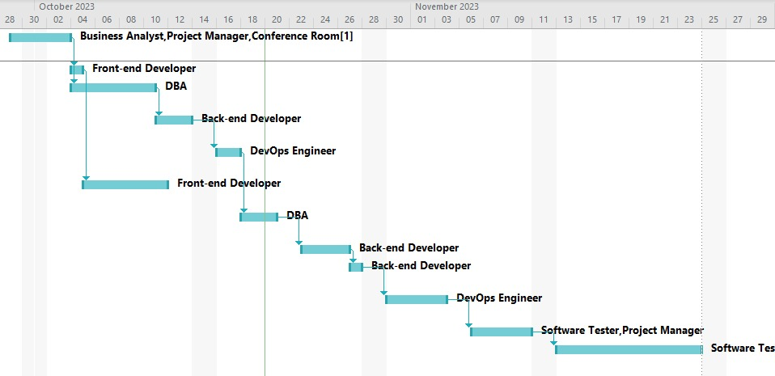

Figure 14: Gantt Chart [1]

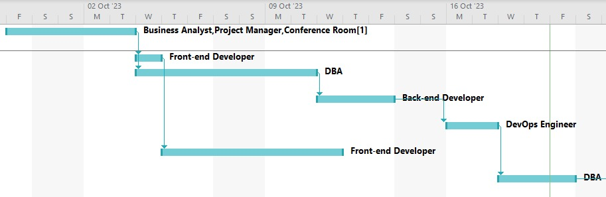

Figure 15: Gantt Chart [2]

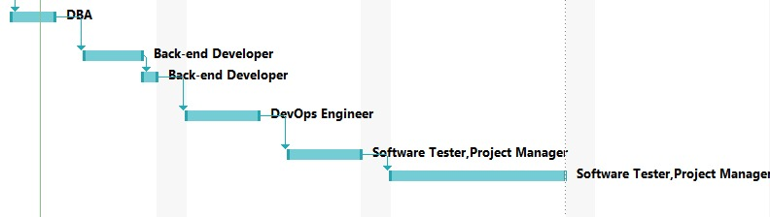

Figure 16: Gantt Chart [3]

**Result:** The Gantt chart was successfully created.

**Evaluation:**

|  |  |  |  |
| --- | --- | --- | --- |
| Marking Criteria | | | |
| Criteria | Total Marks | Marks Obtained | Comments |
| Concept (A) | 2 |  |  |
| Implementation  (B) | 2 |  |  |
| Performance (C) | 2 |  |  |
| Total | 6 |  |  |

**Experiment 5**

**Date:** 11/08/2023

**Aim:** To establish task precedence for the planned real-world project on MS Project.

**Procedure:** Task precedence, also known as task dependencies, determines the order in which tasks are scheduled. There are four common types of task dependencies in MS Project: Finish-to-Start (FS), Start-to-Start (SS), Finish-to-Finish (FF), and Start-to-Finish (SF). Here are the steps to establish task precedence in MS Project:

1. **Open or Create a Project:**

* Launch Microsoft Project and open the project in which you want to establish task precedence. If you are creating a new project, set up your project with basic information.

1. **Create a Task List:**

* In the Gantt Chart view, start by entering the list of tasks for your project.
* Click on the "Task Name" column and type the names of your tasks.
* Press Enter after each task to add more. Use the "Indent" and "Outdent" buttons to create task hierarchies if needed.

1. **Set Task Durations (Optional):**

* In the "Duration" column, specify the estimated duration of each task. While this step is optional at this stage, it is essential for scheduling.

1. **Establish Task Precedence:**

To establish task precedence or dependencies, follow these steps:

* Select the task that needs to be dependent on another task.
* In the "Predecessors" column for the selected task, click on the cell.
* Enter the ID or name of the predecessor task followed by a dependency type. Use the following formats:
  + Finish-to-Start (FS): "1FS" means Task 1 must finish before Task 2 can start.
  + Start-to-Start (SS): "3SS" means Task 3 can start as soon as Task 3 starts.
  + Finish-to-Finish (FF): "4FF" means Task 4 can finish as soon as Task 4 finishes.
  + Start-to-Finish (SF): "5SF" means Task 5 can finish as soon as Task 5 starts.
* You can specify multiple dependencies for a single task by separating them with commas. For example, "1FS, 2SS" means Task 1 must finish before Task 2 can start, and Task 2 can start as soon as Task 1 starts.

1. **Review the Schedule:**

* As you establish task dependencies, MS Project will automatically adjust the schedule based on the defined precedence relationships.

1. **Adjust Dependencies:**

* After establishing dependencies, review the Gantt chart to ensure that the relationships accurately reflect your project's needs.
* Modify dependencies or change their types, if necessary, by clicking on the "Predecessors" column.

1. **Save Your Project:**

* Save your project to ensure that the task dependencies are preserved.

**Description:**

* Task precedence, also known as task dependencies, determines the order in which tasks are scheduled.
* All the required activities of the project are structured according to their course of action.
* For each activity/task, the necessary duration from its start of finish is calculated and set on the Task Sheet.
* The required dependencies among the various tasks are set forming a linkage precedence between the tasks.
* Finally, all the task dependencies are reviewed with the help of a compressive Gantt chart.

**Output:**

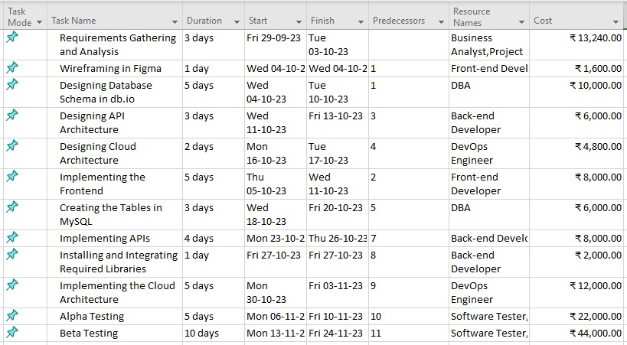

Figure 17: Task Sheet

**Result:** In conclusion, establishing task precedence in Microsoft Project is essential for defining the sequence in which tasks should be executed which has been successfully implemented in this activity.

**Evaluation:**

|  |  |  |  |
| --- | --- | --- | --- |
| Marking Criteria | | | |
| Criteria | Total Marks | Marks Obtained | Comments |
| Concept (A) | 2 |  |  |
| Implementation  (B) | 2 |  |  |
| Performance (C) | 2 |  |  |
| Total | 6 |  |  |

**Experiment 6**

**Date:** 18/08/23

**Aim:** To Allocate Resources using the Resource Sheet and perform Cost Factoring

**Procedure:**

The steps to perform resource allocation in MS Project are:

**Open your Project:** Launch Microsoft Project and open the project you want to work on.

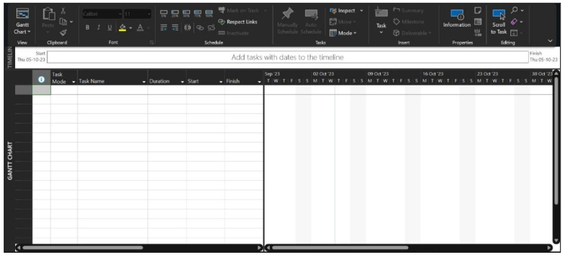

Figure 18: Entering the required resources in the resource sheet

**Enter Tasks and Durations:** Before allocating resources, make sure you have entered all the tasks in your project and estimated their durations.



Figure 19: Enter tasks and durations

**Enter Resources:**

* In the “Resource” tab, click on “Resource Sheet” to open the resource sheet view.
* Enter the names of the resources (e.g., people, equipment, materials) you plan to use in your project. You can also add additional information like resource type, cost, and availability.

**Assign Resources to Tasks:**

* Switch to the Gantt Chart view or Task Sheet view.
* Select the task to which you want to assign a resource.
* In the "Resource" column for that task, click on the cell.
* A drop-down arrow will appear. Click on it to select the resource you want to assign to the task.



Figure 20: Making the resource sheet

**Review Resource Allocation:**

* After assigning resources to tasks, review the resource allocation view to ensure that resources are assigned appropriately without overallocation or underutilizing them.
* Go to the "Resource" tab and choose "Resource Usage" to see a detailed view of resource allocation across all tasks in your project.

**Resolve Resource Overallocations:**

* MS Project will highlight overallocated resources in red. To resolve overallocations, you can do the following:
  + Adjust task durations.
  + Add additional resources to the task.
  + Level resources using the resource levelling tool. .

**Save Your Project:**

* Save your project to preserve the resource allocations and schedule changes.

**Track Resource Usage and Update Information:**

* As you progress with your project, continue to track resource usage to ensure that resources are being utilized as planned. Use the "Resource Usage" view to monitor resource assignments and actual work and update resource information as required.

**Description:**

* Resource allocation in Microsoft Project involves assigning people, equipment, and materials to specific tasks in our project schedule.
* A well-defined resource sheet including IT Managers, Front-end as well as back-end developers was created required for the successful functioning and completion of the project.
* All the necessary resource attributes such as Cost per hour, overtime cost as well as base calendar schedule were added.
* Allocated the required resources such as Developers, Printers, IT Manager etc. (Figure 4) to their corresponding needed tasks.
* Checked for over-allocation and the IT Manager issue was resolved with efficient reallocation.
* Monitored the usage of resources for all the project tasks.

**Result:** The allocation of resources and its cost factoring is successfully implemented.

**Evaluation:**

|  |  |  |  |
| --- | --- | --- | --- |
| Marking Criteria | | | |
| Criteria | Total Marks | Marks Obtained | Comments |
| Concept (A) | 2 |  |  |
| Implementation  (B) | 2 |  |  |
| Performance (C) | 2 |  |  |
| Total | 6 |  |  |

**Experiment 7**

**Date:** 25/08/2023

**Aim:** To perform splitting , unlinking, and merging in a project

**Description:**

1. Merging Tasks

Merging tasks in Microsoft Project involves consolidating multiple tasks into a single task. This is particularly useful when tasks are interrelated or can be executed concurrently, and it simplifies the project schedule by reducing the number of tasks listed. To merge tasks:

1. Select Tasks: Identify the tasks you want to merge by holding down the "Ctrl" key and clicking on the desired tasks in the Gantt chart view.
2. Merge Tasks: Right-click on the selected tasks, and from the context menu, choose "Merge Selected Tasks." Microsoft Project will merge the selected tasks into one, creating a unified task bar on the Gantt Chart [Figure 4.1]
3. Splitting Tasks

Splitting tasks in Microsoft Project involves dividing a task into segments. This division allows for interruptions, resource reallocation, or the introduction of dependencies within the task duration. To split tasks:

1. Select Task: Click on the task bar of the task you want to split in the Gantt Chart view.
2. Split Task: Place the cursor at the desired split point, right-click, and choose "Split Task" from the context menu. Microsoft Project will split the task into two segments at the specified point [Figure 4.3]
3. Unlinking Tasks

Unlinking tasks in Microsoft Project means removing dependency relationships between tasks. Dependencies dictate the sequence in which tasks are executed. Unlinking tasks can be necessary when tasks need to be executed independently or when changes in the project plan require the alteration of task dependencies. To unlink tasks:

1. Select Task: Click on the task you want to unlink in the Gantt Chart view.
2. Remove Dependency: Right-click and choose "Unlink Tasks" from the context menu. This action removes the dependency link between the selected task and its predecessor or successor. [Figure 4.2]

Merging, splitting, and unlinking tasks in Microsoft Project are fundamental operations that allow project managers to refine their project schedules and adapt to changing project requirements. By understanding how to perform these tasks, project managers can ensure that the project plan remains flexible and responsive to the dynamic nature of project management. Microsoft Project's intuitive interface and powerful capabilities make these tasks accessible and manageable, enabling project managers to maintain control over their projects throughout the entire project lifecycle.

**Output:**

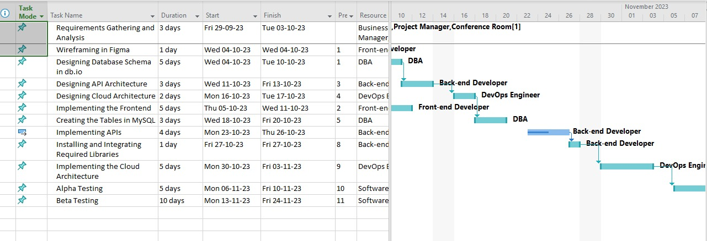

Figure 21: Merging the tasks

Figure 22: Unlinking the tasks

Figure 23: Splitting of tasks

**Result :** Task of merging, splitting, and unlinking with respect to the project is completed.

**Evaluation:**

|  |  |  |  |
| --- | --- | --- | --- |
| Marking Criteria | | | |
| Criteria | Total Marks | Marks Obtained | Comments |
| Concept (A) | 2 |  |  |
| Implementation  (B) | 2 |  |  |
| Performance (C) | 2 |  |  |
| Total | 6 |  |  |

**Experiment 8**

**Date:** 15/09/2023

**Aim:** To add milestones and checkpoints to the real-world project

**Problem Statement:** We have a project, i.e., “Sentiment Analysis of Tweets” for which we have prepared Stepwise planning and the required steps for building the project. Now our task is to add milestones and checkpoints to the project planning.

**Theory :**

There are 4 phases in software project management (SPM), viz., Inception, Elaboration, Construction, and Transition.

1. **Inception Phase:** This phase is the initial stage of a software project. Its primary goal is to establish the project's feasibility and define its scope, objectives, and constraints.
   1. Key Activities: During this phase, you perform activities such as identifying stakeholders, defining the problem to be solved, outlining the system's high-level architecture, creating a preliminary project plan, and estimating resources and costs.
   2. Key Artifacts: Project vision document, initial use cases, business case, and risk assessment.
2. **Elaboration Phase:** The Elaboration phase is where you refine and validate the project's architecture, reduce risks, and develop a detailed plan for the construction phase.
   1. Key Activities: In this phase, you work on defining the system architecture, identifying critical use cases, developing a detailed project plan, and mitigating high-priority risks.
   2. Key Artifacts: Software architecture document, refined use cases, detailed project plan, risk mitigation plan, and a revised business case.
3. **Construction Phase:** The Construction phase focuses on building the actual software system according to the architecture and design established in the previous phases.
   1. Key Activities: You will be primarily involved in coding, testing, and integrating components, tracking progress, and managing quality.
   2. Key Artifacts: Executable code, unit test cases, integration test cases, defect logs, and progress reports.
4. **Transition Phase:** Transition is the final phase where you prepare the software for deployment and ensure a smooth transition to the end-users or the operations team.
5. Key Activities: Activities include user training, system testing, performance tuning, deployment planning, and knowledge transfer to the support team.
6. Key Artifacts: User manuals, deployment plans, training materials, system acceptance test results, and a transition report.

**Procedure :**

1. **Requirements gathering and analysis**
2. The Business Analysts would take the user requirements on the first day.
3. The Business Analysts would prepare the SRS for the client on the second day.
4. The SRS would be shown to the client on the third day where the feedback from the client would be taken and the SRS would be finalized.
5. **Designing the front-end**

The wire-framing for the front-end would be done by using Figma according the the UI requirements mentioned in the SRS.

1. **Designing the back-end**
2. The database schema would be designed on db.io.
3. Design documents for API architecture would be created.
4. Design documents for cloud architecture would be created.
5. **Implementing the front-end using React.js**

The frontend would be implemented using the React framework with some third-party libraries to provide modern application features such as top loading bar and infinite scroll.

**V. Implementing the back-end**

1. Creating the required tables in MySQL.
2. Implementing the APIs using Django.
3. Installing the required libraries and integrating them with the APIs.
4. Provisioning and deploying the database and application servers on RDS and EC2, respectively.
5. Provisioning S3 and CloudFront services for the user-facing part of our application.
   1. **Testing**
6. The Alpha testing would be done by the inhouse development team using Shake and BrowserStack.
7. The Beta testing would be done by using the same tools except at client’s own system and environment.

**Checkpoints/Milestones:**

**Description:** In software project management, milestones and checkpoints are essential tools for tracking progress, managing timelines, and ensuring that a project stays on course. They are used to break down the project into manageable phases and assess its status at various points during its lifecycle.

Milestones: Milestones are significant, predefined points or events in a project that mark the completion of a specific phase, the achievement of a critical task, or the meeting of an important deadline. [Figure 5.1]. They provide clear markers to assess progress, make important decisions, and validate that the project is on track. They help teams and stakeholders understand when key deliverables or objectives have been reached [Figure 5.2].

Checkpoints: Checkpoints are scheduled, intermediate reviews or assessments conducted at predefined intervals throughout the project's lifecycle. These intervals can be based on time, specific project phases, or the completion of certain tasks [Figure 5.4]. Their primary purpose is to evaluate the project's progress, identify potential issues or risks, and make necessary adjustments to keep the project on course. They offer opportunities for stakeholders to review and assess the project's health and direction.

Both milestones and checkpoints are vital tools for effective project management as they help ensure that a project stay aligned with its goals, remains on schedule, and addresses any issues promptly to deliver a successful software product.[Figure 5.3]

**List of Major and Minor Milestones:**

**Minor:** 1. After Activity II [After 1st phase of designing is complete]

2. After Activity IV [After 1st phase of implementation is complete]

**Major:** 1.After Activity III [After designing phase is completed]

2. After Activity V [After implementation phase is completed]

**Output:**

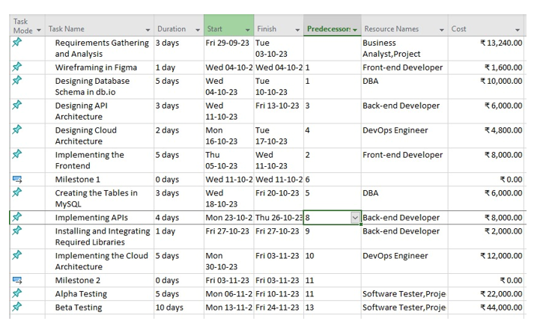

Figure 24: Resource Sheet

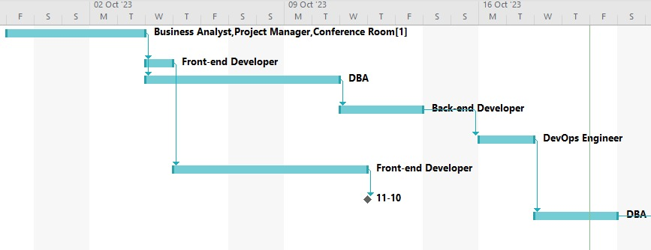

Figure 25: Gantt Chart [1]

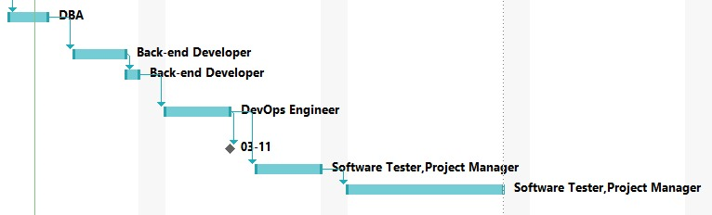

Figure 26: Gantt Chart [2]

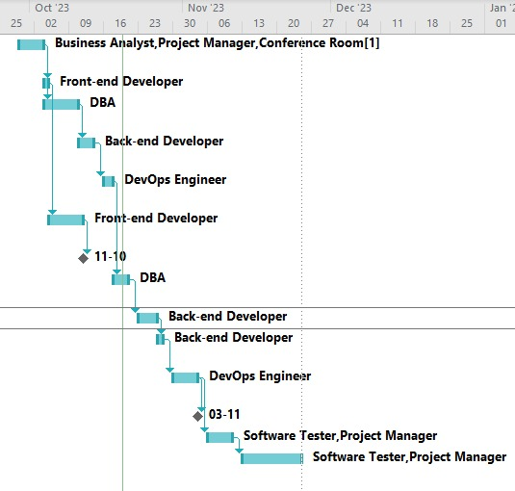

Figure 27: Gantt Chart [3]

**Result:**

We were able to successfully add milestones and checkpoints into our real-world project.

**Evaluation:**

|  |  |  |  |
| --- | --- | --- | --- |
| Marking Criteria | | | |
| Criteria | Total Marks | Marks Obtained | Comments |
| Concept (A) | 2 |  |  |
| Implementation  (B) | 2 |  |  |
| Performance (C) | 2 |  |  |
| Total | 6 |  |  |

**Experiment 9**

**Date:** 22/09/2023

**Aim:** To add detailed notes for each resource used for the real-world project on MS Project

**Description:**

During the scheduling and execution phases of a project, like task-related information, specific details about a resource can be included in the form of text associated with that resource. These details may encompass considerations or reminders pertinent to a specific resource, comments related to the resource, or observations made about the resource's progress on a task.

The Resource Notes feature is accessible in the Resource menu and can be viewed in various project perspectives: Resource Sheet, Resource Usage, Team Planner, and Resource Graph. When a resource is selected, this option displays any attached notes. Alternatively, by double-clicking on a resource and navigating to the Notes tab within the opened Resource Information dialog, one can access the resource notes.

**Benefits:**

Enhanced Resource Allocation: Comprehensive resource notes facilitated precise allocation of tasks, ensuring optimized task assignments based on expertise and availability.

Improved Communication: Resource notes played a pivotal role in enhancing communication, providing a clear insight into each resource's strengths, capabilities, and specialized areas.

Proactive Risk Mitigation: Early detection of potential resource-related risks enabled proactive risk management and implementation of mitigation strategies.

Time-Consuming Data Entry: Generating and filling out the resource notes template for each team member can be a time-intensive process, especially in projects involving many team members.

Maintenance Challenges: Ensuring the resource notes remain current and accurate throughout the project demands consistent effort and monitoring, potentially increasing administrative workload.

**Procedure :**

1. **Setting up the Sentiment Analysis of Tweets Project:** Setting up the Sentiment Analysis of Tweets project involves using natural language processing techniques to analyse the sentiment expressed in tweets. The project goals include developing an efficient sentiment analysis model for accurately categorizing tweets as positive, negative, or neutral. Objectives include collecting a diverse dataset of tweets, building, and training machine learning models, and creating a user-friendly interface for real-time sentiment analysis. The scope encompasses analysing tweets from various topics and industries, and the timeline includes phases for data collection, model development, and testing.
2. **Identifying the Required Resources:** To successfully execute the Sentiment Analysis of Tweets project, several resources are necessary. These include data scientists with expertise in natural language processing, machine learning engineers, software developers proficient in programming languages like Python, testers experienced in evaluating model accuracy, and frontend developers skilled in creating intuitive user interfaces. Additionally, domain experts in the subject matter of the tweets can provide valuable insights into the sentiment analysis process.
3. **Resource Profiling:** Creating a resource sheet is vital for organizing the team. In MS Project, a detailed profile of each resource is created. This includes their roles, expertise in machine learning and natural language processing, relevant experience in sentiment analysis projects, and their availability for the project duration.
4. **Resource Notes Template:** A standardized template for resource notes is developed. Fields in this template include skills (such as Python programming, machine learning, NLP), experience in similar projects, availability (full-time, part-time), specialization in sentiment analysis techniques, and any additional relevant information like certifications or specific tools proficiency.
5. **Resource Note Inclusion:** Within MS Project, the predefined template is utilized for each team member. Relevant details are inputted, creating comprehensive resource notes. This ensures that all team members' qualifications and capabilities are well-documented for reference during the project.
6. **Resource Allocation:** Resource notes are utilized to allocate tasks related to data preprocessing, model training, and interface development. Tasks are assigned based on individual expertise, availability, and specialization in sentiment analysis techniques. This strategic allocation optimizes the utilization of resources.
7. **Task Assignment and Scheduling:** Specific tasks are assigned to resources. Machine learning engineers work on building and fine-tuning sentiment analysis models, software developers focus on creating the user interface, and testers evaluate the model's accuracy. Tasks are scheduled in MS Project, ensuring a cohesive workflow and timely completion of project milestones.
8. **Review and Feedback:** Collaboration within the project team is crucial. Regular reviews are conducted to assess resource allocations and task progress. Feedback from team members is incorporated, and necessary adjustments are made in resource assignments to ensure optimal resource management and project efficiency.
9. **Execution and Monitoring:** During project execution, real-time monitoring of resource performance is essential. Regular assessments are made, and adjustments in task assignments and resource allocations are done promptly based on the project's evolving needs. This continuous monitoring ensures that the project stays on track and meets its objectives effectively.

**Output:**

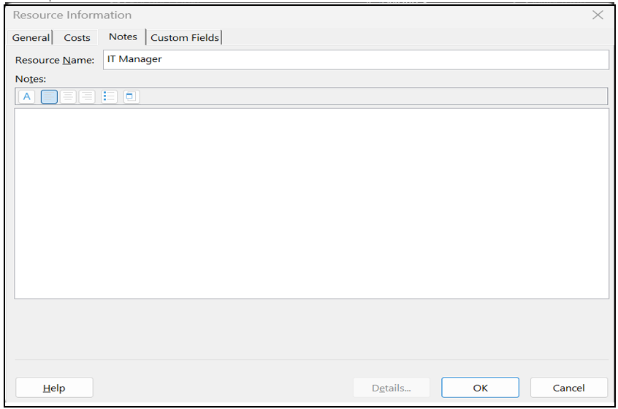

Figure 28: Adding notes through dialog box

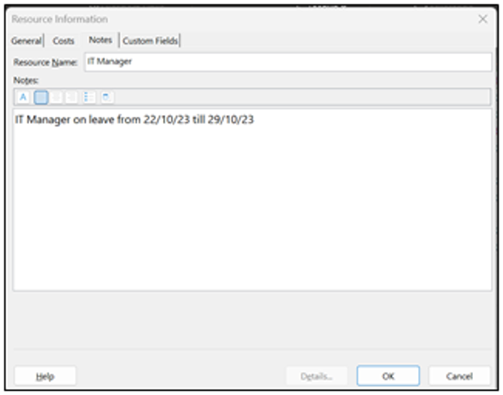

Figure 29: Added notes for the IT manager

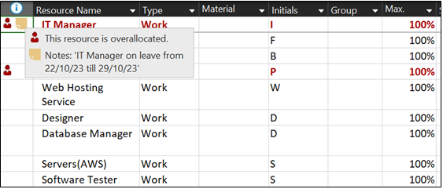

Figure 30: By hovering over the resource, notes are visible

**Result:**

In conclusion, resources have been added in the resource sheet of MS-PROJECT, and the notes have been also added along with the resources which identify some information related with the particular resource.

**Evaluation:**

|  |  |  |  |
| --- | --- | --- | --- |
| Marking Criteria | | | |
| Criteria | Total Marks | Marks Obtained | Comments |
| Concept (A) | 2 |  |  |
| Implementation  (B) | 2 |  |  |
| Performance (C) | 2 |  |  |
| Total | 6 |  |  |

**Experiment 10**

**Date:** 29/09/2023

**Aim:** To utilize MS Project workspace to baseline the project and review the critical path, focusing on formatting and printing the project plan for effective communication and analysis.

**Procedure:**

**Activity 1:** Displaying Project Summary Task / Title

1. Open MS Project and access the Tools menu.
2. Click on Options and navigate to the View tab.
3. Select "Show Project Summary Task" under Outline options for the label and click “Ok.”

**Activity 2:** Creating a New View Based on an Existing View

1. Go to the View menu and choose More Views.
2. In the dialog box, select the desired view and click Copy.
3. Name the new view in the View Definition dialog box and click OK.

**Activity 3:** Formatting Gantt Bars with the Gantt Chart Wizard

1. Navigate to the Format menu and select Gantt Chart Wizard.
2. Follow the instructions provided in the wizard to format the Gantt bars.

**Activity 4:** Drawing a Text Box on the Gantt Chart

1. Access the View menu and point to Toolbars, then select Drawing.
2. Click the Text Box button on the Drawing toolbar and draw a box on the Gantt Chart view.
3. Enter the desired text within the drawn box.

**Activity 5:** Formatting a Category of Text in a View

1. Click on the Format menu and choose Text Styles.
2. Select the type of text you wish to change from the Item to Change list.
3. Adjust font and other formatting options accordingly.

**Activity 6:** Formatting Selected Text in a View

1. Click on the cell containing the text you want to format.
2. Navigate to the Format menu and select Font.
3. Adjust the font and other formatting options as needed.

**Activity 7:** Editing a Report’s Header and Footer

1. Access the Report menu and click on Reports.
2. Choose a report category or select Custom to see all reports, then click Select.
3. Select a report and click Preview.
4. Click Page Setup on the Print Preview toolbar.
5. In the Page Setup dialog box, go to the Header or Footer tab and customize the options as desired.

**Description:**

The experiment aimed to enhance students' proficiency in formatting and presenting project plans using Microsoft Project (MS Project). The focus was on critical aspects such as displaying project summary tasks, customizing views, formatting Gantt bars, incorporating text boxes, styling text, and modifying report headers and footers. These skills are indispensable for project managers as they are tasked with conveying project progress and details to stakeholders and higher management through clear and informative reports.

* **Activity 1:** Displaying Project Summary Task / Title

Understanding how to display project summary tasks is fundamental in presenting an overview of the project. By following the outlined steps, students learned how to enable the display of project summary tasks in MS Project, ensuring a clear representation of the project's structure and major components.

* **Activity 2:** Creating a New View Based on an Existing View

Customizing views to suit specific project requirements is a crucial skill. Students were guided through the process of creating a new view based on an existing one, enabling them to tailor project displays for better insights and clarity in project management.

* **Activity 3:** Formatting Gantt Bars with the Gantt Chart Wizard Gantt charts are vital tools for project visualization. Through the Gantt Chart Wizard, students learned how to format Gantt bars effectively, improving the readability and comprehensibility of the project timeline, thus facilitating better project planning and communication.
* **Activity 4:** Drawing a Text Box on the Gantt Chart

Incorporating annotations and additional textual information within a Gantt chart is essential for conveying specific details. Students acquired the skill to draw text boxes directly onto the Gantt chart, allowing them to provide additional context or notes associated with various project phases.

* **Activity 5:** Formatting a Category of Text in a View

Being able to style text according to categories helps in emphasizing important information. Students gained insights into customizing text styles, enabling them to highlight critical data or distinguish different types of information within the project plan.

* **Activity 6:** Formatting Selected Text in a View

Sometimes, specific text elements require unique formatting to draw attention. Through this activity, students learned how to format selected text, empowering them to tailor the appearance of essential project information for better presentation and clarity.

* **Activity 7:** Editing a Report’s Header and Footer

Reports are a vital medium for communicating project progress and details. Students were instructed on how to edit report headers and footers, enabling them to tailor reports to specific requirements and enhance their professional presentation.

**Result:** Understanding how to effectively format and present project plans is crucial for project managers when communicating project information to higher management. The knowledge gained from this experiment provides students with essential skills in utilizing MS Project for optimal formatting and printing of project plans, enhancing their ability to convey project details in a clear and organized

**Evaluation:**

|  |  |  |  |
| --- | --- | --- | --- |
| Marking Criteria | | | |
| Criteria | Total Marks | Marks Obtained | Comments |
| Concept (A) | 2 |  |  |
| Implementation  (B) | 2 |  |  |
| Performance (C) | 2 |  |  |
| Total | 6 |  |  |

**Experiment 11**

**Date:** 06/10/2023

**Aim:** To track progress effectively within a project using MS Project.

**Procedure:**

**Activity 1:** Setting Baselines

1. Navigate to the Tools menu and select Tracking, then choose Set Baseline.
2. Click OK to save the baseline values for the project.

**Activity 2:** Displaying Variance Table

1. Access the View menu and click on More Views.
2. Choose Task Sheet in the Views Box and click Apply.
3. Within the View menu, point to Table: Entry and select Variance.

**Activity 3:** Recording Project Progress as Scheduled

1. Go to the Tools menu, point to Tracking, and click Update Project.
2. Ensure the Update Work as Complete Through option is selected.
3. Choose the desired date and click OK.

**Activity 4:** Recording Task Completion Percentage

1. Access the View menu and point to Toolbars, then select Tracking.
2. Select the respective task and choose the appropriate percentage of completion (e.g., 0%, 25%, 50%, 75%, or 100%), or click Update Tasks to specify a custom percentage.

**Activity 5:** Entering Actual Work Values for Tasks

1. In a task view like the Task Sheet view, navigate to Table: Entry and click Work.
2. Input the actual work hours in the Actual field and press "ENTER".

**Activity 6:** Entering Actual Start and Duration Values for Tasks

1. Click on the task for which you want to enter actual values.
2. On the Tools menu, point to Tracking, then click Update Tasks.
3. Enter the actual start date in the Start field and the actual duration in the Actual Dur field.
4. Click OK to confirm the entry

**Description:**

The experiment delved into the critical process of tracking progress in a project, a fundamental component of effective project management. Tracking actuals, or real-time data about project activities, enables project managers to assess whether the project is aligning with its original plan, providing insights into task completion, resource utilization, costs, and timeline adherence. By setting baselines, displaying variances, recording progress, and entering actual values, project managers are equipped to make informed decisions that can significantly impact project outcomes.

* **Activity 1:** Setting Baselines

Setting baselines involves creating a reference point by capturing essential project values such as planned start dates, finish dates, and costs of tasks, resources, and assignments. This baseline serves as a benchmark against which actual progress can be compared, aiding in identifying deviations from the initial plan.

* **Activity 2:** Displaying Variance Table

The variance table provides a clear view of the differences between planned and actual values. It helps project managers assess whether tasks are progressing as scheduled or if adjustments are necessary to stay on course.

* **Activity 3:** Recording Project Progress as Scheduled

Recording project progress according to the planned schedule is crucial for evaluating if the project is on track. Comparing the actual progress against the planned schedule allows project managers to assess deviations and adjust future plans accordingly.

* **Activity 4:** Recording Task Completion Percentage

Tracking task completion percentages offers a snapshot of progress on specific tasks. This information is vital for understanding how much of a task has been completed and can help identify potential bottlenecks or areas where additional resources may be required.

* **Activity 5:** Entering Actual Work Values for Tasks

Entering actual work values provides a realistic view of the effort expended on tasks. This is essential for evaluating whether tasks are taking more or less time than initially estimated and allows for adjustments to optimize resource allocation**.**

* **Activity 6:** Entering Actual Start and Duration Values for Tasks

Recording actual start dates and durations for tasks provides insights into the actual time taken to complete a task. Comparing these values with the initially planned durations helps in identifying discrepancies and making necessary adjustments to the project schedule.

By mastering these tracking techniques, project managers can ensure that the project progresses according to the planned schedule and within the allocated resources. It facilitates better decision-making and proactive management, ultimately leading to successful project delivery.

**Result:**

Understanding how to track progress in a project is essential for project managers to effectively manage and control the project's timeline, costs, and resources. By learning how to set baselines, display variances, record progress, and enter actuals for tasks, students gain valuable skills necessary for successful project management. These skills empower project managers to monitor and assess project performance, enabling timely adjustments and ensuring the project stays aligned with the planned objectives and goals.

**Evaluation:**

|  |  |  |  |
| --- | --- | --- | --- |
| Marking Criteria | | | |
| Criteria | Total Marks | Marks Obtained | Comments |
| Concept (A) | 2 |  |  |
| Implementation  (B) | 2 |  |  |
| Performance (C) | 2 |  |  |
| Total | 6 |  |  |