Architecture Design

# Ecommerce Dashboard

|  |  |
| --- | --- |
| **Written By** | Puneet Singh |
| **Document Version** | 1.0 |
| **Last Revised Date** |  |

**DOCUMENT CONTROL**

## Change Record:

|  |  |  |  |
| --- | --- | --- | --- |
| **VERSION** | **DATE** | **AUTHOR** | **COMMENTS** |
| 1.0 | 23-12-2022 | Puneet Singh |  |
|  |  |  |  |

**Reviews:**

|  |  |  |  |
| --- | --- | --- | --- |
| **VERSION** | **DATE** | **REVIEWER** | **COMMENTS** |

**Approval Status:**

|  |  |  |  |  |  |
| --- | --- | --- | --- | --- | --- |
| **VERSION** | **REVIEW**  **DATE** | **REVIEWED BY** |  | **APPROVED BY** | **COMMENTS** |
|  |  |  |  |  |  |

# Contents

1. Introduction 04
   1. What is Architecture Design Document? 04
   2. Scope 04
2. Architecture 05

# Introduction

## What is Architecture design document?

Any software needs the architectural design to represents the design of software. IEEE defines architectural design as “the process of defining a collection of hardware and software components and their interfaces to establish the framework for the development of a computer system.” The software that is built for computer-based systems can exhibit one of these many architectures.

## Scope

Architecture Design Document (ADD) is an architecture design process that follows a step-by-step refinement process.

# Architecture

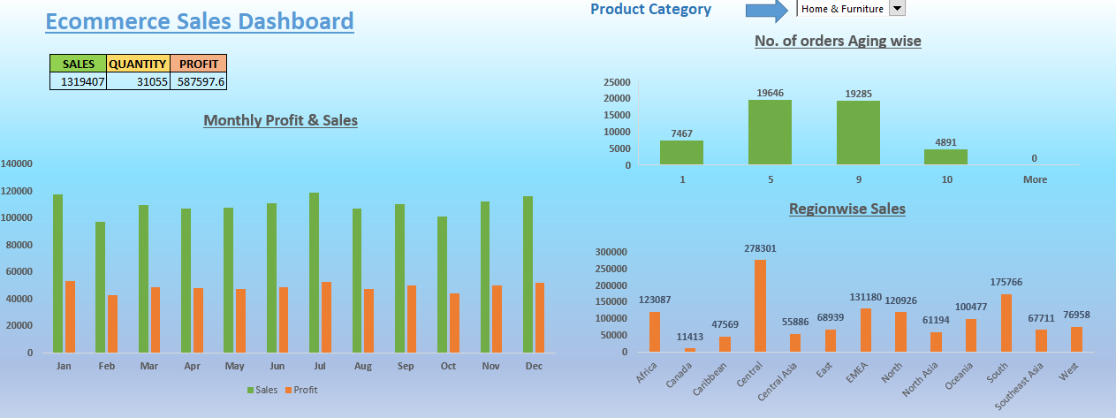

**1.) Monthly Profit & Sales Histogram**

It displays Monthly & Sales data of selected region. It is dynamic in nature.

It displays region wise sales of particular category selected. It is also dynamic in nature.

1. **No. of orders aging wise**

It displays no. of orders according to no. of days it took to ship those orders.

1. **Sales, Quantity & Profit**

These values are dynamic in nature. They display Sales, profit & Quantity of selected region.