Using Scapy, create a frame that consists of an Ethernet layer, with an IP layer on top? With the show method, capture all fields of the frame.
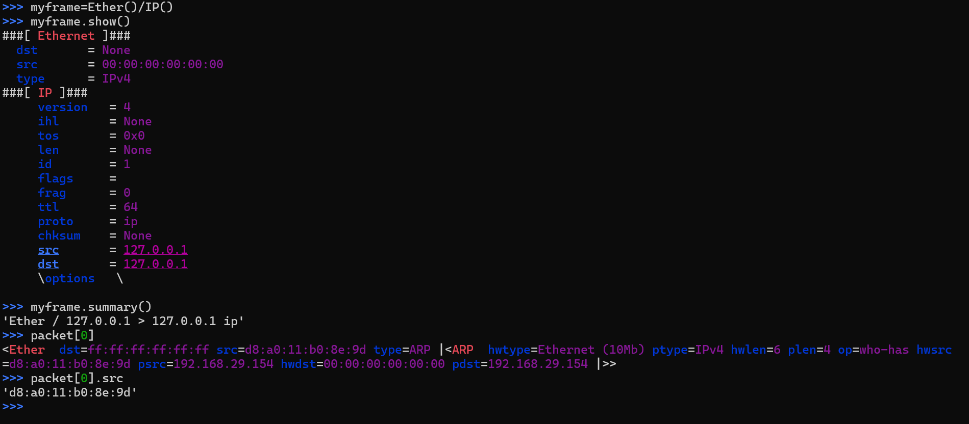

How to Sniff with Scapy (for 10 packets and show the details of all the packets).

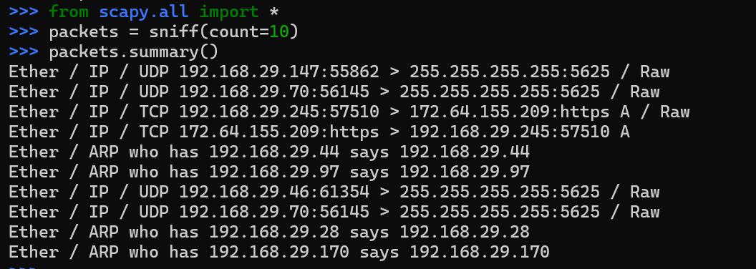

Demonstrate how to perform traceroute in Scapy

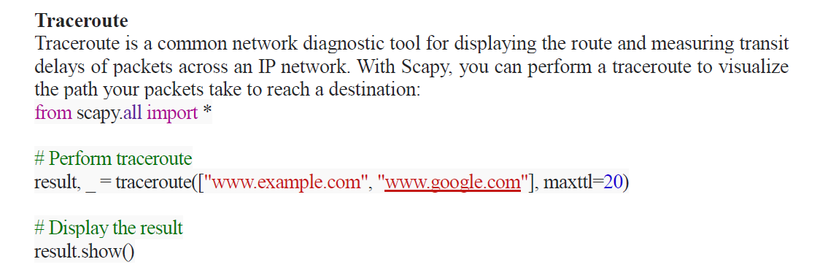
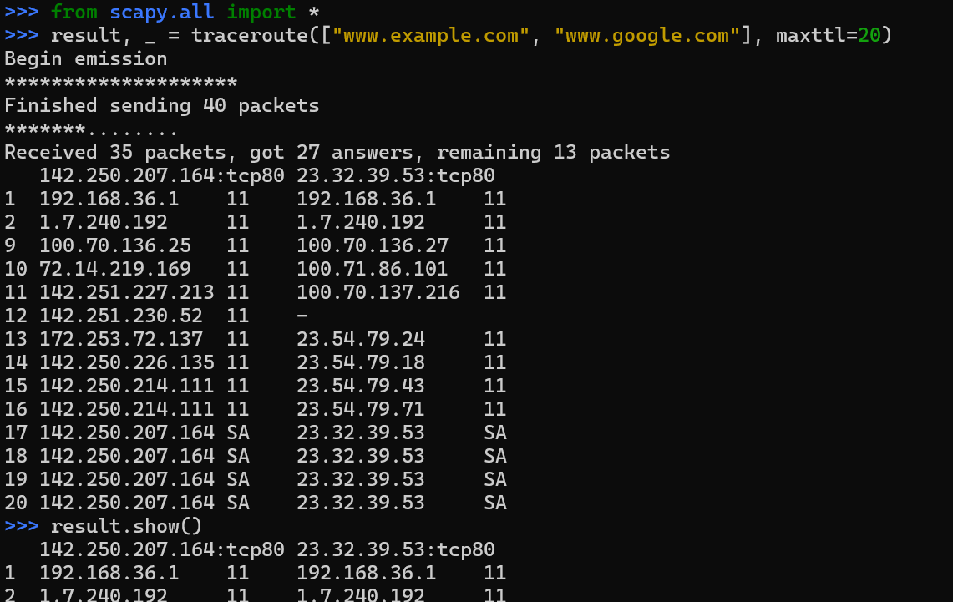

Write a python code using Scapy for creating a Network Scanner (Hint: Create an ARP packet using ARP() method )

Python Code
import scapy.all as scapy
request = scapy.ARP()
request.pdst = 'x'
broadcast = scapy.Ether()
broadcast.dst = 'ff:ff:ff:ff:ff:ff'
request_broadcast = broadcast / request
clients = scapy.srp(request_broadcast, timeout = 1)[0]
for element in clients:
print(element[1].psrc + " " + element[1].hwsrc)

Find the value of x using ifconfig command
ex: request.pdst = '192.168.5.13/24'

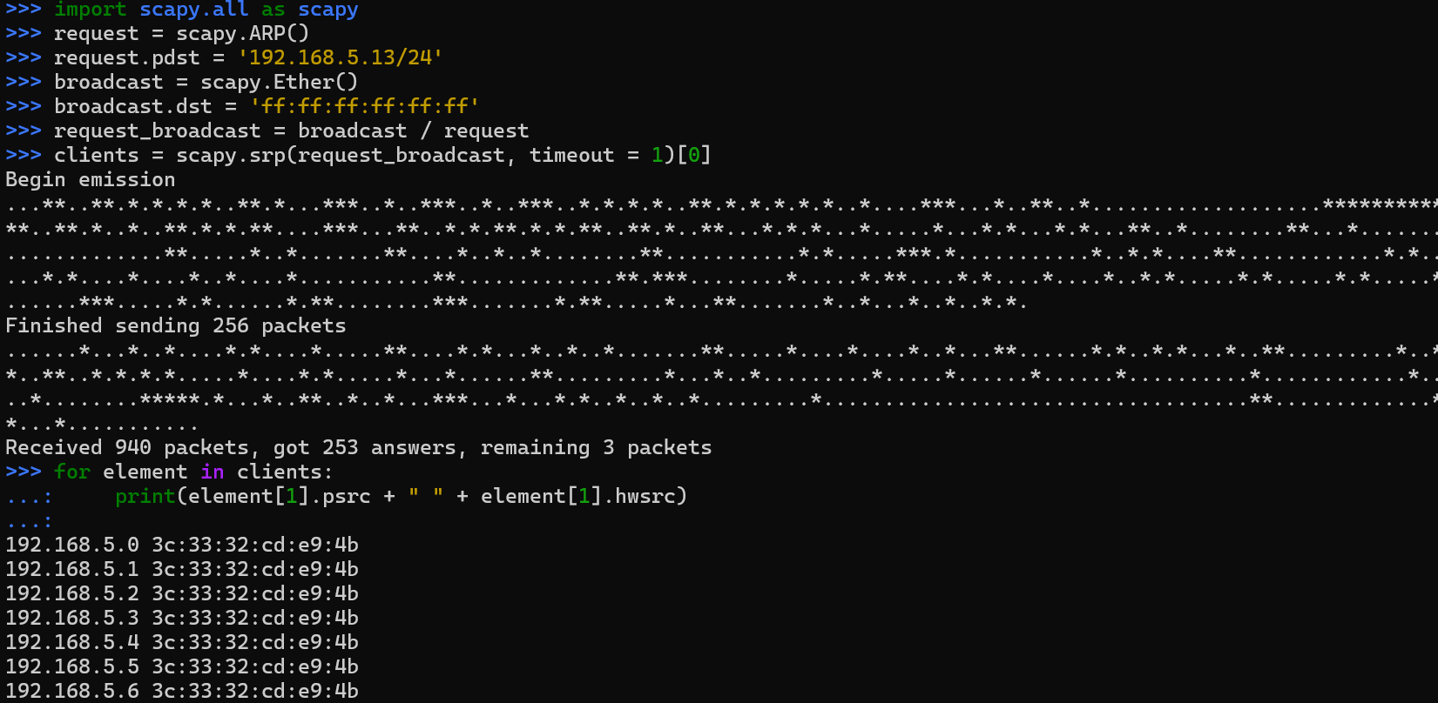

Demonstrate how to Send ICMP packets in Scapy and show the packet captured using Wireshark to destination 8.8.8.8.

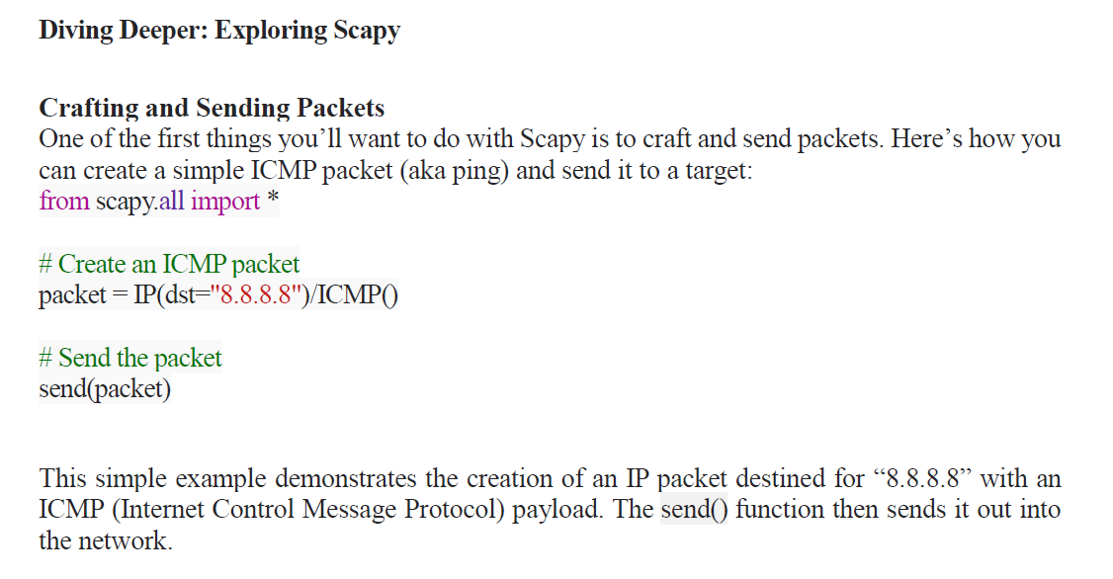
First packet accesses by index packet[0] and so on. Further details are accessed by packet[index].packet_detail
Check in wireshark for the packet
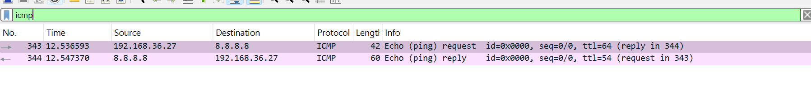
.Demonstrate how to Perform a Port Scan using Scapy tool on target www.example.com.
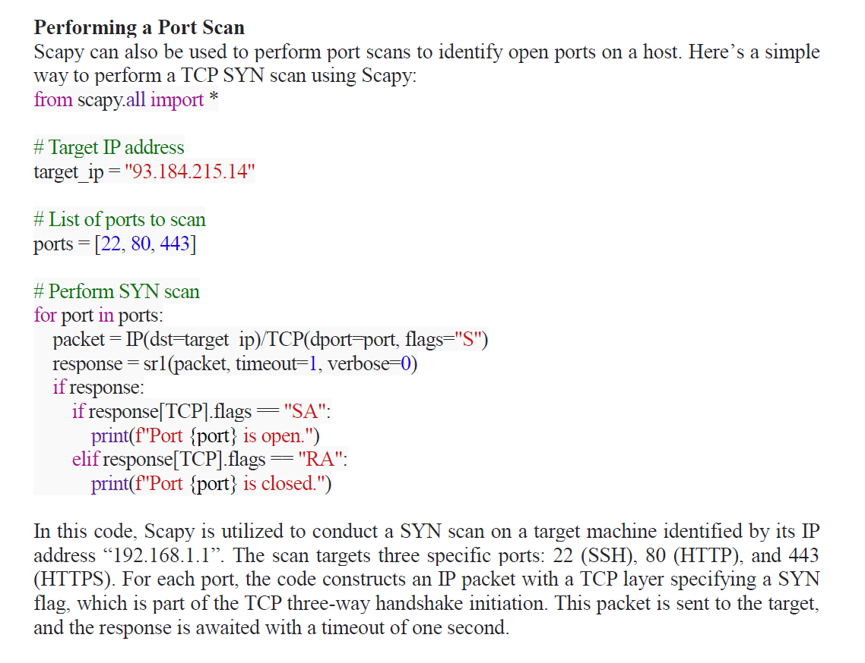
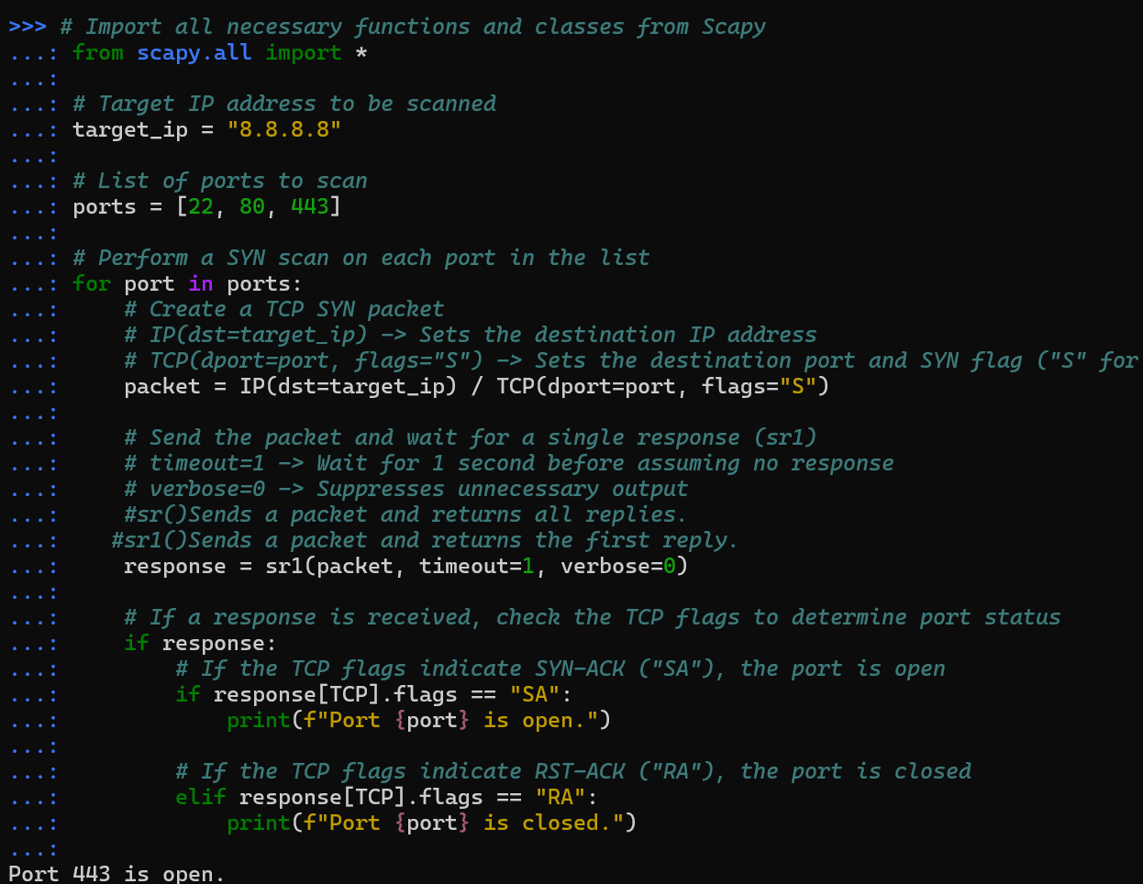

Target_ip , you can change to IP address of www.example.com

Create a simple network monitor that watches for ICMP packets using python function callback in Scapy.
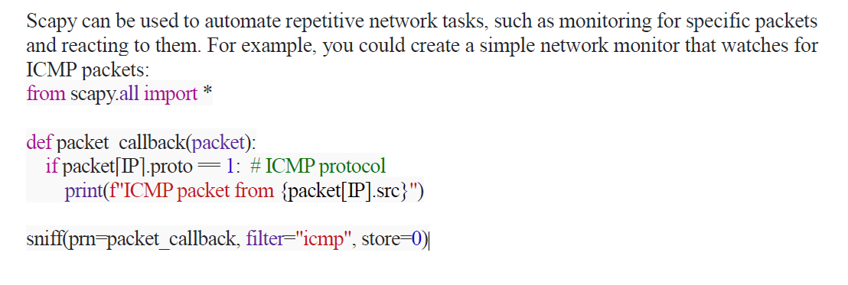
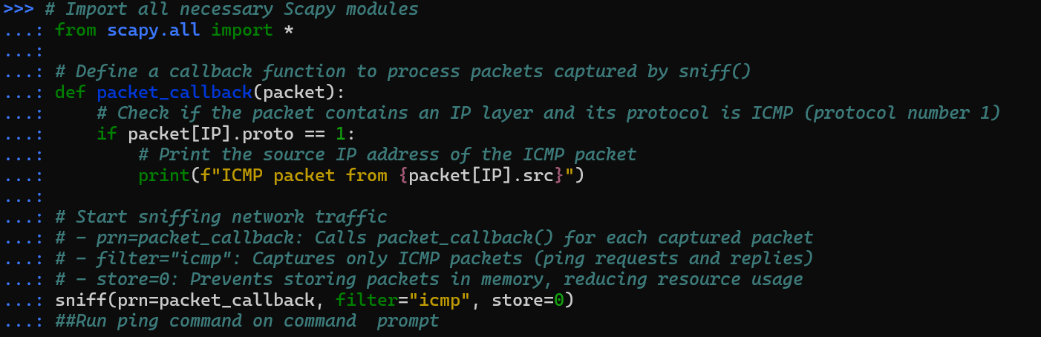

Identify hosts that are up in a local network using Scapy (hint: ARP)
Network Scanner question asked in other way
Python Code
import scapy.all as scapy
request = scapy.ARP()
request.pdst = 'x'
broadcast = scapy.Ether()
broadcast.dst = 'ff:ff:ff:ff:ff:ff'
request_broadcast = broadcast / request
clients = scapy.srp(request_broadcast, timeout = 1)[0]
for element in clients:
print(element[1].psrc + " " + element[1].hwsrc)

Find the value of x using ifconfig command
ex: request.pdst = '192.168.5.13/24'


Display the route and measure transit delays of packets across an IP network with Scapy (on www.example.com, www.google.com)



