PUNEETH A
1NT20IS408
BID DATA LAB

INSERT ONE:

db.puneeth.insertOne({name:"Puneeth",id:100,dept:"resarch",salary:20000})
{
"acknowledged" : true,
"insertedId" : ObjectId("629304ae445701e4fd645a0a")
}

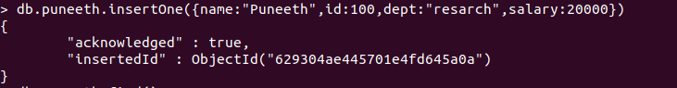
OUTPUT:

> db.puneeth.find();
{ "_id" : ObjectId("629304ae445701e4fd645a0a"), "name" : "Puneeth", "id" : 100, "dept" : "resarch", "salary" : 20000 }

INSERT MANY:

db.puneeth.insertMany([{name:"Irfan",id:101,dept:"resarch",salary:30000}, {name:"Nikhil",id:103,dept:"coding",salary:35000}, {name:"Adarsh",id:104,dept:"Testing",salary:40000}]);
{
"acknowledged" : true,
"insertedIds" : [
ObjectId("62930620445701e4fd645a0b"),
ObjectId("62930620445701e4fd645a0c"),
ObjectId("62930620445701e4fd645a0d")
]
}

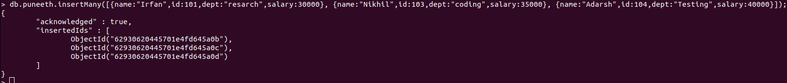

OUTPUT:

> db.puneeth.find();
{ "_id" : ObjectId("629304ae445701e4fd645a0a"), "name" : "Puneeth", "id" : 100, "dept" : "resarch", "salary" : 20000 }
{ "_id" : ObjectId("62930620445701e4fd645a0b"), "name" : "Irfan", "id" : 101, "dept" : "resarch", "salary" : 30000 }
{ "_id" : ObjectId("62930620445701e4fd645a0c"), "name" : "Nikhil", "id" : 103, "dept" : "coding", "salary" : 35000 }
{ "_id" : ObjectId("62930620445701e4fd645a0d"), "name" : "Adarsh", "id" : 104, "dept" : "Testing", "salary" : 40000 }
{ "_id" : ObjectId("62930ce4445701e4fd645a0e"), "name" : "Irfan", "id" : 101, "dept" : "resarch", "salary" : 30000 }
{ "_id" : ObjectId("62930ce4445701e4fd645a0f"), "name" : "Nikhil", "id" : 103, "dept" : "coding", "salary" : 35000 }
{ "_id" : ObjectId("62930ce4445701e4fd645a10"), "name" : "Adarsh", "id" : 104, "dept" : "Testing", "salary" : 40000 }
>

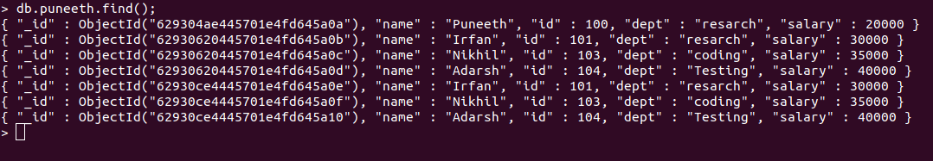

CRUD OPERATIONS:

UPDATE ONE: Updates only one record at a time.

db.puneeth.updateOne({name:"Puneeth"},{$set:{id:107}})
{ "acknowledged" : true, "matchedCount" : 1, "modifiedCount" : 1 }

OUTPUT:

db.puneeth.find();
{ "_id" : ObjectId("629304ae445701e4fd645a0a"), "name" : "Puneeth", "id" : 107, "dept" : "resarch", "salary" : 20000 }
{ "_id" : ObjectId("62930620445701e4fd645a0b"), "name" : "Irfan", "id" : 101, "dept" : "resarch", "salary" : 30000 }
{ "_id" : ObjectId("62930620445701e4fd645a0c"), "name" : "Nikhil", "id" : 103, "dept" : "coding", "salary" : 35000 }
{ "_id" : ObjectId("62930620445701e4fd645a0d"), "name" : "Adarsh", "id" : 104, "dept" : "Testing", "salary" : 40000 }
{ "_id" : ObjectId("62930ce4445701e4fd645a0e"), "name" : "Irfan", "id" : 101, "dept" : "resarch", "salary" : 30000 }
{ "_id" : ObjectId("62930ce4445701e4fd645a0f"), "name" : "Nikhil", "id" : 103, "dept" : "coding", "salary" : 35000 }
{ "_id" : ObjectId("62930ce4445701e4fd645a10"), "name" : "Adarsh", "id" : 104, "dept" : "Testing", "salary" : 40000 }
>

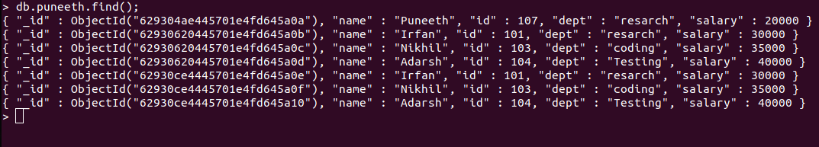

UPDATE MANY:Updates only multiple record at a time.

db.puneeth.updateMany({dept:"Testing"},{$set:{dept:"coding"}})
{ "acknowledged" : true, "matchedCount" : 2, "modifiedCount" : 2 }
>

OUTPUT:

db.puneeth.find();
{ "_id" : ObjectId("629304ae445701e4fd645a0a"), "name" : "Puneeth", "id" : 107, "dept" : "resarch", "salary" : 20000 }
{ "_id" : ObjectId("62930620445701e4fd645a0b"), "name" : "Irfan", "id" : 101, "dept" : "resarch", "salary" : 30000 }
{ "_id" : ObjectId("62930620445701e4fd645a0c"), "name" : "Nikhil", "id" : 103, "dept" : "coding", "salary" : 35000 }
{ "_id" : ObjectId("62930620445701e4fd645a0d"), "name" : "Adarsh", "id" : 104, "dept" : "coding", "salary" : 40000 }
{ "_id" : ObjectId("62930ce4445701e4fd645a0e"), "name" : "Irfan", "id" : 101, "dept" : "resarch", "salary" : 30000 }
{ "_id" : ObjectId("62930ce4445701e4fd645a0f"), "name" : "Nikhil", "id" : 103, "dept" : "coding", "salary" : 35000 }
{ "_id" : ObjectId("62930ce4445701e4fd645a10"), "name" : "Adarsh", "id" : 104, "dept" : "coding", "salary" : 40000 }
>

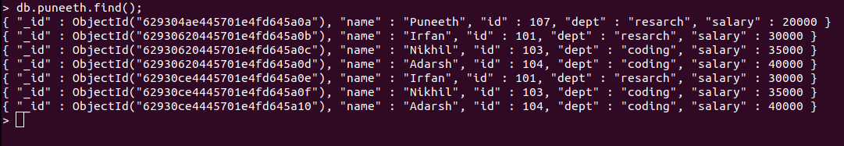

REPLACE ONE: Replaces one record with other in a database.

db.puneeth.replaceOne({id:106},{name:"reuben"})
{ "acknowledged" : true, "matchedCount" : 1, "modifiedCount" : 1 }
>

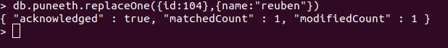

OUTPUT:

> db.puneeth.find();
{ "_id" : ObjectId("629304ae445701e4fd645a0a"), "name" : "Puneeth", "id" : 107, "dept" : "resarch", "salary" : 20000 }
{ "_id" : ObjectId("62930620445701e4fd645a0b"), "name" : "Irfan", "id" : 101, "dept" : "resarch", "salary" : 30000 }
{ "_id" : ObjectId("62930620445701e4fd645a0c"), "name" : "Nikhil", "id" : 103, "dept" : "coding", "salary" : 35000 }
{ "_id" : ObjectId("62930620445701e4fd645a0d"), "name" : "reuben" }
{ "_id" : ObjectId("62930ce4445701e4fd645a0e"), "name" : "Irfan", "id" : 101, "dept" : "resarch", "salary" : 30000 }
{ "_id" : ObjectId("62930ce4445701e4fd645a0f"), "name" : "Nikhil", "id" : 103, "dept" : "coding", "salary" : 35000 }
{ "_id" : ObjectId("62930ce4445701e4fd645a10"), "name" : "Adarsh", "id" : 104, "dept" : "coding", "salary" : 40000 }
>

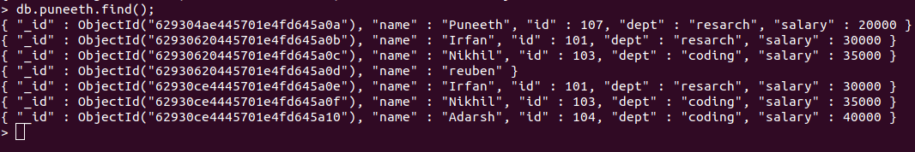

DELETE ONE:

db.puneeth.deleteOne({id:104},{name:"reuben"})
{ "acknowledged" : true, "deletedCount" : 1 }
>
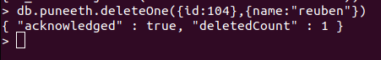

OUTPUT:

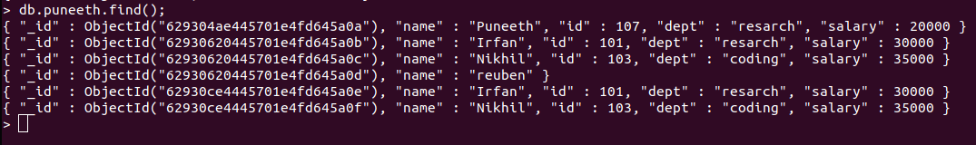

DELETE MANY:

> db.puneeth.deleteMany({dept:"resarch"})
{ "acknowledged" : true, "deletedCount" : 3 }

OUTPUT:

> db.puneeth.find();
{ "_id" : ObjectId("62930620445701e4fd645a0c"), "name" : "Nikhil", "id" : 103, "dept" : "coding", "salary" : 35000 }
{ "_id" : ObjectId("62930620445701e4fd645a0d"), "name" : "reuben" }
{ "_id" : ObjectId("62930ce4445701e4fd645a0f"), "name" : "Nikhil", "id" : 103, "dept" : "coding", "salary" : 35000 }
>

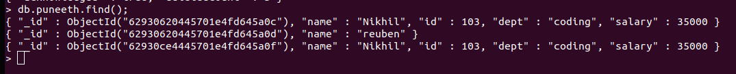

UNSET:

> db.puneeth.update({name:"Nikhil"},{$unset:{dept:""}})
WriteResult({ "nMatched" : 1, "nUpserted" : 0, "nModified" : 1 })
OUTPUT:

db.puneeth.find();
{ "_id" : ObjectId("62930620445701e4fd645a0c"), "name" : "Nikhil", "id" : 103, "salary" : 35000 }
{ "_id" : ObjectId("62930620445701e4fd645a0d"), "name" : "reuben" }
{ "_id" : ObjectId("62930ce4445701e4fd645a0f"), "name" : "Nikhil", "id" : 103, "dept" : "coding", "salary" : 35000 }
>

LOGICAL AND:

db.puneeth.find({$and:[{name:"Nikhil"},{salary:35000}]}) ;
{ "_id" : ObjectId("62930620445701e4fd645a0c"), "name" : "Nikhil", "id" : 103, "salary" : 35000 }
{ "_id" : ObjectId("62930ce4445701e4fd645a0f"), "name" : "Nikhil", "id" : 103, "dept" : "coding", "salary" : 35000 }
>

LOGICAL OR:

db.puneeth.find({$or:[{name:"Nikhil"},{name:"reuben"}]}).pretty()
{
"_id" : ObjectId("62930620445701e4fd645a0c"),
"name" : "Nikhil",
"id" : 103,
"salary" : 35000
}
{ "_id" : ObjectId("62930620445701e4fd645a0d"), "name" : "reuben" }
{
"_id" : ObjectId("62930ce4445701e4fd645a0f"),
"name" : "Nikhil",
"id" : 103,
"dept" : "coding",
"salary" : 35000
}

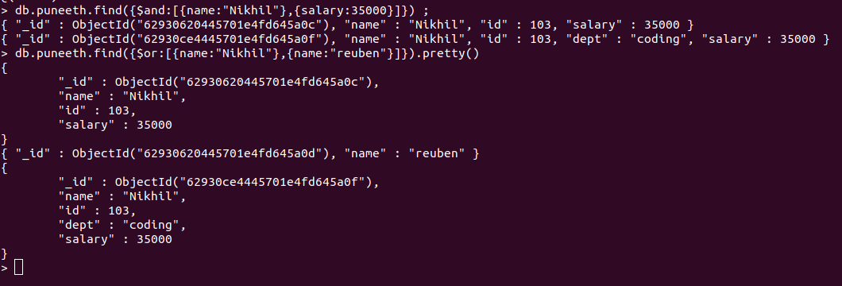

PIPELINE AGGREGATE FUNCTIONS:

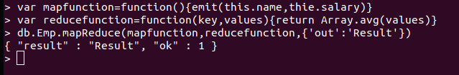
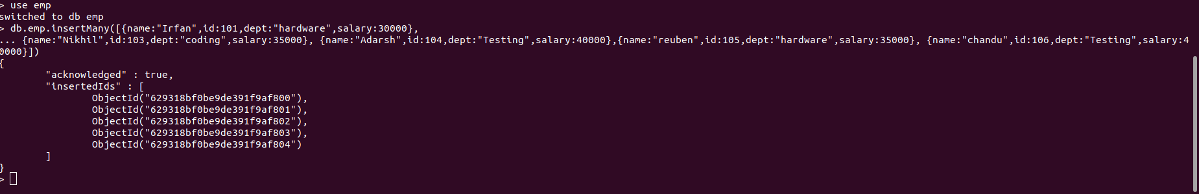

$PROJECT OPERATION:

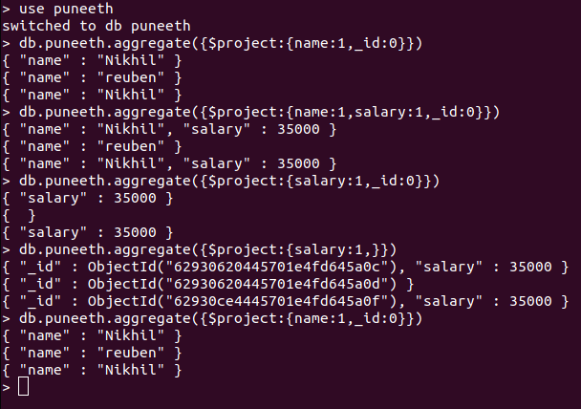

GROUP OPERATION:

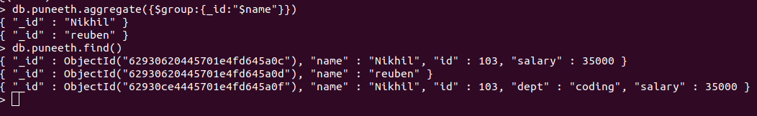

GROUPBY OPERATION:

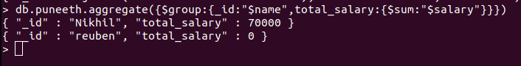

FIRST SALARY:

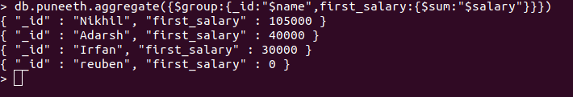

LAST SALARY:

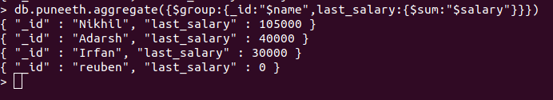

MAX SALARY:

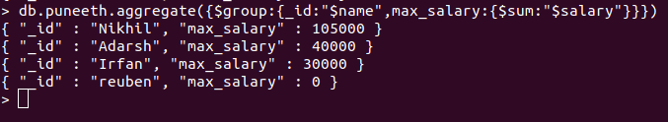

MIN SALARY:

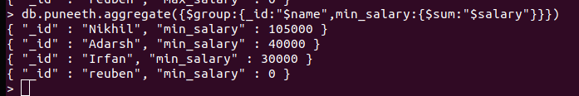

AVERAGE SALARY:

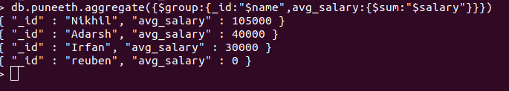

$SORT

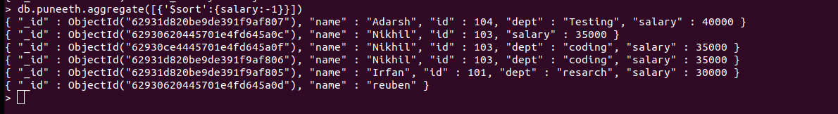

GROUPBY MAX SALARY:

