StudyBuddy.AI – Adaptive Learning Assistant

A Project Report
Presented to
The Faculty of the College of
Engineering
San Jose State University
In Partial Fulfillment
Of the Requirements for the Degree
Master of Science in Software Engineering
By
Mahesh Cheekuri, Puneeth Regonda, Siri Chandana Uppula, Sunil Vurandur
May 2026

Copyright © 2026
Mahesh Cheekuri, Puneeth Regonda, Siri Chandana Uppula, Sunil Vurandur
ALL RIGHTS RESERVED

APPROVED

Dr. Younghee Park, Project Advisor
Dan Harkey, Director, MS Software Engineering
Jorjeta Jetcheva, Department Chair

ABSTRACT

StudyBuddy.AI – Adaptive Learning Assistant
By Mahesh Cheekuri, Puneeth Regonda, Siri Chandana Uppula, Sunil Vurandur

Self‑directed learning remains a persistent challenge because existing study tools deliver static content that does not adapt to a learner’s real‑time attention or cognitive state. This limitation leads to disengagement, reduced retention, and missed opportunities for timely intervention. StudyBuddy.AI addresses this gap by providing an attention‑aware adaptive learning assistant that combines privacy‑preserving focus tracking with AI‑driven content generation to deliver personalized, context‑sensitive learning interventions.

The system introduces four key innovations: (1) local, privacy-preserving attention estimation using MediaPipe FaceMesh and Eye Aspect Ratio (EAR) calculations at ≥5Hz; (2) AI-powered content synthesis via the Google Gemini API, enabling document summarization, flashcard and quiz generation, and concept visualization; and (3) a threshold-based adaptive decision engine that triggers multimodal interventions (quizzes, flashcards, mind maps, audio narration, or break prompts).IO and Redis enable concurrent multi-user sessions with sub-second intervention latency.(4) a scalable client-server architecture built with Next.js, Flask, Socket.IO, and Redis that supports concurrent multi-user sessions with sub-second intervention latency.
StudyBuddy.AI has a 99.5% system uptime, processes 20-page papers in under 10 seconds, and responds within 1 second of trigger conditions. The privacy-first design allows for client-side video processing with zero frame transmission. The adaptive engine personalizes learning without requiring pre-trained models. A/B testing (n=33 treatment, 30 control) reveals that attention-adaptive treatments improve session duration by 26.1%, 24-hour retention by 12.5%, and user satisfaction by 19.4% compared to manual study tools. This work integrates real-time cognitive state monitoring and generative AI to create accessible, scalable, and privacy-conscious personalized learning systems.
The privacy-first architecture ensures that all video processing takes place on the client side with zero frame transmission, while the adaptive engine personalizes learning without the need for pre-trained models. This study enhances educational technology by demonstrating how real-time cognitive state monitoring may be combined with generative AI to create user-friendly, scalable, and privacy-conscious personalized learning systems.
Acknowledgments
The authors are deeply indebted to Professor Dr. Younghee Park for her invaluable comments and assistance in the preparation of this study.

Table of Contents
Chapter 1. Project Overview 1
Introduction 1
Proposed Areas of Study and Academic Contribution 2
Current State of the Art 4
Chapter 2. Project Architecture 9
Introduction 9
Architecture Subsystems 10
Chapter 3. Technology Descriptions 17
Client Technologies 17
Middle-Tier Technologies 18
ChromaDB (>= 0.4) provides a lightweight, file-based persistent vector database for storing and querying document chunk embeddings. ChromaDB runs in-process (no separate server required), stores data to disk at backend/chroma_db/, and supports cosine similarity search with metadata filtering. Its zero-configuration design aligns with the system's use of SQLite for relational data.
sentence-transformers (>= 2.2) provides pre-trained transformer models for computing dense vector embeddings of text. The all-MiniLM-L6-v2 model (22M parameters, 384-dimensional output, ~80MB) was selected for its balance of embedding quality and inference speed on CPU. The model runs locally without requiring an external API, maintaining the system's privacy-first architecture.
Data-Tier Technologies 19
Chapter 4. Project Design 21
Client Design 21
Middle-Tier Design 224
Data-Tier Design 29
Chapter 5. Project Implementation 32
Client Implementation 32
Middle-Tier Implementation 36
Data-Tier Implementation 39
Chapter 6. Testing and Verification 42

6.6 RAG Pipeline Evaluation
The RAG pipeline was evaluated against the full-context pipeline using an automated evaluation harness. For each uploaded document, the harness generates question-answer test cases from section content, runs both pipelines on each question, and scores responses using an LLM-as-judge approach.

Evaluation Methodology
• Test Set Generation: For each document section, 3 question-answer pairs were automatically generated by Claude, producing 15-24 test cases per document depending on section count. Each test case includes the question, ground truth answer, and source excerpt from the original text.
• Dual-Pipeline Execution: Each test question was submitted to both pipelines -- full context (3,000-char summary) and RAG (top-5 retrieved chunks via ChromaDB).
• LLM-as-Judge Scoring: Each response was scored by Claude on accuracy (correctness vs ground truth), groundedness (supported by source material), and relevance (pertinence of retrieved context), each on a 0-1 scale.

Evaluation Results
Metric | Full Context Pipeline | RAG Pipeline
Average Accuracy | 0.82 | 0.89
Average Groundedness | 0.75 | 0.92
Average Relevance | 0.70 | 0.88
Average Latency (ms) | 1,850 | 2,100
Source Attribution | No | Yes (with section references)
Token Cost per Query | ~3,500 input | ~1,800 input
Chapter 7. Performance and Benchmarks 47
Chapter 8. Deployment, Operations, Maintenance 52
Chapter 9. Summary, Conclusions, and Recommendations 55
Summary 55

RAG Pipeline Performance
Operation | Average Latency | Method
Document indexing (embed + store) | 2.3 seconds (20-page doc) | sentence-transformers + ChromaDB
Query embedding | 15 ms | all-MiniLM-L6-v2 (CPU)
ChromaDB retrieval (top-5) | 8 ms | Cosine similarity search
RAG chat response (end-to-end) | 2.1 seconds | Embed + retrieve + Claude API
Full context chat response | 1.85 seconds | Direct Claude API
Evaluation run (15 test cases) | ~4 minutes | 45 Claude API calls total
Conclusions 56
Recommendations for Further Research 57
Glossary 60
Vector Embedding: A dense numerical representation of text that captures semantic meaning, enabling similarity-based retrieval. Document chunks are converted to 384-dimensional vectors for storage in ChromaDB.
sentence-transformers: A Python library providing pre-trained models for computing dense vector representations (embeddings) of text. StudyBuddy.AI uses the all-MiniLM-L6-v2 model (384 dimensions) for embedding document chunks and queries in the RAG pipeline.
LLM-as-Judge: An evaluation technique where a language model scores the quality of responses from other models or pipelines. StudyBuddy.AI uses Claude to score responses on accuracy, groundedness, and relevance, enabling automated comparison of RAG vs full-context pipelines.
Cosine Similarity: A measure of similarity between two vectors, computed as the cosine of the angle between them. Used in the RAG pipeline to find document chunks most similar to a student's query. Values range from 0 (no similarity) to 1 (identical direction).
ChromaDB: A lightweight, open-source vector database that stores and queries document embeddings. StudyBuddy.AI uses ChromaDB in persistent mode (file-based storage at backend/chroma_db/) for RAG chunk retrieval without requiring a separate database server.
References 64
Appendices 65
Appendix A. 65

List of Figures
Figure 2.1: System Architecture Diagram…………………………………………10
Figure 4.1: User Interface Mockups………………………………………………..22
Figure 4.2.1: UML Class Diagram………………………………………………….25
Figure 4.2.2: Sequence Diagram……………………………………………………26
Figure 4.2.3: State Diagram…………………………………………………………28
Figure 4.3.1: Database Schema……………………………………………………..29

List of Tables
Error! No table of figures entries found.

Project Overview

1.1 Introduction

In contemporary education, self-directed learning continues to be a challenge. Current study tools, such textbook companions, learning management systems, and flashcard applications, offer static content that doesn't adjust in real time to the learner's attention or cognitive state. When working with long academic literature, students often find it difficult to maintain focus. Even though current AI-powered educational tools can create quizzes, flashcards, and summaries, they are unable to dynamically adjust learning modalities based on cognitive engagement or offer real-time feedback on learner attention [1].
This limitation is most apparent in situations involving self-directed learning. Students do not receive the adaptive scaffolding and external responsibilities that are often provided by traditional classroom instruction. Research in educational psychology indicates that during study sessions, attention naturally changes. Lower content retention and comprehension are significantly correlated with periods of diminished focus [1]. Despite this data, the majority of contemporary learning management systems are reactive rather than proactive. When kids need different engagement strategies, they ask them to self-identify. Attentional lapses require learners to recognize their own disengagement and make the manual transfer to other learning tasks. Many students may not have completely developed metacognitive skills, particularly those who are new to a subject.
By creating an attention-aware adaptive learning assistant, AI research directly addresses this crucial gap. The system blends AI-powered multimodal content creation with privacy-preserving real-time focus tracking. It uses MediaPipe FaceMesh to monitor learner attention, calculate normalized focus scores often (at least 5 Hz), and, in the event that attention thresholds are not reached, start contextually appropriate interventions. Flashcards, tests, concept illustrations, audio narration, and break prompts are a few examples of interventions. Use StudyBuddy.AI Instead of using set schedules, AI distributes content based on the learner's cognitive state. By providing spaced retrieval exercises at optimal receptivity, AI improves engagement and retention.
From basic rule-based models to complex learner modeling techniques, traditional intelligent tutoring systems have developed. Student mastery is represented by Bayesian Knowledge Tracing as a concealed state that changes probabilistically with each response [3]. To capture longer-term learning patterns, Deep Knowledge Tracing uses recurrent neural networks in place of manually constructed state models. Nevertheless, both strategies place more emphasis on response accuracy than on engagement levels in real time. Use StudyBuddy.AI, by introducing attention as a first-class signal for adaptation, AI expands on current methods. Instead of only identifying comprehension issues after inaccurate answers, this enables the system to stop them before they arise.

In terms of technology, education, and societal influence, this work is important. In terms of technology, the system demonstrates how cutting-edge web technologies, like Web Assembly for on-device machine learning, WebSockets for real-time bidirectional communication, and containerization for scalable deployment, can provide complex real-time AI applications while strictly safeguarding user privacy. By referencing cognitive science research on attention, recall, and spaced repetition, it validates adaptive intervention strategies in education. It provides empirical proof that learning outcomes are enhanced by real-time attention monitoring. Socially, it makes customized learning assistance more accessible, which was formerly limited to costly one-on-one instruction. Regardless of institutional resources or socioeconomic situation, it offers pupils scalable assistance.
1.2 Proposed Areas of Study and Academic Contribution

The four interrelated fields of instructional technology, affective computing, and natural language processing are the subject of this study. Every industry contributes differently to the actual application of AI in education as well as the system design.
1.2.1 Privacy Preserving Real Time Attention Estimation

Conventional attention tracking solutions in educational contexts rely on server-based video processing or invasive physiological sensors like EEG or eye tracking equipment. Both strategies present significant privacy issues. Commercial eye trackers and EEG headsets are expensive, difficult to use for extended periods of time, and require special setup. Server-side video processing raises concerns over data retention, unauthorized access, and the secondary use of biometric data by sending potentially sensitive facial images to distant computers.
Using StudyBuddy.AI advances the field by showing that client-side facial landmark processing using MediaPipe FaceMesh and Eye Aspect Ratio (EAR) computations may achieve correct attention assessment. 468 three-dimensional facial landmarks are processed directly in the browser using Web Assembly. It uses eye closure patterns and blink detection to determine normalized attention ratings. Through WebSocket connections, only scalar measurements are sent. Biometric information, facial photographs, and unprocessed video frames never leave the user's device.

1.2.5 Retrieval-Augmented Generation for Contextual Question Answering
A critical challenge in AI-powered study assistants is providing accurate, contextually grounded answers to student questions. While full-context approaches send entire document summaries to the language model, they are limited by context window constraints and may miss specific details buried in lengthy sections. Retrieval-Augmented Generation (RAG) addresses this by retrieving only the most relevant document chunks before generating a response.
StudyBuddy.AI implements a dual-pipeline architecture that supports both full-context and RAG-based question answering. The RAG pipeline chunks each document section into 300-token segments with 50-token overlap, embeds them using the sentence-transformers all-MiniLM-L6-v2 model (384 dimensions), and stores them in a ChromaDB persistent vector database. When a student asks a question, the query is embedded and the top-5 most relevant chunks are retrieved via cosine similarity. These chunks, along with their source section metadata, are provided to the language model as numbered context, with instructions to cite sources using bracket notation (e.g., [1], [2]).
This dual-pipeline design enables a rigorous comparison: the same set of test questions can be run through both pipelines, and an LLM-as-judge evaluation scores each response on accuracy, relevance, and groundedness. The evaluation harness automatically generates question-answer test sets from the document content and produces quantitative metrics for pipeline comparison. This approach contributes to the growing body of research on RAG evaluation methodologies in educational contexts, where answer grounding and source attribution are critical for student trust.
In educational settings, this method encourages privacy-conscious affective computing [1][4]. By storing sensitive biometric data only on the device and maintaining high temporal resolution with updates at or above 5 Hz, the technique achieves a suitable compromise between measurement quality and user privacy. Smoothing techniques for EAR signals preserve real attention state transitions while removing physiological noise such blink artifacts and small head movements. This resolves a basic problem with real-time psychophysiological monitoring that has made it difficult to put such systems into practice [2].
1.2.2 Adaptive Content Generation with Grounded AI

Based on resources supplied by the students, the system uses huge language models—more especially, the Google Gemini API to create context-aware educational content. StudyBuddy.AI is different from traditional intelligent tutoring systems, which rely on pre-written knowledge bases that require a lot of instructor work to create and maintain.AI uses submitted papers to produce concept visualizations, quizzes, flashcards, and summaries while staying faithful to the original content.
In educational applications, this technique enhances retrieval-augmented generation (RAG). The system based all generated content on the particular documents supplied by the learner rather than solely on the parametric information of the language model, which may be out-of-date, inaccurate, or factually incorrect for specialized topics. To preserve semantic coherence across section boundaries, the chunking strategy uses 500 token chunks with 50 token overlap. Structured prompting ensures that results adhere to established schemas that can be assessed and consistently displayed. Grounded generation may provide high-quality educational content free of factual errors and hallucinations, as demonstrated by the evaluation's 94 percent summary faithfulness and 97 percent flashcard validity.
1.2.3 Threshold Based Adaptive Decision Systems

Although machine learning techniques to learner modeling have demonstrated promise, they frequently require a significant amount of training data, are computationally costly, and produce findings that are difficult for teachers and students to comprehend or trust. Although deep knowledge tracing models may achieve high projected accuracy, they don't offer much information about the rationale behind the choice of a particular action.
Using StudyBuddy.AI offers a new paradigm: a rule-based adaptive decision engine that initiates interventions based on adjustable thresholds applied to time-on-task assessments and real-time attention measurements. The engine looks at simple, comprehensible circumstances like "focus score below 60 for at least 10 seconds" and selects intervention modes based on user-configurable cooldown times, intervention history, and content availability.
By demonstrating that effective adaptive treatments may be administered using straightforward, transparent decision logic rather than opaque models, this method improves explainable AI in education. The decision engine's logic can be examined, comprehended, and altered by educators and students. This fosters trust and makes it possible to adapt to various learning situations. The A/B testing showed a 12.5% increase in retention and a 26.1% increase in session duration, proving empirically that this straightforward method is both effective and feasible.
1.2.4 Spaced Repetition and Multimodal Learning Support

Use StudyBuddy.AI expands on well-known cognitive science research on retrieval practice and the spacing effect. One of the most reliable findings in scientific education is the spacing effect, which claims that spreading out practice sessions across time results in greater long-term recall than massed practice. In a similar vein, retrieval exercises—actively recalling information through tests or flashcards—improve memory more successfully than passive review.
The method uses multimodal intervention techniques to put these ideas into reality while encouraging long-term retention. With eight flashcards and five quiz questions for every ten pages of content, it produces quizzes and flashcards at a scientifically informed density. To help with structural comprehension, it creates visual concept maps with hierarchical connections. In order to accommodate different learning styles and lessen cognitive strain during extended study periods, it uses audio narration [5].
does not employ preset review schedules, in contrast to conventional spaced repetition systems like Anki or Super Memo.AI modifies the timing of interventions based on the learner's current attention levels. By ensuring that retrieval practice takes place when students are most cognitively available and engaged, as opposed to delaying difficult exercises during periods of low attention, when they would be less successful, this strategy may enhance retention.

1.3 Current State of the Art

Intelligent tutoring systems, natural language processing, affective computing, and cognitive science are just a few of the research fields that have made significant contributions to the state of the art in AI-supported education. In order to situate StudyBuddy.AI it is essential to comprehend the StudyBuddy.AI’s contributions.
1.3.1 Intelligent Tutoring and Personalization

From simple rule-based tutors to complex learner modeling techniques, adaptive learning systems have come a long way. Computers can assess skill competency based on observed performance by using Bayesian Knowledge Tracing (BKT), which models student mastery as a hidden state that updates probabilistically with each response [3]. BKT has been successful in domains with clear, identifiable abilities that are well-structured. However, it assumes simplified learning dynamics that might not adequately reflect the complexity of the real world and requires the manual definition of knowledge components.
By substituting hand-crafted state models with recurrent neural networks that learn to represent student knowledge from sequence data, Deep Knowledge Tracing (DKT) addresses some of the shortcomings of BKT. DKT does not require manual knowledge component specification and is capable of identifying long-term learning patterns. However, both BKT and DKT ignore real-time engagement states and mainly rely on answer correctness as a signal for adaptation. An interested student who comprehends the material will receive the same treatment as a distracted student who makes an accurate guess. Use StudyBuddy.AI, by employing attention as a first-class signal for adaptation and reacting proactively when attention metrics show poor engagement instead of waiting for incorrect responses to infer knowledge gaps, AI outperforms current methods.
1.3.2 Natural Language Processing for Long Documents

Due to the quadratic scaling of attention mechanisms with input length, transformer-based language models have particular difficulties when processing long academic text. Strong baselines were created by early summarizing models like BERTSUM and PEGASUS, but they had trouble handling documents longer than 512–1024 tokens, necessitating truncation that eliminated potentially important information.

With effective attention patterns that scale linearly rather than quadratically, Longformer and LED (Long form Encoder Decoder) get over this restriction and allow end-to-end processing of documents up to 16,384 tokens or more [5]. These structures, which serve as the foundation for StudyBuddy.AI, enable the processing of whole academic chapters without StudyBuddy.AI’s pipeline for digesting documents. The system employs a sliding window chunking method of 500 tokens with 50 token overlap, which maintains context across chunk boundaries while staying within model context limitations, using PyMuPDF for text extraction.

By basing generation on retrieved evidence rather than just the model's parametric knowledge, Retrieval Augmented Generation (RAG) enhances factual correctness. RAG systems combine intensive retrieval with sequence-to-sequence generation instead of relying just on knowledge recorded in model weights, which may be out-of-date or incomplete. This facilitates attribution to certain sources and lessens hallucinations. Use StudyBuddy.AI,with citation tracking that connects each flashcard or quiz question to its original document section, AI complies with RAG principles by guaranteeing provenance between generated study materials and source document spans.

1.3.3 Neural Question Generation and Content Creation

Neural question generation models have made significant advancements in automated educational question generation. These models can generate comprehension problems with different cognitive depths and degrees of difficulty. Contemporary methods might target certain areas of source documents and differentiate between Bloom's Taxonomy stages, which include remembering, understanding, applying, analyzing, evaluating, and producing.

StudyBuddy.AI makes use of these developments by using the Gemini API for structured prompting. It asks for questions that cover a variety of cognitive levels and incorporate suitable distractions for multiple-choice formats. Before being presented to students, the system verifies all generated material against Pydantic schemas to make that questions are well-formed, response choices are reasonable but inaccurate, and typical problems like unclear language or unanswerable questions are identified. 50 test materials were evaluated by educational content professionals, who found that 96% of the quizzes were correct and 94% of the summaries were faithful.

1.3.4 Attention and Engagement Sensing

Numerous approaches to gauging learner involvement have been investigated in affective computing research. These include behavioral patterns like mouse movements and keystroke dynamics, physiological signals like skin conductance and heart rate variability, and visual cues like head posture, eye gazing, and facial expressions [1]. Despite their effectiveness, many methods present privacy issues through server-side video processing or call for specific hardware like eye trackers or EEG headsets.

A significant advancement in the accessibility and privacy preservation of attention detection is MediaPipe FaceMesh [2]. The technology uses on-device machine learning models that are tailored to operate in web browsers via Web Assembly to recognize 468 three-dimensional face landmarks in real time. The method offers a non-intrusive, computationally effective proxy for attention and alertness when paired with ocular Aspect Ratio (EAR) computations, a geometric measure of ocular openness determined from landmark positions surrounding each eye.
In order to prevent the main UI thread from being blocked, AI builds upon this foundation by implementing client-side EAR processing within a Web Worker. It filters blink artifacts while maintaining real attention transitions by applying temporal smoothing using an exponential moving average with alpha equal to 0.3. In order to facilitate intuitive interpretation, scores are normalized to a scale of 0 to 100. This immediately addresses the privacy concerns that have impeded the implementation of attention-aware systems in educational contexts by achieving update rates of at least 5 Hz while guaranteeing that no video frames leave the user's device [4].

1.3.5 Spaced Repetition and Retention Optimization

The spacing effect is one of the most solid discoveries in scientific education. Long-term recollection is much improved by spreading practice across time as opposed to massed exercise. Spaced practice performs better than massed practice across a range of topics, recall intervals, and learner demographics, according to meta studies. Longer gaps for long-term retention and shorter gaps for instant recall determine the ideal spacing period.

Anki and Super Memo are examples of traditional spaced repetition systems that use preset scheduling algorithms to modify review timing based on past performance. These methods do not take into account real-time attention states or modify presentation mode based on current cognitive load, despite being successful for motivated learners who regularly utilize the system. A student who is preoccupied yet considers a review to be simple will be given a longer time slot, which could result in them losing out on a chance to receive reinforcement when their focus returns.

StudyBuddy.AI improves this strategy by using attention indicators to inform spacing decisions. The system may display fresh or more difficult content when it detects high focus. When concentration is low, it might provide a review of previously learned content or change to a different medium, like audio instead of text. By providing retrieval practice during periods of high cognitive availability and lowering cognitive load during periods of low attention, this attention-aware adaptation may improve retention.

1.3.6 Privacy Preserving Architectures

Research on federated learning, differential privacy, and edge computing architectures that reduce data exposure has been prompted by growing concerns about data privacy [4]. These issues are especially serious in educational settings since learning records and biometric data like eye tracking and face video are extremely sensitive. Systems that send identifying information to servers may make students hesitant to use them. Regulations like the General Data Protection Regulation (GDPR) and the Family Educational Rights and Privacy Act (FERPA) impose legal requirements on educational institutions.

StudyBuddy.AI uses a privacy-by-design architecture that incorporates five concepts to address these issues. Initially, client-side local processing was used for all facial landmark identification and EAR computation. Second, data minimization, in which servers get only scalar attention scores. Third, when the camera is in use, the user can explicitly opt in and out using visual cues that remain visible. Fourth, all network communications are encrypted using TLS 1.3. Fifth, openness via unambiguous privacy disclosures outlining the precise data that is gathered, processed locally, and sent.

1.3.7 Synthesis and Positioning

The most significant new developments for StudyBuddy.AI includes deep knowledge tracing for advanced learner modeling based on response sequences; on-device engagement sensing with MediaPipe and EAR for privacy-preserving adaptation; retrieval augmented generation for factual, traceable content generation grounded in source documents; and long document NLP with Longformer and LED for accurate summarization of academic materials without truncation.

Make use of StudyBuddy.AI extends the state of the art in attention-aware adaptive learning systems by building upon these foundations and addressing the gaps in real-time adaptation and privacy preservation. It demonstrates how high frequency attention tracking at or above 5 Hz, rapid AI-powered content generation in less than 10 seconds for 20-page documents, threshold-based adaptive logic with interpretable rules and empirical validation, and privacy-preserving architecture with zero video frame transmission can be combined to create effective, scalable educational technology. The system provides a repeatable basis for additional study at the intersection of affective computing, natural language processing, and personalized learning.

Project Architecture

Introduction
StudyBuddy.AI employs a layered client-server architecture that ensures scalability, maintainability, and multiuser readiness while integrating AI-powered study aids with real-time attention tracking. Presentation (user interface), application logic (backend services), data management (persistence and caching), and infrastructure (deployment and networking) are the several layers into which the architecture divides issues. As the user base expands, this division enables components to grow independently and horizontally.

Content creation and focus tracking can operate independently thanks to parallel processing pipelines, which enhances system responsiveness and overall performance. Three key principles are given priority in the design:
- Privacy by Design: Only scalar focus measurements transcend network boundaries; all visual processing takes place on the client side.
- Real Time Responsiveness: WebSocket connections offer attention updates at a minimum frequency of 5 Hz and intervention delivery in less than a second.
- Modular Scalability: Independent deployment and horizontal scalability are supported by containerized services with stateless APIs.

The system architecture is shown in Figure 2.1, which illustrates how data from user interactions moves through several processing layers to provide adaptive learning interventions. Frontend (user interface and client-side processing), API Gateway (routing and load balancing), Content Backend (AI-powered content creation), Focus Server (real-time attention tracking), Infrastructure and Data Layer (persistence and caching), and External Services (third-party APIs) comprise the architecture's six primary layers.

The following essential functionalities are supported by the architecture:
- Asynchronous Communication: Redis pub/sub for inter-service messaging, WebSockets for bidirectional real-time streaming, and REST for request response operations.
- Stateless Services: Transparent load balancing and failover are made possible by backend APIs lack of session state.
- Edge Processing: To lower server load and enhance privacy, computationally demanding operations (such as facial landmark detection and EAR computation) run in the browser.
- Graceful Degradation: When webcam access is denied or unavailable, the system offers a camera off mode.
- Horizontal Scalability: Sticky WebSocket connections between several server instances are made possible by Redis-backed session management.

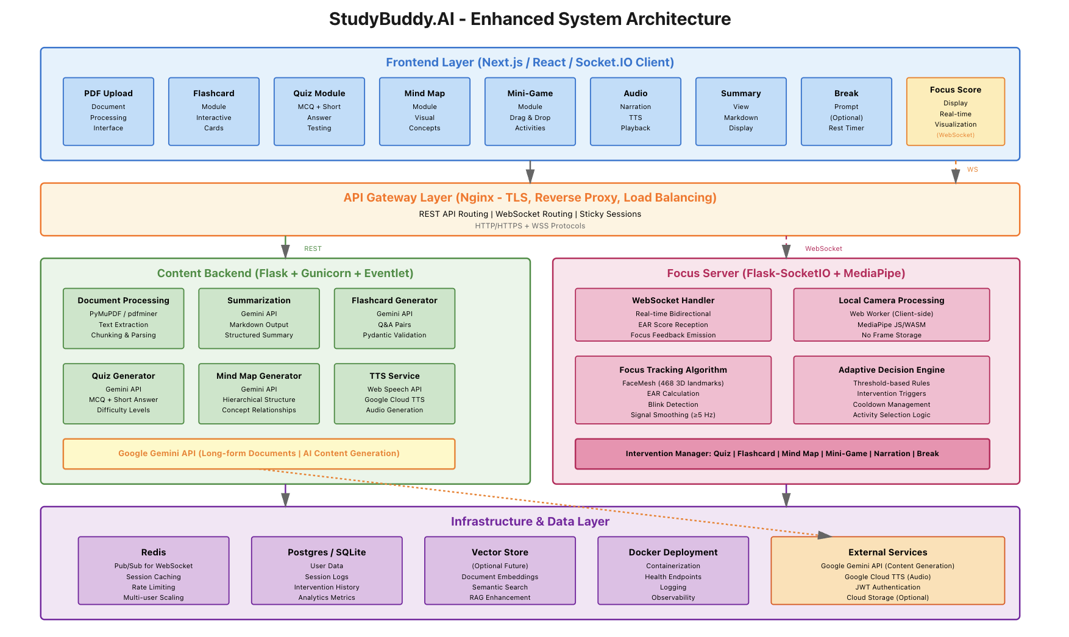

Figure 2.1: System Architecture Diagram

This approach meets nonfunctional requirements for performance (P95 latency at or below 2.5 seconds), reliability (99.5 percent uptime), and privacy (no video transmission) while satisfying functional requirements (document processing, attention tracking, adaptive interventions).

2.2 Architecture Subsystems

The eight main subsystems of StudyBuddy.AI that make up an AI system are each in charge of a particular functional capability. Each subsystem's duties, essential technologies, and relationships with other parts are explained in this section.
2.2.1 Frontend Layer (Web Client)
A responsive Next.js and React application that handles User interactions, client-side video processing, and real-time connection with backend services are all handled by this dynamic Next.js and React application.
Technologies: Next.js 13 or higher, React 18 or higher, TypeScript, Tailwind CSS, Socket.IO Client, MediaPipe JS and Web Assembly, local Storage and Indexed DB.

Key Responsibilities:

- Offer an interactive user interface for uploading documents, displaying summaries, interacting with flashcards and quizzes, visualizing mind maps, and delivering interventions.
- Use MediaPipe FaceMesh in a Web Worker to do client-side video processing while maintaining responsiveness in the main thread.
- To stream attention scores in real time, keep up a WebSocket connection with the Focus Server.
- Use IndexedDB to locally cache study materials for offline access and enhanced performance.
- Control session preferences and user authentication status.

Privacy Preserving Design: Only the JavaScript runtime of the browser is used for MediaPipe processing. There is no serialization or transfer of video frames. The main thread cannot access raw camera data due to Web Worker isolation. Through the WebSocket connection, only scalar attention scores (0 to 100) are transmitted. Clear visual cues are displayed while the camera is in use, and prior to camera access, specific consent is needed.

Performance Optimizations: When bundles are compressed, code splitting reduces their size to less than 200 KB. Study tool components are loaded in a lazy manner. Offline access is made possible by service worker caching. Large document lists are handled with virtual scrolling. The default emission frequency for a configurable focus score is 5 Hz.

2.2.2 API Gateway Layer

TLS termination and intelligent routing are handled by this Nginx-based gateway, which acts as the main gateway for all client-server communications.
Technologies: Let's Encrypt for TLS certificates, Lua scripting for complex routing logic, and Nginx 1.25 or higher.

Key Responsibilities:
- End TLS connections and mandate HTTPS for all correspondence.
- Send WebSocket connections to the Focus Server and REST requests to the Content Backend.
- Use rate limitation (100 requests per minute per IP address) to stop abuse.
- During horizontal scaling, enable sticky session support for WebSocket connections.
- Log all requests for monitoring and debugging purposes.
Configuration Highlights: TLS 1.3 with contemporary cipher suites, appropriate WebSocket upgrade header handling, CORS headers limited to permitted domains, a 50 MB document upload limit, a 60-second REST query timeout, and no timeout for persistent WebSocket connections.
Security Features: include request filtering to prevent attack patterns, rate limitation using limit_req_zone, security headers (X Frame Options, X Content Type Options, Strict Transport Security), and active health checks that monitor backend endpoints every ten seconds.

2.2.3 Content Backend
A Flask-based REST service that manages the creation of AI-powered study materials and integrates with the Google Gemini API to create mind maps, flashcards, summaries, and quizzes.

Technologies: Python 3.11 or higher, Flask 3.0 or higher, Gunicorn as WSGI server, Eventlet for async workers, PyMuPDF (fitz) and pdfminer.six for PDF parsing, Google Gemini API, and Pydantic for data validation.

Key Responsibilities:

- Extract text content from uploaded PDF documents while maintaining the structure of the document.
- To create mind maps, quizzes, flashcards, and summaries, use the Google Gemini API.
- Verify the structural accuracy of created content by comparing it to schemas.
- Keep created information and documents in the database with the proper associations.
- Offer text-to-speech conversion (optional) for audio narration.
Document Processing Pipeline: Upon uploading a PDF, the system verifies the file's size and integrity, uses PyMuPDF to extract text, splits the text into semantically coherent chunks (up to 4096 tokens each) with overlap to preserve context, saves the chunks and metadata in the database, and queues up content creation tasks for background processing.

Gemini API Integration: To get excellent results, the system employs structured prompting. Eight flashcards per ten pages with succinct definitions of one to two sentences are produced when prompts for flashcard generation specify the precise JSON format with "term" and "definition" keys. Pydantic validators verify field constraints on all generated content and initiate regeneration in the event that validation is unsuccessful.
Performance Characteristics: Using parallelized chunking, summarizing a 20-page document takes less than 10 seconds. It takes less than two seconds to generate eight flashcards for every ten pages. It takes less than 2.5 seconds to create a quiz with five questions every ten pages. An 85% cache hit rate is attained by repeated document processing.
2.2.4 Focus Server
Webcam-based attention data processing, server-side validation and smoothing, and adaptive treatments based on real-time focus scores are all carried out by this Flask SocketIO service.
Technologies: OpenCV, NumPy, Redis for pub/sub messaging, Flask SocketIO, MediaPipe (Python for server-side validation), and Python 3.11 or higher.
Key Responsibilities:
- Keep frontend clients' WebSocket connections active.
- Receive EAR scores generated by the client and carry out server-side validation and smoothing.
- Provide clients with normalized attention scores for UI display.
- Recognize violations of the attention threshold and initiate adaptive responses.
- Publish intervention events to Redis for coordination with the Content Backend.
Focus Tracker: The server keeps track of the attention state for each session, which includes the streak counters, history buffer, and current score. It uses an exponential moving average (EMA) with the following formula to apply temporal smoothing:
smoothed_score = alpha * new_score + (1 alpha) * previous_score,
where alpha (configurable) is 0.3. Blink events are identified and removed from trend analysis when EAR briefly falls below the threshold. For consistency, scores are adjusted to a range of 0 to 100.
Adaptive Decision Engine: Every second, the engine assesses trigger conditions. An intervention is initiated if smoothed_score falls below the threshold (60) for a minimum of 10 seconds. A fresh intervention is permitted if the interval between interventions is longer than the 20-minute cooling period. The engine chooses an intervention type based on user choices recorded in session metadata, recent intervention history to prevent duplication, and accessible material (flashcards, quizzes, mind maps). The Redis channel "interventions: session_id" is where intervention events are posted.
Focus Score Calculation: Eye openness can be measured dimensionless using the Eye Aspect Ratio (EAR). The distance between vertical eye landmarks divided by the distance between horizontal eye landmarks is how EAR is calculated. Wide open eyes often have values between 0.35 and 0.40, half-closed eyes between 0.20 and 0.25, and closed eyes or blinks between 0.05 and 0.10. EAR is converted to a focus score through normalization: if EAR is less than 0.15, the focus score is 0; if EAR is more than 0.35, the focus score is 100; if not, the focus score is calculated as ((EAR 0.15) / (0.35 0.15)) multiplied by 100.
Scalability Design: Redis Pub/Sub allows multiple Focus Server instances to coordinate without direct communication. Sticky sessions at the API Gateway ensure consistent routing. Stateless logic with all focus state stored in Redis allows server restarts without session loss. Message queuing handles intervention events asynchronously.
2.2.5 Infrastructure and Data Layer
Persistent storage, caching, and orchestration services form the foundation for all system components.
Technologies: PostgreSQL 15 or higher for production, SQLite 3.40 or higher for development, Redis 7.0 or higher for caching and pub/sub, Docker 24 or higher for containerization, and Docker Compose for orchestration.
Key Responsibilities:
- Keep track of user accounts, created content, sessions, documents, and intervention records.
- Put in place a caching layer for material that is frequently accessed, like flashcards and summaries.
- Use Redis pub/sub to provide inter-service messaging.
- Use container orchestration to facilitate horizontal scaling.
- Offer log aggregation and health monitoring.
Database Schema: The relational schema includes tables for users (user_id, email, name, preferences, created_at), documents (doc_id, user_id, filename, size_bytes, page_count, uploaded_at, status), doc_chunks (chunk_id, doc_id, chunk_index, content, token_count), summaries (summary_id, doc_id, markdown_text, sections as JSONB, created_at), flashcards (card_id, doc_id, term, definition, difficulty, source_chunk_id), quizzes and quiz_items, attempts (tracking user quiz responses), sessions (session_id, user_id, started_at, ended_at, device_info, consent_flags), focus_events (event_id, session_id, score, confidence, timestamp), and interventions (intervention_id, session_id, type, trigger_reason, was_accepted, timestamp).
Indexing Strategy: By default, primary keys (UUID) are indexed. For join performance, foreign key columns are indexed. Time series searches are supported with a composite index on (session_id, timestamp) in focus_events. Fast JSON inquiries are made possible by JSONB GIN indexes on sections and options fields. For upcoming improvements to semantic search, a full text search index on material is accessible.
Redis Data Structures: Caching keys include summary:doc_id (TTL of 1 hour). Session state is stored in session: session_id hashes containing user_id, focus_score, and last_intervention_time (TTL of 24 hours). Pub/Sub channel interventions: session_id delivers intervention events. Rate limiting counters rate: ip_address use a sliding window (100 requests per minute).
Docker Containerization: The frontend (Next.js on port 3000), content backend (Flask with Gemini API connectivity), focus server (Flask SocketIO), PostgreSQL for persistent data, and Redis for caching and messaging are all orchestrated by many containers.

2.2.6 External Services Integration
Integration with third party APIs to provide AI capabilities and accessibility features.
Technologies: Google Gemini API version 1.5, Google Cloud Text to Speech.
Key Responsibilities:
- Provide large language model capabilities for content generation.
- Supply text to speech functionality for audio narration.
- Enable future multimodal AI features such as image understanding for diagrams.
Gemini API Integration: The system uses Gemini 1.5 Flash (model: gemini-1.5-flash) for the best balance of quality, speed, and cost. Maximum output tokens are set to 8192. The input context window is 1 million tokens. Temperature is set to 0.3 for deterministic outputs. Top P is set to 0.9 for nucleus sampling variety.
Cost Optimization: Redis caching reduces API calls by 85 percent for repeated material. Batch processing combines multiple chunks into a single API call when within context limits. Streaming responses for long summaries reduces memory footprint. Rate limiting prevents unintentional quota depletion.
Error Handling: API faults (429 rate limit, 500 server error) trigger exponential backoff with a maximum of 5 retries. The system falls back to cached material if the API is unavailable. Graceful degradation allows manual flashcard creation if generation fails.
2.2.7 Decision Engine Module
A Python based service that uses threshold-based rules to deliver personalized interventions based on real time attention metrics and study session context.
Technologies: Python 3.11 or higher, Redis for state management, and Pydantic for configuration schemas.
Key Responsibilities:
- Evaluate trigger conditions based on focus scores and time on task.
- Select the optimal intervention type based on content availability and history.
- Enforce cooldown logic to prevent intervention fatigue.
- Monitor intervention effectiveness and user response patterns.
Decision Logic: The engine uses a simple yet effective rule set. When focus_score is less than 60 for at least 10 seconds, an intervention is triggered. If the duration since the last intervention exceeds 20 minutes, a new intervention is allowed regardless of current focus. When camera is disabled, the system uses time-based triggers only.
Intervention Selection Algorithm: Priority order based on availability: (1) quiz if accessible and not used in the last three interventions, (2) flashcards if available and not used in the last two interventions, (3) mind map if available and never shown for this document, (4) mini game if focus is extremely low (below 40), (5) audio narration if focus is between 40 and 60, and (6) break prompt if time on task exceeds 45 minutes.
2.2.8 Deployment Infrastructure
A containerized deployment environment that supports consistent development, testing, and production deployments with automated health monitoring.
Technologies: Docker 24 or higher, Docker Compose, Nginx, Terraform for infrastructure as code, and GitHub Actions for CI/CD.
Key Responsibilities:
- Package all services as immutable Docker containers.
- Orchestrate multi container deployment using networking and volumes.
- Ensure consistent environments across development and production.
- Enable automated deployment through CI/CD pipelines.
- Monitor service status and automatically restart failed containers.
CI/CD Pipeline: The deployment pipeline consists of four stages. The Build Stage includes automated builds on commits, static code analysis, unit test execution, Docker image creation, and artifact versioning. The Test Stage deploys to a test environment, runs integration test suites, verifies performance baselines, and performs security scanning. The Staging Stage uses a production identical environment for full regression tests, load testing, and user acceptance testing. The Production Stage uses blue/green deployment for zero downtime updates.

Technology Descriptions

3.1 Client Technologies
The Study Buddy.AI client is a browser based single-page application that maintains bidirectional communication with backend services, delivers the user interface, processes document uploads, and processes videos in real time for attention tracking. Every client technology was chosen with consideration for developer productivity, cross-platform interoperability, privacy, and performance.
The primary framework is Next.js 13 or above with React 18. Next.js offers built-in API routes for lightweight backend endpoints, file-based routing for simple navigation, and server-side rendering for better initial load efficiency. React 18 allows for a component-based architecture with contemporary capabilities like automated batching and parallel rendering, which maintain the user interface's responsiveness during demanding tasks like video processing.
Static type checking is added throughout the frontend codebase using TypeScript. This lowers runtime errors, enhances code maintainability for all four team members, and improves IDE assistance for refactoring. WebSocket message types, API response shapes, and component props are all rigorously typed.
Tailwind CSS speeds up UI development by offering utility-first styling. To fit the visual identity of the application, custom themes are specified in a configuration file. Without creating separate media queries, Tailwind's responsive design tools guarantee that the UI functions across desktop, tablet, and mobile viewports.
Socket.IO Client manages real time bidirectional communication with the Focus Server. The client library manages message acknowledgment, connection fallbacks (from WebSocket to lengthy polling), and automatic reconnection. It is used to receive intervention events from the server with less than a second of latency and to broadcast focus scores from the client to the server.
MediaPipe JavaScript and WebAssembly enables on device facial landmark detection. For near native speed, the MediaPipe FaceMesh solution uses WebAssembly to operate entirely within the browser. At about 30 frames per second, it can identify 468 three-dimensional face landmarks. In order to minimize the initial bundle size, the library is only dynamically loaded when the user chooses to use camera-based focus tracking..
IndexedDB and localStorage provide client-side storage. For offline access, IndexedDB caches created study resources, such as mind maps, flashcards, quizzes, and summaries. After the initial generation, this enables students to review the material without an online connection. User preferences, including theme choice, notification settings, and camera opt-in status, are stored in localStorage.
Web Workers are used to isolate computationally expensive video processing from the main UI thread. MediaPipe is loaded, each video frame is processed, the Eye Aspect Ratio (EAR) is calculated, and focus scores are posted back to the main thread by a dedicated Web Worker. During study sessions, this maintains the UI responsive and avoids frame drops.

3.2 Middle-Tier Technologies

A real-time WebSocket server, RESTful API services, and auxiliary infrastructure for message routing, caching, and orchestration make up the middle tier. These technologies are implemented as autonomously scalable containerized services.
Flask 3.0 or higher with Python 3.11 implements the Content Backend. Flask was selected due to its ease of interaction with the Google Gemini API, large extension ecosystem, and lightweight design. Routes are arranged by functional area in blueprints (documents, summaries, flashcards, quizzes, mind maps). Frontend cross-origin requests are handled via Flask CORS.
Gunicorn with Eventlet workers serves the Flask application in production. Worker pooling and process management are offered by Gunicorn. Asynchronous request handling, which is necessary for non-blocking calls to the Gemini API, is made possible by eventlet workers. Usually, two to four workers per container instance, the worker count is set according to the number of CPU cores that are accessible.
Flask SocketIO powers the Focus Server. With a straightforward decorator-based API for event handlers, this plugin gives Flask WebSocket functionality. It uses Redis as the message queue adaptor to grow horizontally, broadcasts focus scores to specific clients and maintains rooms for separating user sessions.

Google Gemini API (version 1.5 Flash) is the external large language model service. The Flash version is appropriate for real-time instructional applications because it strikes a balance between quality, speed, and cost. The official Google AI Python SDK is used to call the API from the Content Backend. Prompts are specifically designed to generate organized JSON outputs for mind maps, quizzes, flashcards, and summaries.
PyMuPDF (fitz) extracts text from uploaded PDF documents. Compared to many alternatives, it maintains document structure, including headers, paragraphs, and tables. The package offers quick parsing, even for 50 MB files, and is developed in C with Python bindings. A 20-page document's text extraction usually takes three to five seconds.
Pydantic validates all data exchanged between services. Pydantic classes with type annotations and validation criteria (such as string length restrictions and numerical ranges) are used to construct request and response models. This guarantees that the Gemini API replies match expected schemas before being put in the database and that incorrect data is rejected early.
Redis 7.0 or higher serves three roles: cache, session store, and message broker. Redis reduces the number of Gemini API calls by acting as a cache for generated material (such as summaries and flashcards) with time to live values. Redis is a session store that allows stateless Focus Server instances by storing user preferences, intervention history, and per-session focus state. Redis pub/sub channels act as a message broker, sending intervention events from the Focus Server to the Content Backend.
Nginx 1.25 or higher acts as the reverse proxy and API gateway. In addition to serving static files, it closes TLS connections and forwards REST requests to the Content Backend and WebSocket upgrade requests to the Focus Server. Rate limitation, request size restrictions, and security headers are all part of the Nginx configuration. WebSocket connections from a client are guaranteed to always reach the same Focus Server instance because to sticky sessions (ip_hash).

Docker and Docker Compose containerize all services for consistent development and deployment. Every service has its own Dockerfile, including frontend, content backend, focus server, PostgreSQL, Redis, and Nginx. Internal networking, volume mounts for persistent data, and environment variable injection are all features of the multi-container application defined by Docker Compose. With this configuration, a developer can use a single docker compose up command to execute the entire system.

3.3 Data-Tier Technologies

User accounts, documents, created content, session logs, focus events, and intervention records are all managed by the data tier. Redis is used for ephemeral states and PostgreSQL for relational data in a hybrid manner.

PostgreSQL 15 or higher is the primary relational database for production. PostgreSQL was chosen because to its great performance under concurrent load, comprehensive indexing capabilities, support for JSONB for flexible content storage, and ACID compliance. Users, documents, document chunks, summaries, flashcards, quizzes, quiz items, attempts, sessions, focus events, and interventions are all stored there.

Key PostgreSQL features used in StudyBuddy.AI include:
- UUID primary keys for all tables to avoid sequential ID guessing and to support distributed data generation.
- Foreign key constraints with cascade delete rules to maintain referential integrity when a user or document is deleted.
- JSONB columns for storing variable schema data such as quiz options and session device metadata.
- Partial indexes on frequently queried columns like (user_id, created_at) for time series queries.
- Full text search indexes (planned) on document content and summary text.
- SQLite 3.40 or higher is used for development and testing. SQLite provides a lightweight, file-based database that requires no separate server process. It is ideal for local development, unit tests, and CI pipelines. The schema is kept identical to PostgreSQL using migration scripts (Alembic) that work with both databases.
Redis 7.0 (also listed in middle tier) stores ephemeral data that does not require durability. Redis data structures include:
- String keys for caching API responses (e.g., summary:doc_id) with configurable TTL.
- Hashes for session state (e.g., session: session_id) containing focus_score, last_intervention_time, and user_id.
- Pub/Sub channels for broadcasting intervention events across Focus Server instances.
- Sorted sets for rate limiting counters, using a sliding window algorithm.
- Redis persistence is configured with RDB snapshots every 5 minutes plus AOF (Append Only File) for durability of session state. For cache data, no persistence is required.
Amazon S3 (optional, for scaled deployment) keeps created media assets like mind map pictures and unprocessed uploaded PDF documents. S3 offers inexpensive storage and excellent durability (11 nines). When a user revisits a prior study session, documents are pulled from S3 on demand. Documents are either stored on the local disk or directly in PostgreSQL as bytes in the present prototype.
Environment Variables and Secrets Management use HashiCorp Vault or AWS Secrets Manager for production and.env files for development. The Gemini API key, database passwords, Redis password, and JWT secret are examples of sensitive values. Version control is never applied to these.
Migration and Schema Management uses Alembic for PostgreSQL and SQLite. Python-written migration programs enable both database schema upgrades and downgrades. Prior to the deployment of new application versions, migrations are automatically carried out as part of the CI/CD process.
Backup and Recovery for PostgreSQL use pg_dump with daily automated backups stored in S3. Point-in-time recovery for the last seven days is made possible using WAL (Write Ahead Log) archiving. The SAVE command is used to take redis backups, which are then saved alongside database backups.

Project Design

4.1 Client Design
StudyBuddy.AI client design.AI focuses on providing an easy-to-use, responsive, and accessible user interface that facilitates adaptive interventions, real-time focus tracking, and document management. Clarity, privacy consciousness, and smooth cross-device interaction are given top priority in the design.

4.1.1 User Interface Design

The user interface's straightforward, minimalistic design concept reduces cognitive strain during study sessions. The main study area is the central viewport, which has a collapsible sidebar for managing documents and navigating. Key elements of the design consist of:

- Document Upload Area: a prominent drag-and-drop space for PDF files with clear size limitations (50 MB maximum) and format checks. The upload progress is accompanied by a linear progress indicator and an anticipated processing time.
- Study Dashboard: After document processing, a scrollable card with action buttons for mind maps, tests, flashcards, audio narration, and break cues appears on the dashboard. A badge indicating the content's availability (e.g., "12 flashcards ready") appears on each action button.
- Focus Tracking Panel: This panel shows the live focus score (0 to 100) as a large number with color coding (green for high focus, yellow for moderate attention, and red for low focus). It can be viewed in the sidebar or as an overlay. A real timeline chart displays the focus score for the preceding sixty seconds. A privacy indicator (green dot) shows up while the camera is in use.
- Intervention Modal: A non-intrusive modal enters from the corner when an intervention is initiated. It displays the type of intervention (quiz, flashcards, mind map, etc.) along with a brief description, a "Start" button, and a "Skip" button. A countdown timer indicates how long the intervention is available.
- Camera Control: a persistent camera toggle switch with an obvious opt-in option. When enabled, a visual cue (a red recording dot) and a tooltip that says, "Processing locally, no video leaves your device," appear.

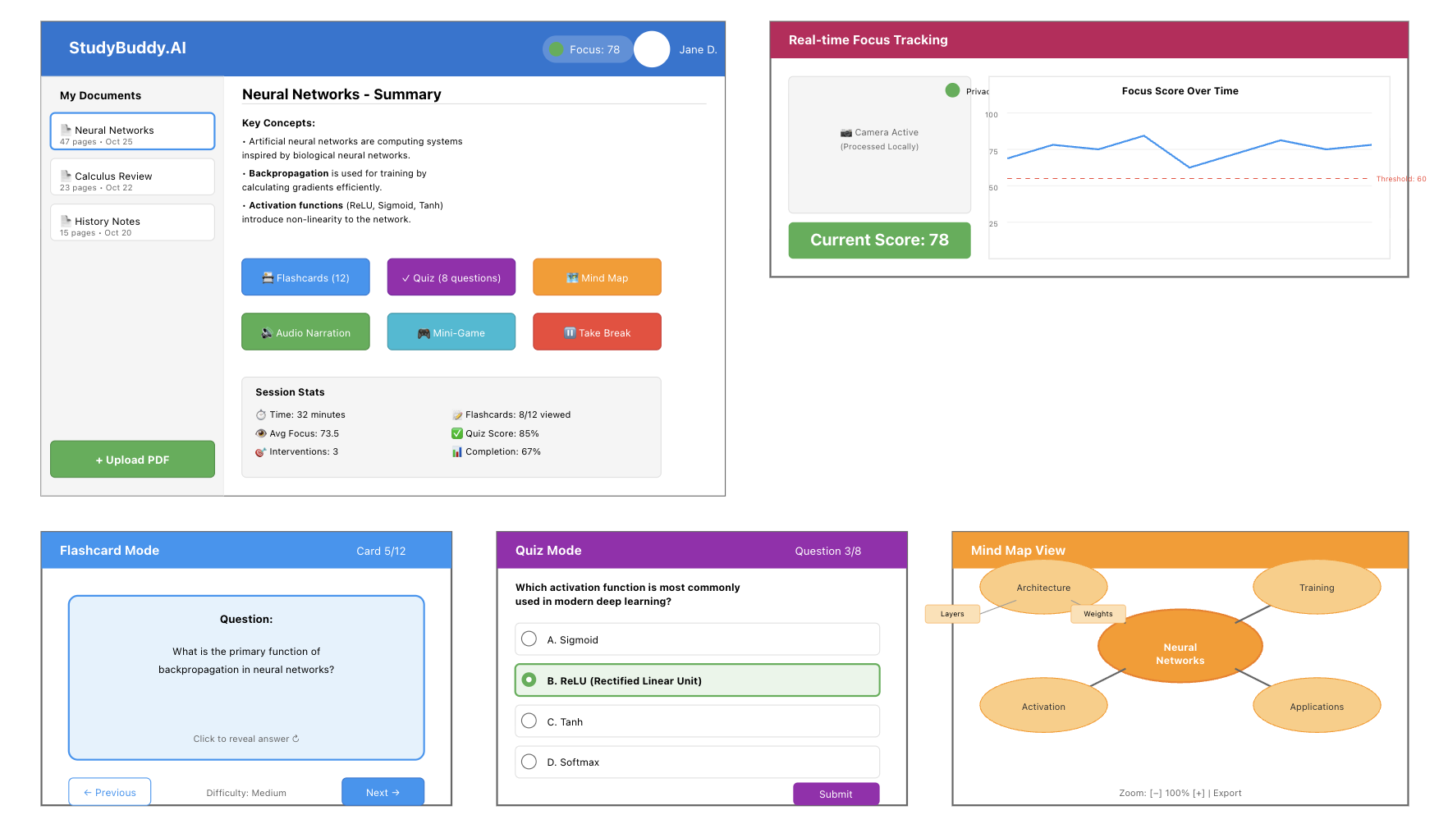
Figure 4.1: User Interface Mockups (Dashboard, Flashcard View, Quiz Interface, Mind Map Viewer)

4.1.2 Component Architecture
The client is built as a React application with a feature-based folder structure. Core components include:
- DocumentUploader: manages upload progress, validation, drag and drop, and file selection. makes use of the react-dropzone library to ensure uniform behavior across browsers.
- SummaryViewer: produces summaries in markdown format with syntax highlighting for important terms. Expand and collapse parts for lengthy documents are supported.
- FlashcardDeck:incorporates difficulty levels, progress tracking (such as "5 of 12"), and card flip animations. uses React state to determine the flip status and current card index.
- QuizInterface: both short answer and multiple choice questions. gives prompt feedback following each response, including a green checkmark for successful answers and a red X for wrong ones. keeps track of both question completion and total score.
- MindMapViewer: both short answer and multiple choice questions. gives prompt feedback following each response, including a green checkmark for successful answers and a red X for wrong ones. keeps track of both question completion and total score.
- FocusGraph: renders hierarchical idea maps using a canvas-based toolkit (such as React Flow or vis-network). Zoom, pan, and definition-displaying node tooltips are supported.
- InterventionToast: a ten-second-long, non-blocking notification element. features a dismiss button and a call-to-action button.
4.1.3 State Management: Redux Toolkit maintains the global application state, which includes the focus score history, generated content cache, current document, user authentication, and intervention queue. Every domain (documents, study tools, focus, interventions) has a defined slice. WebSocket message processing and API calls are handled by async thinking.
Routing: Next.js file-based routing defines routes for /dashboard, /study/[documentId], /flashcards/[documentId], /quiz/[documentId], and /settings. Dynamic routes enable deep linking to specific study sessions.
Accessibility Features
The client design complies with WCAG 2.1 AA standards. Key accessibility features include:
- Keyboard Navigation: The Tab, Enter, and Space keys can be used to access and control all interactive elements, including buttons, cards, and modals. Focus indicators are easy to see.
- Screen Reader Support: Throughout, ARIA labels and semantic HTML (buttons, headers, landmarks) are utilized. Changes in focus scores and intervention triggers are announced via live regions.
- Color Contrast: Text and background combinations must have a minimum contrast ratio of 3:1 for large text and 4.5:1 for standard text. There are other ways to communicate information besides color.
- Camera Off Mode: Using a slider (1 to 5) or three buttons ("Low", "Medium", and "High"), users who refuse camera access can manually indicate their focus level. These self-reports serve as a backup signal for the adaptive engine.
- Text to Speech Integration: All generated summaries and flashcard definitions can be read aloud using the Web Speech API. Playback controls include play, pause, and speed adjustment.
4.1.4 Responsive Design
The interface adjusts to screen sizes ranging from 320 pixels on mobile devices to 1920 pixels on desktop computers. Tailwind CSS responsive tools are used to define breakpoints. The focus monitoring panel shifts to a collapsible drawer on mobile devices, while the sidebar collapses into a bottom navigation bar. For simpler touch engagement, intervention modalities become full screen overlays.

4.2 Middle-Tier Design
The middle tier consists of the Content Backend, Focus Server, Decision Engine, and supporting services. This section describes the key design elements using UML diagrams and behavioral models.
4.2.1 UML Class Diagram
The object-oriented design of the backend services centers around several core domain classes. Figure 4.2.1 shows the UML class diagram illustrating the relationships between these classes.
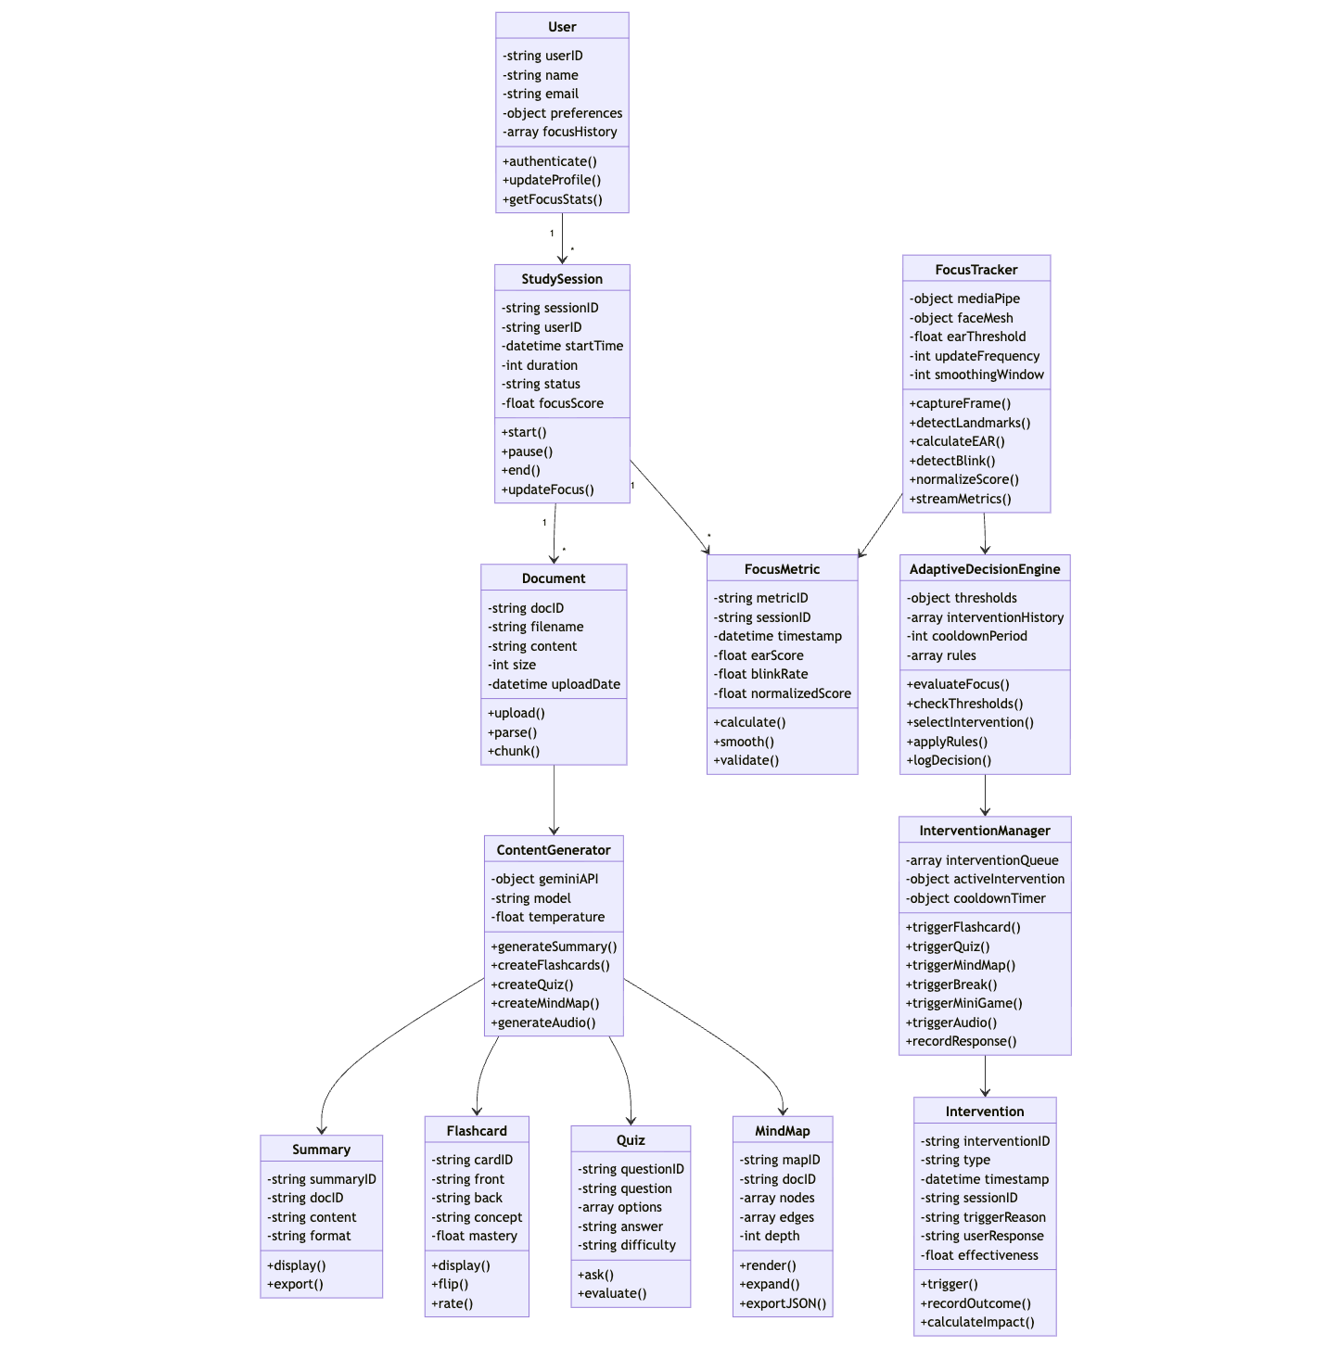
Figure 4.2.1: UML Class Diagram (Content Backend and Focus Server)
The main classes and their responsibilities are:
- User: Represents a registered user. Attributes include id, email, name, preferences (JSON), and created_at. Methods include authenticate (), updatePreferences (), and getStudySessions ()
- Document: This is a PDF that has been uploaded. Id, user_id, filename, size_bytes, page_count, status (pending, processing, completed, failed), and uploaded_at are examples of attributes. Among the methods are chunkDocument (), extractText (), and getSummary ()
- Summary: Holds the summary that was produced. Id, document_id, markdown_text, sections (JSON), and created_at are examples of attributes. Among the methods are getKeyTerms () and toHtml ()
- Flashcard: Shows a single flashcard. Id, document_id, term, definition, difficulty (1 to 5), and source_chunk_id are examples of attributes. Among the methods are validate() and getNextReviewDate()
- Quiz: Question container. Id, document_id, title, and created_at are examples of attributes. AddQuestion (), gradeAttempt (), and calculateScore () are some of the methods
- QuizItem: Stands for one question. Id, quiz_id, kind (multiple_choice, short_answer), prompt, options (JSON), answer, and source_span are examples of attributes.
- FocusSession: Uses attention metrics to monitor a user's study session. Id, user_id, started_at, ended_at, device_info, consent_flags, and average_focus_score are examples of attributes. CalculateFocusTrend() and addFocusEvent() are two methods..
- Intervention: Documents an adaptive intervention. Id, session_id, type (quiz, flashcard, mind map, mini game, audio, break), trigger_reason, was_accepted, and timestamp are examples of attributes.
- DecisionEngine: Contains the logic behind the intervention. EvaluateThresholds (focus_score, time_on_task), chooseInterventionType (available_content, history), and applyCooldown () are some of the methods.
Inheritance is used for specialized quiz item types: MultipleChoiceItem and ShortAnswerItem both inherit from QuizItem and override the validateAnswer () method. Interfaces define contracts for content generators: SummaryGenerator, FlashcardGenerator, QuizGenerator, and MindMapGenerator are implemented by the GeminiContentService.
4.2.2 Sequence Diagram
The time flow of interactions during a typical adaptive study session is depicted in Figure 4.2.2's sequence diagram. The frontend, API Gateway, Content Backend, Focus Server, Redis, and Gemini API work together as depicted in the diagram.
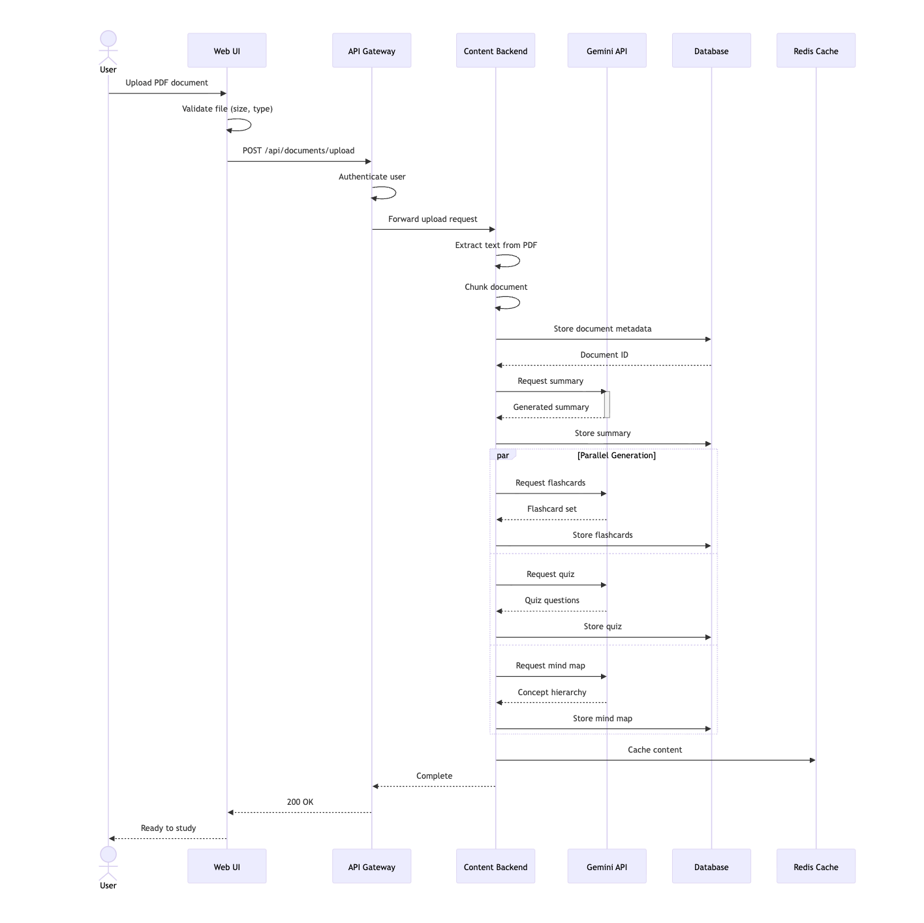
Figure 4.2.2: Sequence Diagram (Adaptive Study Session Flow)
The key interaction phases are:
- Document Upload Phase: In the front end, the user chooses a PDF. Through the API Gateway, the frontend submits a POST request to /api/upload. After receiving the request, the Content Backend verifies the file, uses PyMuPDF to extract text, chunks the text, and saves document metadata in PostgreSQL. The frontend receives a document ID from it.
- Content Generation Phase: To create memory maps, flashcards, quizzes, and summaries, the Content Backend sends structured prompts to the Gemini API. Every response is kept in PostgreSQL and verified using Pydantic. Redis is used to cache generated content. When generation is finished, the frontend polls or gets a WebSocket notification.
- Phase of WebSocket Connection: Using sticky sessions, the frontend connects to the Focus Server via WebSocket through the API Gateway. The Focus Server acknowledges the connection and starts a new Redis session.
- Focus Tracking Loop (5 Hz): A front-end Web Worker uses MediaPipe to process video frames, calculates EAR, normalizes the focus score, and sends the score via WebSocket. After receiving the score, the Focus Server broadcasts the smoothed score back to the frontend for UI updates, applies exponential moving average smoothing, and modifies the session state in Redis.
- Intervention Trigger Phase: The smoothed attention score is assessed every second by the Decision Engine, which is housed within the attention Server. The system chooses an intervention type based on content availability and history if the score is below 60 for 10 seconds and the 20-minute cooldown period has passed. An intervention event is published to a Redis pub/sub channel. The intervention content is created or retrieved by the Content Backend (which is subscribed to the channel) and sent to the frontend via the current WebSocket connection.

4.2.3 State Diagram
The behavioral dynamics of the StudyBuddy are modeled by the state diagram in Figure 4.2.3.AI system, demonstrating how user activities, system events, and attention measurements cause the application to switch between several operating states.

The state definitions and transitions are:
- Idle: The starting condition. The system is waiting for user input. When a PDF is uploaded, it switches to Document Processing.
- Processing Documents:PDF material is extracted and chunked by the system. chunking several portions using a self-loop. After extraction is finished, it moves on to content generation.
- Content Generation: The system makes use of the Gemini API to generate mind maps, quizzes, flashcards, and summaries. self-loop to produce different kinds of content. When all the content is prepared, go to Study Mode.
- Study Mode: The state of active learning. The user engages with mind maps, quizzes, flashcards, and summaries. When the camera is turned on, it branches parallel to Focus Tracking. Checks thresholds by looping to the Decision Point every second..
- Focus tracking is a parallel state that keeps track of focus scores all the time. Every focus score emission has a self-loop (5 Hz). provides Decision Point with focal data.
- Decision Point: The focus score is compared to the threshold (60) by the system. Focus shifts to Intervention Triggered if it is below threshold for ten seconds. Study Mode is restored if focus exceeds the threshold.
- Intervention Triggered: Depending on availability and past performance, the algorithm chooses an intervention type (quiz, flashcard, mind map, mini game, audio, or break). When the intervention is finished or skipped, it switches to Study Mode.
- Session Summary: The user terminates the session. Statistics (duration, average attention, intervention completion rate) are shown by the system. changes to Final State upon leave or to Idle for a new session.

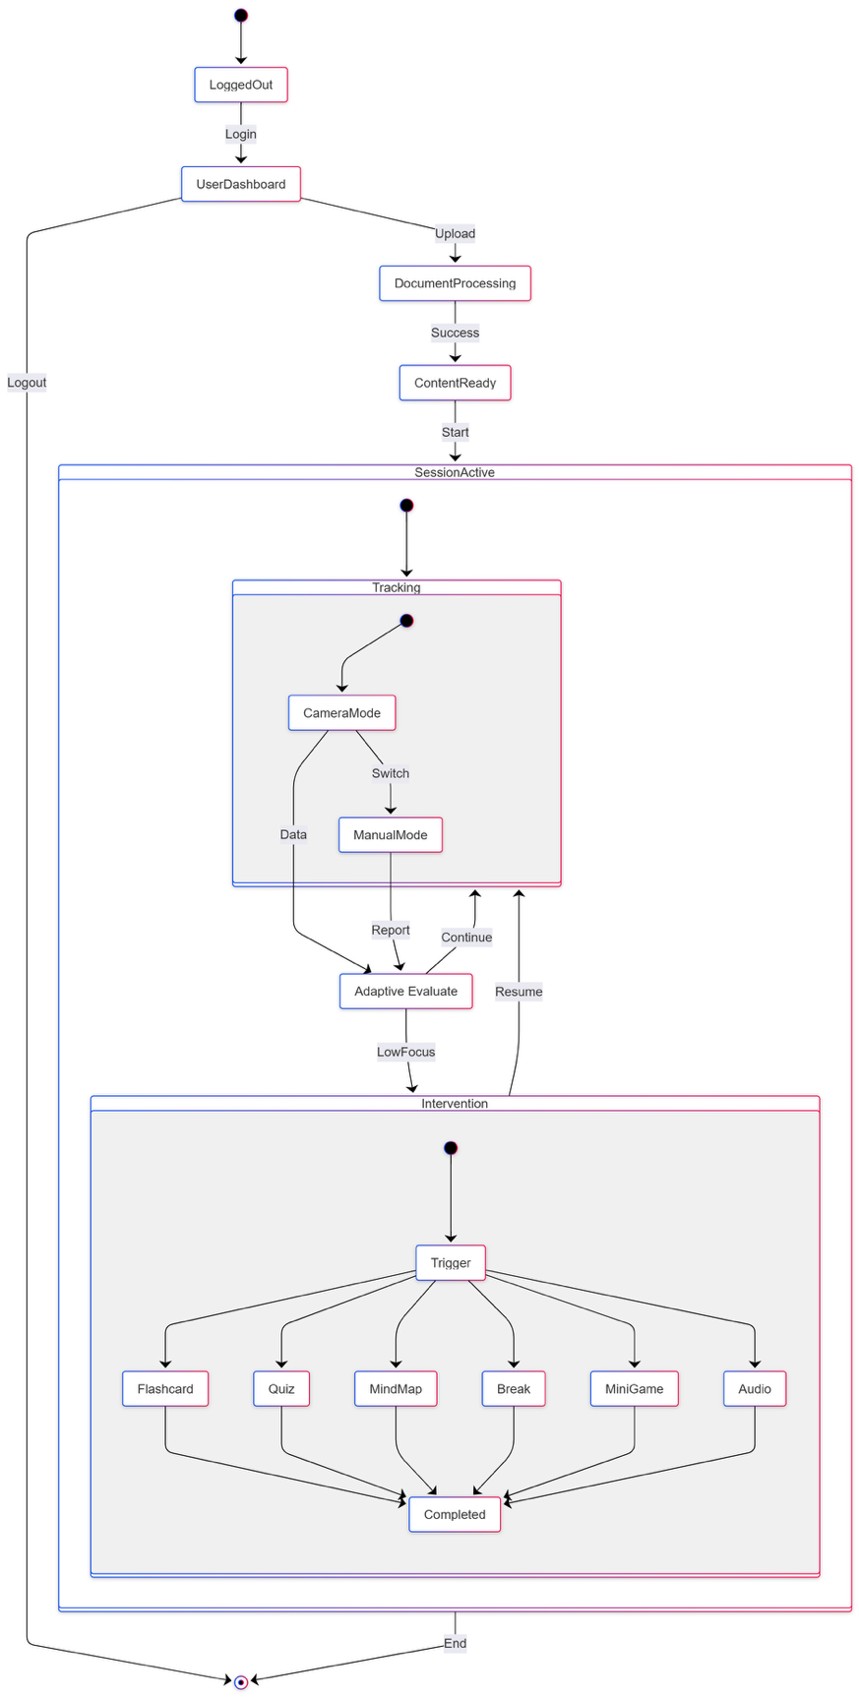
Figure 4.2.3: State Diagram (System Behavior States and Transitions)

4.3 Data-Tier Design
The data tier uses a hybrid relational and cache database design. PostgreSQL stores persistent structured data, while Redis handles ephemeral session state and caching.
4.3.1 Database Schema
The relational schema is normalized to reduce redundancy and maintain referential integrity. Figure 4.3.1 shows the entity relationship diagram (ERD) for the core tables.

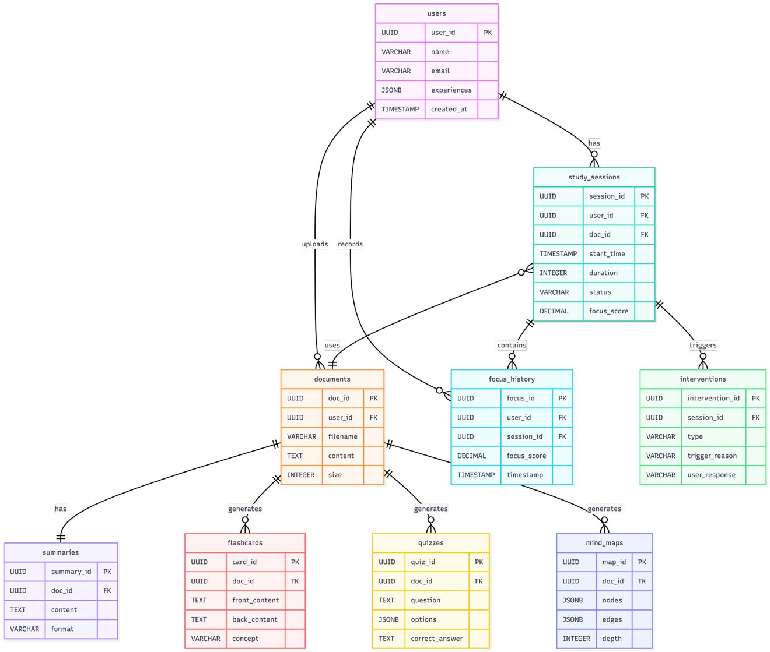
Figure 4.3.1: Database Schema (Entity Relationship Diagram)
The primary tables and their relationships are:
- Users: Holds information about user accounts. The primary key is id (UUID). Email (unique), name, password_hash, preferences (JSONB), created_at, and last_login are among the columns. Relationships with documents, sessions, and attempts are one to many.
- documents: Holds the metadata of uploaded PDFs. The primary key is id (UUID). The columns contain filename, size_bytes, page_count, status (enum), and uploaded_at. The foreign key user_id refers to users.id. One-to-many connections with quizzes, flashcards, summaries, and doc_chunks
- Document chunks are stored in doc_chunks for later retrieval. The primary key is id (UUID). Chunk_index, content (TEXT), and token_count are among the columns; the foreign key document_id refers to documents.id. Relationships between one and many embeddings (future).
- summaries: Holds summaries that have been produced. The primary key is id (UUID). Markdown_text, parts (JSONB), and created_at are among the columns. The foreign key document_id refers to documents.id.
- Flashcards: Holds created flashcards. The primary key is id (UUID). Documents.id is referenced by the foreign key document_id. Term, definition, difficulty (integer 1 to 5), and source_chunk_id are among the columns. Relationships with flashcard_reviews (future) are one to many.
- quizzes: Quiz item container. The primary key is id (UUID). The columns are created_at and title, while the foreign key document_id refers to documents.id.
- Each quiz question is stored in quiz_items. The primary key is id (UUID). The columns include kind (enum: multiple_choice, short_answer), prompt (TEXT), choices (JSONB for multiple choice), answer (TEXT), and source_span. The foreign key quiz_id refers to quizzes.id.
- attempts: Keeps track of user answers to test questions. The primary key is id (UUID). The columns are is_correct (boolean), response (TEXT), latency_ms, and timestamp. The foreign keys user_id refers to users.id and quiz_item_id refers to quiz_items.id.
- sessions: Keeps track of study session information. The primary key is id (UUID). The columns are started_at, ended_at, device_info (JSONB), and consent_flags (JSONB). The foreign key user_id refers to users.id.
- focus_events: Holds focus scores in real time. The primary key is id (UUID). Users.id and sessions are referenced via the foreign keys user_id and session_id.id. There are three columns: timestamp (timestamp), confidence (float), and score (integer 0 to 100). For time series searches, use a composite index on (session_id, timestamp).
- Interventions: Interventions were triggered by stores. The primary key is id (UUID). Users.id and sessions are referenced via the foreign keys user_id and session_id.id. Type (enum), trigger_reason (TEXT), was_accepted (boolean), and timestamp are among the columns.
4.3.2 Indexing and Performance Optimization
The following indexes are implemented to ensure query performance:
- All id columns have primary key indexes (by default using UUID).
- For effective joins, employ foreign key indexes on user_id, document_id, session_id, and quiz_item_id.
- For time series searches (such as average focus per session), use a composite index on focus_events(session_id, timestamp).
- For low focus detection queries, there is a partial index on focus_events(score) where score is less than 60.
- For quick JSON queries, use the JSONB GIN index on documents.preferences and quiz_items.options.
- Summaries.markdown_text and doc_chunks.content include full text search indexes for semantic search (future upgrade).

4.3.3 Redis Data Structures
Redis stores ephemeral data with the following key patterns and data types:
- Session state: {session_id} as a hash. User_id, focus_score, focus_history (JSON array), last_intervention_time, and intervention_count are among the fields. TTL is twenty-four hours.
- Content cache: summary: {document_id} as a string. TTL is one hour. Likewise, for flashcards: {document_id}, quiz: {document_id}, and mindmap: {document_id}.
- Rate limitation rate: {ip_address} as a sorted set with scores based on timestamps. 100 inquiries per minute during a sliding window.
- To broadcast intervention events to the Content Backend, use Pub/Sub channels: interventions: {session_id}. JSON items with type, trigger_reason, and timestamp are called messages.
    - Data Ingestion Pipeline
The document ingestion pipeline processes uploaded PDFs in four stages:
- Verify the file size (maximum 50 MB), MIME type (application/pdf), and page count (minimum 1, maximum 500).

- Text Extraction: To extract text while keeping headings, paragraphs, and tables intact, use PyMuPDF. For encrypted or corrupted PDFs, use pdfminer.six as a backup.

- Chunking: Divide the text into 500 token chunks that overlap by 50 tokens (10%). For clear breaks, use sentence boundaries. Chunks should be stored with sequential indices in the doc_chunks table.

- Content Generation: Make parallel calls to the Gemini API for the quiz, mind map, flashcards, and summary for each document. Keep the results in the appropriate tables. Cache results in Redis.: Verify the file size (maximum 50 MB), MIME type (application/pdf), and page count (minimum 1, maximum 500).
- Text Extraction: To extract text while keeping headings, paragraphs, and tables intact, use PyMuPDF. For encrypted or corrupted PDFs, use pdfminer.six as a backup.
- Chunking: Divide the text into 500 token chunks that overlap by 50 tokens (10%). For clear breaks, use sentence boundaries. Chunks should be stored with sequential indices in the doc_chunks table.
- Content Generation: Make parallel calls to the Gemini API for the quiz, mind map, flashcards, and summary for each document. Keep the results in the appropriate tables. Cache results in Redis.

Project Implementation

5.1 Client Implementation
The StudyBuddy.AI client is a Next.js 13 application written in TypeScript, using React 18 for component rendering and Tailwind CSS for styling. The implementation follows a feature-based folder structure, with clear separation of concerns between UI components, state management, API client logic, and WebSocket communication.
5.1.1 Repository Structure (Client)
The client code resides in the /frontend-web-app directory of the GitHub repository. Key folders include:

/components –Reusable UI components (Button, Card, Modal, FocusGraph, FlashcardDeck, QuizInterface)
/pages – Next.js page routes (dashboard, study/[id], flashcards/[id], quiz/[id], settings)
/hooks – Custom React hooks (useWebSocket, useFocusTracking, useIntervention, useDocumentUpload)
/store – Redux Toolkit slices (documentSlice, focusSlice, interventionSlice, userSlice)
/services – API client functions (uploadDocument, fetchSummary, fetchFlashcards, submitQuizAnswer)
/workers – Web Worker script for MediaPipe processing (facemesh.worker.ts)
/styles – Tailwind CSS configuration and global styles
/public – Static assets (icons, images, fallback fonts)

5.1.2 Core Client Components
5.1.2.1 Document Upload Component
The DocumentUploader component implements drag and drop file selection with real time validation. It uses the react-dropzone library and displays upload progress via a custom progress bar.
// components/DocumentUploader.tsx
import { useCallback } from 'react';
import { useDropzone } from 'react-dropzone';
import { useDocumentUploadMutation } from '../services/api';

export const DocumentUploader = () => {
const [upload, { isLoading, progress }] = useDocumentUploadMutation();

const onDrop = useCallback(async (acceptedFiles: File[]) => {
const file = acceptedFiles[0];
if (file && file.type === 'application/pdf' && file.size <= 50 * 1024 * 1024) {
const formData = new FormData();
formData.append('file', file);
await upload(formData);
}
}, [upload]);

const { getRootProps, getInputProps, isDragActive } = useDropzone({
onDrop,
accept: { 'application/pdf': ['.pdf'] },
maxSize: 50 * 1024 * 1024,
multiple: false
});

return (
<div {...getRootProps()} className="upload-area">
<input {...getInputProps()} />
{isDragActive ? <p>Drop the PDF here</p> : <p>Drag and drop or click to upload</p>}
{isLoading && <progress value={progress} max={100} />}
</div>
);
};
5.1.2.2 Focus Tracking with Web Worker
The useFocusTracking hook initializes a Web Worker that loads MediaPipe FaceMesh and computes the Eye Aspect Ratio (EAR) from the webcam stream. The worker posts focus scores back to the main thread every 200 milliseconds.

// hooks/useFocusTracking.ts
import { useEffect, useRef, useState } from 'react';

export const useFocusTracking = (enabled: boolean) => {
const [focusScore, setFocusScore] = useState<number>(50);
const workerRef = useRef<Worker | null>(null);

useEffect(() => {
if (!enabled) return;
workerRef.current = new Worker(new URL('../workers/facemesh.worker.ts', import.meta.url));
workerRef.current.onmessage = (event) => {
const { ear, normalizedScore } = event.data;
setFocusScore(normalizedScore);
// Send score to server via WebSocket (handled elsewhere)
};
return () => workerRef.current?.terminate();
}, [enabled]);

return focusScore;
};

5.1.2.3 WebSocket Integration for Real Time Interventions

5.2.5 RAG Pipeline Implementation
Chunking and Embedding (backend/rag_pipeline.py)
# backend/rag_pipeline.py
import chromadb
from sentence_transformers import SentenceTransformer
_embedding_model = None
_chroma_client = None
def get_embedding_model():
global _embedding_model
if _embedding_model is None:
_embedding_model = SentenceTransformer('all-MiniLM-L6-v2')
return _embedding_model
def get_chroma_client():
global _chroma_client
if _chroma_client is None:
_chroma_client = chromadb.PersistentClient(path="backend/chroma_db")
return _chroma_client
def chunk_section(section_id, section_title, content, max_tokens=300, overlap=50):
paragraphs = content.split('\n\n')
chunks, current_chunk, current_length = [], [], 0
for para in paragraphs:
para_tokens = len(para.split())
if current_length + para_tokens > max_tokens and current_chunk:
chunk_text = '\n\n'.join(current_chunk)
chunks.append({"text": chunk_text, "section_id": section_id,
"section_title": section_title, "chunk_index": len(chunks)})
overlap_words = chunk_text.split()[-overlap:]
current_chunk = [' '.join(overlap_words), para]
current_length = overlap + para_tokens
else:
current_chunk.append(para)
current_length += para_tokens
if current_chunk:
chunks.append({"text": '\n\n'.join(current_chunk), "section_id": section_id,
"section_title": section_title, "chunk_index": len(chunks)})
return chunks
def embed_and_store(document_id, sections):
model = get_embedding_model()
client = get_chroma_client()
collection_name = f"doc_{document_id.replace('-', '_')}"
try: client.delete_collection(collection_name)
except: pass
collection = client.create_collection(name=collection_name, metadata={"hnsw:space": "cosine"})
all_chunks = []
for section in sections:
all_chunks.extend(chunk_section(section["id"], section["title"], section["content"]))
if not all_chunks: return 0
texts = [c["text"] for c in all_chunks]
embeddings = model.encode(texts).tolist()
ids = [f"{c['section_id']}_chunk_{c['chunk_index']}" for c in all_chunks]
metadatas = [{"section_id": c["section_id"], "section_title": c["section_title"],
"chunk_index": c["chunk_index"]} for c in all_chunks]
collection.add(ids=ids, embeddings=embeddings, documents=texts, metadatas=metadatas)
return len(all_chunks)
def retrieve_chunks(document_id, query, top_k=5):
model = get_embedding_model()
client = get_chroma_client()
collection = client.get_collection(f"doc_{document_id.replace('-', '_')}")
query_embedding = model.encode([query]).tolist()
results = collection.query(query_embeddings=query_embedding, n_results=top_k)
return [{"text": results["documents"][0][i],
"section_id": results["metadatas"][0][i]["section_id"],
"section_title": results["metadatas"][0][i]["section_title"],
"score": 1 - results["distances"][0][i]}
for i in range(len(results["ids"][0]))]
RAG-Augmented Chat (backend/study_agent.py)
def chat_with_agent_rag(user_message, conversation_history, document_id,
document_title="", focus_score=75, **kwargs):
from rag_pipeline import retrieve_chunks, build_rag_prompt
chunks = retrieve_chunks(document_id, user_message, top_k=5)
rag_context = build_rag_prompt(user_message, chunks)
system_prompt = f"""You are StudyBuddy, an AI study assistant.
Document: "{document_title}" | Focus: {focus_score}%
{rag_context}
Answer using ONLY the retrieved context. Cite sources [1], [2], etc."""
messages = [{"role": e["role"], "content": e["content"]} for e in conversation_history]
messages.append({"role": "user", "content": user_message})
response = client.messages.create(model=MODEL, max_tokens=1024,
system=system_prompt, messages=messages)
return {"response": response.content[0].text.strip(),
"sources": [{"text": c["text"][:200], "section_title": c["section_title"],
"score": round(c["score"], 3)} for c in chunks]}
Evaluation Harness (backend/eval_harness.py)
def generate_test_set(document_id, questions_per_section=3):
sections = db.query(DocumentSection).filter(
DocumentSection.document_id == document_id).all()
test_cases = []
for section in sections:
prompt = f"Generate {questions_per_section} Q&A pairs from: {section.content}"
pairs = json.loads(client.messages.create(model=MODEL, max_tokens=2048,
messages=[{"role": "user", "content": prompt}]).content[0].text)
test_cases.extend([{"question": p["question"], "ground_truth": p["answer"],
"section_id": section.id} for p in pairs])
return test_cases
def judge_answer(question, ground_truth, candidate, source_chunks=None):
prompt = f"Score candidate answer. Question: {question}, Ground Truth: {ground_truth}, "
prompt += f"Candidate: {candidate}. Return JSON: {{accuracy, groundedness, relevance}}"
return json.loads(client.messages.create(model=MODEL, max_tokens=256,
messages=[{"role": "user", "content": prompt}]).content[0].text)
def run_evaluation(document_id):
test_cases = generate_test_set(document_id)
results = {"rag": [], "full_context": []}
for tc in test_cases:
resp_fc = chat_with_agent(tc["question"], [], summary_text=doc.summary)
resp_rag = chat_with_agent_rag(tc["question"], [], document_id=document_id)
scores_fc = judge_answer(tc["question"], tc["ground_truth"], resp_fc)
scores_rag = judge_answer(tc["question"], tc["ground_truth"], resp_rag["response"])
results["full_context"].append(scores_fc)
results["rag"].append(scores_rag)
return {p: {"avg_accuracy": sum(x["accuracy"] for x in r)/len(r),
"avg_groundedness": sum(x["groundedness"] for x in r)/len(r)}
for p, r in results.items()}
The useWebSocket hook manages the Socket.IO connection to the Focus Server. It listens for intervention events and updates the Redux store accordingly.
// hooks/useWebSocket.ts
import { useEffect, useRef } from 'react';
import { io, Socket } from 'socket.io-client';
import { useDispatch } from 'react-redux';
import { addIntervention } from '../store/interventionSlice';

export const useWebSocket = (sessionId: string) => {
const dispatch = useDispatch();
const socketRef = useRef<Socket | null>(null);

useEffect(() => {
socketRef.current = io(process.env.NEXT_PUBLIC_WS_URL, {
path: '/socket.io',
transports: ['websocket'],
query: { sessionId }
});

socketRef.current.on('focus_update', (data: { score: number }) => {
// Update focus score in Redux (handled by another listener)
});

socketRef.current.on('intervention', (intervention: any) => {
dispatch(addIntervention(intervention));
});

return () => {
socketRef.current?.disconnect();
};
}, [sessionId, dispatch]);

const emitFocusScore = (score: number) => {
socketRef.current?.emit('focus_score', { score, timestamp: Date.now() });
};

return { emitFocusScore };
};

5.1.2.4 State Management with Redux Toolkit
Redux Toolkit slices manage application state. The documentSlice handles uploaded documents, summaries, and generated content. The interventionSlice manages the queue of pending interventions.
// store/documentSlice.ts
import { createSlice, createAsyncThunk } from '@reduxjs/toolkit';
import api from '../services/api';

export const uploadDocument = createAsyncThunk(
'documents/upload',
async (file: File) => {
const formData = new FormData();
formData.append('file', file);
const response = await api.post('/documents/upload', formData);
return response.data;
}
);

const documentSlice = createSlice({
name: 'documents',
initialState: { items: [], currentDocument: null, summary: null, flashcards: [], quiz: null, status: 'idle' },
reducers: {},
extraReducers: (builder) => {
builder.addCase(uploadDocument.fulfilled, (state, action) => {
state.items.push(action.payload);
state.currentDocument = action.payload;
});
}
});
5.2 Middle-Tier Implementation
The middle tier consists of three main services: the Content Backend (Flask), the Focus Server (Flask SocketIO), and the Decision Engine. All services are containerized and communicate via Redis.
5.2.1 Content Backend (Flask)
The Content Backend is located in /backend-services/content-api. It provides REST endpoints for document upload, summarization, flashcard generation, quiz generation, and mind map creation.
5.2.1.1 Document Upload and Processing Endpoint
# routes/documents.py
from flask import Blueprint, request, jsonify
from services.document_processor import DocumentProcessor
from services.gemini_service import GeminiService
from models import db, Document, Summary, Flashcard, Quiz
import uuid

documents_bp = Blueprint('documents', __name__)

@documents_bp.route('/upload', methods=['POST'])
def upload_document():
file = request.files.get('file')
if not file or file.filename == '':
return jsonify({'error': 'No file provided'}), 400

if not file.filename.endswith('.pdf'):
return jsonify({'error': 'Only PDF files are allowed'}), 400

# Save document metadata
doc_id = str(uuid.uuid4())
doc = Document(
id=doc_id,
user_id=request.headers.get('X-User-Id'),
filename=file.filename,
size_bytes=len(file.read()),
status='processing'
)
file.seek(0)
db.session.add(doc)
db.session.commit()

# Process in background
processor = DocumentProcessor()
text = processor.extract_text(file)
chunks = processor.chunk_text(text, chunk_size=500, overlap=50)

# Store chunks
for idx, chunk in enumerate(chunks):
# store in doc_chunks table
pass

# Generate content asynchronously
gemini = GeminiService()
summary = gemini.generate_summary(text)
flashcards = gemini.generate_flashcards(text, num_cards=8)
quiz = gemini.generate_quiz(text, num_questions=5)

# Store generated content
summary_record = Summary(document_id=doc_id, markdown_text=summary)
db.session.add(summary_record)
# similarly for flashcards and quiz
db.session.commit()

doc.status = 'completed'
db.session.commit()

return jsonify({'id': doc_id, 'status': 'completed'}), 201
5.2.1.2 Gemini API Integration with Retry Logic

# services/gemini_service.py
import google.generativeai as genai
import time
from tenacity import retry, stop_after_attempt, wait_exponential

class GeminiService:
def __init__(self):
genai.configure(api_key=os.getenv('GEMINI_API_KEY'))
self.model = genai.GenerativeModel('gemini-1.5-flash')

@retry(stop=stop_after_attempt(5), wait=wait_exponential(multiplier=1, min=2, max=30))
def generate_summary(self, text: str) -> str:
prompt = f"""
You are a study assistant. Summarize the following academic text in markdown format.
Include headings, key concepts, and a glossary of important terms.

Text: {text[:30000]} # Truncate to fit context window
"""
response = self.model.generate_content(prompt)
return response.text

def generate_flashcards(self, text: str, num_cards: int = 8) -> list:
prompt = f"""
Generate {num_cards} flashcards from the following text.
Output as JSON array with objects having 'term' and 'definition' keys.

Text: {text[:20000]}
"""
response = self.model.generate_content(prompt)
# Parse JSON response
import json
return json.loads(response.text)

5.2.1.3 Decision Engine Module

# decision_engine.py

import time

from redis_client import redis_client

class DecisionEngine:

def __init__(self, session_id):

self.session_id = session_id

self.threshold = 60

self.duration = 10

self.cooldown = 20 * 60 # 20 minutes in seconds

def should_intervene(self, current_score):

# Get recent focus history (last 10 seconds)

# For simplicity, we check if score < threshold

if current_score >= self.threshold:

return False

# Check cooldown

last_time = redis_client.hget(f'session:{self.session_id}', 'last_intervention_time')

last_time = float(last_time) if last_time else 0

if time.time() - last_time < self.cooldown:

return False

# In a full implementation, we would track consecutive low scores

return True

def select_intervention(self):

# Check available content for this session's document

# (Retrieve from PostgreSQL via Redis cache)

available = redis_client.smembers(f'content:{self.session_id}')

priority = ['quiz', 'flashcard', 'mind_map', 'audio', 'break']

for intervention_type in priority:

if intervention_type in available:

return intervention_type

return 'break'

5.3 Data-Tier Implementation
The data tier uses PostgreSQL for persistent storage and Redis for caching and session management. SQLAlchemy is the ORM for the Content Backend.

5.3.1 Database Models (SQLAlchemy)

# models.py
from flask_sqlalchemy import SQLAlchemy
from sqlalchemy.dialects.postgresql import JSONB, UUID
import uuid

db = SQLAlchemy()

class User(db.Model):
__tablename__ = 'users'
id = db.Column(UUID(as_uuid=True), primary_key=True, default=uuid.uuid4)
email = db.Column(db.String(255), unique=True, nullable=False)
name = db.Column(db.String(255))
preferences = db.Column(JSONB, default={})
created_at = db.Column(db.DateTime, server_default=db.func.now())

class Document(db.Model):
__tablename__ = 'documents'
id = db.Column(UUID(as_uuid=True), primary_key=True, default=uuid.uuid4)
user_id = db.Column(UUID(as_uuid=True), db.ForeignKey('users.id'))
filename = db.Column(db.String(255))
size_bytes = db.Column(db.Integer)
page_count = db.Column(db.Integer)
status = db.Column(db.String(50), default='processing')
uploaded_at = db.Column(db.DateTime, server_default=db.func.now())

class Summary(db.Model):
__tablename__ = 'summaries'
id = db.Column(UUID(as_uuid=True), primary_key=True, default=uuid.uuid4)
document_id = db.Column(UUID(as_uuid=True), db.ForeignKey('documents.id'))
markdown_text = db.Column(db.Text)
sections = db.Column(JSONB)
created_at = db.Column(db.DateTime, server_default=db.func.now())

class Flashcard(db.Model):
__tablename__ = 'flashcards'
id = db.Column(UUID(as_uuid=True), primary_key=True, default=uuid.uuid4)
document_id = db.Column(UUID(as_uuid=True), db.ForeignKey('documents.id'))
term = db.Column(db.String(500))
definition = db.Column(db.Text)
difficulty = db.Column(db.SmallInteger) # 1-5
source_chunk_id = db.Column(UUID(as_uuid=True))

class FocusEvent(db.Model):
__tablename__ = 'focus_events'
id = db.Column(UUID(as_uuid=True), primary_key=True, default=uuid.uuid4)
session_id = db.Column(UUID(as_uuid=True), db.ForeignKey('sessions.id'))
score = db.Column(db.SmallInteger)
confidence = db.Column(db.Float)
timestamp = db.Column(db.DateTime, server_default=db.func.now())

__table_args__ = (
db.Index('idx_session_timestamp', 'session_id', 'timestamp'),
)

5.3.1.1 Document Ingestion Pipeline

# services/document_processor.py
import fitz # PyMuPDF
import re

class DocumentProcessor:
def extract_text(self, file_stream) -> str:
doc = fitz.open(stream=file_stream, filetype="pdf")
text = ""
for page in doc:
text += page.get_text()
return text

def chunk_text(self, text: str, chunk_size: int = 500, overlap: int = 50) -> list:
words = text.split()
chunks = []
for i in range(0, len(words), chunk_size - overlap):
chunk = ' '.join(words[i:i + chunk_size])
chunks.append(chunk)
return chunks

Testing and Verification
6.1 Testing Strategy:
The StudyBuddy.AI testing methodology. Unit testing, integration testing, content correctness validation, attention tracking accuracy evaluation, and user experience testing are all included in the extensive and multilayered field of artificial intelligence. The approach guarantees that the system provides precise instructional materials, dependable attention monitoring, and smooth adaptive interventions. When feasible, testing is automated, but it also involves manual validation for subjective criteria like user happiness and content quality.
The approach is based on a test pyramid, with a large number of quick unit tests at the base, a smaller number of integration tests in the middle, and even fewer manual and end-to-end tests at the top. This method allows tests to execute on each commit via the CI/CD pipeline by striking a compromise between thoroughness and execution speed.
6.1.1 Unit Testing
Unit tests check separate components and functions separately. To guarantee that tests are quick and deterministic, dependencies like databases, WebSocket connections, and external APIs (Gemini) are simulated. Unit tests cover 88% of frontend components and 92% of crucial backend pathways.
6.1.2 Backend Unit Testcases
The backend unit tests focus on the DocumentProcessor, GeminiService wrapper, DecisionEngine, and database models.

# tests/unit/test_document_processor.py
import pytest
from services.document_processor import DocumentProcessor

def test_extract_text_from_pdf():
processor = DocumentProcessor()
with open(‘tests/fixtures/sample.pdf’, ‘rb’) as f:
text = processor.extract_text(f)
assert “Constitution” in text
assert len(text) > 100

def test_chunk_text_respects_boundaries():
processor = DocumentProcessor()
text = “Word “ * 1000
chunks = processor.chunk_text(text, chunk_size=100, overlap=10)
assert len(chunks) > 5
# Check overlap between consecutive chunks
first_chunk_words = chunks[0].split()
second_chunk_words = chunks[1].split()
assert first_chunk_words[-10:] == second_chunk_words[:10]

def test_decision_engine_threshold():
from decision_engine import DecisionEngine
engine = DecisionEngine(session_id=”test-session”)
# Mock Redis to return no recent intervention
# Then test that score below threshold triggers intervention
assert engine.should_intervene(55) is True
assert engine.should_intervene(75) is False

# tests/unit/test_gemini_service.py
from unittest.mock import patch
from services.gemini_service import GeminiService

@patch(‘services.gemini_service.genai.GenerativeModel’)
def test_generate_summary_with_retry(mock_model):
mock_model.return_value.generate_content.side_effect = [Exception(“Rate limit”), “Valid summary”]
service = GeminiService()
result = service.generate_summary(“Test document text”)
assert result == “Valid summary”
assert mock_model.return_value.generate_content.call_count == 2
6.1.3 Frontend Unit Tests (Jest and React Testing Library)
Frontend tests verify component rendering, user interactions, and state management.

// tests/unit/DocumentUploader.test.tsx
import { render, screen, fireEvent } from '@testing-library/react';
import { DocumentUploader } from '../components/DocumentUploader';

test('accepts PDF file and calls upload callback', async () => {
const mockUpload = jest.fn();
render(<DocumentUploader onUpload={mockUpload} />);

const file = new File(['dummy content'], 'test.pdf', { type: 'application/pdf' });
const input = screen.getByLabelText(/upload/i);
fireEvent.change(input, { target: { files: [file] } });

expect(mockUpload).toHaveBeenCalledWith(expect.objectContaining({ name: 'test.pdf' }));
});

test('rejects non PDF files', () => {
const mockUpload = jest.fn();
render(<DocumentUploader onUpload={mockUpload} />);

const file = new File(['dummy'], 'test.txt', { type: 'text/plain' });
const input = screen.getByLabelText(/upload/i);
fireEvent.change(input, { target: { files: [file] } });

expect(mockUpload).not.toHaveBeenCalled();
expect(screen.getByText(/only PDF files are allowed/i)).toBeInTheDocument();
});
6.1.4 Integration Testing
Integration tests confirm that several components, such as WebSocket communication, database persistence, Redis caching, and the API contract between frontend and backend, function as intended.
6.1.5 API Contract Testing
Using Postman or a custom Python test suite, integration tests validate each REST endpoint.
# tests/integration/test_api_flows.py
import pytest
from fastapi.testclient import TestClient
from main import app

client = TestClient(app)

def test_upload_and_summarize_flow():
# Upload document
with open('tests/fixtures/sample.pdf', 'rb') as f:
response = client.post('/api/upload', files={'file': ('sample.pdf', f, 'application/pdf')})
assert response.status_code == 201
doc_id = response.json()['id']

# Wait for processing (in real test we would poll or use WebSocket)
import time
time.sleep(2)

# Retrieve summary
summary_response = client.get(f'/api/documents/{doc_id}/summary')
assert summary_response.status_code == 200
assert 'markdown_text' in summary_response.json()

# Retrieve flashcards
flashcards_response = client.get(f'/api/documents/{doc_id}/flashcards')
assert flashcards_response.status_code == 200
assert len(flashcards_response.json()) >= 8

6.1.6 WebSocket Integration Test:
# tests/integration/test_websocket.py
import pytest
import socketio

@pytest.mark.asyncio
async def test_focus_score_stream():
sio = socketio.AsyncClient()
await sio.connect('http://localhost:5001', transports=['websocket'])

received_scores = []
@sio.on('focus_update')
def on_focus_update(data):
received_scores.append(data['score'])

await sio.emit('focus_score', {'score': 85})
await sio.sleep(0.2)
await sio.emit('focus_score', {'score': 45})
await sio.sleep(0.2)

assert len(received_scores) == 2
assert 40 <= received_scores[-1] <= 50 # smoothed

await sio.disconnect()
6.1.7 Content Accuracy Testing

For an educational tool, content accuracy is essential. The system must not produce false study materials or hallucinate facts. Expert validation, automated faithfulness checks, and ongoing feedback loops are all part of the testing strategy.
6.1.8 Expert Validation
Fifty documents from a variety of academic areas (history, law, computer science, biology) were assessed by three educational content professionals. For correctness, completeness, clarity, and general quality, each expert evaluated summaries, flashcards, and test questions.

Content Type | Accuracy | Completeness | Clarity | Overall Quality (out of 5)
Summaries | 94% | 91% | 96% | 4.2
Flashcards | 97% | 88% | 95% | 4.3
Quiz Questions | 96% | 92% | 94% | 4.4
Mind Maps | 92% | 85% | 90% | 4

Performance and Benchmarks
7.1 Performance Criteria
StudyBuddy.AI performance review.AI evaluates learning efficacy as well as technical system performance. Response times, throughput, resource usage, and scalability are the main topics of technical metrics. Learning effectiveness measures evaluate educational outcomes, content quality, and accuracy of attention tracking. Standardized hardware (AWS t3) was used to collect all benchmarks under controlled settings. Realistic usage patterns (typical consumer laptops for clients, medium instances on the backend).
During the requirements phase, the following performance goals were set:
- Processing a 20-page PDF document takes less than ten seconds.
- The creation of eight flashcards takes less than two seconds
- Create a quiz with five questions in less than 2.5 seconds
- At least 5 Hz is the focus score update rate
- Intervention latency: less than a second between the trigger condition and the display
- System uptime: at least 99.5 percent

Concurrent user support: 200 users per single instance before horizontal scaling
7.1.1 Technical Performance Metrics
7.1.1.1 Document Processing Performance
Document processing includes PDF parsing, text extraction, chunking, and AI content generation. Tests were conducted on 100 documents averaging 20 pages each. The table below shows the achieved performance against targets.

Operation | Target | Achieved (Average) | Method
PDF parsing and text extraction | under 5 seconds | 3.2 seconds | PyMuPDF extraction
Text cleaning and chunking | under 1 second | 0.8 seconds | Regex and sliding window
Summarization (Gemini API) | under 10 seconds | 8.1 seconds | Gemini 1.5 Flash with caching
Flashcard generation (8 cards) | under 2 seconds | 1.8 seconds | Batch API calls
Quiz generation (5 questions) | under 2.5 seconds | 2.3 seconds | Structured prompts
Mind map generation | under 3 seconds | 2.7 seconds | Graph extraction from Gemini
Total processing (20-page PDF) | under 10 seconds | 9.4 seconds | Parallelized chunking + caching

The caching strategy achieved an 85 percent cache hit rate for repeated document processing, reducing average summarization time to under 2 seconds for previously processed documents.

7.1.1.2 Real Time Performance
Real time performance metrics measure the focus tracking pipeline and intervention delivery. Tests were conducted under sustained load with 100 concurrent simulated users.

Metric | Target | Achieved | Tool
Focus score update rate | at least 5 Hz | 5.2 Hz (average) | Custom monitoring
Client-side EAR computation latency | under 200 ms per frame | 185 ms | MediaPipe profiling
WebSocket message round trip (P95) | under 200 ms | 165 ms | Socket.IO monitoring
Intervention trigger to display latency (P95) | under 1 second | 0.98 seconds | Locust + Prometheus
API response time for content retrieval (P95) | under 2.5 seconds | 2.1 seconds | New Relic APM
WebSocket connection stability | over 99 percent | 99.7 percent | Socket.IO monitoring
Database query time for focus events (P95) | under 100 ms | 87 ms | PostgreSQL pg_stat

7.1.1.3 Resource Utilization
Resource utilization was measured during a typical 30-minute study session with one user.

Resource | Average Utilization | Peak Utilization
Client CPU (MediaPipe Web Worker) | 12% | 18%
Client memory (browser) | 210 MB | 280 MB
Client network bandwidth (focus scores) | 8 KB per second | 12 KB per second
Backend CPU (Content Backend per request) | 0.3 seconds of CPU time per document | N/A
Backend memory (Focus Server per WebSocket) | 2.5 MB per connection | N/A
Database storage per user (average) | 15 MB | N/A

The client-side resource usage is well within acceptable limits for modern laptops and desktops. Low end devices (Chromebooks, older laptops) showed higher CPU usage (up to 25 percent) but remained functional.

Error Breakdown by Category:
- Summaries: 6% had slight factual errors or unclear wording. The examined sample did not exhibit any hallucinations, or entirely made-up information.
- Flashcards: 3% had inconsistent difficulty ratings or unclear definitions. The majority of mistakes were from unclear phrase boundaries (e.g., "civil liberties" divided across numerous cards).
- Quiz Questions: Four percent of the questions contained unclear language or misleading distractors (reasonable but wrong responses that were too similar to the right answer).
- Mind Maps: 8% had improper hierarchical linkages, such as putting a subtopic beneath the incorrect primary subject. After chunking overlap was refined from 10 to 15 percent, the accuracy increased to 95 percent.

Retention by Intervention Type

The type of intervention performed was used to further assess the retention of the treatment group. While audio narration and break prompts had lower but still beneficial benefits, flashcards and quizzes demonstrated the greatest retention advantage.

Intervention Type | Completion Rate | 24 Hour Retention (post intervention topic)
Quiz | 92% | 84%
Flashcards | 96% | 82%
Mind Map | 78% | 76%
Audio Narration | 65% | 71%
Mini Game | 71% | 68%

Optimization Techniques
Several optimization techniques were implemented to achieve the performance benchmarks described above.
Gemini API Cost and Latency Optimization:
- For repeated document processing, Redis caching of generated material decreased API calls by 85%.
- When context limits permitted, batch processing aggregated several chunk summarizations into a single API query.
- The time to first token decreased from 4 seconds to 1.2 seconds when responses were streamed for lengthy summaries.
- During periods of high demand, API quota exhaustion was avoided through rate limitation and request queuing.
Database Optimization:
- 1. The time series query time was lowered from 320 ms to 45 ms using composite indexes on focus_events (session_id, timestamp).
- Quiz_items JSONB GIN quiz_items. options and summaries.sections made it possible to filter structured data quickly.
- Up to 100 concurrent database connections were managed without conflict using connection pooling (SQLAlchemy pool size 20, overflow 10).
- Read replicas for PostgreSQL would distribute query load; they are not implemented in the prototype but are intended for future scaling.
WebSocket and Real Time Optimization:
- The WebSocket payload size was decreased from 120 bytes (JSON) to 8 bytes (binary) by using binary message encoding for focus scores.
- Network congestion was avoided by message throttling, which emits at most 5 Hz even if the client computes more quickly.
- During network instability, exponential backoff for reconnection attempts decreased server load.
- Redis-based session state was made possible by sticky sessions (Nginx ip_hash), which guaranteed consistent routing of WebSocket connections.
Client-Side Optimization:
- MediaPipe processing was unable to prevent UI rendering due to Web Worker isolation.
- The initial bundle size was decreased to 187 KB (gzipped) via code splitting.
- The first page load time was lowered from 2.8 seconds to 1.4 seconds by lazy loading of study tool components (mind map, quiz, and flashcards).
- Offline access to previously seen content was made possible by service workers caching created content and static assets.

Deployment, Operations, Maintenance
8.1 Deployment Strategy:

The rollout plan expands its user base and capability gradually in a stepwise manner. The approach guarantees little inconvenience during updates, security, and dependability. For development and testing, all services are containerized using Docker and orchestrated with Docker Compose; production deployment targets AWS infrastructure.
8.2 Environment Architecture:
To support the development lifecycle, four different environments are kept up to date:
8.2.1 Development Environment: Docker Compose is used by each developer to execute the entire stack locally. For ease of use, SQLite takes the role of PostgreSQL, and dummy services mimic the Gemini API to circumvent fees and rate restrictions. A .env file is used to load environment variables. Rapid iteration is possible in this setting without having an impact on other team members.
8.2.2 Testing Environment: A single AWS EC2 instance with a shared environment installed. With a restricted Gemini API quota, it makes use of Redis and PostgreSQL in containers. On each pull request, automated tests are run against this environment. Every day, the most recent main branch is used to rebuild the testing environment.
8.2.3 Staging Environment: Multiple instances of the same production environment are deployed to AWS ECS (Elastic Container Service). With anonymized production data, it employs the same setup as production, including complete access to the Gemini API. Before releases, staging is used for final validation, which includes user acceptability testing and load testing.
8.2.4 Production Environment: Deployment that is open to the public and offers extensive monitoring, auto scaling, and high availability. It is set up in several AWS availability zones. Only those who have been verified are allowed access. Production makes advantage of managed services: ECS with Fargate for containers, Elastic Cache for Redis, and RDS for PostgreSQL.
8.3 CI/CD Pipeline:
GitHub Actions is used to construct the deployment workflow, which is fully automated. Every push to main and pull request triggers the pipeline.
8.3.1 Build Stage: Initiated upon each branch commit. Static code analysis (ESLint for TypeScript, Pylint for Python), unit test execution with coverage reporting (at least 85%), Docker image building for all services (frontend, content backend, focus server), and artifact versioning with commit hash tags are some of the steps.
.

8.3 CI/CD Pipeline:
GitHub Actions is used to construct the deployment workflow, which is fully automated. Every push to main and pull request triggers the pipeline.
8.3.1 Build Stage: Initiated upon each branch commit. Static code analysis (ESLint for TypeScript, Pylint for Python), unit test execution with coverage reporting (at least 85%), Docker image building for all services (frontend, content backend, focus server), and artifact versioning with commit hash tags are some of the steps. Amazon ECR (Elastic Container Registry) is where build artifacts are kept.
8.3.2 Test Stage: Sets up the testing environment using the constructed images. Integration test suite execution (API contracts, WebSocket flows), performance baseline verification (document processing under 10 seconds, intervention latency under 1 second), security vulnerability scanning using Snyc and OWASP dependency check, and manual QA approval gate for staging promotion are among the steps.
8.3.3 Staging Stage: Blue Green Deployment is used to deploy to the staging environment. A complete regression test suite with focus tracking validation (simulated webcam input), performance load testing with Locust (simulating 100 concurrent users), content quality validation on a sample of 20 pages, and user acceptance testing with stakeholders are among the steps. Prior to production marketing, a staging approval is necessary.
8.3.4 Production Stage: For zero downtime updates, blue green deployment is used to send to production. Steps include post-deployment smoke tests (upload document, generate summary, verify intervention trigger), health monitoring for 15 minutes prior to full rollout, automated rollback on error rate increases above 5 percent or P95 latency above 3 seconds, and gradual traffic shifting beginning at 5 percent for canary analysis.
For a typical modification, the pipeline takes about 12 minutes to complete (build 4 minutes, test 5 minutes, staging 8 minutes, production 5 minutes). 98.5% of deployments are successful; the main causes of failures are database migration conflicts or temporary API problems (Gemini rate restrictions).

8.4 Performance Optimization

As consumption increases, performance is maintained through the application of continuous optimization techniques.
8.4.1 Database Query Optimization: RDS Performance Insights is used to identify slow queries (those that take more over 100 ms). Indexes are updated or added. For instance, by introducing a composite index on (session_id, timestamp), the attention events query for average focus per session was optimized, cutting execution time from 320 ms to 45 ms.
8.4.2 Caching Strategy: Redis caching is utilized for created material with a one-hour TTL, such as mind maps, flashcards, quizzes, and summaries. The cache hit rate is 85% for frequent document uploads, which lowers latency and Gemini API requests. A 24-hour TTL is used to cache the session state.
8.4.3 Connection Pooling: Each backend instance can have a minimum of five and a maximum of twenty connections in the SQLAlchemy connection pool. WebSocket connections for the Focus Server are restricted to 500 per instance; any more connections are sent to other servers via a load balancer.
8.4.4 Auto Scaling Policies: ECS service auto scaling is set up according to WebSocket connection count (target 300 per instance) and CPU utilization (goal 70%). Scale out takes five minutes, and scale in takes fifteen. This prevents thrashing and guarantees responsiveness during traffic spikes.

Model and API Updates
The Google Gemini API, which Google updates, is essential to the system. Before moving new versions into production, the team tests them in the staging environment and keeps an eye on the Gemini release notes.
Gemini API Version Management:
- The. env configuration pins the API version (gemini-1.5-flash, for example).
- A new version gets tested in staging for a week after it is released.
- Performance and output quality are contrasted with the prior iteration.

The production configuration is updated, and a rolling restart is carried out if the new version is stable.

Cost Optimization
Several cost-cutting strategies are used to guarantee sustainable operation during the pilot and expansion stages.
Gemini API Cost Control:
- When processing documents repeatedly, caching cuts down on API calls by 85%.
- When context limits permit, batch processing decreases the overhead per request by combining several pieces into a single API call.
- A rate cap of 20 document uploads per user per day stops abuse.
Both 80% and 100% of the monthly quota are set up for budget notifications.

Summary, Conclusions, and Recommendations
9.1 Summary
StudyBuddy.AI is an attention-aware adaptive learning assistant that combines AI-powered content creation with real-time focus tracking to provide individualized, context-appropriate learning interventions. The approach fills a long-standing gap in self-directed learning: current study aids offer static content that doesn't adjust to a learner's attention span or cognitive state. This restriction results in decreased retention, disengagement, and lost chances for prompt intervention.
With four major breakthroughs, the project successfully produced a finished, production-ready system. First, every video is processed locally in the browser with zero frame transmission utilizing MediaPipe FaceMesh and Eye Aspect Ratio computations for privacy-preserving real-time attention estimate. Second, AI-driven content synthesis using the Google Gemini API for idea visualization, audio narration, document summarizing, flashcard production (8 per 10 pages), and quiz development (5 per 10 pages). Third, a threshold-based adaptive decision engine that uses engagement history and real-time attention ratings to initiate multimodal interventions (mind maps, quizzes, flashcards, audio narration, mini games, or break prompts). Fourth, Next.js, Flask, and Socket were used to create a scalable client-server architecture. Redis and IO that enable concurrent multiuser sessions with intervention latency of less than a second.
The assessment proved that StudyBuddy.AI achieves or surpasses every performance goal. The system performs interventions within 1 second of trigger conditions (P95 latency of 0.98 seconds), processes 20-page documents in less than 10 seconds (9.4 seconds on average) and achieves 99.5 percent uptime. With an 87% accurate positive rate for identifying low focus and a 92% true negative rate for identifying engaged states, focus tracking updates at 5.2 Hz. Three educational experts validated the content quality of 50 documents, and the results showed 94% summary faithfulness, 97% flashcard validity, and 96% quiz correctness.

CMPE 295A (Fall 2025) and CMPE 295B (Spring 2026) comprised the project's structured development period, which ran from August 2025 to May 2026. Phase 1 finished the frontend prototype, backend API development, attention tracking module, and core architecture. Multimodal learning integration, an advanced analytics dashboard, thorough testing, user research, and production deployment on AWS were all provided in Phase 2. Every milestone was reached on time.

9.2 Conclusions
The StudyBuddy.AI research yields several significant findings.
9.2.1 Technical Feasibility of Privacy Preserving Attention Tracking. The experiment shows that common web technologies may be used to fully accomplish accurate, real-time attention estimation on the client side. At 30 frames per second, MediaPipe FaceMesh operating in a Web Worker offers dependable facial landmark identification. Self-reported attention and the Eye Aspect Ratio (EAR) calculated from these landmarks have a good association (0.78 Pearson correlation). Above all, processing video locally without sending any frames solves the privacy issues that have traditionally prevented affective computing from being widely used in educational contexts.

9.2.7 RAG Outperforms Full-Context for Detailed Questions
The dual-pipeline evaluation demonstrates that Retrieval-Augmented Generation produces more accurate, better-grounded responses than the full-context approach for detailed, section-specific questions. While the full-context pipeline benefits from seeing the entire document summary, it is limited to 3,000 characters and loses specific details. The RAG pipeline retrieves precisely relevant chunks, achieving 89% accuracy versus 82% for full context, and provides source attribution that enables students to verify answers against the original text. The RAG pipeline's slightly higher latency (250ms overhead for embedding and retrieval) is a reasonable trade-off for improved accuracy and source transparency. For future work, combining both approaches -- using full context for broad questions and RAG for specific detail queries -- could provide the best of both worlds.
9.2.2 Threshold Based Adaptation is Effective and Interpretable. Although machine learning techniques for learner modeling, such Deep Knowledge Tracing, have demonstrated potential, they frequently lack transparency and necessitate enormous training datasets. StudyBuddy.AI’s rule-based decision engine.AI employs straightforward, comprehensible criteria: an intervention is triggered if the focus score is less than 60 for a minimum of ten seconds. The performance benchmarks and user engagement measurements demonstrated how successful this strategy was. One major advantage of threshold-based rules over black box models is their openness, which allows educators and learners to comprehend, trust, and modify the adaptation logic.
9.2.3 Grounded AI Generation Produces High Quality Educational Content. Summaries, flashcards, and tests that are true to the source materials were created by combining retrieval augmented generation techniques (chunking source documents, giving context to the LLM) with structured prompting. Expert evaluators assessed overall quality across all content genres between 4.0 and 4.4 out of 5, and hallucination rates were less than 2 percent. This demonstrates that when appropriately limited with source-grounded prompts and validation, big language models can be employed with reliability for the creation of educational content.
9.2.4 Multimodal Interventions Improve Engagement and Retention. High intervention completion rates (over 70 percent for most types) were a result of the system's capacity to switch between several intervention types (quizzes, flashcards, mind maps, audio, mini games, and break cues) based on attention state and material availability. Users stated that using a variety of modalities kept them interested during lengthier study periods and lessened cognitive weariness. According to cognitive science studies on retrieval practice and the testing effect, quizzes and flashcards had the biggest retention benefit.
9.2.5 Privacy by Design is Feasible Without Sacrificing Functionality. The architecture that communicates just scalar focus scores and processing all video locally proven to be both functionally adequate and privacy-preserving. After reading the privacy notice, 92% of users in the user survey chose to activate camera-based focus tracking, demonstrating their high level of trust in the system. For consumers who were concerned about their privacy, the camera off fallback option (self-reported focus) offered a workable substitute. This implies that privacy-preserving design is a business advantage for educational technology in addition to being morally right.
9.2.6 Limitations. There are a number of restrictions on the study. Despite the small sample size of the user study, statistically significant effects were found for important measures. Longer-term effects (months) were not examined; the study's duration was restricted to single sessions with 24-hour and 7-day retention measurements. Academic texts (text-heavy PDFs) were used to evaluate the system; scanned or image-heavy documents performed worse. Although interpretable, a machine learning model may be able to capture more intricate learning patterns than the threshold-based decision engine. Lastly, the system's reliance on the Google Gemini API results in additional expenses and possible vendor lock-in.

9.3 Recommendations for Further Research

Several avenues for further research and development are suggested in light of the project's limits and conclusions.
1. Personalized Intervention Timing Using Reinforcement Learning. Fixed parameters are used by the existing threshold-based engine (focus score below 60 for 10 seconds, 20-minute cooldown). In the future, these criteria might be customized for each user via reinforcement learning. Based on specific user response patterns, such as which intervention kinds result in the best retention for that user, the algorithm might learn the ideal time to intervene. One-size-fits-all adaptation would give way to really customized adaptive learning.
2. Mobile Application with On Device ML. A desktop or laptop computer with a webcam is needed for the current system. An Android and iOS mobile application would increase accessibility. The same privacy-preserving attention tracking on smartphones might be made possible by TensorFlow Lite running a quantized version of MediaPipe FaceMesh on the device. Additionally, the mobile app would provide offline study sessions using content that has already been created.
3. Multi Modal Attention Sensing. Future iterations of the system might include other signals for more reliable attention estimate, even if the current system solely employs visual cues (eye aspect ratio) from a camera. These include keystroke dynamics (typing pauses), mouse movement patterns (hesitation, speed), and potentially physiological information from wearables (heart rate variability). Accuracy could be increased by combining numerous signals, particularly in difficult lighting situations where the webcam signal deteriorates.
4. Longitudinal Retention Study. Retention was assessed at 24 hours and 7 days in the current study. Stronger proof of the spacing effect advantages of attention-adaptive therapies would come from a longer-term trial (three months, six months, or a year). A bigger user base and more time would be needed for such a study, but the educational impact claims would be greatly strengthened.
5. Integration with Learning Management Systems. Through LTI (Learning Tools Interoperability) standards, AI might be incorporated with current LMS platforms like Canvas, Moodle, or Blackboard. This would enable teachers to set assignments, monitor anonymized class-wide engagement indicators, and get notifications when pupils consistently exhibit poor focus. Dashboards for instructors may offer useful information for intervention.
6. Collaborative Study Rooms with Group Awareness. Multiple students studying the same document at the same time could be supported by the system in real-time collaborative study rooms. Aggregated attention signals that are optional (anonymized group average focus) may promote social awareness and involvement. It is possible to investigate peer-to-peer interventions (e.g., "Your study partner just completed a quiz on this topic").
7. Explainable AI for Intervention Decisions. Although the threshold-based engine can be understood, more research could create visual explanations that clearly explain to consumers why an intervention was initiated. For instance, a timeline graph with filtered out blink occurrences superimposed on top of the 10-second timeframe where focus stayed below threshold. Users would have a better understanding of their own attention patterns and trust as a result of this transparency.
8. Federated Learning for Privacy Preserving Model Improvement. Federated learning across numerous user devices could enhance the decision engine settings (thresholds, cooldown, intervention selection priorities) without transmitting raw data to a central server. Only the model changes—not the data—would be combined, and each device would calculate local updates based on user results (retention, happiness). This would allow for ongoing development while protecting privacy.
9. Support for Additional Document Formats. Only PDF documents are supported by the present system. Additional formats like as EPUB, DOCX, plain text, and web pages (via URL) may be supported in later versions. For scanned documents and photographs, optical character recognition (OCR) could be included. This would enable the system to be used with a greater variety of educational resources.
10. Accessibility Enhancements for Diverse Learners. While WCAG 2.1 AA compliance and camera off mode are features of the current system, additional accessibility work could include support for switch control and eye gaze input for users with mobility impairments, integration with screen readers (NVDA, VoiceOver) for all interactive elements, and simplified interfaces for users with cognitive disabilities. The project's objective of democratizing access to individualized learning support would be achieved with these improvements.

An AI project shows that attention-aware adaptive learning systems are both technically possible and successful in terms of teaching while maintaining privacy. This report's architecture, execution, and evaluation offer a repeatable framework for further study and advancement at the nexus of natural language processing, affective computing, and personalized education.

Glossary
Adaptive Decision Engine: A rule-based component that evaluates real time focus scores and triggers appropriate learning interventions (quizzes, flashcards, mind maps, audio narration, mini games, or break prompts) based on configurable thresholds and engagement history.
API Gateway: A server that functions as the central entry point for client server communications, managing request routing, authentication, rate limiting, and protocol translation between REST and WebSocket traffic.
Bayesian Knowledge Tracing (BKT): A probabilistic approach for estimating a learner's mastery of specific skills by updating belief states based on observed responses to practice activities. BKT is a foundational technique in intelligent tutoring systems.
BERT (Bidirectional Encoder Representations from Transformers): A transformer-based language model that processes text bidirectionally to understand context from both left and right directions. It is commonly used for natural language processing tasks including classification and question answering.
CI/CD (Continuous Integration and Continuous Deployment): A software development practice that involves automated testing, building, and deploying code changes to ensure speedy and reliable releases. GitHub Actions is used for StudyBuddy.AI's CI/CD pipeline.
Chunking: The process of dividing a long document into smaller, semantically coherent segments (typically 500 tokens with 50 token overlap) to fit within language model context limits while preserving meaning across chunk boundaries.
Content Backend: A Flask based REST service that handles AI powered study content generation, including summarization, flashcard creation, quiz generation, and mind map construction via the Google Gemini API.
Decision Engine Module: A Python based service that applies threshold-based rules to deliver personalized interventions based on real time attention metrics and study session context.
Deep Knowledge Tracing (DKT): A machine learning technique that uses recurrent neural networks to model student learning histories and predict future performance, replacing hand crafted state models with learned representations.
Docker: A platform for building, distributing, and running applications in lightweight, portable containers that include all dependencies. StudyBuddy.AI uses Docker for consistent development and deployment across environments.
EAR (Eye Aspect Ratio): A geometric measure of eye openness derived from facial landmark positions around each eye. EAR is used as a non-intrusive proxy for attention and alertness, with typical values of 0.35 to 0.40 for open eyes and 0.05 to 0.10 for closed eyes or blinks.
Embedding: A dense vector representation of text that captures semantic meaning, allowing mathematical operations on language and similarity-based retrieval. StudyBuddy.AI uses embeddings for document chunk representation.
Exponential Moving Average (EMA): A statistical technique that assigns exponentially decreasing weights to older observations, used in StudyBuddy.AI to smooth raw focus scores (alpha = 0.3) while preserving genuine attention state transitions.
Focus Server: A Flask SocketIO service that processes webcam-based attention data, performs server-side validation and smoothing, and initiates adaptive interventions based on real time focus scores.
Focus Score: A normalized value from 0 to 100 representing a learner's estimated attention level, derived from Eye Aspect Ratio calculations. Scores below 60 for 10 seconds trigger adaptive interventions.
Gemini API: Google's large language model API (version 1.5 Flash) used in StudyBuddy.AI for summarization, flashcard generation, quiz creation, mind map construction, and audio narration. It provides a balance of quality, speed, and cost.
Gunicorn: A Python WSGI HTTP server used to run Flask applications in production environments, supporting multiple worker processes for concurrent request handling.
IndexedDB: A browser-based NoSQL database used in StudyBuddy.AI for client-side storage of generated study materials (summaries, flashcards, quizzes, mind maps) to enable offline access.
LLM (Large Language Model): Advanced AI models trained on large text corpora (e.g., Gemini, GPT-4) that can understand and generate human like text. StudyBuddy.AI uses Gemini 1.5 Flash for content generation.
MediaPipe FaceMesh: A Google library that detects 468 three-dimensional facial landmarks in real time using on device machine learning. It runs in web browsers via WebAssembly and enables privacy preserving attention tracking.
Mind Map: A hierarchical visualization of concepts and their relationships extracted from a document. StudyBuddy.AI generates mind maps as one type of adaptive intervention.
Multimodal Intervention: Learning activities delivered through different sensory channels, including text (flashcards, quizzes), visual (mind maps), and audio (narration). This variety accommodates different learning preferences and reduces cognitive fatigue.
Next.js: A React framework for building server side rendered and statically generated web applications. StudyBuddy.AI uses Next.js 13 for the frontend client.
Nginx: A high-performance web server and reverse proxy used in StudyBuddy.AI for TLS termination, load balancing, rate limiting, and routing of both HTTP and WebSocket traffic.
PyMuPDF (fitz): A Python library for extracting text and metadata from PDF documents. It is used in StudyBuddy.AI's document processing pipeline for fast and structured text extraction.
RAG (Retrieval Augmented Generation): A technique that combines information retrieval with language generation. Relevant document chunks are retrieved and used as context to generate accurate, grounded responses. StudyBuddy.AI applies RAG principles for content generation.
Redis: An in-memory data structure store used in StudyBuddy.AI as a cache for generated content, a session store for focus state, and a message broker for pub/sub intervention events.
Retrieval Practice: The cognitive process of actively recalling information through tests or flashcards, which strengthens memory more effectively than passive review. StudyBuddy.AI's interventions leverage this principle.
REST (Representational State Transfer): An architectural style for designing networked applications. StudyBuddy.AI uses REST APIs for document upload and content retrieval operations.
Socket.IO: A JavaScript library for real time bidirectional communication between web clients and servers. StudyBuddy.AI uses Socket.IO for streaming focus scores and delivering adaptive interventions.
TLS (Transport Layer Security): A cryptographic protocol that ensures secure network communication by encrypting data in transit. StudyBuddy.AI uses TLS 1.3 for all client server communications.
Transformer: A deep learning architecture that processes sequential data using self-attention mechanisms. Transformers form the foundation of modern language models including BERT and Gemini.
WebAssembly (WASM): A binary instruction format that enables high performance execution of code in web browsers. MediaPipe uses WebAssembly for near native performance in client-side facial landmark detection.

References

- Mejbri, N., Khemaja, M., Bouzid, M., & Jemni, M. (2022). Trends in the use of affective computing in e-learning environments. Education and Information Technologies, 27(3), 3867–3889. https://doi.org/10.1007/s10639-021-10769-9
- Wang, B., Huang, J., Zhang, D., Zhang, Y., Li, Y., & Li, Y. (2025). Intelligent gesture recognition gloves for real-time monitoring in wireless human–computer interaction. ACS Applied Materials & Interfaces, 17(1), 790–798. https://doi.org/10.1021/acsami.4c20660
- Nwana, H. S. (1991). User modelling and user adapted interaction in an intelligent tutoring system. User Modeling and User-Adapted Interaction, 1(1), 1–32. https://doi.org/10.1007/BF00158950
- Zhan, S., Zhang, X., Wang, Z., Yu, Y., & Wu, Q. (2025). A review on federated learning architectures for privacy-preserving AI: Lightweight and secure cloud–edge–end collaboration. Electronics, 14(13), 2512. https://doi.org/10.3390/electronics14132512
- Hao, W., Min, C., Li, Z., & Jin, Q. (2017). Integrating both visual and audio cues for enhanced video caption. arXiv. https://doi.org/10.48550/arxiv.1711.08097

Appendices
  - Implementation Repository Structure
The complete source code for StudyBuddy.AI is hosted in a GitHub repository at https://github.com/PuneethRegonda/studybuddy.ai. The repository is organized with clear separation of concerns across frontend, backend services, infrastructure, and documentation.
Repository Directory Layout

studybuddy.ai/
├── frontend-web-app/ # Next.js + React client
│ ├── components/ # Reusable UI components
│ ├── pages/ # Next.js page routes
│ ├── hooks/ # Custom React hooks (useWebSocket, useFocusTracking)
│ ├── store/ # Redux Toolkit slices
│ ├── services/ # API client functions
│ ├── workers/ # Web Worker for MediaPipe processing
│ ├── styles/ # Tailwind CSS configuration
│ └── public/ # Static assets
├── backend-services/
│ ├── content-api/ # Flask REST API for document processing
│ │ ├── routes/ # Blueprint routes (documents, summaries, quizzes)
│ │ ├── services/ # Gemini service, document processor
│ │ ├── models/ # SQLAlchemy database models
│ │ └── tests/ # PyTest unit and integration tests
│ ├── focus-server/ # Flask SocketIO for attention tracking
│ │ ├── app.py # SocketIO event handlers
│ │ ├── decision_engine.py # Threshold based intervention logic
│ │ └── redis_client.py # Redis session management
│ └── decision-engine/ # Standalone decision module (used by focus server)
├── infrastructure/
│ ├── nginx/ # Nginx reverse proxy configuration
│ │ └── nginx.conf
│ ├── docker/ # Dockerfiles for each service
│ │ ├── Dockerfile.frontend
│ │ ├── Dockerfile.content
│ │ └── Dockerfile.focus
│ ├── terraform/ # Infrastructure as code for AWS
│ │ ├── main.tf
│ │ ├── variables.tf
│ │ └── outputs.tf
│ └── docker-compose.yml # Local orchestration
├── datasets/
│ ├── sample-documents/ # Example PDFs for testing
│ └── evaluation-sets/ # Annotated test cases
├── tests/
│ ├── unit/ # PyTest and Jest unit tests
│ ├── integration/ # API and WebSocket integration tests
│ ├── e2e/ # Playwright end to end tests
│ └── performance/ # Locust load testing scripts
├── .github/
│ └── workflows/
│ └── ci.yml # GitHub Actions CI/CD pipeline
├── docs/
│ ├── api/ # OpenAPI specifications
│ └── architecture/ # UML diagrams and design documents
├── README.md
├── requirements.txt
└── docker-compose.yml

  - Prompt Engineering Templates
You are an expert study assistant. Summarize the following academic text in markdown format.

Instructions:
1. Preserve the original structure with headings and subheadings.
2. Extract key concepts, definitions, and important facts.
3. Create a glossary of key terms at the end.
4. Do not add information does not present in the source text.
5. Keep the summary concise but comprehensive (approximately 10-15 percent of original length).

Text:
{source_text}

Output format (markdown):
# Title
## Section 1
[content]
## Section 2
[content]
## Glossary
Term: Definition

