ELLORA
Fashion & Lifestyle Store

Backend Architecture Report
Admin Panel — Complete Technical Documentation

Date: July 16, 2026
Version: 1.0
Scope: Static HTML → Dynamic CMS with Admin Panel

Table of Contents

1. Executive Summary
2. Technology Stack
3. System Architecture
4. Database Schema (14 Tables)
5. API Endpoints (40+ Routes)
6. Authentication & Security
7. Middleware Pipeline
8. Model Layer (Data Access)
9. File Upload Strategy
10. Data Seeding
11. Admin Panel UI Architecture
12. Server Entry Point
13. Development Roadmap
14. Environment Configuration
15. Summary & Metrics

1. Executive Summary
The Ellora storefront is currently a static HTML template with no backend, no database, and no admin capabilities. This report details the complete backend architecture required to add a full-featured admin panel where the site owner can manage every piece of content — from the topbar announcement to the footer copyright.
The backend will use Node.js + Express as the server, SQLite as the database, and EJS for server-side rendering. This stack was chosen for simplicity, zero-configuration setup, and the fact that the project already runs on Node.js/npm.

2. Technology Stack
The following technologies form the core of the backend system:

Component | Technology | Version | Rationale
Runtime | Node.js | 22.x | Already installed on the system
Framework | Express.js | 4.x | Industry-standard, lightweight, massive ecosystem
Database | SQLite (better-sqlite3) | 11.x | Zero-config, file-based, no separate DB server
Templating | EJS | 3.x | Simple HTML-like syntax, easy to convert existing HTML
Authentication | express-session + bcryptjs | — | Secure session-based login with hashed passwords
File Uploads | multer | 1.x | Handles multipart/form-data for image uploads
Environment | dotenv | 16.x | Manages secrets (session key, admin credentials)
Flash Messages | connect-flash | 0.1.x | Success/error notifications in admin UI
Validation | express-validator | 7.x | Input sanitization and validation
Dev Tools | nodemon | 3.x | Auto-restart server on file changes

npm Dependencies (package.json):
{
"dependencies": {
"express": "^4.21.0",
"ejs": "^3.1.10",
"express-ejs-layouts": "^2.5.1",
"better-sqlite3": "^11.6.0",
"bcryptjs": "^2.4.3",
"express-session": "^1.18.0",
"connect-flash": "^0.1.1",
"multer": "^1.4.5-lts.1",
"dotenv": "^16.4.5",
"express-validator": "^7.2.0"
},
"devDependencies": {
"nodemon": "^3.1.0"
}
}

3. System Architecture
The application follows a classic three-tier architecture: Client → Server → Data. The Express server sits in the middle, routing requests from the browser to the appropriate handlers and database queries.

3.1 Architecture Overview
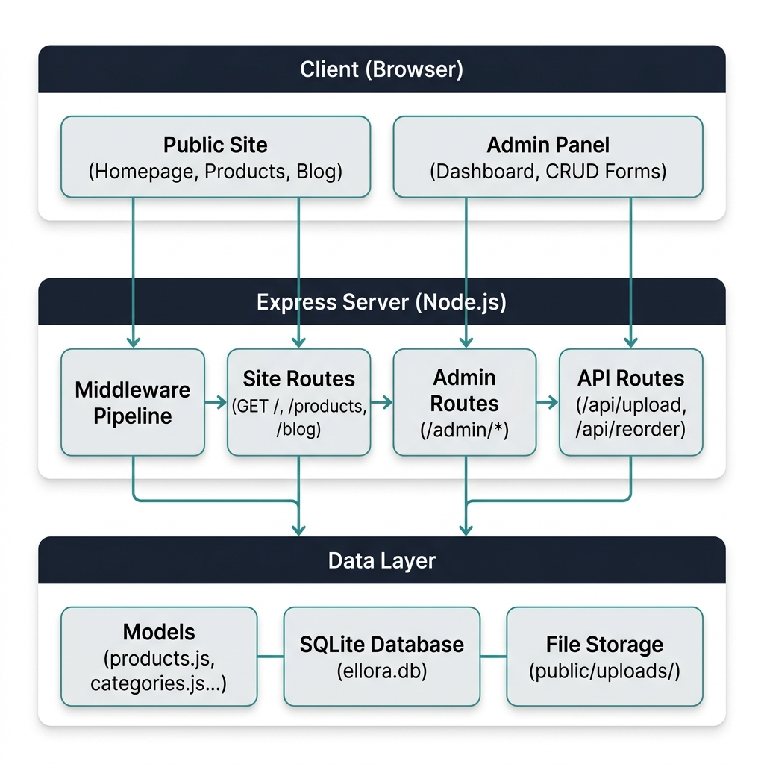

3.2 Request Flow
Every HTTP request follows this sequence through the server:
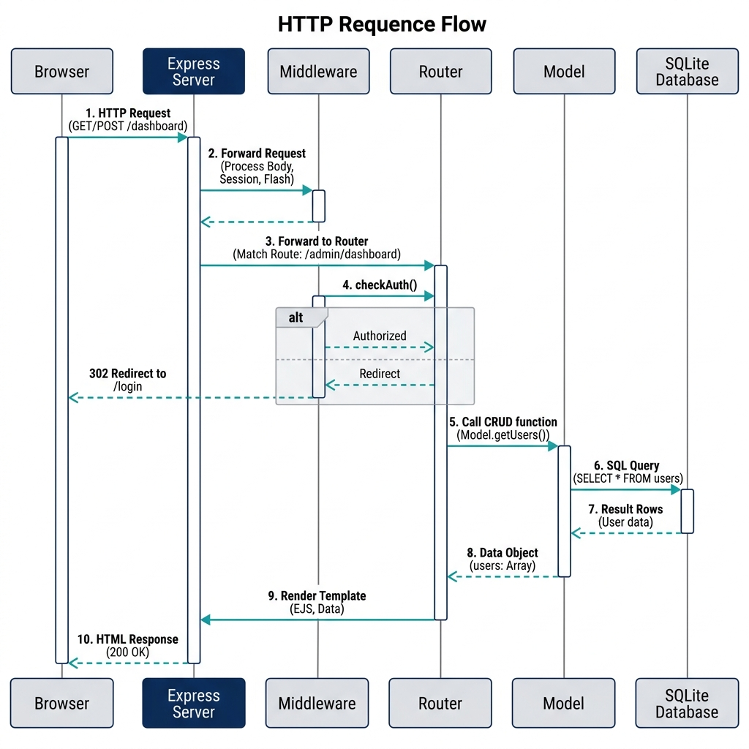

4. Database Schema
The SQLite database (server/data/ellora.db) contains 14 tables. Below is the complete schema for each table.

4.1 users — Admin Accounts
Column | Type | Constraints | Description
id | INTEGER | PRIMARY KEY AUTOINCREMENT | Unique ID
name | TEXT | NOT NULL | Display name
email | TEXT | NOT NULL UNIQUE | Login email
password | TEXT | NOT NULL | bcrypt hashed password
role | TEXT | DEFAULT "admin" | Role (for future multi-role support)
created_at | DATETIME | DEFAULT CURRENT_TIMESTAMP | Account creation time

4.2 settings — Global Site Settings
Column | Type | Description
id | INTEGER | PRIMARY KEY (always 1)
site_title | TEXT | Browser tab title
meta_description | TEXT | SEO meta description
meta_keywords | TEXT | SEO keywords
favicon | TEXT | Path to favicon image
logo | TEXT | Path to header logo
logo_white | TEXT | Path to footer logo (white)
topbar_text | TEXT | Topbar announcement text
topbar_icon | TEXT | Font Awesome icon class
topbar_visible | INTEGER | 1 = show, 0 = hide
phone | TEXT | Contact phone number
email | TEXT | Contact email
copyright_text | TEXT | Footer copyright line

4.3 categories — Product Categories
Column | Type | Description
id | INTEGER | PRIMARY KEY AUTOINCREMENT
name | TEXT | Category name (e.g., "Men's Fashion")
slug | TEXT | URL-friendly slug (UNIQUE)
image | TEXT | Category image path
product_count | INTEGER | Display count
sort_order | INTEGER | Display order

4.4 products — All Products
Column | Type | Description
id | INTEGER | PRIMARY KEY AUTOINCREMENT
name | TEXT | Product name
slug | TEXT | URL slug (UNIQUE)
description | TEXT | Full description (HTML allowed)
price | REAL | Current selling price
original_price | REAL | Strikethrough / original price
image | TEXT | Main product image path
gallery | TEXT | JSON array of additional image paths
rating | REAL | Star rating (1-5)
categories | TEXT | Comma-separated category slugs
is_featured | INTEGER | 1 = show on homepage
is_highlighted | INTEGER | 1 = highlighted card style
sku | TEXT | Stock keeping unit
stock | INTEGER | Quantity in stock
sort_order | INTEGER | Display order
created_at | DATETIME | Creation timestamp

4.5 posts — Blog Posts
Column | Type | Description
id | INTEGER | PRIMARY KEY AUTOINCREMENT
title | TEXT | Blog post title
slug | TEXT | URL slug (UNIQUE)
content | TEXT | Full HTML content
excerpt | TEXT | Short summary
featured_image | TEXT | Image path
author | TEXT | Author name
status | TEXT | "published" or "draft"
published_at | DATETIME | Publish date
created_at | DATETIME | Creation timestamp

4.6 – 4.14 Additional Tables
Table | Key Columns | Purpose
testimonials | id, quote, author_name, author_role, author_image, rating, sort_order | Customer reviews / testimonials
faqs | id, question, answer, sort_order | Frequently asked questions
hero_sections | id, badge_text, heading, description, cta_text, cta_link, background_image | Hero banner content
offers | id, discount_text, title, description, image, cta_text, cta_link, sort_order | Best offer banners
special_discounts | id, label, discount_text, description, image, sort_order | Special discount banners
new_arrivals | id, title, image, link, sort_order | New arrival items
brands | id, name, logo, sort_order | Brand logos
social_links | id, platform, url, icon_class, sort_order | Social media links
footer_links | id, group_name, label, url, sort_order | Footer navigation groups

Entity Relationship Diagram
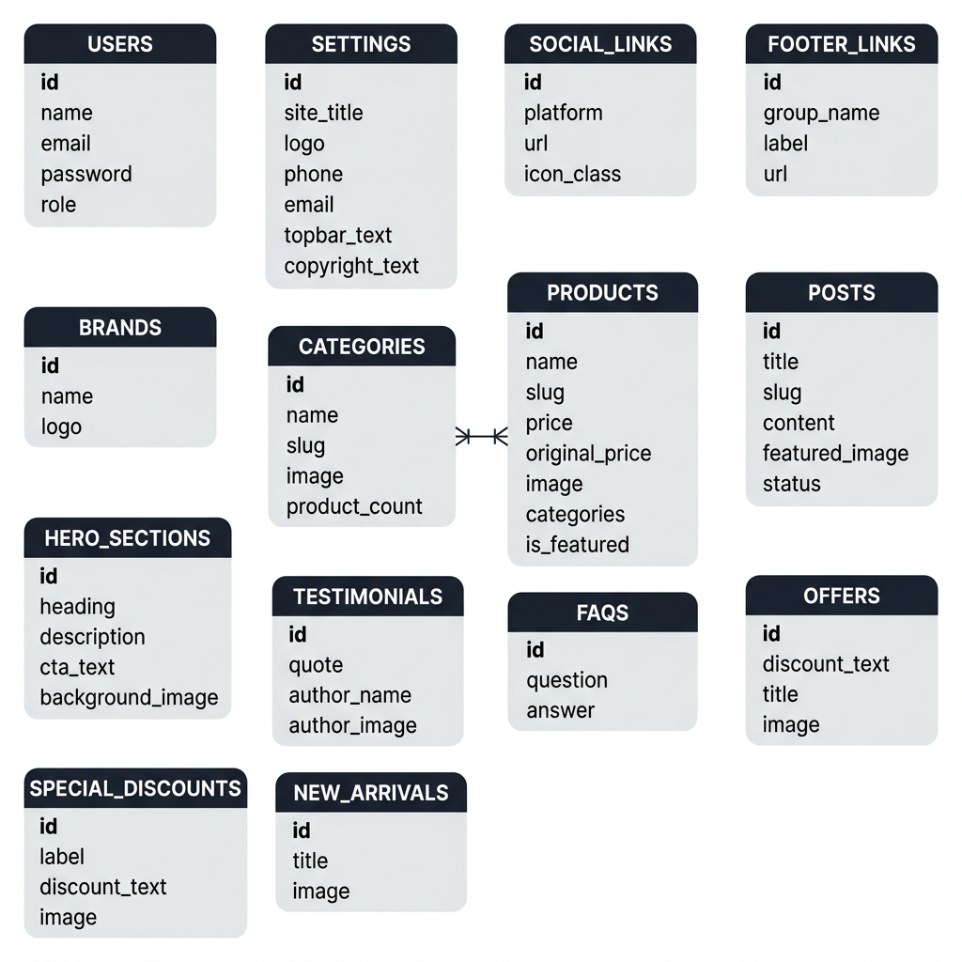

5. API Endpoints (All Routes)

5.1 Authentication Routes
Method | Path | Description | Auth?
GET | /admin/login | Show login form | No
POST | /admin/login | Process login (email + password) | No
GET | /admin/logout | Destroy session, redirect | Yes

5.2 Products Management
Method | Path | Description
GET | /admin/products | List all products (with search/filter)
GET | /admin/products/create | Show "Add Product" form
POST | /admin/products/create | Save new product to DB
GET | /admin/products/:id/edit | Show "Edit Product" form
POST | /admin/products/:id/edit | Update product in DB
POST | /admin/products/:id/delete | Delete product

5.3 Categories Management
Method | Path | Description
GET | /admin/categories | List all categories
GET | /admin/categories/create | Show add form
POST | /admin/categories/create | Save new category
GET | /admin/categories/:id/edit | Show edit form
POST | /admin/categories/:id/edit | Update category
POST | /admin/categories/:id/delete | Delete category

5.4 Blog Posts Management
Method | Path | Description
GET | /admin/posts | List all blog posts
GET | /admin/posts/create | Show add form
POST | /admin/posts/create | Save new post
GET | /admin/posts/:id/edit | Show edit form
POST | /admin/posts/:id/edit | Update post
POST | /admin/posts/:id/delete | Delete post

5.5 Testimonials & FAQs
Method | Path | Description
GET | /admin/testimonials | List all testimonials
POST | /admin/testimonials/create | Save new testimonial
POST | /admin/testimonials/:id/edit | Update testimonial
POST | /admin/testimonials/:id/delete | Delete testimonial
GET | /admin/faqs | List all FAQs
POST | /admin/faqs/create | Save new FAQ
POST | /admin/faqs/:id/edit | Update FAQ
POST | /admin/faqs/:id/delete | Delete FAQ

5.6 Section & Footer Management
Method | Path | Description
GET/POST | /admin/sections/hero | Edit hero banner
GET | /admin/sections/offers | Manage offer banners
POST | /admin/sections/offers/create | Add new offer
POST | /admin/sections/offers/:id/delete | Delete offer
GET | /admin/sections/arrivals | Manage new arrivals
GET | /admin/sections/discounts | Manage special discounts
GET | /admin/sections/brands | Manage brand logos
GET/POST | /admin/footer | Edit footer link groups
POST | /admin/footer/social | Save social media links
GET/POST | /admin/settings | Edit site-wide settings

5.7 File Upload & Public Routes
Method | Path | Description
POST | /api/upload | Upload image/video, returns file path
POST | /api/reorder | Update sort_order for drag-and-drop
GET | / | Homepage — reads all sections from DB
GET | /products | Product listing — filterable by category
GET | /product/:slug | Single product page
GET | /blog | Blog listing page
GET | /blog/:slug | Single blog post
GET | /about | About page
GET | /contact | Contact page
GET | /cart | Cart page
GET | /checkout | Checkout page
GET | /faqs | FAQs page
GET | /testimonials | Testimonials page
GET | /privacy-policy | Privacy policy page
GET | /terms-conditions | Terms & conditions page

6. Authentication & Security

6.1 Login Flow
The admin login follows a secure session-based authentication flow:
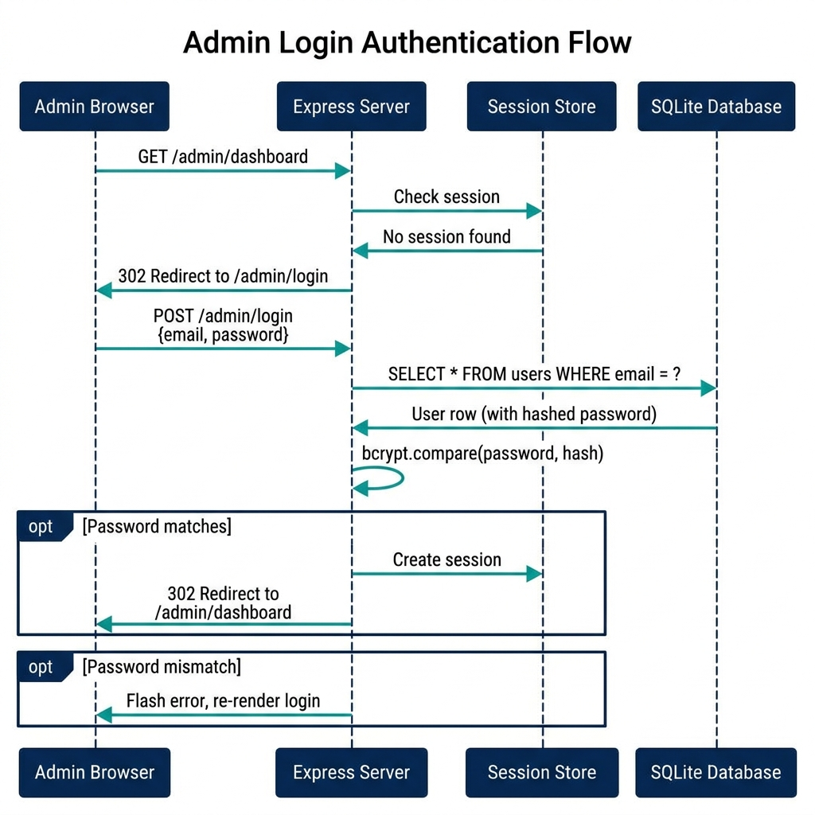

6.2 Security Measures
Measure | Implementation
Password hashing | bcryptjs with 12 salt rounds
Session security | httpOnly, secure (in production), sameSite: strict
CSRF protection | Unique tokens embedded in forms
Input sanitization | express-validator on all form inputs
File upload validation | multer file-type filter (jpg, png, svg, webp, gif only)
File size limit | Max 5 MB per upload
SQL injection prevention | better-sqlite3 uses parameterized queries by default
Rate limiting | Optional express-rate-limit on login endpoint

7. Middleware Pipeline
Every request passes through this middleware chain in order:
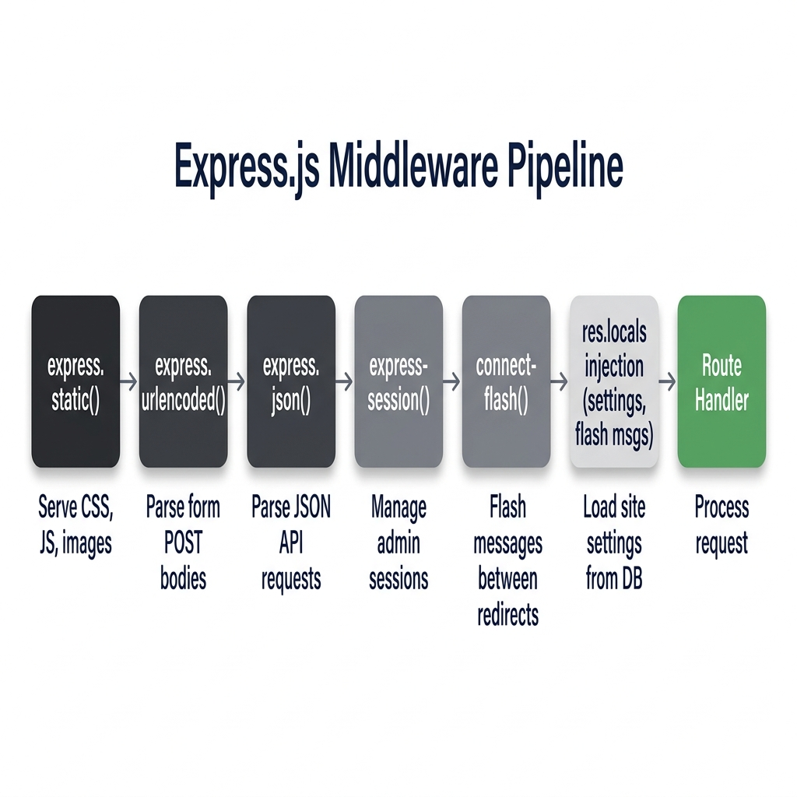
Order | Middleware | Purpose
1 | express.static("public") | Serve CSS, JS, images, uploads
2 | express.urlencoded({ extended: true }) | Parse form POST bodies
3 | express.json() | Parse JSON API requests
4 | express-session | Manage admin sessions
5 | connect-flash | Store flash messages between redirects
6 | Custom: injectGlobals | Load site settings from DB for all templates
7 | Custom: requireAuth | Protect /admin/* routes (except /admin/login)

requireAuth Middleware:
function requireAuth(req, res, next) {
if (req.session && req.session.userId) {
return next();
}
req.flash("error", "Please log in to access the admin panel.");
res.redirect("/admin/login");
}

8. Model Layer (Data Access)
Each model file exports pure functions that interact with SQLite. No ORM — direct SQL for performance and simplicity.

File | Entity | Key Functions
users.js | Admin accounts | findByEmail, create, verifyPassword
settings.js | Site settings | get, update (single-row table)
products.js | Products | getAll, getById, getBySlug, create, update, delete, getFeatured, count
categories.js | Categories | getAll, getById, create, update, delete
posts.js | Blog posts | getAll, getPublished, getBySlug, create, update, delete, count
testimonials.js | Testimonials | getAll, create, update, delete
faqs.js | FAQs | getAll, create, update, delete
sections.js | Hero, offers, etc. | getHero, updateHero, getOffers, createOffer, deleteOffer, etc.
footer.js | Footer content | getGroups, updateGroup, getSocialLinks, updateSocialLinks

Example — products.js Model:
const db = require("../config/db");

module.exports = {
getAll(filters = {}) {
let sql = "SELECT * FROM products";
const params = [];
if (filters.category) {
sql += " WHERE categories LIKE ?";
params.push(`%${filters.category}%`);
}
sql += " ORDER BY sort_order ASC, created_at DESC";
return db.prepare(sql).all(...params);
},

getById(id) {
return db.prepare("SELECT * FROM products WHERE id = ?").get(id);
},

create(data) { /* INSERT INTO products ... */ },
update(id, data) { /* UPDATE products SET ... WHERE id = ? */ },
delete(id) { /* DELETE FROM products WHERE id = ? */ },
count() { /* SELECT COUNT(*) ... */ },
getFeatured() { /* WHERE is_featured = 1 */ }
};

9. File Upload Strategy

9.1 Upload Flow
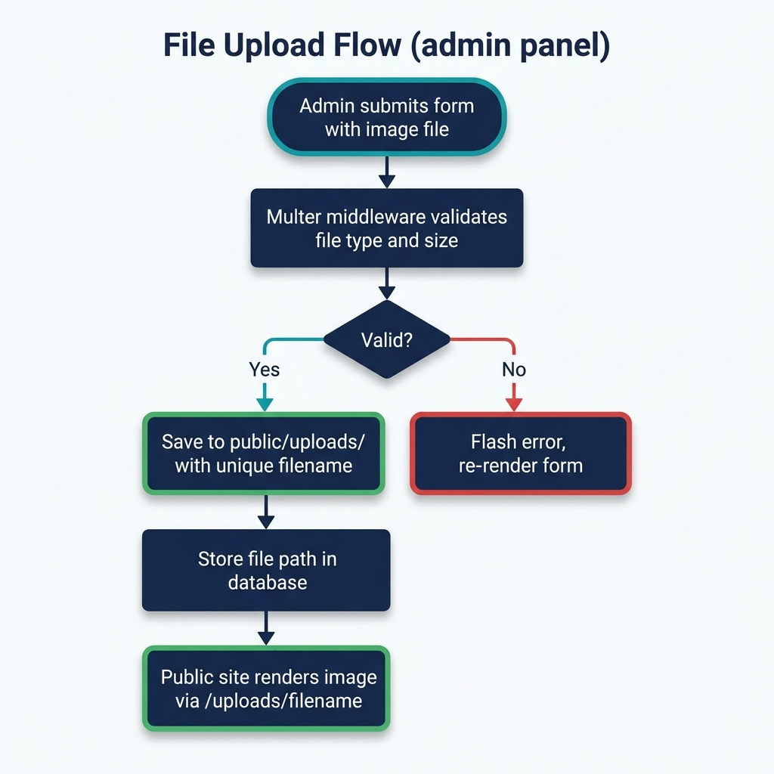

9.2 Upload Directory Structure
public/uploads/
├── products/ # Product images
├── categories/ # Category images
├── posts/ # Blog post featured images
├── testimonials/ # Author avatars
├── brands/ # Brand logos
├── sections/ # Hero, offers, discount banner images
└── general/ # Misc uploads (logo, favicon, etc.)

9.3 Multer Configuration
Setting | Value
Storage | diskStorage — saves to public/uploads/ with unique timestamped filenames
Allowed types | image/jpeg, image/png, image/svg+xml, image/webp, image/gif
Max file size | 5 MB (5,242,880 bytes)
Naming | timestamp + random number + original extension

10. Data Seeding
On first run, server/seed.js parses the existing HTML template content and populates the database so the dynamic site looks identical to the original.
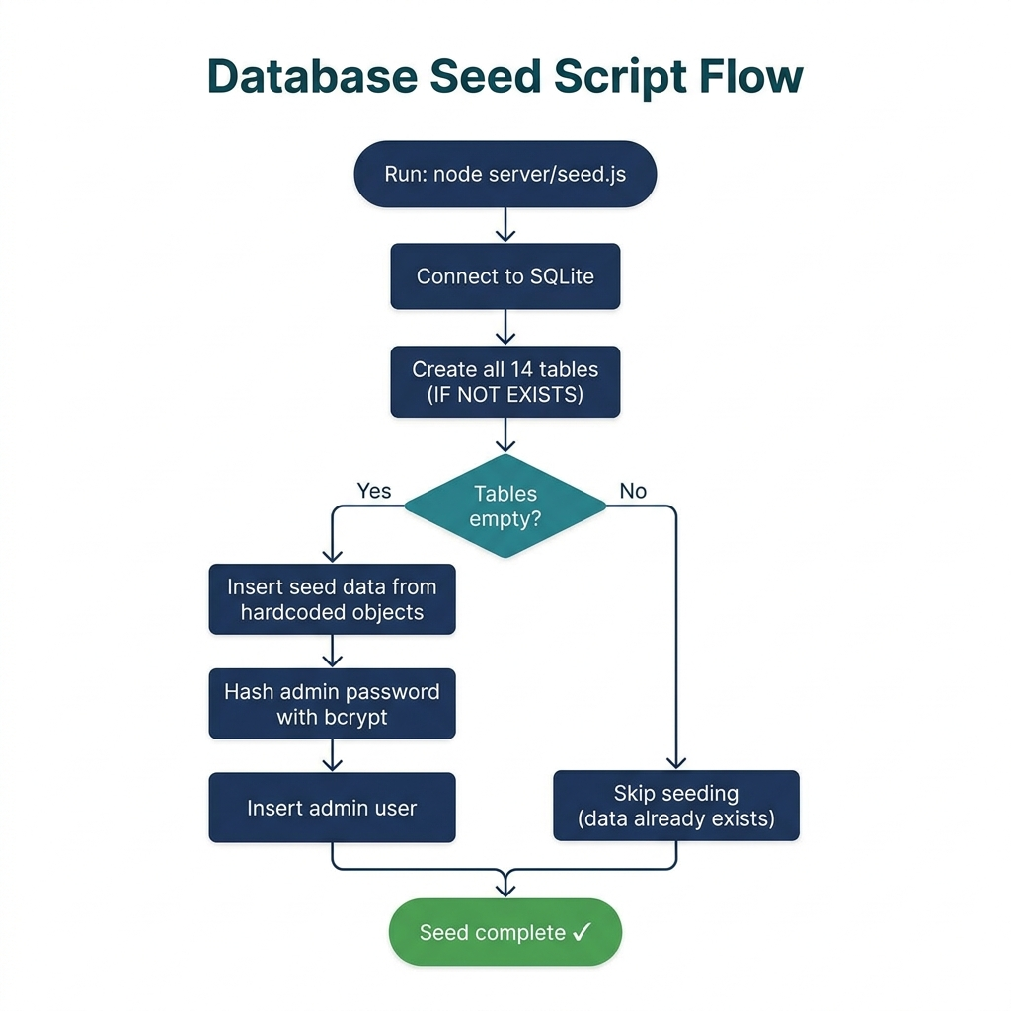

10.1 Seed Data Summary
Table | Source | Count
users | Hardcoded credentials | 1 admin user
settings | index.html header/footer | 1 settings row
categories | Categories section | 5 categories
products | Products section | 8 featured products
posts | Blog section | 3 blog posts
testimonials | Testimonials section | 3 testimonials
faqs | FAQ section | 5 FAQ items
hero_sections | Hero section | 1 hero banner
offers | Best Offers section | 3 offer banners
special_discounts | Special Discount section | 3 discount banners
new_arrivals | New Arrivals section | 4 arrival items
brands | Brands section | 8 brand logos
social_links | Footer | 4 social links
footer_links | Footer | 3 link groups (12 links total)

11. Admin Panel UI Architecture
The admin panel uses a sidebar layout with EJS partials. All admin pages share a common layout with a dark sidebar, top navigation bar, and main content area.

11.1 Admin Sidebar Navigation
Icon | Menu Item | Route
📊 | Dashboard | /admin/dashboard
📦 | Products | /admin/products
📂 | Categories | /admin/categories
📝 | Blog Posts | /admin/posts
💬 | Testimonials | /admin/testimonials
❓ | FAQs | /admin/faqs
🖼️ | Page Sections → Hero Banner | /admin/sections/hero
🖼️ | Page Sections → Best Offers | /admin/sections/offers
🖼️ | Page Sections → New Arrivals | /admin/sections/arrivals
🖼️ | Page Sections → Special Discounts | /admin/sections/discounts
🖼️ | Page Sections → Brand Logos | /admin/sections/brands
🔗 | Footer | /admin/footer
⚙️ | Settings | /admin/settings
🚪 | Logout | /admin/logout

11.2 View Template Structure
views/admin/
├── layout.ejs ← Master layout (sidebar + topbar + content area)
├── login.ejs ← Standalone login page
├── dashboard.ejs ← Stats cards + recent activity
├── products/
│ ├── index.ejs ← Data table with search, filter
│ └── form.ejs ← Shared add/edit form
├── categories/
│ ├── index.ejs
│ └── form.ejs
├── posts/
│ ├── index.ejs
│ └── form.ejs
├── testimonials/
│ ├── index.ejs
│ └── form.ejs
├── faqs/
│ ├── index.ejs
│ └── form.ejs
├── sections.ejs ← Tabbed interface for hero, offers, etc.
├── footer.ejs ← Edit footer link groups + social links
└── settings.ejs ← Site title, logo, meta, topbar

12. Server Entry Point

12.1 Initialization Flow
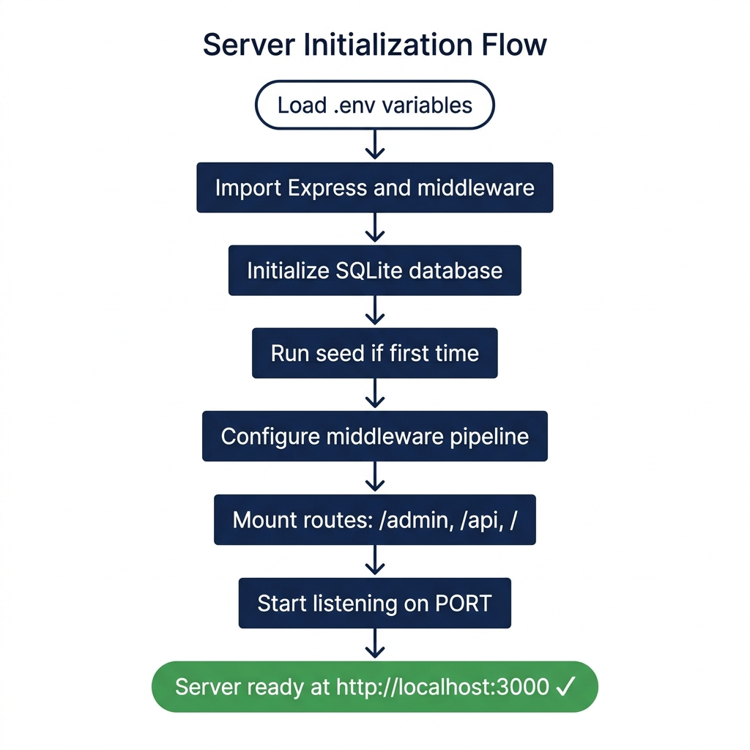

12.2 app.js Pseudocode
require("dotenv").config();
const express = require("express");
const session = require("express-session");
const flash = require("connect-flash");
const path = require("path");

const app = express();

// View engine
app.set("view engine", "ejs");
app.set("views", path.join(__dirname, "../views"));

// Static files
app.use(express.static(path.join(__dirname, "../public")));

// Body parsing, session, flash middleware...

// Global template variables (settings, flash, auth status)

// Routes
app.use("/admin", require("./routes/admin"));
app.use("/api", require("./routes/api"));
app.use("/", require("./routes/site"));

// Start
const PORT = process.env.PORT || 3000;
app.listen(PORT, () => {
console.log(`Server running at http://localhost:${PORT}`);
console.log(`Admin panel at http://localhost:${PORT}/admin`);
});

13. Development Roadmap
The implementation is divided into 4 phases, each building on the previous:
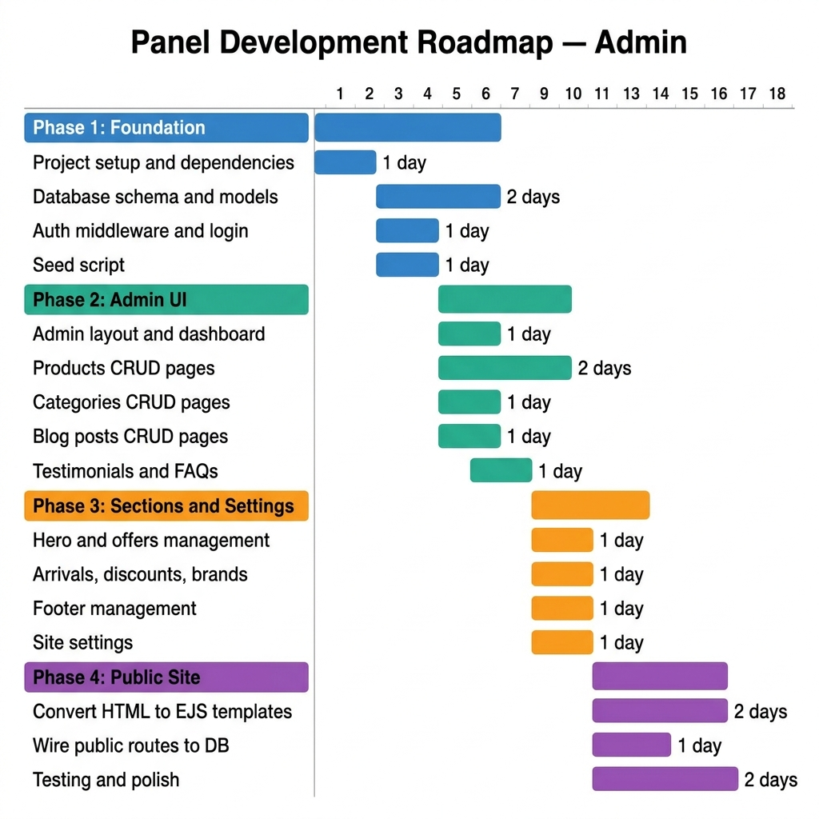

Phase | Focus | Duration | Key Deliverables
Phase 1 | Backend Foundation | ~5 days | Express app, SQLite schema, auth, seed data
Phase 2 | Admin CRUD | ~6 days | Dashboard, products, categories, posts, testimonials, FAQs
Phase 3 | Sections & Config | ~4 days | Hero, offers, discounts, brands, footer, settings
Phase 4 | Dynamic Public Site | ~5 days | Convert HTML to EJS, wire to DB, testing

14. Environment Configuration
.env File:
# Server
PORT=3000
NODE_ENV=development

# Session
SESSION_SECRET=ellora-super-secret-key-change-me-in-production

# Default Admin (used only during first seed)
ADMIN_NAME=Admin
ADMIN_EMAIL=admin@ellora.com
ADMIN_PASSWORD=admin123

# Upload
MAX_FILE_SIZE=5242880
UPLOAD_DIR=public/uploads

15. Summary & Metrics
Metric | Value
Total database tables | 14
Total API routes | 40+
Admin panel pages | 15+
Public site pages | 15+
npm dependencies | 10 (production) + 1 (dev)
Estimated development | ~15-20 days (4 phases)
Database size (initial) | ~50 KB (ellora.db)
External services required | None — everything runs locally
Default admin credentials | admin@ellora.com / admin123
Server command | npm start or node server/app.js

This architecture is designed to be simple, maintainable, and self-contained. No Docker, no cloud services, no external databases. Just run npm start and everything works.

