***ASSIGNMENT – 5***

**1. Install Docker on Windows desktop and Pull Helloworld image from Docker HUB**

**Write about following concepts in Docker**

1. **Docker Image 2. Docker Container 3. Docker File.**

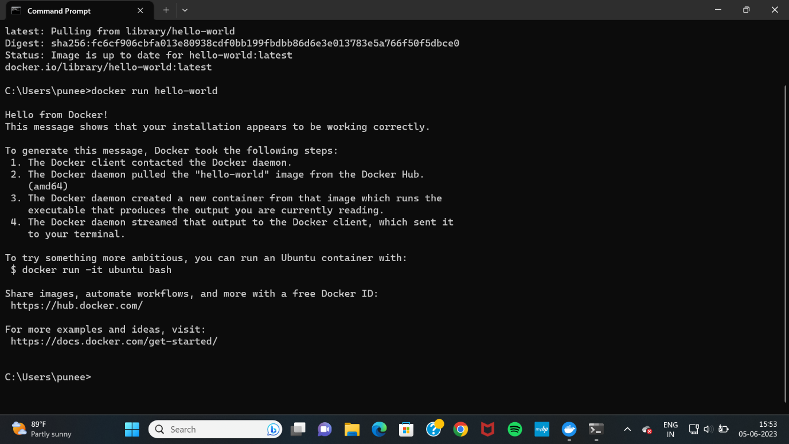

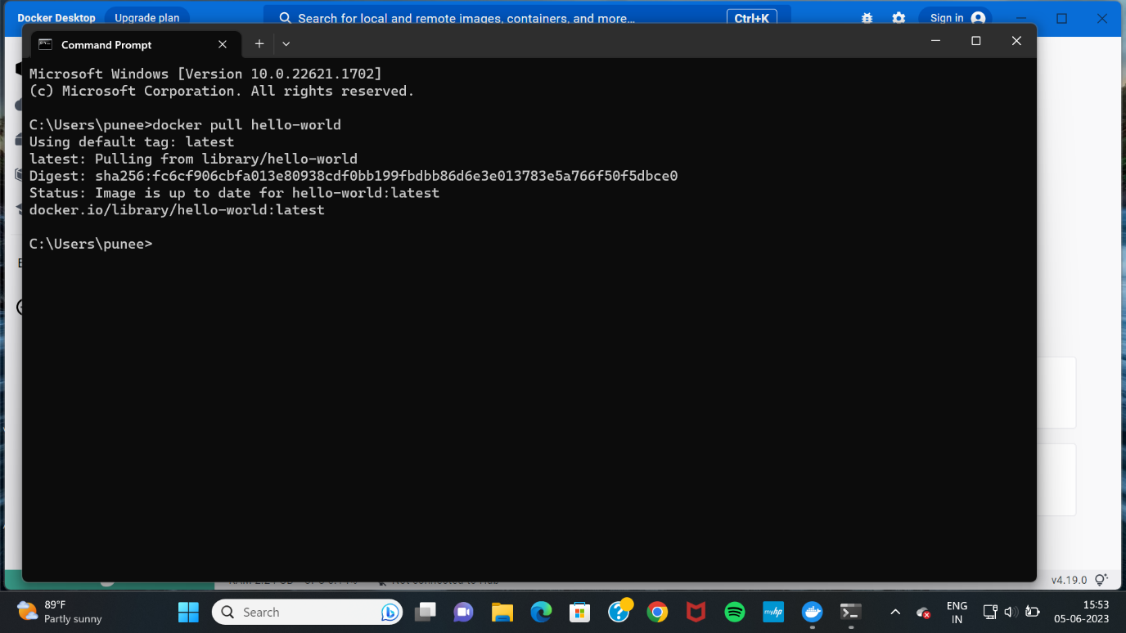

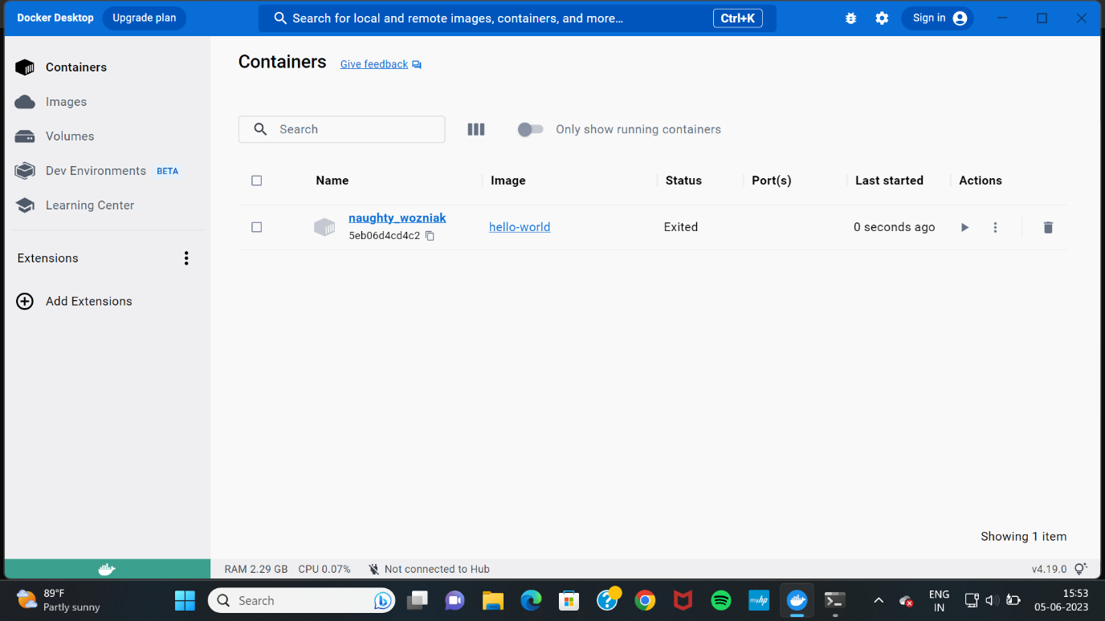

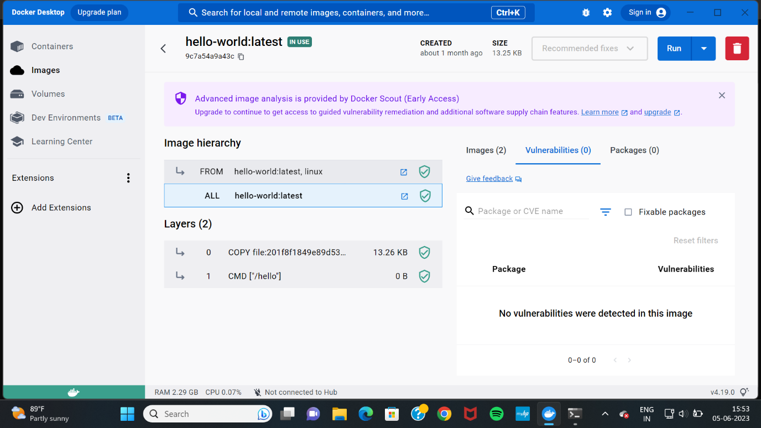

1. Docker Image: A Docker image is a file used to execute code in a Docker container. It acts as a set of instructions to build a Docker container, like a template . You can create a Docker image using different methods such as using the `docker commit` command to take a container and produce a new image from it or by creating a `Dockerfile` and running the `docker build` command in the terminal ¹.

2. Docker Container: A Docker container is an isolated and secure application platform that can share and access resources running in a different host or container⁵. It is created from a Docker image and contains everything needed to run an application.

3. Docker file: A `Docker file` is a text document that contains all the commands a user could call on the command line to assemble an image. It is used to create a Docker image of the application and download all the necessary dependencies needed for the application to run successfully .

**2.Write Simple Python Program and do unit testing with PYUNIT.**

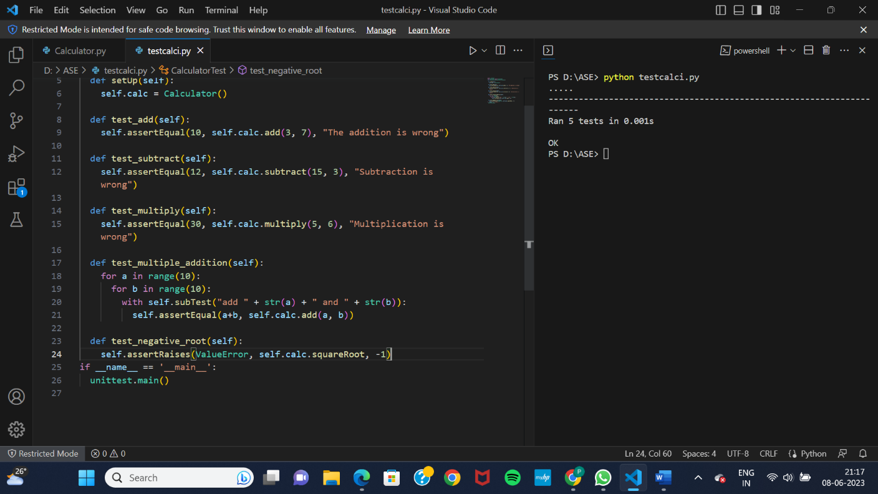

**3.Write Python Program and store in GIT/GITHUB.** 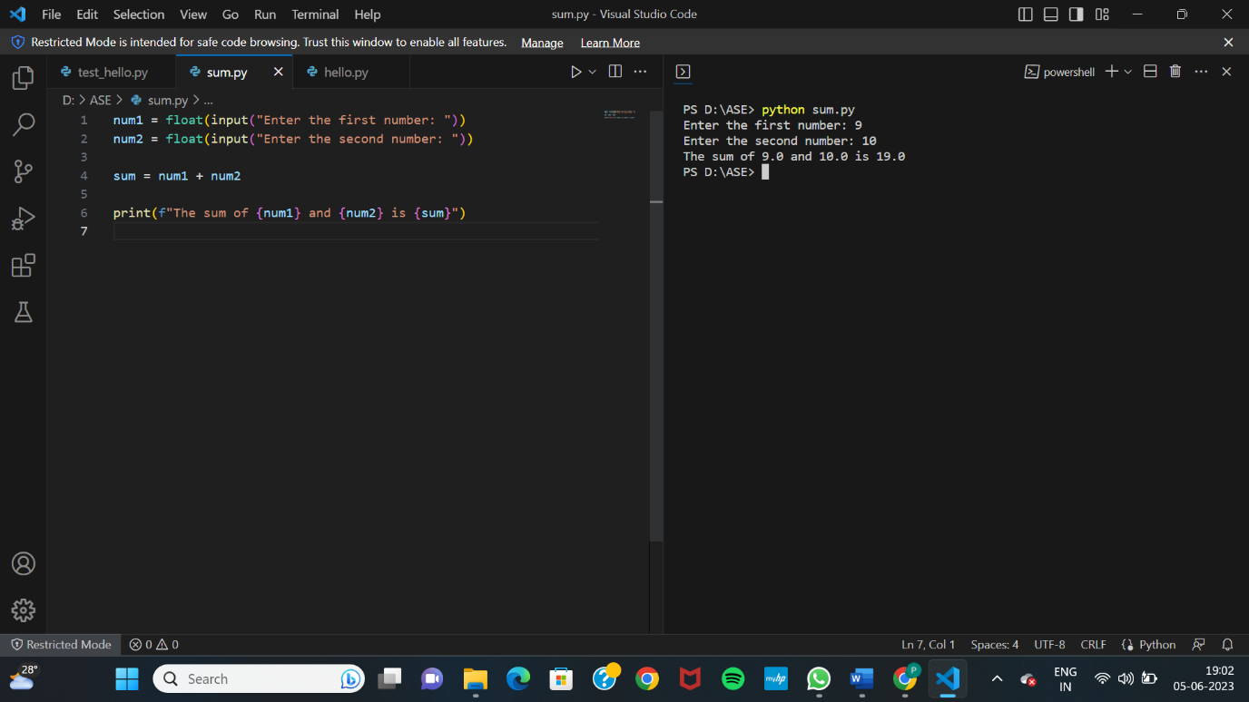

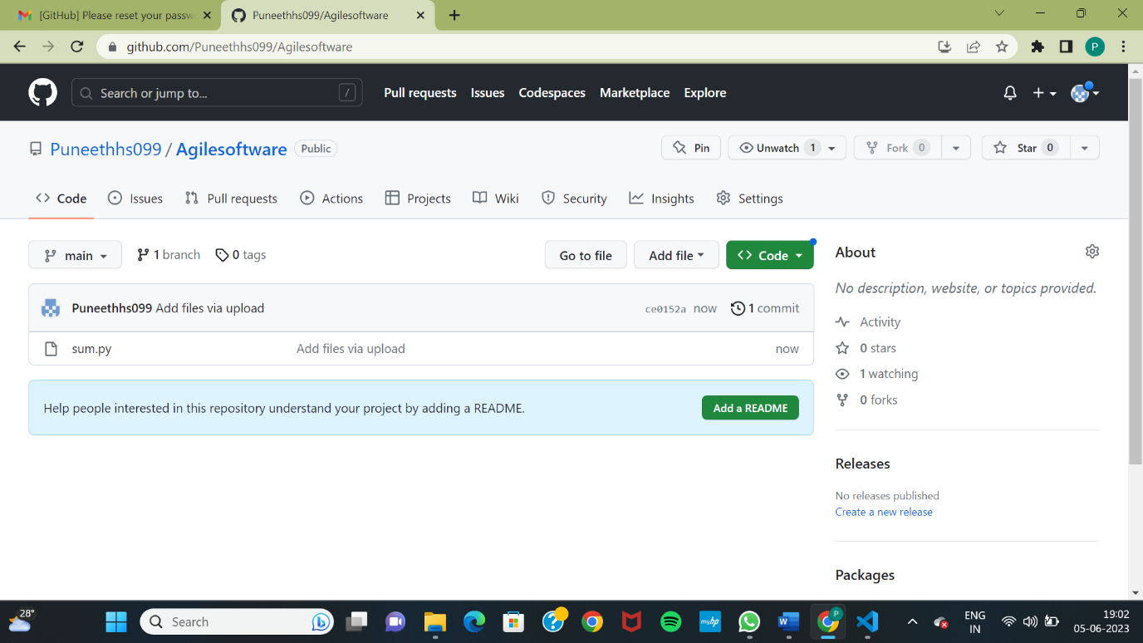

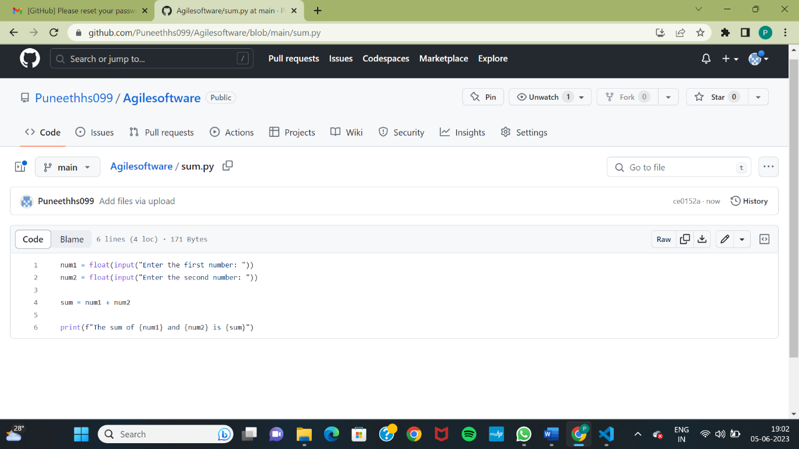

**4. What is Maven?**

Maven is a powerful project management tool that can be used to manage a project's build, reporting, and documentation from a central piece of information . It provides developers with a complete build lifecycle framework and simplifies the build process .

**5. What is JENKINS ?**

[Jenkins is an open-source continuous integration/continuous delivery and deployment (CI/CD) automation software DevOps tool](https://www.techtarget.com/searchsoftwarequality/definition/Jenkins). [It is used to implement CI/CD workflows, called pipelines, which automate testing and reporting on isolated changes in a larger code base in real-time](https://www.techtarget.com/searchsoftwarequality/definition/Jenkins). [Jenkins can help teams practicing Agile by providing access to working copies of software and supporting the Agile principle](https://www.udemy.com/course/jenkins-tutorial-for-beginners-devops-and-developers/).