**Purpose of the document:**

The document explains the low level and high level design for the Expense calculator application.

This is a Qt application intended to run on Desktop environment (Windows, Linux and Mac)

Application overview:

The inspiration for this application is to keep track of the monthly expenses and savings.

This will help us in identifying areas where we can reduce our expenses and increase our savings.

The application main page will display as below (rough screen)

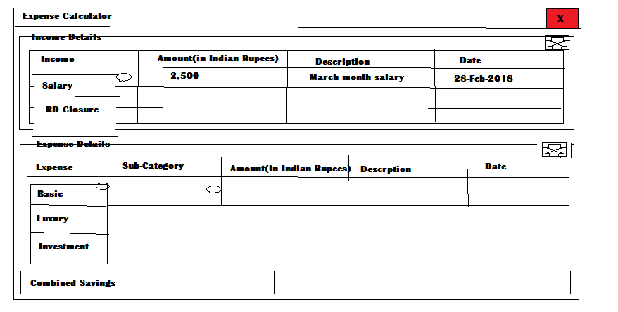

SQLite database is used to store the data.

Following tables would be needed

1: Categories

|  |  |  |
| --- | --- | --- |
| Category | Category Type | Subcategory |
| Salary | Income |  |
| RD Closure | Income |  |
| Basic | Expense | Grocery & household expenses |
| Basic | Expense | Baby Expenses |
| Basic | Expense | House rent |
| Basic | Expense | Gym |
| Basic | Expense | Doctor |
| Basic | Expense | Insurance premium |
| Luxury | Expense | Personal goods & clothing |
| Luxury | Expense | Vacations |
| Luxury | Expense | Restaurants |
| Luxury | Expense | EMI |
| Investment | Expense | Savings EMI |
| Investment | Expense | LIC premium |

2: Income table

|  |  |  |  |  |
| --- | --- | --- | --- | --- |
| Transaction Id(Primary Key) | Income category | Amount | Description | Date |
| Integer | Varchar(20) | Integer | Varchar(20) | Date |

3: Expense table

|  |  |  |  |  |  |
| --- | --- | --- | --- | --- | --- |
| Transaction Id(Primary Key) | Expense category | Expense sub category | Amount | Description | Date |
| Integer | Varchar(20) | Varchar(20) | Integer | Varchar(20) | Date |

The below collection of classes are required for implementation: