DBS Synopsis
Presented by
1.Puneeth N Naik(1ms15cs093)
2.Paritosh Gupta(1ms15cs083)
Inventory Management System

Abstract

The What of 'Inventory Management'
Inventory management is the practice overseeing and controlling of the ordering, storage and use of components that a company uses in the production of the items it sells.
Inventory management is also the practice of overseeing and controlling of quantities of finished products for sale.
A business's inventory is one of its major assets and represents an investment that is tied up until the item sells.

The importance of Inventory management
The problem of Inventory management becomes evident for large companies. E-commerce companies, or courier companies like Fedex, Amazon, Flipkart have millions of inventory that go from one place to another.
Managing such massive amount of inventory becomes a hectic task.
Therefore most companies have a dedicated inventory management software to better track their inventory.
Inventory management Software also aim to increase the productivity and revenue of the company.

E-R Diagram
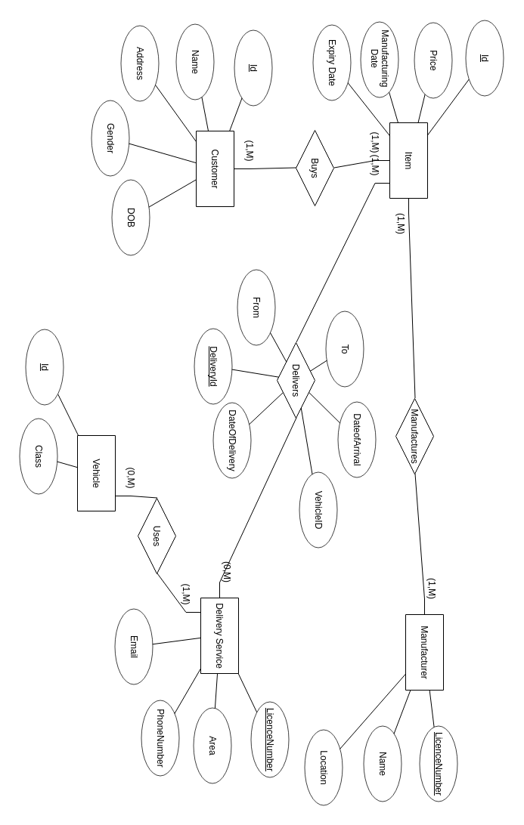

Project Deliverables

