**G – Organic**

* **The Natural Product**

**Team Mates**: **Puneethraj K (4VP21MC030)**

**Soorya Kumar M H (4VP21MC048)**

**CHAPTER – 1**

**INTRODUCTION**

**Project Overview**:

* To buy and sell the fruits online with no brokerage.
* Encouraging organic farming by supporting the organic fruits growing farmers.
* By providing competitive amount for the fruits in the market and selling with compititive price to the buyers the healthy fruits.
* In between storing the fruits in cold storage and quality check in all phases.

**Objective**:

* The farmers are registering into our portal and if the farmer is growing the fruits in **organic way** (Organic farming certified) **only be allowed to register** into our portal.
* We are going to buy their fruits by doing the **quality check** and it will be stored in **cold storage** and once again the quality check will be done and **shipping** should be done by Seller.
* The money will be collected from the **seller** based on the quantity of items sold.
* To **encourage organic farming**, **healthy life**, to give good price to our farmers efforts and to learn the **complete web application development life cycle** is the main objective

**Programming Languages**:

* Front-end: HTML, CSS, JS.
* Database: mySql.
* Back-end: PHP
* Web – Server: Apache
* Framework : angular-js.

**CHAPTER – 2**

**REQUIREMENT ANALYSIS**

**2.1 EXISTING AND PROPOSED SYSTEM**

**2.1.1 EXISTING SYSTEM**

The brokerage become the biggest problem for the farmers to sell their product considering this in mind and to encourage organic farming we are providing this software.

**2.1.2 PROPOSED SYSTEM**

Our Platform provides services like buying and selling fresh organic fruit directly from the organic farms to the customers doorstep by paying the amount mentioned by the farmers.

In our platform the farmers should get a membership in order to sell their products.

The membership cost is of low price (Farmer’s friendly) depending on the quantity of the product and they get access to our sell section

When it comes to buyer section, they can buy the fruits listed by multiple farmers by seeing the description and cost of the fruit and it will be delivered to the customers.

**Advantage:**

* No brokerage
* Fresh fruits (Organic certified by the Government)
* Easy access to platform for all the farmers and clients
* Direct fetching from the farms delivery to customers.

**2.2 TOOLS AND TECHNOLOGIES USED**

**2.2.1 TOOLS**

* **Visual Studio Code:**

Easy to write the codes because of the intellisense which makes the coding easier

And also, it provides multi language support and support multiple-platforms

* **XAMPP:**

A cross platform web-server, which helps us to test our application on a local server before deploying it, this feature reduces the future risk of our application

**2.2.2 TECHNOLOGY**

* For Backend PHP is used to write server-side script using php easily and effectively
* **Angular-js**: Used in validations

**2.3 HARDWARE AND SOFTWARE REQUIREMENTS**

**2.3.1 SOFTWARE REQUIREMENTS**

* IDE: Visual Studio Code
* XAMPP

**2.3.2 HARDWARE REQUIREMENTS**

* Processor: Dual Core or higher
* RAM: Minimum1GB
* Hard disk space: Minimum 1 GB
* Operating System: all operating systems

**CHAPTER – 3   
SOFTWARE REQUIREMENTS SPECIFICATION**

**3.1 INTRODUCTION:**

This Document provides guidelines regarding the components used to build our software and also it helps to study the software when new developer wants to modify this software and by looking at this document, we get the clear-cut idea of the clients’ needs and whether our software is going to fulfil all those needs or not

It will be used by the designing team to design the client’s requirements in a easier way

So that it can be implemented easily without any dilemma.

It can be further used when we want to change the tech-stack and want to build using that stack it will be easier because we have this document. We can easily adopt the changes without chaos

**3.2 FUNCTIONAL REQUIREMENTS**

• **ADMIN**:

* Admin has complete power to handle the database. He/she can view the Farmers (Sellers) and Buyers complete information’s.
* They have all the access to the software
* **FARMER(SELLER)**:

The farmer is the seller. He can sell the fruits he has grown. The  
farmer must be an organic farmer. Once he gets in to our platform to sell his fruits,  
he/she has to register himself for further process.

▪ **Registration**:

1. User Name
2. Address
3. Phone number
4. Create Password
5. Confirm Password

▪ **Login**:

1. User Name
2. Password  
   Once the Registration and login process is done, the sell section will be activated for the sellers.

▪ **Sell**:

1. Fruit Name
2. Fruit Description
3. Fruit Image
4. Price
5. All their selling’s will be listed

• **Buyer**:

Buyer is person who buys the fruits from our platform. He/she can view the  
fruits in the platform but he/she cannot buy the products before registration. Once he/she  
clicks the buy now or add to cart button that located below the fruits image, it will open  
the registration/login from if they are not registered/logged in.

▪ **Registration**:

1. User Name
2. Address
3. Phone number
4. Create Password
5. Confirm Password

▪ **Buy:**

1. Select Quantity
2. Place Order
3. Cash On Delivery Only

▪ **Login**

1. User Name
2. Password  
   After that he/she can buy the fruits that he/she wish.

**3.3 NON-FUNCTIONAL REQUIREMENTS**

**Portability:**

* Our software is portable in all the platforms
* So that we can reach maximum clients

**Usability:**

* User friendly given with instructions (How to use)
* So that it will be easier for the farmers to know our platform better

**Reliability:**

* Our Software is reliable that we not share our user information’s
* We will provide additional security for user information’s

**Scalability:**

* We are going to develop this software which is scalable to any number

**Maintainability:**

* We are going to maintain our website regularly for the smooth experience of our clients
* We maintain all the information’s regularly, so that there is no threat and cyber theft
* By maintaining the website, we can maximise the life cycle of software and new changes in our application

**Natural Interface:**

* If there are any updation then there will be drastic updation, the users are not affected and their experience will be smoother.

**CHAPTER – 4   
ANALYSIS AND DESIGN**

**4.1 ER – DIAGRAM**

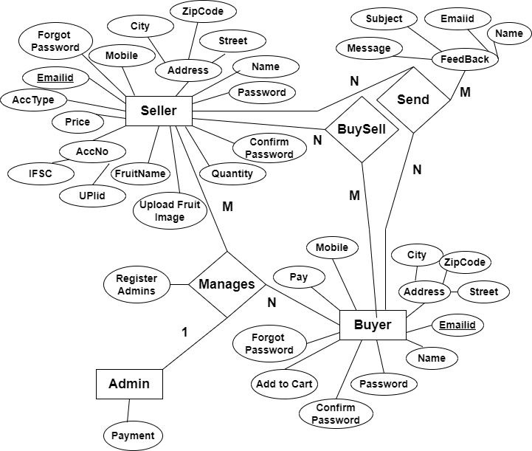

**4.2 DFD**

* To graphically document boundaries of a system.
* To provide hierarchy breakdown of the system.
* To show movement of information between a system and its environment.

**4.2.1 Seller**

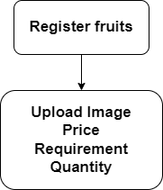

**4.2.2 ADMIN**

* **Payment**

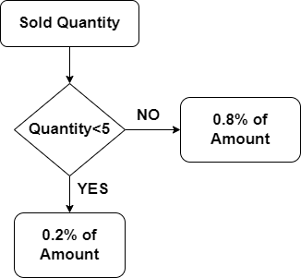

* **Verify**

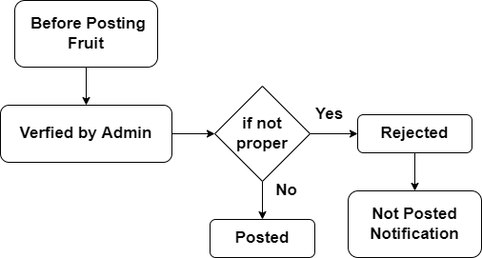

* **Account Settings**

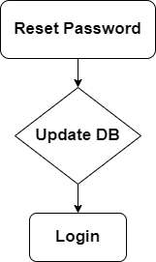

* **Buyer**

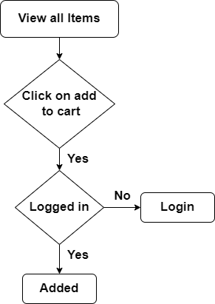

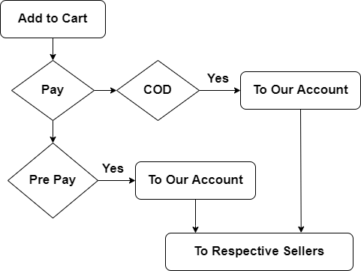

**4.2.3 REGISTRATION**

* **Buyer**

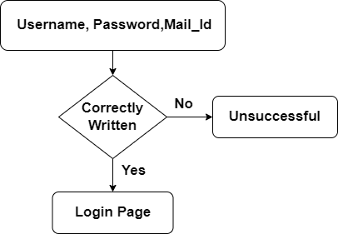

* **Seller**

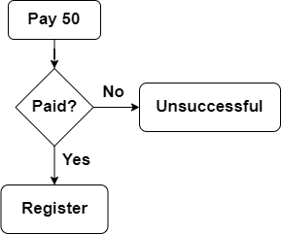

* **Login**

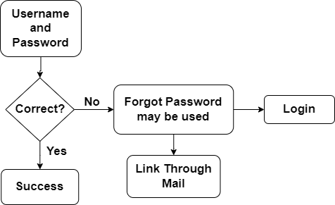

**CHAPTER – 5  
IMPLEMENTATION**

**5.1 BUYER**

Buyer is the one who take the Fruits from Our platform.

The seller adds the Fruits to Our platform which he has grown. G – Organic is the platform which is used for Sell as well as Buy the Fruits. It works without middle man. The seller itself sell the product in this platform. The Buyer look into the Fruits in our platform which is added by the seller and he also get the details of the seller. The seller also get the details of the buyer. So that they can easily communicate to transfer the Fruits.

The buyer can easily enter into our platform. He/She can visit and take the information of all the Fruits. If He/She like to buy that fruit, firstly he selects the Fruits and click to the “Buy here” button. It will redirect them to the data entry field. Here the buyer enters his/her details and next click the Cash On delivery option then check the terms and conditions. Once He/She checks the checkbox the button named “Place an Order” is enabled. Then only He/She will buy the Fruit.

**CHAPTER – 6  
TESTING**