Final Mini Project Report
SAP-1 Computer Architecture Implementation in Verilog
Course: Computer Architecture
Project: Simple-As-Possible-1 CPU with ADD, SUB, MUL, and DIV

1. Introduction
This report presents an SAP-1 CPU implementation using Verilog. SAP-1 stands for Simple-As-Possible-1 and is an educational computer architecture. The implementation is an 8-bit, single-bus, hardwired-control CPU with 16 bytes of memory. The main objective is to show how instructions are fetched, decoded, and executed using registers, memory, an ALU, and control signals.
The required reference program is LDA 3 followed by ADD 6. With the memory assumption Memory[3] = 4 and Memory[6] = 5, the final value in the A register should be 9. The ALU is also extended to support subtraction, multiplication, and division.

2. Architecture Overview
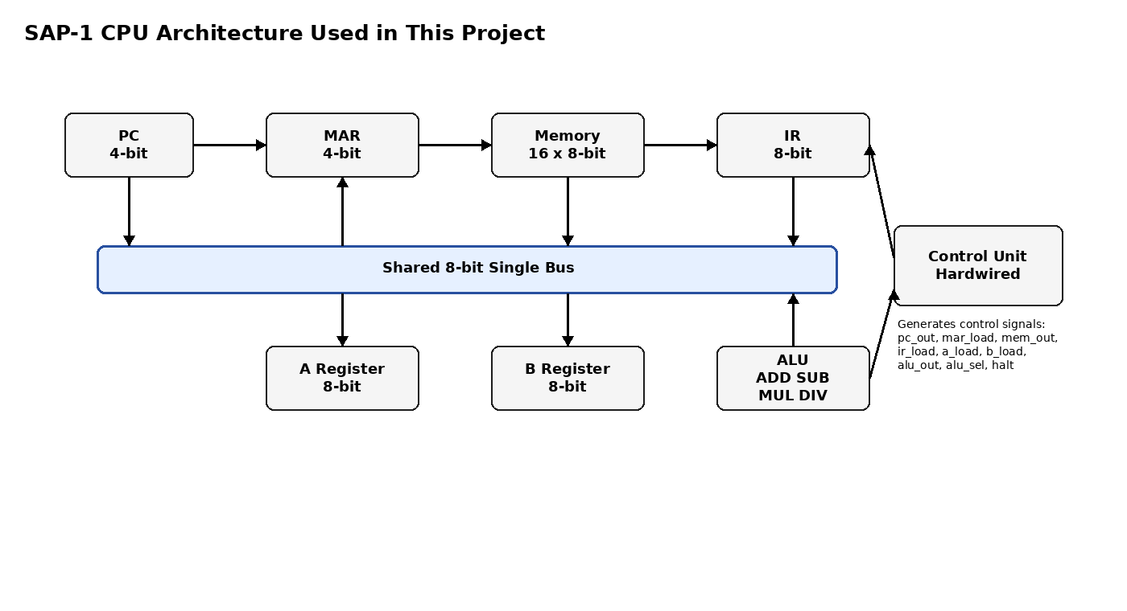

3. Module Breakdown
Module | Purpose
cpu.v | Top module. Connects the PC, MAR, memory, IR, A register, B register, ALU, bus multiplexer, and control unit.
control_unit.v | Hardwired control unit. Uses opcode and timing state to generate control signals.
program_counter.v | 4-bit PC. Stores the address of the next instruction and increments after instruction fetch.
register4.v | 4-bit register used for MAR. Holds the memory address.
register8.v | 8-bit register used for IR, A register, and B register.
memory.v | 16 x 8-bit memory. Stores both instructions and data.
alu.v | Arithmetic logic unit supporting ADD, SUB, MUL, and DIV.
bus_mux.v | Implements the shared 8-bit single bus using a multiplexer instead of internal tri-state buses.
sap1_tb.v | Testbench for the required ADD test and extra SUB, MUL, DIV random tests.

4. Instruction Format and Instruction Set
The memory size is 16 bytes, so each address uses 4 bits. Each instruction is 8 bits: the upper 4 bits are the opcode and the lower 4 bits are the operand address.
[ opcode ][ address ]
4 bits 4 bits
Instruction | Opcode | Meaning
LDA addr | 0001 | Load A register with Memory[addr].
ADD addr | 0010 | A = A + Memory[addr].
SUB addr | 0011 | A = A - Memory[addr].
MUL addr | 0100 | A = A * Memory[addr]. Lower 8 bits are kept.
DIV addr | 0101 | A = A / Memory[addr]. If divisor is zero, result is 0.
HLT | 1111 | Stop the CPU.

5. Control Signals
Signal | Meaning when signal is 1
pc_out | PC value is placed on the bus.
pc_inc | PC increments by 1 at the clock edge.
mar_load | MAR loads bus[3:0] at the clock edge.
mem_out | Memory data at address MAR is placed on the bus.
ir_load | IR loads the current bus value at the clock edge.
ir_out | IR operand IR[3:0] is placed on the bus.
a_load | A register loads the current bus value at the clock edge.
b_load | B register loads the current bus value at the clock edge.
alu_out | ALU result is placed on the bus.
alu_sel | Selects ALU operation: 00 ADD, 01 SUB, 10 MUL, 11 DIV.
halt | CPU stops changing timing states.

6. Timing Steps for Required Program
The required program and memory are:
Memory[0] = 13h // LDA 3
Memory[1] = 26h // ADD 6
Memory[2] = F0h // HLT
Memory[3] = 04h // data = 4
Memory[6] = 05h // data = 5
The CPU uses a repeated fetch cycle followed by an execution cycle. The final expected result is A = 09h.
Timing step | Active control signals | Operation and result
LDA T0 | pc_out = 1, mar_load = 1 | PC outputs 0 to the bus. MAR loads 0, so the next memory access uses address 0.
LDA T1 | mem_out = 1, ir_load = 1, pc_inc = 1 | Memory[0] outputs 13h. IR loads 13h, meaning opcode = LDA and operand = 3. PC increments from 0 to 1.
LDA T2 | ir_out = 1, mar_load = 1 | IR operand 3 is placed on the bus. MAR loads 3.
LDA T3 | mem_out = 1, a_load = 1 | Memory[3] outputs 04h. A register loads 04h. The LDA instruction is complete.
ADD T0 | pc_out = 1, mar_load = 1 | PC outputs 1 to the bus. MAR loads 1.
ADD T1 | mem_out = 1, ir_load = 1, pc_inc = 1 | Memory[1] outputs 26h. IR loads 26h, meaning opcode = ADD and operand = 6. PC increments from 1 to 2.
ADD T2 | ir_out = 1, mar_load = 1 | IR operand 6 is placed on the bus. MAR loads 6.
ADD T3 | mem_out = 1, b_load = 1 | Memory[6] outputs 05h. B register loads 05h.
ADD T4 | alu_sel = 00, alu_out = 1, a_load = 1 | ALU calculates A + B = 04h + 05h = 09h. ALU result is placed on the bus and A loads 09h.
HLT T0 | pc_out = 1, mar_load = 1 | PC outputs 2 to the bus. MAR loads 2.
HLT T1 | mem_out = 1, ir_load = 1, pc_inc = 1 | Memory[2] outputs F0h. IR loads F0h, and PC increments to 3.
HLT T2 | halt = 1 | The control unit activates halt, and the CPU stops.

7. Simulation Result
The trace below summarizes the waveform values expected from behavioral simulation. In Vivado, the same signals should be added to the waveform window: clk, reset, pc, mar, ir, a_reg, b_reg, bus, t_state, alu_result, halt, and the control signals.
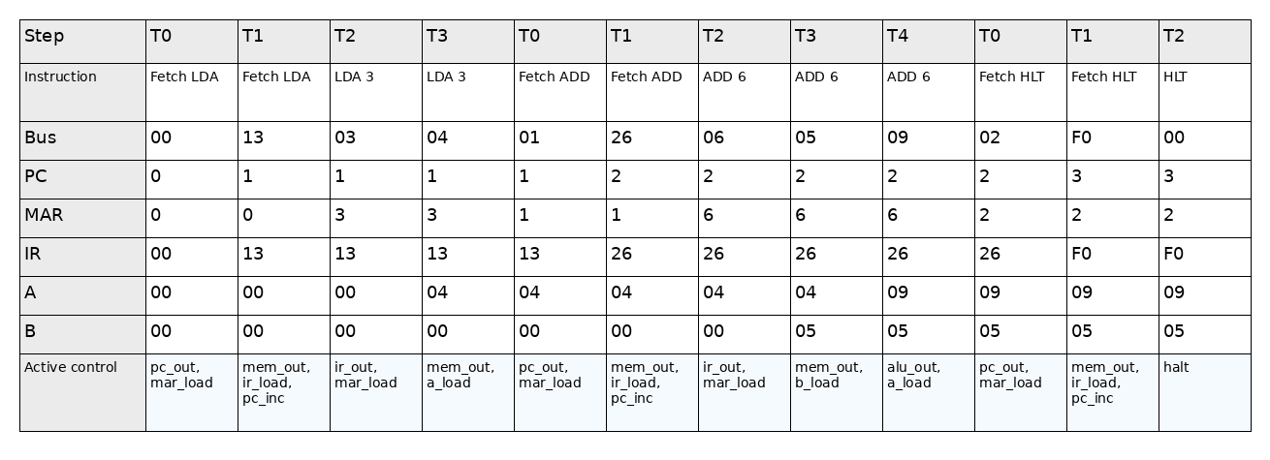
Important required result: after executing LDA 3 and ADD 6, the A register becomes 09h, which is decimal 9.

8. Extra Random Test Verification
Test | Program | Data | Expected final A
Addition | LDA 3; ADD 6; HLT | Memory[3] = 4, Memory[6] = 5 | 9
Subtraction | LDA 3; SUB 6; HLT | Memory[3] = 9, Memory[6] = 2 | 7
Multiplication | LDA 3; MUL 6; HLT | Memory[3] = 4, Memory[6] = 5 | 20
Division | LDA 3; DIV 6; HLT | Memory[3] = 10, Memory[6] = 2 | 5

9. Conclusion
This project successfully implements an SAP-1 style CPU using Verilog. The design uses an 8-bit single bus, 16-byte memory, hardwired control unit, PC, MAR, IR, A register, B register, and ALU. The required program LDA 3 followed by ADD 6 correctly loads 4 into A, loads 5 into B, and stores the ALU result 9 back into A. The ALU extension also supports SUB, MUL, and DIV for additional verification tests.

Appendix A: How to Capture the Vivado Waveform Screenshot
1. Open Vivado and create an RTL project. Add all source files except sap1_tb.v as design sources, then add sap1_tb.v as a simulation source.
2. Set sap1_tb as the simulation top and run Behavioral Simulation.
3. In the Objects window, add the important signals to the waveform: clk, reset, pc, mar, ir, a_reg, b_reg, bus, t_state, alu_result, halt, pc_out, mar_load, mem_out, ir_load, ir_out, a_load, b_load, alu_out, and alu_sel.
4. Zoom to the part where LDA 3 and ADD 6 are executed. Capture the screenshot and include it in the submitted report if your instructor specifically requires the real Vivado screenshot.

