

**ICS108 Project**

*Section 2*

*Created by:*

Ahmad Al-Ahmad (201969490)

Mohammed Al-Mohammedi (201971510)

**Project description:**

**This program has the ability to store questions and its answers. The user is provided with tools for editing, adding, and deleting questions. Additionally, the user can check their answer after choosing one.**

Solution Description:

First off, we created a launch window that prompts the user whether they want to add, delete, view, or edit questions to the program. A problem we faced was that the user could enter the edit menu when there we no questions, so we added an error text telling the user there wero no questions to edit, view, or delete, the were then prompted to add questions.

When the user presses the add button in the menu, there are multiple text boxes and radio buttons which the user can use to enter the information of the questions and chose the correct answer. A problem we faced was that when the user presses the button to add the question, the text box would not clear itself for another input, so we added a function to clear the text boxes when the user adds a question, so he can write the next question instantly.

The View button lets the user cycle through the created questions and answer them, there is a “check answer” button that checks the user’s choice and then informs whether it was the correct choice of not, we checked if the answer was correct by getting the text of the selection and comparing it t the answer parameter in the object.

The delete button is similar to the view button, it will show you the questions and let you cycle through them, but you cannot select an answer from the choices, it will only display them to you, there is a “delete” button that will delete the question you are viewing and then change the displayed question to the one with the first index.

The edit button is similar to the add button, but now you can cycle through the question and the content in the text boxes, you can edit the text in the text boxes and press the edit button which will rewrite the question object with these new values.

Screenshots:

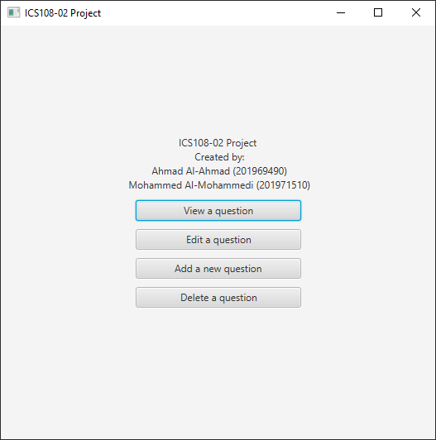Main menu:

Add:

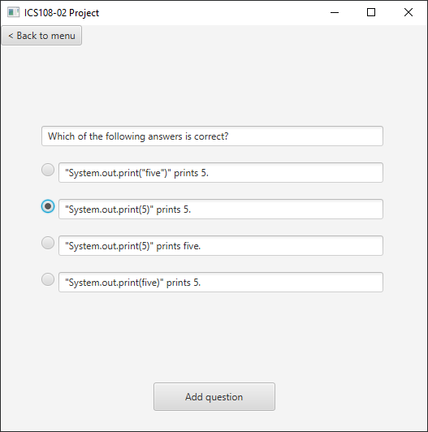

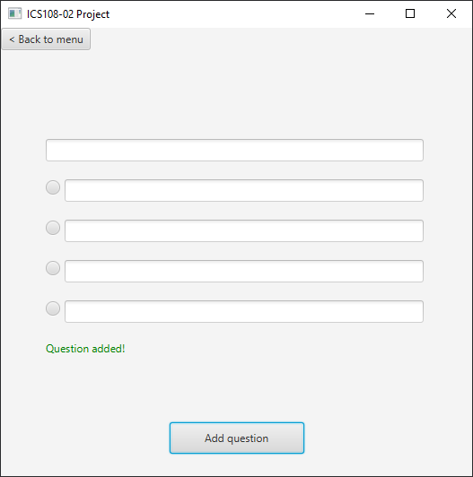

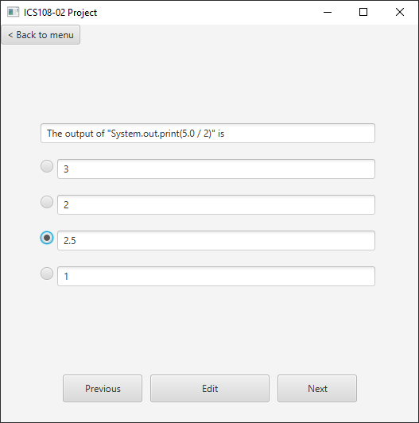Edit:

View:

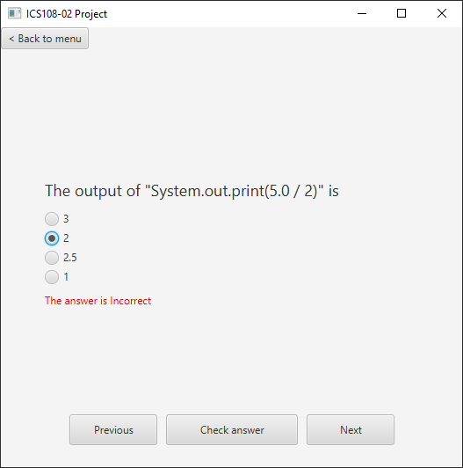

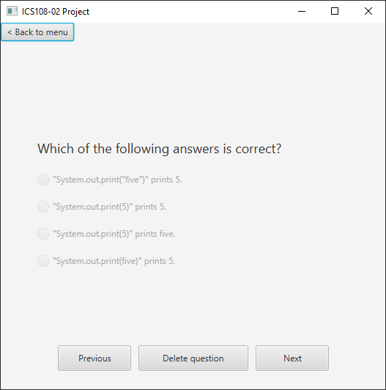Delete:

Work Distribution:

**Mohammad Al Mohammadi (50%):**

-Question class

-User interface

**Ahmad AlAhmad (50%):**

-Logic

-Binary files