- HOME PAGE:

<html>
<head>
<meta name="viewport" content="width=device-width, initial-scale=1.0">
<title> Cricket Pro Academy </title>
<link rel="stylesheet" href="https://stackpath.bootstrapcdn.com/bootstrap/4.5.2/css/bootstrap.min.css">
<link href="https://fonts.googleapis.com/css2?family=Poppins:wght@400;600;700&display=swap" rel="stylesheet">
<link rel="stylesheet" href="style.css">
<link rel="stylesheet" href="https://cdnjs.cloudflare.com/ajax/libs/font-awesome/5.15.4/css/all.min.css">
</head>
<body>

<nav class="navbar navbar-expand-lg navbar-dark bg-dark fixed-top">
<a href="Home.html" class="navbar-brand font-weight-bold">Cricket Pro Academy</a>
<button class="navbar-toggler" type="button" data-toggle="collapse" data-target="#nav">
<span class="navbar-toggler-icon"></span>
</button>
<div class="collapse navbar-collapse" id="nav">
<ul class="navbar-nav ml-auto">
<li class="nav-item"><a href="home.html" class="nav-link"> Home </a></li>
<li class="nav-item"><a href="fees.html" class="nav-link"> Training Programs </a></li>
<li class="nav-item"><a href="blog.html" class="nav-link"> cricket News/blogs </a></li>
<li class="nav-item"><a href="about us.html" class="nav-link"> About Us </a></li>
<li class="nav-item"><a href="register.html" class="nav-link"> Register </a></li>
<li class="nav-item"><a href="Login.html" class="nav-link"> Login </a></li>
</ul>
</div>
</nav>

<div style="height:56px"></div>

<!-- Hero -->
<section class="hero" style="background:url('1.jpg') center/cover no-repeat; padding:120px 0; color:white;">
<div class="container">
<div class="hero-content">
<h1>TRAIN LIKE A CHAMPION,<br>PLAY LIKE A PRO</h1>
<a href="fees.html" class="btn btn-success btn-lg mt-3">Join Now!</a>
</div>
</div>
</section>

<!-- About Section -->
<section id="about" class="py-5">
<div class="container">
<div class="row align-items-center">

<div class="col-md-6 mb-4 mb-md-0">
<img src="youngboys.jpeg" alt="About Cricket Academy" class="img-fluid rounded shadow">
</div>

<div class="col-md-6">
<h2 class="mb-3">About Us</h2>
<p>
<strong>Cricket Pro Academy</strong> is dedicated to grooming young talent with world-class cricket coaching.
Our certified coaches, modern training equipment, and competitive environment help players develop skills
for district, state, and national levels.
</p>
<a href="AboutUs.html" class="btn btn-success mt-3">Learn More</a>
</div>
</div>
</div>
</section>

<!-- Services Section -->
<section id="services" class="py-5 bg-light">
<div class="container">
<h2 class="text-center mb-5">Our Cricket Programs</h2>
<div class="row">

<div class="col-md-6 col-lg-3 mb-4">
<div class="card h-100 shadow">
<div class="card-body text-center">
<h4 class="card-title">Batting Coaching</h4>
<p class="card-text">Improve footwork, timing, and shot selection with professional batting sessions.</p>
<a href="News.html#batting" class="btn btn-success btn-sm">Read More</a>
</div>
</div>
</div>

<div class="col-md-6 col-lg-3 mb-4">
<div class="card h-100 shadow">
<div class="card-body text-center">
<h4 class="card-title">Bowling Coaching</h4>
<p class="card-text">Master swing, spin, pace, and accuracy with advanced bowling techniques.</p>
<a href="News.html#bowling" class="btn btn-success btn-sm">Read More</a>
</div>
</div>
</div>

<div class="col-md-6 col-lg-3 mb-4">
<div class="card h-100 shadow">
<div class="card-body text-center">
<h4 class="card-title">Fielding Training</h4>
<p class="card-text">Boost speed, reflexes, and catching with dedicated ﬁelding drills.</p>
<a href="News.html#fielding" class="btn btn-success btn-sm">Read More</a>
</div>
</div>
</div>

<div class="col-md-6 col-lg-3 mb-4">
<div class="card h-100 shadow">
<div class="card-body text-center">
<h4 class="card-title">Fitness & Conditioning</h4>
<p class="card-text">Enhance stamina and strength with tailored cricket-specific fitness routines.</p>
<a href="News.html#fitness" class="btn btn-success btn-sm">Read More</a>
</div>
</div>
</div>

</div>
</div>
</section>

<!-- Footer -->
<footer class="bg-dark text-light pt-5 pb-4 mt-5">
<div class="container text-md-left">
<div class="row text-md-left">

<div class="col-md-3 col-lg-3 col-xl-3 mx-auto mt-3">
<h5 class="text-uppercase mb-4 font-weight-bold text-success">Cricket Pro Academy</h5>
<p>
Train hard, play smart. Become the cricketer you dream to be with world-class coaching and facilities.
</p>
</div>

<div class="col-md-2 col-lg-2 col-xl-2 mx-auto mt-3">
<h5 class="text-uppercase mb-4 font-weight-bold text-success">Quick Links</h5>
<p><a href="Home.html" class="text-light" style="text-decoration:none;">Home</a></p>
<p><a href="about us.html" class="text-light" style="text-decoration:none;">About Us</a></p>
<p><a href="fees.html" class="text-light" style="text-decoration:none;">Tranning Programs</a></p>
<p><a href="blog.html" class="text-light" style="text-decoration:none;">Cricket News</a></p>
</div>

<div class="col-md-3 col-lg-2 col-xl-2 mx-auto mt-3">
<h5 class="text-uppercase mb-4 font-weight-bold text-success">Support</h5>
<p><a href="register.html" class="text-light" style="text-decoration:none;">Register</a></p>
<p><a href="Login.html" class="text-light" style="text-decoration:none;">Login</a></p>
<p><a href="#" class="text-light" style="text-decoration:none;">Privacy Policy</a></p>
<p><a href="#" class="text-light" style="text-decoration:none;">Terms & Conditions</a></p>
</div>

<div class="col-md-4 col-lg-3 col-xl-3 mx-auto mt-3">
<h5 class="text-uppercase mb-4 font-weight-bold text-success">Contact</h5>
<p><i class="fas fa-home mr-3"></i> Surat, Gujarat, India</p>
<p><i class="fas fa-envelope mr-3"></i> info@cricketpro.com</p>
<p><i class="fas fa-phone mr-3"></i> +91 98765 43210</p>
<p><i class="fas fa-clock mr-3"></i> Mon - Sat: 6AM - 10PM</p>
</div>
</div>

<hr class="mb-4">

<div class="row align-items-center">
<div class="col-md-7 col-lg-8">
<p>© 2025 <strong class="text-success">Cricket Pro Academy</strong> | All Rights Reserved</p>
</div>
<div class="col-md-5 col-lg-4">
<div class="text-center text-md-right">
<a href="#" class="mx-2"><i class="fab fa-facebook-f"></i></a>
<a href="#" class="mx-2"><i class="fab fa-instagram"></i></a>
<a href="#" class="mx-2"><i class="fab fa-twitter"></i></a>
<a href="#" class="mx-2"><i class="fab fa-youtube"></i></a>
</div>
</div>
</div>

</div>
</footer>
<!-- ====== Footer End ====== -->
</body>

</html>
output:


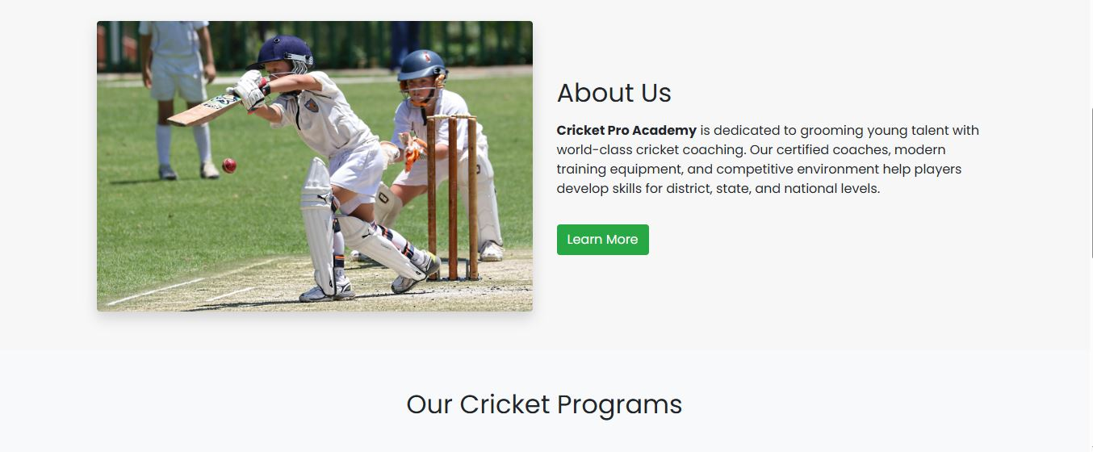

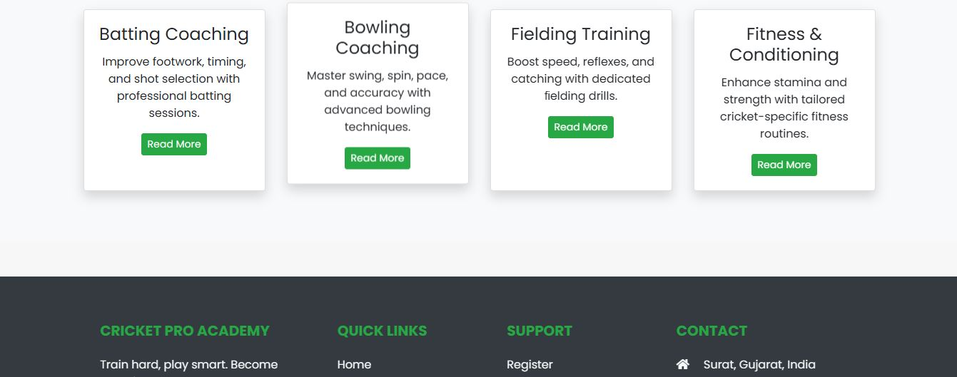

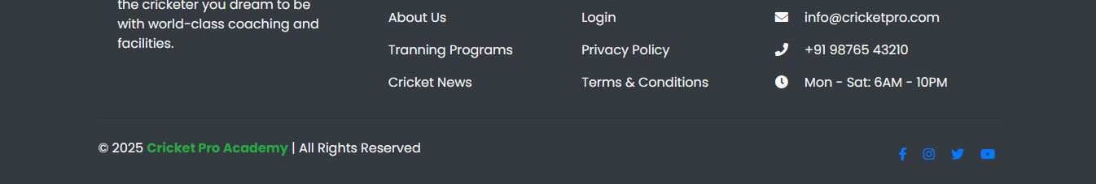

- FEES PAGE:
<html>
<head>
<meta name="viewport" content="width=device-width, initial-scale=1.0">
<title> Cricket Pro Academy - Training Plans </title>
<link rel="stylesheet" href="https://stackpath.bootstrapcdn.com/bootstrap/4.5.2/css/bootstrap.min.css">
<link rel="stylesheet" href="style.css">
<link href="https://fonts.googleapis.com/css2?family=Poppins:wght@400;600;700&display=swap" rel="stylesheet">
<link rel="stylesheet" href="https://cdnjs.cloudflare.com/ajax/libs/font-awesome/5.15.4/css/all.min.css">
</head>

<body>
<nav class="navbar navbar-expand-lg navbar-dark bg-dark fixed-top">
<a href="home.html" class="navbar-brand font-weight-bold">Cricket Pro Academy</a>
<button class="navbar-toggler" type="button" data-toggle="collapse" data-target="#nav">
<span class="navbar-toggler-icon"></span>
</button>
<div class="collapse navbar-collapse" id="nav">
<ul class="navbar-nav ml-auto">
<li class="nav-item"><a href="home.html" class="nav-link"> Home </a></li>
<li class="nav-item"><a href="blog.html" class="nav-link"> cricket News/blogs </a></li>
<li class="nav-item"><a href="about us.html" class="nav-link"> About Us </a></li>
<li class="nav-item"><a href="register.html" class="nav-link"> Register </a></li>
<li class="nav-item"><a href="Login.html" class="nav-link"> Login </a></li>
</ul>
</div>
</nav>

<div style="height:56px"></div>

<!-- Cricket Training Plans Section -->
<section class="py-5 bg-light">
<div class="container">
<h1 class="text-center mb-5">Cricket Coaching Plans</h1>
<div class="row">

<!-- Plan 1 -->
<div class="col-md-6 col-lg-3 mb-4">
<div class="card h-100 shadow text-center">
<div class="card-body">
<h3 class="card-title">Beginner Training</h3>
<p class="card-text">Basic batting, bowling, and fielding drills for new learners.</p>
<h4 class="mb-3">₹1,499 / month</h4>
<a href="#" class="btn btn-success">Enroll Now</a>
</div>
</div>
</div>

<!-- Plan 2 -->
<div class="col-md-6 col-lg-3 mb-4">
<div class="card h-100 shadow text-center">
<div class="card-body">
<h3 class="card-title">Intermediate Coaching</h3>
<p class="card-text">Advanced batting stance, spin & pace basics, fitness sessions.</p>
<h4 class="mb-3">₹2,499 / month</h4>
<a href="#" class="btn btn-success">Enroll Now</a>
</div>
</div>
</div>

<!-- Plan 3 -->
<div class="col-md-6 col-lg-3 mb-4">
<div class="card h-100 shadow text-center">
<div class="card-body">
<h3 class="card-title">Advanced Cricket Plan</h3>
<p class="card-text">Match simulations, power-hitting, swing bowling, agility training.</p>
<h4 class="mb-3">₹3,499 / month</h4>
<a href="#" class="btn btn-success">Enroll Now</a>
</div>
</div>
</div>

<!-- Plan 4 -->
<div class="col-md-6 col-lg-3 mb-4">
<div class="card h-100 shadow text-center">
<div class="card-body">
<h3 class="card-title">Elite Pro Plan</h3>
<p class="card-text">Personal coaching, video analysis, diet plan, strength training.</p>
<h4 class="mb-3">₹4,999 / month</h4>
<a href="#" class="btn btn-success">Enroll Now</a>
</div>
</div>
</div>

<!-- Plan 5 -->
<div class="col-md-6 col-lg-3 mb-4">
<div class="card h-100 shadow text-center">
<div class="card-body">
<h3 class="card-title">Annual Cricket Plan</h3>
<p class="card-text">1-year full access with tournaments, workshops & performance tracking.</p>
<h4 class="mb-3">₹24,999 / year</h4>
<a href="#" class="btn btn-success">Enroll Now</a>
</div>
</div>
</div>

</div>
</div>
</section>

<!-- Footer -->
<footer class="bg-dark text-light pt-5 pb-4 mt-5">
<div class="container text-md-left">
<div class="row text-md-left">

<div class="col-md-3 col-lg-3 col-xl-3 mx-auto mt-3">
<h5 class="text-uppercase mb-4 font-weight-bold text-success">Cricket Pro Academy</h5>
<p>Professional cricket coaching, performance development, and skill enhancement for all age groups.</p>
</div>

<div class="col-md-2 col-lg-2 col-xl-2 mx-auto mt-3">
<h5 class="text-uppercase mb-4 font-weight-bold text-success">Quick Links</h5>
<p><a href="Home.html" class="text-light" style="text-decoration:none;">Home</a></p>
<p><a href="about us.html" class="text-light" style="text-decoration:none;">About Us</a></p>
<p><a href="fees.html" class="text-light" style="text-decoration:none;">Tranning Programs</a></p>
<p><a href="blog.html" class="text-light" style="text-decoration:none;">Cricket News</a></p>
</div>

<div class="col-md-3 col-lg-2 col-xl-2 mx-auto mt-3">
<h5 class="text-uppercase mb-4 font-weight-bold text-success">Support</h5>
<p><a href="register.html" class="text-light">Register</a></p>
<p><a href="Login.html" class="text-light">Login</a></p>
<p><a href="#" class="text-light">Privacy Policy</a></p>
<p><a href="#" class="text-light">Terms & Conditions</a></p>
</div>

<div class="col-md-4 col-lg-3 col-xl-3 mx-auto mt-3">
<h5 class="text-uppercase mb-4 font-weight-bold text-success">Contact</h5>
<p><i class="fas fa-home mr-3"></i> Surat, Gujarat, India</p>
<p><i class="fas fa-envelope mr-3"></i> info@cricketacademy.com</p>
<p><i class="fas fa-phone mr-3"></i> +91 98765 43210</p>
<p><i class="fas fa-clock mr-3"></i> Mon - Sat: 6AM - 10PM</p>
</div>
</div>

<hr class="mb-4">

<div class="row align-items-center">
<div class="col-md-7 col-lg-8">
<p>© 2025 <strong class="text-success">Cricket Pro Academy</strong> | All Rights Reserved</p>
</div>
<div class="col-md-5 col-lg-4">
<div class="text-center text-md-right">
<a href="#" class="mx-2"><i class="fab fa-facebook-f"></i></a>
<a href="#" class="mx-2"><i class="fab fa-instagram"></i></a>
<a href="#" class="mx-2"><i class="fab fa-twitter"></i></a>
<a href="#" class="mx-2"><i class="fab fa-youtube"></i></a>
</div>
</div>
</div>
</div>
</footer>
</body>
</html>
OUTPUT:
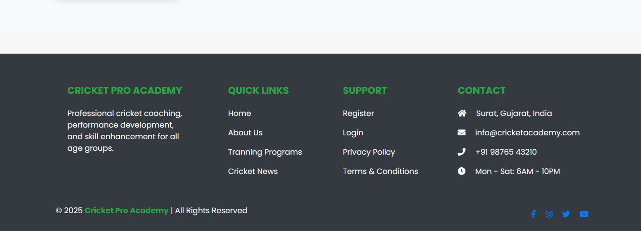
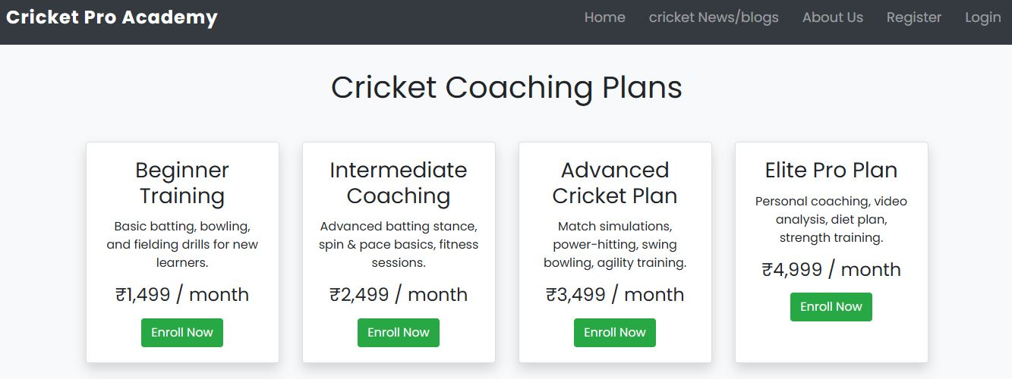

- Blog page:
<html>
<head>
<meta name="viewport" content="width=device-width, initial-scale=1.0">
<title> Cricket Pro Academy </title>
<link rel="stylesheet" href="https://stackpath.bootstrapcdn.com/bootstrap/4.5.2/css/bootstrap.min.css">
<link rel="stylesheet" href="style.css">
<link href="https://fonts.googleapis.com/css2?family=Poppins:wght@400;600;700&display=swap" rel="stylesheet">
<link rel="stylesheet" href="https://cdnjs.cloudflare.com/ajax/libs/font-awesome/5.15.4/css/all.min.css">
</head>
<body>

<!-- NAVBAR -->
<nav class="navbar navbar-expand-lg navbar-dark bg-dark fixed-top">
<a href="home.html" class="navbar-brand font-weight-bold">Cricket Pro Academy</a>
<button class="navbar-toggler" type="button" data-toggle="collapse" data-target="#nav">
<span class="navbar-toggler-icon"></span>
</button>
<div class="collapse navbar-collapse" id="nav">
<ul class="navbar-nav ml-auto">
<li class="nav-item"><a href="home.html" class="nav-link"> Home </a></li>
<li class="nav-item"><a href="fees.html" class="nav-link"> Training Programs </a></li>
<li class="nav-item"><a href="about us.html" class="nav-link"> About Us </a></li>
<li class="nav-item"><a href="register.html" class="nav-link"> Register </a></li>
<li class="nav-item"><a href="Login.html" class="nav-link"> Login </a></li>
</ul>
</div>
</nav>
<div style="height:56px"></div>

<!-- BLOG/PROGRAM CONTENT -->
<section class="py-5">
<div class="container">
<h1 class="text-center mb-5">Our Cricket Training Programs</h1>

<!-- Batting Training -->
<div id="batting" class="mb-5">
<h2>Professional Batting Coaching</h2>
<p>
Learn footwork, timing, shot selection, and power-hitting from certified cricket coaches.
Our academy offers net practice sessions, bowling machine drills, and one-on-one batting development.
</p>
</div>

<!-- Bowling Training -->
<div id="bowling" class="mb-5">
<h2>Bowling Development Program</h2>
<p>
Master fast bowling, swing, seam, and spin with specialized coaching.
We analyze bowling action, run-up, landing, and release to help bowlers improve accuracy and consistency.
</p>
</div>

<!-- Fielding Sessions -->
<div id="fielding" class="mb-5">
<h2>Fielding & Agility Training</h2>
<p>
Become a lightning-fast fielder with catching drills, diving techniques, reflex training,
and ground fielding practice. Fielding fitness and quick-movement coaching included.
</p>
</div>

<!-- Fitness Conditioning -->
<div id="fitness" class="mb-5">
<h2>Cricket-specific Fitness & Conditioning</h2>
<p>
Build stamina, endurance, and muscle strength tailored for cricket.
Includes sprint training, endurance sessions, flexibility drills, and strength workouts.
</p>
</div>
</div>
</section>

<!-- FOOTER -->
<footer class="bg-dark text-light pt-5 pb-4 mt-5">
<div class="container text-md-left">
<div class="row text-md-left">

<div class="col-md-3 col-lg-3 col-xl-3 mx-auto mt-3">
<h5 class="text-uppercase mb-4 font-weight-bold text-success">Cricket Pro Academy</h5>
<p>
Train like a champion with world-class cricket coaching, modern facilities,
and dedicated performance programs.
</p>
</div>

<div class="col-md-2 col-lg-2 col-xl-2 mx-auto mt-3">
<h5 class="text-uppercase mb-4 font-weight-bold text-success">Quick Links</h5>
<p><a href="Home.html" class="text-light" style="text-decoration:none;">Home</a></p>
<p><a href="about us.html" class="text-light" style="text-decoration:none;">About Us</a></p>
<p><a href="fees.html" class="text-light" style="text-decoration:none;">Tranning Programs</a></p>
<p><a href="blog.html" class="text-light" style="text-decoration:none;">Cricket News</a></p>
</div>

<div class="col-md-3 col-lg-2 col-xl-2 mx-auto mt-3">
<h5 class="text-uppercase mb-4 font-weight-bold text-success">Support</h5>
<p><a href="Register.html" class="text-light" style="text-decoration:none;">Register</a></p>
<p><a href="Login.html" class="text-light" style="text-decoration:none;">Login</a></p>
<p><a href="#" class="text-light" style="text-decoration:none;">Privacy Policy</a></p>
<p><a href="#" class="text-light" style="text-decoration:none;">Terms & Conditions</a></p>
</div>

<div class="col-md-4 col-lg-3 col-xl-3 mx-auto mt-3">
<h5 class="text-uppercase mb-4 font-weight-bold text-success">Contact</h5>
<p><i class="fas fa-home mr-3"></i> Surat, Gujarat, India</p>
<p><i class="fas fa-envelope mr-3"></i> info@cricketacademy.com</p>
<p><i class="fas fa-phone mr-3"></i> +91 98765 43210</p>
<p><i class="fas fa-clock mr-3"></i> Mon - Sat: 6AM - 10PM</p>
</div>
</div>

<hr class="mb-4">

<div class="row align-items-center">
<div class="col-md-7 col-lg-8">
<p>© 2025 <strong class="text-success">Cricket Pro Academy</strong> | All Rights Reserved</p>
</div>
<div class="col-md-5 col-lg-4">
<div class="text-center text-md-right">
<a href="#" class="mx-2"><i class="fab fa-facebook-f"></i></a>
<a href="#" class="mx-2"><i class="fab fa-instagram"></i></a>
<a href="#" class="mx-2"><i class="fab fa-twitter"></i></a>
<a href="#" class="mx-2"><i class="fab fa-youtube"></i></a>
</div>
</div>
</div>
</div>
</footer>

</body>
</html>
Output:
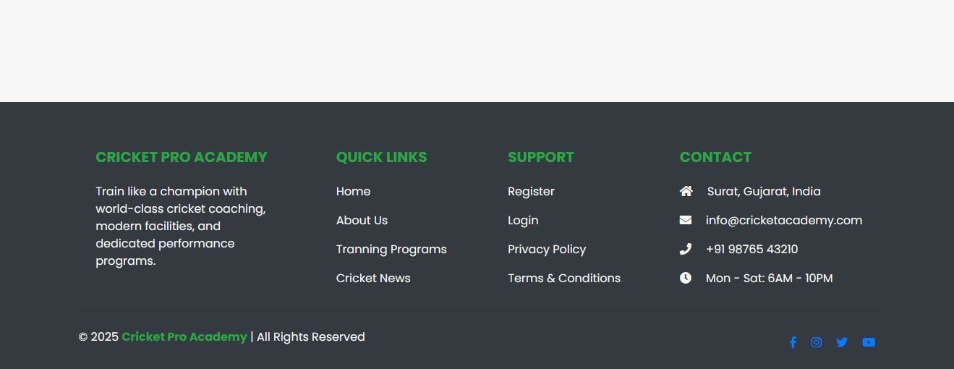


- About Us:
<html>
<head>
<meta name="viewport" content="width=device-width, initial-scale=1.0">
<title> Cricket Zone Academy </title>
<link rel="stylesheet" href="https://stackpath.bootstrapcdn.com/bootstrap/4.5.2/css/bootstrap.min.css">
<link rel="stylesheet" href="style.css">
<link href="https://fonts.googleapis.com/css2?family=Poppins:wght@400;600;700&display=swap" rel="stylesheet">
<link rel="stylesheet" href="https://cdnjs.cloudflare.com/ajax/libs/font-awesome/5.15.4/css/all.min.css">
</head>
<body>

<nav class="navbar navbar-expand-lg navbar-dark bg-dark fixed-top">
<a href="home.html" class="navbar-brand font-weight-bold">Cricket Zone Academy</a>
<button class="navbar-toggler" type="button" data-toggle="collapse" data-target="#nav">
<span class="navbar-toggler-icon"></span>
</button>
<div class="collapse navbar-collapse" id="nav">
<ul class="navbar-nav ml-auto">
<li class="nav-item"><a href="home.html" class="nav-link"> Home </a></li>
<li class="nav-item"><a href="fees.html" class="nav-link"> Training Programs </a></li>
<li class="nav-item"><a href="blog.html" class="nav-link"> cricket News/blogs </a></li>
<li class="nav-item"><a href="register.html" class="nav-link"> Register </a></li>
<li class="nav-item"><a href="Login.html" class="nav-link"> Login </a></li>
</ul>
</div>
</nav>

<div style="height:56px"></div>

<section class="py-5">
<div class="container">
<h1 class="mb-4 text-center">About Us</h1>
<p class="lead text-center">
Welcome to <strong>Cricket Zone Academy</strong>, the ultimate training destination for budding cricketers.
Our mission is to transform raw talent into world-class performers.
</p>

<div class="row mt-5">
<div class="col-md-6">
<h3>Our Vision</h3>
<p>To develop and nurture cricketing talent with professional coaching, modern
training facilities, and performance‑oriented programs. Whether you're preparing for district,
state, or national level cricket — <strong>Cricket Zone Academy</strong> is your home ground.</p>
</div>

<div class="col-md-6">
<h3>Why Train With Us?</h3>
<ul>
<li>Certified cricket coaches & former professional players</li>
<li>Modern nets, bowling machines & fitness setup</li>
<li>Specialized batting, bowling & fielding sessions</li>
<li>Match simulations & performance analytics</li>
</ul>
</div>
</div>

<div class="row mt-5">
<div class="col text-center">
<img src="coach.jpeg" alt="Our Coaches" class="img-fluid rounded shadow">
<p class="mt-3"><em>Meet our certified coaches and support staff</em></p>
</div>
</div>
</div>
</section>

<footer class="bg-dark text-light pt-5 pb-4 mt-5">
<div class="container text-md-left">
<div class="row text-md-left">

<div class="col-md-3 col-lg-3 col-xl-3 mx-auto mt-3">
<h5 class="text-uppercase mb-4 font-weight-bold text-success">Cricket Zone Academy</h5>
<p>Train like a champion. Join our academy and take your cricketing journey to the next level.
Professional coaching, advanced facilities, and dedicated mentorship await you.</p>
</div>

<div class="col-md-2 col-lg-2 col-xl-2 mx-auto mt-3">
<h5 class="text-uppercase mb-4 font-weight-bold text-success">Quick Links</h5>
<p><a href="Home.html" class="text-light" style="text-decoration:none;">Home</a></p>
<p><a href="about us.html" class="text-light" style="text-decoration:none;">About Us</a></p>
<p><a href="fees.html" class="text-light" style="text-decoration:none;">Tranning Programs</a></p>
<p><a href="blog.html" class="text-light" style="text-decoration:none;">Cricket News</a></p>
</div>

<div class="col-md-3 col-lg-2 col-xl-2 mx-auto mt-3">
<h5 class="text-uppercase mb-4 font-weight-bold text-success">Support</h5>
<p><a class="text-light" style="text-decoration:none;" href="Register.html">Register</a></p>
<p><a class="text-light" style="text-decoration:none;" href="Login.html">Login</a></p>
<p><a class="text-light" href="#" style="text-decoration:none;">Privacy Policy</a></p>
<p><a class="text-light" href="#" style="text-decoration:none;">Terms & Conditions</a></p>
</div>

<div class="col-md-4 col-lg-3 col-xl-3 mx-auto mt-3">
<h5 class="text-uppercase mb-4 font-weight-bold text-success">Contact</h5>
<p><i class="fas fa-home mr-3"></i> Surat, Gujarat, India</p>
<p><i class="fas fa-envelope mr-3"></i> info@cricketzone.com</p>
<p><i class="fas fa-phone mr-3"></i> +91 98765 43210</p>
<p><i class="fas fa-clock mr-3"></i> Mon - Sat: 6AM - 10PM</p>
</div>
</div>

<hr class="mb-4">

<div class="row align-items-center">
<div class="col-md-7 col-lg-8">
<p>© 2025 <strong class="text-success">Cricket Zone Academy</strong> | All Rights Reserved</p>
</div>
<div class="col-md-5 col-lg-4">
<div class="text-center text-md-right">
<a href="#" class="mx-2"><i class="fab fa-facebook-f"></i></a>
<a href="#" class="mx-2"><i class="fab fa-instagram"></i></a>
<a href="#" class="mx-2"><i class="fab fa-youtube"></i></a>
</div>
</div>
</div>
</div>
</footer>

</body>
</html>
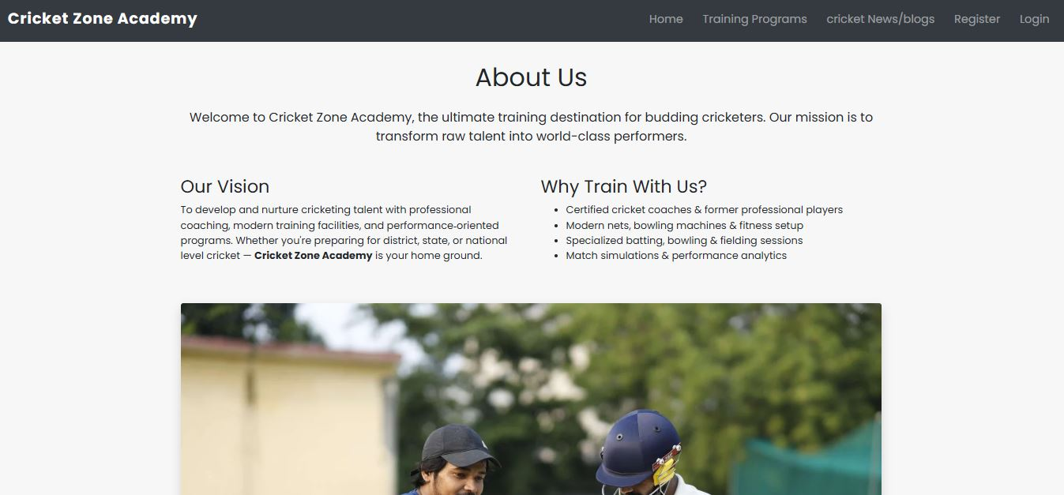
Output:

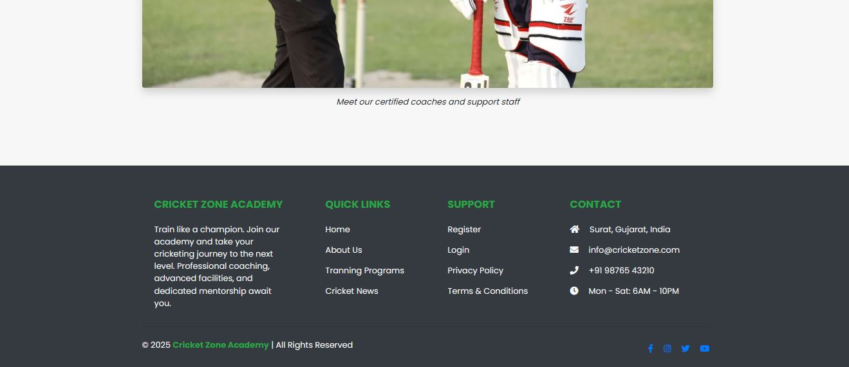

- Register page:
<!DOCTYPE html>
<html>
<head>
<meta name="viewport" content="width = device-width initial-scale = 1.0">
<title> Cricket Pro Academy - Register </title>
<link rel="stylesheet" href="https://stackpath.bootstrapcdn.com/bootstrap/4.5.2/css/bootstrap.min.css">
<link rel="stylesheet" href="style.css">
<link href="https://fonts.googleapis.com/css2?family=Poppins:wght@400;600;700&display=swap" rel="stylesheet">
</head>

<body>
<nav class="navbar navbar-expand-lg navbar-dark bg-dark fixed-top">
<a href="#" class="navbar-brand font-weight-bold">Cricket Pro Academy</a>
<button class="navbar-toggler" type="button" data-toggle="collapse" data-target="#nav">
<span class="navbar-toggler-icon"></span>
</button>
<div class="collapse navbar-collapse" id="nav">
<ul class="navbar-nav ml-auto">
<li class="nav-item"><a href="home.html" class="nav-link"> Home </a></li>
<li class="nav-item"><a href="Login.html" class="nav-link"> Login </a></li>
</ul>
</div>
</nav>

<div style="height:56px"></div>

<div class="register-container">
<h3 class="text-center mb-4">Register for Cricket Pro Academy</h3>
<form id="registerForm" novalidate>
<div class="form-group">
<label for="name">Full Name</label>
<input type="text" class="form-control" placeholder="Full Name" id="fullname" required>
<div id="fullname-error" class="text-danger small"></div>
</div>

<div class="form-group">
<label for="email">Email address</label>
<input type="email" class="form-control" placeholder="Email Address" id="email" required>
<div id="email-error" class="text-danger small"></div>
</div>

<div class="form-group">
<label for="date">Date Of Birth</label>
<input type="date" class="form-control" id="dob" required>
<div id="dob-error" class="text-danger small"></div>
</div>

<div class="form-group">
<label for="password">Password</label>
<input type="password" class="form-control" placeholder="Password" id="password" required>
<div id="password-error" class="text-danger small"></div>
</div>

<div class="form-group">
<label for="confirmPassword">Confirm Password</label>
<input type="password" class="form-control" placeholder="Confirm Password" id="confirmPassword" required>
<div id="confirm_pass-error" class="text-danger small"></div>
</div>

<p class="text-center mt-3">Already have an account? <a href="login.html">Login</a></p>
<button type="submit" class="btn btn-success btn-block">Register</button>
</form>
</div>

<script>
const form = document.getElementById("registerForm");
form.addEventListener("submit", function (e) {
e.preventDefault();

const name = document.getElementById("fullname").value;
const email = document.getElementById("email").value;
const dob = document.getElementById("dob").value;
const pass = document.getElementById("password").value;
const conPass = document.getElementById("confirmPassword").value;

let isValid = true;
document.getElementById("fullname-error").textContent = "";
document.getElementById("email-error").textContent = "";
document.getElementById("dob-error").textContent = "";
document.getElementById("password-error").textContent = "";
document.getElementById("confirm_pass-error").textContent = "";

const nameRegex = /^[a-zA-Z ]{1,30}$/;
if (!nameRegex.test(name)) {
document.getElementById("fullname-error").textContent = "Name must be 1-30 letters.";
isValid = false;
}

const emailRegex = /^([a-zA-Z0-9._%+-]+)@([a-zA-Z.-]+)\.([a-zA-Z]{2,})$/;
if (!emailRegex.test(email)) {
document.getElementById("email-error").textContent = "Invalid email address.";
isValid = false;
}

const passRegex = /^(?=.*[A-Z])(?=.*[a-z])(?=.*\d)(?=.*[!@#$%&])[A-Za-z\d!@#$%&]{8,}$/;
if (!passRegex.test(pass)) {
document.getElementById("password-error").textContent = "Password must have 8+ chars, 1 uppercase, 1 number, 1 special char.";
isValid = false;
}

const today = new Date();
const bDate = new Date(dob);
const age = today.getFullYear() - bDate.getFullYear();
const month = today.getMonth() - bDate.getMonth();

if (age < 18 || (age === 18 && month < 0)) {
document.getElementById("dob-error").textContent = "You must be at least 18 years old.";
isValid = false;
}

if (pass !== conPass) {
document.getElementById("confirm_pass-error").textContent = "Passwords do not match.";
isValid = false;
}

if (isValid) {
alert("Registration Successful! Welcome to Cricket Pro Academy.");
}
});
</script>
</body>
</html>
Output:
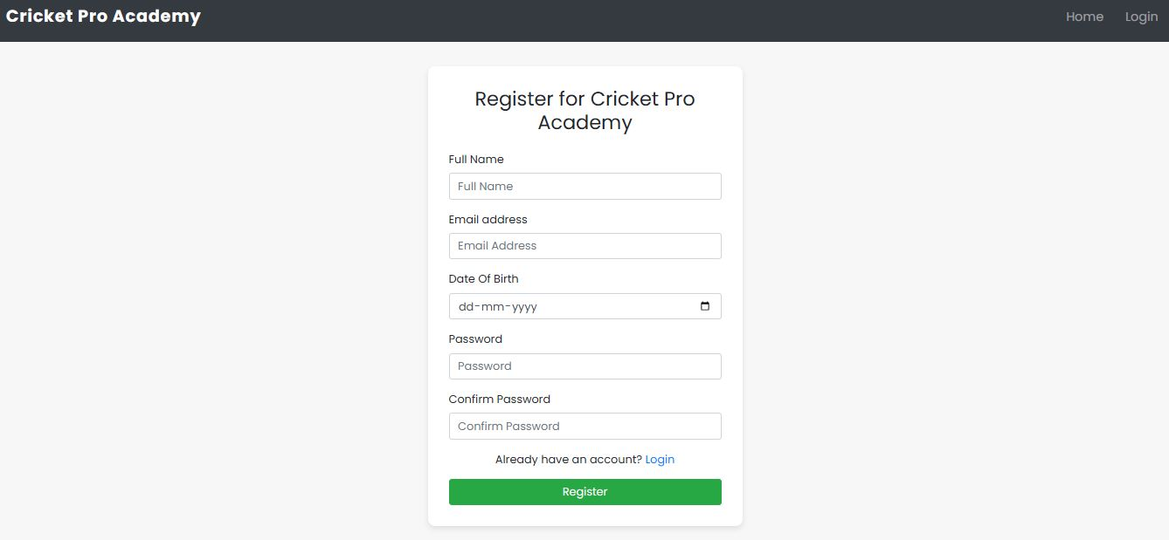

- Login page:
<!DOCTYPE html>
<html>

<head>
<meta name="viewport" content="width = device-width initial-scale = 1.0">
<title> Cricket Pro Academy </title>
<link rel="stylesheet" href="https://stackpath.bootstrapcdn.com/bootstrap/4.5.2/css/bootstrap.min.css">
<link rel="stylesheet" href="style.css">
<link href="https://fonts.googleapis.com/css2?family=Poppins:wght@400;600;700&display=swap" rel="stylesheet">
</head>

<body>
<nav class="navbar navbar-expand-lg navbar-dark bg-dark fixed-top">
<a href="#" class="navbar-brand font-weight-bold">Cricket Pro Academy</a>
<button class="navbar-toggler" type="button" data-toggle="collapse" data-target="#nav">
<span class="navbar-toggler-icon"></span>
</button>
<div class="collapse navbar-collapse" id="nav">
<ul class="navbar-nav ml-auto">
<li class="nav-item"><a href="home.html" class="nav-link"> Home </a></li>
<li class="nav-item"><a href="register.html" class="nav-link"> Register </a></li>
</ul>
</div>
</nav>
<div style="height:56px"></div> <!-- navbar spacer -->

<div class="login-container">
<h3 class="text-center mb-4">Login to Cricket Pro Academy</h3>

<form id="loginForm">
<div class="form-group">
<label for="email">Player Email</label>
<input type="email" class="form-control" id="email" required>
<div id="email-error" class="text-danger small"></div>
</div>

<div class="form-group">
<label for="password">Player Password</label>
<input type="password" class="form-control" id="password" required>
<div id="password-error" class="text-danger small"></div>
</div>

<p class="text-center mt-3">New to Cricket Pro Academy? <a href="register.html">Join For New</a></p>

<button type="submit" class="btn btn-success btn-block">Login</button>
</form>
</div>

<script>
const form = document.getElementById("loginForm");

form.addEventListener("submit", function (e) {
e.preventDefault();

const email = document.getElementById("email").value;
const password = document.getElementById("password").value;

let isValid = true;
document.getElementById("email-error").textContent = "";
document.getElementById("password-error").textContent = "";

const emailRegex = /^([a-zA-Z0-9._%+-]+)@([a-zA-Z.-]+)\.([a-zA-Z]{2,})$/;
if (!emailRegex.test(email)) {
document.getElementById("email-error").textContent = "Invalid email address.";
isValid = false;
}

const passRegex = /^(?=.*[A-Z])(?=.*[a-z])(?=.*\d)(?=.*[!#@$%&])[A-Za-z\d!@#$%&]{8,}$/;
if (!passRegex.test(password)) {
document.getElementById("password-error").textContent =
"Password must have 8+ chars, 1 uppercase, 1 number, 1 special char.";
isValid = false;
}

if (isValid) {
alert("🏏 Welcome back, Player! You are successfully logged in!");
}
});
</script>

</body>

</html>
Output:
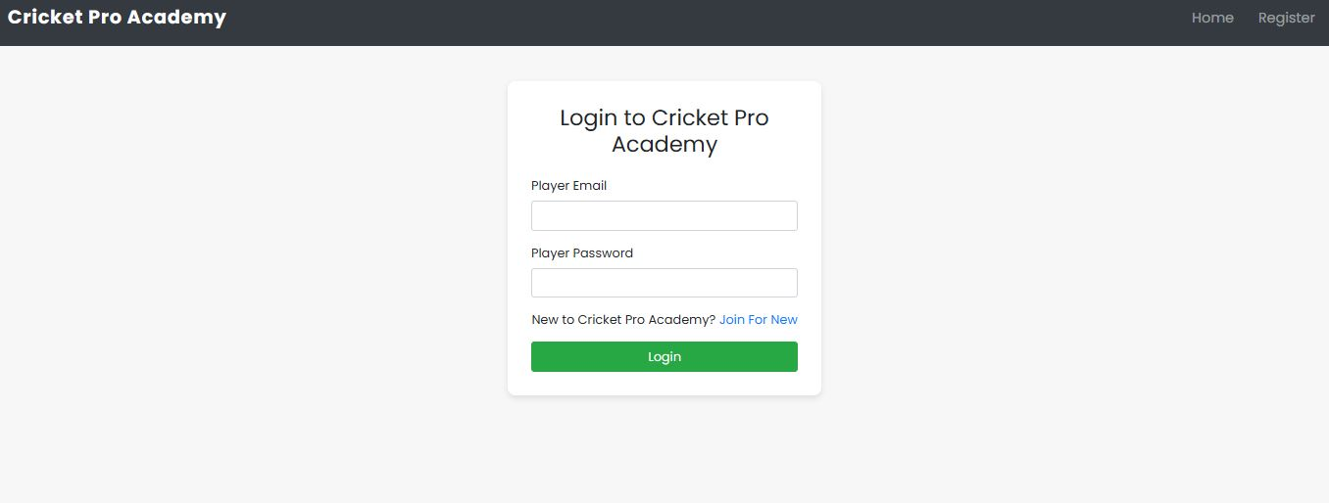

- Css style for this website:
* {
font-family: 'Poppins', sans-serif;
}

/* Navbar link size */
.navbar .nav-link {
font-size: 18px;
/* 16–20px safe range */
font-weight: 500;

}

/* Navbar */
.navbar {
padding: 0.8rem 1rem;
}

.navbar-brand {
font-size: 1.5rem;
font-weight: bold;
letter-spacing: 1px;
}

.nav-link {
font-size: 1rem;
margin-left: 15px;
transition: color 0.3s;
}

.nav-link:hover {
color: #ffc107 !important;
}

/* Hero */
.hero {
background: url('image/gym5.jpg') no-repeat center left;
background-size: cover;
height: 100vh;
display: flex;
align-items: center;
/* vertical center */
color: white;
}

.hero-content {
max-width: 500px;
text-align: center;
}

.hero h1 {
font-size: 3.5rem;
font-weight: bold;
text-shadow: 2px 2px 5px black;
}

.hero a {
margin-top: 20px;
text-shadow: 2px 2px 5px black;
}

/* CARD (HOME PAGE)*/
.card {
transition: transform 0.3s;
}

.card:hover {
transform: translateY(-10px);
}

/* fees PAGE */
.plan-card {
transition: transform 0.3s;
}

.plan-card:hover {
transform: translateY(-10px);
}

/* REGISTER PAGE */
body {
background: #f7f7f7;
}

.register-container {
max-width: 450px;
margin: 50px auto;
background: #fff;
padding: 30px;
border-radius: 10px;
box-shadow: 0px 4px 8px rgba(0, 0, 0, 0.1);
}
/*
.success-msg,
.error-msg {
display: none;
margin-top: 20px;
} */

/* LOGIN PAGE */
.login-container {
max-width: 400px;
margin: 60px auto;
background: #fff;
padding: 30px;
border-radius: 10px;
box-shadow: 0px 4px 8px rgba(0, 0, 0, 0.1);
}

/* Footer */
.social-icon {
color: #fff;
font-size: 1.5rem;
transition: all 0.3s ease;
}

.social-icon:hover {
color: #ff5722; /* orange highlight */
transform: scale(1.2); /* thoda zoom effect */
}

