1 . Create Student Table with appropriate constraints. STUDENT(sno number primary key, sname text(20), age number, total_marks number) write python programs to perform following task: 1) store the table data into a dataframe and display the dataframe. 2) List out top three records from the dataframe 3) Display all records from dataframe whose age is not less than 18. 4) Display age of student whose sno is 5. (use loc() and iloc() function)

import pandas as pd

data={
'sno':[1,2,3,4,5],
'sname':['krish','veer','sujal','janvi','ravi'],
'age':[19,16,11,22,25],
'total_marks':[85,55,92,65,100]
}
df=pd.DataFrame(data) print("DataFrame:") print(df)
top_three=df.head(3) print("\n Top three records:") print(top_three) above_18=df[df['age']>=18] print("\n Records
1
with age not less than 18:") print(above_18) row_loc=df.loc[df['sno']==5 ,'age'].values[0] row_iloc=df.iloc[df.index[df['sno']==5],df.columns .get_loc('age')].values[0] print("\nage of student with sno 5 (loc):",row_loc) print("\nage of student with sno 5 (iloc):",row_iloc)

OUTPUT
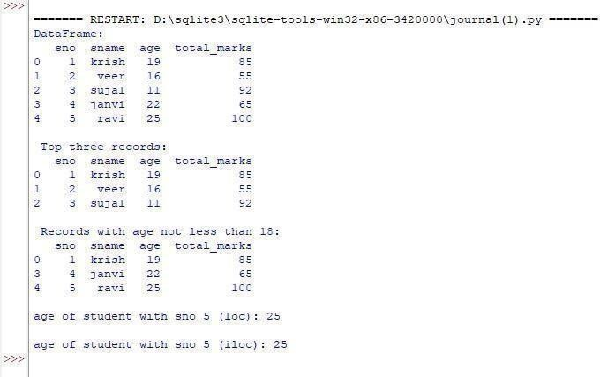

2. Create following table and store an`y five records:
Employee(eno number primary key, Ename text(20),designation text(10),basic number , da number, gross_salary number) write python programs to perform following tasks: 1) Store the table data into dataframe and display the dataframe. 2) Sort the dataframe based used on gross salary and List out bottom two record from the dataframe. 3) Display all records from dataframe whose gross Display gross salary is more than 25000 . 4) Display gross salary of employee whose eno is 4.

Ans 2 : import pandas as pd
import numpy as np dict={
'eno':[1,2,3,4,5],
'Ename':['krish','veer','sujal','janvi','ravi'],
'designation':['manager','account','technician',' manager','proffesor'],
'basic':[15000,20000,70000,40000,50000],

'da':[1500,2000,7000,4000,5000],
'gross_salary':[17500,22000,77000,44000,55000
]
}
dataframe=pd.DataFrame(dict) print('Ans 1.') print(dataframe) sorted=dataframe.sort_values(by='gross_salary') bottom_two=sorted.tail(2) print('\nAns 2.') print(bottom_two)
salary_more_than_25000=dataframe[dataframe[' gross_salary'] >= 25000] print('\nAns 3.')
print(salary_more_than_25000)

employee_4=dataframe.loc[dataframe['eno'] == 4,'gross_salary'].values[0] print('\nAns 4.')
print(employee_4)
OUTPUT
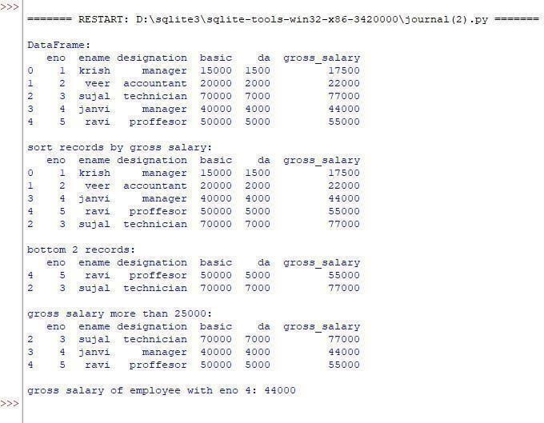
3. Create CSV file for product selling for 6 months and add only 5 record for 5 different product.
Prod_name | JAN | FEB | MAR | APR | MAY | JUN
Create Python script for following program: 1) Read data into DataFrame 2) Add columns and calculate total_sell, average_sell 3) Plot Total sell and average sell together on Line chart with proper legends, Titles and Lables. 4) Save the DataFrame to CSV named 'sell_analysis.csv'

Ans 3 :
import pandas as pd
import matplotlib.pyplot as plt
data={
'prod_name':['A','B','C','D','E'],
'JAN':[100,150,80,120,90],
'FEB':[120,110,100,140,85]
'MAR':[90,120,110,140,85],
'APR':[110,140,90,125,105],
'MAY':[130,100,120,110,115],
'JUN':[105,130,95,135,125]
}
df = pd.DataFrame(data)
print('DataFram :') print(df) df['total_sell']=df.iloc[:,1:].sum(axis=1) df['average_sell']=df.iloc[:,1:].mean(axis=1) print(df) plt.figure(figsize=(10,6)) plt.plot(df['prod_name'],df['total_sell'],label='Total Sell',marker='o')
plt.plot(df['prod_name'],df['average_sell'],label=' Average Sell',marker='o')
plt.xlabel('products')
plt.ylabel('amount')
plt.title('product sell analysis')
plt.legend()
plt.grid(True)
plt.show()
df.to_csv('sell_analysis.csv',index=False)

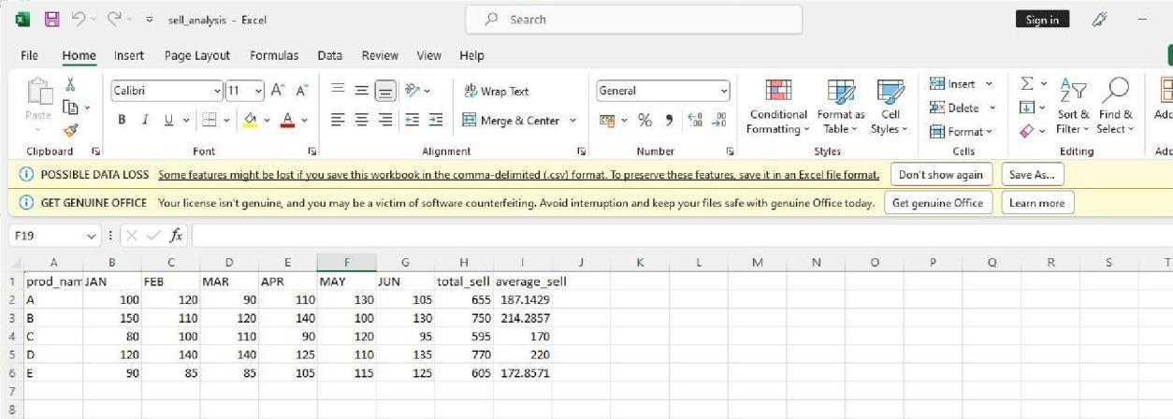
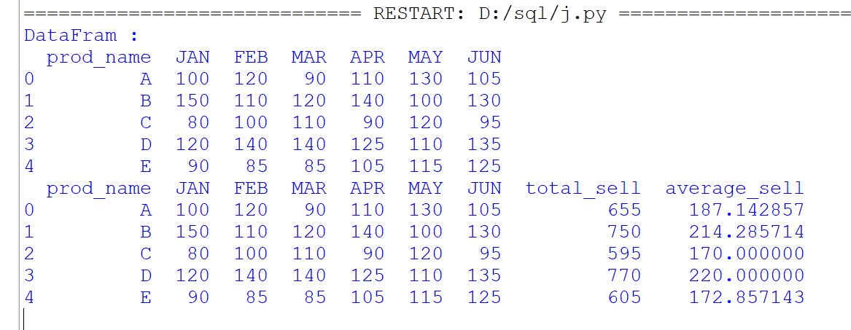

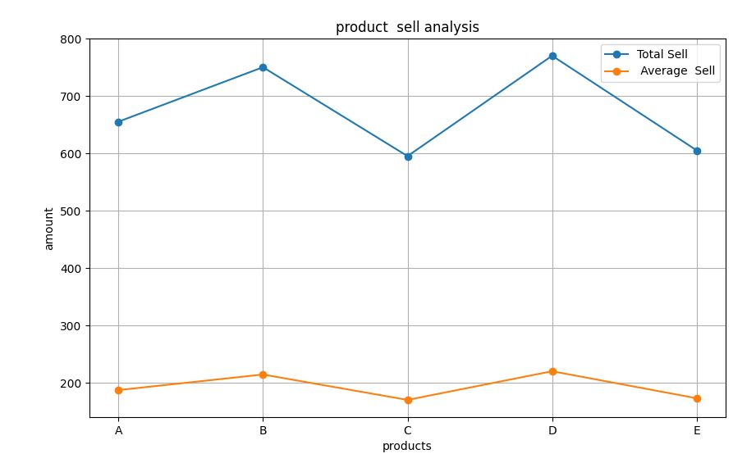

4. Write a phython script to do following on student (Rollno, Name, Sub 1, Sub 2, Sub 3, total) table: 1) Insert atleast 5 to 10 records. 2) Update the specific record value. 3) Delete the record specific record. 4) Display student detail who got highest total marks

Ans 4 :
import sqlite3
def create_table(): db=sqlite3.connect('student. db') cur=db.cursor()
cur.execute('''create table student( rollno number, name text, sub1 number, sub2 number, sub3 number, total number);''')
print('table created. ..')

create_table()
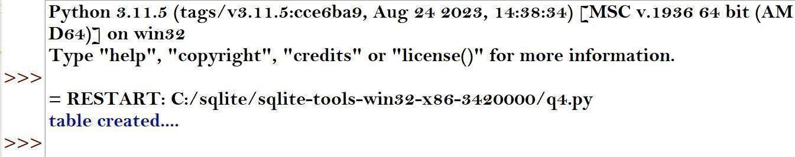

Import sqlite3 def insert_record():
db=sqlite3.connect('student.db')
cur=db.cursor()
cur.execute("insert into student values(1,'krish',90,95,85,270),(2,'veer',65,55,74,194),(3,'sujal',96,74,55,225),(4,'janvi',85,76,98,259),(5,'ravi',80,45,66,191),(5,'aadi',96,84,66,246),(6,'naitik',65,48,90 ,203),(7,'heet',40,25,31,96)")
db.commit()
print('record inserted. ..')
insert_record()

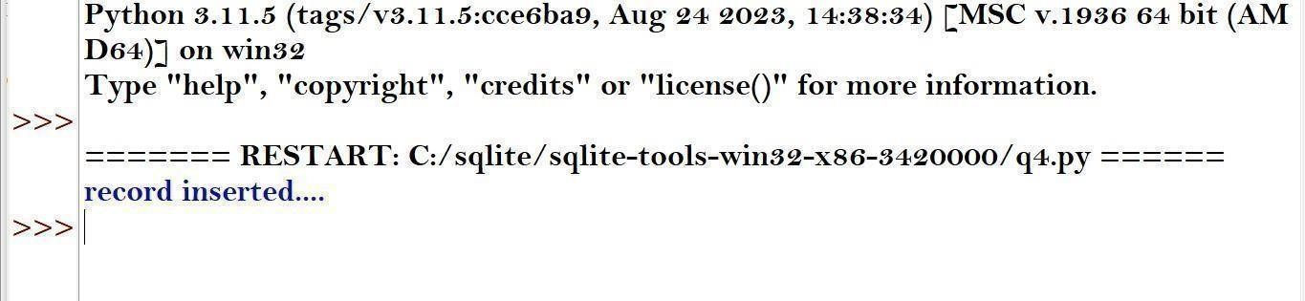

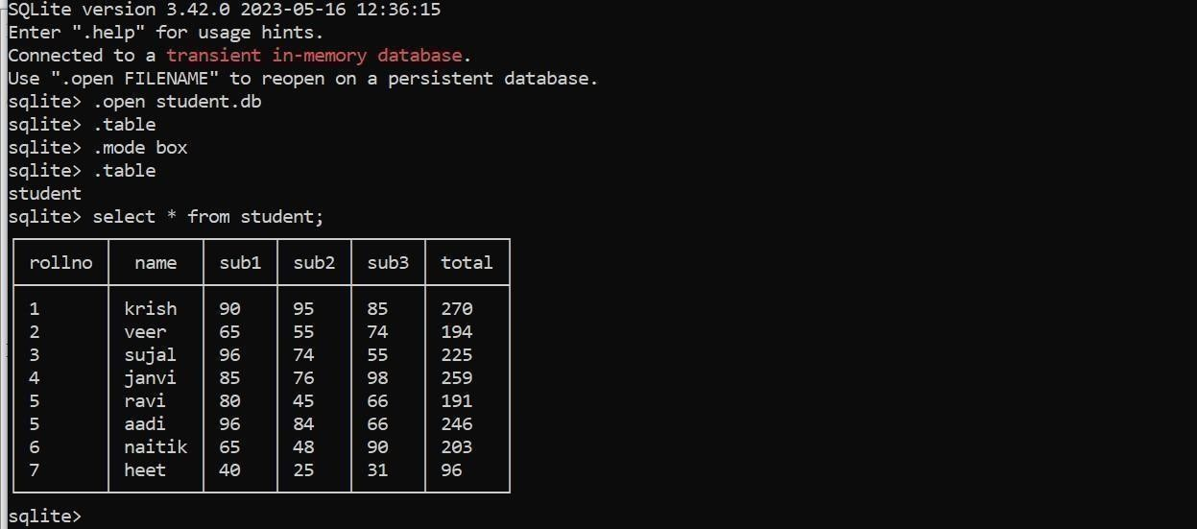
Import sqlite3 def update_value(): db=sqlite3.connect('student.db')
cur=db.cursor()
cur.execute("update student set sub1=100 where rollno=1")
db.commit()
print('value updated... ')
update_value()
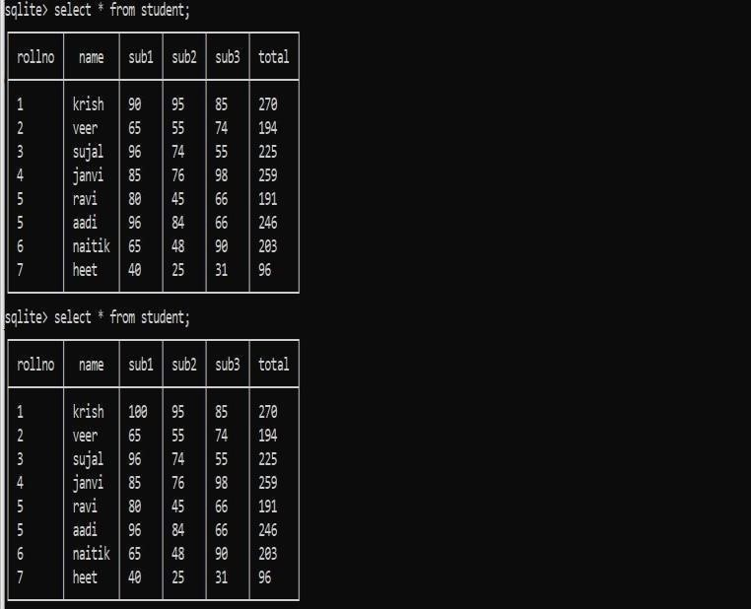
Import sqlite3 def delete_record():
db=sqlite3.connect('student.db') cur=db.cursor() cur.execute("delete from student where name='sujal'") db.commit() print('record deleted... ')

delete_record()

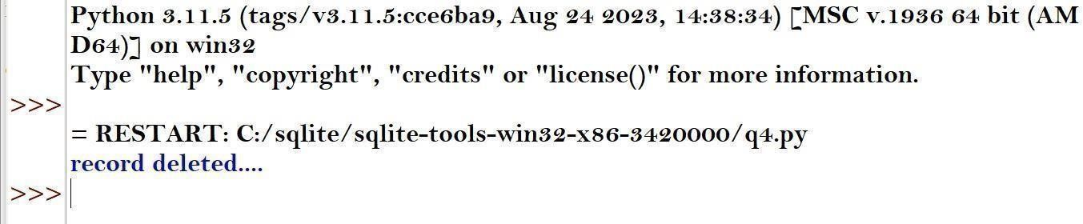
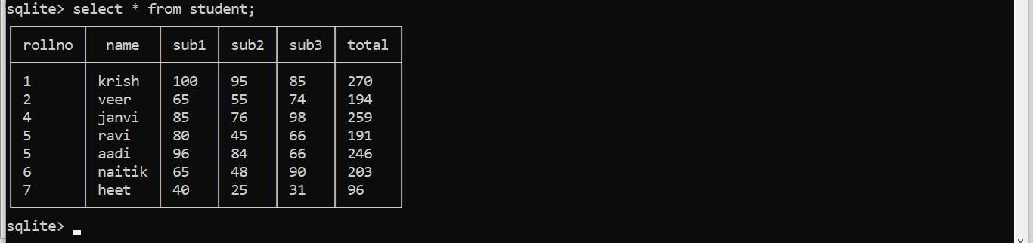

Import sqlite3
def highest_total(): db=sqlite3.connect('student.db') i=0
cur=db.cursor()
cur.execute("select * from student order by total desc limit 1")
while
True: record=cur.fetchone() if record==None: break i=i+1 print('\nstudent with highest total marks
:')
print(record)

highest_total()

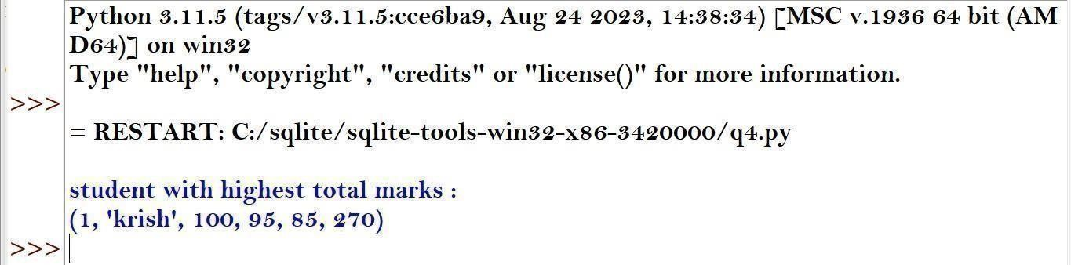

5. Write Python Script to do followings on item.csv (Item_no, Item_name, Price, Qty, total) 1) Write item's detail in the item.csv file. Calculate total = price * Qty 2) Using data frame display item name and price whose price is between 1000 to 5000. 3) Display alternate records from item.csv file. 4) Display items whose price is minimum, maximum. 5) Sort the data according to item name wise. 6) Display items rows between 3th to 7th row. 7) Display last 6 rows.
import pandas as pd

df=pd.read_csv('item.csv') new_item={
'Item_no':11,
'Item_name':'mouse',
'price':2000,
'qty':10
}
new_item['total']=new_item['price']* new_item['qty' ] df=df._append(new_item,ignore_ind ex=True)
df.to_csv('item.csv',index=False)
print('Item details added to item.csv')
item=df[(df['price'] >= 1000) & (df['price'] <= 5000)][['Item_name','price']]
print('\nitem with price between 1000 to 5000 :')
print(item)

alternate_rec=df.iloc[::2] print('\nAlternate record:')
print(alternate_rec)
min_price=df[df['price'] == df['price'].min()] max_price=df[df['price']
== df['price'].max()]
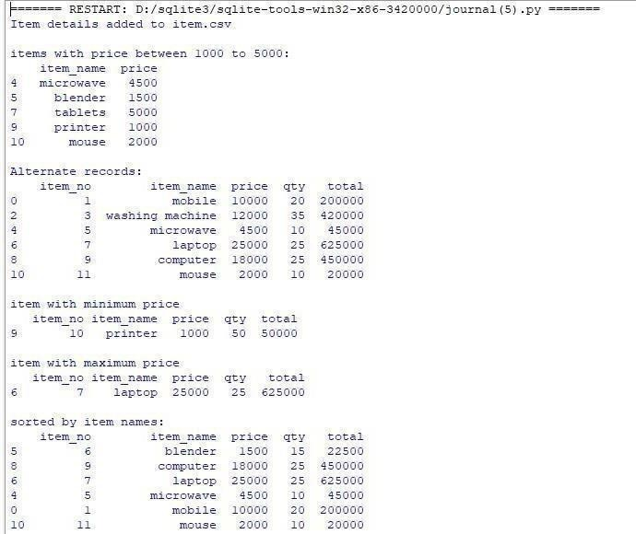
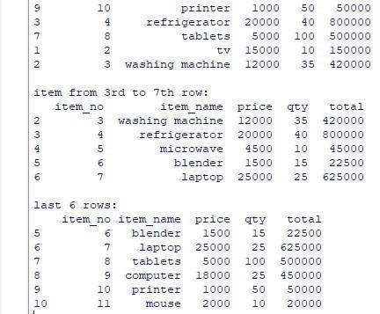
print('\nprint with minimum price :')

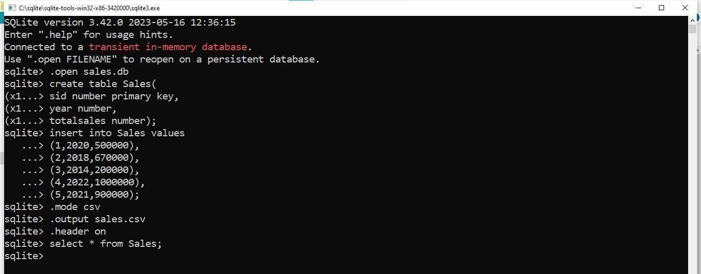
6. Sales (sid, year, totalsales) Create above table into a SQLite database with appropriate constraints. 1) Insert at least 5-10 records into the sales table 2) Export sales table data into sales.csv file. 3) Write a python scripts that read the sales.csv file and plot a bar chart that shows totalsales of the year. Also decorate the chart with appropriate title, lables, colours etc.

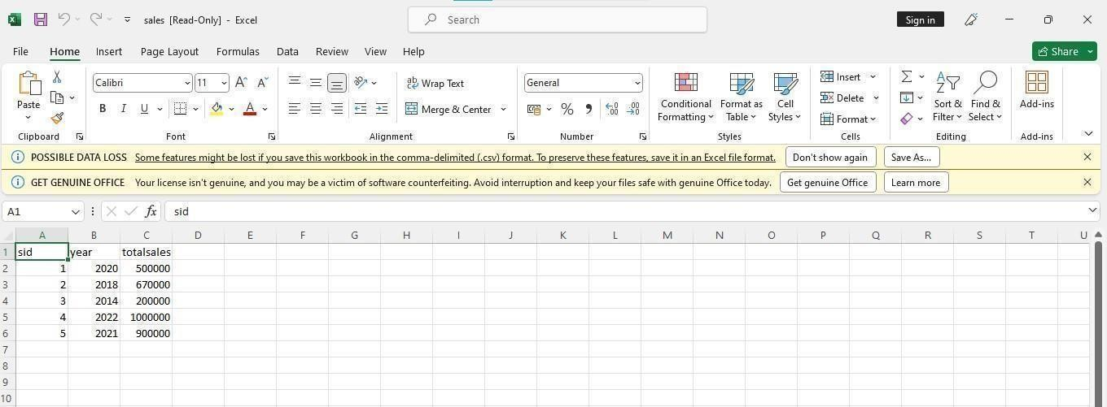
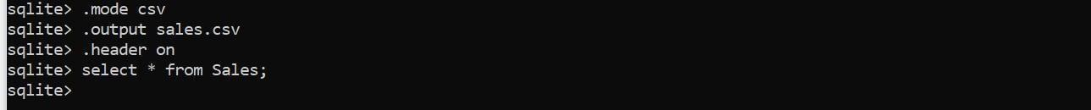

import csv import pandas as pd
import matplotlib.pyplot as plt
with open('sales.csv', 'r') as file
df = csv.reader(file)
for row in df:
print(row)
df=pd.read_csv('sales.cs v')
plt.figure(figsize=(10,6))
plt.bar(df['year'],df['totalsales'],colo r='skyblue')
plt.xlabel('year')
plt.ylabel('total sales')
plt.title('total sales by year')
plt.xticks(rotation=45)
plt.grid(axis='y',linestyle='--',alpha=0.7)
plt.tight_layout()
plt.show()
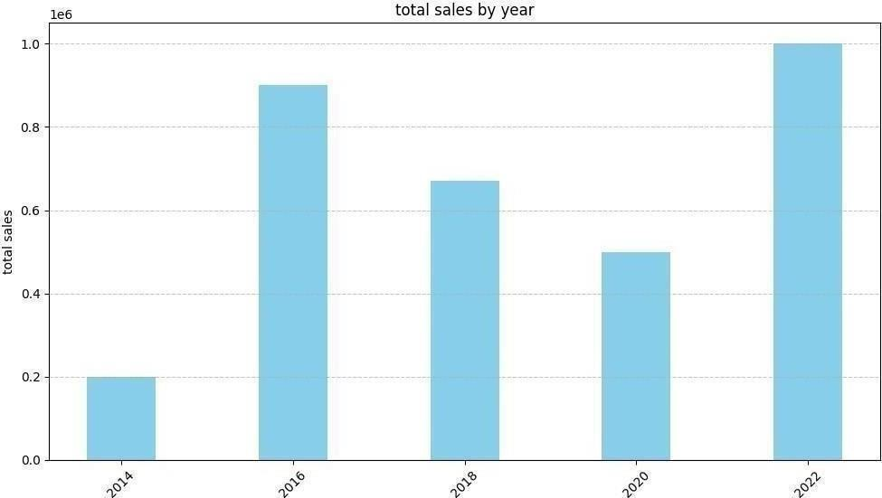

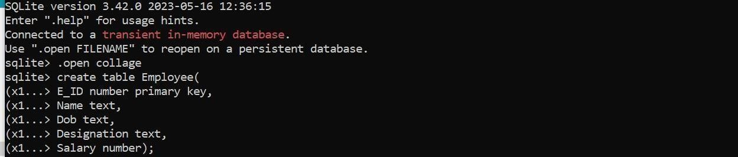
7. Create following table with appropriate constraints in Collage Database: Employee (E_ID, Name, Dob, Designation, Salary ) a) Dump Employee table structure and data in Emp.csv file. b) Dump whole Database named College in Emp1.csv file.
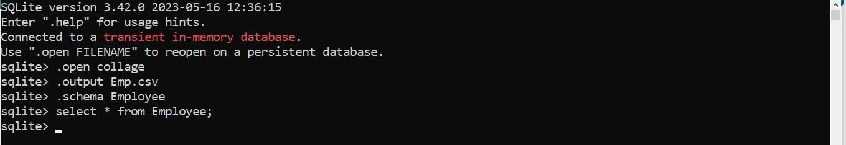

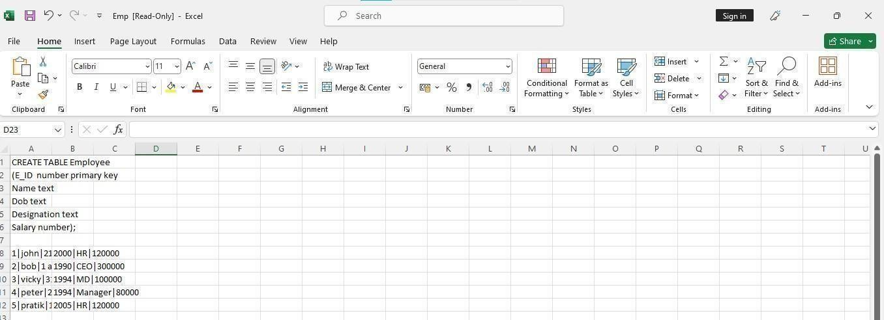

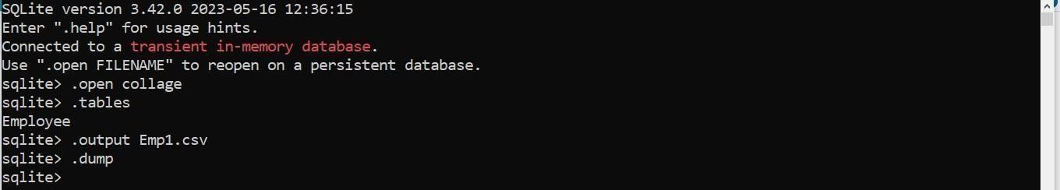

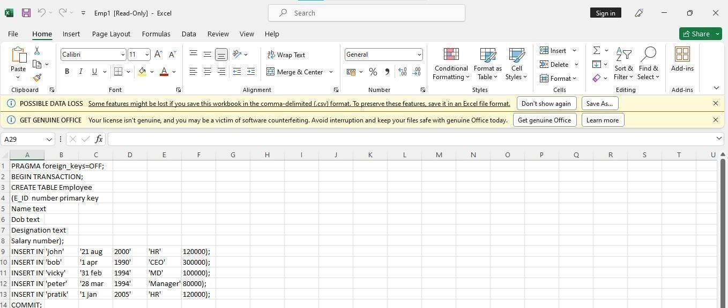

8. Create following table with appropriate Constraints: Product (prod_id , prod_name , price, qty,total_amount) 1) Import Product.csv file data into Product table. 2) Export Product table data into prod.csv file.
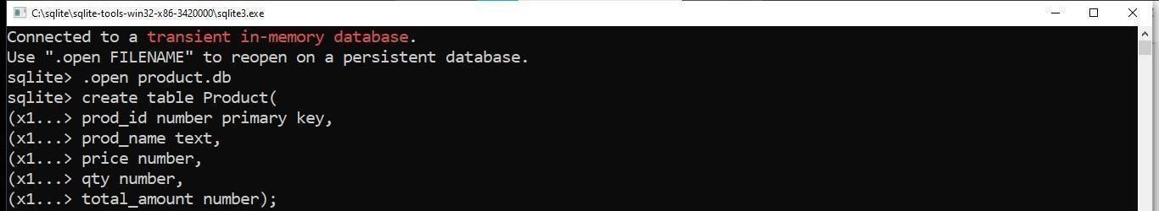

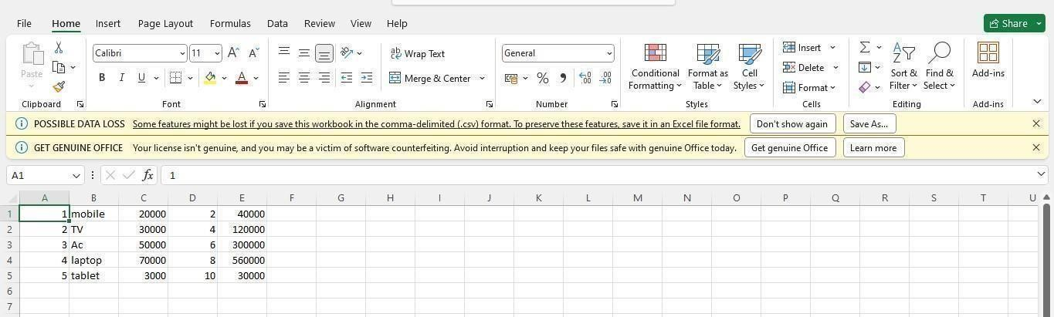

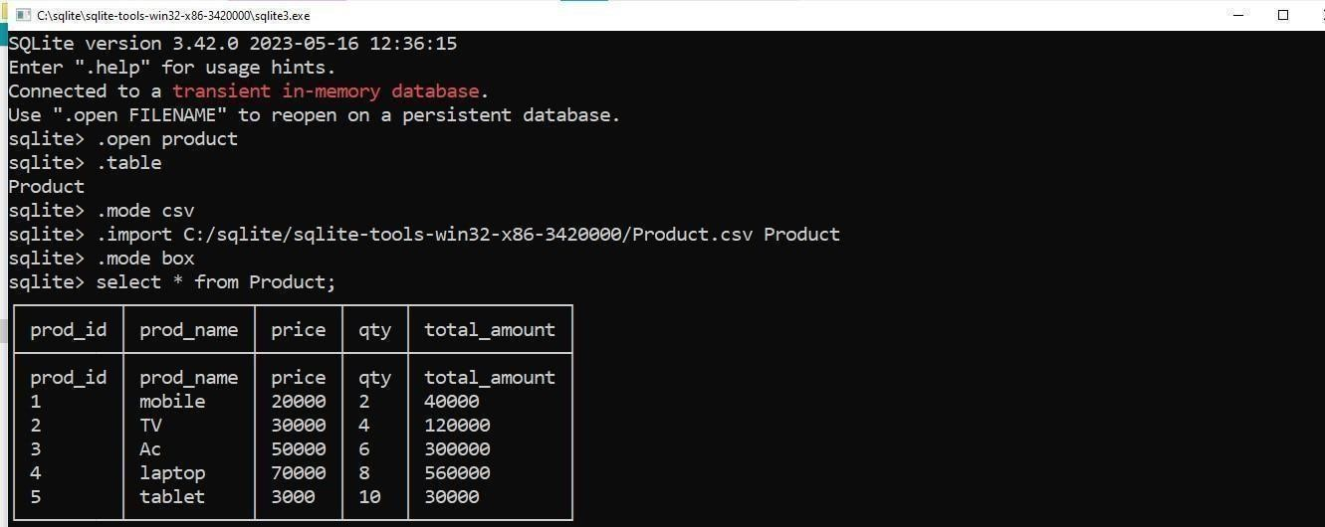

9. Employee(Eno number ,Ename text ,Desg text ,Salary number ,City text ,Email text) Write a SQL trigger named emp_trigger that is designed to execute before inserting records into the emp table. The trigger should perform the following action: 1) Check if the 'email' field in the newly inserted record follows a specific email address pattern. (example : abc@gmail.com)
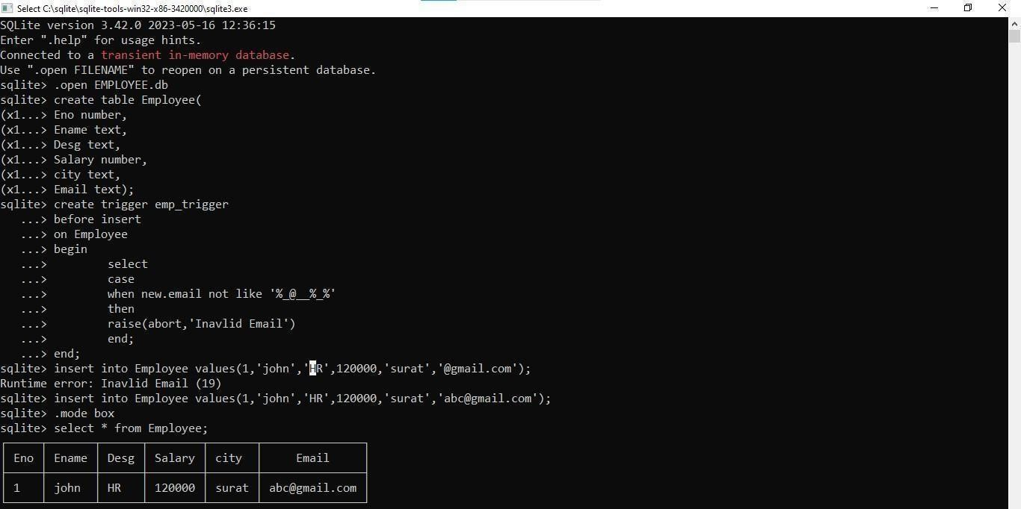

10. Create COLLEGE database and perform following tasks.
a. Create following table using SQLite and then close the connection. Student (roll_no INTEGER Primary key, name text (20), city text (20), age INTEGER)
b. Insert 10 student records for Student table.
c. Add column course and display all records of student having city Navsari and course BCA using python cursor.
d. Dump sales tables query to sql file with name student_table.sql
e. Export the Student table to CSV file and display in Python IDLE.
import sqlite3
import csv

# a. Create the Student table
conn=sqlite3.connect('COLLEGE.db’)
cursor =
conn.cursor()

# Create Student table cursor.execute('''CREATE TABLE IF NOT EXISTS Student(roll_no INTEGER PRIMARY KEY,
name TEXT(20),city TEXT(20),age INTEGER)''')

conn.commit()

# Insert 10 student records students = [
(1, 'John Doe', 'Navsari', 20),
(2, 'Jane Doe', 'Surat', 22),
(3, 'Mike Ross', 'Navsari', 21),
(4, 'Rachel Zane', 'Ahmedabad', 23),
(5, 'Harvey Specter', 'Navsari', 25),
(6, 'Louis Litt', 'Mumbai', 24),
(7, 'Donna Paulsen', 'Navsari', 22),
(8, 'Jessica Pearson', 'Delhi', 27),
(9, 'Sheila Sazs', 'Navsari', 26),
(10, 'Benjamin Kim', 'Surat', 23)
]
cursor.executemany("INSERT INTO Student (roll_no, name, city, age) VALUES (?, ?, ?, ?)", students) conn.commit()

# c. Add column course and display students from
Navsari with course BCA cursor.execute("ALTER TABLE Student ADD COLUMN course TEXT") conn.commit()

# Update course for students
cursor.execute("UPDATE Student SET course = 'BCA' WHERE city = 'Navsari'") conn.commit()

# Fetch students from Navsari enrolled in BCA
cursor.execute("SELECT * FROM Student WHERE city = 'Navsari' AND course = 'BCA'") navsari_bca_students = cursor.fetchall()

# d. Dump Student table query to sql file with
open('/mnt/data/student_table.s
ql', 'w') as f: for line in conn.iterdump(): f.write('%s\n' % line)

# e. Export Student table to CSV cursor.execute("SELECT * FROM Student") all_students = cursor.fetchall()

csv_file_path = '/mnt/data/student_table.csv'
with open(csv_file_path, 'w', newline='') as csv_file:
csv_writer = csv.writer(csv_file)
csv_writer.writerow([i[0]for i in cursor.description]) # Write headers
csv_writer.writerows(all_students)
conn.close()

# Show fetched Navsari BCA students navsari_bca_students
Output :

[ (1, 'John Doe', 'Navsari', 20, 'BCA'), (3, 'Mike Ross', 'Navsari', 21, 'BCA'), (5,
'Harvey Specter', 'Navsari', 25, 'BCA'), (7, 'Donna Paulsen', 'Navsari', 22, 'BCA'), (9, 'Sheila Sazs', 'Navsari', 26, 'BCA')]
11. Create a table "tbl_Emp" in Database "MyDB.db" having fields like emp_no, emp_name, age, salary. a. Write python code to generate emp.csv file having all employees whose age > 25.
import sqlite3
import csv

# Connect to MyDB.db and create table tbl_Emp conn = sqlite3.connect('MyDB.db') cursor =
conn.cursor()

# Create tbl_Emp table
cursor.execute('''CREATE TABLE IF NOT EXISTS tbl_Emp (emp_no INTEGER PRIMARY KEY,
emp_name TEXT,
age INTEGER,
salary REAL)''')

# Insert employee records into tbl_Emp table
employees = [
(1, "Amit", 24, 30000),
(2, "Punit", 27, 45000),
(3, "Rahul", 30, 55000),
(4, "Sneha", 22, 28000),
(5, "Reema", 29, 60000)
]

cursor.executemany("INSERT INTO tbl_Emp (emp_no,
emp_name, age, salary) VALUES (?, ?, ?, ?)", employees) conn.commit()

# Fetch all employees with age > 25
cursor.execute("SELECT * FROM tbl_Emp WHERE age > 25") employees_above_25 = cursor.fetchall()

# Export employees with age > 25 to emp.csv csv_file_path = '/mnt/data/emp.csv' with open(csv_file_path, 'w', newline='') as csv_file: csv_writer = csv.writer(csv_file) csv_writer.writerow([i[0] for i in cursor.description]) # Write headers csv_writer.writerows(employees_above_25)
conn.close()

# Output employees with age > 25
employees_above_25

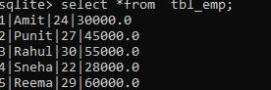

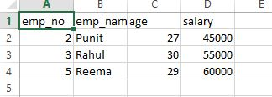

12. Create a SQLite database 'college' with table students (rollno, name, subject1, subjects, subject3) 1. insert 10 records 2. Write a python script that define function getdata (min, max). Here min define lower limit & max define upper limit. 3. Display all students records who score marks in given range in subject1
import sqlite3

# Step 1: Create database and table
con = sqlite3.connect("college.db")
cur = con.cursor()

cur.execute("""
CREATE TABLE IF NOT EXISTS students (
rollno INTEGER PRIMARY KEY,
name TEXT,
subject1 INTEGER,
subject2 INTEGER,
subject3 INTEGER
)
""")

# Step 2: Insert 10 records
records = [
(1, "Amit", 45, 55, 60),
(2, "Punit", 80, 70, 65),
(3, "Riya", 62, 58, 71),
(4, "Karan", 90, 85, 88),
(5, "Sneha", 30, 40, 45),
(6, "Meera", 50, 52, 48),
(7, "Jay", 72, 68, 75),
(8, "Nisha", 66, 70, 72),
(9, "Tara", 39, 50, 49),
(10, "Arjun", 95, 90, 92)
]

cur.executemany("INSERT OR REPLACE INTO students VALUES (?, ?, ?, ?, ?)", records)
con.commit()

# Step 3: Define function getdata(min, max)
def getdata(min_marks, max_marks):
query = "SELECT * FROM students WHERE subject1 BETWEEN ? AND ?"
cur.execute(query, (min_marks, max_marks))
rows = cur.fetchall()

# Display records
print(f"\nStudents scoring between {min_marks} and {max_marks} in subject1:\n")
print("RollNo\tName\tSubject1\tSubject2\tSubject3")
print("-" * 50)
for r in rows:
print(f"{r[0]}\t{r[1]}\t{r[2]}\t\t{r[3]}\t\t{r[4]}")

# Example call
getdata(60, 90)

# Close connection
con.close()
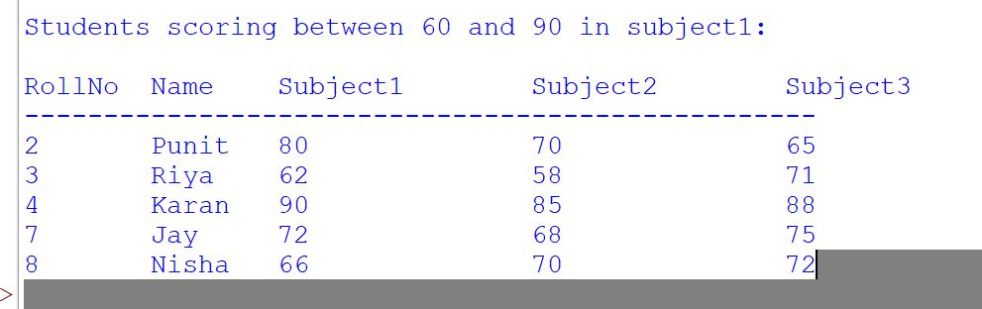
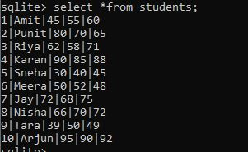

13. Write a Python code to implement following operation on Students table using SQLite module. Students (roll_no,s_name,subject 1,subject2,subject3). Write a menu driven python script perform following task . 1. insert records 2. Display all records using cursor. 3. Display Students detail who secures highest marks in subject1.
import sqlite3

con = sqlite3.connect("college.db")
cur = con.cursor()

cur.execute("""
CREATE TABLE IF NOT EXISTS Students (
roll_no INTEGER PRIMARY KEY,
s_name TEXT,
subject1 INTEGER,
subject2 INTEGER,
subject3 INTEGER
)
""")
con.commit()

def insert_record():
roll = int(input("Enter Roll No: "))
name = input("Enter Student Name: ")
s1 = int(input("Enter Subject1 Marks: "))
s2 = int(input("Enter Subject2 Marks: "))
s3 = int(input("Enter Subject3 Marks: "))

cur.execute("INSERT INTO Students VALUES (?, ?, ?, ?, ?)", (roll, name, s1, s2, s3))
con.commit()
print("Record inserted successfully!\n")

def display_all():
print("\nAll Student Records:\n")
cur.execute("SELECT * FROM Students")
rows = cur.fetchall()

print("RollNo\tName\tSubject1\tSubject2\tSubject3")
print("-" * 60)
for r in rows:
print(f"{r[0]}\t{r[1]}\t{r[2]}\t\t{r[3]}\t\t{r[4]}")
print()

def highest_subject1():
print("\nStudent(s) with Highest Marks in Subject1:\n")

cur.execute("SELECT MAX(subject1) FROM Students")
highest = cur.fetchone()[0]

cur.execute("SELECT * FROM Students WHERE subject1 = ?", (highest,))
rows = cur.fetchall()

print("RollNo\tName\tSubject1\tSubject2\tSubject3")
print("-" * 60)
for r in rows:
print(f"{r[0]}\t{r[1]}\t{r[2]}\t\t{r[3]}\t\t{r[4]}")
print()

while True:
print("===== STUDENT MANAGEMENT MENU =====")
print("1. Insert Record")
print("2. Display All Records")
print("3. Display Student With Highest Marks in Subject1")
print("4. Exit")

choice = int(input("Enter your choice: "))

if choice == 1:
insert_record()
elif choice == 2:
display_all()
elif choice == 3:
highest_subject1()
elif choice == 4:
print("Exiting Program...")
break
else:
print("Invalid Choice! Try Again.\n")

con.close()
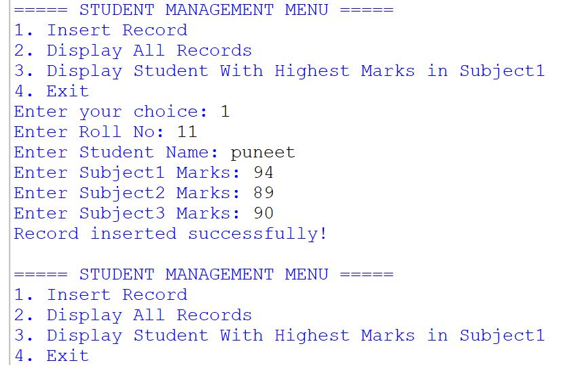

14. Write a python script to do following task. 1. Create Result Table (Rno, Student_name, IC, CPPM, DMA, Maths, CS) And Insert 10 Records. 2. Add Column Total Marks, Percentage in Result Table and Calculate Total and Percentage. 3. Display Student Name whose name start with 'A' and Percentage is between 40 and 50. 4. Display IC and CPPM Subject mark in ascending order. 5. Export all table data to csv named student_results.csv 6. Write a python script that read student_results.csv file and Plot a bar chart that shows Roll no and Total marks with proper Legends, titles and labels.
import sqlite3
import pandas as pd
import matplotlib.pyplot as plot
con=sqlite3.connect("clg.db")
cursor=con.cursor()

#cursor.execute("""create table result (Rno number, Student_name text,
# IC number, CPPM number, DMA number, Maths number, CS number);""")

'''cursor.execute("""insert into result values(1, 'Arjun', 45, 55, 60, 50, 65),
(2, 'Amit', 40, 42, 45, 39, 50),
(3, 'Rahul', 70, 65, 80, 75, 72),
(4, 'Sneha', 60, 58, 62, 61, 59),
(5, 'Karan', 30, 35, 40, 25, 38),
(6, 'Meena', 55, 60, 58, 62, 57),
(7, 'Riya', 80, 85, 78, 82, 90),
(8, 'Anita', 38, 42, 40, 35, 45),
(9, 'Vikas', 65, 68, 70, 72, 66),
(10, 'Alok', 45, 48, 50, 52, 46); """)'''

#cursor.execute("alter table result add column total number")
#cursor.execute("alter table result add column persentage number")
#cursor.execute("update result set total=ic+cppm+dma+maths+cs")
cursor.execute("update result set persentage=(ic+cppm+dma+maths+cs)*100/500")

df=pd.read_sql_query("select *from result", con)
print(df)

print(df[(df['Student_name'].str.startswith('A'))&(df['persentage'].between(40,50))])

#print(df[df[['ic','cppm']].sort_values(by=['ic','cppm'])])
print(df[["IC", "CPPM"]].sort_values(by=["IC", "CPPM"]))
a=df.to_csv()
print(a)
with open ('result.csv','w') as f:
df.to_csv(f)

df.plot.bar(x='rno',y='total',rot=15 ,title='bar chart')
plot.xlabel('rno')
plot.ylabel('total')
plot.show()
con.commit();

