# KPI’s REQUIREMENT

--1. Total Revenue

select sum(total_price) as Total_Revenue from pizza_sales

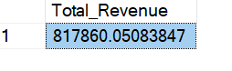

--2. Average Order values

select (sum(total_price)/ count(distinct order_id)) as Average_Order_Value from pizza_sales;

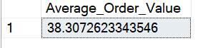

--3. Total Pizzas Sold

select sum(quantity) as Total_pizza_sold from pizza_sales

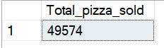

--4. Total Orders

select count(distinct order_id) as Total_orders from pizza_sales



--5. Average Pizzas Per Order

select (sum(quantity)/count(distinct order_id)) as Average_Pizza_Per_order from pizza_sales

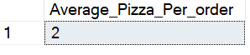

# PROBLEM STATEMENT

--1.Daily Trend for Total Orders

select Datename(dw, order_date) as Order_day, COUNT(Distinct order_id) as Average_order

from pizza_sales

group by Datename(dw, order_date);

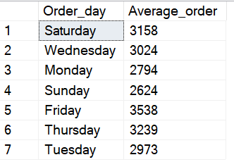

--2.Monthly Trend for Total Orders

select DATENAME(month, order_date) as Order_month, count(Distinct order_id) as Average_order

from pizza_sales

group by DATENAME(month, order_date)

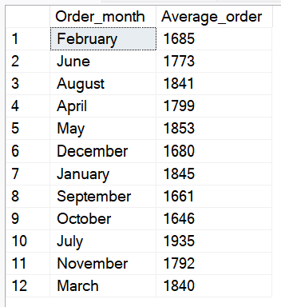

--3.Percentage of Sales by Pizza Category

select distinct(pizza_category), cast(sum(total_price)*100/

(select sum(total_price) from pizza_sales) as decimal(10,2)) as Total_Sales

from pizza_sales

group by pizza_category

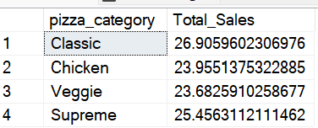

--4.Percentage of Sales By Pizza Size

select distinct(pizza_size), cast(sum(total_price)*100/

(select sum(total_price) from pizza_sales) as decimal(10,2)) as Total_sales

from pizza_sales

group by pizza_size

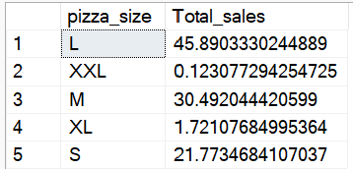

--5.Top 5 Best Sellers by Revenue, Total Quantity and Total Orders

select top 5 pizza_name, sum(total_price) as total_sales,

sum(quantity) as Total_qunatity,

count(distinct order_id) as Total_orders

from pizza_sales

group by pizza_name

order by total_sales desc

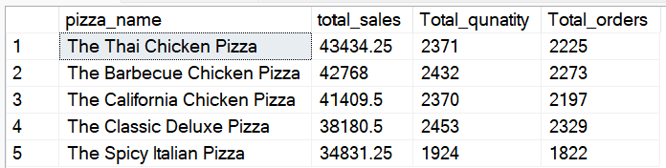

--6. Bottom 5 Best Sellers by Revenue, Total Quantity and Total Orders

select top 5 pizza_name, sum(total_price) as total_sales,

sum(quantity) as Total_qunatity,

count(distinct order_id) as Total_orders

from pizza_sales

group by pizza_name

order by total_sales

