**Business Requirement Document**

**for**

**ERP web backend Development**

**by**

**(Duplex Technologies Services)**

**for**

**Mr. Dipanshu Kumar**

**(Leader Range Technologies)**

**Revision Table**

|  |  |  |  |
| --- | --- | --- | --- |
| **Revision** | **Date** | **Content of Revision** | **Revised By** |
| 0 | 02-11-2020 | Item Master | Mr. Dipanshu Kumar |
| 1 | 15-12-2020 | Vendor Master | Sophie McKenzie |
| 2 | 04-11-2020 | Engineering Portal | Sophie McKenzie |
| 3 |  |  |  |

**Introduction:**

Overview /Goal: The goal of this software named **“ERP”** is to provide an optimized software for management of all sales and purchase. For the dedicated master related user, they can create, edit, delete, and maintain all services for different masters with keeping track of everything which they offer.

**What is the Product:**

ERP stands for enterprise resource planning (ERP). It is a business process management software that manages and integrates a company's financials, supply chain, operations, manufacturing, Warehouse etc.

**Key Features/ Modules:**

1. Item Master
2. Store Module
3. Engineering
4. Vendor
5. Finance
6. Material Requirement Planning
7. Interactive UI as per the template shared by client.
8. Nested grid view forms.
9. Some field from the Item creation forms will be exported in xml format to integrate with solidworks.

The above listed key modules will be the main masters of this ERP and we going to develop this ERP module wise. And this platform will be non-responsive in nature. Below is all about different modules:

1. **Item Master**

The term Item is also applicable to raw materials or components of products yet to be produced (before they can be sold to customers).this master allows you to manage all sorts of items like raw-materials, sub-assemblies, finished goods, item variants, and service items. And this module will have below features:

* Dynamic Search Facility
* Importing Data from Excel to create items
* Avoid duplicity in items with same characteristic under same ITEM type. But allows same manufacturer part number under different ITEM type.
* Scrapping of data from web
* Active Dashboard
* Part Reports
* Multiple Photo Upload, crop, copy & paste and to be shown as an image slider
  1. **Landing Page:**

This Page will have three options that will allow users to

* + 1. Generate Item Number
    2. Edit/Deactivate Item
    3. Search an Item
    4. **Generate Part Number:** After selecting this, users will be redirected to select **Item Type** page. User can select the item type & sub item type and can proceed to create/ add an item to this ERP by filling a form. And the functionality for the same is as below
* On select item type page, it will show the number of total item codes created in in each item type.
* The list of different item type is as below
  + Fastener
  + AC component
  + DC component
  + RF component
  + Electronic component
  + Pneumatic component
  + Motion component
  + Cable
  + Hardware
  + Connector
  + Electronic Products
  + Computer Peripheral
  + Others
* After selecting item type, user need to select sub item type for it’s respective item type.
* After selecting sub item type, user will be redirected to main form to enter all item related details and generate the part/item number.
* Mainly the designer will perform these actions to generate an item number. And after that the dedicated departments will need to enter data the in the respective fields.
* The data of member who has generated or created the item and the member who has edited the item must be there in the database.
* Below are the form fields which need to be filled to generate/create an item.
* **Main Form**

|  |  |  |
| --- | --- | --- |
| Field | Data Type | User Input & System Validation |
| UoM | Dropdown | System Validation: List must the list of UoM added in the UoM Master. User Input: user must be able to choose the options from dropdown. |
| Group List of UoM | Dropdown |  |
| Valuation Type | Dropdown |  |
| Item Type | Dropdown |  |
| Sub Item Type | Dropdown |  |
| Manage Item | Dropdown |  |
| Material Category | Dropdown |  |
| Description | Text Box |  |
| Manufacture | Text Box |  |
| Brand | Text Box | System should accept characters only. User must not be able to enter more than 30 characters. |
| Supplier Name | Text Box |  |
| Price | Text Box |  |
| MOQ (Min. Order Qty) | Text Box |  |
| Threshold (MSQ) | Text Box |  |
| HS Code | Text Box |  |
| URL Link | Text Box |  |
| Manufacturing Part Number | Text Box | User need to enter the Manufacturing part number in this field in the format of ABC-XXXXXXX or any format system should be able detect duplicity with respect to this and Item. Characteristics. **System Validation** System will check for the entered part number with the existing part numbers within their respective item type only and their characteristics in database to avoid the redundancy in data. System will throw an error if entered data will get matched with existing data. But the user can create same part number for another item type and system will allow users to create the same. |
| COO (Co-Country of Origin) | Text Box | Master Data |
| Shipping Cost | Text Box | Manually entered |
| Contact Details | Text Box | Manually entered |
| E-Mail | Text Box | Manually entered |
| We Chat | Text Box | Manually entered |
| WhatsApp | Text Box | Manually entered |
| Other Contact Type | Text Box | Manually entered |
| Upload Data Sheet | Attachment | Saved domain as discussed |
| Upload Compliance | Attachment | Saved domain as discussed |
| Upload CAD File | Attachment | Saved domain as discussed |
| Upload Certification | Attachment | Saved domain as discussed |
| Scrapping from Web | Attachment | Saved domain as discussed |
| Upload Images | Attachment | Images are web scrapped or crop and paste |
| Add | Button |  |
| Status | Dropdown | Admin need to select the status of item i.e. (i). Active (ii). Inactive |
| Generate Internal Item Code | Button | After Clicking on this button, an item code will get autogenerated  **System Validation**  All details will get saved in database. |

***Note:*** *Above are the generic form field and remaining form fields will be added in this form before creating/generating any item number according to different item type/ group will be consider as sub masters and there will be a master data of each field as well. Which are as below:*

* **From Fields for Sub Masters: *To be provided by client later***

|  |  |  |
| --- | --- | --- |
|  |  |  |
|  |  |  |
|  |  |  |
|  |  |  |
|  |  |  |
|  |  |  |
|  |  |  |
|  |  |  |

* **Item Masters:** Item masters from fields will be linked to main form. So that all departments can manage the masters accordingly in terms of Add, edit, view, and delete the master data and the functionality of the item masters as below:
* Automatic Master ID creation
* After adding details to any master, system will automatically generate and assign the ID.
* User can see the listing of added masters on the in a tabular format and view, edit and delete the same.
* Only respective department members and view, add, edit and delete the Master Data.

|  |  |  |
| --- | --- | --- |
| Field | Data Type | User Input & System Validation |
| Currency Master | | |
| Currency ID | Auto Generate |  |
| Currency Code | Text Field | Automatically taken based on currency name |
| Currency Name | Text Field | Added By user selected from the list. |
| International Code | Text Field | Auto select from the list |
| International Name | Text Field | Auto select from the list |
| Decimal Unit | Text Field | Select from options given |
| Currency Symbol | AUTOMATED | Automatically taken based on currency name |

|  |  |  |
| --- | --- | --- |
| Country Master | | |
| Country ID | Auto Generating | Automatically taken based on country name |
| Country Code | Text Field | Automatically taken based on country name |
| Country Name | Drop down | Selected by user from Drop Down. |

|  |  |  |
| --- | --- | --- |
| State Master | | |
| State ID | Auto Generate | Automatically taken based on State name |
| State Code Name | Text Field | Repeated |
| State Code | Text Field | Automatically taken based on State name |
| State Name | DROPDOWN | Selected from the list |
| GST Code | Text Field | Added by the user |

|  |  |  |
| --- | --- | --- |
| City Master | | |
| City ID | Auto Generate |  |
| Country Code Name | Text Field |  |
| State Code Name | Text Field |  |
| City Name | Text Field |  |

|  |  |  |
| --- | --- | --- |
| Area Master | | |
| Area ID | Auto Generate |  |
| Country Code Name | Text Field |  |
| State Code Name | Text Field |  |
| City Code Name | Text Field |  |
| Area Name | Text Field |  |

|  |  |  |
| --- | --- | --- |
| Company Group Master | | |
| Company Group ID | Auto Generate |  |
| Company Group Code | Text Field |  |
| Company Group Name | Text Field |  |
| Currency | Drop Down |  |
| Language | Drop Down |  |
| Company Group Image | IMAGE to be uploaded |  |

|  |  |  |
| --- | --- | --- |
| Company Master | | |
| Company Input | | |
| Company Code | Text Box |  |
| Company Name | Text Box |  |
| Currency | Dropdown |  |
| Language | Dropdown |  |
| Company Image | Attachment |  |
| Company Address Input | | |
| Company Address ID | Auto Generate |  |
| Company ID | Dropdown |  |
| Contact Person | Text Box |  |
| House no./ Building Name | Text Box |  |
| Street 1 | Text Box |  |
| Street 2 | Text Box |  |
| Landmark | Text Box |  |
| Country | Dropdown |  |
| State | Dropdown |  |
| City | Dropdown |  |
| Pin Code | Text Box |  |
| Mobile Number | Text Box |  |
| Alternate Mobile Number | Text Box |  |
| Telephone Number | Text Box |  |
| Landline Number | Text Box |  |
| FAX Number | Text Box |  |
| Website | Text Box |  |
| Email ID | Text Box |  |
| Category | Text Box |  |

|  |  |  |
| --- | --- | --- |
| Company Assignment | | |
| Company ID | Auto Generate |  |
| Company Group | Dropdown |  |
| Company Name | Dropdown |  |

|  |  |  |
| --- | --- | --- |
| Branch Master | | |
| Branch Input | | |
| Branch ID | Auto Generate |  |
| Branch Code | Text Box |  |
| Branch Name | Text Box |  |
| Currency | Dropdown |  |
| Language | Text Box |  |
| GST Number | Text Box |  |
| SST Number | Dropdown |  |
| Is Plant | Dropdown |  |
| Is warehouse | Dropdown |  |
| Branch Address Input | | |
| Branch Address ID | Auto Generate |  |
| Branch ID | Dropdown |  |
| Contact Person | Text Box |  |
| House no./ Building Name | Text Box |  |
| Street 1 | Text Box |  |
| Street 2 | Text Box |  |
| Landmark | Text Box |  |
| Country | Dropdown |  |
| State | Dropdown |  |
| City | Dropdown |  |
| Pin Code | Text Box |  |
| Mobile Number | Text Box |  |
| Alternate Mobile Number | Text Box |  |
| Telephone Number | Text Box |  |
| Phone Number | Text Box |  |
| Alternate Phone Number | Text Box |  |
| Website | Text Box |  |

|  |  |  |
| --- | --- | --- |
| Branch Assignment | | |
| Branch Assignment ID | Auto Generate |  |
| Company Name | Text Box |  |
| Branch Name | Dropdown |  |

|  |  |  |
| --- | --- | --- |
| Unit of Measure Master | | |
| Group ID | Auto Generate |  |
| Group Code | Text Box |  |
| Group Name | Text Box |  |

|  |  |  |
| --- | --- | --- |
| Unit of Measure Group Master | | |
| UoM ID | Auto Generate |  |
| UoM Code | Auto Generate |  |
| UoM Name | Drop down |  |

|  |  |  |
| --- | --- | --- |
| Unit of Measure Group Input | | |
| UoM Group ID | Auto Generate |  |
| Base Quantity | Drop down |  |
| Base UoM | Drop down |  |
| Alt Quantity | Drop down |  |
| Alt UoM | Drop down |  |

|  |  |  |
| --- | --- | --- |
| HSN Code | | |
| HS Code | Text Box |  |

|  |  |  |
| --- | --- | --- |
| Item Group Master | | |
| Item Group ID | Auto Generate |  |
| Item Group Code | Auto Generate |  |
| Item Group Name | Drop Down |  |

|  |  |  |
| --- | --- | --- |
| Valuation Method Master | | |
| Valuation Method ID | Auto Generate |  |
| Valuation Method Code | Auto Generate |  |
| Valuation Method Name | Drop Down |  |

|  |  |  |
| --- | --- | --- |
| Priority Master | | |
| Priority ID | Auto Generate |  |
| Priority Name | Drop Down |  |

|  |  |  |
| --- | --- | --- |
| Exchange Rate Master | | |
| Exchange Rate ID | Auto Generate |  |
| Company | Dropdown |  |
| Date | Select from Calendar |  |
| Currency | Dropdown |  |
| Amount | Text Box |  |

|  |  |  |
| --- | --- | --- |
| Bank Master | | |
| Bank ID | Auto Generate |  |
| Bank Code | Text Box |  |
| Bank Name | DROPDOWN |  |
| Amount | Text Box |  |

|  |  |  |
| --- | --- | --- |
| Payment Master | | |
| Payment Term ID | Auto Generate |  |
| Payment Term Code | Text Box |  |
| Payment Term Name | Text Box |  |
| Credit Days | Text Box |  |
| Amount | Text Box |  |
| Tolerance Days | Text Box |  |
| Related To | Dropdown |  |

|  |  |  |
| --- | --- | --- |
| Posting Period Master | | |
| Posting Period ID | Auto Generate |  |
| Company | Dropdown |  |
| Period Code | Text Box |  |
| Period Name | Text Box |  |
| Sub Period | Dropdown |  |
| Financial Period Start | Text Box |  |

* + 1. **Edit Item:** To edit any item, there are some conditions under which items admin can make changes for the same. These conditions are as below:
* Designers, Stores and SCM can edit the items.
* Form, Addition of multiple suppliers, information update, rack number and document can be edit any time but if the designer wants to update any item code then,
* System will check whether the Purchase order or Purchase request has been raised if they PO or PR has been raised for the same then the designers will get and alert that you can’t edit this item code *only manager can edit this info.*
* If Purchase order or Purchase request has not been raised then, designers can edit the item number and the request will go to the manager or head of department and after getting approval on updated item number, they updated info. will start reflecting in the item listing table.
* If the is already in stock, then it cannot be edit.
* Any item cannot be deleted, it can be deactivated only.
* If any department wants to edit any item, then they can only edit those fields which are dedicated to that department only.
* If any item is inactive needs to be active again then, only admin can edit activate it irrespective of different departments.
  + 1. **Search an Item:** This functionality will provide an easy interactive way to search an item in the data base and know other information that will help all departments to get complete insight of the item available in the warehouse/inventory for use. Below are the features of this functionality
* After clicking on search from the landing page users will be redirected to the page containing the name of all item groups.
* When the user will hover over each item group the respective card will be highlight and user need to click on the name of item group for which they want to search an item.
* After selecting the item group, user will be redirected to the search page where they enter the item name to be search in the search bar even they can select the category of item from the dropdown presented at the right corner of the search bar.
* Users can search an item by keyword, item code, part number, item group wise, item sub groupwise. And there will be a general search option with filter to refine the search.
* The search will be dynamic and global in nature so that after entering any keyword, the related items will appear on the screen with images and its item number.
* User can copy the item number and after clicking on the item card, all details with respect to that item will start reflecting on the search page.
* User can view attached document to the particular item and also download a CAD file.
  1. **Active Dashboard:** There will be some information which will show the real time in terms of item listing, graphs and charts or analytics. The features of this dashboard are as below:
* There will be a column bar graph to show the graphical representation of Total Item code created.
* There will be pie graph which entail the approved and pending approval numbers.
* When the user will click upon approved or pending data on the pie chart, another window will be pop up showing all the data related to revision history and pending approval respectively.
  1. **Item Listing:** There will be tab inside the menu option named as *Item Listing* and by clicking on this tab, users will be redirected to item listing page. It will have below features
* By this listing user can see the listing of all added items on this ERP.
* By Clicking on View Button user will be redirected to the detailed page for each item.
* The listing will be in tabular format and user can see below attributes from this page:
  + Item Number
  + Item Name
  + Item Type
  + **TBD by client. (Kindly suggest at least 3 more fields for the same and the Actions as well)**
  1. **Modules to be linked:** There are some other modules which will be developed from us in later phase and after that those modules will be linked to this Item Master module. So that the respective department of each module can access, view, edit, and add the data for different items accordingly. The listing of modules to be link are as below:

1. **Vendor Module**
2. **Supply Chain Management Module**
3. **Engineering Module**
4. **Store Module**
5. **Finance Module**
6. **Planning Module**
7. **Engineering Module:** It is a document management portal where the document and the work of engineering can be managed.

* SMD and PMD document auto arranging: This portal will sort the data/documents of the projects related to SMD and PMD
* Revision Control: Admin can access all the revised document links.
* Work Status Update Project wise: Admin can see the work status of programmers.
* SCM Support for Sheet Metal Requirement: This portal will
* Active Dash Boards: Admin can access the dashboard for different activities.
* Updated CNC Programs: Admin can see the link of update CNC programs which are coming from programmers.
* Integrated with External Programmer Module: This portal will be integrated to External Programmer Module to send the requirement of CNC programs by uploading the designs and to fetch the data from External Programmer Module to keep track of updated programs, time taken by programmer, to access the emergency comments.
* Revision Control of CNC Programs
* Verification Mechanism: Admin can verify the CNC programs.
* Audit: The documents which has not been used since a year, they will automatically get disappear from this portal.
  1. **Add new Project:**
* Admin can add a new project by clicking on the new project tab from dashboard
* Project number, Part number list and Drawings and CAD files are added by Sales or Design team in this portal (Mandatory fields)
* After clicking on New Project tab, admin can see the list of part numbers with respect to its drawing number which are coming from Design department and Sales department.
* Admin can add a new project as below:

|  |  |  |
| --- | --- | --- |
| Field | Data type | System Validation |
| Upload Drawings | Prefilled | System will save this file in the DB and it will create a link to download that uploaded file |
| Upload CAD files | Prefilled | System will sort and arrange the both CAD files and Drawings according to their name. |
| Project Name | Prefilled |  |
| Project Number | Prefilled |  |
| SMD/PMD | Radio Button |  |
| Submit (if SMD) | Button | System will save the entered details in the database. |

* **If SMD:** *System will group the data as per the input provided by* ***RFQ Module*** *i.e. sheet sizes against each part number. The system will sort as per the sheet metal type & thickness and provide the below output.*

|  |  |
| --- | --- |
| Part Number | Drawing Number |
| 1234 | 1234.dxf |
| 1245 | 1245.dxf |
| 1256 | 1256.dxf |

***Note:*** *The nesting will be done manually and the quantity of sheets will be forwarded to* ***SCM Module***.

* The Output data of will look like below:

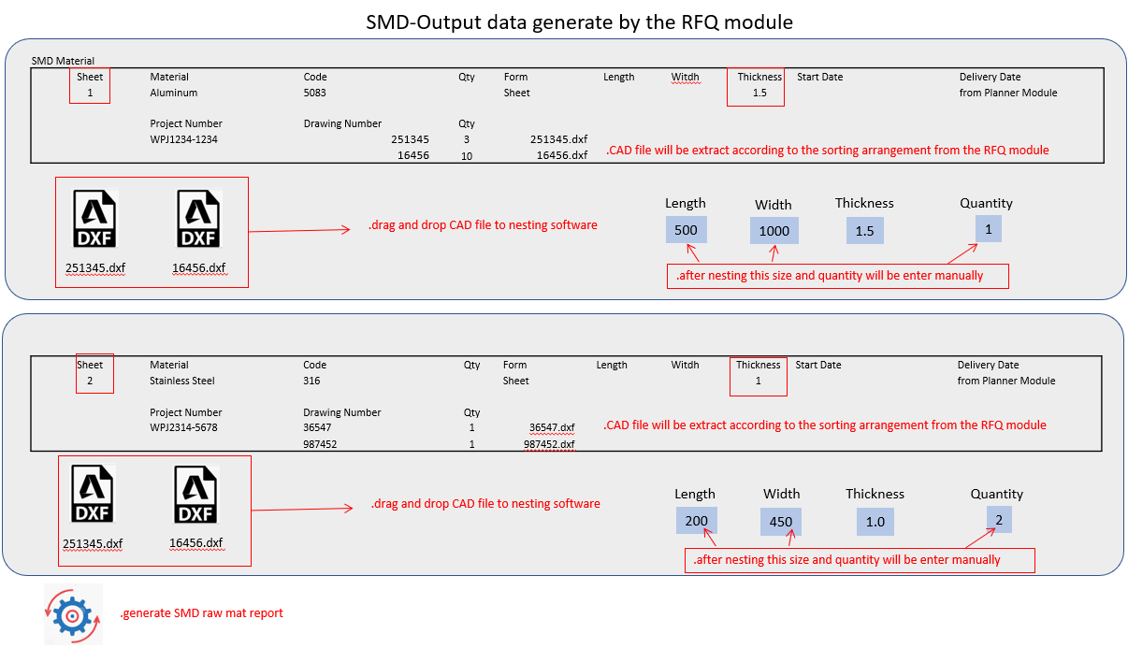

* The generated raw material report from this engineering portal will look like:

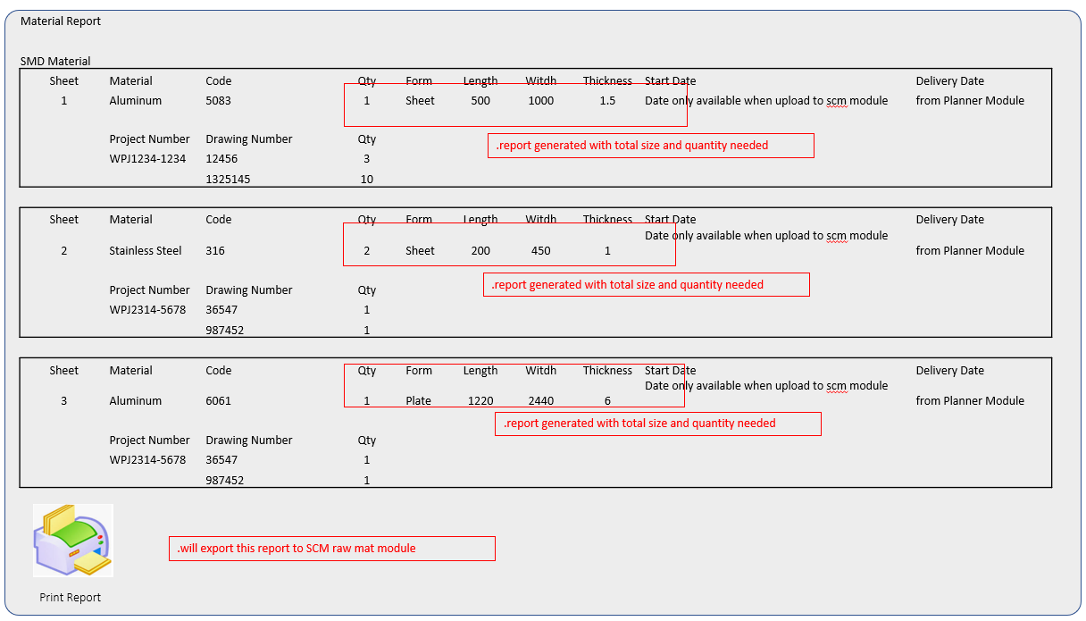

* + *The output from this SMD will be the link of Nested files and the CNC code to run the machine provided in the database link.*
* **IF PMD:** After the sorting of CAD files and Drawings the Admin will choose whether the coding for each drawing is supposed to done by LRT’s internal team or External Programmer as below:

|  |  |  |  |
| --- | --- | --- | --- |
| Field |  | Data Type |  |
| Project Name: WPJ-001123 | | Prefilled | Need to Done by: |
| Part Number: 12345 | | Prefilled | Dropdown (1. Internal Programmer 2. External Programmer) |
| Drawing Name: 12345.dxf | | Prefilled |  |
| Need to done by: | | Dropdown | Admin need to choose from below options i.e. 1. Internal Programmer 2. EPL-1  3. EPL-2  4. EPL-3  5. EPL-4  6. EPL-5 |
| Enter Due Date (if admin chose External Programmer from above Need to done by: dropdown) | | Date picker | The system will calculate the finish time by this entered due date and after comparing the upload date of the external programmer system will check whether the finishing time of the task is on-time or delayed. |
| Submit | | Button | After clicking on this button, the request of program will get uploaded on external programmer portal with the uploaded design link. |

* + If the admin selects internal programmer then internal team will upload CNC program from their end after that the admin will check the program and can verify the same.
  + If the admin selects external programmer then, the request for the drawings will get moved to the External programmer portal and the external programmer will upload CNC program from their portal after that the admin will check the program and can verify the same.
  + The name of the assigned programmer with their level will get saved in the system and will appear in the listing of different projects. (example: EPL1-PRADEEP)

***Note:*** During this process if the Drawing will be revised then the revision history will be taken care as below:

* + **Case 1 (If the admin replaced the design e.g. 12345.dxf and external programmer has not accepted the request then)**
    - The Drawing Number will remain same as it was at time of upload i.e12345.dxf-UR0
  + **Case 2 (If the admin replaced the drawing e.g. 12345.dxf and external programmer has accepted the request but not uploaded the program from his portal)**
    - The Drawing Number will get updated i.e. 12345.dxf-UR1 and the dedicated external programmer will get a notification that *the design has been replaced!*
  + **Case 3 (If the admin replaced the design e.g. 12345.dxf and external programmer has accepted the request and uploaded the program from his portal)**
    - The Drawing Number will get updated i.e. 12345.dxf-UR1 and the dedicated external programmer will get a notification that *the design has been replaced!*
  + Once the program will be uploaded by External or internal programmer the link of program will start appearing to engineering portal and admin can verify the program by checking below conditions:

|  |  |  |
| --- | --- | --- |
| Field | Datatype | System Validation |
| Is CNC program as per latest drawing? | Checkbox | System will save the entered value in the DB |
| Is the drawing latest uploaded | Checkbox | System will save the entered value in the DB |
| All required document for production uploaded? | Checkbox | System will save the entered value in the DB |

* + After checking all among conditions system will save the name of the user who has verified the program and their name will start reflecting in the listing of projects in ***Verified by*** column.
  + If During Verification any comment the same will be notified to External programmer.
  + The listing for all above conditions will look as below:

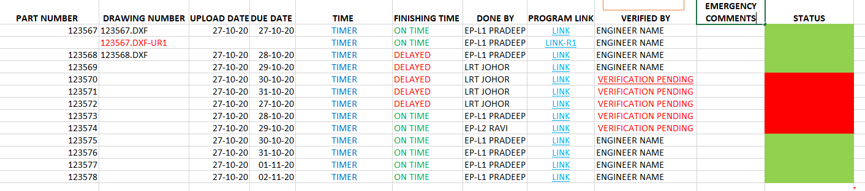

* + ***Note (i):*** By clicking on the verification pending hyperlink at verified by column, the checklist of above defined conditions will get opened in a pop up and after checking all among conditions system will save the name of the user who has verified the program and their name will be updated in the listing of projects in ***Verified by*** column in the above list.
  + ***Note (ii):*** Once the verification is done by LRT team, all actions for the external programmer will get freeze and the external programmer won’t be able to change or upload anything from their portal. They can only put emergency comments from their portal which will start reflecting on this engineering portal in above ***Emergency Comments*** column.
  1. **Edit Project:** The admin can edit a project with below conditions:
* Can add more designs
* Can replace the designs
* Can remove the designs
* Can Edit the fields of Project like Due date , done by etc.

Admin can access all of editing feature as below:

|  |  |  |
| --- | --- | --- |
| Part Number | Drawing Number | Action |
| 12334 | 12334.dxf | Edit || delete |
| 34635 | 34635.dxf; 34635.dxf-UR1 | Edit || delete |
| 6567 | 6567.dxf | Edit || delete |

* After clicking on edit button admin will be able to do below actions:

|  |  |  |
| --- | --- | --- |
| Field | Data type | Action |
| Part Number FC-34534 |  |  |
| Drawing Number 34534.dxf; & 34534.dxf-UR1 | Button | Add More || Replace || Remove |

* 1. **Search Option:** Admin can search a project by entering below details and the search bar
* By entering project name
* By entering part number
  1. **Active Dashboard:**
* **Running Projects:** It will show the number all created projects for which the verification is not done.
* **Revised Uploads:** It will show the number of replaced designs uploaded by sales and design department.
* **Delays:** It will show the number of the drawings for which the estimated due date has been elapsed.
* **New Projects:** I will show the number all of uploaded Part numbers & Drawing numbers so that the admin can add project name and project number for the same as defined above.
* **Pending Verification:** It will show the number of submitted programs by programmers for which the verification is pending from the admin.
* **Emergency Comments:** it will show the number of emergency comments which are coming from the external programmer portal.
  + ***Note:*** After clicking on each card of the dashboard the admin will be redirected to its respective listing from where admin can perform different action accordingly.
  1. **Direction of data transfer:** Below is the pictorial representation of transferring the data between Engineering Portal to External Programmer Portal;

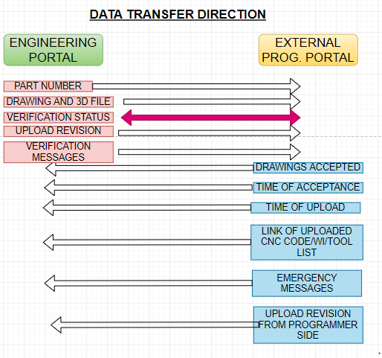

1. **Vendor Module:** This module will have two sub modules i.e.
   1. **Vendor Master:** This master will be accessed by admin and the admin can manage below listed functionalities
      1. **Invite Vendor:** Admin can invite vendors by entering some basic details as below

|  |  |  |
| --- | --- | --- |
| Field | Data Type | System Validation |
| Company Name (Mandatory) | Text Field | First Name must be in characters only. |
| Contact Person | Text Field | Last Name must be in characters only. |
| Email ID (Mandatory) | Text Field | Email must be in the basic format i.e. *adb@mail.com* |
| Invite | Button | After clicking on invite button, the vendors will receive an invitation mail with the link of the form which they need to fill and submit |

|  |
| --- |
| Email Trigger |
| The email triggers and its content has provided by client and the link for the same is mentioned below |
| <https://drive.google.com/file/d/1iudkYS8URmGFGc8S5L3jC-_fe292JGOg/view?usp=sharing> |

* + 1. **Vendor Requests:** By this admin can access the listing of vendor requests, sort the listing as below:

|  |  |  |  |  |  |
| --- | --- | --- | --- | --- | --- |
| Company Name | Contact Person | Email -ID | Source | Status | Action |
| Store Name | User Name | [xyx@mail.com](mailto:xyx@mail.com) | Internal | Invited | View | Approve | Stand by |
| Store Name | User Name | [xyx@mail.com](mailto:xyx@mail.com) | External | Submitted | View | Approve | Stand by |
| Store Name | User Name | [xyx@mail.com](mailto:xyx@mail.com) | Internal | Stand by | View | Approve | Stand by |

***Note:*** *If the source is internal that means the vendor has been invited by admin and if the source is External it means the vendors have registered themselves from LRT’s official website.*

* + **View:** After clicking on view admin can all details ***submitted by*** vendor from the registration form as below:

|  |  |  |
| --- | --- | --- |
| Field | Data Type | System Validation |
| Vendor Details | | |
| Vendor Short Name | Prefilled | Admin can see vendor short name filled by vendor. |
| Company Name | Prefilled | Admin can see company name filled by vendor. |
| Address | Prefilled | Admin can see address filled by vendor. |
| City | Prefilled | Admin can see city filled by vendor. |
| State | Prefilled | Admin can see state filled by vendor. |
| Country | Prefilled | Admin can see country filled by vendor. |
| Pin Code | Prefilled | Admin can see pin code filled by vendor. |
| Telephone Number | Prefilled | Admin can see telephone number filled by vendor. |
| Fax No. | Prefilled | Admin can see Fax No. filled by vendor. |
| Mobile Number | Prefilled | Admin can see mobile number filled by vendor. |
| Alternate Number | Prefilled | Admin can see alternate number filled by vendor. |
| GST Number | Prefilled | Admin can see GST number filled by vendor. |
| SST Number | Prefilled | Admin can see SST Number filled by vendor. |
| Payment Terms | Prefilled | Admin can see Payment Terms filled by vendor. |
| Currency | Prefilled | Admin can see Currency filled by vendor. |
| Category Name | Prefilled | Admin can see Vendor Category filled by vendor. |
| Region | Prefilled | Admin can see region filled by vendor. |
| Work Samples | Prefilled | Admin can download the work samples uploaded by vendor. |
| Machine Capability | Prefilled | Admin can see filled by vendor. |
| Personal Details | | |
| System ID/PASSWORD | Prefilled | GENERATED BY SYSTEM AND MAILED |
| Name | Prefilled | Admin can see the vendor name. |
| Email Address | Prefilled | Admin can see the email id of vendor. |
| AV (APPROVED VENDOR) NUMBER | Prefilled | Admin can see the ID number of vendors. |
| Passport Number | Prefilled | Admin can see the passport number of vendors. |
| Skill/CAPABILITY | Prefilled | Admin can see the skill checked by vendor. |
| Engineer Level | Prefilled | Admin can see the level of the vendor. |
| Telephone Number 1 | Prefilled | Admin can access the telephone number of the vendor. |
| Telephone Number 2 | Prefilled | Admin can access the telephone number of the vendor. |
| Address | Prefilled | Admin can access the address of the vendor. |
| City | Prefilled | Admin can access the city of the vendor. |
| Pin Code | Prefilled | Admin can access the pin code of the vendor. |
| Country | Prefilled | Admin can access the country of the vendor. |
| Location | Prefilled | Admin can access the location of vendor from maps as well. |
| Bank Details | | |
| Bank Details/PayPal | Prefilled | Admin can see if the vendor is using bank for transaction or PayPal. |
| If vendor chose Bank: | | |
| Bank Name | Prefilled | Admin can see the name of bank. |
| Swift Code | Prefilled | Admin can see the swift code. |
| Account Number | Prefilled | Admin can see the account number |
| Receiver Name | Prefilled | Admin can see the name of receiver. |
| Bank Address 1 | Prefilled | Admin can see the bank address. |
| Bank Address 2 | Prefilled | Admin can see the bank address. |
| Bank Address 3 | Prefilled | Admin can see the bank address. |
| Postal code | Prefilled | Admin can see the postal code of bank. |
| City | Prefilled | Admin can see the city of bank. |
| State | Prefilled | Admin can see the state of bank. |
| Country | Prefilled | Admin can see the country of bank. |
| Bank Contact Number 1 | Prefilled | Admin can see the contact number of bank. |
| Bank Contact Number 2 | Prefilled | Admin can see the contact number of bank. |
| If Vendor Chose PayPal: | | |
| Email ID |  | Admin will be able to see the email ID of vendor’s PayPal account. |
| NDA | Pre-uploaded |  |
| Select Status | Radio Button | Admin need to choose the status of vendor from (i) Active (ii) Suspend |
| Portal Access? | Drop Down | Admin need to select an option from (i) Yes (ii) No if admin select portal access yes then, some addition fields of vendor permissions with a checkbox will start appearing on this page and admin can assign different permissions to the vendor to access their portal. ***Note:*** The vendor permission are defined below in ***2.1.3. Vendor Permissions*** para. |
| Approve | Button | After clicking on this button, **if Portal Access = No**: the vendors will be notified on their above-mentioned email saying *your request has been approved.*  **If Portal access = Yes:** the vendors will be notified on their above-mentioned email saying *your request has been approved with the link of vendor portal and its credentials to access the vendor portal.* And the listing of this particular vendor will be removed from vendor request page and will start appearing at vendor listing page |
| Stand By | Button | After clicking on this button, the vendors will remain at vendor request page and admin can approve them in future. |

* + **Sort By:** There will be sort by button and the admin can sort this vendor request listing on below parameters:
    - Company Name
    - Contact Person
    - Invited
    - Submitted
    - Stand By
    1. **Vendor Permissions:** By this, admin can assign the portal permissions to be accessed by vendor form their portal as below
* Admin can change permissions anytime from this panel.
* The permissions will be assigned to each vendor individually.
* The permissions will be in checkbox so that the admin check the boxes and the respective permission will get assigned to a particular vendor as below:

|  |  |
| --- | --- |
| Field | Data Type |
| Select All | Checkbox |
| Payments | Checkbox |
| QC Report | Checkbox |
| KPI | Checkbox |
| PO | Checkbox |
| PR | Checkbox TBC by Client……... |

* + 1. **Vendor Listing:** Admin can access the vendor listing as below:

|  |  |  |  |  |
| --- | --- | --- | --- | --- |
| Company Name | Vendor Name | Category | GST No. | Action |
| xyz company | User name | Finishing/treatment | **-** | View | Suspend |
| xyz company | User name | Hardware | xxxxxxxxxxxx | View | Suspend |
| xyz company | User name | Material | xxxxxxxxxxxx | View | Suspend |

* + 1. **Payments:**
    2. **Quality Analysis & feedback:**
    3. **Delivery:**
    4. **Purchase Orders:**
  1. **Vendor Portal:** There will be two ways to register the vendors with LRT.
* By registering themselves via LRT official website.
* By receiving the invitation from Admin of ERP.
* The registration form details are as below:

|  |  |  |
| --- | --- | --- |
| Field | Data Type | System Validation |
| Vendor Short Name (Mandatory) | Text Field | Vendor short name must be in characters only. |
| Company Name (Mandatory) | Text Field | Company name can be alpha numeric. |
| Address (Mandatory) | Text Field | Vendors need to fill their address in this field. |
| City (Mandatory) | Dropdown | Vendors need to select their city from this dropdown  The listing of cities is coming from Area Master |
| State (Mandatory) | Dropdown | Vendors need to select their city from this dropdown  The listing of States is coming from Area Master |
| Country (Mandatory) | Dropdown | Vendors need to select their city from this dropdown  The listing of Country is coming from Area Master |
| Pin Code (Mandatory) | Text Field | Vendors need to fill their Pin code in this field.  The pin code must be of five digits and the data type must be numeric digits only. |
| Telephone Number | Text Field | Vendors need to fill their telephone in this field. |
| Fax No. | Text Field | Vendors need to fill the fax no. in this field. |
| Mobile Number (Mandatory) | Text Field | Vendors need to fill their mobile in this field. |
| Alternate Number | Text Field | Vendors need to fill the alternate number in this field. |
| GST Number | Text Field | Vendors need to fill the GST number in this field. |
| SST Number | Text Field | Vendors need to fill the SST number in this field. |
| Payment Terms (Mandatory) | Text Field | Vendors need to fill their payment terms in this field. |
| Currency (Mandatory) | Text Field | Vendors need to fill their Currency in this field. |
| Category Name (Mandatory) | Dropdown | Vendors need to select their Category in this field. |
| Region (Mandatory) | Radio Button | Vendors need to select their region in below options:   1. Local 2. Oversea |
| Work Samples | Attachment | Vendors need to upload their work samples by this attachment. |
| Machine Capability (If category is finishing or Fabrication then mandatory) | Button | * After clicking on this a pop up will get opened in a tabular format of 3 columns and 10 rows. * The columns will contain below 3 headings   + Machine Name   + Machine Function   + Machine Capability & Limitations * Vendor can upload up to 10 machines.   if the vendor selected fabrication or finishing category from vendor category dropdown then it’s mandatory to fill their Machine Capability in the popup. |
| Personal Details | | |
| System ID | Textbox | Vendors need to fill the alphanumeric characters. |
| Name | Textbox | Vendors need to fill the characters only. |
| Email Address | Textbox | Vendors need to fill the email id in the form of xyx@mail.com |
| ID Number | Textbox | Vendors need to fill the alphanumeric characters. |
| Passport Number | Textbox | Vendors need to fill the alphanumeric characters. |
| Skill | Checkbox | Vendors can select their skill from below options:   * MASTERCAM * SURCAM * HYPERMILL |
| Engineer Level | Dropdown | Vendors can select their level from below options:   * EL1 * EL2 * EL3 * EL4 * EL5 |
| Telephone Number 1 | Textbox | Vendors need to enter their mobile number in numeric characters only. Note: There will be a dropdown to select the country code of the phone number. |
| Telephone Number 2 | Textbox | Vendors need to enter their mobile number in numeric characters only. Note: There will be a dropdown to select the country code of the phone number. |
| Address | Textbox | Vendor need to enter their address in alphanumeric. |
| City | Dropdown | Vendor need to select their city from the dropdown. |
| Pin Code | Text field | Vendor need to enter the pin code in numeric characters only. |
| Country | Dropdown | Vendor need to select their country from the dropdown |
| Location | Map | There will be map view, from there the vendors can either search their location from the search bar associated with mapbox or can click on crosshair icon so that the system will be able to access their current location. |
| Bank Details | | |
| Bank Details/PayPal | Radio Button | Vendor need to choose the payment provider to give the details of PayPal or Bank. |
| If vendor chose Bank: | | |
| Bank Name | Dropdown | Vendor need to select the Bank Name from the dropdown. |
| Swift Code | Dropdown | Vendor need to select the swift code from the dropdown. |
| Account Number | Textbox | Vendor need to enter the account number in alphanumeric. |
| Receiver Name | Textbox | Vendor need to enter the name of receiver in characters only. |
| Bank Address | Textbox | Vendor need to enter the bank address in alphanumeric characters. |
| Postal code | Textbox | Vendor need to enter the postal code of bank in numeric characters only. |
| City | Dropdown | Vendor need to select the city from the dropdown. |
| State | Dropdown | Vendor need to select the state from the dropdown. |
| Country | Dropdown | Vendor need to select the country from the dropdown. |
| Bank Contact Number 1 | Textbox | Vendors need to enter the contact number in numeric characters only. Note: There will be a dropdown to select the country code of the phone number. |
| Bank Contact Number 2 | Textbox | Vendors need to enter the contact number in numeric characters only. Note: There will be a dropdown to select the country code of the phone number. |
| If Vendor Chose PayPal: | | |
| Email ID | Textbox | Vendors need to fill the email id in the form of [xyx@mail.com](mailto:xyx@mail.com) associated with their PayPal account. |
| NDA | Attachment | Vendors need to download the NDA from here and has to upload the counter sign copy of the NDA in .pdf format only. Note: below will the conditions to download and upload the NDA written in the form   * Please download your NDA agreement. * Type your name and use pen to draw your signature. |
| Submit | Button | After clicking on this button, system will save their requests and the saved requests will be moved to the vendor requests page at admin panel. |