

MC & IoT Project work Report
on

“Project title”

Submitted in partial fulfillment of the requirements for the IV Semester Bachelor of Engineering in Computer Science and Engineering
of Ramaiah Institute of Technology, Bengaluru.

by

Name USN
Name USN

Under the Guidance of:

Dr. Devaraju B M
Associate Professor
Dept. of CSE

Department of Computer Science and Engineering
(Autonomous Institute, Affiliated to VTU)
(Approved by AICTE, New Delhi & Govt. of Karnataka)
Accredited by NBA & NAAC with 'A+' Grade

2026-2027



CERTIFICATE

This is to certify that the MC & IoT Project work submitted by Name 1 (USN), Name 1 (USN) and Name 1 (USN) have completed the “Project title” as part of Microcontroller & IoT project. We declare that the entire content embodied in this B.E 4th Semester report contents are not plagiarized.

Guide:

Dr. Devaraju B M
Associate Professor

Examiners Viva:
Name of the Examiner Signature with Date
1.

ACKNOWLEDGMENT

The acknowledgment section in a project report is written to express gratitude to the people and organizations that supported the student during the project work. It is usually placed after the abstract and before the table of contents. The acknowledgment should be written in a polite, respectful, and formal manner.

While writing the acknowledgment, students should thank their project guide, faculty members, head of the department, principal, and institution for their guidance and support. The contribution of each person should be acknowledged briefly and sincerely.

The content should be short and meaningful, generally written in one or two paragraphs. Students should avoid using overly emotional or informal language. The acknowledgment should focus only on academic and project-related support. Proper grammar and sentence structure should be maintained to give a professional appearance to the report.

A good acknowledgment section reflects gratitude, respect, and professionalism, and it helps recognize the efforts of those who contributed to the successful completion of the project.

ABSTRACT

An abstract is a short summary of the entire project report. It gives the reader a quick understanding of the project topic, objective, methodology, and results. The abstract is usually written in a single section at the beginning of the report and should be clear, concise, and informative. Generally, an abstract contains about 150–300 words and is written after completing the project work.

While writing an abstract, students should briefly explain the purpose of the project and the problem it aims to solve. The technologies, tools, or methods used in the project should also be mentioned. A short description of how the system works and the major outcomes or benefits achieved through the project should be included. The language should be simple, formal, and easy to understand.

Students should avoid adding diagrams, tables, references, or lengthy explanations in the abstract. The content should focus only on important points of the project. Proper grammar, meaningful sentences, and logical flow must be maintained. A well-written abstract helps readers understand the project quickly and creates a good impression of the report.

CONTENTS

Sl no. Chapters Name Page No.

1. INTRODUCTION 01

2. PROBLEM STATEMENT 07

3.1 EXISTING SYSTEM & LIMITATIONS

3.3 PROPOSED SYSTEM & ADVANTAGES

3. REQUIREMENT ANALYSIS AND FEASIBILITY STUDY

4.1 FUNCTIONAL REQUIREMENT

4.3 HARDWARE REQUIREMENT

4.4 SOFTWARE REQUIREMENT

5. SYSTEM DESIGN

5.1 SYSTEM ARCHITECTURE

5.2 DATA FLOW DIAGRAMS (DFD)/ FLOW CHARTS

6. IMPLEMENTATION

6.2 CONFIGURATION
6.3 CODE

- RESULT ANALYSIS

7.3 RESULTS

7.4 SNAPSHOTS

8. CONCLUSION AND FUTURE WORK
8.1 CONCLUSION
8.2 LIMITATIONS AND FUTURE WORK

BIBLIOGRAPHY (IEEE format)

Chapter 1
INTRODUCTION

The Introduction chapter is the first chapter of a project report and provides the basic background of the project. It helps the reader understand the project topic, the need for the project, and the overall objectives. The introduction should clearly explain what the project is about and why it is important. It should be written in simple, formal, and meaningful language so that readers can easily understand the context of the work.

While writing the introduction, students should begin with general information related to the project domain and then gradually move toward the specific problem being addressed. The chapter should explain the existing issues or limitations in current systems and describe how the proposed project attempts to solve them. Students should also mention the aim, objectives, scope, and significance of the project. If necessary, a brief overview of the technologies or tools used in the project can be included.

The introduction chapter should be well-organized and divided into proper sections and subsections wherever required. Students should avoid unnecessary technical details, lengthy explanations, and copied content. Proper grammar, logical flow, and paragraph structure should be maintained throughout the chapter. The introduction should create interest in the project and provide a strong foundation for the remaining chapters of the report.

Chapter 2
PROBLEM STATEMENT

The Problem Statement chapter explains the main issue or challenge that the project is intended to solve. It helps readers understand why the project is necessary and what motivated the development of the system. This chapter should clearly describe the existing problem, limitations of current methods, and the need for an improved solution. The writing should be simple, clear, and focused on the actual problem related to the project domain.

While writing the Problem Statement chapter, students should first introduce the background of the problem and explain the difficulties faced in the current system or process. The chapter should identify specific issues such as lack of efficiency, high cost, security problems, manual work, time consumption, or poor performance. Students should avoid unnecessary technical details and instead focus on explaining the real-world problem in an understandable manner.

The chapter should also mention how the proposed project aims to overcome these limitations. Students can briefly explain the expected improvements or advantages of the new system compared to the existing approach. The problem statement must be realistic, relevant, and directly connected to the project objectives. Proper paragraph structure, formal language, and logical flow should be maintained throughout the chapter.

“Students should avoid copying content from other sources and ensure the problem statement is written in their own words, but the main focus should remain on clearly defining the problem and its importance. A well-written problem statement helps readers understand the purpose and significance of the project effectively”.

Chapter 3
REQUIREMENT ANALYSIS AND FEASIBILITY STUDY

The Requirement Analysis and Feasibility Study chapter explains the requirements needed for successful development and implementation of the project. It helps identify the functions of the system, resources required, and the feasibility of the proposed solution. This chapter provides a clear understanding of how the project will operate and what technologies are necessary for its execution. Proper requirement analysis helps in reducing errors and improving project efficiency.

The Functional Requirement section describes the important functions performed by the system. It explains how the system accepts inputs, processes data, and produces outputs according to user requirements. This section may include features such as data monitoring, user interaction, sensor operation, communication between devices, and report generation. Functional requirements help define the expected behavior and performance of the system.

The Hardware Requirement section explains the physical components used in the project, such as microcontrollers, sensors, power supply units, display modules, and communication devices. The Software Requirement section describes the software tools and technologies used for development, including operating systems, programming languages, IDEs, and databases. These requirements ensure proper development, testing, and execution of the project in an efficient and reliable manner.

Chapter 4
SYSTEM DESIGN

The System Design chapter explains the structure and working model of the project. It describes how different components of the system are organized, connected, and operated to achieve the project objectives. This chapter helps readers understand the technical design and internal workflow of the proposed system.

The System Design chapter should be written in a clear and organized manner using proper headings and diagrams. Students should explain the design logically and avoid unnecessary theoretical details. The chapter usually includes system architecture, data flow diagrams, and flow charts that represent the functioning of the system visually.

4.1 SYSTEM ARCHITECTURE
The System Architecture section explains the overall structure of the project and how different hardware and software components interact with each other. Students should include a neat architecture diagram and explain each component used in the project such as sensors, microcontrollers, servers, databases, cloud platforms, applications, or communication modules.
The explanation should describe:
- Input components
- Processing units
- Communication methods
- Output devices
- Data storage or cloud services
- User interaction
The architecture description should clearly explain the flow of data and communication between components. Each block in the architecture diagram should be labeled properly and explained briefly in paragraph form. Students should maintain proper alignment, figure numbering, and captions for diagrams.
Example:
“In the proposed system, sensor data is collected through IoT sensors and transmitted to the Raspberry Pi controller. The controller processes the data and sends it to the cloud server for storage and monitoring. Users can access the information through a web or mobile application.”
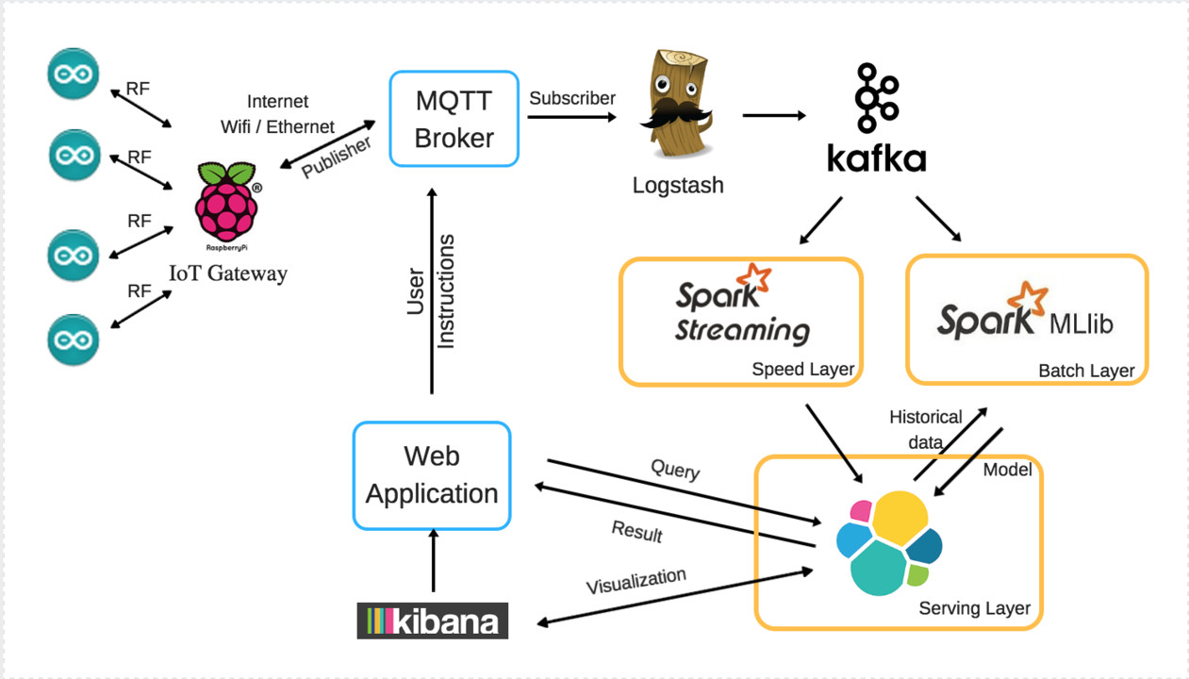
Figure 4.1: IoT Architecture diagram

4.2 DATA FLOW DIAGRAMS (DFD) / FLOW CHARTS
This section explains the step-by-step flow of information and operations within the system. Students should include DFDs or flow charts to represent how the system processes input data and produces output.
Data Flow Diagram (DFD)
A DFD shows:
- Input data
- Processing steps
- Data storage
- Output information
- Data movement between modules
Students may include:
- Level 0 DFD (Context Diagram)
- Level 1 DFD
- Level 2 DFD (if required)
Each diagram should contain proper symbols, arrows, labels, and process names. After every diagram, a short explanation should be provided describing the data flow and system operation.

Flow Chart
A flow chart represents the sequence of operations in the project using symbols such as:
- Start/Stop
- Process
- Decision
- Input/Output
- Flow arrows
The flow chart should explain the working procedure of the system from beginning to end. Students should keep the flow simple, logical, and easy to understand. Every decision or process block should contain meaningful statements.
Example:
“The flow chart begins with system initialization. The sensor continuously monitors input values and sends the data to the controller. Based on threshold conditions, the system performs the required action and updates the output display.”

Important Writing Guidelines
- Use proper headings and subheadings
- Include neat and properly labeled diagrams
- Explain each figure clearly below the diagram
- Maintain logical sequence in explanations
- Avoid overcrowding diagrams with too much information
- Use formal and technical language
- Number all figures correctly (Example: Figure 4.1, Figure 4.2)
- Ensure diagrams are readable and aligned properly
A well-written System Design chapter improves the technical quality of the project report and helps readers understand the structure and functioning of the proposed system clearly.

BIBLIOGRAPHY

- Internet of Things: A Hands-On Approach, A. Bahga and V. Madisetti, Internet of Things: A Hands-On Approach. Hyderabad, India: Universities Press, 2015.
- Building the Internet of Things, M. Kranz, Building the Internet of Things: Implement New Business Models, Disrupt Competitors, Transform Your Industry. Hoboken, NJ, USA: Wiley, 2016.
- The Internet of Things: Key Applications and Protocols, O. Hersent, D. Boswarthick, and O. Elloumi, The Internet of Things: Key Applications and Protocols. 2nd ed. Hoboken, NJ, USA: Wiley, 2012.
- S. Kumar and P. Ramesh, “Smart Home Automation Using IoT,” International Journal of Advanced Research in Computer Science, vol. 10, no. 3, pp. 45–50, Mar. 2024.
- R. Sharma and K. Patel, “IoT Based Smart Agriculture Monitoring System,” International Journal of Engineering Research & Technology (IJERT), vol. 12, no. 5, pp. 112–118, May 2023.
- Raspberry Pi Foundation, “Raspberry Pi Documentation,” 2025. Available: Raspberry Pi Official Website
- Arduino, “Arduino UNO Technical Specifications,” 2025. Available: Arduino Official Website
- Python Software Foundation, “Python Programming Language Documentation,” 2025. Available: Python Official Website
- A. Verma and S. Nair, “Cloud-Based IoT Monitoring and Control System,” in Proceedings of the International Conference on Smart Computing and Communication, Bangalore, India, 2023, pp. 210–215.
- M. Singh, “Wireless Sensor Networks for IoT Applications,” Journal of Embedded Systems and Applications, vol. 8, no. 2, pp. 78–84, Feb. 2022.

Instructions for Report writing:

- The color of the outer cover page of the report : CREAM
- Report size is maximum 10 -20 pages (Single side printout )
- All the Project reports should be neatly typed on A4 size bond sheet and soft bound.
- Entire report should be in Times New Roman font style
- Topic title should be Italic in the front page and certificate
- Abstract – Full one page with a three paragraphs.
- Font Size for Chapter Titles: 16 (Left justified)
- Font Size for Titles: 18 (centered)
- Font Size for Sections with their Headings: 16 (Left justified)
- Font Size for Subsections with their Headings: 14 (Left justified)
- Font Size for Text: 12 (justified) Line spacing: 1.5 and Paragraph Tab is 0.5
- Margins Left: 1.25, Right: 1.0, Top:0.75, Bottom:0.75
- Entire report should be fully justified.
- Don’t use underlines in the report.
- Figures, Tables and Mathematical equations should be centered in a page
- Figures and Tables must be numbered chapter wise. ( Ex: Fig: 2.1 and Table 2.1)
- Page Footer contains, Dept. of CSE, RIT – Left Justified, 2026-27 ( Page Centered) , Page number– Right Justified.

- Figure description/name, Header, Footer font Size should be 11pt and should not be Bold.
- Table of contents must be as per the format.
- Chapter title, Section and Sub-section, should be Bold in the report
- Maintain equal or similar amount of spaces between paragraphs, between Sections and Paragraph, between Sub-sections and paragraph in the entire report
- In Content page, page numbers must be in double digit format ( 01, 02, 03……….)
- References : must be separate chapter and without chapter number
- References are indexed with numbers (IEEE format)

