INTRODUCTION
Temperature monitoring systems are widely used in industries, laboratories, homes, data centers, and safety applications to detect abnormal environmental conditions and prevent damage caused by overheating. Continuous monitoring of temperature is essential in many applications because sudden increases in temperature may lead to equipment failure, fire hazards, reduced system performance, and safety risks. Traditional methods of temperature monitoring often require manual observation, which can be time-consuming, inefficient, and less reliable in critical situations. Therefore, automated temperature monitoring systems have become increasingly important in modern embedded and IoT-based applications.
With the rapid development of embedded systems and Internet of Things (IoT) technologies, microcontrollers such as ESP32 are widely used for designing smart monitoring systems due to their high processing capability, low power consumption, and support for sensor interfacing. Sensors play an important role in collecting real-time environmental data, while microcontrollers process the sensor data and perform necessary actions automatically. In this project, the DHT22 temperature sensor is used to continuously monitor the surrounding temperature and send the measured values to the ESP32 microcontroller for processing and analysis.
The main objective of this project is to design and implement a Temperature Monitoring and Alert System using ESP32. The system continuously reads temperature values from the DHT22 sensor and compares them with a predefined threshold value programmed into the controller. Whenever the measured temperature exceeds the threshold limit, the ESP32 automatically activates a buzzer to alert the user about the abnormal temperature condition. The temperature readings are also displayed on the Serial Monitor for real-time monitoring and observation.
The proposed system provides a simple, efficient, reliable, and low-cost solution for temperature monitoring applications. The project helps in reducing manual monitoring effort and improving safety by generating immediate alerts during high-temperature conditions. The system can be used in various applications such as industrial monitoring systems, fire safety systems, electronic equipment protection, smart homes, and server room monitoring. The project is implemented using hardware components such as ESP32 microcontroller, DHT22 temperature sensor, buzzer, breadboard, jumper wires, and USB data cable. Arduino IDE is used for programming the ESP32 using Embedded C language.
The introduction chapter provides the overall background, objectives, scope, and significance of the project. It explains the importance of automated temperature monitoring systems and describes how the proposed project attempts to overcome the limitations of manual monitoring methods. The chapter also introduces the technologies and hardware components used in the implementation of the system and provides a strong foundation for the remaining chapters of the project report.

PROBLEM STATEMENT
Temperature plays a critical role in maintaining the safety and proper functioning of electronic devices, industrial equipment, laboratories, and residential environments. Sudden increases in temperature may lead to overheating, equipment damage, fire hazards, and reduced operational efficiency. In many places, temperature monitoring is still performed manually, which is time-consuming and less reliable, especially in situations where continuous observation is required. Manual monitoring methods also increase the possibility of human error and delayed response during abnormal temperature conditions.

Existing System & Limitations
Existing temperature monitoring systems often lack real-time alert mechanisms, require continuous manual supervision, and may involve expensive or complex equipment. Delayed detection of abnormal temperature conditions can lead to equipment failure, fire hazards, safety risks, and operational losses.
The major limitations of the existing system include:
- Lack of real-time monitoring capabilities
- Dependency on manual supervision
- Delayed response to temperature changes
- Higher cost and complex infrastructure in advanced systems
- Possibility of human error during observation
- No automatic alert or notification mechanism
- Limited scalability for multiple monitoring points

Proposed System & Advantages
The proposed Temperature Monitoring and Alert System using ESP32 is designed to overcome these limitations by providing continuous and automated temperature monitoring using a DHT22 sensor and ESP32 microcontroller.
Whenever the measured temperature exceeds a predefined threshold value, the system automatically activates a buzzer to alert the user immediately.

Advantages of the proposed system:
- Real-time temperature monitoring
- Automatic alert generation using a buzzer
- Reduced dependency on manual supervision
- Low-cost and simple hardware design
- Faster response to abnormal temperature conditions
- Suitable for multiple environments such as homes, industries, and server rooms

The proposed system provides an efficient, reliable, and cost-effective solution for real-time temperature monitoring applications. It improves safety, reduces manual effort, and ensures immediate response during critical temperature conditions. The system is particularly useful in environments where continuous monitoring is essential to prevent damage and ensure operational stability.

REQUIREMENT ANALYSIS AND FEASIBILITY STUDY

Functional Requirements
- Collect sensor data in real time
- Process data using microcontroller
- Display output to user interface

Hardware Requirements
- Microcontroller (Arduino / ESP32)
- Sensors (temperature / humidity)
- Power supply module

Software Requirements
- Arduino IDE
- Embedded C / C++
- Serial monitor / logging tools

SYSTEM DESIGN

System Architecture
The system consists of sensors connected to a microcontroller which processes input data and sends output to a display or monitoring system.

System Architecture

Data Flow Diagram / Flow Chart
Data flows from sensors → microcontroller → processing unit → output display.

DFD

IMPLEMENTATION

Configuration
The microcontroller is configured using Arduino IDE and required libraries are installed for sensor communication.

Code
```c #include <stdio.h>
void loop() { int sensorValue = analogRead(A0); printf(“Sensor Value: %d”, sensorValue); }

RESULT ANALYSIS

Results
The system successfully reads sensor input and displays real-time values.
Data is consistently updated without delay.

Snapshots
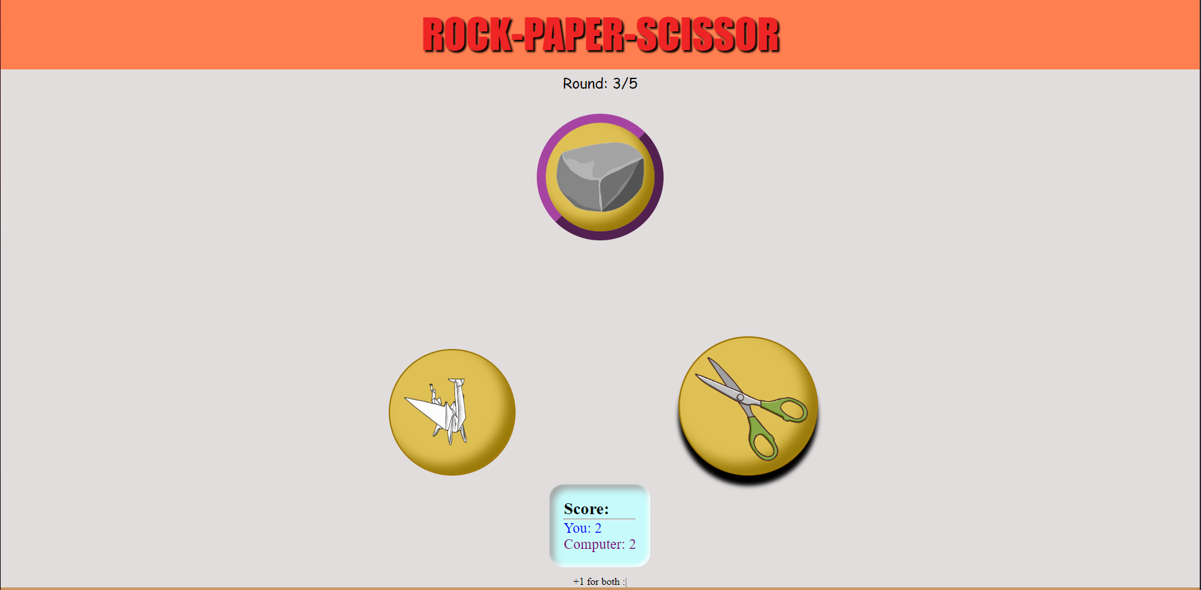
Output Screen

CONCLUSION AND FUTURE WORK

Conclusion
The project demonstrates an effective IoT-based monitoring system using microcontroller technology.

Limitations and Future Work
Future improvements include wireless communication and cloud integration for remote monitoring.

BIBLIOGRAPHY
[1] Arduino Documentation, https://www.arduino.cc
[2] Raspberry Pi Foundation, https://www.raspberrypi.org
[3] Internet of Things Fundamentals, IEEE Journals

