ShopNest
E-Commerce Website
Web Development Major Project Report

HTML | CSS | JavaScript | Node.js | Express.js | MongoDB
User Module (9 Pages) + Admin Module (5 Pages) | Full REST API
February 2026

Table of Contents

1. Project Overview & Goals 3
2. Technology Stack 4
3. Software Installation 5
4. Project Folder Structure 6
5. Step-by-Step Build Process 7
6. User Module — All 9 Pages Explained 9
7. Admin Module — All 5 Pages Explained 12
8. Backend — Server, Models & API 13
9. How the Database Works 15
10. How to Run the Project 16
11. Final Summary & Skills Learned 17

1. Project Overview & Goals

ShopNest is a fully functional e-commerce website built entirely from scratch as a major web development project. It operates in much the same way as well-known platforms such as Amazon or Flipkart — customers can create accounts, browse a product catalog, add items to a shopping cart, proceed through checkout, and track the status of their orders. A completely separate Admin Panel runs alongside the user-facing store, giving the store owner full control over products, orders, and customers without interfering with the shopping experience.
The project was conceived with two goals in mind. The first was educational: to experience, hands-on, how a modern full-stack web application is planned, built, and connected together. The second was professional: to produce a portfolio-quality project that demonstrates competence across the entire web development stack, from an attractive responsive frontend to a secure, well-structured backend API and a properly normalised database.

What Was Built
The finished product consists of fifteen distinct pages divided into two modules. The User Module provides the complete shopping journey for customers, including registration, login, product browsing, cart management, checkout, order history, and notifications. The Admin Module provides a protected management interface where the store owner can add or remove products, view and update all customer orders, and monitor the registered customer base. A Node.js and Express backend serves a twelve-endpoint REST API, and MongoDB persists all application data through three Mongoose data models.

Project Goals
The core learning objectives were to understand how a real-world website is structured across frontend and backend layers, to develop practical skill in HTML, CSS, and JavaScript for building engaging user interfaces, to learn how Express.js manages server-side routing and middleware, to see how MongoDB stores and retrieves data in a document-based format, and to understand how authentication works in practice through JWT tokens and bcrypt password hashing.

2. Technology Stack

The project uses a combination of technologies that developers commonly refer to as the MERN-lite stack — MongoDB, Express, and Node.js on the server side, with Vanilla JavaScript instead of React on the client side. This choice allowed the project to be built without any frontend build tools or bundlers, making the focus purely on understanding how the web platform works at a fundamental level.
The table below describes each technology used, what role it plays, and where it appears in the project's codebase.

Technology | What It Does | Where It Is Used
HTML | Defines the structure and layout of every page on the website | All 15 frontend pages
CSS | Handles all visual styling — colours, fonts, responsive layout, and dark theme | style.css shared stylesheet
JavaScript | Powers all interactivity — clicks, form submissions, and backend API calls | Inside every HTML page
Node.js | Runs the backend server environment on the computer | server.js
Express.js | Manages all routing and REST API endpoint definitions | routes/ folder
MongoDB | NoSQL database storing all users, products, and orders permanently | Cloud or local database
Mongoose | Object-Document Mapper connecting Node.js to MongoDB | models/ folder
JWT | Keeps users securely authenticated using signed tokens | middleware/auth.js
bcryptjs | Hashes passwords before storing them — plain-text passwords are never saved | models/User.js
dotenv | Loads secret configuration values from a .env file at startup | .env file
nodemon | Automatically restarts the server whenever source code changes | Dev tool (npm run dev)

Every technology in this list was chosen deliberately. The frontend trio of HTML, CSS, and JavaScript keeps things grounded in browser fundamentals. Node.js and Express form the backbone of the server, while MongoDB offers the flexibility of a schema-light document store that integrates cleanly with JavaScript. Security is handled by JWT for session management and bcryptjs for password storage, both industry-standard approaches used in production applications worldwide.

3. Software Installation

Before a single line of code could be written, three essential pieces of software had to be installed on the development machine. These tools form the foundation of the development environment and are prerequisites for any modern web project built on this technology stack.

Step 1 — Visual Studio Code
VS Code is the code editor where all project files are written, managed, and debugged. It was downloaded from code.visualstudio.com and installed using the standard installer. After installation, the Live Server extension was added from the VS Code Extensions Marketplace. Live Server is a critical quality-of-life tool that allows any HTML file to be opened directly in the browser with a single click, and it automatically refreshes the page whenever the source file is saved. This made frontend development significantly faster throughout the project.

Step 2 — Node.js
Node.js is the runtime environment that allows JavaScript to execute on the server side, outside of a browser. The LTS (Long-Term Support) version was downloaded from nodejs.org and installed using the provided installer. Crucially, installing Node.js also automatically installs npm — the Node Package Manager — which is the tool used throughout the project to install all backend dependencies such as Express, Mongoose, bcryptjs, and dotenv. After installation, the command node --version was run in the terminal to confirm a successful setup.

Step 3 — MongoDB
MongoDB is the database system that stores all application data persistently. The Community Edition was downloaded from the official MongoDB website, and during installation the "Complete" setup type was selected with "Install as a Service" checked. This configuration ensures that MongoDB starts automatically whenever the computer boots, which means the database is always available when the development server is running. MongoDB Compass, a visual GUI tool for inspecting database contents, was also installed alongside. After installation, mongod --version in the terminal confirmed a working setup.
⚠️ After all three tools are installed, the computer should be restarted before proceeding with any project work. This ensures all environment paths and services are correctly initialised.

4. Project Folder Structure

One of the first and most important decisions in any web project is how to organise its files. A well-planned folder structure makes the codebase easier to navigate, maintain, and explain to others. The ShopNest project follows a clean separation between backend (server logic) and frontend (website pages), with every file having a clear purpose and a logical home.
The root folder is named ecommerce. Inside it, a backend folder contains all server-side code and a frontend folder contains all HTML pages and shared CSS. The backend is further divided into models (database schemas), routes (API endpoint handlers), and middleware (security checks). The frontend is divided into user (customer-facing pages) and admin (management pages), plus a shared css folder.
The backend entry point is server.js, which imports the route files and connects to MongoDB. The package.json file lists all npm dependencies so the project can be reinstalled on any machine with a single npm install command. The .env file holds sensitive configuration values — the database connection string, the JWT secret key, and the server port — so these are never hardcoded into the source files. The seed.js script is a utility file that was run once to populate the database with an admin account and six sample products.
On the frontend side, the css/style.css file is the single shared stylesheet imported by every one of the fifteen pages. Each HTML page is self-contained: it includes its own structure and a JavaScript block at the bottom that handles user interactions and communicates with the backend through fetch() API calls. This keeps each page focused and easy to debug independently.

5. Step-by-Step Build Process

The project was built in a deliberate sequence of seven steps. Rather than jumping between backend and frontend tasks at random, the build followed a structured progression where each step built logically on the previous one. This approach reflects how experienced developers typically work on full-stack projects, and it prevented a common pitfall of building a backend with no interface to test it against, or building an interface with no server to receive its data.

Step 1 — Create the Folder Structure
The first task was to create the entire folder hierarchy before writing any code. The root ecommerce folder was created, and inside it the backend and frontend folders were set up along with all sub-directories. Having the structure in place from the start prevented disorganised file placement as the project grew.

Step 2 — Build the Shared CSS Stylesheet
A single CSS file was created in the css folder and linked by every page. The stylesheet uses CSS custom properties (variables) for colours, making it easy to maintain a consistent visual identity across the entire site. The design uses a dark background theme with an amber/gold accent colour. Custom fonts — Syne for headings and DM Sans for body text — were loaded from Google Fonts. The stylesheet also includes responsive media queries so the website adapts correctly to smaller screens and mobile devices.

Step 3 — Build All Frontend Pages
With the CSS ready, all fifteen HTML pages were created one by one. Each page imports the shared stylesheet and contains its own JavaScript block at the bottom. Following a frontend-first approach meant that the visual experience could be evaluated in the browser before the backend existed, using placeholder data to confirm layout and interaction logic.

Step 4 — Build the Backend Models
Three Mongoose schema files were created to define the structure of data stored in MongoDB. The User model captures name, email, phone number, a bcrypt-hashed password, and a role field set to either "user" or "admin". The Product model stores the product name, description, price, category, image URL, and stock quantity. The Order model stores a reference to the purchasing user, an array of ordered items with their prices, the complete delivery address, the payment method, the total amount, and the order status.

Step 5 — Build the API Routes
Four route files were created to handle the four primary domains of the application. The auth.js file handles all authentication endpoints: user registration, user login, and admin login. The products.js file handles retrieving all products, retrieving a single product by ID, adding new products (admin only), and deleting products (admin only). The orders.js file handles placing new orders and retrieving the current user's order history. The admin.js file handles admin-exclusive operations such as viewing all orders and updating order statuses.

Step 6 — Build the Authentication Middleware
A middleware function in middleware/auth.js was created to protect every route that should not be publicly accessible. When a protected route receives a request, the middleware intercepts it, reads the JWT token from the Authorization header, and verifies its signature. If the token is valid, the request proceeds to the route handler. If it is missing or invalid, the middleware immediately returns a 401 Unauthorised response and the route handler is never reached.

Step 7 — Connect Everything in server.js
The final step was writing server.js, the main entry point that ties all the other pieces together. It creates the Express application, applies the cors() and express.json() middleware, mounts each of the four route files at their base URL paths, connects to MongoDB using the Mongoose library and the connection string from the .env file, and starts the HTTP server listening on port 5000. Once this file runs without errors and prints "MongoDB Connected" and "Server running on http://localhost:5000", the project is fully operational.
⚠️ ShopNest was built frontend-first, then backend — a real-world approach used by many professional development teams.

6. User Module — All 9 Pages Explained

The User Module is the shopping experience that customers interact with. It covers every step of the customer journey from the moment they first land on the site to placing and tracking their orders. The module consists of nine pages, and the natural flow through them mirrors how users would experience a real e-commerce platform.

Page 1 — Register (register.html)
This is where new customers create their accounts. The form collects a full name, email address, phone number, password, and a confirm password field. Client-side validation ensures the password is at least six characters long and that both password fields match before the form is submitted. On successful registration, the account details are saved to MongoDB through the POST /api/auth/register endpoint and the user is redirected to the login page.
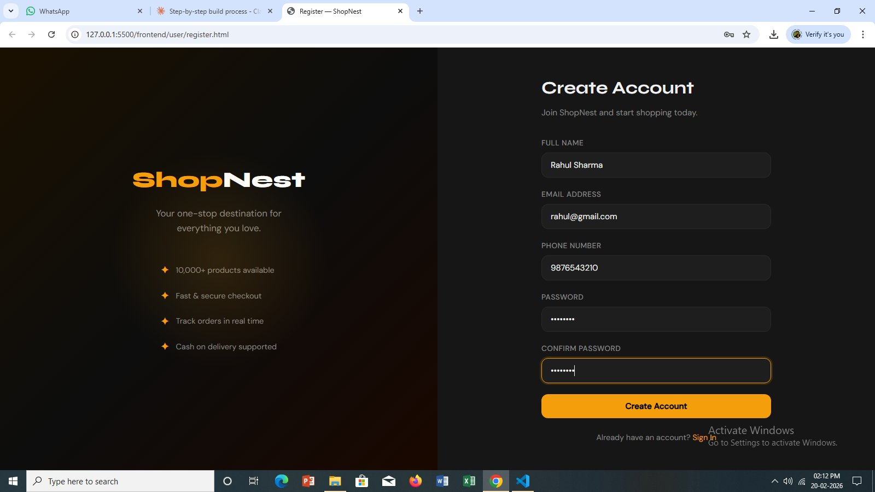
Figure 1 — User Registration Page: New customers create their ShopNest account here

Page 2 — Login (login.html)
Registered users sign in on this page using their email address and password. The backend verifies the credentials against the stored bcrypt hash. If they match, a JWT token is generated and returned. The JavaScript on the login page saves this token to the browser's localStorage, then immediately redirects the user to the dashboard. The entire token lifecycle — creation, storage, and transmission — happens automatically in the background.

Page 3 — Dashboard (dashboard.html)
The dashboard is the main shopping page where all available products are displayed in a responsive grid layout. Products are loaded live from the database through the GET /api/products endpoint. The page includes a search bar that filters products by name as the user types, and a category dropdown that narrows the displayed products to a chosen category. Each product card shows the product image, category label, name, and price, along with View and Add to Cart buttons.
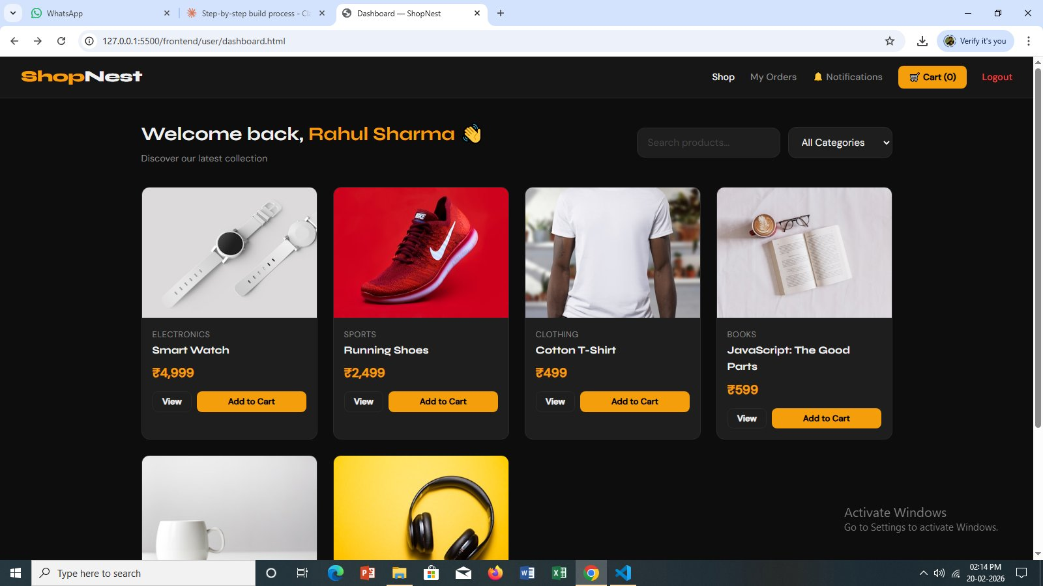
Figure 2 — Product Dashboard: All products displayed in a grid with search and category filter
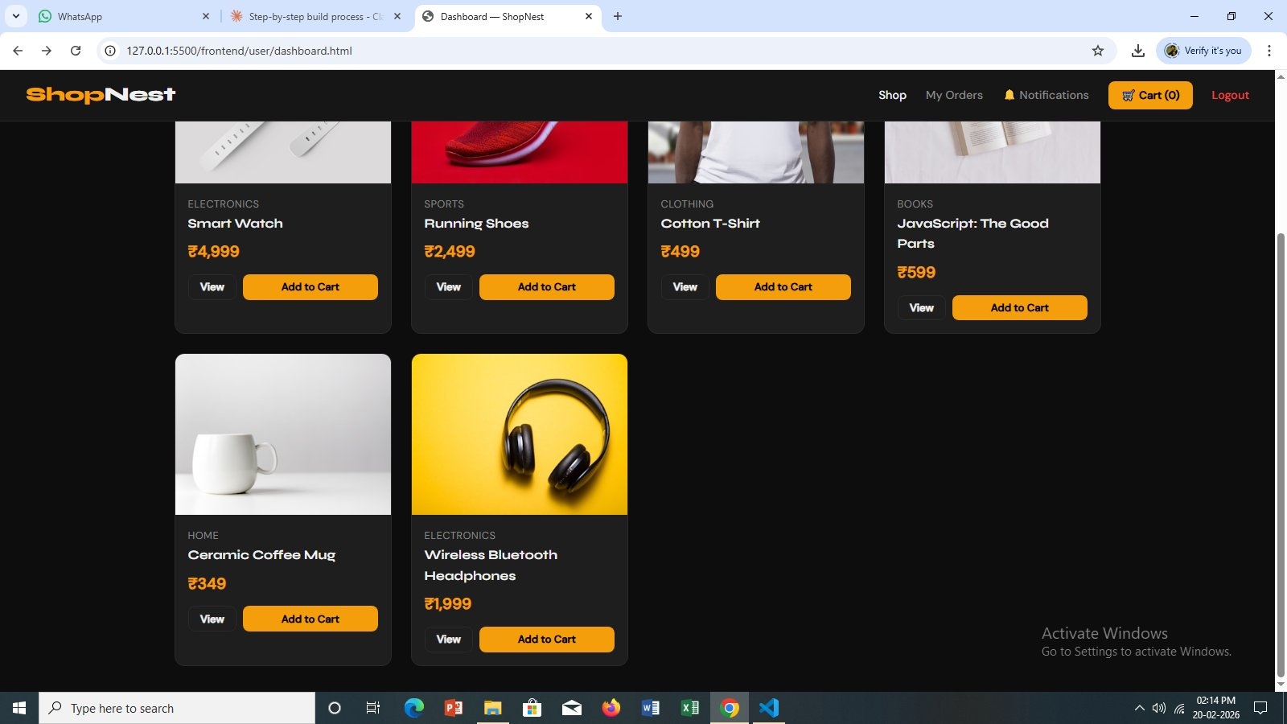
Figure 3 — Dashboard (continued): Bottom of the product grid showing remaining items

Page 4 — Product Detail (product.html)
Clicking View on any product card navigates to the product detail page, which shows the full product information: a large image, category badge, product name, price, and description. A quantity selector allows customers to choose how many units they want, and two action buttons — Add to Cart and Buy Now — provide options for adding to the cart or skipping straight to checkout.
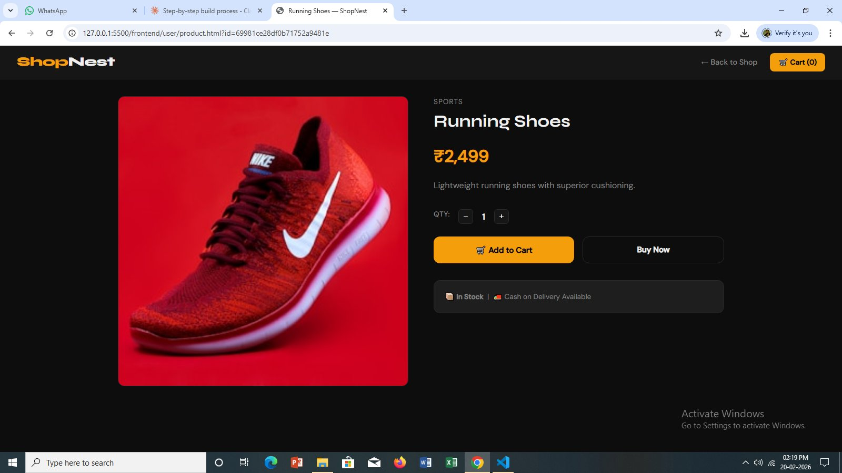
Figure 4 — Product Detail Page: Full product view for Running Shoes with quantity selector and action buttons
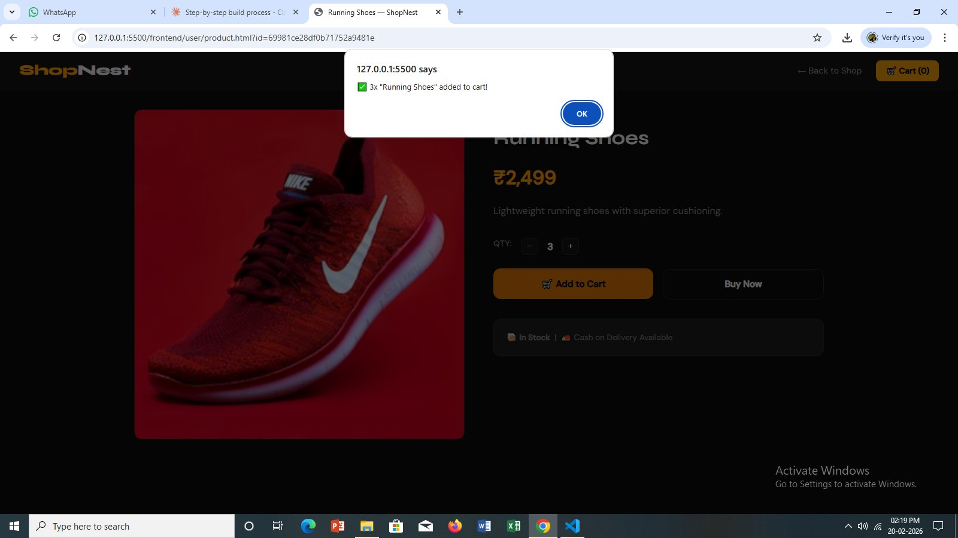
Figure 5 — Add to Cart Confirmation: Browser alert confirming 3 units of Running Shoes were added to the cart

Page 5 — Cart (cart.html)
The cart page displays all items the customer has added during their session. Cart data is stored in the browser's localStorage, which means it persists between page navigations without requiring a server round-trip. The page shows each item with its name, price, and quantity, along with controls to increase or decrease the quantity or remove the item entirely. A live-updating total price is displayed, and a Proceed to Checkout button sends the customer to the payment page.

Page 6 — Checkout / Payment (payment.html)
The checkout page is where the customer enters their delivery details and places the order. The form collects full name, phone number, address line, city, state, and PIN code. The only available payment method at present is Cash on Delivery. An order summary panel on the right side of the page shows all items with their quantities and the final total. When Place Order is clicked, the order is submitted through the POST /api/orders endpoint, saved to MongoDB, the cart in localStorage is cleared, and the customer is redirected to the notification page.
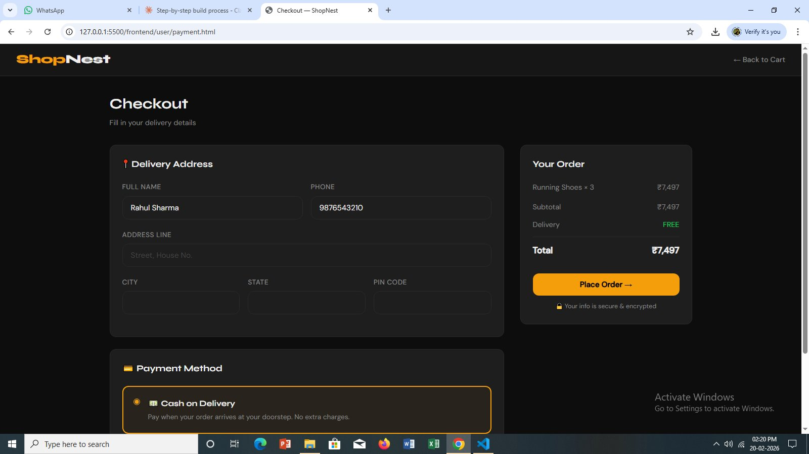
Figure 6 — Checkout Page: Delivery address form with order summary on the right
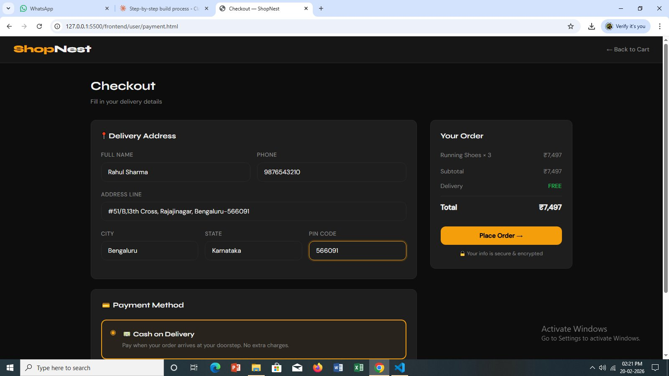
Figure 7 — Checkout with Filled Address: Customer has entered their complete Bengaluru delivery address
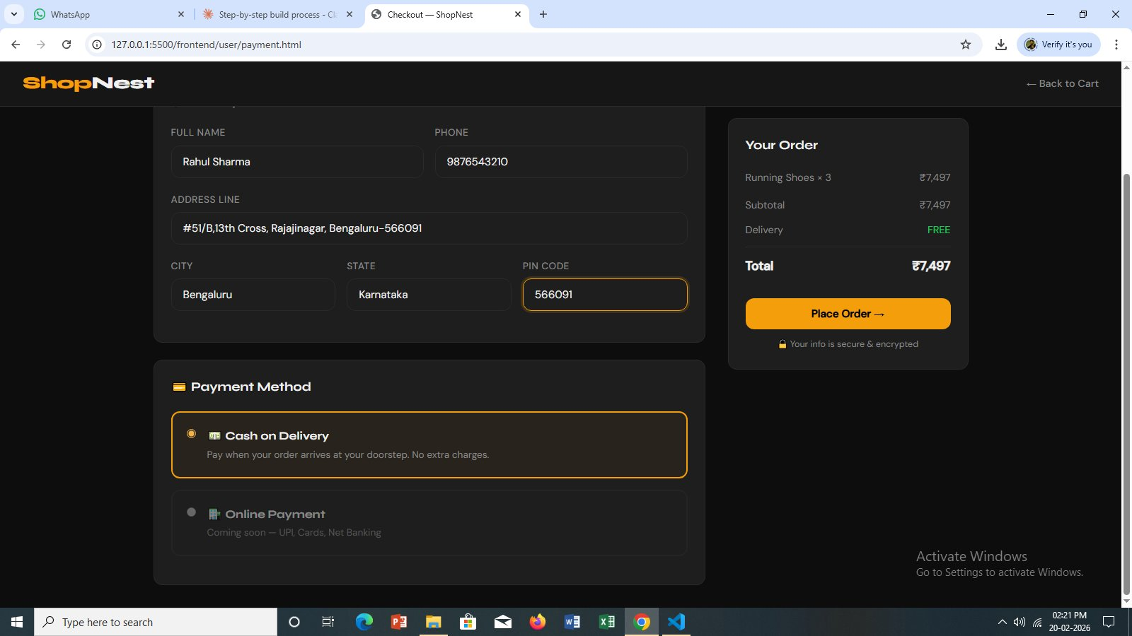
Figure 8 — Payment Method Selection: Cash on Delivery selected, with Online Payment coming soon

Page 7 — My Orders (orders.html)
After placing an order, and at any point afterwards, customers can visit My Orders to see their complete order history. Each order entry shows the Order ID, the items purchased, the total amount, the payment method, the current status, and the date the order was placed. Orders can pass through five status values: Pending, Processing, Shipped, Delivered, and Cancelled. The data is fetched live using the GET /api/orders/my endpoint, which only returns orders belonging to the currently logged-in user.
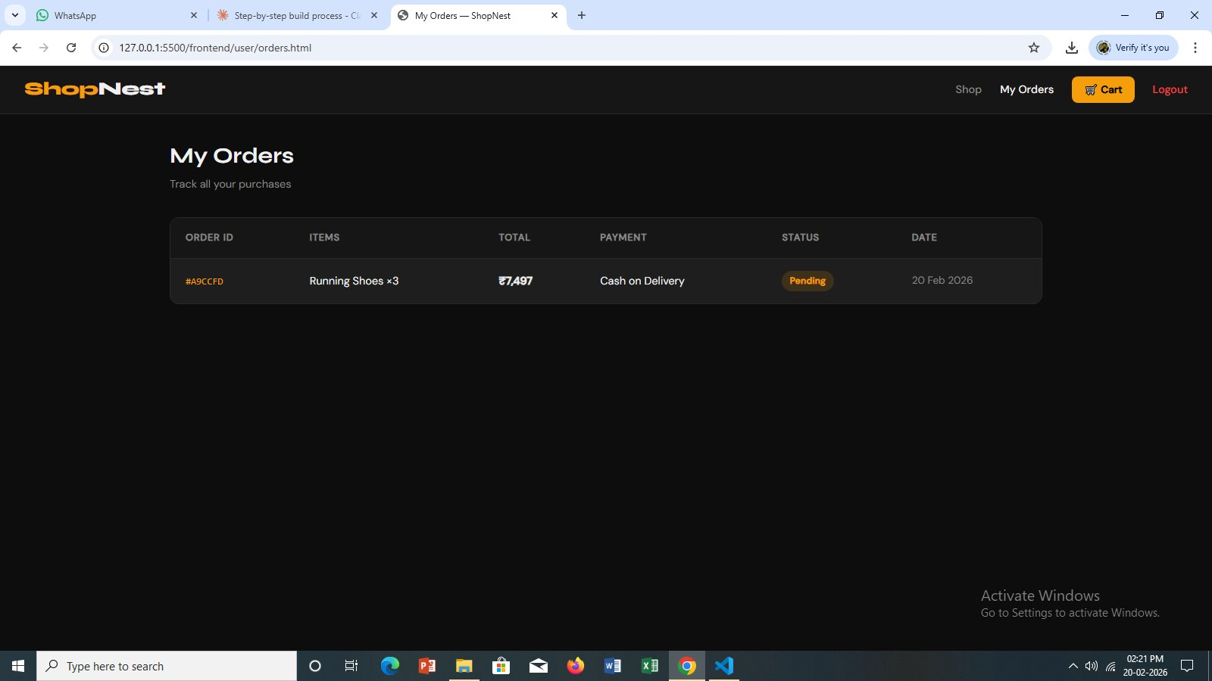
Figure 9 — My Orders Page: Order #A9CCFD showing Running Shoes ×3 with Pending status and Cash on Delivery

Page 8 — Notifications (notification.html)
The notifications page provides a colour-coded summary of the customer's order activity. Each order appears as a card whose colour reflects its current status — different shades communicate whether an order is still pending, has been shipped, or has been delivered. The page automatically fetches the latest order data from the backend when it loads, so customers always see the most current information without needing to refresh manually.
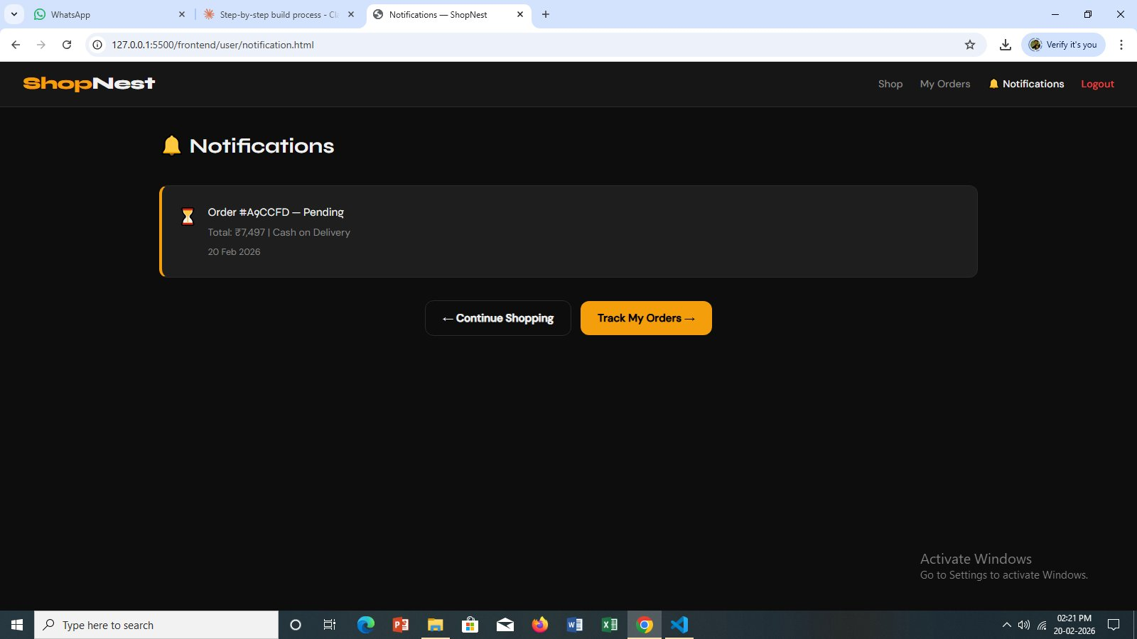
Figure 10 — Notifications Page: Order #A9CCFD displayed with Pending status, total ₹7,497 and order date

Page 9 — Logout
Logout is not a dedicated HTML page but a function triggered from the navigation bar. When clicked, the JWT token and user object stored in localStorage are cleared, and the customer is immediately redirected to the login page. This simple mechanism is secure because the token is removed client-side and subsequent API calls without a valid token will receive 401 errors from the backend middleware.

7. Admin Module — All 5 Pages Explained

The Admin Module is a completely separate panel from the customer-facing store. It uses a fixed sidebar navigation layout rather than the top navbar used on the user pages, which immediately makes the administrative context visually distinct. Access to the admin panel is protected both at the login level (a separate endpoint checks that the account has admin role) and at the API level (every admin route requires a valid token with the admin role).
⚠️ Admin access is strictly protected. Regular user accounts cannot enter the admin panel even if they know the URL, because every API call will be rejected by the backend middleware.

Page 1 — Admin Login (admin/login.html)
The admin login page is visually similar to the user login page but uses the POST /api/auth/admin-login endpoint, which performs an additional check to confirm the account has admin role before issuing a token. The default admin credentials created by the seed script are admin@shopnest.com with password admin123.
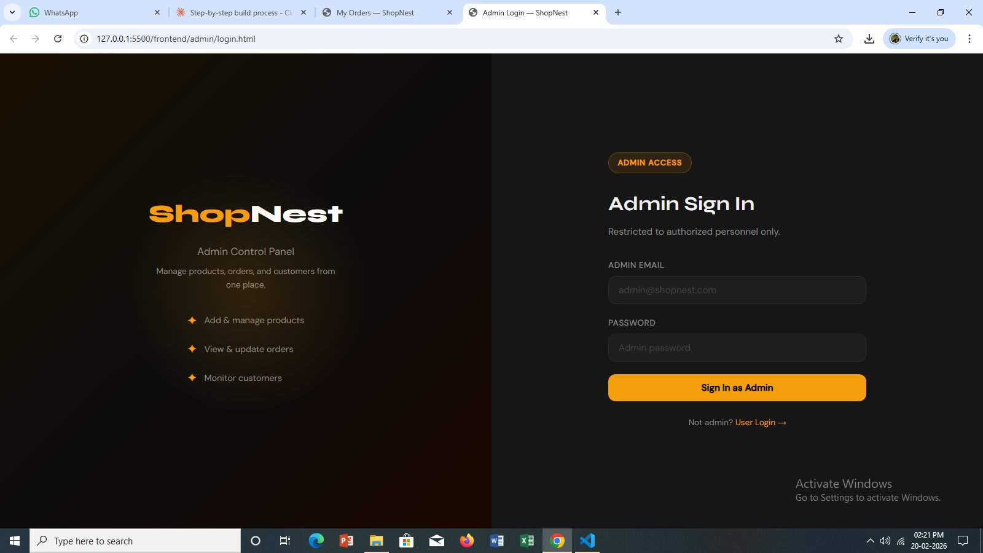
Figure 11 — Admin Login Page: Dedicated sign-in interface restricted to authorised store administrators
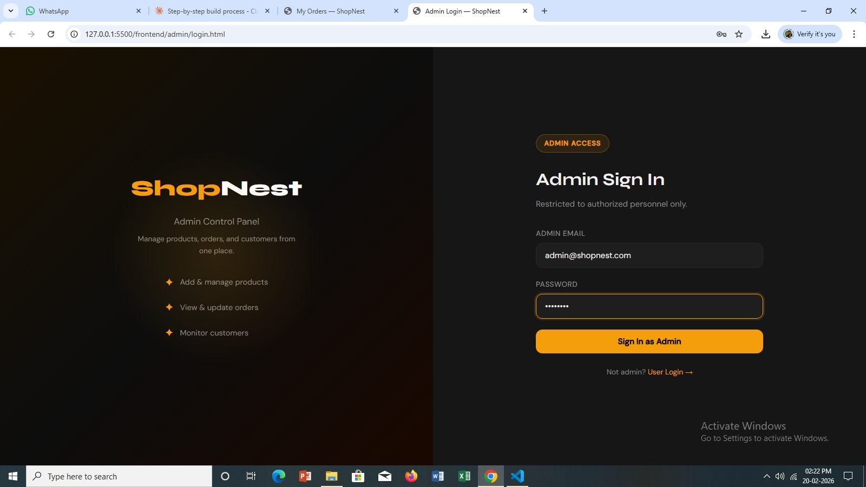
Figure 12 — Admin Login (Credentials Entered): Admin email and password filled in, ready to sign in

Page 2 — Admin Dashboard (admin/dashboard.html)
The admin dashboard gives the store owner an at-a-glance overview of the entire business. Four summary statistics cards show the total number of products, total orders placed, total registered customers, and the cumulative revenue generated. Below the stats cards, a table displays the eight most recent orders with their customer names, item lists, amounts, and current statuses. This data is assembled by simultaneously calling three API endpoints and rendering the combined results on the page.

Page 3 — Add Product (admin/add-product.html)
This page allows the admin to add new products to the store catalog. The form collects all required product fields: name, category, price, stock quantity, image URL, and description. As the admin types, a live product card preview on the right side of the page updates in real time, showing exactly how the product will appear to customers on the dashboard. Below the form, the page also lists all existing products with a Delete button next to each one, allowing products to be removed from the catalog immediately.
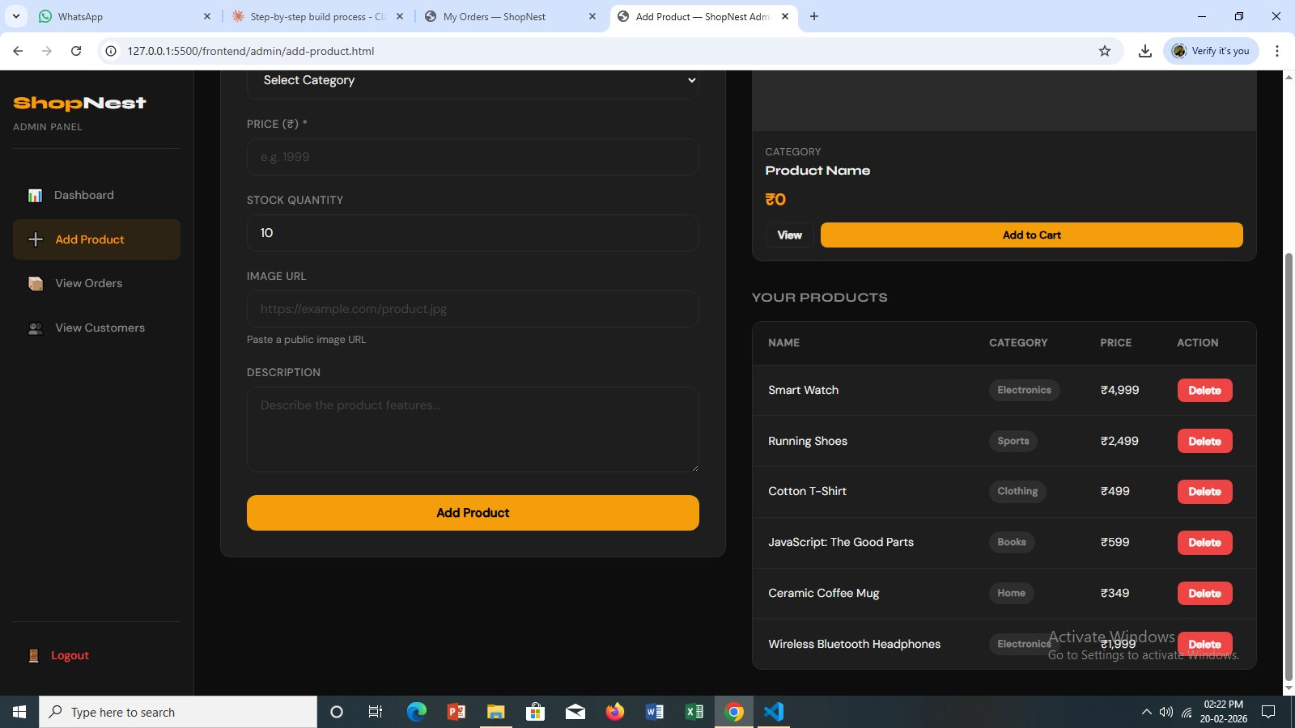
Figure 13 — Add Product Page: Admin form with live preview and existing products list with delete options

Page 4 — View Orders (admin/view-orders.html)
The orders management page shows every order placed by every customer across the entire store. A filter dropdown at the top of the page allows the admin to narrow the list by order status — showing only Pending orders, for example, to prioritise new fulfilment work. Each row in the orders table includes a dropdown selector where the admin can update the order status to any of the five possible values. The change is submitted immediately through the PATCH /api/admin/orders/:id/status endpoint, and a confirmation alert is shown.
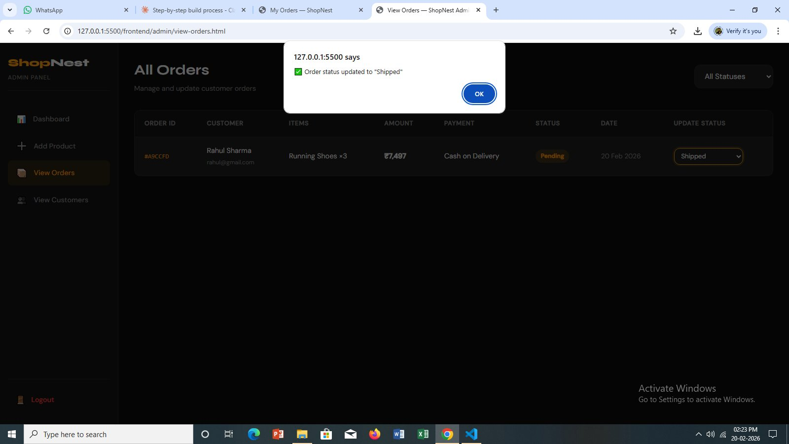
Figure 14 — View Orders Page: Admin updating order #A9CCFD status to "Shipped" with confirmation dialog

Page 5 — View Customers (admin/view-customers.html)
The customers page displays a table of every registered account in the system. Each row shows the customer's initials avatar, full name, email address, phone number, registration date, and their total order count. A search input at the top of the page allows the admin to quickly locate specific customers by name or email. This page is read-only — the admin can view customer information but cannot modify it, which protects customer data integrity.
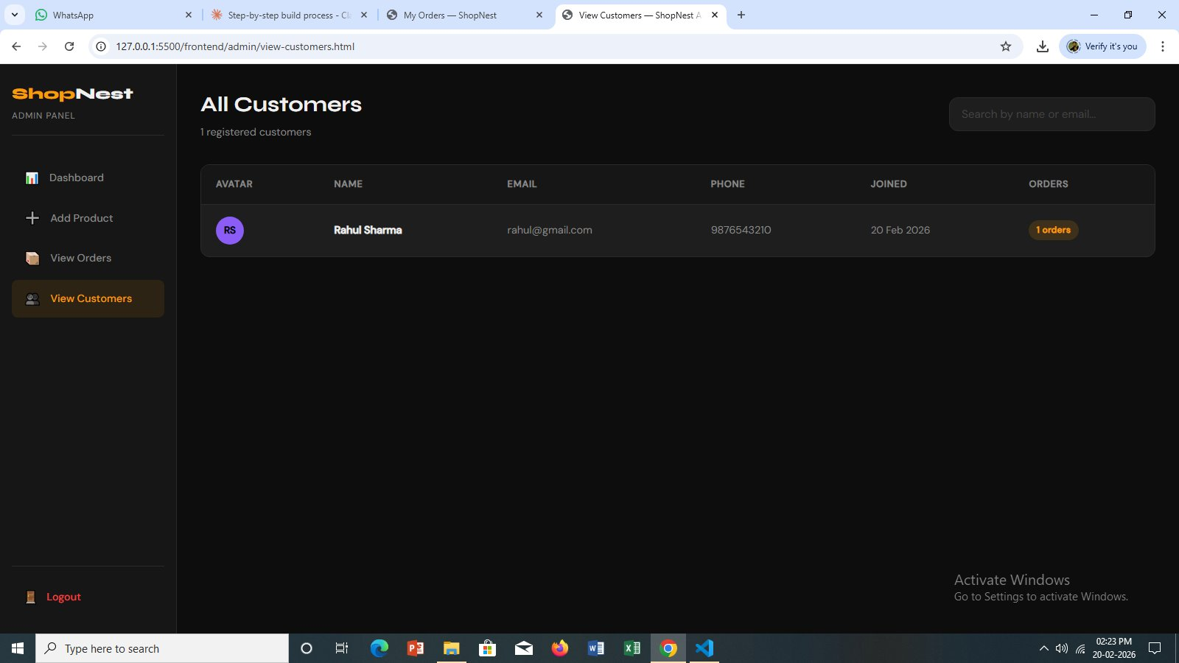
Figure 15 — View Customers Page: All registered customers listed with their details and order counts

8. Backend — Server, Models & API

The backend is the engine that powers everything the user sees and does on ShopNest. It runs as a Node.js process and listens for incoming HTTP requests on port 5000. The frontend pages communicate with it using the browser's built-in fetch() function, sending requests to the appropriate endpoint and then rendering the returned data on the page.

How the Server Works
When server.js is executed, it first creates an Express application and applies two global middleware functions: cors(), which allows the browser-based frontend to communicate with the server even though they run on different ports, and express.json(), which automatically parses incoming request bodies from JSON format into JavaScript objects. The four route files are then mounted — auth routes at /api/auth, product routes at /api/products, order routes at /api/orders, and admin routes at /api/admin. Finally, Mongoose is used to connect to MongoDB using the connection string stored in the .env file. Once the database connection is confirmed, the server begins listening for requests.

Authentication Flow
When a user logs in, their submitted password is compared against the bcrypt hash stored in the database using bcrypt's compare function. If the credentials are valid, a JWT token is generated using the secret key from the .env file and returned to the client. The client stores this token in localStorage and attaches it to every subsequent request in the Authorization header in the format "Bearer <token>". The auth middleware on the server intercepts every protected request, extracts the token, and verifies it using the same secret key. If verification succeeds, the decoded user information is attached to the request object so the route handler can access it. If it fails, a 401 error is returned immediately.

Complete API Endpoints Reference

Method | Endpoint | Access | Description
POST | /api/auth/register | Public | Register a new user account
POST | /api/auth/login | Public | User login — returns JWT token
POST | /api/auth/admin-login | Public | Admin login — returns JWT token
GET | /api/products | Logged-in | Fetch all products
GET | /api/products/:id | Logged-in | Fetch a single product by ID
POST | /api/products | Admin only | Add a new product to the catalog
DELETE | /api/products/:id | Admin only | Remove a product from the catalog
POST | /api/orders | Logged-in | Place a new order
GET | /api/orders/my | Logged-in | Get the current user's orders
GET | /api/admin/orders | Admin only | Get all orders across the system
PATCH | /api/admin/orders/:id/status | Admin only | Update the status of any order
GET | /api/admin/customers | Admin only | Get all registered customer records
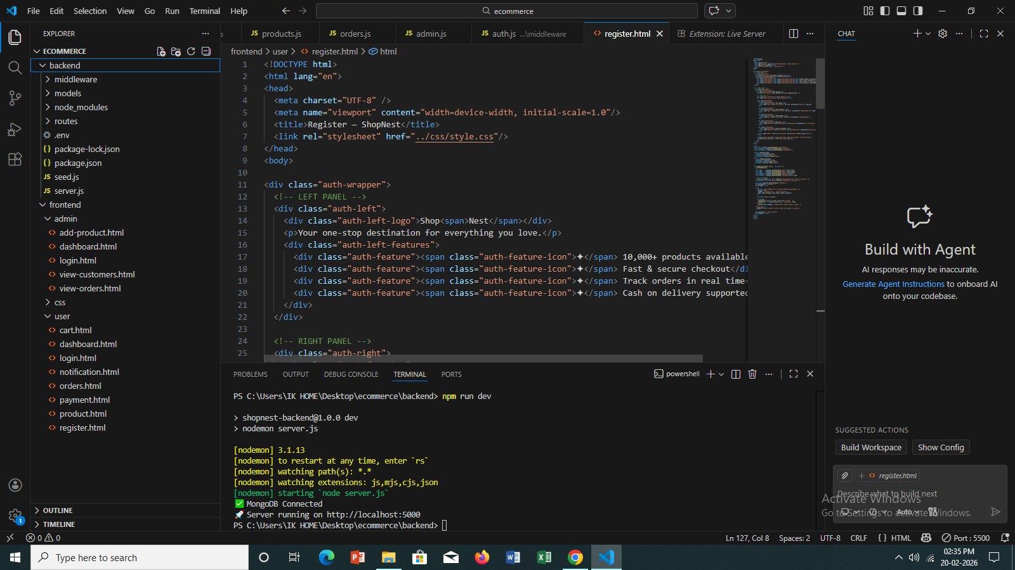

This photo above proves that it’s not a ready-made website but it’s done manually by trial and error method facing lots of trouble and code issues for several days this is the outcome that is being coming out from the project made by using the help of Claude ai also because guidance is necessary for any young freshers.

The screenshot shows the Shop Nest project open in Visual Studio Code, where the Explorer panel on the left displays the complete folder structure of the project with both the backend folder (containing middleware, models, routes, .env, package. Json, seed.js, and server.js) and the frontend folder (containing all admin and user HTML pages) clearly visible, while the main editor area shows the register.html source code with its two-panel HTML layout and the shared CSS stylesheet linked at line 7. At the bottom, the integrated terminal shows the server being launched with npm run dev, and the two green confirmation messages — "MongoDB Connected" and "Server running on http://localhost:5000" — confirm that nodemon has successfully started the backend, while the status bar shows Live Server running on port 5500, meaning both the frontend and backend were fully operational at the time this screenshot was taken.

9. How the Database Works

MongoDB is a NoSQL database that stores data as documents — flexible JSON-like objects — rather than as rows and columns in a traditional relational table. This makes it a natural fit for JavaScript applications, since the data format is the same throughout the entire stack: the browser sends JSON, the server processes JavaScript objects, and MongoDB stores documents that look identical to JSON.
Mongoose is the library that connects Node.js to MongoDB and adds a schema layer on top of it. Rather than allowing any arbitrary data to be stored, Mongoose schemas define exactly what fields each document must or can contain, what type each field must be, and what validation rules apply. This strikes a balance between the flexibility of a document database and the safety of a structured schema.

Users Collection
The Users collection stores one document per registered account. Each user document contains the user's full name (String), a unique email address used for login (String), an optional phone number (String), the bcrypt-hashed version of their password — the plain text is never stored (String), a role field set to either "user" or "admin" (String), and a createdAt timestamp generated automatically by Mongoose when the document is first saved.

Products Collection
The Products collection stores one document per item in the store catalog. Each product document contains the product name, a detailed description, the price expressed in Indian Rupees, a category string drawn from a fixed list of Electronics, Clothing, Books, Sports, and Home, a URL pointing to the product image, and a stock quantity indicating how many units are available.

Orders Collection
The Orders collection stores one document per placed order. Each order document contains a user field that holds a reference (ObjectId) pointing to the User document of the customer who placed the order, an items array where each element captures the product name, price, and quantity, a deliveryAddress object containing all the shipping details, a paymentMethod string, a totalAmount number, and a status string that progresses from Pending through Processing, Shipped, and Delivered, or may be set to Cancelled.

The Seed Script
A utility script called seed.js was written and executed once during initial setup. Running node seed.js created the administrator account with the email admin@shopnest.com and password admin123, and populated the Products collection with six sample items: Wireless Bluetooth Headphones, Running Shoes, Cotton T-Shirt, JavaScript: The Good Parts, Ceramic Coffee Mug, and a Smart Watch. These products gave the store content to display from the very first time it was opened in a browser.

10. How to Run the Project

Getting the project running requires two things to be true at the same time: MongoDB must be active as a background service, and the Node.js server must be started from the terminal. On a machine where MongoDB was installed with "Install as a Service" selected, the database starts automatically with the computer and requires no manual action.

First-Time Setup
On the first use, the project dependencies must be installed and the database must be seeded with initial data. Open the ecommerce folder in VS Code, open the integrated terminal using Ctrl + ` (backtick), navigate into the backend folder with cd backend, and run npm install to download and install all packages listed in package.json. Once complete, run node seed.js to create the admin account and sample products. This step only needs to be performed once.

Starting the Server
On every subsequent use, open VS Code and the terminal, navigate to the backend folder, and run npm run dev. This starts the server using nodemon, which watches for code changes and restarts automatically. The terminal will print two lines to confirm success: "MongoDB Connected" and "Server running on http://localhost:5000". Once these appear, open frontend/user/register.html in VS Code, right-click, and choose Open with Live Server. The website opens in the browser and is ready to use.

Testing the Full Flow
To verify that every part of the system is working correctly, the following sequence can be followed. First, open register.html and create a new customer account — the account should be saved and the browser should redirect to the login page. Log in with those credentials — the dashboard should open and display six products. Click View on any product to see its detail page, then click Add to Cart. Navigate to the cart page to confirm the item is there, then proceed to checkout, fill in a delivery address, and click Place Order.
Next, open admin/login.html and sign in using the admin credentials. Navigate to View Orders in the admin sidebar — the order just placed should appear with a Pending status. Use the status dropdown to change it to Shipped and confirm the dialog. Return to the customer's My Orders page and verify that the status has been updated. This end-to-end test confirms that the frontend, backend, database, and authentication system are all working together correctly.

Stopping the Server
When finished working on the project, click in the terminal window and press Ctrl + C. The server process will terminate and the website will stop responding. The database service continues running in the background as a system service and does not need to be stopped manually.

11. Final Summary & Skills Learned

ShopNest is a complete, working, end-to-end e-commerce application built entirely from scratch over the course of this project. It is not a tutorial clone or a heavily templated starter — every line of code was written deliberately, every connection between the frontend and backend was implemented by hand, and every error that appeared along the way was diagnosed and fixed as part of the learning process.

Project Statistics

15  Total Pages Built | 12  Backend Files | 3  Database Models | 12  API Endpoints

Key Concepts Learned
The process of building ShopNest produced understanding across a wide range of areas. At the structural level, the project demonstrated how a full-stack web application is decomposed into frontend, backend, and database layers, and how these layers communicate through a clearly defined API contract. On the frontend, the combination of HTML, CSS, and JavaScript showed how structure, style, and behaviour work together to produce an interactive user experience, and how fetch() allows browser-side JavaScript to talk to remote servers without refreshing the page.
On the backend, Express.js demonstrated how route files organise API endpoints, how middleware functions intercept requests before they reach handlers, and how asynchronous code using async/await keeps the server responsive while waiting for database operations. MongoDB and Mongoose illustrated how document-based databases store data differently from relational tables, and how schemas and models bring structure and validation to an otherwise schema-free system.
Security concepts were embedded throughout the project. bcryptjs showed why passwords must never be stored in plain text and how a one-way hashing function allows verification without decryption. JWT demonstrated how stateless authentication works — a signed token carries the user's identity with every request, eliminating the need for server-side session storage. Role-based access control, implemented through the auth middleware and role checks on protected routes, showed how different levels of privilege can be enforced at the API boundary.
Finally, the project gave practical experience with the Node.js development toolchain: using npm to install and manage packages, keeping secrets out of source code using dotenv, speeding up development with nodemon, and reading error logs to diagnose and fix problems. These are all day-to-day skills used by professional web developers.

Reference — Claude.ai Step-by-Step Build Process
The step-by-step build guidance used throughout this project was developed and refined using Claude.ai, an AI assistant. The screenshot below shows part of the final workflow summary generated during the build process, confirming the daily workflow for running the project.
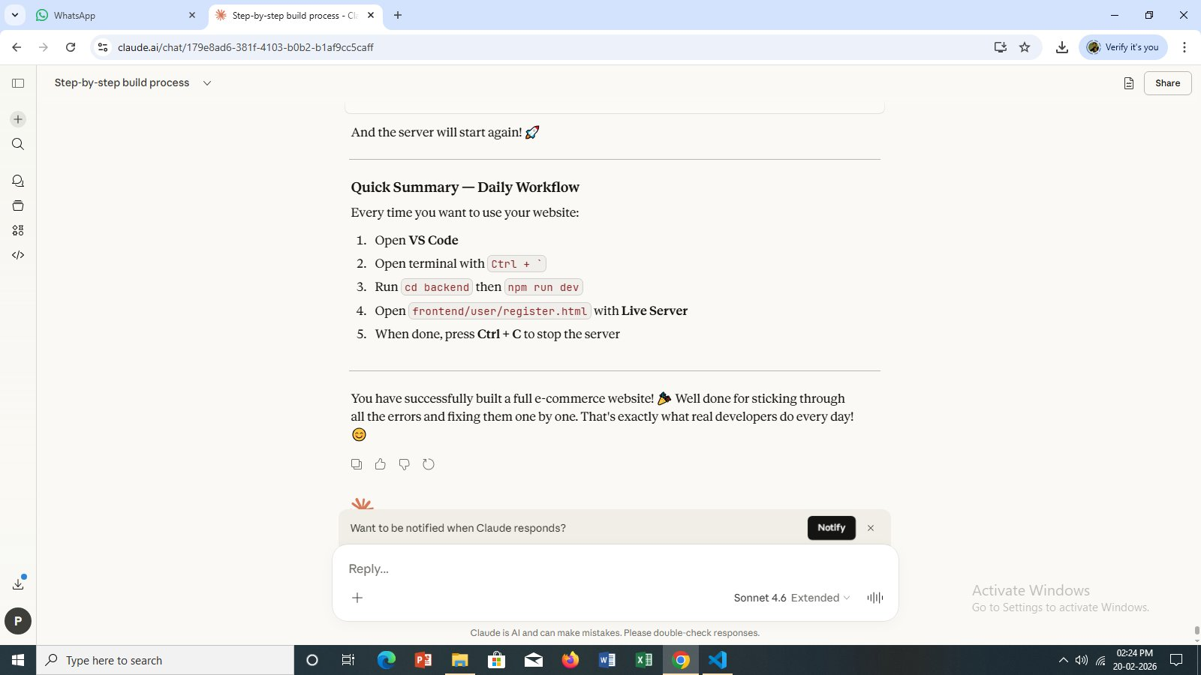
Figure 16 — Claude.ai Build Process: The step-by-step build guidance used throughout this project

ShopNest is a production-ready portfolio project that demonstrates real-world full-stack web development skills across frontend, backend, database, and security domains.

ShopNest — Web Development Major Project
HTML | CSS | JavaScript | Node.js | Express | MongoDB | February 2026

