ACTIVITY-2
Deploy a simple application on the cloud / Deploy one simple web app on a web server using a cloud platform
- Download any .exe file(software) from the following website
python.exe
Create a Mega account from the following website /https://mega.nz/registe
- Upload the Downloaded .exe file to the cloud
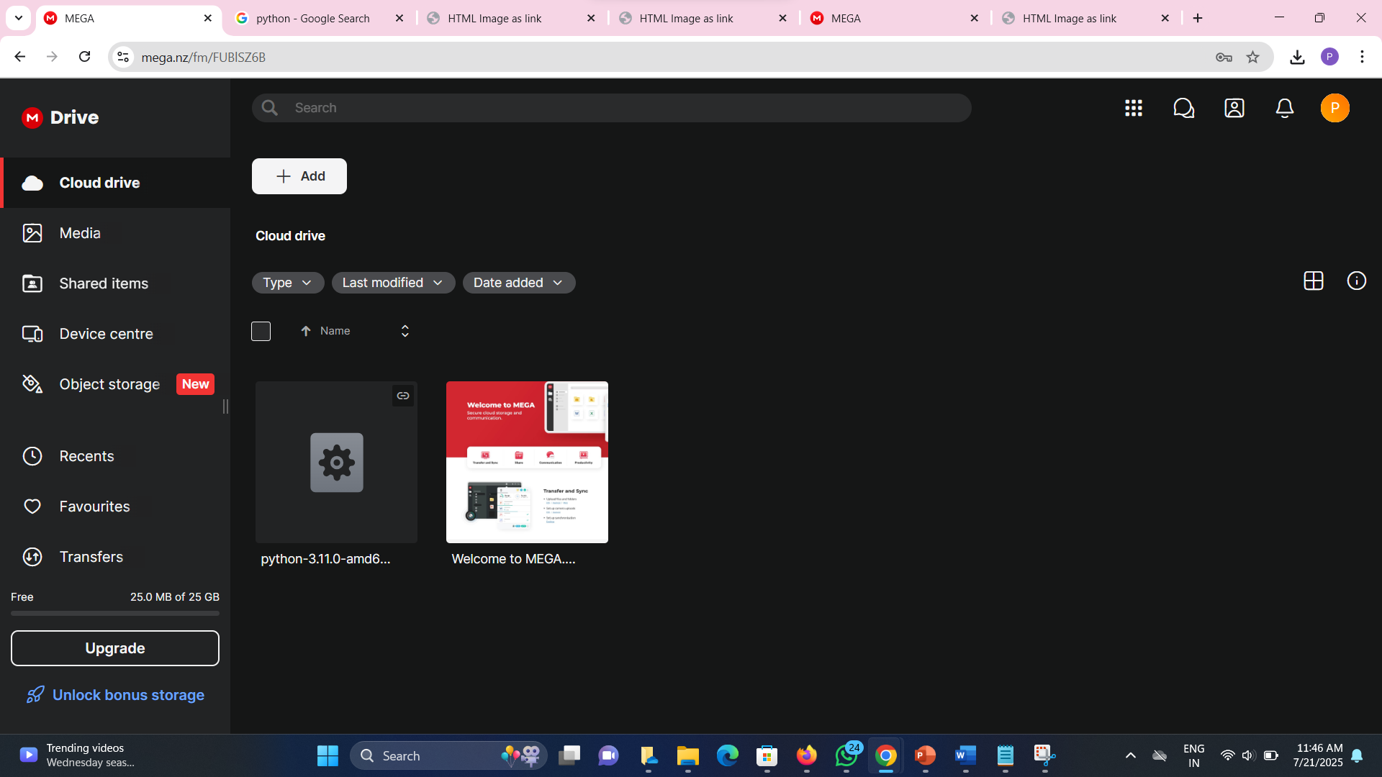

- Design a simple web page using HTML
‎<!DOCTYPE html>
‎<html>
‎ <head>
‎ <title>HTML Image as link</title>
‎ </head>
‎ <body>
‎Python(3.11.0) download:<br>
<a href=https://mega.nz/file/FYYzVRLZ#NUNOiuI7N_tqBc4od_OOvos6rWH3UxhxSDAqgGVFk5U>
‎ <img src="/storage/emulated/0/Download/python3.11.0amd64.exe"width="800"
height="500">
‎</a>
‎</body>
‎ </html>
‎
- Download a python image and locate the Folder path and copy it to img src in the HTML code.

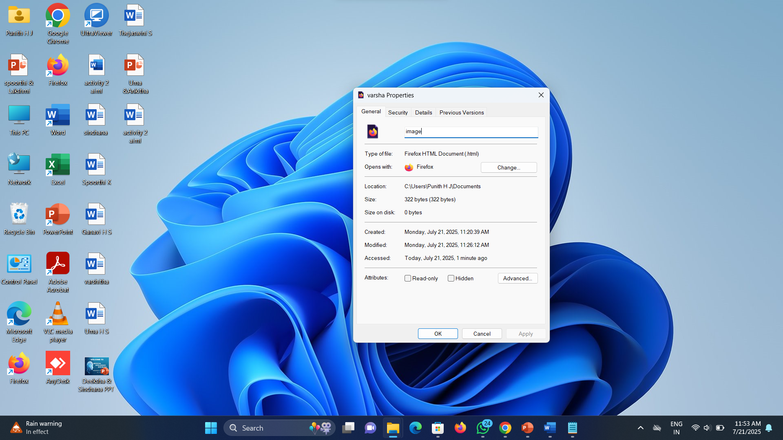
- Now change the href link in your code using the link of the.exe file that you have uploaded in the cloud.

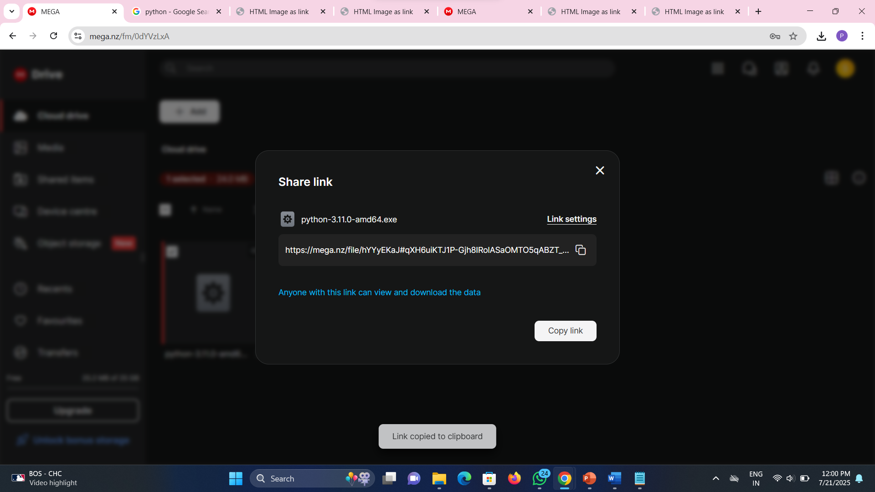
- Now save the file in .html extension and open it using any web browser.

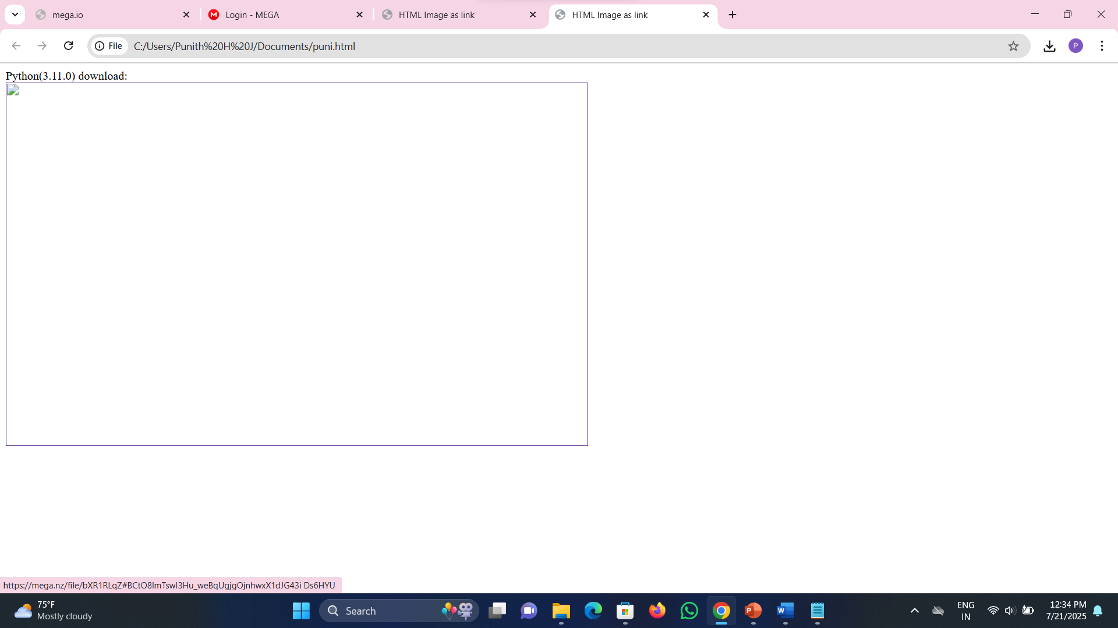
- Click on the python image and it will redirect the page to cloud storage where you have uploaded your .exe file.
