LAB 1
Object Oriented Programming with Java — Lab Record
Name | Punith C
USN | 1BF25CS196
Institution | BMS College of Engineering
Subject | Object Oriented Programming with Java (OOPs Java)
Date of Execution | 26-09-2026
List of Programs
1. Hello World Program
2. Addition of Two Numbers
3. Subtraction of Two Numbers
4. Multiplication of Two Numbers
5. Division of Two Numbers
6. Area of a Rectangle
7. Area of a Square
8. Area of a Circle
9. Class and Object Demonstration — Employee and Student Classes

Program 1: Hello World Program
Code:
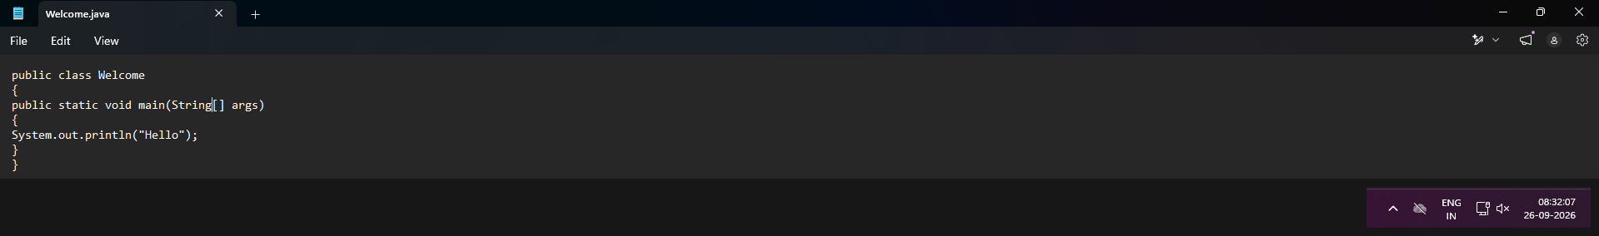
Code screenshot captured on 26-09-2026 at 08:32:07
Explanation:
This is the first and simplest Java program. It defines a class named Welcome containing the main() method, which is the entry point of every Java application.
Inside main(), the statement System.out.println("Hello"); prints the text Hello to the console followed by a new line. The program demonstrates the basic skeleton every Java program follows: a class declaration, the public static void main(String[] args) method signature, and use of the System.out.println() function for output.
Output:
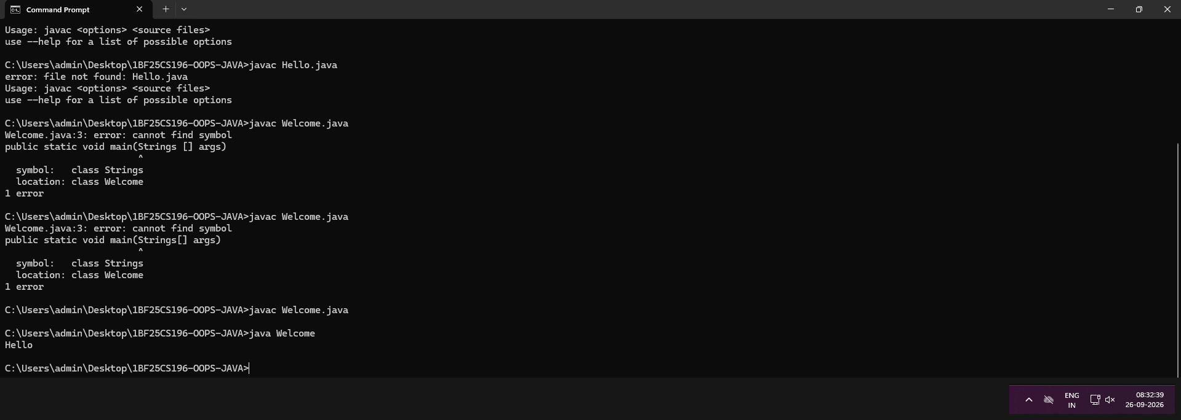
Terminal screenshot captured on 26-09-2026 at 08:32:39
Observation: the terminal history also shows two earlier mistakes made while learning the compile-run cycle — trying to compile a file named Hello.java that did not exist, and typing "Strings[] args" instead of the correct "String[] args" in the method signature. After correcting the file name and the syntax, javac Welcome.java compiled successfully and java Welcome printed Hello, confirming the program worked as intended.

Program 2: Addition of Two Numbers
Code:
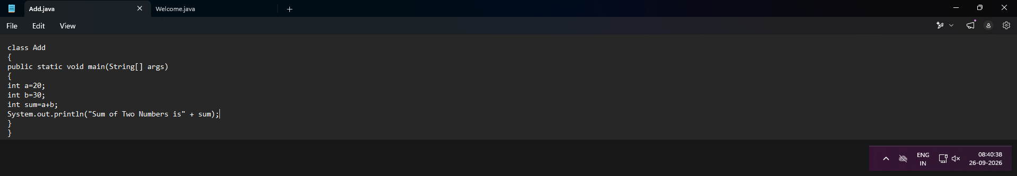
Code screenshot captured on 26-09-2026 at 08:40:38
Explanation:
The class Add declares two integer variables, a = 20 and b = 30, and calculates their sum in a third variable, sum = a + b.
The result is displayed using System.out.println("Sum of Two Numbers is" + sum);, which concatenates the string with the integer value of sum for display. This program demonstrates variable declaration, the int data type, the + arithmetic operator, and string concatenation with numeric output.
Output:
Terminal screenshot captured on 26-09-2026 at 08:47:16
Output: Sum of Two Numbers is 50, which correctly equals 20 + 30.

Program 3: Subtraction of Two Numbers
Code:
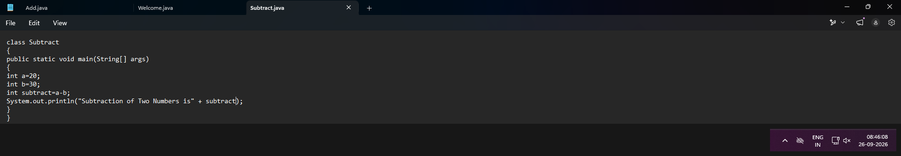
Code screenshot captured on 26-09-2026 at 08:46:08
Explanation:
The class Subtract follows the same pattern as the addition program but uses the - operator to compute subtract = a - b, where a = 20 and b = 30.
Since b is greater than a, the result is negative, showing that Java handles signed integer arithmetic automatically without any special handling required from the programmer.
Output:
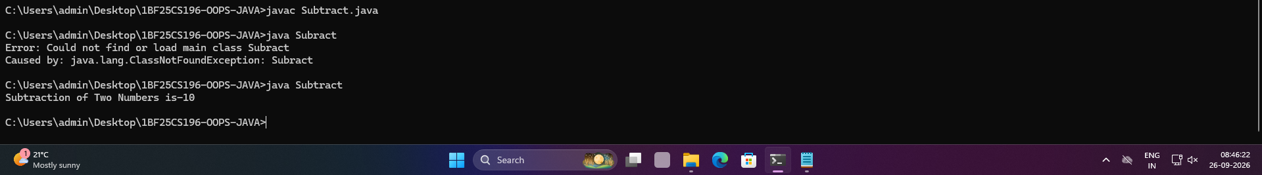
Terminal screenshot captured on 26-09-2026 at 08:46:22
Observation: an earlier run attempted java Subract (a typing mistake, missing the letter "t"), which failed with a ClassNotFoundException because no class by that name exists. Running java Subtract with the correct spelling produced the expected output: Subtraction of Two Numbers is -10.

Program 4: Multiplication of Two Numbers
Code:
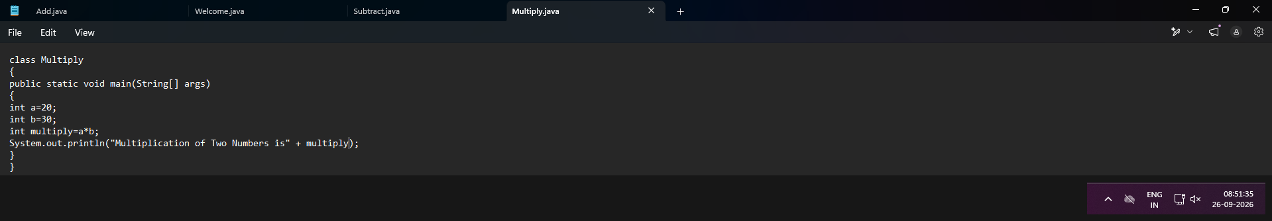
Code screenshot captured on 26-09-2026 at 08:51:35
Explanation:
The class Multiply computes the product of a = 20 and b = 30 using the * operator, storing the result in the variable multiply, and prints it using string concatenation.
This program reinforces the same structure as the earlier arithmetic programs while introducing the multiplication operator.
Output:
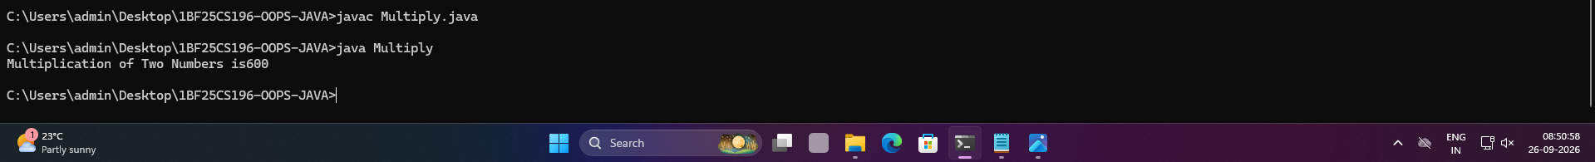
Terminal screenshot captured on 26-09-2026 at 08:50:58
Output: Multiplication of Two Numbers is 600, which correctly equals 20 × 30.

Program 5: Division of Two Numbers
Code:
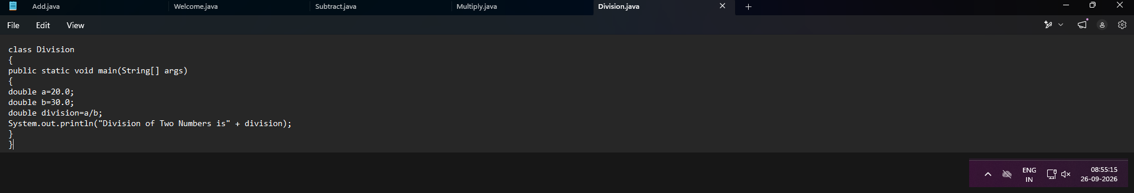
Code screenshot captured on 26-09-2026 at 08:55:15
Explanation:
The class Division declares a = 20.0 and b = 30.0 as double variables and computes division = a / b, printing the quotient using string concatenation.
Using double (rather than int) allows the program to produce a decimal (fractional) result instead of truncating it to a whole number, which is essential since 20 divided by 30 is not a whole number.
Output:
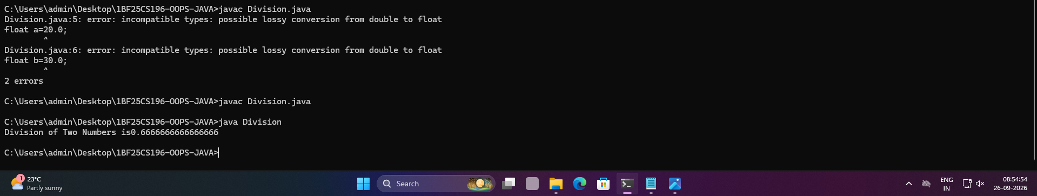
Terminal screenshot captured on 26-09-2026 at 08:54:54
Observation: the variables were first declared as float, but assigning literals like 20.0 and 30.0 (which Java treats as double by default) to a float variable caused a "possible lossy conversion from double to float" compile-time error. Changing the data type to double resolved the error, and the program then compiled and ran successfully, printing Division of Two Numbers is 0.6666666666666666.

Program 6: Area of a Rectangle
Code:
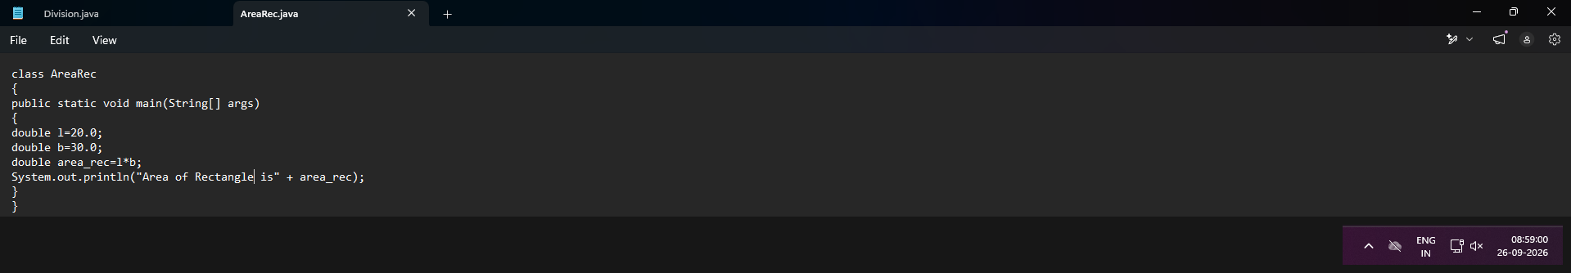
Code screenshot captured on 26-09-2026 at 08:59:00
Explanation:
The class AreaRec declares the length l = 20.0 and breadth b = 30.0 as double values, then computes the area using the standard formula area = length × breadth (area_rec = l * b).
The result is printed using string concatenation, demonstrating how a simple mathematical formula can be translated directly into a Java expression.
Output:
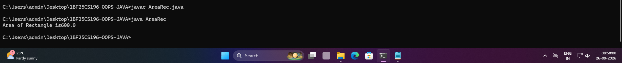
Terminal screenshot captured on 26-09-2026 at 08:58:00
Output: Area of Rectangle is 600.0, which correctly equals 20 × 30.

Program 7: Area of a Square
Code:
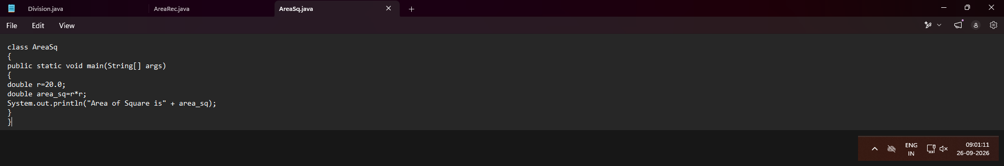
Code screenshot captured on 26-09-2026 at 09:01:11
Explanation:
The class AreaSq declares a single side variable r = 20.0 (representing the side of the square) and computes the area using the formula area = side × side (area_sq = r * r).
This program shows how the same multiplication logic used earlier can be reused for a different geometric formula, and that a variable name does not have to describe the shape it belongs to as long as its purpose is understood.
Output:
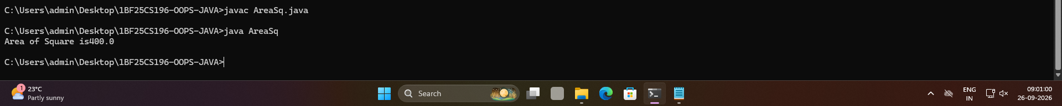
Terminal screenshot captured on 26-09-2026 at 09:01:00
Output: Area of Square is 400.0, which correctly equals 20 × 20.

Program 8: Area of a Circle
Code:
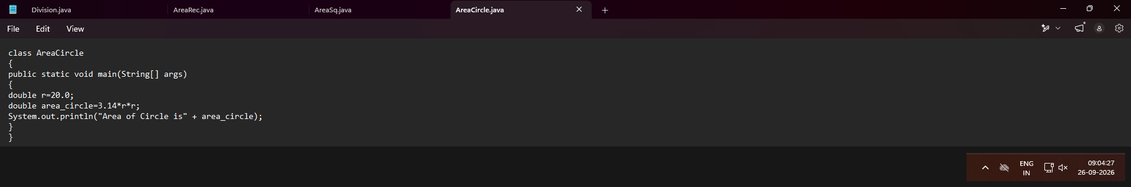
Code screenshot captured on 26-09-2026 at 09:04:27
Explanation:
The class AreaCircle declares the radius r = 20.0 and computes the area using the standard formula area = π × r² (area_circle = 3.14 * r * r), using 3.14 as an approximation of π.
This program completes the set of basic geometry programs, showing how a constant (3.14) can be combined with variables in a single arithmetic expression.
Output:
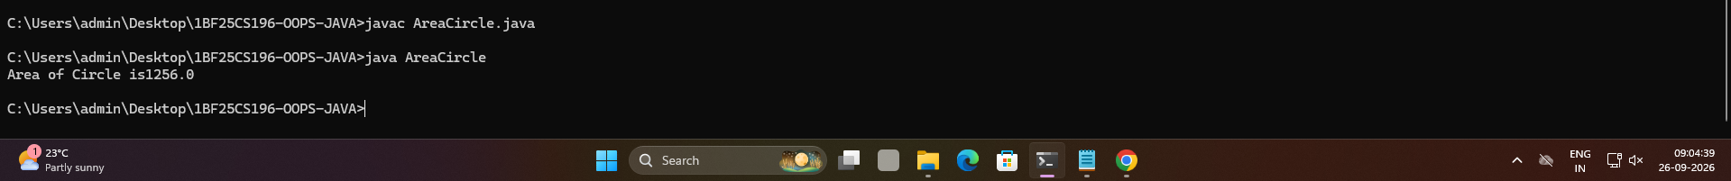
Terminal screenshot captured on 26-09-2026 at 09:04:39
Output: Area of Circle is 1256.0, which correctly equals 3.14 × 20 × 20.

Program 9: Class and Object Demonstration — Employee and Student Classes
Code (Employee class — Main.java):
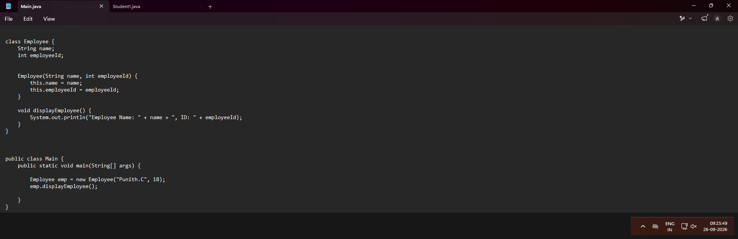
Code screenshot captured on 26-09-2026 at 09:25:49
Code (Student class — Student1.java):
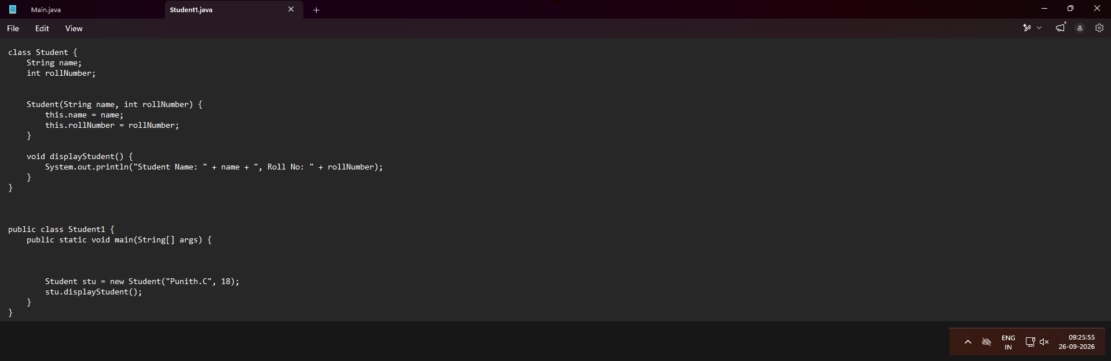
Code screenshot captured on 26-09-2026 at 09:25:55
Explanation:
These two programs demonstrate the core idea of Object-Oriented Programming: representing real-world entities as classes made up of data (fields) and behaviour (methods).
In Main.java, the class Employee has two fields, name and employeeId, along with a parameterized constructor Employee(String name, int employeeId) that uses the this keyword to assign the constructor's parameters to the object's own fields. The method displayEmployee() prints the employee's details. Inside the public class Main, an Employee object (emp) is created with the values "Punith.C" and 18, and emp.displayEmployee() is called to print its data.
Student1.java follows an identical pattern for a Student class with fields name and rollNumber, a matching constructor, and a displayStudent() method. The driver class Student1 creates a Student object (stu) and calls stu.displayStudent().
Together, these programs illustrate class definition, constructors, the this keyword, instance methods, and object creation/instantiation — the foundational building blocks of OOP in Java.
Output:
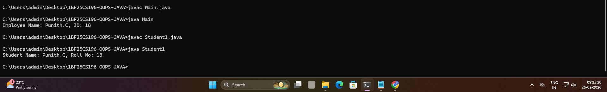
Terminal screenshot captured on 26-09-2026 at 09:25:28 — output: Employee Name: Punith.C, ID: 18 and Student Name: Punith.C, Roll No: 18, confirming both classes correctly store and display the object data passed to their constructors.

