LAB 2
Object-Oriented Programming with Java (OOPS-JAVA) – Lab Record
Student Name | Punith C
USN | 1BF25CS196
Date of Execution | 17-10-2026
Number of Programs | 5 (Books, TypeCasting, ProductPrices, StudentDemo, VehicleDemo)
Tools Used | Notepad (source code), Command Prompt (javac and java)

About this document
For every program this record shows (1) the screenshot of the source code, (2) a simple-words explanation of how the code works, (3) the screenshot of the output from Command Prompt, and (4) a short verification of the result. Unnecessary parts of each screenshot were trimmed, and the date and time at which each screenshot was taken is written in the small caption below the image.

Summary of programs
No. | Program | File | Concepts demonstrated | Result
1 | Book details | Books.java | Class and objects, constructor, this keyword, method overloading, static variable and static method | Verified
2 | Type casting | TypeCasting.java | Scanner input, explicit type casting (double to int) | Verified
3 | Product prices | ProductPrices.java | Arrays, loops, maximum, minimum, average, counting | Verified
4 | Student details | StudentDemo.java | Class and objects, passing Scanner to a method | Verified
5 | Parking bill | VehicleDemo.java | Constructor, method overloading, static final constant, private field with getter, static method | Verified

Program 1: Book Details (Books.java)
Aim: Create a Book class that stores book details, can display them, can search a book by ID or by title, can find the costlier of two books, and keeps a count of all books created.

Source Code
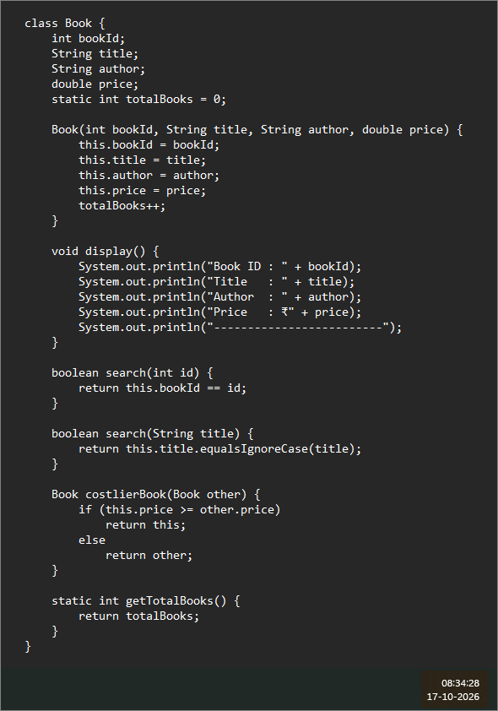
Figure 1.1 – Books.java, Part 1 of 2: the Book class. Screenshot taken on 17-10-2026 at 08:34:28.
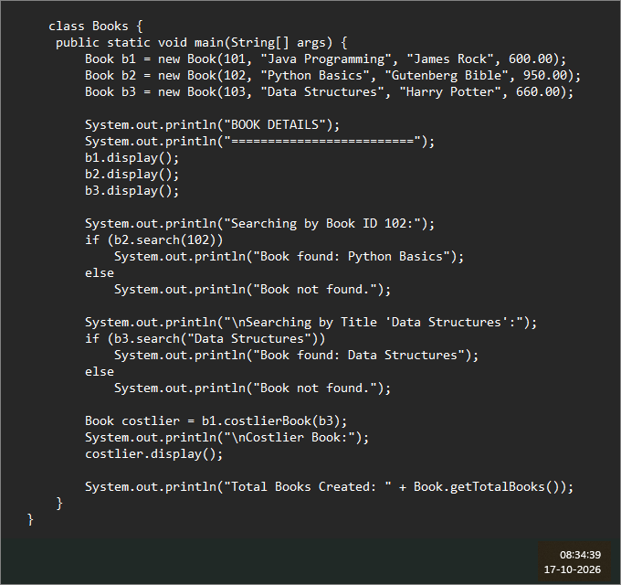
Figure 1.2 – Books.java, Part 2 of 2: the Books class with the main method. Screenshot taken on 17-10-2026 at 08:34:39.

Explanation in Simple Words
- class Book is a blueprint for a book. Every book has an ID, a title, an author and a price.
- static int totalBooks is a single shared counter that belongs to the whole class, not to one book. It goes up by 1 every time a new book is created.
- The constructor runs automatically when we write new Book(...). The word this points to the book being created, so this.title = title means "store the given title in this book".
- display() prints the ID, title, author and price of a book, followed by a line of dashes.
- search(int id) and search(String title) have the same name but take different inputs. This is called method overloading. The title search ignores capital and small letters.
- costlierBook(Book other) compares the price of this book with another book and returns the one with the higher price.
- getTotalBooks() is a static method, so it is called with the class name: Book.getTotalBooks().
- In main, three books are created and displayed. Book ID 102 is searched, the title "Data Structures" is searched, the costlier of b1 (600) and b3 (660) is found, and finally the total number of books is printed.

Output
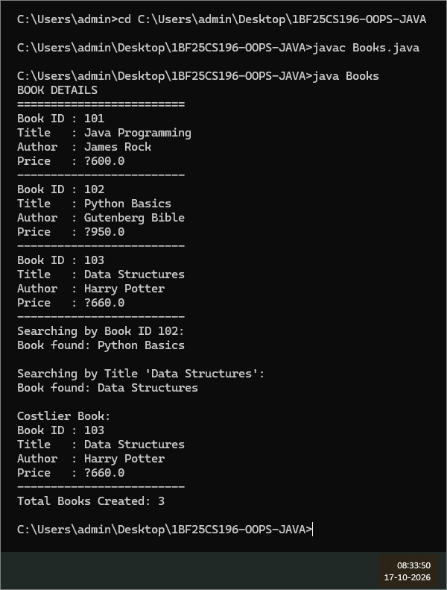
Figure 1.3 – Compiling (javac Books.java) and running (java Books) the program. Screenshot taken on 17-10-2026 at 08:33:50.
Verification: The program compiled without errors. Searching ID 102 and the title "Data Structures" both report the book as found, the costlier book is Book 103 (Rs. 660 is more than Rs. 600) and the total count is 3. This matches the code. The rupee sign appears as "?" only because the Windows console cannot display it (see the notes at the end).

Program 2: Type Casting (TypeCasting.java)
Aim: Read an amount with decimals from the keyboard and separate it into its integer part and its decimal part using type casting.

Source Code
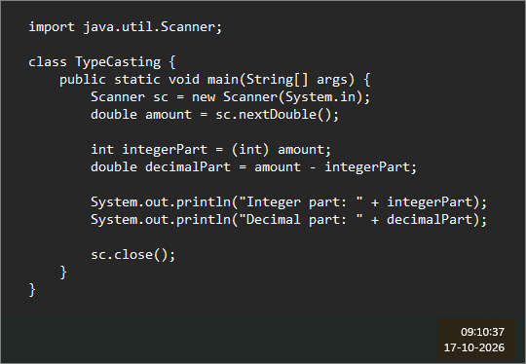
Figure 2.1 – Source code of TypeCasting.java. Screenshot taken on 17-10-2026 at 09:10:37.

Explanation in Simple Words
- Scanner reads what the user types. sc.nextDouble() reads a number that may have a decimal point, for example 1270.75.
- (int) amount is explicit type casting. It forces the double value into an int, which simply cuts off everything after the decimal point (it does not round). So 1270.75 becomes 1270.
- The decimal part is found by subtracting the integer part from the full amount: 1270.75 - 1270 = 0.75.
- Both parts are printed and the Scanner is closed with sc.close().

Output
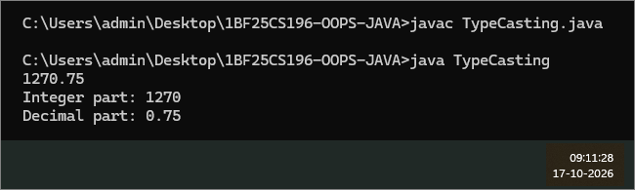
Figure 2.2 – Compiling and running TypeCasting with the input 1270.75. Screenshot taken on 17-10-2026 at 09:11:28.
Verification: For the input 1270.75 the program prints Integer part: 1270 and Decimal part: 0.75, which is correct. (For some other inputs, such as 1270.7, a double can print a tiny extra fraction like 0.7000000000000455 because of how decimals are stored in binary.)

Program 3: Product Prices (ProductPrices.java)
Aim: Read the prices of 10 products into an array and find the most expensive price, the least expensive price, the average price, and how many products cost more than Rs. 1000.

Source Code
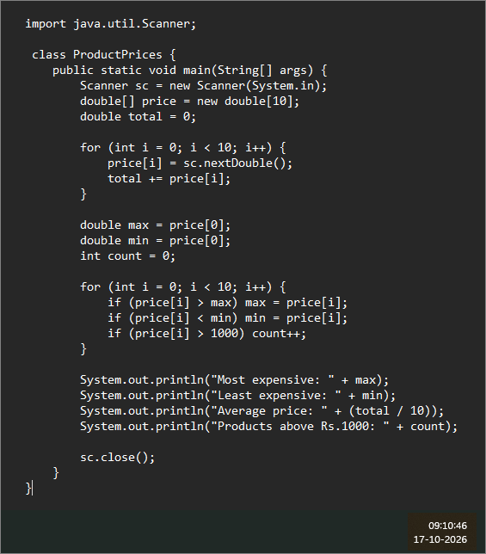
Figure 3.1 – Source code of ProductPrices.java. Screenshot taken on 17-10-2026 at 09:10:46.

Explanation in Simple Words
- double[] price = new double[10] creates an array, a row of 10 boxes, each able to hold one price.
- The first for loop reads 10 numbers from the keyboard into the boxes and keeps adding them into total.
- max and min both start with the first price. The second loop looks at every price: if it is bigger than max, max is updated; if it is smaller than min, min is updated; if it is above 1000, count goes up by 1.
- The average is total / 10. At the end the four results are printed.

Output
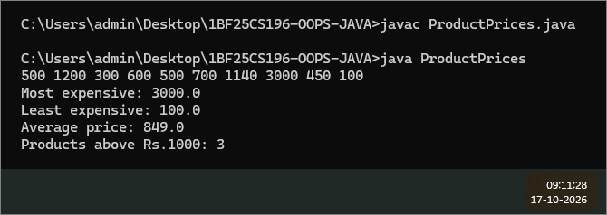
Figure 3.2 – Compiling and running ProductPrices with 10 prices as input. Screenshot taken on 17-10-2026 at 09:11:28.
Verification: Input: 500 1200 300 600 500 700 1140 3000 450 100. The sum is 8490, so the average is 8490 / 10 = 849.0. The largest value is 3000.0 and the smallest is 100.0. The prices above 1000 are 1200, 1140 and 3000, so the count is 3. All four results match the program output.

Program 4: Student Details (StudentDemo.java)
Aim: Create a Student class that accepts the USN and name of a student from the keyboard and displays them, and use it for two students.

Source Code
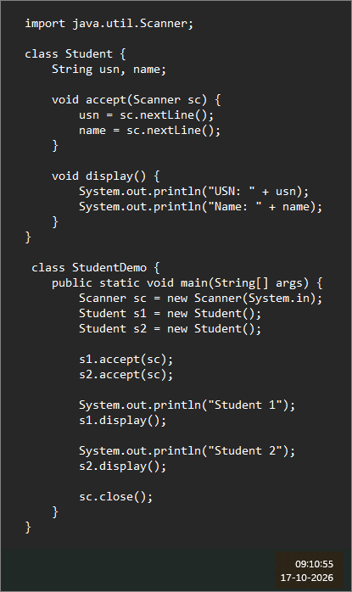
Figure 4.1 – Source code of StudentDemo.java. Screenshot taken on 17-10-2026 at 09:10:55.

Explanation in Simple Words
- class Student has two fields, usn and name.
- accept(Scanner sc) reads two full lines from the keyboard: first the USN, then the name. nextLine() is used so that names containing spaces can also be read.
- display() prints the USN and the name.
- In StudentDemo, one Scanner is created and two Student objects (s1 and s2) are made. The same Scanner is passed to both accept calls, then each student is displayed under the heading "Student 1" or "Student 2".

Output
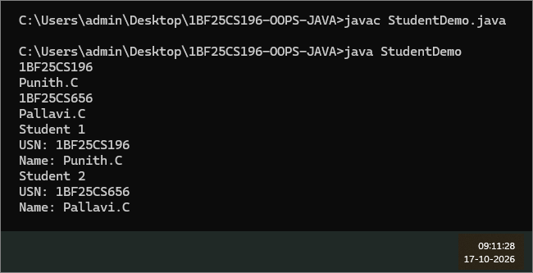
Figure 4.2 – Compiling and running StudentDemo with the details of two students typed in. Screenshot taken on 17-10-2026 at 09:11:28.
Verification: The four typed lines (1BF25CS196, Punith.C, 1BF25CS656, Pallavi.C) are stored in the two objects and printed back correctly under Student 1 and Student 2.

Program 5: Parking Bill (VehicleDemo.java)
Aim: Create a Vehicle class that calculates a parking charge from the vehicle type and the parking hours, and prints a bill for three vehicles.

Source Code
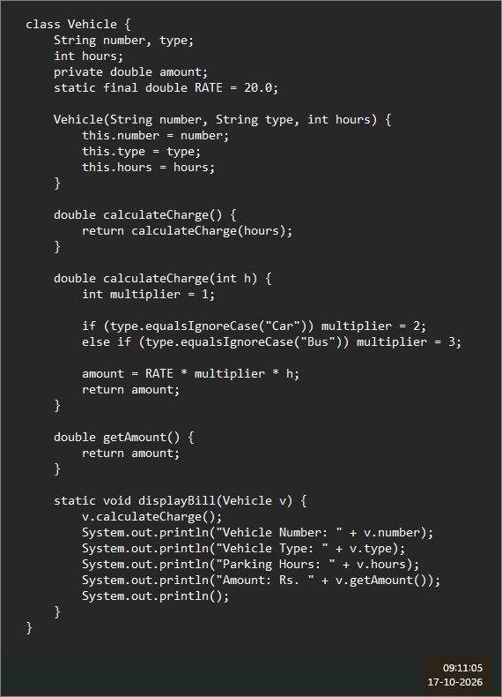
Figure 5.1 – VehicleDemo.java, Part 1 of 2: the Vehicle class. Screenshot taken on 17-10-2026 at 09:11:05.
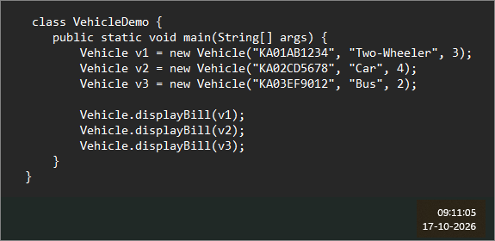
Figure 5.2 – VehicleDemo.java, Part 2 of 2: the VehicleDemo class with the main method. Screenshot taken on 17-10-2026 at 09:11:05.

Explanation in Simple Words
- Each vehicle has a number, a type and the parking hours. RATE is declared static final, so it is a fixed value (Rs. 20 per hour) shared by all vehicles and can never be changed.
- amount is private, so other classes cannot touch it directly. They read it through the getAmount() method. This protection of data is called encapsulation.
- calculateCharge() (no input) and calculateCharge(int h) share a name, which is method overloading. The first simply calls the second with the vehicle's own hours.
- The multiplier is 1 by default (two-wheeler), 2 for a Car and 3 for a Bus. The charge is RATE × multiplier × hours.
- displayBill(Vehicle v) is a static method. It calculates the charge for the given vehicle and prints the number, type, hours and amount.
- In main, three vehicles (a two-wheeler for 3 hours, a car for 4 hours and a bus for 2 hours) are created and their bills are printed.

Output
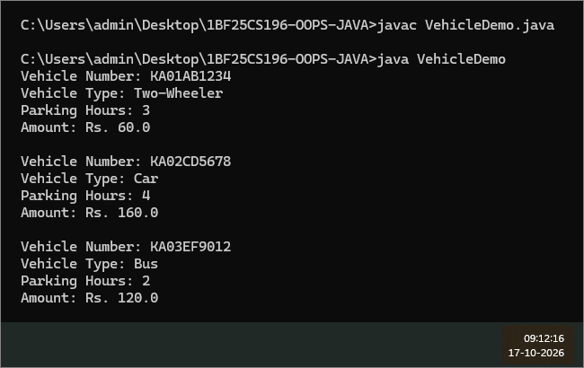
Figure 5.3 – Compiling and running VehicleDemo. Screenshot taken on 17-10-2026 at 09:12:16.
Verification: Two-wheeler: 20 × 1 × 3 = Rs. 60. Car: 20 × 2 × 4 = Rs. 160. Bus: 20 × 3 × 2 = Rs. 120. All three amounts match the program output.

Overall Verification and Notes
All five programs were compiled with javac without any error and were run with java. The output of every program was checked by hand against the code and the input values, and each one is correct.
Program | Checked | Outcome
Books | IDs, search results, costlier book, total count | Book 103 (Rs. 660) is costlier than Book 101 (Rs. 600); total = 3
TypeCasting | 1270.75 split into two parts | 1270 and 0.75
ProductPrices | Sum 8490, max, min, average, count above 1000 | 3000.0, 100.0, 849.0 and 3
StudentDemo | Both students stored and displayed | Matches the typed input
VehicleDemo | Charge = 20 × multiplier × hours | Rs. 60, Rs. 160, Rs. 120

Notes
- Rupee sign shows as "?" in Program 1: the code prints the ₹ symbol, but the Windows Command Prompt uses a code page that cannot show it. To see it correctly, run chcp 65001 first, then java -Dstdout.encoding=UTF-8 Books. Alternatively, print "Rs." instead of the symbol, as the other programs do.
- Floating-point values: prices and amounts are stored as double. This is fine here, but money in real applications is usually handled with BigDecimal to avoid tiny rounding errors.
- Screenshot times: every screenshot was taken on 17-10-2026; the exact time is written under each figure.

