LAB 3
Object Oriented Programming using Java
Abstract Classes, Abstract Methods and Method Overriding
Name | Punith C
USN | 1BF25CS196
Programs in this lab | 2 (AbstractEmployee, EnergyManagement)
Executed on | 24-10-2026
Folder | C:\Users\admin\Desktop\1BF25CS196-OOPS-JAVA

Overview
This lab is about abstraction: writing a parent class that only says what must be done, and letting each child class decide how to do it. Both programs below follow this idea.
No. | Program (file) | What it shows | Result
1 | AbstractEmployee.java | Abstract class Employee with HR and Manager child classes giving different salaries | Compiled and ran correctly
2 | EnergyManagement.java | Abstract class EnergyResource with SolarEnergy and WindEnergy child classes calculating efficiency | Compiled and ran correctly

Concepts used in this lab
Concept | Simple meaning
Abstract class | A half-finished class. You cannot create an object of it directly; it exists to be extended.
Abstract method | A method with only a name and no body. Every child class must write its own body.
Inheritance (extends) | A child class gets everything the parent has, and can add more.
Method overriding (@Override) | A child class gives its own version of a method that the parent declared.
Polymorphism | One method call (like salary()) behaves differently depending on which child object is behind it.
super | Lets the child call the parent’s constructor or method.
protected | A variable that the class and its child classes can use, but outsiders cannot.

Program 1: Employee Salary using an Abstract Class

Aim
To create an abstract class Employee with an abstract method salary(), and then create HR and Manager classes that each show their own salary.

Code
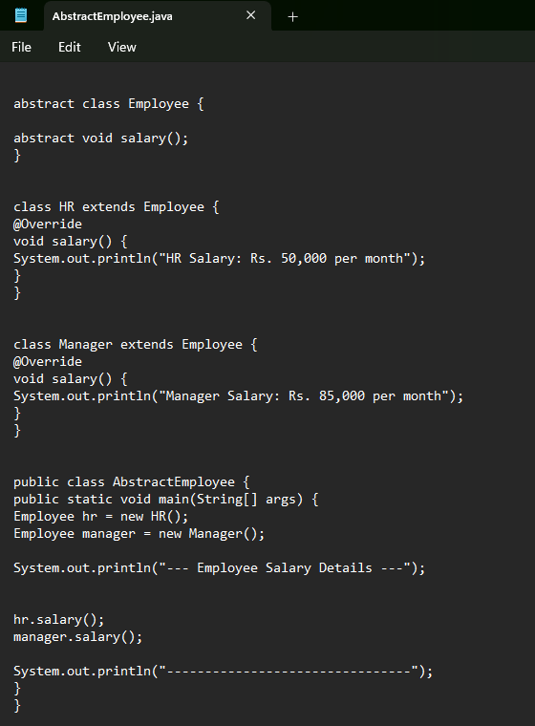
Figure 1.1: AbstractEmployee.java source code (screenshot taken on 24-10-2026 at 08:49:14)

Explanation in simple words
- abstract class Employee is the blueprint. It has one abstract method, abstract void salary();, which only says “every employee must have a salary()”. It does not say how much, so no body is written.
- class HR extends Employee means HR is a type of Employee. Because Employee demanded a salary() method, HR writes it and prints HR Salary: Rs. 50,000 per month. The @Override tag tells Java “I am filling in the parent’s method”.
- class Manager extends Employee does the same, but prints Manager Salary: Rs. 85,000 per month.
- public class AbstractEmployee holds the main() method, which is where the program starts. The file name is also AbstractEmployee.java because this is the public class.
- Inside main, Employee hr = new HR(); and Employee manager = new Manager(); create the objects. The variable type is the parent (Employee), but the object inside is the child. This is allowed and is the base of polymorphism.
- Then hr.salary() and manager.salary() are called. The call looks the same, but each prints its own salary because the real objects are different.
- The program starts with a heading line and ends with a dashed line, both printed using System.out.println.
How it was run: javac AbstractEmployee.java (compile) and then java AbstractEmployee (run).

Output
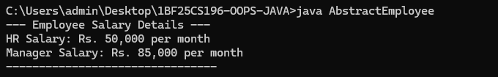
Figure 1.2: Output of java AbstractEmployee (screenshot taken on 24-10-2026 at 08:50:18)

Output explanation
- The first line is the heading printed at the start of main.
- The next two lines come from hr.salary() and manager.salary() in that order, so HR (Rs. 50,000) comes before Manager (Rs. 85,000).
- The last line is the dashed separator.
Checked: the code compiles without errors and every line of the output matches what the code is written to print.

Program 2: Energy Management using an Abstract Class

Aim
To create an abstract class EnergyResource that stores common details of an energy source, and child classes SolarEnergy and WindEnergy that calculate efficiency in their own way.

Code
The file is long, so the screenshot is split into two parts. Part 2 starts from the WindEnergy class, so a few lines overlap with Part 1 and nothing is missed.
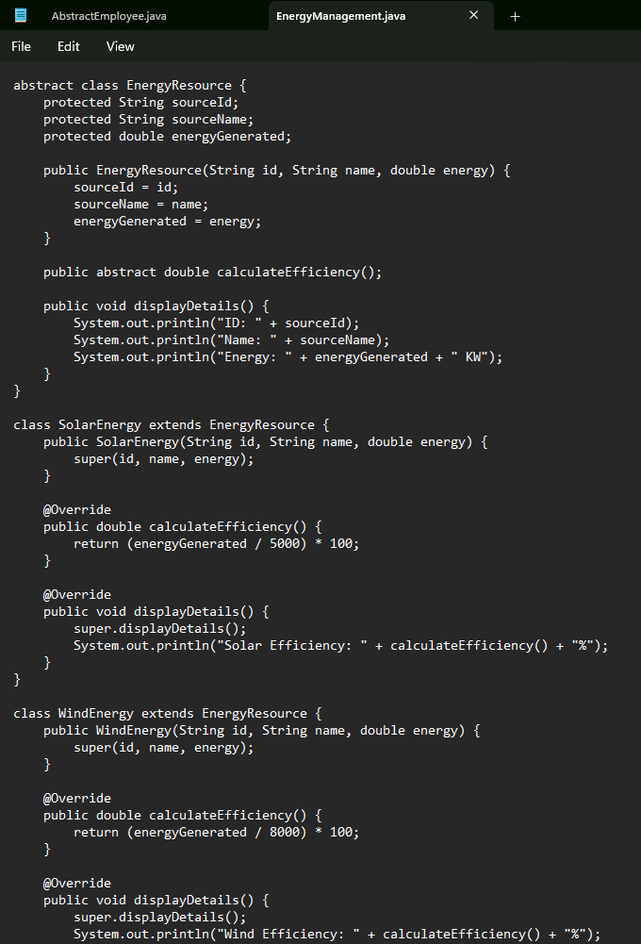
Figure 2.1: EnergyManagement.java, Part 1 – EnergyResource and SolarEnergy (screenshot taken on 24-10-2026 at 09:02:07)
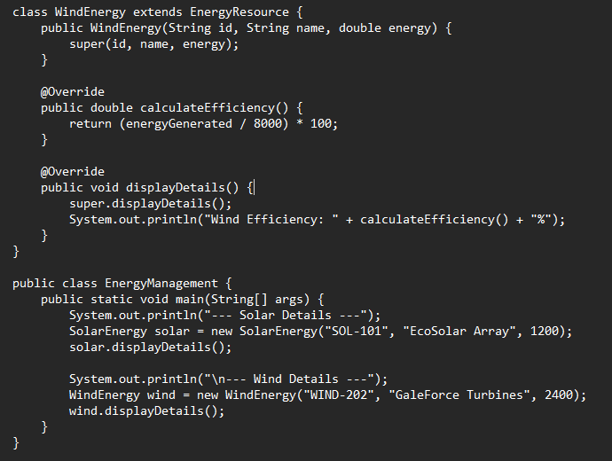
Figure 2.2: EnergyManagement.java, Part 2 – WindEnergy and main method (screenshot taken on 24-10-2026 at 09:02:17)

Explanation in simple words
- abstract class EnergyResource is the common parent. It keeps three protected variables: sourceId, sourceName and energyGenerated. Its constructor stores the values it receives into these variables.
- It has one abstract method, calculateEfficiency(). Solar and wind are measured differently, so the parent leaves it empty and forces each child to write it.
- It also has a normal method, displayDetails(), which prints the ID, Name and Energy (in KW). Every child gets this for free.
- class SolarEnergy extends EnergyResource: its constructor sends the values up using super(id, name, energy). Its calculateEfficiency() returns (energyGenerated / 5000) * 100, which turns the energy into a percentage.
- SolarEnergy overrides displayDetails(): it first calls super.displayDetails() to print the common three lines, then adds its own line Solar Efficiency.
- class WindEnergy works exactly the same way, but divides by 8000 and prints Wind Efficiency.
- main() creates a SolarEnergy object (SOL-101, EcoSolar Array, 1200) and calls its displayDetails(). The \n in the next print adds a blank line. Then it creates a WindEnergy object (WIND-202, GaleForce Turbines, 2400) and calls its displayDetails().
How it was run: javac EnergyManagement.java (compile) and then java EnergyManagement (run).

Output
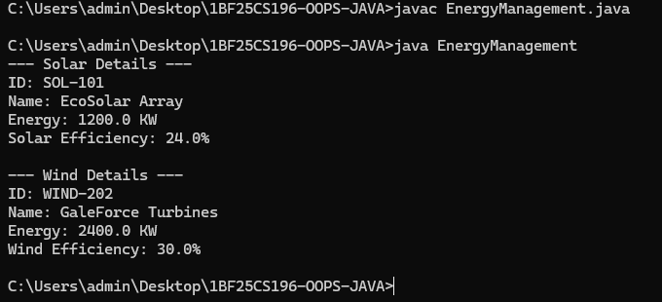
Figure 2.3: Output of java EnergyManagement (screenshot taken on 24-10-2026 at 09:02:28)

Output explanation
- The first block shows the solar source: ID, Name and Energy come from the parent’s displayDetails(), and the Solar Efficiency line is added by SolarEnergy.
- The blank line between the blocks comes from the \n in the code.
- The second block shows the wind source in the same pattern.

Calculation check
The efficiency values in the output were re-calculated by hand from the formulas in the code:
Source | Energy (KW) | Formula in code | Result (matches output)
Solar | 1200 | (1200 / 5000) × 100 | 24.0%
Wind | 2400 | (2400 / 8000) × 100 | 30.0%
Checked: the code compiles without errors, the output matches the code line by line, and both calculated values are correct.

Verification Summary
Check | Program 1: AbstractEmployee | Program 2: EnergyManagement
Compiles with javac | Yes, no errors | Yes, no errors
Runs with java | Yes | Yes
File name matches public class | AbstractEmployee.java | EnergyManagement.java
Abstract method implemented by all child classes | Yes (HR, Manager) | Yes (SolarEnergy, WindEnergy)
Output matches the code | Yes | Yes
Calculations correct | Not applicable (fixed salaries) | Yes (24.0% and 30.0%)

Small observations (optional improvements)
- In Program 2 the capacities 5000 and 8000 are typed directly inside the formulas. Keeping them in named variables would make them easier to change.
- The energy unit is printed as “KW”; the usual way to write it is “kW”. This is only cosmetic.
- In Program 1 the salaries are fixed inside each class. Storing them in a variable would let different employees have different salaries.

Screenshot log
Figure | Image file name (in the zip) | Taken on
1.1 | 01_AbstractEmployee_java_code.png | 24-10-2026, 08:49:14
1.2 | 02_AbstractEmployee_output_HR_and_Manager_salary.png | 24-10-2026, 08:50:18
2.1 | 03_EnergyManagement_java_code_part1_EnergyResource_SolarEnergy.png | 24-10-2026, 09:02:07
2.2 | 04_EnergyManagement_java_code_part2_WindEnergy_and_main.png | 24-10-2026, 09:02:17
2.3 | 05_EnergyManagement_output_Solar_and_Wind_details.png | 24-10-2026, 09:02:28

Conclusion
In this lab, two programs were written using abstract classes. The parent class fixed the structure (what must be there), and the child classes supplied the details (how it is done). Method overriding, super and polymorphism were used in both programs, and both ran with the expected output.

