OOPS WITH JAVA – LAB RECORD
LAB 5 & 6: Packages and Exception Handling
Name: Punith C | USN: 1BF25CS196 | BMS College of Engineering

Overview
This record has three Java programs. Each one has the code screenshot, a simple explanation of the code, the output screenshot and an explanation of the output. Every screenshot is trimmed to the useful part, and its capture date and time is written in the caption below it.
No. | Program | What it demonstrates
1 | TransactionProject (Account, TransactionReport, MainApplication) | User-defined packages: classes kept in different packages and used with import
2 | Rails.java (Railway seat reservation) | Custom exception, throw / throws, multiple catch blocks and finally
3 | Divide.java | Handling ArithmeticException (divide by zero) with try-catch

Program 1: User-Defined Packages (TransactionProject)

Aim
To create a bank-account program in which the classes are placed in two packages (transaction and reports), and to use them from a main class with import statements.

Project structure
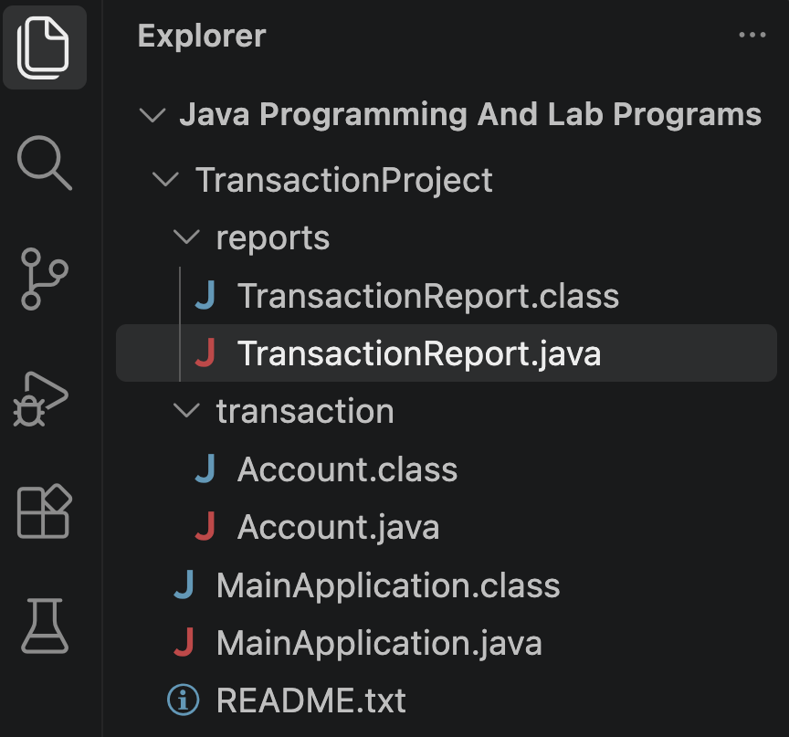
Figure 1: Folder structure of TransactionProject. (Screenshot taken on 05 Nov 2026, 4:54:46 PM)
- transaction folder = package transaction, holds Account.java.
- reports folder = package reports, holds TransactionReport.java.
- MainApplication.java sits in the project folder and uses both packages.
- A package is just a folder with a name. It keeps related classes together and avoids name clashes.

Code 1: Account.java (package transaction)
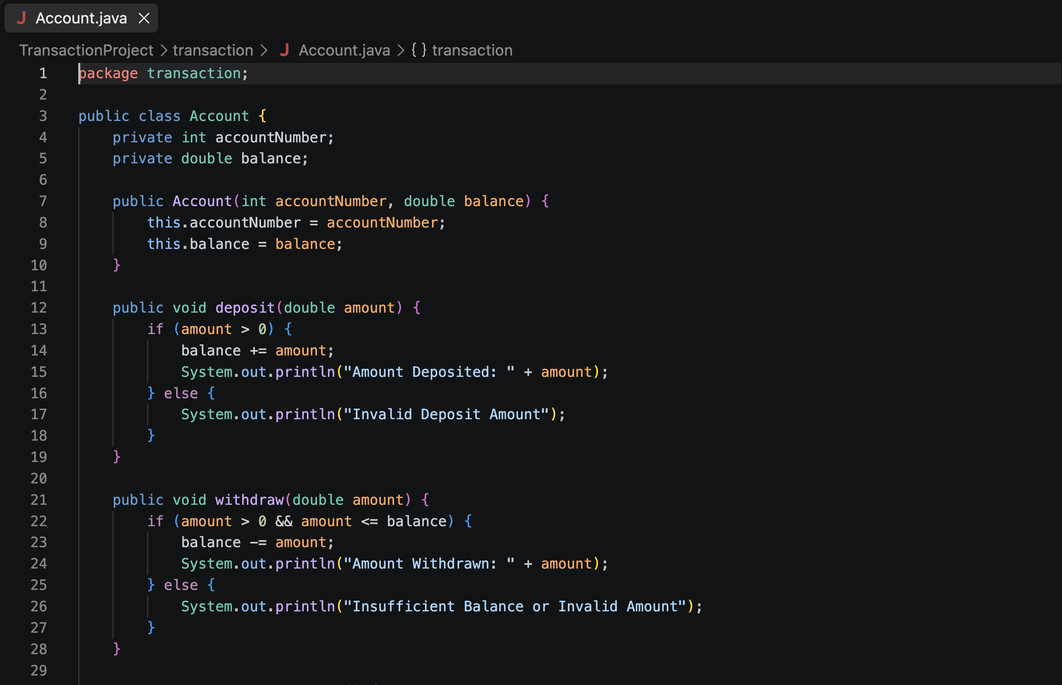
Figure 2: Account.java, lines 1 to 29 (variables, constructor, deposit and withdraw). (Screenshot taken on 05 Nov 2026, 4:55:02 PM)
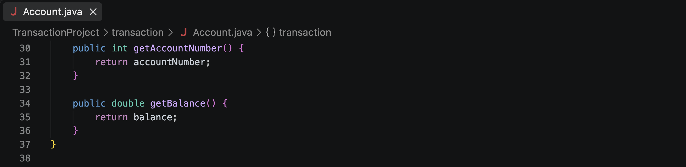
Figure 3: Account.java, lines 30 to 38 (getter methods and end of the class). (Screenshot taken on 05 Nov 2026, 4:55:09 PM)

Explanation in simple words
- package transaction; tells Java that this class belongs to the transaction package.
- The class stores two private values: accountNumber and balance. Private means no other class can change them directly.
- The constructor sets the account number and the starting balance when an Account object is created.
- deposit(): adds the amount to the balance only if it is greater than 0. Otherwise it prints "Invalid Deposit Amount".
- withdraw(): subtracts the amount only if it is more than 0 and not more than the balance. Otherwise it prints "Insufficient Balance or Invalid Amount".
- getAccountNumber() and getBalance(): are getters. They let other classes read the private values safely.

Code 2: TransactionReport.java (package reports)
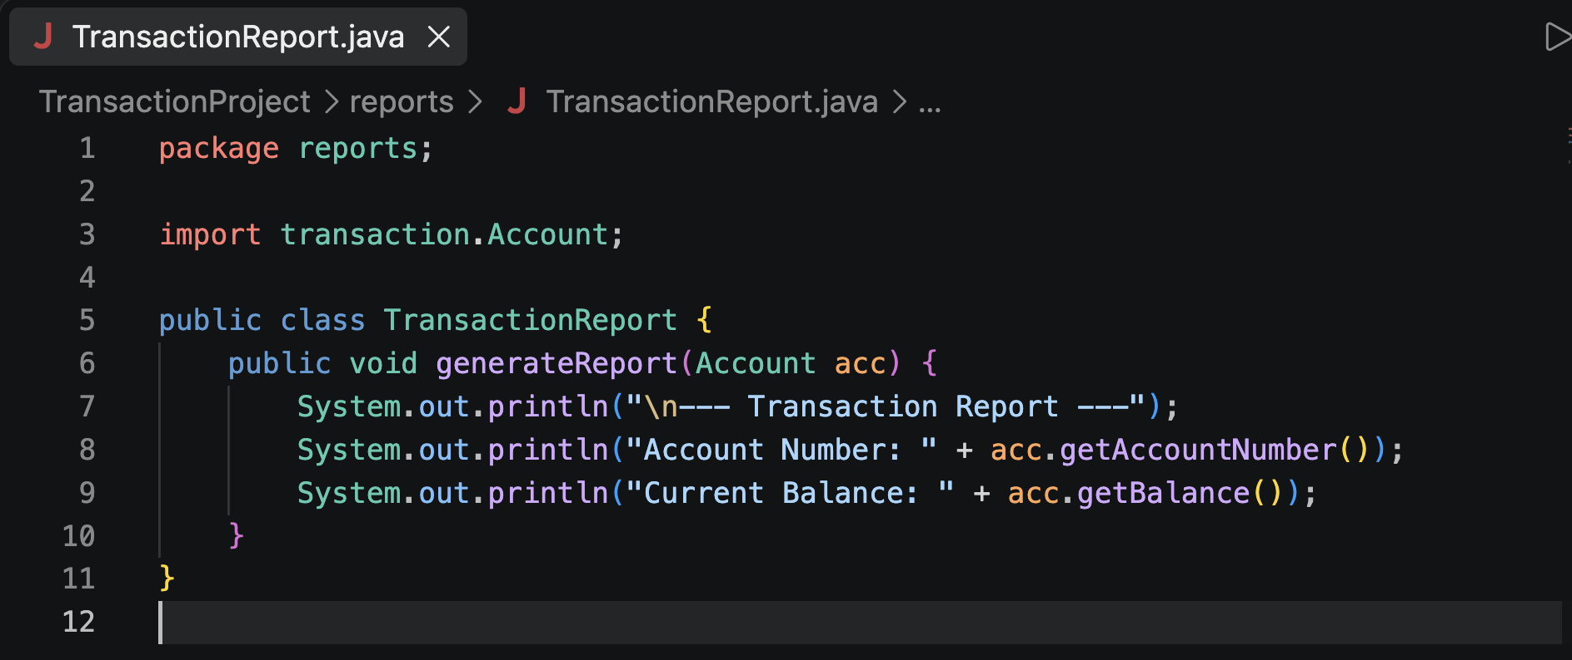
Figure 4: TransactionReport.java (package reports). (Screenshot taken on 05 Nov 2026, 4:54:46 PM)

Explanation in simple words
- package reports; puts this class in the reports package.
- import transaction.Account; lets this class use Account from the other package.
- generateReport() receives an Account object and prints a heading, the account number and the current balance.

Code 3: MainApplication.java (main class)
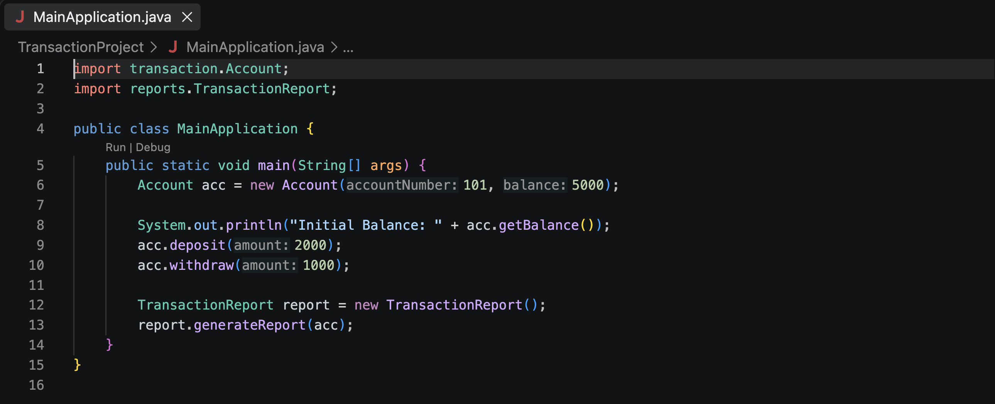
Figure 5: MainApplication.java (imports both packages and runs the program). (Screenshot taken on 05 Nov 2026, 4:55:26 PM)

Explanation in simple words
- Two import lines bring in Account (from transaction) and TransactionReport (from reports).
- An Account is created with account number 101 and balance 5000.
- The program prints the initial balance, deposits 2000, then withdraws 1000.
- Finally it creates a TransactionReport and calls generateReport(acc) to print the summary.

Output
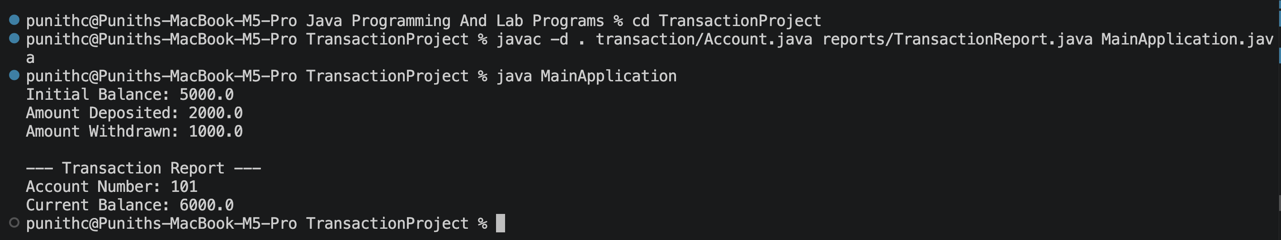
Figure 6: Compiling with javac -d . and running MainApplication. (Screenshot taken on 05 Nov 2026, 4:55:52 PM)

Explanation of the output
- javac -d . compiles all three files together and creates the package folders (transaction and reports) with the .class files.
- java MainApplication runs the program.
- Initial Balance 5000.0, then 2000.0 is deposited and 1000.0 is withdrawn.
- The report shows Account Number 101 and Current Balance 6000.0, which is correct: 5000 + 2000 - 1000 = 6000.

Program 2: Railway Seat Reservation (Custom Exception)

Aim
To reserve seats in a train with 5 seats, using a user-defined exception for an already booked seat, and to handle wrong inputs with try, catch and finally.

Code: Rails.java
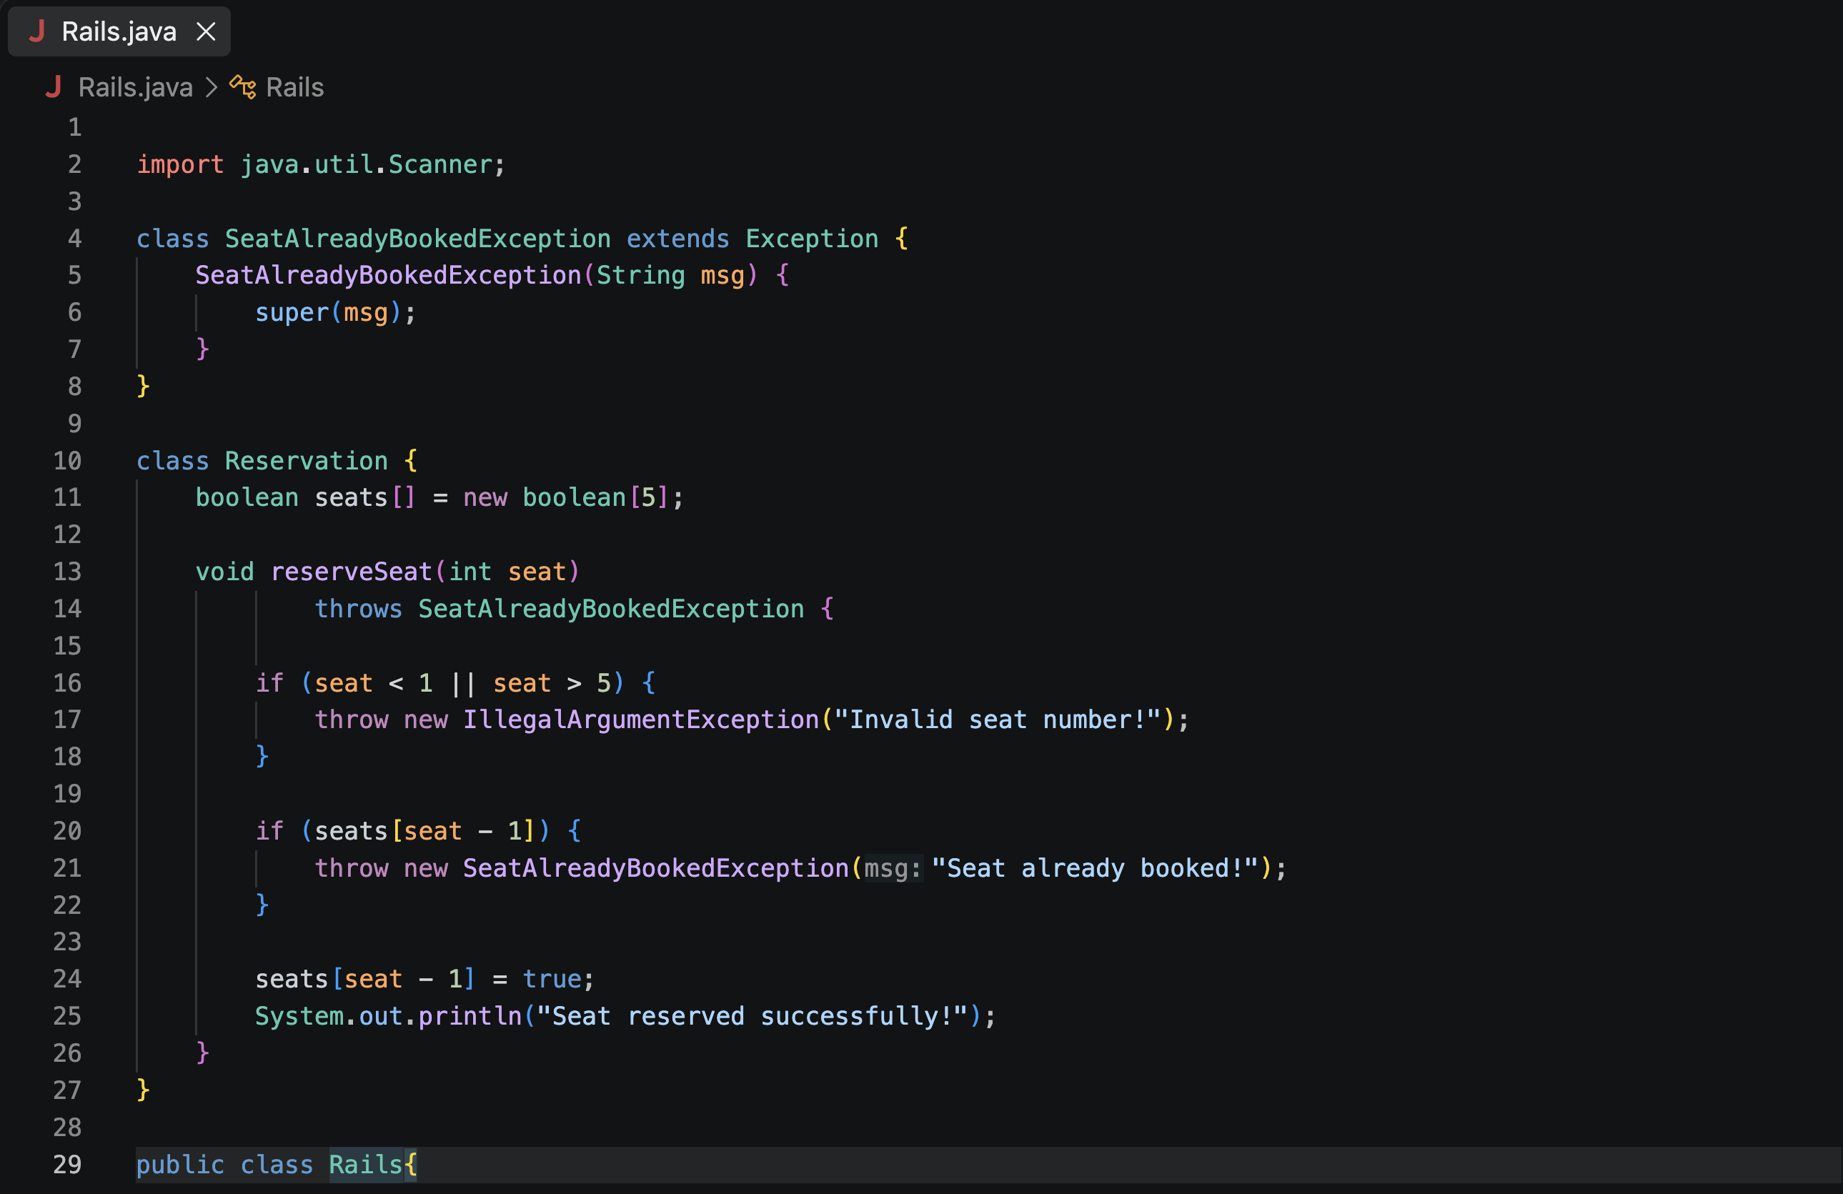
Figure 7: Rails.java, lines 1 to 29 (custom exception and Reservation class). (Screenshot taken on 05 Nov 2026, 7:19:57 PM)
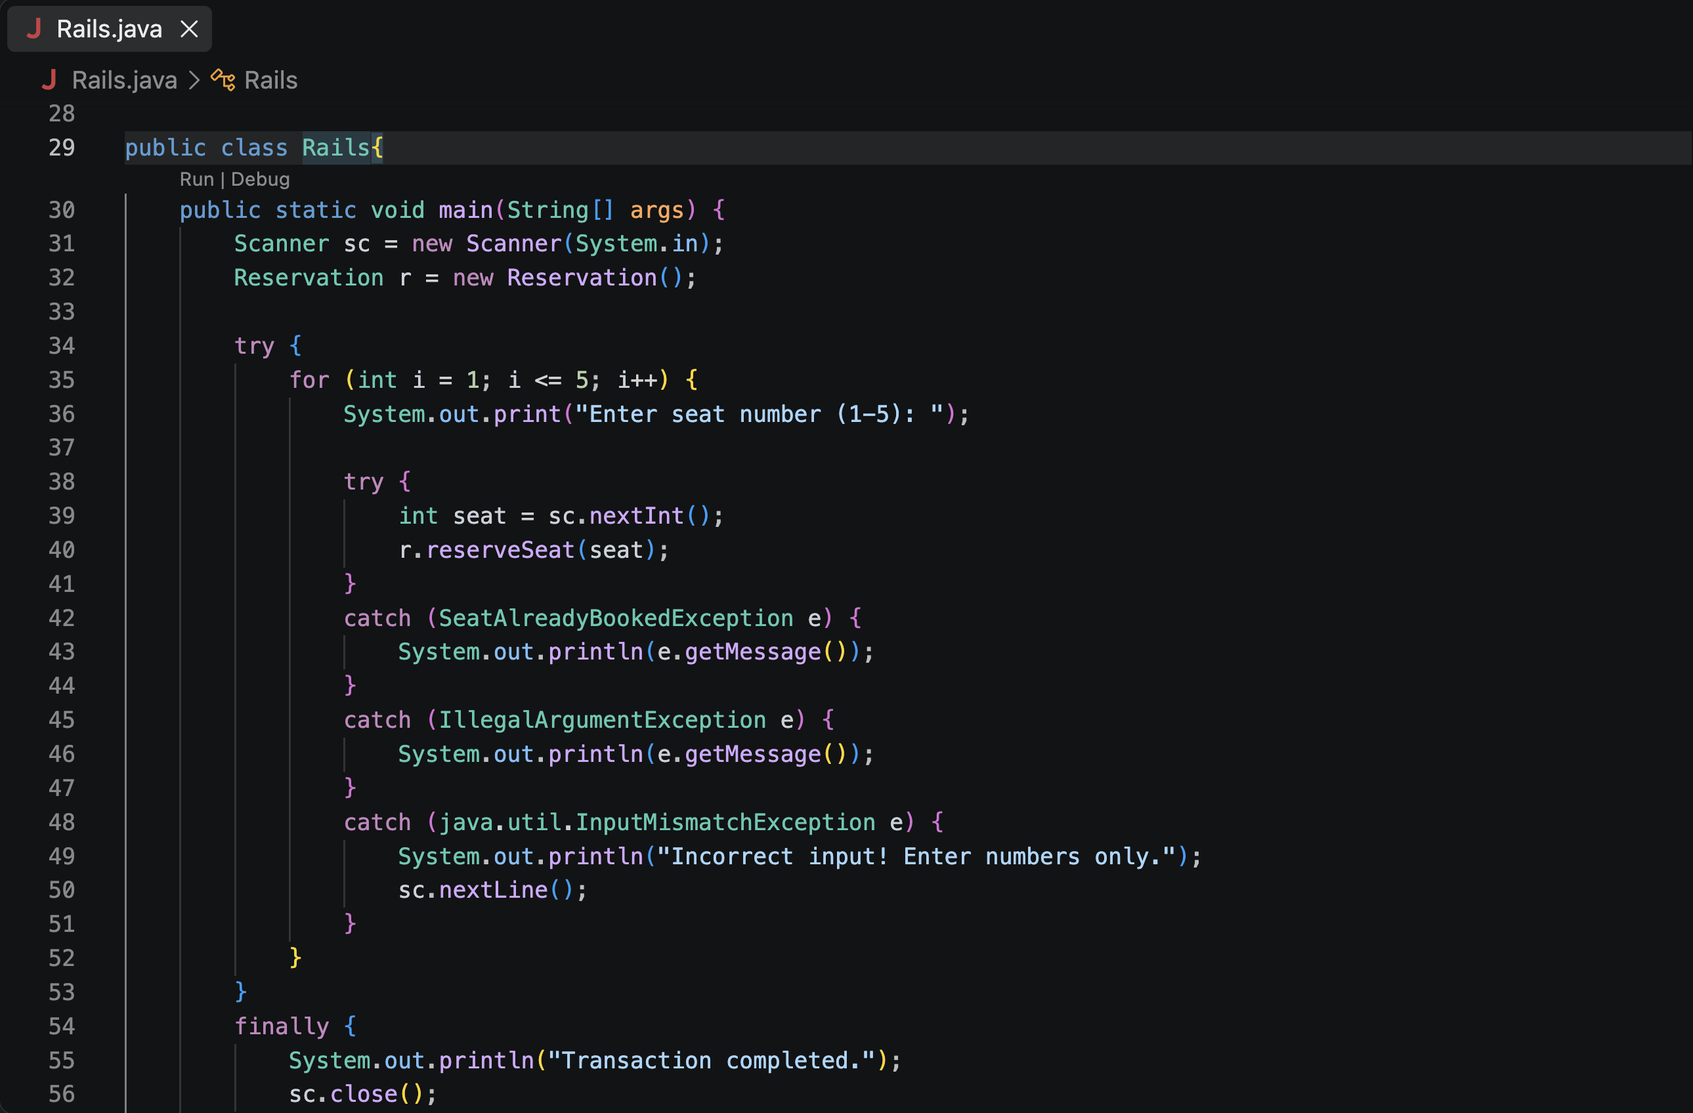
Figure 8: Rails.java, lines 28 to 56 (main method with nested try-catch). (Screenshot taken on 05 Nov 2026, 7:20:05 PM)
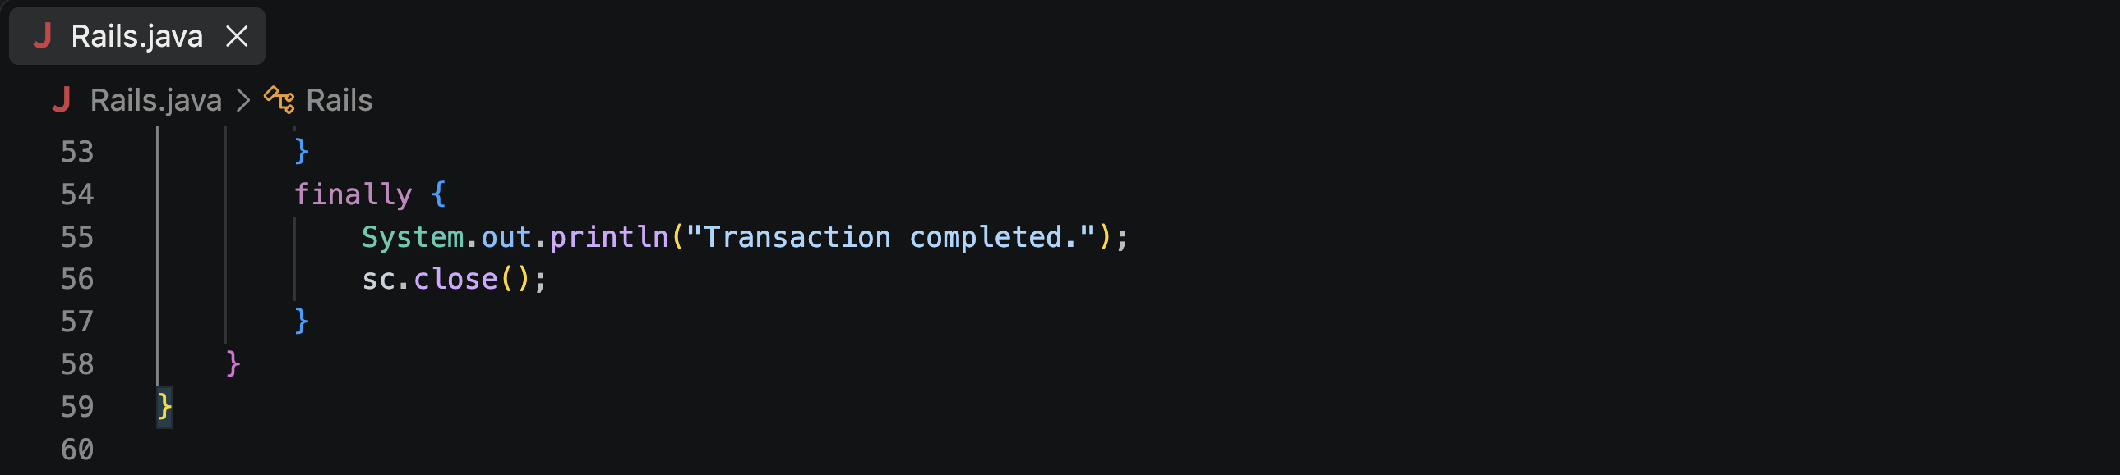
Figure 9: Rails.java, lines 53 to 60 (finally block and end of the program). (Screenshot taken on 05 Nov 2026, 7:20:13 PM)

Explanation in simple words
- SeatAlreadyBookedException is our own exception. It extends Exception and passes its message to the parent class with super(msg).
- Reservation keeps a boolean array of 5 seats. false means free and true means booked.
- reserveSeat(int seat): if the seat is below 1 or above 5 it throws IllegalArgumentException ("Invalid seat number!"). If the seat is already true it throws our SeatAlreadyBookedException. Otherwise it marks the seat as booked. The "throws" keyword warns callers about the custom exception.
- main(): a for loop asks for a seat number 5 times. Inside it, an inner try-catch calls reserveSeat().
- Three catch blocks: SeatAlreadyBookedException and IllegalArgumentException print their messages. InputMismatchException handles non-numbers such as "abc" and clears the bad input with sc.nextLine().
- finally: always runs at the end. It prints "Transaction completed." and closes the Scanner.

Output
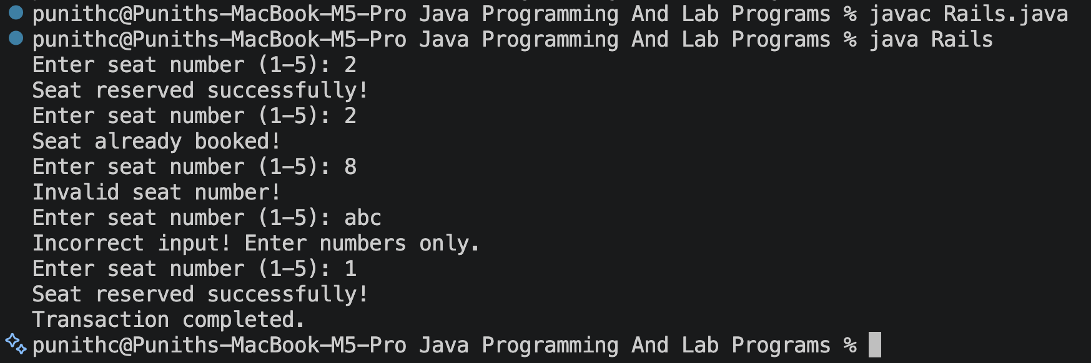
Figure 10: Compiling and running Rails with different inputs. (Screenshot taken on 05 Nov 2026, 7:19:48 PM)

Explanation of the output
Input | What the program printed | Why
2 | Seat reserved successfully! | Seat 2 was free
2 | Seat already booked! | Seat 2 is now true, so the custom exception is thrown
8 | Invalid seat number! | 8 is outside 1 to 5, so IllegalArgumentException
abc | Incorrect input! Enter numbers only. | Text cannot be read by nextInt(), so InputMismatchException
1 | Seat reserved successfully! | Seat 1 was free
(end) | Transaction completed. | The finally block runs after the loop

Program 3: Divide by Zero (ArithmeticException)

Aim
To divide two numbers entered by the user and handle division by zero without the program crashing.

Code: Divide.java
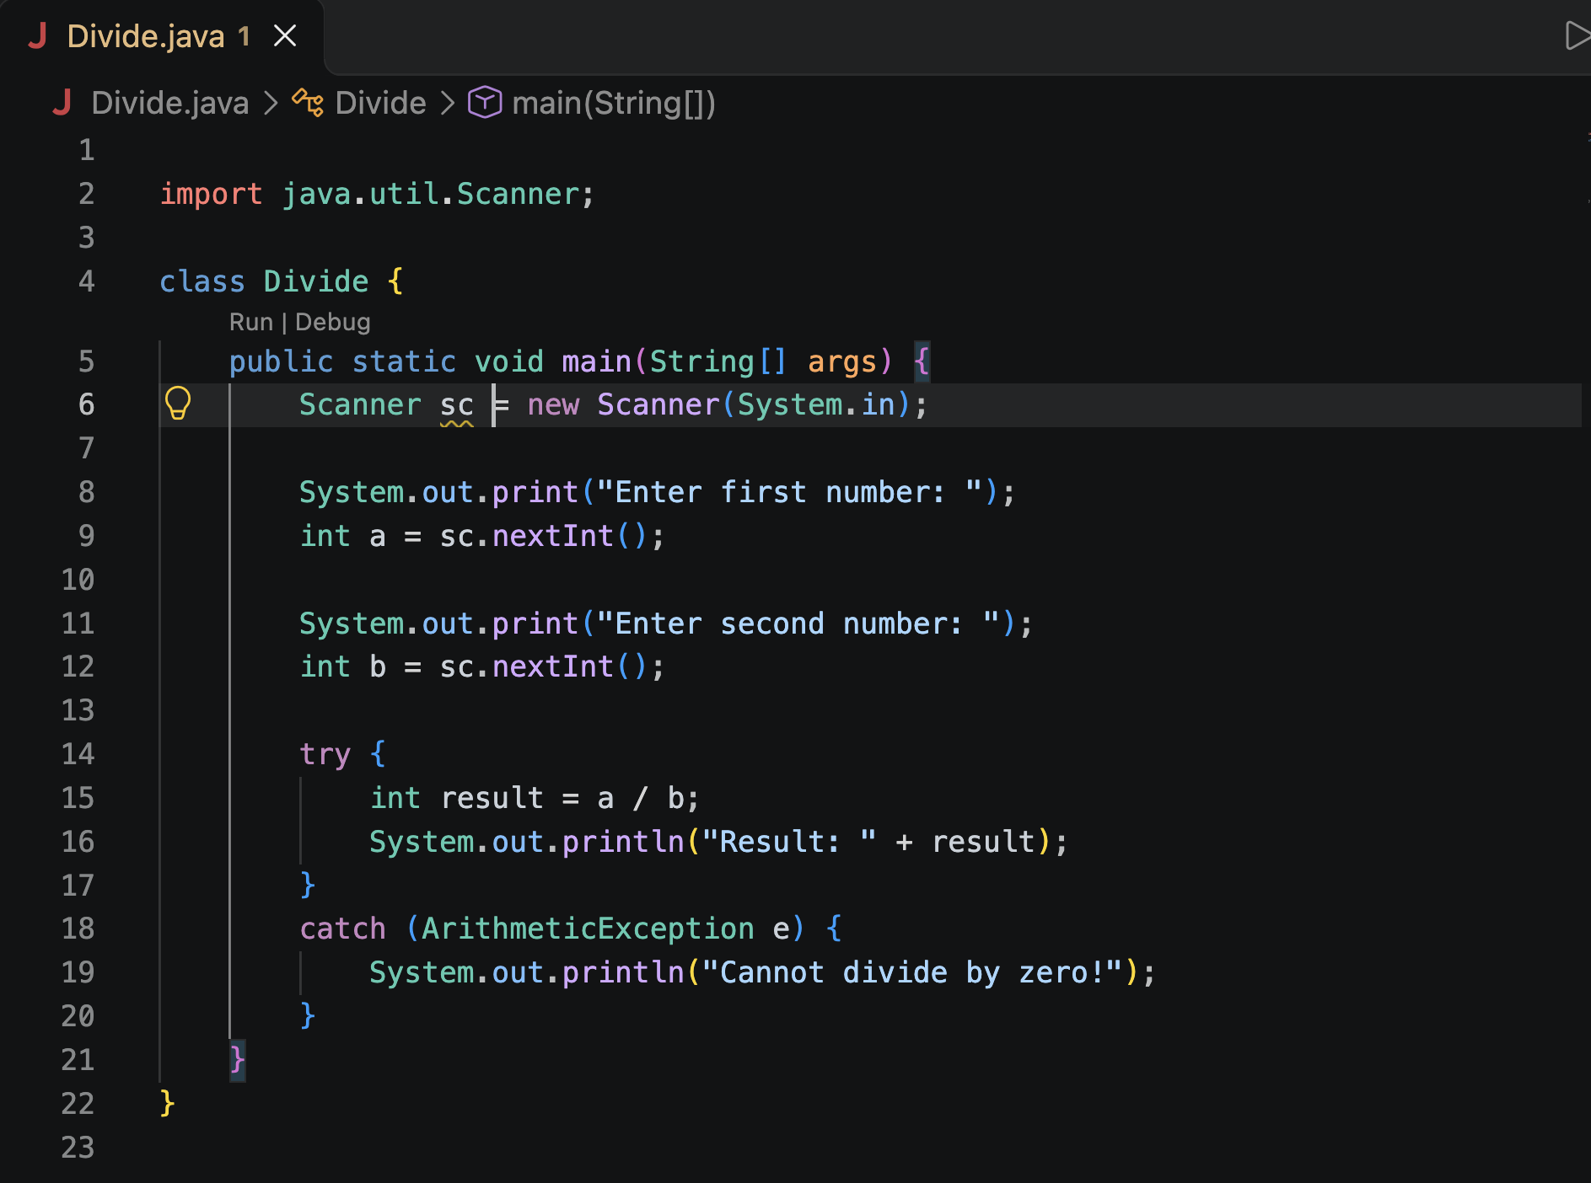
Figure 11: Divide.java (reads two numbers and divides them inside try-catch). (Screenshot taken on 06 Nov 2026, 6:55:03 PM)

Explanation in simple words
- A Scanner reads two whole numbers, a and b, from the keyboard.
- The division a / b is placed inside a try block, because it may fail.
- Dividing an integer by zero makes Java throw an ArithmeticException.
- The catch block catches it and prints "Cannot divide by zero!", so the program ends normally instead of crashing.

Output
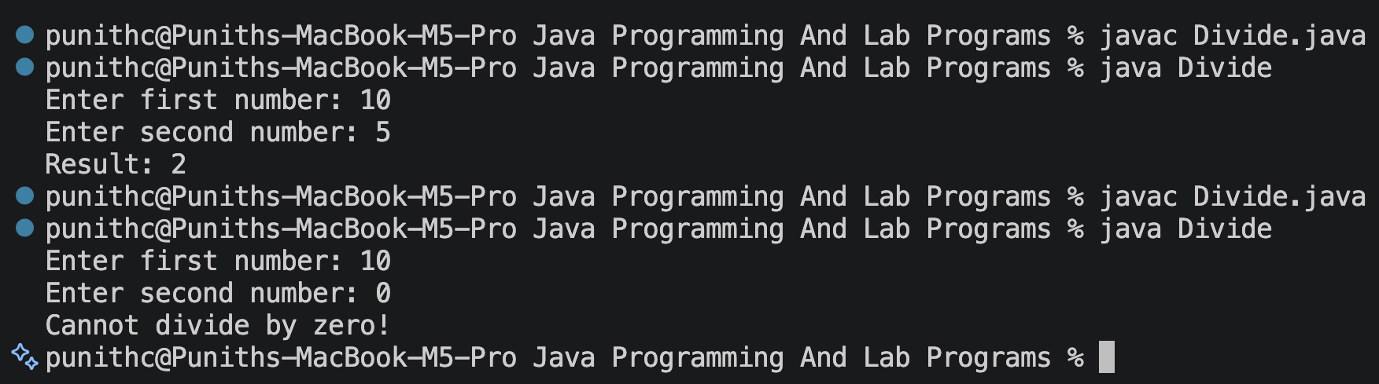
Figure 12: Two runs of Divide: 10 / 5 and 10 / 0. (Screenshot taken on 06 Nov 2026, 6:56:01 PM)

Explanation of the output
- First run: 10 and 5 are entered, so the result is 2 (10 / 5 = 2).
- Second run: 10 and 0 are entered, so the catch block prints "Cannot divide by zero!".

Check of All Programs and Outputs
All three programs were compiled and run, and each output was compared with what the code should print.
Program | Input | Output seen | Status
Transaction project | 101, 5000, deposit 2000, withdraw 1000 | Balance 5000.0 then 6000.0 in the report | Correct
Rails | 2 | Seat reserved successfully! | Correct
Rails | 2 (again) | Seat already booked! | Correct
Rails | 8 | Invalid seat number! | Correct
Rails | abc | Incorrect input! Enter numbers only. | Correct
Rails | 1, then loop ends | Seat reserved successfully! / Transaction completed. | Correct
Divide | 10, 5 | Result: 2 | Correct
Divide | 10, 0 | Cannot divide by zero! | Correct

Observations
- The Transaction project compiled with no errors and the Problems count was 0 in the editor.
- Divide.java shows 1 editor warning: the Scanner "sc" is never closed (resource leak). It does not affect the output. Adding sc.close() at the end of main removes it.
- In Divide.java the two nextInt() calls are outside the try block, so typing text such as "abc" would crash the program. Moving them inside the try block, with a catch for InputMismatchException, would fix this (Rails.java already does it).
- In Rails.java the loop runs 5 times, which means 5 attempts, not 5 successful bookings. That is why the output stops after 5 inputs.

Conclusion
- Packages organise classes into folders, and import lets one package use another.
- try, catch and finally let a program handle errors and carry on.
- A custom exception (extends Exception) lets us create our own meaningful error, as in the seat booking program.

