LAB 9 - OOPS JAVA
String Handling in Java: Email Address Program
Item | Details
Name | Punith.C
USN | 1BF25CS196
Subject | Object Oriented Programming with Java
Program | StringHandling.java (file: StringHandling.java)
Topic | String methods: length, trim, indexOf, substring, toLowerCase, startsWith, endsWith, replace, contains, equalsIgnoreCase
Screenshots dated | 12-Nov-2026 (taken from the screenshot file names; the exact time is not stored in the image files)

1. Aim
To write a Java program that takes an email address from the user and performs different String operations on it: finding its length, trimming spaces, extracting the username and domain, checking the domain, converting to lowercase, checking a prefix and suffix, replacing the domain, searching for a sequence, and comparing two email addresses.

2. Program Overview
The program reads input with the Scanner class and then works step by step on the email. Each numbered output line (1 to 6) in the terminal matches one operation in the code. The program is shown below in four screenshots, followed by the output.
Step | Operation | Java method used
1 | Length of the email | length()
2 | Remove extra spaces at the ends | trim()
3 | Get the username (text before @) | indexOf('@'), substring(0, at)
4 | Get the domain (text after @) and check it | substring(at + 1), equalsIgnoreCase()
5 | Convert the email to lowercase | toLowerCase()
- | Check prefix and suffix | startsWith(), endsWith()
6 | Replace the domain with cse.bmsce.ac.in | replace()
- | Search for a sequence of characters | contains()
- | Compare two email addresses ignoring case | equalsIgnoreCase()

3. Code and Explanation

3.1 Part 1: Setup, length, trim and username (lines 1-29)
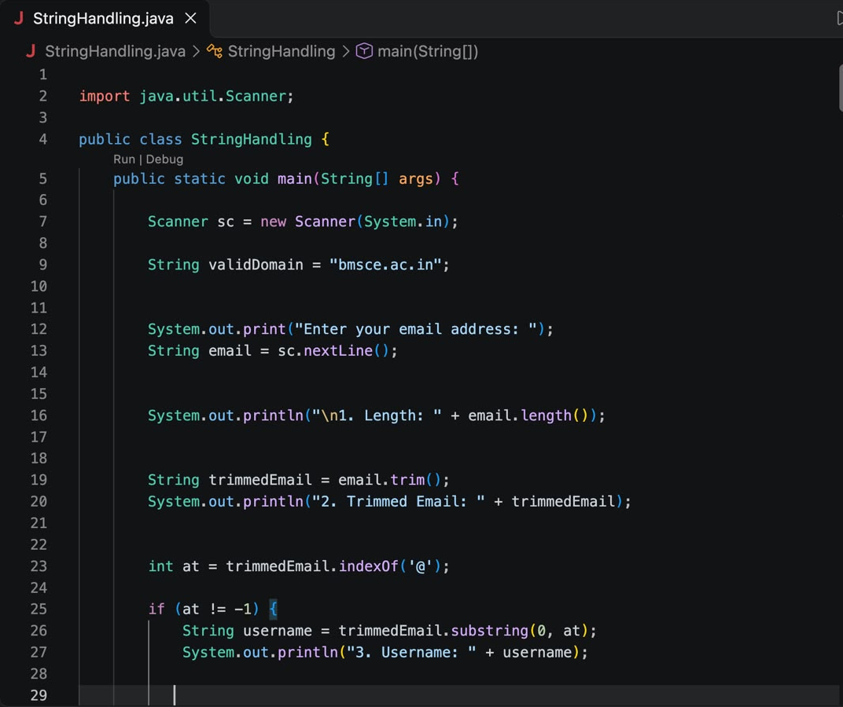
Figure 1: StringHandling.java, lines 1-29 (setup, length, trim, username) | Screenshot date: 12-Nov-2026 (from file name; time is not stored in the image)
In simple words:
- import java.util.Scanner; lets us read what the user types on the keyboard.
- String validDomain = "bmsce.ac.in"; stores the correct college domain, which we compare against later.
- The program asks "Enter your email address" and stores the answer in email using sc.nextLine() (reads the whole line).
- email.length() counts the characters in the email and prints it as output 1.
- email.trim() removes any spaces at the start or end. The cleaned email is saved in trimmedEmail (output 2).
- indexOf('@') finds the position of the @ symbol. If it is not -1, the @ exists, so substring(0, at) cuts out everything before @ as the username (output 3).

3.2 Part 2: Domain, lowercase and prefix check (lines 28-55)
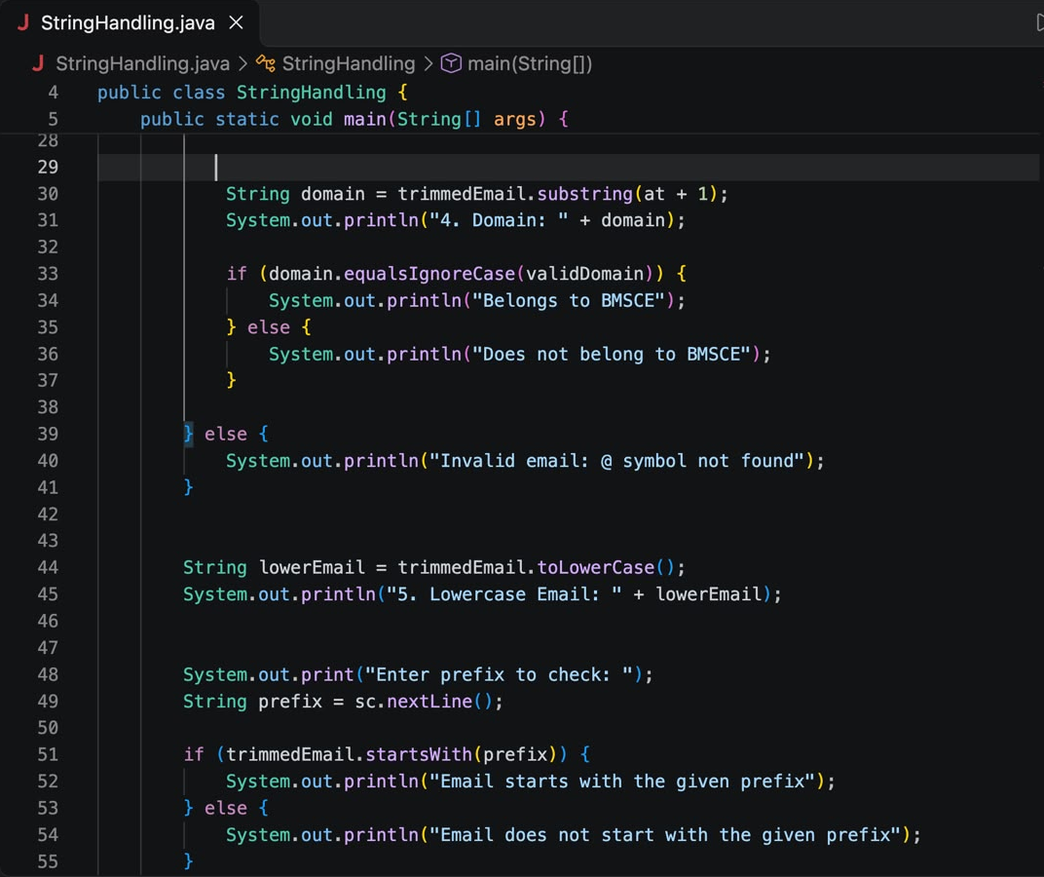
Figure 2: StringHandling.java, lines 28-55 (domain, lowercase, prefix check) | Screenshot date: 12-Nov-2026 (from file name; time is not stored in the image)
In simple words:
- substring(at + 1) takes everything after the @ symbol. This is the domain (output 4).
- domain.equalsIgnoreCase(validDomain) checks if the domain is the same as bmsce.ac.in, ignoring capital or small letters. It prints "Belongs to BMSCE" or "Does not belong to BMSCE".
- The else part (line 39) runs when there is no @ in the email, and prints "Invalid email: @ symbol not found".
- trimmedEmail.toLowerCase() makes every letter small and stores it in lowerEmail (output 5).
- The program asks for a prefix and uses startsWith(prefix) to check whether the email begins with it.

3.3 Part 3: Ends with, replace and contains (lines 56-83)
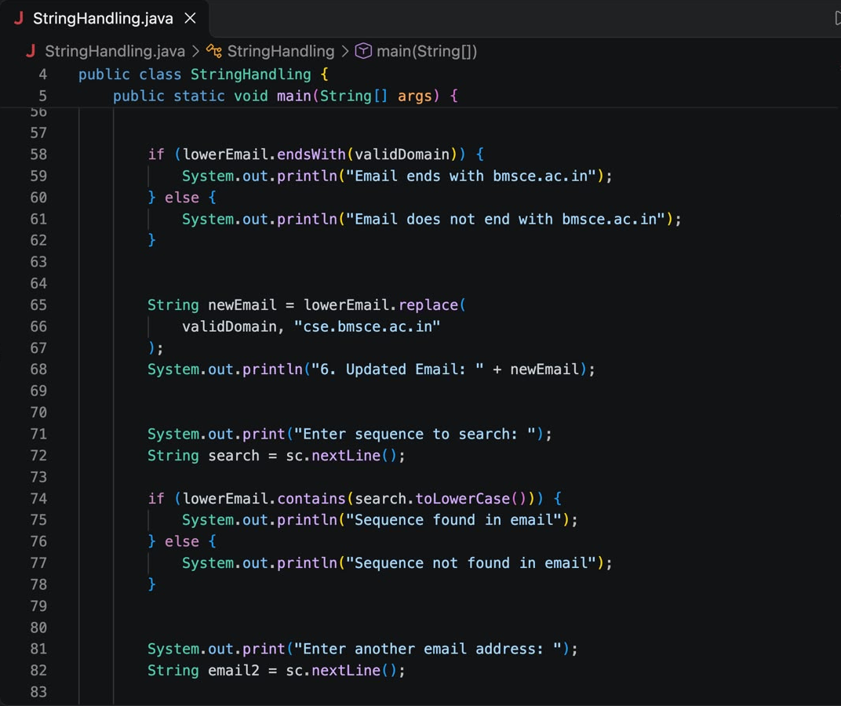
Figure 3: StringHandling.java, lines 56-83 (endsWith, replace, contains) | Screenshot date: 12-Nov-2026 (from file name; time is not stored in the image)
In simple words:
- lowerEmail.endsWith(validDomain) checks that the email finishes with bmsce.ac.in.
- lowerEmail.replace(validDomain, "cse.bmsce.ac.in") swaps the old domain with the new one, giving a new email address (output 6).
- The program asks for a sequence (any text) to search. contains(search.toLowerCase()) tells whether that text is present anywhere inside the email.
- It then asks for another email address, which is used in the last part.

3.4 Part 4: Comparing two emails and closing the scanner (lines 75-93)
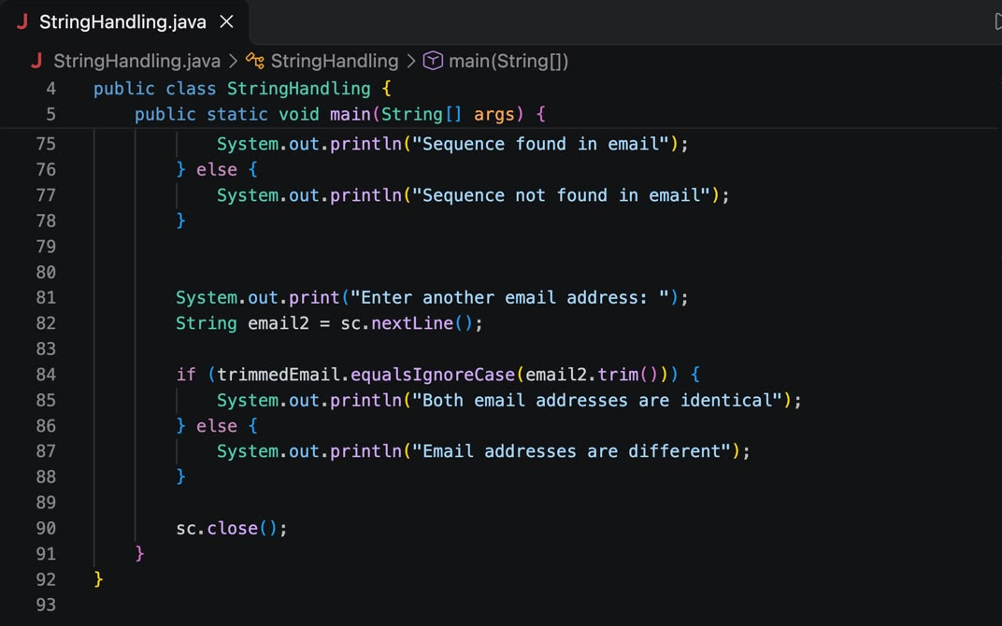
Figure 4: StringHandling.java, lines 75-93 (compare two emails, close scanner) | Screenshot date: 12-Nov-2026 (from file name; time is not stored in the image)
In simple words:
- trimmedEmail.equalsIgnoreCase(email2.trim()) compares both emails after removing spaces and ignoring capital letters.
- If they match it prints "Both email addresses are identical", otherwise "Email addresses are different".
- sc.close(); closes the Scanner to release the resources, and the braces close the method and the class.

4. Output
The program was compiled and run from the terminal using javac StringHandling.java followed by java StringHandling. The inputs given were:
- Email: 1bf25cs196@bmsce.ac.in
- Prefix: 1bf25cs | Sequence: 2025 | Second email: 1BF25CS196@BMSCE.AC.IN
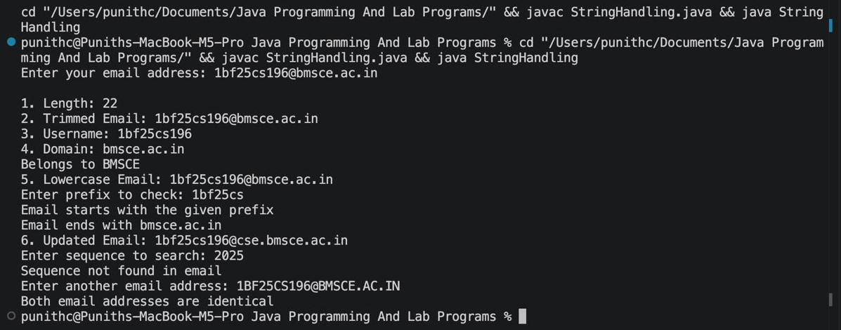
Figure 5: Terminal output of the program run | Screenshot date: 12-Nov-2026 (from file name; time is not stored in the image)

5. Verification of Program and Output
Each line of output was checked against the code and the inputs. All results are correct.
Operation | Expected result | Output shown | Status
length() | 1bf25cs196 (10) + @ (1) + bmsce.ac.in (11) = 22 | 22 | Correct
trim() | No extra spaces, email unchanged | 1bf25cs196@bmsce.ac.in | Correct
Username | Text before @ | 1bf25cs196 | Correct
Domain | Text after @ | bmsce.ac.in | Correct
Domain check | Same as bmsce.ac.in | Belongs to BMSCE | Correct
toLowerCase() | Already lowercase | 1bf25cs196@bmsce.ac.in | Correct
startsWith("1bf25cs") | Email begins with this | Email starts with the given prefix | Correct
endsWith(domain) | Email ends with bmsce.ac.in | Email ends with bmsce.ac.in | Correct
replace() | Domain becomes cse.bmsce.ac.in | 1bf25cs196@cse.bmsce.ac.in | Correct
contains("2025") | Not present in the email | Sequence not found in email | Correct
equalsIgnoreCase() | Same email, only case differs | Both email addresses are identical | Correct

Observations:
- The code has no syntax errors. It compiled and ran successfully ("Java: Ready" in the editor, 0 errors).
- The program only validates the domain and the @ symbol. It does not check other email rules (for example, spaces inside the address or multiple @ symbols).
- Searching for "2025" returned "not found" because the email contains "25" only inside "1bf25cs196", not the full sequence "2025". This is the correct result.

6. String Methods Used (Quick Reference)
Method | What it does
length() | Returns the number of characters in the string
trim() | Removes spaces from the start and end
indexOf(char) | Returns the position of a character, or -1 if not found
substring(a, b) | Returns the part of the string from a up to (not including) b
toLowerCase() | Converts all letters to small letters
startsWith(x) / endsWith(x) | Checks whether the string begins or ends with x
replace(old, new) | Replaces every old text with the new text
contains(x) | Checks whether x appears anywhere inside the string
equalsIgnoreCase(x) | Compares two strings, ignoring capital/small letters

7. Conclusion
The StringHandling program successfully performed all the required String operations on an email address. The output matches the expected results for every step, which shows the String methods of Java were used correctly.

