LAB 4
Interfaces and Polymorphism in Java
Object Oriented Programming with Java (OOPS Java) – Lab Record
Detail | Information
Name | Punith C
USN | 1BF25CS196
College | BMS College of Engineering
Subject | Object Oriented Programming with Java
Lab topic | Interfaces, implementing classes and polymorphism
Screenshots taken | 31-10-2026, between 08:09 and 08:40

Programs at a glance
No. | Program file | What it does | Interface | Output
1 | ParkingDemo.java | Calculates the parking charge of a two-wheeler and a four-wheeler | ParkingCharge | Rs. 60.0 and Rs. 190.0
2 | Pay.java | Pays an amount using Credit Card, UPI and PayPal | Payment | Amount: 100.0, 200.0, 300.0
3 | SalaryEmployee.java | Calculates the salary of a permanent and a contract employee | Salary | 35000.0 and 16000.0

The idea behind all three programs
- Interface – a list of method names with no bodies. Think of it as a rule book: every class that implements it must write the body of each method.
- Many classes, one interface – each class writes the method in its own way (for example, a two-wheeler and a four-wheeler are charged at different rates).
- Interface variable – a variable such as Payment p; can hold an object of any class that implements Payment. When p.pay() is called, Java runs the version that belongs to the actual object. This is polymorphism (“many forms”).
Each program follows the same order: code screenshot, explanation in simple words, output screenshot, and a quick check of the result.

Program 1: Parking Charge (ParkingDemo.java)
Aim: To calculate the parking charge for different vehicles using an interface, inheritance and polymorphism.
Concepts used: interface, extends, implements, constructor with super, if–else, interface reference variable.

Code
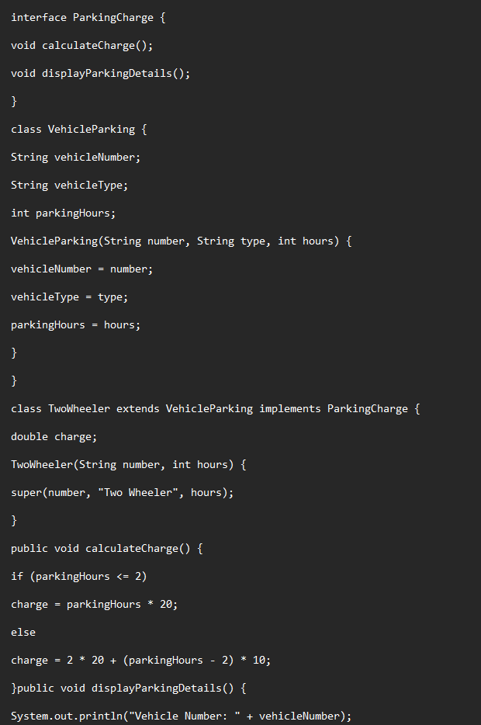
Figure 1: ParkingDemo.java – code, part 1 of 3 (top of the file). Screenshot taken on 31-10-2026 at 08:09:49.
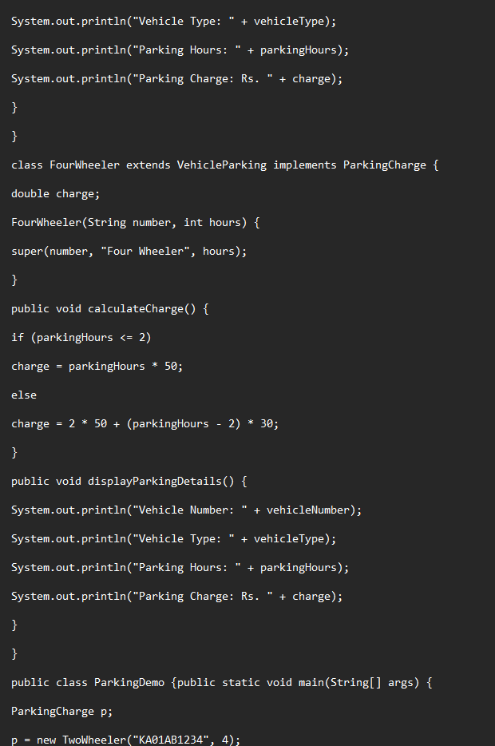
Figure 2: ParkingDemo.java – code, part 2 of 3 (middle of the file). Screenshot taken on 31-10-2026 at 08:10:08.
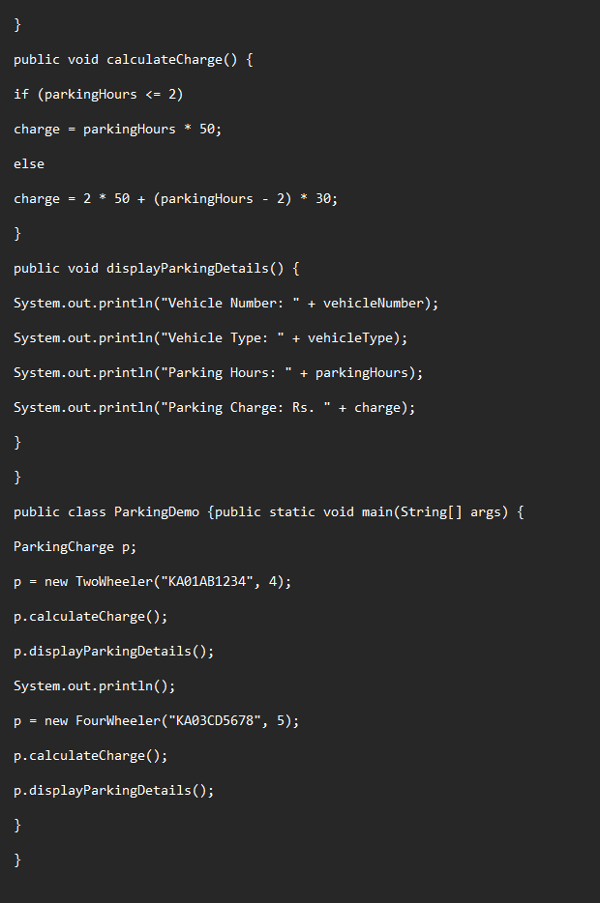
Figure 3: ParkingDemo.java – code, part 3 of 3 (end of the file, includes main). Screenshot taken on 31-10-2026 at 08:10:21.
Note: the file was scrolled between screenshots, so the end of one part repeats a few lines at the start of the next.

Code explained in simple words
- interface ParkingCharge – the rule book. Any vehicle class that wants parking charges must have calculateCharge() and displayParkingDetails(). Only the names are written here, not the work.
- class VehicleParking – the common parent. It stores the vehicle number, vehicle type and parking hours, and its constructor fills these three values. Things common to every vehicle are written once here.
- class TwoWheeler extends VehicleParking implements ParkingCharge – extends means it gets the parent’s variables; implements means it promises to follow the interface. Its constructor takes only the number and hours and calls super(number, "Two Wheeler", hours), so the type is filled in automatically.
- TwoWheeler.calculateCharge() – up to 2 hours the charge is Rs. 20 per hour. For more than 2 hours, the first 2 hours cost 2 × 20 = Rs. 40 and every extra hour costs Rs. 10.
- class FourWheeler – built in exactly the same way, with higher rates: Rs. 50 per hour up to 2 hours; after that, 2 × 50 = Rs. 100 plus Rs. 30 for every extra hour.
- displayParkingDetails() – prints the vehicle number, type, hours and the final charge.
- main – creates ParkingCharge p;. First p points to a TwoWheeler (KA01AB1234, 4 hours); the charge is calculated and printed. Then the same p points to a FourWheeler (KA03CD5678, 5 hours) and the same two calls are made. The calls look identical but give different results because the actual objects are different.

Output
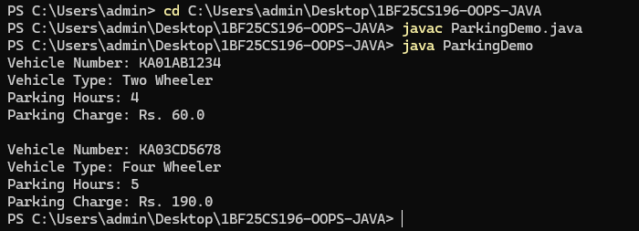
Figure 4: Compiling and running ParkingDemo (javac ParkingDemo.java, java ParkingDemo). Screenshot taken on 31-10-2026 at 08:10:40.

Checking the result
Vehicle | Hours | Calculation | Program output | Result
Two Wheeler | 4 | 2 × 20 + (4 − 2) × 10 = 40 + 20 = 60 | Rs. 60.0 | Correct
Four Wheeler | 5 | 2 × 50 + (5 − 2) × 30 = 100 + 90 = 190 | Rs. 190.0 | Correct

Program 2: Payment Methods (Pay.java)
Aim: To show how one interface (Payment) can be used by different payment methods.
Concepts used: interface, implements, one method written differently by each class, interface reference variable.

Code
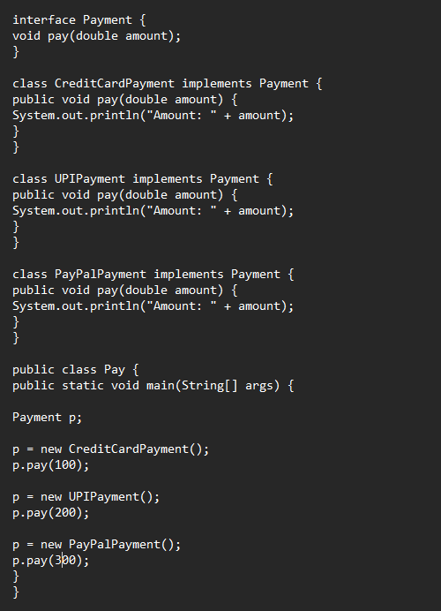
Figure 5: Pay.java – complete code. Screenshot taken on 31-10-2026 at 08:39:40.

Code explained in simple words
- interface Payment – has one rule: every payment type must have a pay(double amount) method.
- CreditCardPayment, UPIPayment, PayPalPayment – three classes that implements Payment. Each one writes its own pay() method. Here each one simply prints the amount; in a real app each would talk to a different service.
- main – declares Payment p;. First p is a CreditCardPayment and p.pay(100) is called, then p becomes a UPIPayment for 200, and finally a PayPalPayment for 300. One variable, three different objects.
- Why 100.0 and not 100? The method takes a double, so the whole number 100 is converted to 100.0 before printing.

Output
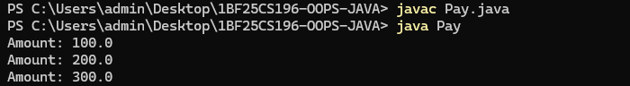
Figure 6: Compiling and running Pay (javac Pay.java, java Pay). Screenshot taken on 31-10-2026 at 08:39:49.

Checking the result
Payment class | Amount passed | Program output | Result
CreditCardPayment | 100 | Amount: 100.0 | Correct
UPIPayment | 200 | Amount: 200.0 | Correct
PayPalPayment | 300 | Amount: 300.0 | Correct

Program 3: Employee Salary (SalaryEmployee.java)
Aim: To calculate the salary of different types of employees using an interface.
Concepts used: interface, implements, instance variables with initial values, interface reference variable.

Code
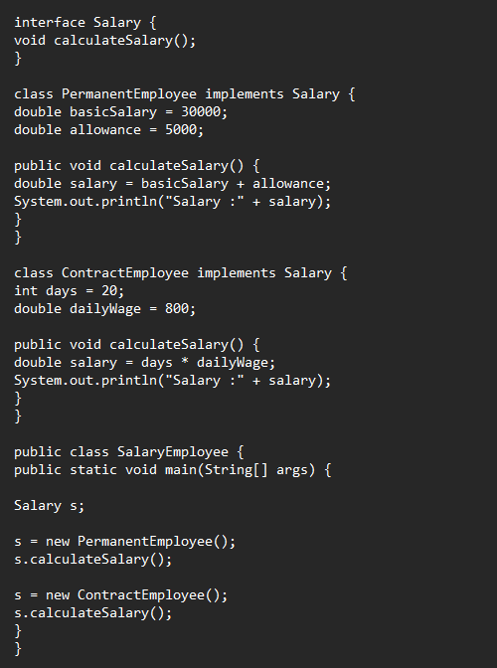
Figure 7: SalaryEmployee.java – complete code. Screenshot taken on 31-10-2026 at 08:39:58.

Code explained in simple words
- interface Salary – the rule: every employee type must have a calculateSalary() method.
- PermanentEmployee – keeps a basic salary of 30000 and an allowance of 5000. Its salary is basic + allowance = 35000.
- ContractEmployee – is paid per day: 20 days at 800 per day. Its salary is days × daily wage = 16000.
- main – declares Salary s;. First s points to a PermanentEmployee and the salary is printed; then s points to a ContractEmployee and the salary is printed. The same call s.calculateSalary() gives two different results.

Output
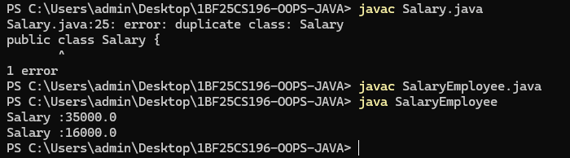
Figure 8: Compile error for Salary.java, then SalaryEmployee compiled and run successfully. Screenshot taken on 31-10-2026 at 08:40:12.
About the error in the output: The first command, javac Salary.java, failed with “duplicate class: Salary”. That file had both interface Salary and public class Salary, so two types shared the same name. The fix was to rename the public class to SalaryEmployee and save the file as SalaryEmployee.java, which then compiled and ran correctly.

Checking the result
Employee | Calculation | Program output | Result
PermanentEmployee | 30000 + 5000 = 35000 | 35000.0 | Correct
ContractEmployee | 20 × 800 = 16000 | 16000.0 | Correct

Summary and Checks

What was checked
- All three programs were compiled and run again from the code shown in the screenshots; the results matched the output screenshots exactly.
- Every calculation was worked out by hand (see the “Checking the result” tables) and agrees with the program output.
- File names match the public class names: ParkingDemo.java, Pay.java, SalaryEmployee.java. A file can have only one public class, and its name must match the file.
- The only error seen was the “duplicate class” error from Salary.java, explained and fixed in Program 3.
- Small style tip: in ParkingDemo.java the closing brace and the next method sit on one line (}public void displayParkingDetails()). It works, but putting them on separate lines is easier to read.

Conclusion
An interface lets different classes follow the same set of rules while doing the work in their own way. Using an interface variable, one piece of code (p.calculateCharge(), p.pay(), s.calculateSalary()) works with many types of objects. This is the main idea of polymorphism and makes programs easy to extend: a new vehicle, payment method or employee type only needs a new class that implements the interface.

