Installing Vagrant In Ubuntu

Name: K.Punith Sai

Reg.No: 12115191

Roll No: K21XRA11

Update the packages.

Install vagrant by “apt-get install vagrant" command.

Check the installation of vagrant by “vagrant –version”.

Create a directory and initialize vagrant by “vagrant init” command.After execution of command , a file named “Vagrantfile” will be created.

Open the Vagrant

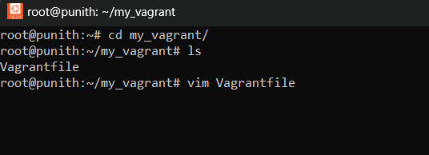

Enter the configuration.

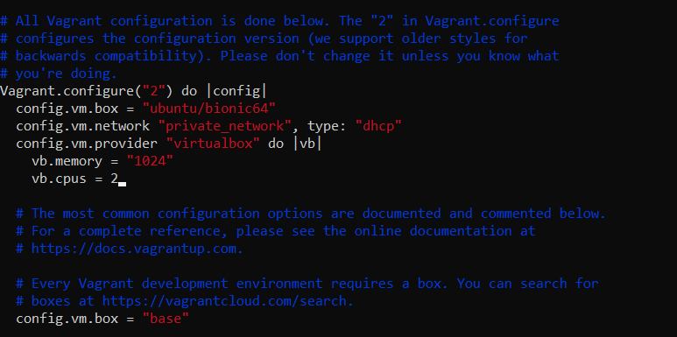

Run “vagrant up “. It creates an virtual machine .

