**Constructors**

Constructors are a special member/ special method of a class which is used to initialize data members/ variable.

**Rules**

* Constructor name should be same as class name.
* Constructors will not have any return type.
* Constructors will not have any default value.
* Constructors will always be non-static.

**Types of constructors**

constructor

User Default constructor

Parameterized

Parameterized

Default constructor

**Syntax**

Class <class_name>

{

<class_name>

{

//statement

}

Main method

}

Example

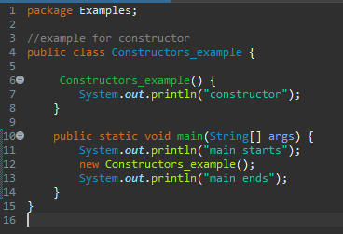

1. Write a program to print student_id and student_name using constructor

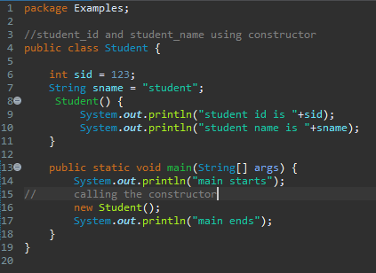

1. Write a program to print student_id and student_name using constructor and reference variable

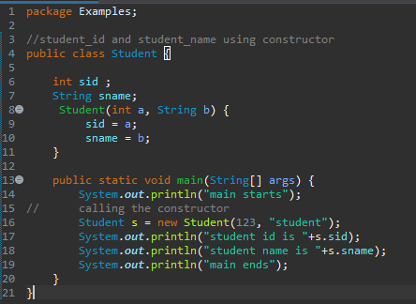

1. Write a program to initialize emp_id, emp_name, emp_sal using constructors

