**Methods**

Method is a block of statement which will get executed whenever it is called or invoked.

Syntax:

Access_specifiers modifers return_type method_name (arguments)

{

Return;

}

Access_specifiers modifers return_type method_name (arguments)

↓ ↓ ↓ ↓ ↓

Public static int //identifiers //method declaration

Private non-static char

Protected float

Default / package level double

Boolean

String

Public static void main (String arguments [])

↓ ↓ ↓ ↓ ↓

Access_ specifiers modifers return_type //identifiers //method declaration

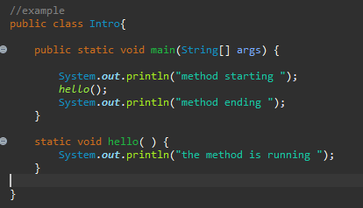

Method with parameters

Whenever we want to give input for the method then we go for method with parameters.

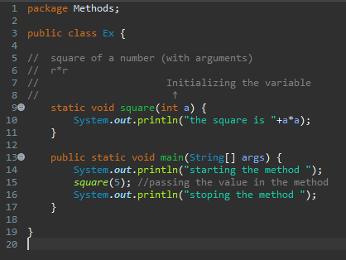

Practice examples

1. Write a program to calculate area of a circle with method with and without parameters.
2. Write a program of addition of 2 numbers, subtraction of 3 numbers and multiplication of 3 numbers.