**Variables**

Variables are named memory location which can store some value or data and can be executed whenever it is called or invoked, in variables we have 2 data types

Primitive data types

* Int
* Char
* Float
* double
* byte
* long
* short
* Boolean

Non-primitive data types

* String
* Array
* User-defined class

Syntax:

Datatype <variable name> = value

Int a = 10;

Program

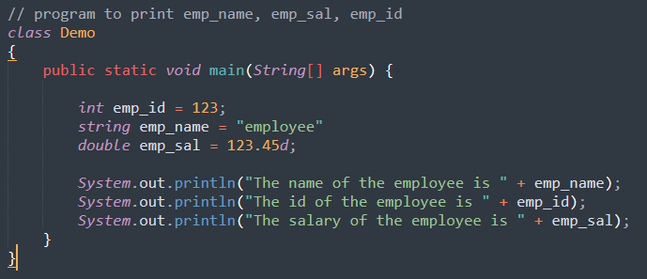

Variable are classified into 2 types

Local variable and Global variable

**Local variable:-**

* Any variable that is declared within the method is called as local variable.
* The scope of the local variable is from beginning of the method till the end of the method.
* It cannot be classified into static and non-static.
* It will have default values.
* Local variables should be initialized before utilization.

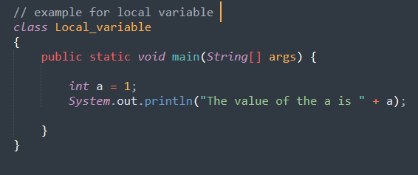

**Global variable**: -

* Any variable which is declared outside the method and inside the class is called as Global variable.
* The scope of the global variable is from beginning of the class till the end of the class.
* It can be classified as static and non-static.
* It will not have default values.
* Once the global variable are initialized immediately in the next line it cannot be re-initialized.

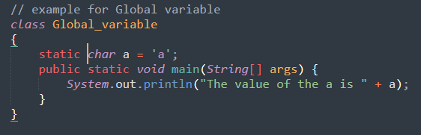

|  |  |  |
| --- | --- | --- |
| Data types | Default Value | Size |
| Int | 0 | 32 |
| Float | 0.0f | 32 |
| Double | 0.0d | 64 |
| Char | ‘/u0000’ | 1 |
| Boolean | false | 1 |
| Short | 0 | 16 |
| Long | 0 | 64 |
| Byte | 0 | 8 |

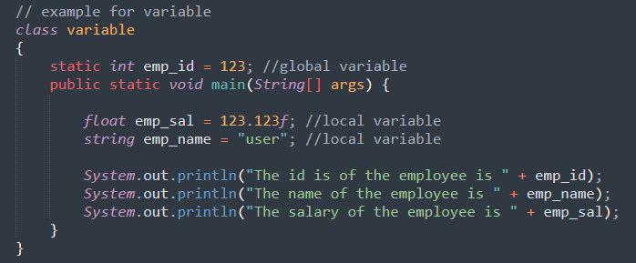

Real time examples for variables

1. Mobile cost, module name , color.
2. Car cost, module name, color.
3. School name, fee, class.