**Workday Calendar Web Application**

# Summary

Workday Calendar is the web application which is used to calculate and returns the working day from the chosen calendar date from the end user adding the Number of days to the selected date.

Conditions:

* The chosen date can be any date in the past or in the future
* The number of days can be decimal number.
* Since the workday is the unit of the application,, one day is considered as 8 hours
* No authentication

# Tech used

* C# programming Language
* .Net 8.0 framework (SDK)
* Blazor
* MS Test

# Architecture and Design Patterns

#### DDD- Domain Driven Design

DDD is design principle encovering various design patterns and approaches. DDD is based upon domain, with their subdomain and supporting domain. It has be in bounded context which mean the approach or pattern should use the same ubiquitous language as requirement

In our web application, working day calendar as the main domain

#### Singleton Pattern

**Singleton** is a creational design pattern that lets you ensure that a class has only one instance, while providing a global access point to this instance.

In our application Workday calendar is is used as single instance all over the application. Single instance for single request.

Measurement has been taken to make the web application responsive by async/await and lock to ensure to single access to the functionality at one poibt of time

#### SOLID Principe

Single responsibility

Dependency Injection

# Declarations and Features

Workday calendar allows to set the start time and end time of the working.

* Start and End time area allowed between 05:00 AM to 12:00 PM
* The difference between the start time and end time time should not more than 8 hours
* 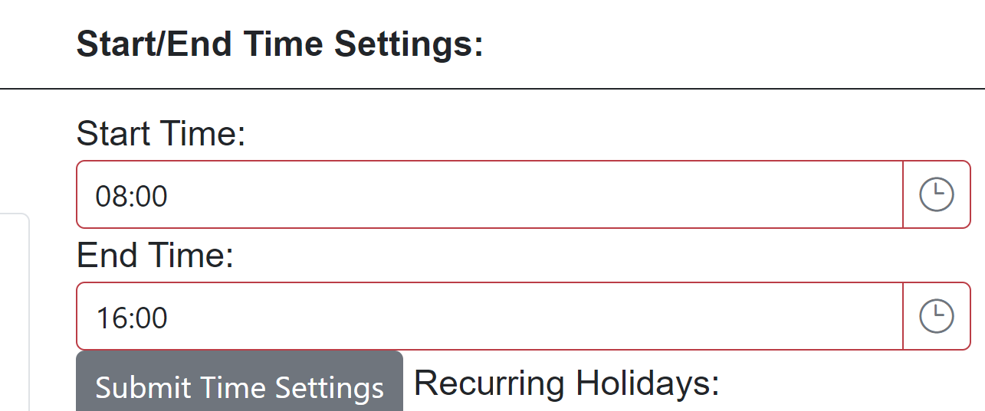

Workday calendar we application allows the end user to set the Public holidays and Recurring Holiday

* Both holidays can be chosen in Date Calendar type, from Min year 1920
* Respective option of recurring or public can be chosen from radio button as shown
* Each date has to be selected from calendar back and forth and confirmation message is seen.
* The List of public/recurring holidays can be seen in the right side of the panel which facilates the end user to verify

# Functionalities.

Date can be chosen by end user

Num of days can be entered by end user

Result is return in top of the wep page

# MS Test:

This web application consists of 12 different test cases

