Project 1: Multi region Web app implementation using Application Gateway

Step 1

**Create a Web App in Region 1 (e.g., UK South):**

In the Azure portal, search for "App Services" and click Create.

Fill in the required details (App name, Subscription, Resource group, etc.).

Choose the Region (e.g., UK South).

Deploy your web app code to this region.

Create a Web App in Region 2 (e.g., UK West):

Repeat the steps above but choose a different region (e.g., UK West).

Ensure that the same version of the app is deployed in both regions.

Test both web apps by accessing them individually through their respective URLs (e.g., app1ha.azurewebsites.net and app2-westeurope.azurewebsites.net).

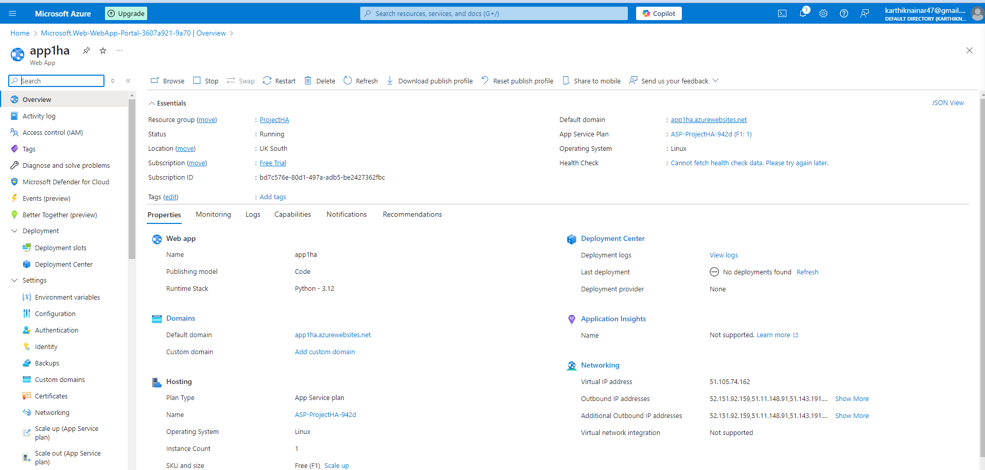

Deployed Code for webapp

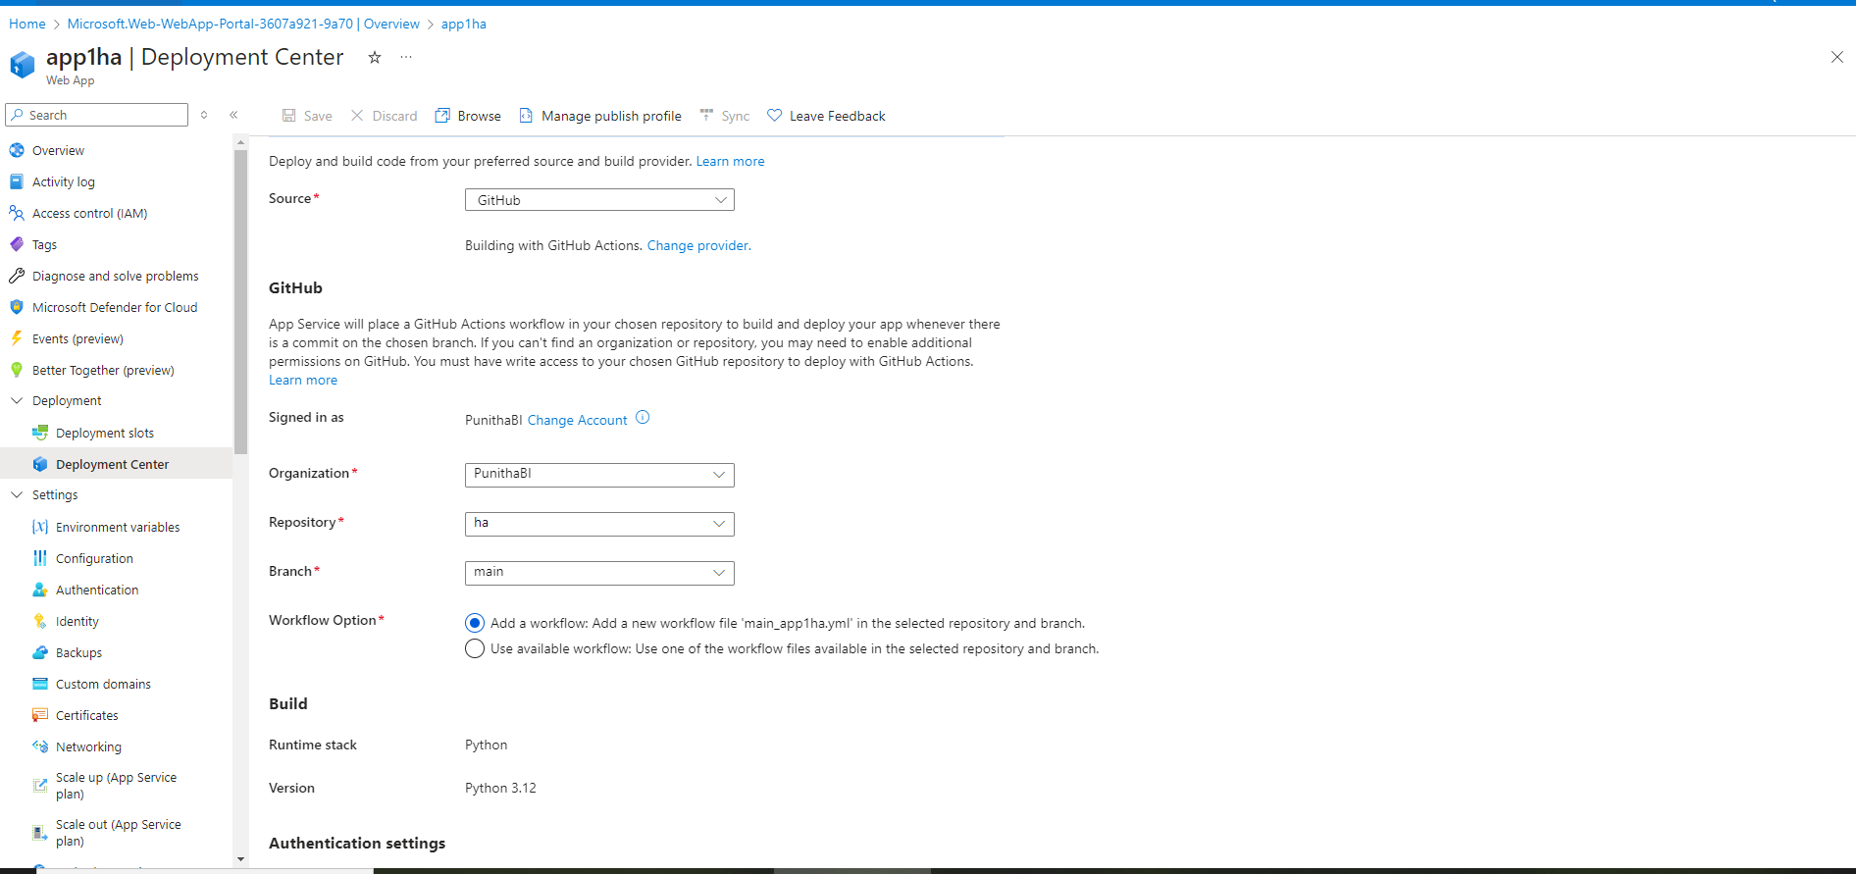

App.py

# app.py

from flask import Flask

import os

app = Flask(__name__)

# Home route

@app.route("/")

def hello_world():

return "Hello, World from Azure App Service!"

# Health check route

@app.route("/healthcheck")

def healthcheck():

return "Healthy", 200

if __name__ == "__main__":

port = int(os.environ.get("PORT", 5000))

app.run(host="0.0.0.0", port=port)

requirement.txt

Flask==2.3.2

Executed web page to test 1 and 2

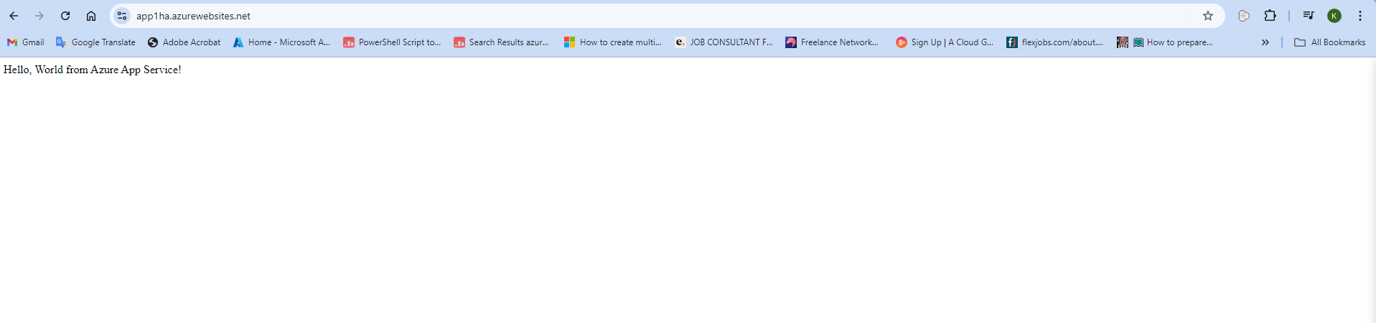



**2. Create Azure Traffic Manager Profile**

The Traffic Manager will route users to the nearest or best-performing region.

Steps:

In the Azure portal, search for "Traffic Manager Profiles" and click Create.

Fill in the following details:

Name: Choose a name for the Traffic Manager profile.

Routing Method: Select a routing method based on your needs:

Performance: Routes users to the region with the lowest latency.

Priority: Routes users to a primary region and fails over to secondary if the primary is down.

Geographic: Routes users to a region based on their geographic location.

Weighted: Distributes traffic between regions based on weights you specify.

Resource Group: Select or create a resource group.

Subscription: Choose your Azure subscription.

Click Create.

After the Traffic Manager profile is created, add Endpoints for your web apps:

Go to the Traffic Manager Profile you just created.

Under Settings, click Endpoints.

Click Add and select Azure Endpoint.

Choose the first web app (e.g app1ha.azurewebsites.net).

Repeat the steps for the second web app (e.g., app2ha.azurewebsites.net).

Configure Health Probes (optional but recommended):

Go to the Configuration tab of the Traffic Manager Profile.

Adjust Health probe path (e.g., /healthcheck endpoint of your app) and the frequency to monitor the app's availability.

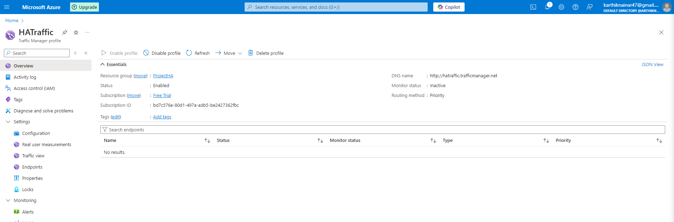

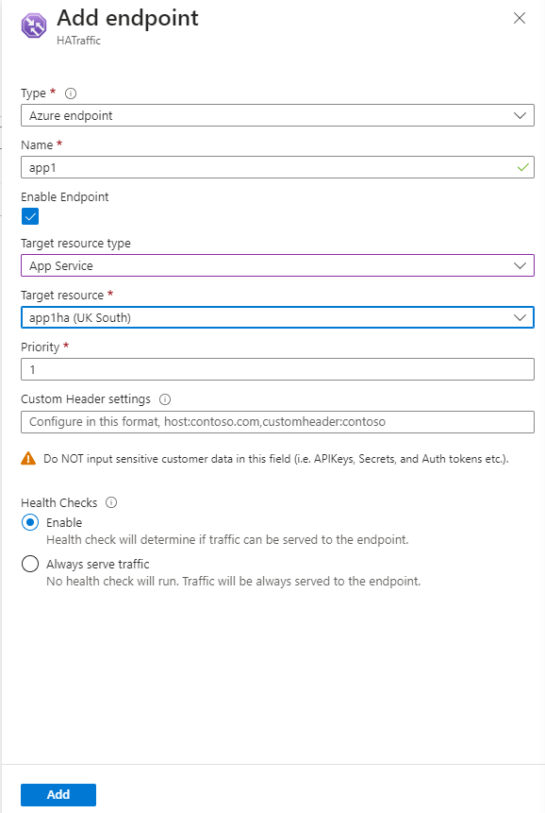

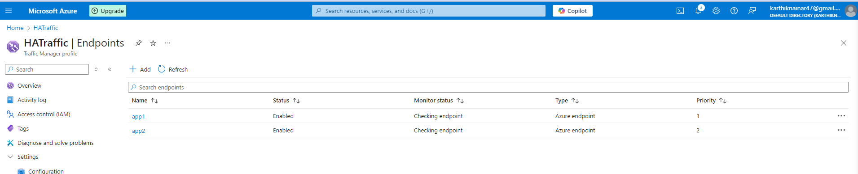

**3. Create Application Gateway in Each Region**

Within each region, Application Gateway will provide advanced traffic management, such as SSL termination, URL-based routing, and Web Application Firewall (WAF) features.

Steps for Region 1 (UK South):

In the Azure portal, search for "Application Gateways" and click Create.

Fill in the following details:

Name: Provide a name for your Application Gateway (e.g., APG1).

Tier: Choose the appropriate tier (Standard, WAF, or Autoscaling).

Region: Select the same region where your web app is deployed (e.g., UK South).

Virtual Network: Create a new virtual network or select an existing one. This virtual network should contain your web app backend servers.

Frontend IP: Choose either Public IP or Private IP based on your needs.

Backend Pool: Add your web app (e.g., Back1) as a backend pool.

Routing Rule: Create a routing rule that defines how traffic is forwarded to the backend (based on path, HTTP headers, etc.).

Click Create to deploy the Application Gateway.

Repeat these steps for Region 2 (UK West):

Create another Application Gateway (e.g., APG2) and add the second web app as a backend pool.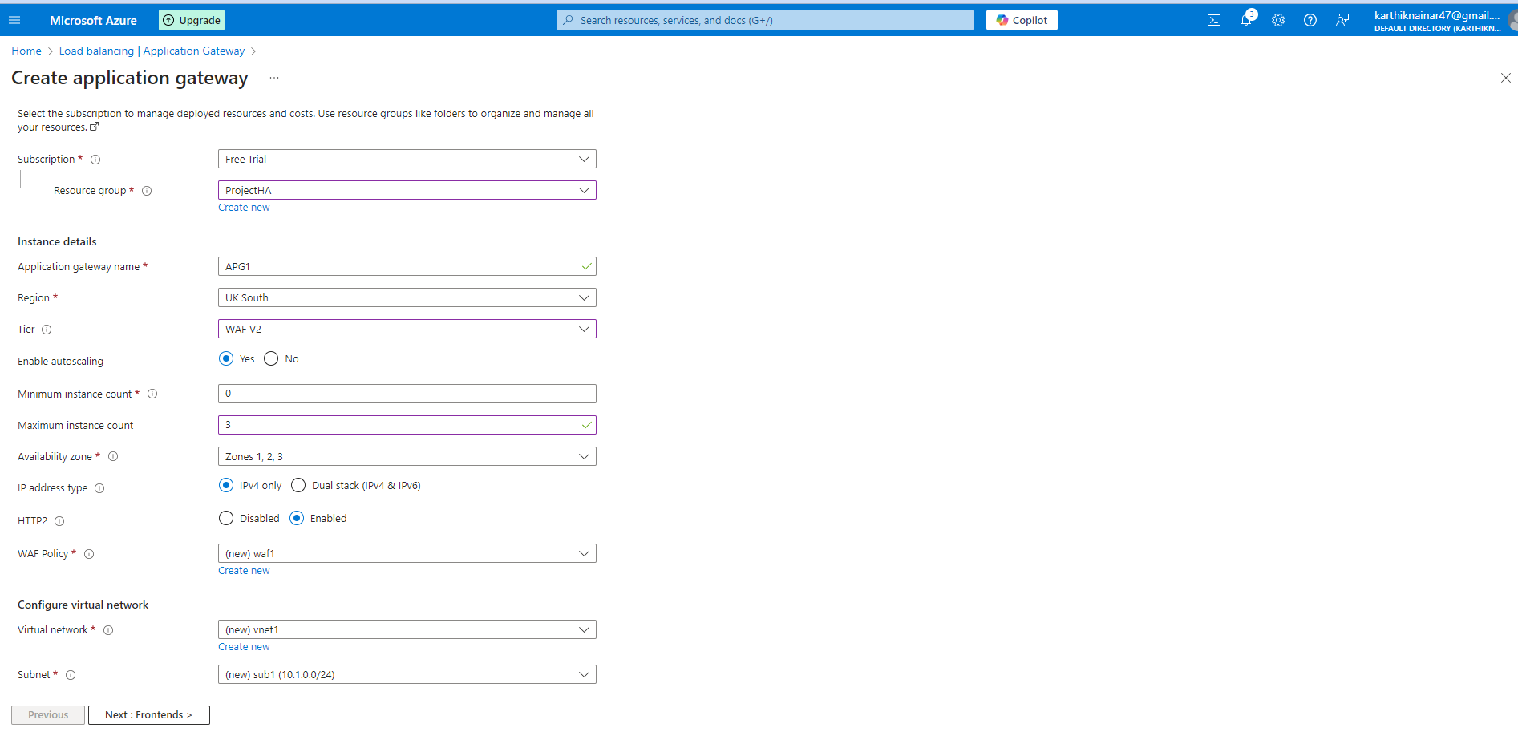

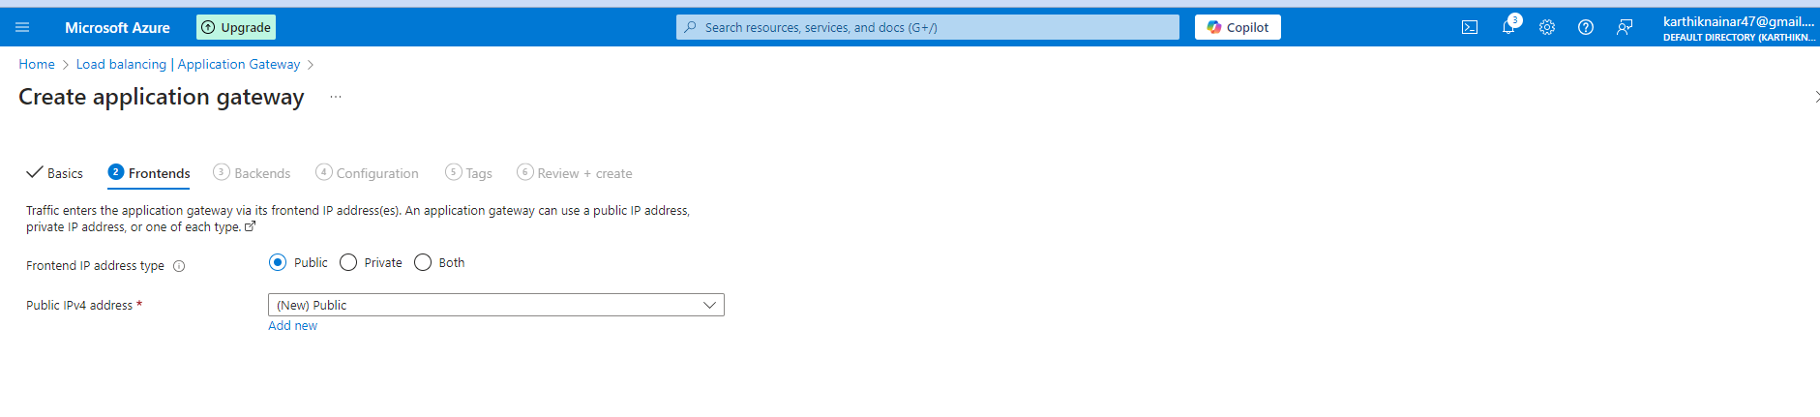

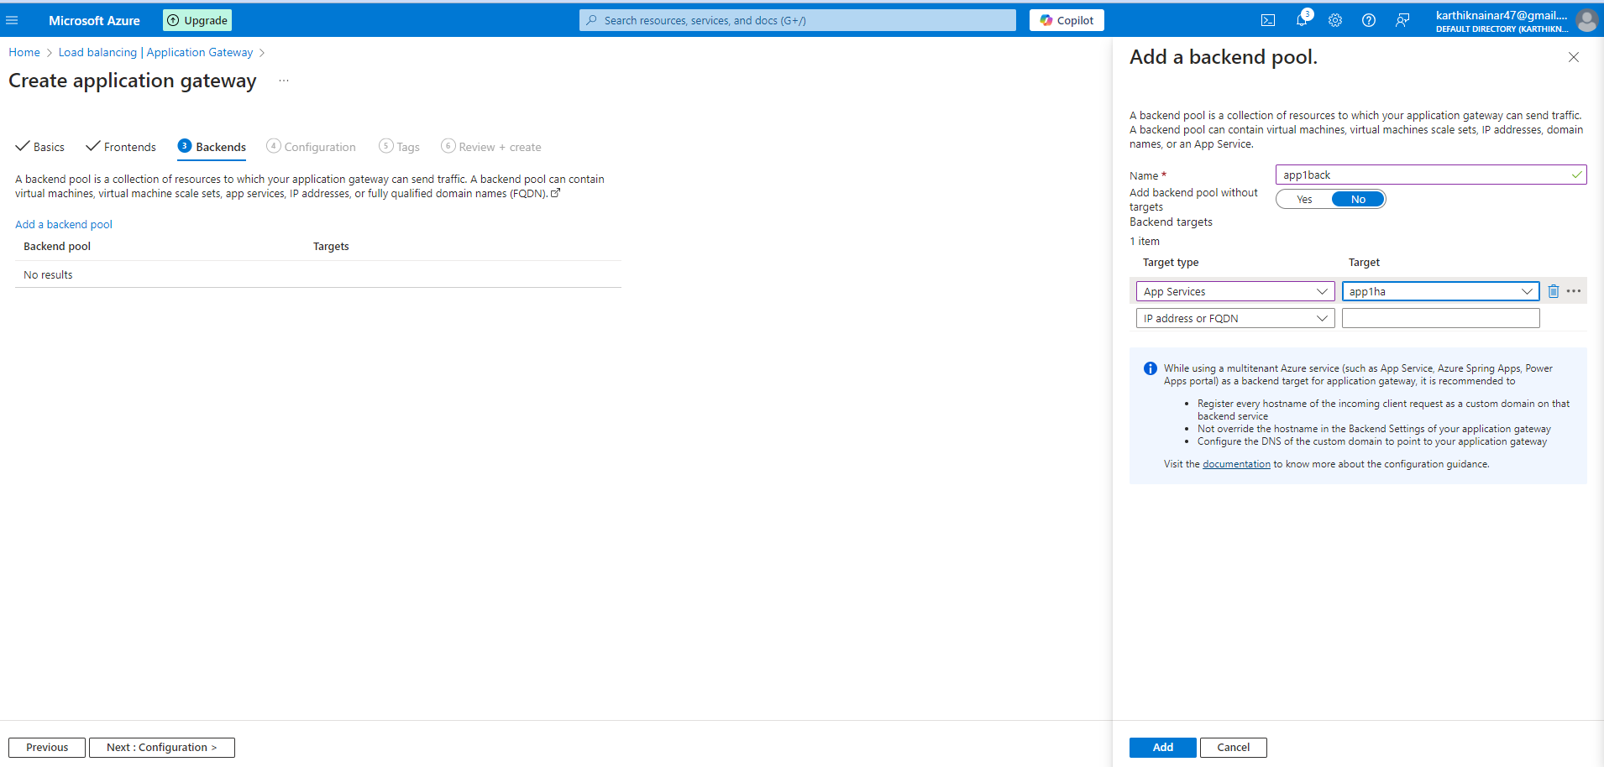

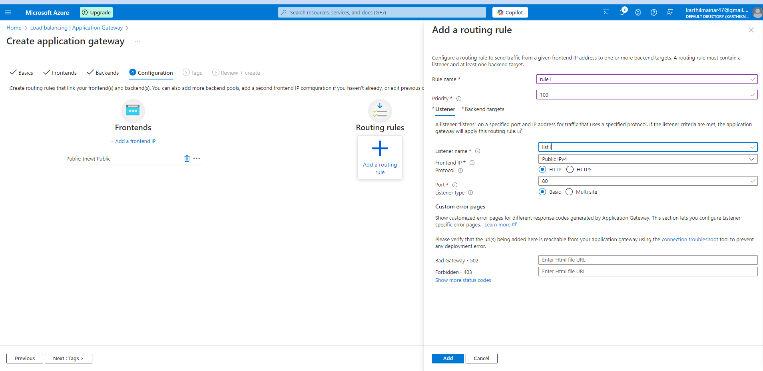

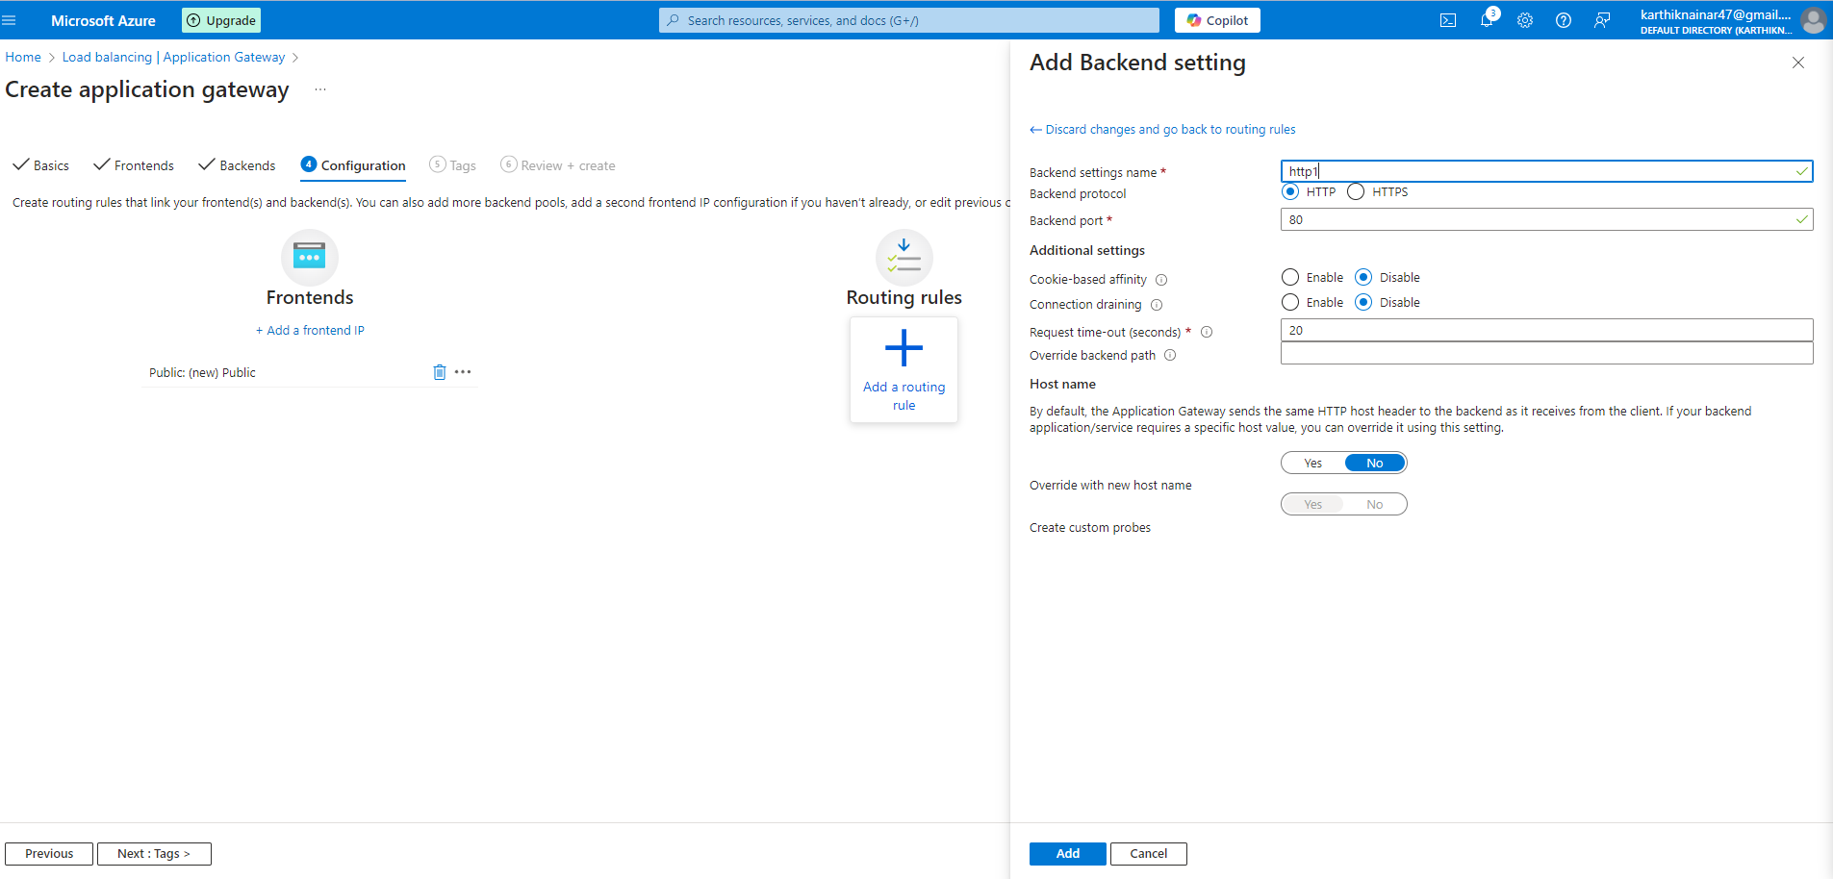

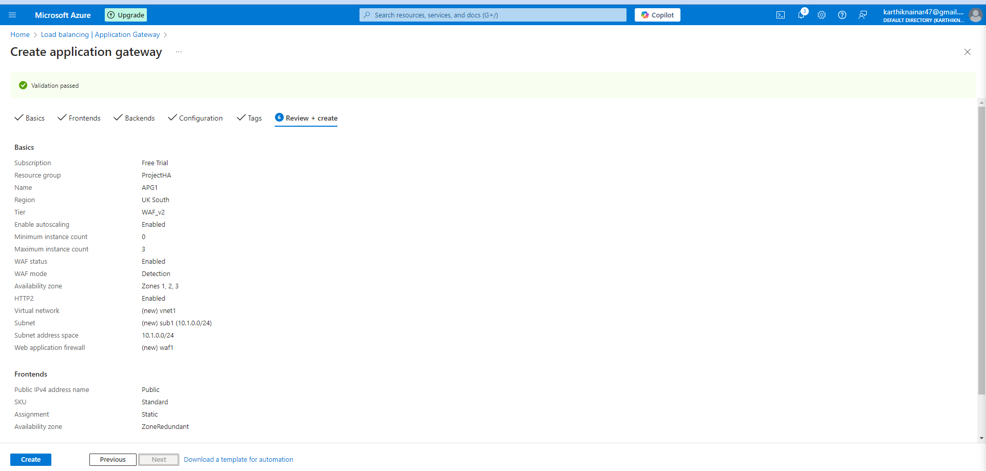

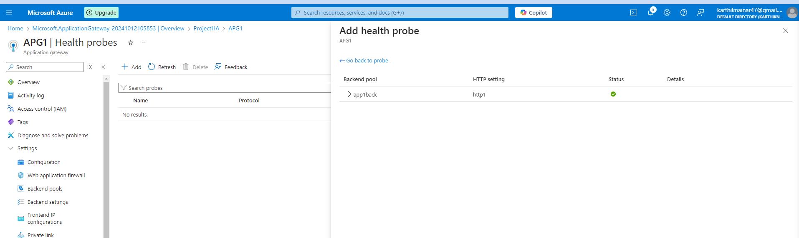

**4. Configure Application Gateway Backend Pools**

For each Application Gateway, ensure that the backend pools point to your web apps in the respective regions.

Steps:

After the Application Gateway is deployed, navigate to the Backend Pools section.

Add the Web App (e.g., app1-eastus for the East US Application Gateway) to the backend pool.

Set up HTTP Settings such as enabling SSL termination, configuring health probes, and setting up custom domains if needed.

Repeat the same steps for the second region’s Application Gateway.

**5. Integrate Traffic Manager with Application Gateway**

Once both Application Gateways and Web Apps are deployed, you need to ensure that Traffic Manager directs traffic to the Application Gateways instead of directly to the Web Apps.

Steps:

Go to the Traffic Manager Profile you created earlier.

Remove the individual Web App endpoints (if necessary) and add Application Gateway endpoints:

Add the Public IP of the Application Gateway for Region 1 (East US) as an endpoint.

Add the Public IP of the Application Gateway for Region 2 (West Europe) as an endpoint.

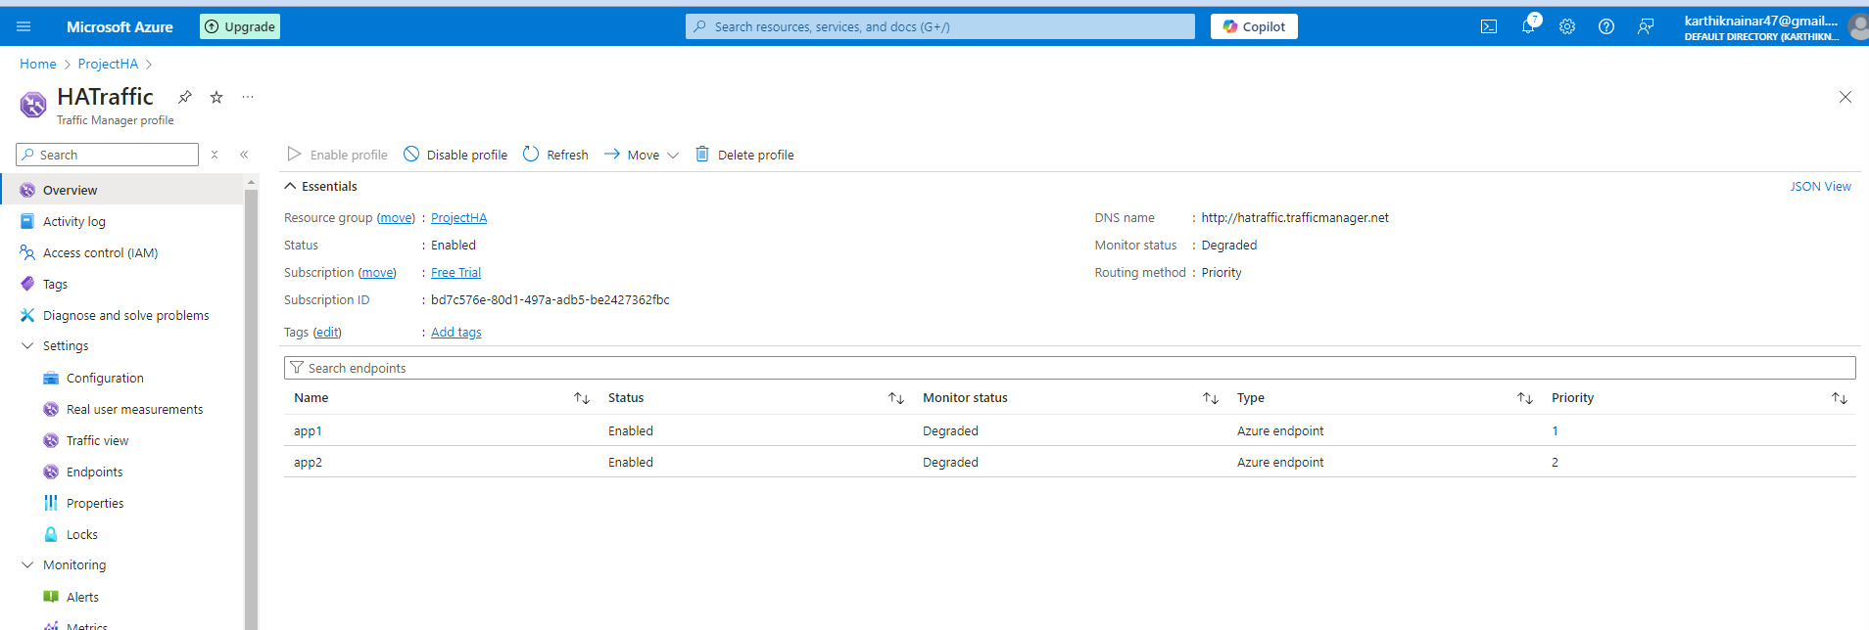

1. **Query the Default Azure Domain**

nslookup app1ha.azurewebsites.net

2. **Query a Specific Record Type**

o query **A records** (IP addresses):

nslookup -type=A app1ha.azurewebsites.net

To query **CNAME records**:

nslookup -type=CNAME app1ha.azurewebsites.net

To query **MX records** (for mail servers):

nslookup -type=MX app1ha.azurewebsites.net

Use a Specific DNS Server

By default, nslookup queries the DNS server that your system is configured to use. You can specify a different DNS server by appending the server address at the end of the command.

For example, to query Google's public DNS (8.8.8.8):

nslookup myapp1ne.azurewebsites.net 8.8.8.8

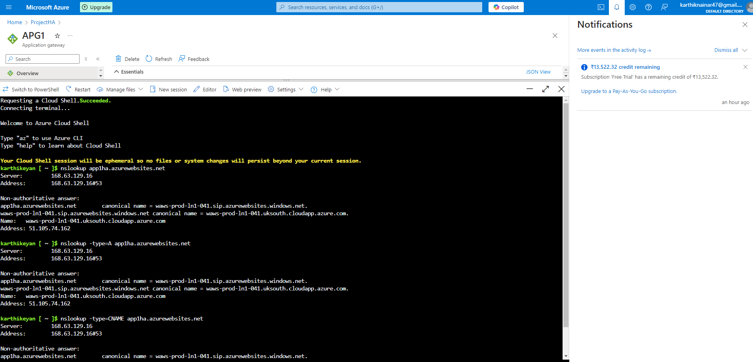

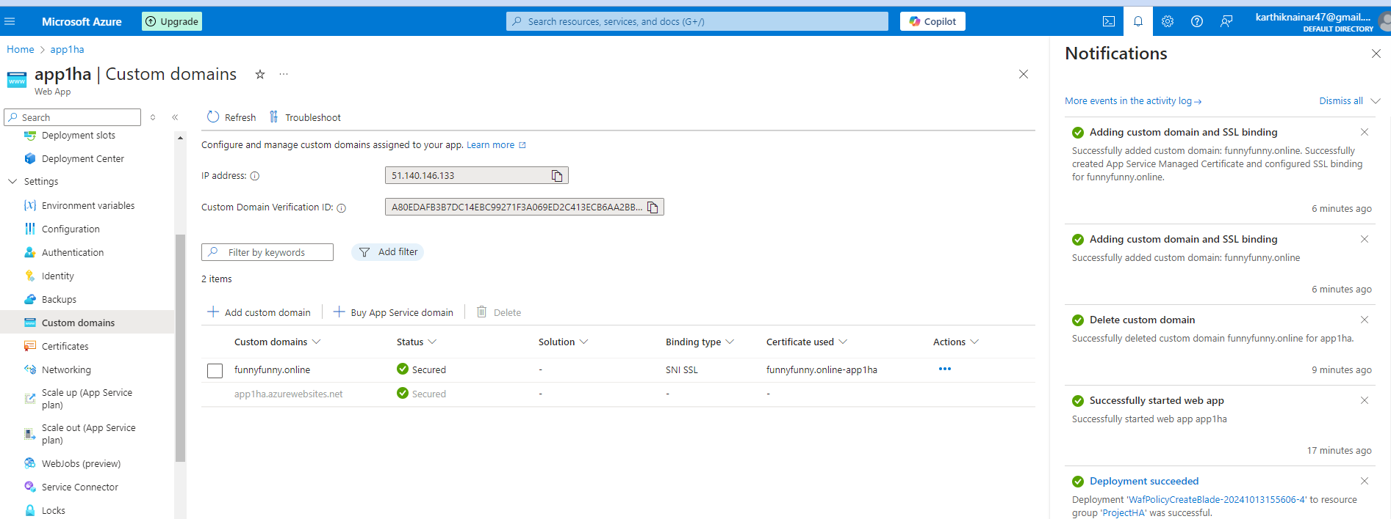

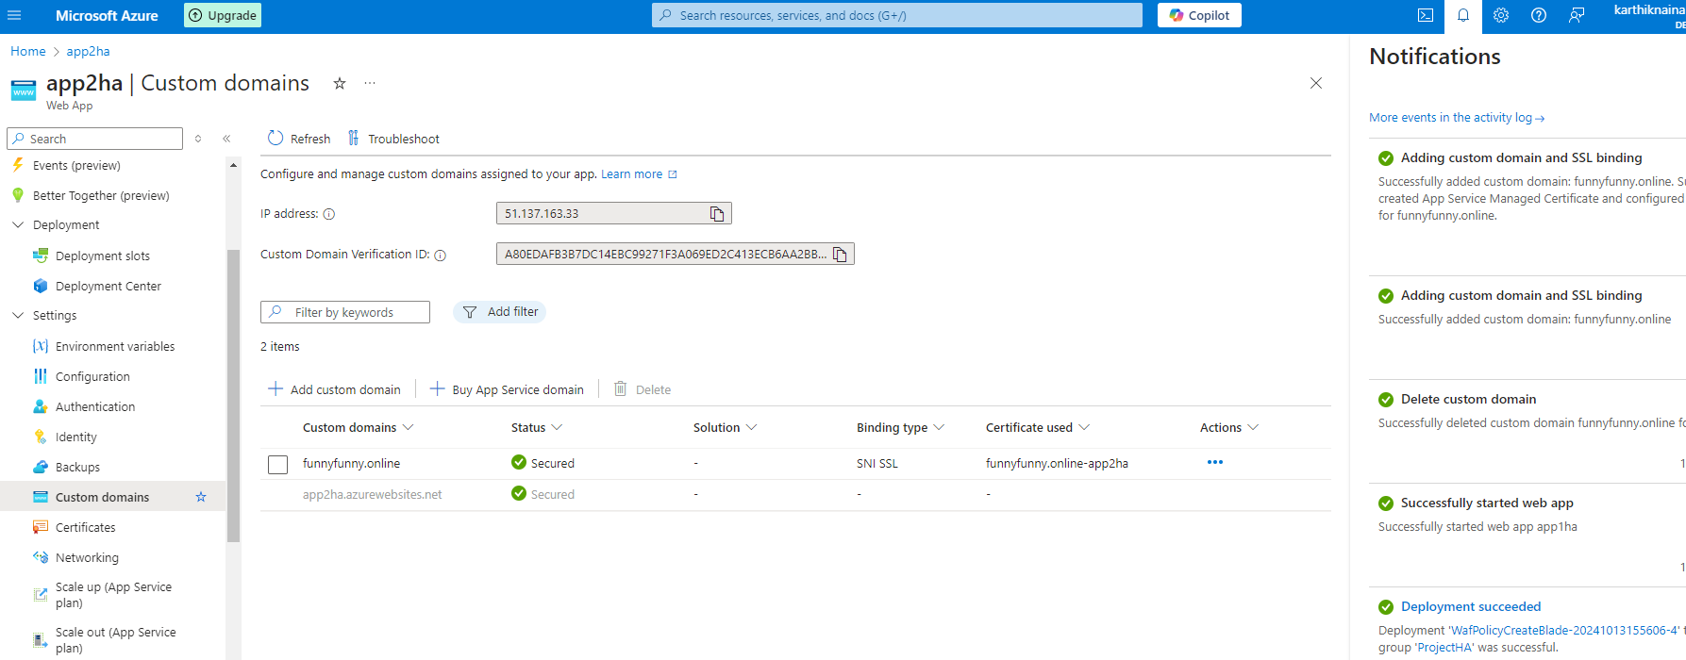

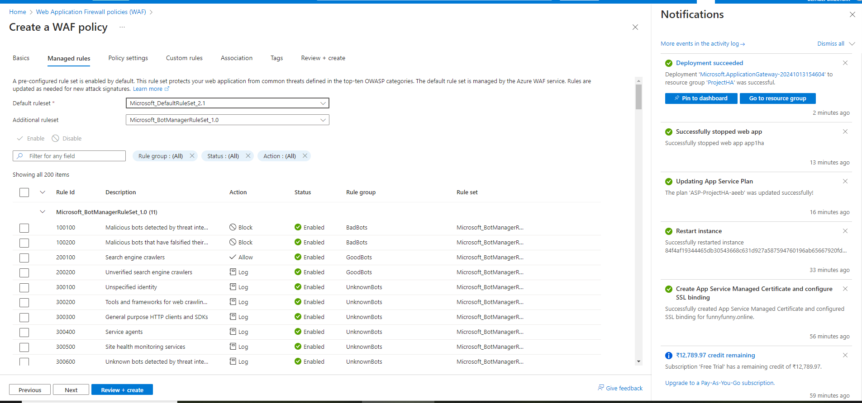

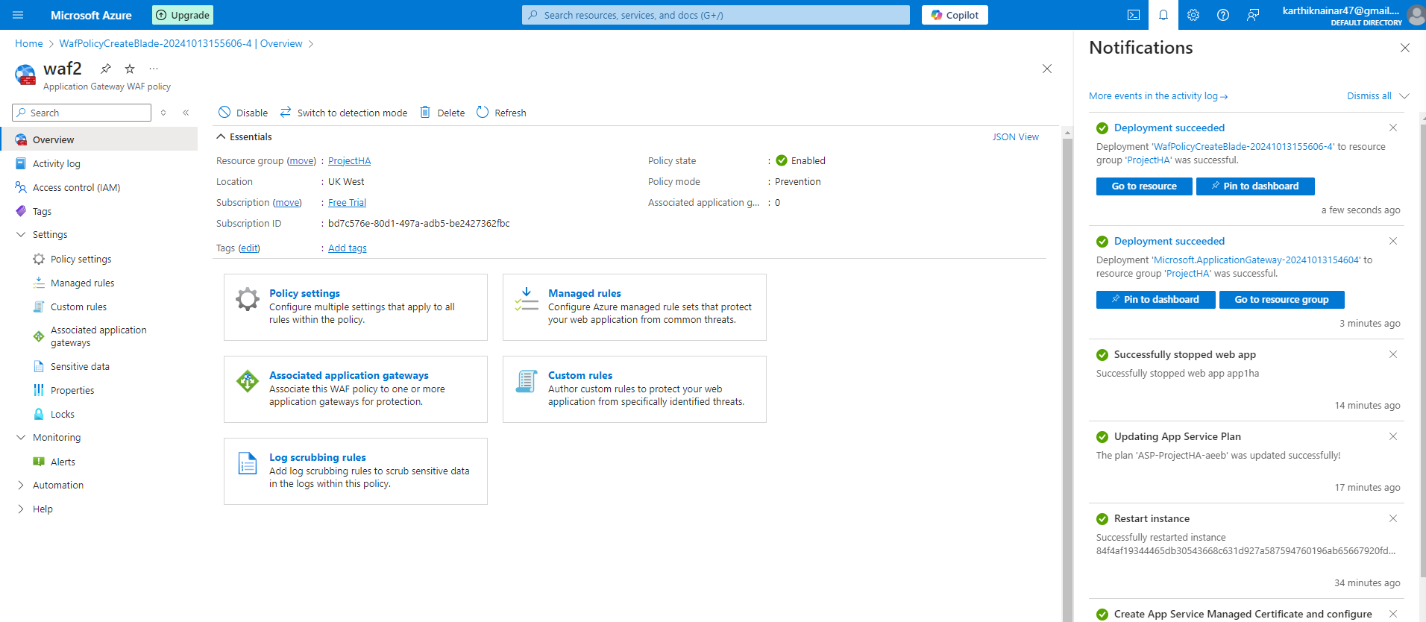

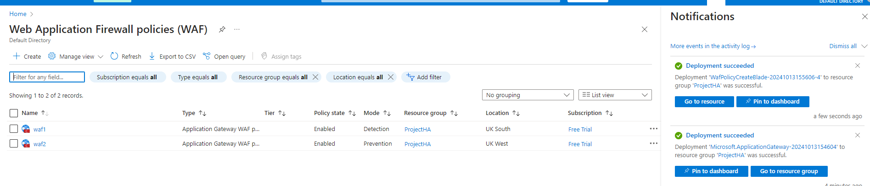

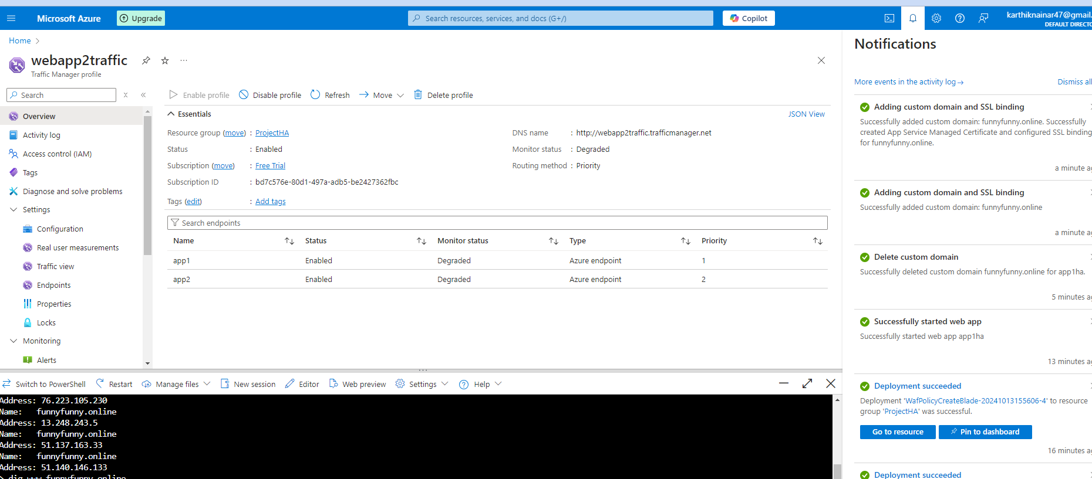

Conclusion:

By following these steps, you’ll have a highly available, globally distributed web app architecture where Azure Traffic Manager handles the global traffic routing between regions, and Application Gateway manages the regional traffic distribution within each region.