Research Contribution to be considered for the Sun Pharma Award
A Shift of Balance from Anti-inflammatory to Pro-inflammatory Immune Response by miRNA and Interacting Proteins in Mammalian Host: A Strategy to Combat the Drug Resistant form of the Pathogen Leishmania donovani

Suvendra N. Bhattacharyya
CSIR-Indian Institute of Chemical Biology, Kolkata, INDIA

Summary
The kinetoplastid protozoan Leishmnia donovani (Ld) infects host tissue macrophages of liver and spleen. The pathogen affects expression of genes in the host and also in the neighbouring cells to ensure an anti-inflammatory response essential for pathogen survival. We have identified how the anti-inflammatory response has been ensured by the pathogen during the infection by targeting the miRNA pathway components. Proteins HuR and PP2A have been identified by us as agonist and antagonist of inflammation in infected macrophage respectively that act primarily through miRNA-inactivation and reactivation mode to control expression of inflammatory cytokines in macrophage cells. The pathogen Leishmania targets both proteins to augment miRNA-mediated gene suppression and ensure anti-inflammatory response in infected macrophage cells. Simultaneous upregulation of HuR and inhibition of PP2A has been found to be effective in curing the host from antimonial drug resistant form of Ld.
Interestingly, simultaneous reduction of miR-122 in hepatocytes is consistent with a loss of serum cholesterol regulated by the same miRNA in mammalian host upon Ld infection. Cholesterol is important for Ld for its survival and, by reducing miR-122, the parasite downregulates cholesterol level in the infected animals. We have identified the mechanism of Ld-mediated reduction in miR-122 content and have established the anti-infection activity of miR-122. We also have documented the effectiveness of miR-122 treatment to cure the deadly pathogen from infected mouse liver. miRNA-mediated gene regulation in metazoan
miRNAs, the small 21-25 nucleotide non-coding RNAs, regulate gene expression in plants and animals by base pairing to their target genes and negatively regulate gene expression post-transcriptionally. Originally discovered in the nematode C. elegans, miRNAs show tissue specific expression pattern during different phases of animal development . Nascent miRNA transcripts (pri-miRNA) are first processed by the Nuclear RNase Drosha into ~70 nucleotide precursors (pre-miRNA) which are then exported from the nucleus into the cytoplasm by Exportin 5 and are further processed by the RNaseIII enzyme Dicer to generate ~21-25 nucleotide mature miRNAs . miRNAs are incorporated into AGO proteins to form ribonucleoprotein complexes called miRISCs (Figure1).
In mammals, miRNAs are predicted to control the activity of more than 50% of all protein-coding genes and participate in the regulation of almost every metabolic processes investigated to date. Bioinformatic predictions also indicate regulation of more than 50% of all protein-coding genes by miRNAs in mammalian hosts . Changes in expression of miRNAs are observed in, and might underlie, various human pathologies including cancer . Along with miRNAs, factors that are required for the biogenesis of miRNAs have also been associated with various diseases and might themselves function as tumour suppressors and oncogenes.
Macrophages : first line of defence against invading microbes
Although macrophages are capable of engulfing the invading pathogens and killing them , but there are certain microbes that may fool the macrophages by tampering with their signalling pathways which in turn are responsible for activation of macrophage defence mechanism. These complex mechanisms conducted by the invaders within host cells render the inactivation of the host immune system. This also helps the microbes to survive and propagate within the host cells and system.
Leishmania donovani, the protozoan parasite, is the causative agent of the deadly visceral leishmaniasis in humans. The parasite gets into the macrophage through host phagocytic activity and lives within the parasitophorous vacuoles, a special class of endosomal structures that get matured but do not get fused to lysosomes in infected cells through an unique strategy adopted by the internalized pathogen to prevent its own killing by host lysosomal machineries . Therefore, it can live and replicate within the host macrophages without being destroyed by the host immune system .

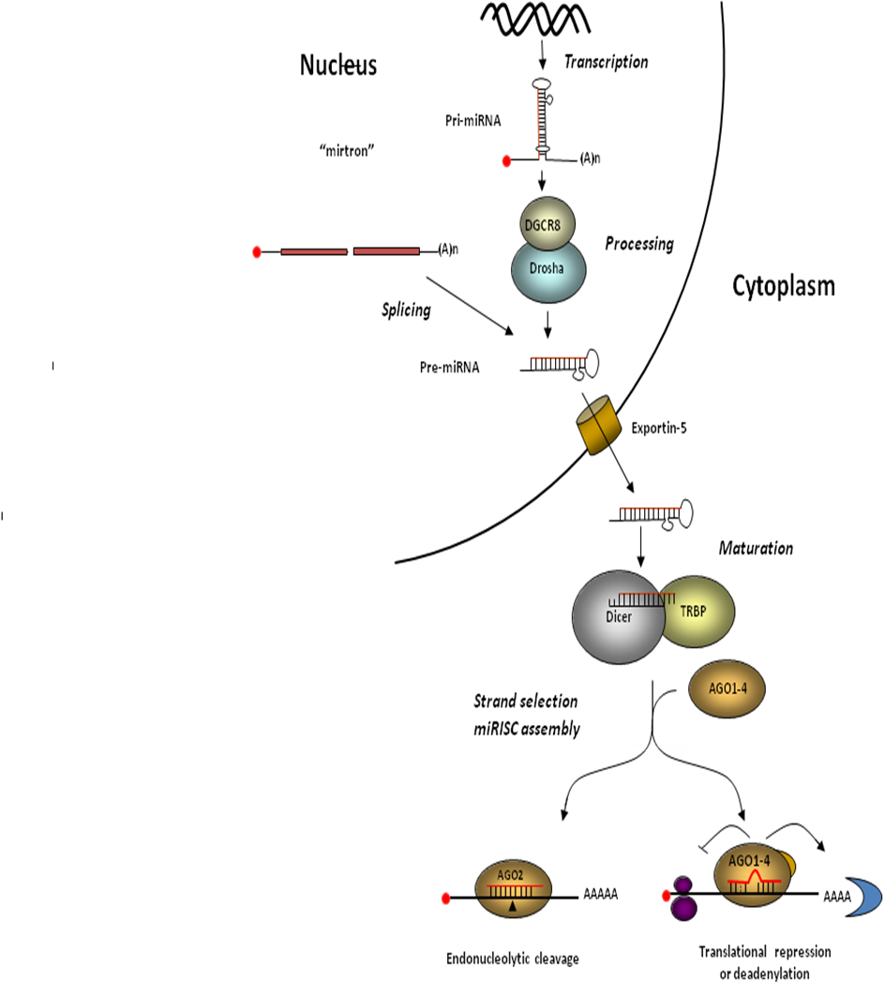

Figure1 miRNA processing and miRNP/miRISC formation in mammalian cells

The Leishmania-invaded macrophage, therefore remains immunologically dormant all along the infection process as its defence machineries are locked down by the selective action of complex molecules secreted by the pathogen . To impair the acquired immunity of the host, Leishmania prevents processing of the pathogen-derived antigens and its presentation by infected macrophage or dendritic cells on their surface as part of MHC complex for antibody production . On the other hand, in order to prevent the killing of the internalized pathogens, the pathogen also ensures reduction in production of nitric oxide and reactive oxygen species in invaded cells . Further, by inactivating the p38/MAPK-driven NF-kβ signalling, the transcription of the pro-inflammatory cytokine encoding mRNAs is compromised while production of anti-inflammatory cytokines like IL-10 gets enhanced in Leishmania - invaded macrophages .
The balance between pro- inflammatory and anti-inflammatory cytokine production is a complex and robust process that involves extensive task and complicated crosstalk between cellular signalling machineries. It is primarily controlled by several kinases and phosphatases which in turn regulate the transition of activated–deactivated states of cellular signalling components. Leishmania is known to control many of these kinases and phosphatases that are involved in determining the balanced expression of both pro- and anti-inflammatory cytokines .

Role of miRNAs in controlling the innate immune system of eukaryotes
miRNAs are responsible for keeping the cytokine production in check by controlling the cytokine gene expression at post-transcriptional levels and thus play a pivotal role in regulation of both pro and anti-inflammatory cytokine response. It is very interesting to note that different miRNAs control the immune response in mammals by harmonizing the origination and maintenance of different humoral cells, including macrophage . Macrophage clear the invading pathogens primarily by inducing the expression of proinflammatory cytokines and nitric oxide production . In absence of any stimulus, miRNAs control the cytokine production in immune cell so as to prevent uncontrolled cytokine production. Hence, miRNAs also save the cells from cell death that could have otherwise resulted from the unnecessary, robust cytokine production , thereby ensuring an optimal inflammatory response .
Interestingly, it has also been reported that the phosphorylation of the protein Ago2 is reason behind this transient derepression of target mRNAs,, which is the important component of microribo- nucleoprotein complexes. Ago2’s association with miRNAs in its dephosphorylated form is necessary for miRNA activity . Ago2 phosphorylation, leads to impaired binding of the protein with miRNAs and to the corresponding target mRNAs. This has been verified in macrophages expressing a mutant, of Ago2, incapable of undergoing phosphorylation. This mutant remains bound to miRNAs during macrophage activation and have a weakened pro-inflammatory response on macrophage stimulation .
Remarkably, it is to be noted that the defective derepression of miRNA-targeted pro-inflammatory cytokine mRNAs at initial hours of macrophage activation eventually is responsible for the poor resistance of host macrophages against invasion of the pathogenic parasite Leishmania donovani. During infection, it has been reported that Leishmania upregulates the binding of Ago2 with miRNAs .

Protein Phosphatase responsible for dephosphorylating phospho-Ago2

A very recent study has identified Protein phosphatase 2A to be the potential candidate phosphatase that acts on phosphorylated Ago2 to reactivate it in prolonged LPS-treated cells. Moreover, phosphorylated Ago2 that undergoes PP2A-mediated dephosphorylation effectively acts as the substrate for subsequent de novo miRNA loading during late phase of LPS treatment of mammalian macrophages.

As PP2A specifically dephosphorylates Ago2 at Y529 position and phosphorylation at Y529 position of Ago2 is known to cause miRNA unbinding, therefore it should be effective in controlling miRNA-Ago2 binding . Thus, phosphorylation–dephosphorylation cycle of Ago2 controls miRNP recycling and de novo miRNP formation. Interestingly, PP2A is a serine-specific phosphatase, therefore it should act on proteins with a phosphorylated serine. However, PP2A is also known to act on phosphotyrosine in the presence of an adaptor protein Phosphotyrosyl phosphatase activator (PTPA). PTPA enables PP2A to dephosphorylate Tyrosine . Hence, PP2A requires PTPA for dephosphorylation of Ago2 .
During, Ld infection, the pro-inflammatory cytokine production of the host macrophage is inhibited by the pathogen so as to dodge the host immune response. This can be easily achieved by ensuring miRNP-mediated gene repression of target pro-inflammatory cytokine encoding mRNAs in infected cells. This, in turn can be achieved by keeping the phosphorylation of Ago2 at minima. Protein phosphatase 2A upregulation in Leishmania-infected macrophages lowers the phosphorylated Ago2 level and ensures robust repression of pro-inflammatory cytokines, which is necessary for the parasite survival and infection process.
Ld upregulates PP2A to promote anti-inflammatory responses . A recent study corroborates with their finding and has further detected an increase in the production of IL-10, the hallmark anti-inflammatory cytokine expressed in Ld-infected mammalian macrophages. They have also shown that depletion of PP2A by siRNA or its inhibition by Okadaic acid resulted in downregulation of IL-10 production in Ld-infected cells. There was also increased production of pro-inflammatory cytokine IL-6 both at mRNA and protein level. Interestingly, internalization of the pathogen was reduced in the presence of siPP2A. Thus, Protein phosphatase 2A-mediated stabilization of miRNPs facilitates anti-inflammatory response and Ld infection observed in mammalian macrophages (Goswami et al 2020).

HuR : the miRNA antagonist and promoter or inflammatory response
miRNA function is challenged by a mighty RNA-binding protein called ELAVL-1 (Embryonic Lethal Abnormal Vision – Like RNA binding Protein 1) or Human Antigen R i.e., HuR. This ubiquitously expressed protein is primarily nuclear-based but shuttles to cytoplasm via a nuclear localisation signal, when the cell is subjected to stress that includes infection related stimulation. HuR has three RNA binding domains – RRM I , RRM II, RRM III and a hinge region connecting the RRM II and III. Interestingly, RRM I and II are known to bind with the target messages and have strong affinity for the AU-rich elements (ARE) present in the 3’ UTR of the target mRNAs . Therefore, there are there are three very interesting aspects of HuR-mRNA binding -a. HuR only binds to those mRNAs that have AREs in their 3’ UTR , b. Both HuR and miRNAs bind on 3’ UTR of target mRNAs but their binding sites are distinct keeping the interaction mutually exclusive and c. HuR polymerizes forming dimers or even multimers after binding with the target thereby spreading upon the 3’ UTR to cover up the miRNA binding sites. This property of self-polymerization enables HuR to kick out the bound miRNAs and relieve the target mRNAs from miRNA-mediated repression of gene expression and facilitate the translation of the corresponding protein that including the cytokines with HuR binding sites .
Extracellular Vescicles (EVs) or Exosomes: Extracellular carrier of miRNA
To cut a long story short, miRNAs and HuR are antagonistic in function as miRNA represses gene expression whereas HuR relieves the target genes from miRNA-imposed repression and facilitates translation of the cytokines and other proteins. Interestingly, it has earlier been reported in hepatic cells and cancer cells that the protein HuR is also known to bind with the Ago2-replaced miRNAs. The mechanistic study in amino acid starved hepatic cells has shown that this binding occurs via its RRM III and the HuR protein navigates the miRNAs to the multivescicular bodies from the sites on endoplasmic reticulum. Subsequently, HuR unbinds itself from the miRNAs upon its ubiquitination and mediates the packaging of the miRNAs into 100 – 200 nm sized extracellular vescicles or exosomes . These are bodies that are formed by fusion of multivescicular bodies with plasma membrane and are shed into extracellular space for cell-to-cell communication. A recent study has shown that apart from stabilising the AU-rich element containing cytokine mRNAs and relieving them from from miRNA-induced repression so that translation is facilitated, HuR also mediates the extracellular export of the replaced miRNAs in stimulated macrophages. HuR binds with the miRNAs and eventually help in their export via extracellular vesicles. As this, HuR-mediated phenomenon is necessary and sufficient for pro-inflammatory immune response in mammalian macrophages, therefore HuR plays a two-fold vital role in regulating the inflammation process to occur in eukaryotes .
Leishmania downregulates HuR to to reduce pro-inflammatory cytokine production

The effect of HuR on cytokine mRNAs and miRNAs favours the proinflammatory response of the macrophage. It has been reported earlier that in Ld-infected cells the parasite affects the accumulation of miRNPs in the ER-associated fraction possibly to restrict miRNA export . On the other hand, during pro-inflammatory response, miRNAs are decoupled from Ago2 due to its phosphorylation and get exported out of the cells in a HuR-dependent manner . HuR also plays a vital role in miRNA-Ago2 uncoupling . Therefore, in order to ensure a retarded miRNA export and poor pro-inflammatory response, the parasite targets the protein HuR .
From an extensive bioinformatics analysis on the expression status of probable HuR target mRNAs in Ld-infected human macrophages, it is evident that certain HuR targets that could be upregulated on HuR knock-down were also found to be upregulated in Ld- infected human macrophages. Similarly, certain HuR targets that were found to be downregulated on HuR knock-down were also found to show reduced expression in Ld-infected isolated human macrophages .
Interestingly, a recent study has delineated the plausible mechanism of HuR downregulation by the Leishmanial parasite. The protein gets cleaved in Ld -infected macrophage cells. Remarkably, not only Leishmani donovani but also L.major and L. mexicana also showed HuR level reduction in PEC or mouse macrophage RAW 264.7 cells upon infection. The decrease in HuR level could be arrested by using proteasome inhibitor MG132. This eventually rescued the mRNA level of pro-inflammatory cytokine TNF-α. Further, this report also states some interesting informations about the spacio-temporal aspects of this Ld-mediated loss of HuR. In Ld-infected cells, HuR downregulation occurs primarily from the endoplasmic reticulum (ER) and polysome attached fraction.
When RAW 264.7 cell lysate was incubated with Ld lysate (SLA), similar degradation of HuR was documented and this can be blocked by Zn²⁺ chelator ortho-phenanthroline (OPT) which suggests the plausible role of the most important Leishmanial Zn-metalloprotease GP63. Leishmanial GP63 cleaves cellular HuR protein to ensure not only robust infection but also downregulation of pro-inflammatory cytokine production in invaded macrophages . A previous interesting report had also suggested the role of this eminent Zn-metalloprotease in the cleavage of Dicer1, thereby disrupting miRNA biogenesis in Ld-infected hepatic cells .I a recent report, it has been shown that the purified GP63 targets the cleavage of recombinant His-tagged HuR or cellular HA-HuR in RAW 264.7 cell lysate and this can be inhibited by Zn²⁺ chelator OPT. Further, it has also been shown via treatment of RAW 264.7 cells with liposomes containing purified GP63 that the Zn-metalloprotease alone is sufficient to directly cause HuR degradation .

Crosstalk between the miRNA-activity modulator proteins PP2A and HuR
During Ld infection, PP2A production increases whereas HuR, the negative regulator of PP2A, is downregulated by the pathogen, This is perhaps to ensure robust anti-inflammatory response observed in infected macrophage cells. However, HA-HuR-expressing cells, PP2A mRNA level decreases which in turn also decreases PP2A protein level. On the other hand, Ld infection induces upregulation of PP2A both at protein and mRNA levels and enhances the miRNA-mediated repression of proinflammatory cytokines (Goswami et al 2020). Therefore, it is likely that both HuR and PP2A, by inversely regulating miRNP machineries targeting the pro-inflammatory cytokines in host cells, can effectively yet reciprocally regulate the inflammatory immune response of macrophage cells.
A relevant pathway analysis has identified probable regulatory mechanisms between HuR and PP2A and determined the common targets that both HuR and PP2A regulate in mammalian cells. Interestingly, PP2A is directly regulated by HuR at the mRNA level and indirectly regulated via multiple miRNAs. Moreover, PP2A and HuR (ELAVL1) are both involved in regulating inflammatory responses in immune cells (Goswami et al 2020).
Using a candidate approach to verify this relation, Gowami et al plotted the changes in expression level of IL-6 mRNA, an important cytokine that is expressed in activated macrophage and regulated by let-7a miRNA , and followed the changes in its level in LPS activated macrophage over time along with changes in miRNA let-7a (known to target IL-6), HuR and PP2A. Mathematical modelling and curve fitting for IL-6 mRNA levels were done in LPS-stimulated macrophages. The equation fitting the data can explain the changes of IL-6 expression as a function of HuR and PP2A concentrations that resulted in a biphasic pattern of IL-6 regulation. It suggests a mutually exclusive effect of HuR and PP2A on IL- 6 cytokine expression which is possibly governed by the action of these proteins on cellular miRNPs. At lower concentration levels, a fluctuation of HuR can influence the IL-6 mRNA level prominently while at a higher concentration PP2A dominates over HuR to control IL-6 mRNA levels .

Effect of restoration of HuR expression on Ld infection
Ectopic expression of HuR resulted in reduction of the number of internalized parasites compared to the neighbouring macrophage cells not expressing HA-HuR. HA-HuR expression also ensured increase in expression of pro-inflammatory cytokines TNF-α and IL-1β whereas reduced expression of anti-inflammatory cytokine IL-10 in HA-HuR-expressing RAW 264.7 cells. In vivo results corroborated with these as in infected mouse liver also, the level of HuR drops upon infection similar to what was observed in RAW 264.7 cells upon Ld infection. Similarly, HuR level also dropped in mouse liver injected with liposomes containing leishmanial GP63 protein. However, upon the tail vein injection of HA-HuR expression plasmid in infected animals, the expression levels of cytokines IL-10 dropped while the TNF-α expression had increased in liver. Remarkably, infection levels dropped in mouse liver .

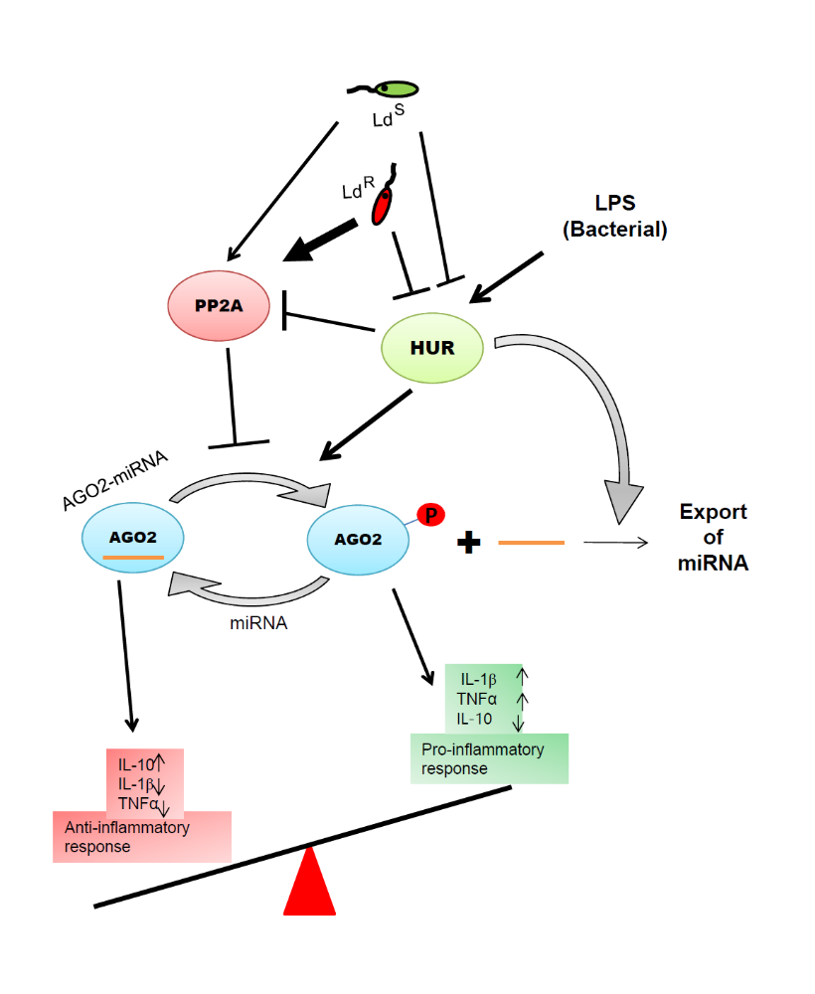

Fiure 2 The model gives a schematic account of how the two proteins PP2A and HuR, by altering the Ago2 phosphorylation–dephosphorylation cycle and mediating the exosomal export of miRNAs respectively, can maintain the inter-regulatory balance between pro-inflammatory and anti-inflammatory responses, in mammalian macrophage cells . During Leishmania infection, the pathogen upregulates PP2A and downregulates HuR to suppress the pro-inflammatory immuneresponse and increase the anti-inflammatory immune response in the infected macrophages. In case of drug sensitive strain of the pathogen, overexpression of HuR is sufficient to suppress the pathogen-induced increase in anti-inflammatory immune response, thereby arresting the infection process by the growing pro-inflammatory immune response. On the contrary, in case of the drug resistant version of Leishmania, upregulation of HuR or downregulation of PP2A alone is rendered ineffective to defeat the pathogen. Therefore, in order to clear the pathogen by shifting the inflammatory immune response to the pro-inflammatory direction, both HuR overexpression and PP2A inhibition has to be done simultaneously.

Simultaneous expression of HuR protein and depletion of PP2A can be an effective strategy to combat the robust effect of drug-resistant Leishmania Ld^{R} on host PP2A expression
Almost nine decades ago, organic pentavalent antimonials were introduced in the Indian subcontinent with dramatic clinical success to combat the deadly disease visceral leishmaniasis or kala-azar. However, with time, the parasite has developed resistance to the drug as reported in several cases in Bihar, India. Therefore, nowadays the drug is not much used in the Indian subcontinent. The antimonial drug-resistant form of the Ld parasite (Ld^{R}) is known for increased IL-10 production upon infection. Compared to drug-sensitive (Ld^{s}) Ag83 strain of Ld, the drug resistant BHU 569 strain (Ld^{R}) showed increased IL-10 expression with low TNF-α expression and strong induction of ERK phosphorylation in host cells. It also showed increased drug resistance associated protein MDR1 expression in RAW 264.7 cells .
It was noted that the drug resistant strain of the Leishmanial parasite Ld^{R} also cleaves the protein HuR, similar to its drug - sensitive counterpart Ld^{S}, thereby lowering the pro-inflammatory cytokine expression whereas it has a much stronger impact on the PP2A levels compared to Ld^{S}. By enhancing the level of phosphatase PP2A, Ld^{R} BHU569 strain increases the anti-inflammatory immune response of the infected cells to such an extent that it cannot be neutralized alone by expression of the prinflammatry protein HuR,. Therefore, as expected, HA-HuR expression in RAW 264.7 infected with Ld^{R} BHU569 strain cells had no effect on internalized parasite number or expression of pro-inflammatory cytokines. However, if PP2A was blocked by using its inhibitor Okadaic acid, and simultaneously HuR protein was ectopically expressed in Ld^{R} BHU569-infected cells – the combined effect of both HuR overexpression and PP2A downregulation acted synergistically to increase the pro-inflammatory cytokine levels of IL-1β and TNF-α .
This also holds true in mouse model of infection with Ld^{R} In BALB/c mice infected with Ld^{R}, either HuR overexpression or PP2A depletion alone could not affect infection process. Hence, there was neither any significant change in number of internalised parasites nor any difference in the cytokine expression in mouse liver when the levels of HuR and PP2A were altered singularly. Similar to ex vivo experimental results, in mouse model also simultaneous HuR expression and PP2A inhibition not only increases the pro-inflammatory response significantly, but also ensures clearance of the drug resistant form of the parasite from the infected mice liver. During Ld^{R} infection, the parasite lowers HuR and upregulates PP2A simultaneously, thereby shifting the balance to anti-inflammatory pathways .
As HuR and PP2A have opposite function - PP2A increases miRNA activity whereas HuR antagonises it. HuR promotes pro-inflammatory immune response and is downregulated by Leishmanial parasites during infection. On the other hand, PP2A is upregulated by the invading parasites to increase anti-inflammatory immuneresponse. Therefore infection by the drug sensitive variant Ls^{S} can be cured by altering HuR alone whereas simultaneous HuR upregulation and PP2A downregulation render the infection process ineffective for the drug resistant parasite. These two proteins HuR and PP2A and their respective pathways can therefore be simultaneously and reciprocally targeted in connection with the miRNP machinery so as to regulate the inflammatory immuneresponse of the infected eukaryotes for therapeutics of Leishmania (Figure 2).

miRNA as regulator of cholesterol metabolism in mammals
Mechanisms that are essential for metabolic control and maintenance of homeostasis are complex processes that involve transcriptional, translational, posttranslational, and allosteric regulation of gene expression primarily happening in all higher metazoan animals. miRNAs are primary regulators that act at post-transcription level to control metabolic homestasis in higher eukaryotes. Several miRNAs are being reported to control multiples steps of metabolic pathways in mammalian cells. Doubling of total body triacylglycerides upon loss of miR-14 expression was an initial evidence of participation of miRNAs in metabolic control in the fruit fly Drosophila melanogaster . To date several miRNAs including miR-122, miR-370, miR-378/378*, miR-335, miR-125a-5p, and miR-33 have been identified as the regulator of lipid metabolism. miR-122 is key regulator of lipid metabolism in liver and is utilized by hepatitis C virus for its replication and infection. Downregulation of miR-122 has been reported in hepatocellular carcinoma (HCC) . Antisense treatment against miR-122 resulted in increased expression of hundreds of genes normally repressed in hepatocytes. In addition, several genes involved in fatty acid synthesis and oxidation were altered in mice treated with anti-miR-122 including FAS, ACC1, and ACC2 . Furthermore, miR-122 inhibition in the liver of high-fat fed mice reduces hepatic steatosis and cholesterol synthesis and enhances fatty-acid oxidation .
Cholesterol regulates pathogenesis of leishmania
In visceral Leishmaniasis (VL) serum cholesterol content is found to be compromised in patient with progression of disease and bears an inverse correlation to splenic parasite load . Membrane cholesterol content was monitored and found to get lowered with leishmania donovani infection of macrophage and resulted membrane raft disruption . Membrane lipid rafts are membrane microdomains consisting of cholesterol and sphingolipids . Disruption of lipid rafts resulted defective antigen presentation and poor immune response in infected animals that can be corrected by liposomal delivery of cholesterol . In the experimental hamster model of VL, liposomal cholesterol administration reduces organ parasite burden and membrane cholesterol level was restored with concomitant increase in membrane rigidity .
Leishmania mediated changes in cholesterol production in mammalian hosts
Determination of the lipid profile in experimental mice model of progressive Leishmania donovani infection confirmed a reduction in total cholesterol, LDL, HDL with gradual infection . Whole genome microarray analysis of RNA isolated from liver of the normal and infected animal liver shows differential expression of lipid metabolic genes in infected mice. The gene expression data suggested that a major alteration in lipid metabolism occurs in infected mouse liver.
miRNA expression affected by parasite
Regulation of gene expression is often governed by small RNA molecules. In this respect, the connection between miR-122 and lipid metabolism is very well documented . Being the most abundant miRNA in liver, miR-122 has an indirect effect on lipid metabolism although key lipid metabolic genes are not the direct targets of miR-22 but are indirectly regulated by miR-122. A more detailed analysis of the microarray data highlighted a very interesting finding. A cluster of lipid metabolising genes showing differential expression was found to be regulated by miR-122. Total RNA were isolated from the liver of normal and infected animals & miR-122 expression was monitored. A significant downregulation of miR-122 with progressive infection was noted .
Mechanism of miRNA alteration by Leishmania
L.donovani infection reduces expression of miR-122 in mouse liver and alter lipid metabolism. Target RNA repressive ability of miR-122 is also compromised in hepatic cells after interaction with pathogens. Interestingly, pre-miR-122 expression increases after infection. pre-miR-122 accumulation with progressive infection was documented in infected mice that rises to 3 fold above normal level after 60 days post infection . After pre-miRNAs are cleaved by the Dicer, the mature miRNA is loaded to Argonaut 2 to form the minimal RISC complex in mammalian cells . After formation of the miRNP, the mRNA targets are recognized through the 3`-UTR seed sequence and subsequently mRNA cleavage or translational repression takes place . A drastic reduction in Ago2 bound miR-122 level (almost 6 fold) was observed in L. donovani treated Huh7. This unique finding sheds some light to the fact how L. donovani reduces miR-122 activity in hepatica cells after their exposure to the pathogens .
Factors important for host cell miRNA alteration during infection
Exosomes serve as communicators between mammalian cells . Leishmania secrets exosomes that act as modulators of host cell machineries-necessary for parasite survival and infection . Exosomes, probably being the key player in cellular communication may answers the most important question of how Küpffer cell resident parasite could modulate the status of a molecule exclusively expressed in the hepatocytes. It can be hypothesized that exosomes released from infected Küpffer cells are taken up by the surrounding hepatocytes where they deliver various virulence factors necessary for miR-122 downregulation. In experiments using anti-GP63 antibody or o-Phenanthrolin, a Zn-chelator, it has been shown that GP63 is the factor necessary for miR-122 downregulation in Leishmania interacting cells .
Potential role of miRNAs as therapeutic agents in treatment of visceral Leishmaniasis
For majority of Leishmania species, genetic and bioinformatic studies suggest absence of Ago proteins and Dicer in their genome. Possible absence of miRNAs and RNAi machinery in Leishmania species encouraged us to consider these machines in host system as targets for therapeutic intervention. Antisense oligonucleotide approaches and siRNA like technologies for inhibiting miRNA function are being explored as potential therapeutic agents in different diseases. Actually, the exciting first step towards miRNA therapy in the liver was with miR-122 antagomir . In this study, the pharmacological approach proposed by Krutzfeldt et al. was remarkably efficient, specific and stable. Injection of the antagomir into the tail veins of the mice selectively degraded miR-122 but not other miRNAs in the liver, even after more than 20 days indicating a durable effect . Thus, in contrast to the challenges raised by gene therapy, the efficacy of intravenous antagomir to target the liver suggests that some issues such as the mode of delivery and the specificity will be more easily alleviated. Taken together, these studies show that while some safety issues still need to be carefully addressed, treatment of hepatic disorders through RNAi is becoming a plausible scenario. Silencing of miRNAs by LNA-antimiRs exhibited a suppressive effect on HCV expression in human hepatoma cells harbouring an HCV replicon. Jopling in 2005 first showed the dependence of HCV replication on hepatic miR-122 . miR-122 was seen to bind at two sites S1 and S2, in the 5’UTR of the HCV RNA and is required to maintain viral abundance in the infected cell. In the presence of miR-122, there is an increase in translation of viral RNA and infectious virus production. Inhibition of HCV replication by inhibiting miR-122 in liver therefore has a promising future to get an effective treatment in HCV infection that otherwise are limited.
Furthermore other recent strategies are coming up with better potential. Lipofection of an antisense oligonucleotide based on a Locked Nucleic Acids (LNA)/2′-O-methyl mixmer or electroporation of a Peptide Nucleic Acid (PNA) oligomer is effective at blocking miR-122 activity in human and rat liver cells. These oligonucleotide analogs, evaluated for the first time in microRNA inhibition, are more effective than standard 2′-O-methyl oligonucleotides in binding and inhibiting microRNA action. It is also shown that miRNA inhibition can be achieved without the need for transfection or electroporation of the human or rat cell lines, by conjugation of an antisense PNA to the cell-penetrating peptide R6-Penetratin, or merely by linkage to just four Lys residues, highlighting the potential of PNA for future therapeutic applications as well as for studying miRNA function.
After administration of miR-122 expression plasmid in the normal animals via tail miR-122 level in liver were monitored for 1, 3, 5 and 7 days post treatment . miR-122 expression was maximum at 3 days and reduces to the normal level by 7 days. Interestingly, the administration of miR-122 expression plasmid and higher miR-122 level prevent Leishmania infection . Parasite burden was monitored, with an unrelated plasmid shRNA under the same promoter showed no alternation in infectivity. Similar experiments were conducted on infected animals and interestingly there was a remarkable reduction in hepatic parasite load in the experimental group whereas the mock group did not show any rescue. The cholesterol level was also found to be almost equal to that of normal animals .
To better highlight the protective role of miR-122, miR-122 expression was restored in liver after the initial establishment of infection. After only 3 doses of miR-122 expression plasmid injection an increase in miR-122 level with a concomitant elevation in cholesterol level was noted. More importantly, the hepatic parasite load was reduced as previous showing that the protective action of miR122 is observed even after initial infection is established .
Leishmanial exosome contain GP63 metalloprotease that downregulate host cell proteins of important function to control inflammatory response. Dicer-1 is also dowregulated by GP63 in hepatic cells and restoration of Dicer1 Expression in Parasite-Infected Livers Rescues miR-122 Expression and reduces liver parasite burden . When expressed exogenously, NHA-DICER1 expression was found to be low in L. donovani-infected mouse livers. This observation was consistent with the prediction of Dicer1 as a target that L. donovani degrades to downregulate miR-122 in infected mouse liver. With infection, the level of GP63 was increased in mouse livers and purified gp63 from L. donovani entrapped in liposomes when delivered to Huh7 cells, a substantial decrease in miR-122 activity was noted in cells receiving GP63-containing liposomes . During infection, exosomes may be the vehicles for GP63 transfer to hepatocytes. Delivery of purified L. donovani exosomes downregulated Dicer1 but Dicer1 restoration can clear L. donovani from infected mouse liver. Excess Dicer1 in liver increased liver miR-122 expression and also restored the serum cholesterol level in infected animals. This was accompanied with a drastic reduction in liver parasite load. Importantly, no apparent change in liver cell morphology, tissue integrity, or production of serum albumin was documented .

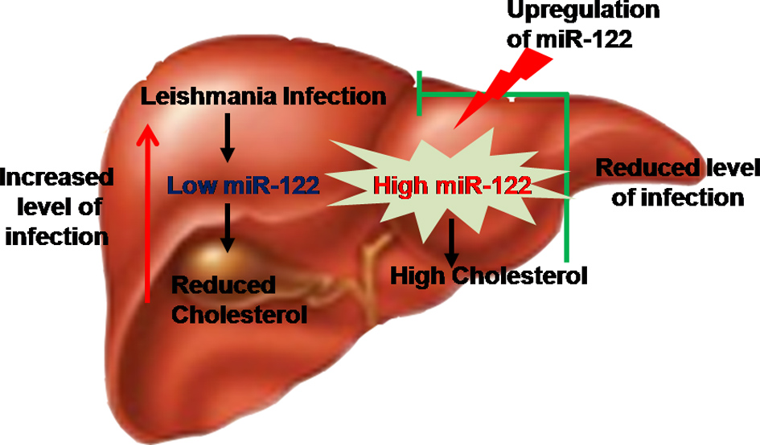
Figure 3 miRNA-122 restrict Leishmania donovani infection in mammalian liver

miRNA as a therapeutic agent against visceral Leishmaniasis
The potential of small regulatory RNAs as therapeutic agents has not been explored extensively. miR-122 is discovered as a key molecule, over expression of which can cause clearance of parasite from infected animal liver. We are now testing this miRNAs against drug resistant parasites in different mammalian host. miR-122 primarily act as anti-leishmanial factor by upregulating the expression of cholesterol in infected tissue. The initial findings are promising and miR-122 may be useful in future as anti-leishmanial gent in L.donovani infected individual (Figure 3)
References
Baltimore, D., M.P. Boldin, R.M. O'Connell, D.S. Rao, and K.D. Taganov. 2008. MicroRNAs: new regulators of immune cell development and function. Nature immunology. 9:839-845.
Banerjee, S., J. Ghosh, S. Sen, R. Guha, R. Dhar, M. Ghosh, S. Datta, B. Raychaudhury, K. Naskar, A.K. Haldar, C.S. Lal, K. Pandey, V.N. Das, P. Das, and S. Roy. 2009. Designing therapies against experimental visceral leishmaniasis by modulating the membrane fluidity of antigen-presenting cells. Infection and immunity. 77:2330-2342.
Bhatnagar, S., and J.S. Schorey. 2007. Exosomes released from infected macrophages contain Mycobacterium avium glycopeptidolipids and are proinflammatory. The Journal of biological chemistry. 282:25779-25789.
Bhatnagar, S., K. Shinagawa, F.J. Castellino, and J.S. Schorey. 2007. Exosomes released from macrophages infected with intracellular pathogens stimulate a proinflammatory response in vitro and in vivo. Blood. 110:3234-3244.
Bhattacharyya, S.N., R. Habermacher, U. Martine, E.I. Closs, and W. Filipowicz. 2006a. Relief of microRNA-mediated translational repression in human cells subjected to stress. Cell. 125:1111-1124.
Bhattacharyya, S.N., R. Habermacher, U. Martine, E.I. Closs, and W. Filipowicz. 2006b. Stress-induced reversal of microRNA repression and mRNA P-body localization in human cells. Cold Spring Harbor symposia on quantitative biology. 71:513-521.
Chakrabarty, Y., and S.N. Bhattacharyya. 2017. Leishmania donovani restricts mitochondrial dynamics to enhance miRNP stability and target RNA repression in host macrophages. Molecular biology of the cell. 28:2091-2105.
Chakraborty, D., S. Banerjee, A. Sen, K.K. Banerjee, P. Das, and S. Roy. 2005. Leishmania donovani affects antigen presentation of macrophage by disrupting lipid rafts. J Immunol. 175:3214-3224.
Courret, N., C. Frehel, N. Gouhier, M. Pouchelet, E. Prina, P. Roux, and J.C. Antoine. 2002. Biogenesis of Leishmania-harbouring parasitophorous vacuoles following phagocytosis of the metacyclic promastigote or amastigote stages of the parasites. Journal of cell science. 115:2303-2316.
Elmen, J., M. Lindow, S. Schutz, M. Lawrence, A. Petri, S. Obad, M. Lindholm, M. Hedtjarn, H.F. Hansen, U. Berger, S. Gullans, P. Kearney, P. Sarnow, E.M. Straarup, and S. Kauppinen. 2008a. LNA-mediated microRNA silencing in non-human primates. Nature. 452:896-899.
Elmen, J., M. Lindow, A. Silahtaroglu, M. Bak, M. Christensen, A. Lind-Thomsen, M. Hedtjarn, J.B. Hansen, H.F. Hansen, E.M. Straarup, K. McCullagh, P. Kearney, and S. Kauppinen. 2008b. Antagonism of microRNA-122 in mice by systemically administered LNA-antimiR leads to up-regulation of a large set of predicted target mRNAs in the liver. Nucleic acids research. 36:1153-1162.
Esau, C., S. Davis, S.F. Murray, X.X. Yu, S.K. Pandey, M. Pear, L. Watts, S.L. Booten, M. Graham, R. McKay, A. Subramaniam, S. Propp, B.A. Lollo, S. Freier, C.F. Bennett, S. Bhanot, and B.P. Monia. 2006. miR-122 regulation of lipid metabolism revealed by in vivo antisense targeting. Cell metabolism. 3:87-98.
Esquela-Kerscher, A., and F.J. Slack. 2006. Oncomirs - microRNAs with a role in cancer. Nature reviews. Cancer. 6:259-269.
Filipowicz, W., S.N. Bhattacharyya, and N. Sonenberg. 2008. Mechanisms of post-transcriptional regulation by microRNAs: are the answers in sight? Nature reviews. Genetics. 9:102-114.
Friedman, R.C., K.K. Farh, C.B. Burge, and D.P. Bartel. 2009. Most mammalian mRNAs are conserved targets of microRNAs. Genome research. 19:92-105.
Ghosh, J., M. Bose, S. Roy, and S.N. Bhattacharyya. 2013. Leishmania donovani targets Dicer1 to downregulate miR-122, lower serum cholesterol, and facilitate murine liver infection. Cell Host Microbe. 13:277-288.
Ghosh, J., C.S. Lal, K. Pandey, V.N. Das, P. Das, K. Roychoudhury, and S. Roy. 2011. Human visceral leishmaniasis: decrease in serum cholesterol as a function of splenic parasite load. Annals of tropical medicine and parasitology. 105:267-271.
Girard, M., E. Jacquemin, A. Munnich, S. Lyonnet, and A. Henrion-Caude. 2008. miR-122, a paradigm for the role of microRNAs in the liver. Journal of hepatology. 48:648-656.
Goswami, A., K. Mukherjee, A. Mazumder, S. Ganguly, I. Mukherjee, S. Chakrabarti, S. Roy, S. Sundar, K. Chattopadhyay, and S.N. Bhattacharyya. 2020. MicroRNA exporter HuR clears the internalized pathogens by promoting pro-inflammatory response in infected macrophages. EMBO molecular medicine. 12:e11011.
Janssens, V., C. Van Hoof, W. Merlevede, and J. Goris. 1998. PTPA regulating PP2A as a dual specificity phosphatase. Methods Mol Biol. 93:103-115.
Jopling, C.L., M. Yi, A.M. Lancaster, S.M. Lemon, and P. Sarnow. 2005. Modulation of hepatitis C virus RNA abundance by a liver-specific MicroRNA. Science. 309:1577-1581.
Kar, S., A. Ukil, G. Sharma, and P.K. Das. 2010. MAPK-directed phosphatases preferentially regulate pro- and anti-inflammatory cytokines in experimental visceral leishmaniasis: involvement of distinct protein kinase C isoforms. Journal of leukocyte biology. 88:9-20.
Krutzfeldt, J., N. Rajewsky, R. Braich, K.G. Rajeev, T. Tuschl, M. Manoharan, and M. Stoffel. 2005. Silencing of microRNAs in vivo with 'antagomirs'. Nature. 438:685-689.
Kumar, A., S. Das, A. Mandal, S. Verma, K. Abhishek, V. Kumar, A.K. Ghosh, and P. Das. 2018. Leishmania infection activates host mTOR for its survival by M2 macrophage polarization. Parasite immunology. 40:e12586.
Kundu, P., M.R. Fabian, N. Sonenberg, S.N. Bhattacharyya, and W. Filipowicz. 2012. HuR protein attenuates miRNA-mediated repression by promoting miRISC dissociation from the target RNA. Nucleic acids research. 40:5088-5100.
Lanford, R.E., E.S. Hildebrandt-Eriksen, A. Petri, R. Persson, M. Lindow, M.E. Munk, S. Kauppinen, and H. Orum. 2010. Therapeutic silencing of microRNA-122 in primates with chronic hepatitis C virus infection. Science. 327:198-201.
Lee, Y., C. Ahn, J. Han, H. Choi, J. Kim, J. Yim, J. Lee, P. Provost, O. Radmark, S. Kim, and V.N. Kim. 2003. The nuclear RNase III Drosha initiates microRNA processing. Nature. 425:415-419.
Lee, Y., K. Jeon, J.T. Lee, S. Kim, and V.N. Kim. 2002. MicroRNA maturation: stepwise processing and subcellular localization. The EMBO journal. 21:4663-4670.
Liew, F.Y., D. Xu, E.K. Brint, and L.A. O'Neill. 2005. Negative regulation of toll-like receptor-mediated immune responses. Nature reviews. Immunology. 5:446-458.
Liu, D., and J.E. Uzonna. 2012. The early interaction of Leishmania with macrophages and dendritic cells and its influence on the host immune response. Frontiers in cellular and infection microbiology. 2:83.
Lujambio, A., and S.W. Lowe. 2012. The microcosmos of cancer. Nature. 482:347-355.
Lund, E., S. Guttinger, A. Calado, J.E. Dahlberg, and U. Kutay. 2004. Nuclear export of microRNA precursors. Science. 303:95-98.
Mazumder, A., M. Bose, A. Chakraborty, S. Chakrabarti, and S.N. Bhattacharyya. 2013. A transient reversal of miRNA-mediated repression controls macrophage activation. EMBO Rep. 14:1008-1016.
Meisner, N.C., and W. Filipowicz. 2011. Properties of the Regulatory RNA-Binding Protein HuR and its Role in Controlling miRNA Repression. Advances in experimental medicine and biology. 700:106-123.
Mogensen, T.H. 2009. Pathogen recognition and inflammatory signaling in innate immune defenses. Clinical microbiology reviews. 22:240-273, Table of Contents.
Mukherjee, B., R. Mukhopadhyay, B. Bannerjee, S. Chowdhury, S. Mukherjee, K. Naskar, U.S. Allam, D. Chakravortty, S. Sundar, J.C. Dujardin, and S. Roy. 2013. Antimony-resistant but not antimony-sensitive Leishmania donovani up-regulates host IL-10 to overexpress multidrug-resistant protein 1. Proceedings of the National Academy of Sciences of the United States of America. 110:E575-582.
Mukherjee, K., B. Ghoshal, S. Ghosh, Y. Chakrabarty, S. Shwetha, S. Das, and S.N. Bhattacharyya. 2016. Reversible HuR-microRNA binding controls extracellular export of miR-122 and augments stress response. EMBO Rep. 17:1184-1203.
O'Connell, R.M., D.S. Rao, A.A. Chaudhuri, and D. Baltimore. 2010. Physiological and pathological roles for microRNAs in the immune system. Nature reviews. Immunology. 10:111-122.
O'Neill, L.A., F.J. Sheedy, and C.E. McCoy. 2011. MicroRNAs: the fine-tuners of Toll-like receptor signalling. Nature reviews. Immunology. 11:163-175.
Olivier, M., D.J. Gregory, and G. Forget. 2005. Subversion mechanisms by which Leishmania parasites can escape the host immune response: a signaling point of view. Clinical microbiology reviews. 18:293-305.
Podinovskaia, M., and A. Descoteaux. 2015. Leishmania and the macrophage: a multifaceted interaction. Future microbiology. 10:111-129.
Poria, D.K., A. Guha, I. Nandi, and P.S. Ray. 2016. RNA-binding protein HuR sequesters microRNA-21 to prevent translation repression of proinflammatory tumor suppressor gene programmed cell death 4. Oncogene. 35:1703-1715.
Reinhart, B.J., F.J. Slack, M. Basson, A.E. Pasquinelli, J.C. Bettinger, A.E. Rougvie, H.R. Horvitz, and G. Ruvkun. 2000. The 21-nucleotide let-7 RNA regulates developmental timing in Caenorhabditis elegans. Nature. 403:901-906.
Rosenberger, C.M., J.H. Brumell, and B.B. Finlay. 2000. Microbial pathogenesis: lipid rafts as pathogen portals. Current biology : CB. 10:R823-825.
Rossol, M., H. Heine, U. Meusch, D. Quandt, C. Klein, M.J. Sweet, and S. Hauschildt. 2011. LPS-induced cytokine production in human monocytes and macrophages. Critical reviews in immunology. 31:379-446.
Silverman, J.M., J. Clos, C.C. de'Oliveira, O. Shirvani, Y. Fang, C. Wang, L.J. Foster, and N.E. Reiner. 2010. An exosome-based secretion pathway is responsible for protein export from Leishmania and communication with macrophages. Journal of cell science. 123:842-852.
Slack, F.J., M. Basson, Z. Liu, V. Ambros, H.R. Horvitz, and G. Ruvkun. 2000. The lin-41 RBCC gene acts in the C. elegans heterochronic pathway between the let-7 regulatory RNA and the LIN-29 transcription factor. Molecular cell. 5:659-669.
Soulat, D., and C. Bogdan. 2017. Function of Macrophage and Parasite Phosphatases in Leishmaniasis. Frontiers in immunology. 8:1838.
Sun, K., and E.C. Lai. 2013. Adult-specific functions of animal microRNAs. Nature reviews. Genetics. 14:535-548.
Xu, P., S.Y. Vernooy, M. Guo, and B.A. Hay. 2003. The Drosophila microRNA Mir-14 suppresses cell death and is required for normal fat metabolism. Current biology : CB. 13:790-795.


September 10, 2021

