**Sun Pharma Science Foundation Research Awards 2021**

**Statement of Research Achievements:**

I have not received any award yet.

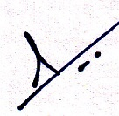

Dr. Seema V. Pattewar

Sanjivani College of pharmaceutical Education and research