1. ***Sharma JB, Sharma E, Sharma S, Dharmendra S.*** [***Recent Advances in Diagnosis and Management of Female Genital Tuberculosis.***](https://pubmed.ncbi.nlm.nih.gov/34483510/) ***J Obstet Gynaecol India. 2021 Aug 28:1-12.***

Female genital tuberculosis (FGTB) is an important cause of significant morbidity and infertility. Gold-standard diagnosis by demonstration of acid fast bacilli on microscopy or culture or detection of epithelioid granuloma on histopathology of endometrial or peritoneal biopsy is positive in only small percentage of cases due to its paucibacillary nature. Use of gene Xpert on endometrial or peritoneal biopsy has improved sensitivity of diagnosis. Composite reference standard (CRS) is a significant landmark in its diagnosis in which combination of factors like AFB on microscopy or culture, positive gene Xpert, epithelioid granuloma on endometrial or peritoneal biopsy, demonstration of definite or probable findings of FGTB on laparoscopy or hysteroscopy. There have been many advances and changes in management of FGTB recently. The program is now called National Tuberculosis Elimination Program (NTEP), and categorization of TB has been stopped. Now, patients are divided into drug-sensitive FGTB for which rifampicin (R), isoniazid (H), pyrazinamide (Z) and ethambutol (E) are given orally daily for 2 months followed by three drugs (rifampicin, isoniazid and ethambutol (RHE) orally daily for next 4 months. Multi-drug-resistant FGTB is treated with shorter MDR TB regimen of 9-11 months or longer MDR TB regimen of 18-20 months with reserved drugs. In vitro fertilization and embryo transfer have good results for blocked tubes and receptive endometrium, while surrogacy or adoption is advised for severe grades of Asherman's syndrome.

2***. Sharma JB, Kumar R, Singh U, Kumari A, Dharmendra S, Sachani H.*** [***Pre- treatment and post treatment positron emission tomography-computed tomography (PET-CT) to evaluate treatment response in tuberculous Tubo-Ovarian masses.***](https://pubmed.ncbi.nlm.nih.gov/34303072/) ***Eur J Obstet Gynecol Reprod Biol. 2021 Sep;264:128-134.***

It's a Prospective study on 47 confirmed cases of FGTB with infertility having TO masses. All patients were subjected to 18F-FDGPET/CT to see the glucose uptake by the TO mass and extent of the disease. Category I treatment under DOTS was given for 6 months. All underwent follow-up of PET/CT to see the response to ATT. Results of pre ATT PET/CT were compared with post ATT PET/CT.

1. ***Sharma JB, Sharma E, Sharma S, Singh J, Chopra N.*** [***Genital tb-diagnostic algorithm and treatment.***](https://pubmed.ncbi.nlm.nih.gov/33308655/) ***Indian J Tuberc. 2020 Dec;67(4S):S111-S118.***

Female genital tuberculosis (FGTB) is a common cause of infertility in India but its diagnosis remains elusive due to paucibacillary nature of disease. Traditional methods of diagnosis include demonstration of acid fast bacilli on endometrial or peritoneal biopsy or epithelioid granuloma on the biopsy or positive gene Xpert on the biopsy, but they are positive in small percentage of cases only missing diagnosis in many cases. Positive polymerase chain reaction (PCR) alone is not taken for diagnosis due to high false positivity. Diagnostic laparoscopy and hysteroscopy can detect many cases by direct demonstration of TB lesions. Composite reference standard is a useful method to diagnose FGTB. This review discusses various diagnostic modalities including endometrial or peritoneal biopsy to detect acid fast bacilli on microscopic or culture or epithelioid granuloma, role of PCR, role of radiological imaging (hysterosalpingography, ultrasound, CT scan, MRI and PET-CT scan) and role of endoscopic techniques (laparoscopy and hysteroscopy) in diagnosis of FGTB including role of composite reference standard. The International and National studies highlight the role of composite reference standard and its components like demonstration of AFB on microscopy or culture of endometrial or peritoneal biopsy or epithelioid granuloma or gene Xpert or PCR or latest tests like loop-mediated isothermal amplification (TB-LAMP) test and other newer molecular methods like Xpert Ultra for diagnosis of FGTB. It also detects role of endoscopy in FGTB and role of diagnostic algorithm for diagnosis of FGTB. Treatment is with four primary drugs (rifampicin, isoniazid, ethambutol and pyrazinamide) for two months followed by three drugs (rifampicin, isoniazid and ethambutol) daily orally for 4 months for drug sensitive FGTB. Shorter Multidrug-resistant TB (MDR-TB) regimen is given for Rifampicin resistant (RR)/MDR confined to only FGTB while longer all oral regimen is given for RR/MDR with or without additional drug resistance, HIV seropositives with FGTB or involvement of other sites or pulmonary TB (PTB) along with FGTB. Composite reference standard which combines various diagnostic modalities is a useful strategy to diagnose FGTB.

1. ***Sharma JB, Dharmendra S, Jain S, Sharma SK, Singh UB, Soneja M, Sinha S, Vanamail P*** [***Evaluation of Gene Xpert as compared to conventional methods in diagnosis of Female Genital Tuberculosis.***](https://pubmed.ncbi.nlm.nih.gov/33256922/) ***Eur J Obstet Gynecol Reprod Biol. 2020 Dec;255:247-252.***

It was a prospective study conducted over 167 cases of infertile female genital tuberculosis (FGTB) diagnosed on composite reference standard (CRS) (smear for AFB, histopathological evidence of epithelioid granuloma or definite or possible findings of tuberculosis on laparoscopy). All women underwent endometrial biopsy for AFB microscopy, culture, gene Xpert, PCR and histopathology) and laparoscopy and hysteroscopy for diagnosis and prognostication of disease. The results of Gene Xpert were compared with conventional methods in detection of FGTB.

1. ***Sharma JB.*** [***Sharma's sigmoid colonic adhesive band - A new laparoscopic sign in female genital tuberculosis.***](https://pubmed.ncbi.nlm.nih.gov/32825859/) ***Indian J Tuberc. 2020 Jul;67(3):327-332.***

It was a prospective study in a tertiary referral center as a part of our ongoing tuberculosis project on 148 infertile women found to have FGTB on microbiological or laparoscopic findings over previous 10 years. A new laparoscopic "Sharma's Sigmoid colonic adhesive band" was looked for in these cases on laparoscopy.

1. ***Sharma JB, Sharma E, Sharma S, Dharmendra S.*** [***Female genital tuberculosis: Revisited.***](https://pubmed.ncbi.nlm.nih.gov/30964083/)

***Indian J Med Res. 2018 Dec;148(Suppl):S71-S83.***

Female genital tuberculosis (FGTB) is caused by Mycobacterium tuberculosis (rarely Mycobacterium bovis and/or atypical mycobacteria) being usually secondary to TB of the lungs or other organs with infection reaching through haematogenous, lymphatic route or direct spread from abdominal TB. In FGTB, fallopian tubes are affected in 90 per cent women, whereas uterine endometrium is affected in 70 per cent and ovaries in about 25 per cent women. It causes menstrual dysfunction and infertility through the damage of genital organs. Some cases may be asymptomatic. Diagnosis is often made from proper history taking, meticulous clinical examination and judicious use of investigations, especially endometrial aspirate (or biopsy) and endoscopy. Treatment is through multi-drug antitubercular treatment for adequate time period (rifampicin, isoniazid, pyrazinamide, ethambutol daily for 60 days followed by rifampicin, isoniazid, ethambutol daily for 120 days). Treatment is given for 18-24 months using the second-line drugs for drug-resistant (DR) cases. With the advent of increased access to rapid diagnostics and newer drugs, the management protocol is moving towards achieving universal drug sensitivity testing and treatment with injection-free regimens containing newer drugs, especially for new and previously treated DR cases.

1. ***Sharma JB, Goyal M, Kumar S, Roy KK, Sharma E, Arora R.*** [***Concomitant female genital tuberculosis and endometriosis.***](https://pubmed.ncbi.nlm.nih.gov/28709484/) ***Indian J Tuberc. 2017 Jul;64(3):173-177.***

To demonstrate an association between female genital tuberculosis (FGTB) and endometriosis. A total of 16 women who underwent laparoscopy (12 cases) or laparotomy (4 cases) and were found to have female genital tuberculosis and endometriosis were enrolled in this retrospective study. Female genital tuberculosis and endometriosis may have similar manifestations and can co-exist.Bottom of Form

1. ***Sharma JB.*** [***Current Diagnosis and Management of Female Genital Tuberculosis.***](https://pubmed.ncbi.nlm.nih.gov/26663993/) ***J Obstet Gynaecol India. 2015 Dec;65(6):362-71.***

Female genital tuberculosis (FGTB) is an important cause of significant morbidity, short- and long-term sequelae especially infertility whose incidence varies from 3 to 16 % cases in India. Mycobacterium tuberculosis is the etiological agent for tuberculosis. The fallopian tubes are involved in 90-100 % cases, endometrium is involved in 50-80 % cases, ovaries are involved in 20-30 % cases, and cervix is involved in 5-15 % cases of genital TB. Tuberculosis of vagina and vulva is rare (1-2 %). The diagnosis is made by detection of acid-fast bacilli on microscopy or culture on endometrial biopsy or on histopathological detection of epithelioid granuloma on biopsy. Polymerase chain reaction may be false positive and alone is not sufficient to make the diagnosis. Laparoscopy and hysteroscopy can diagnose genital tuberculosis by various findings. Treatment is by giving daily therapy of rifampicin (R), isoniazid (H), pyrazinamide (Z) and ethambutol (E) for 2 months followed by daily 4 month therapy of rifampicin (R) and isoniazid (H). Alternatively 2 months intensive phase of RHZE can be daily followed by alternate day combination phase (RH) of 4 months. Three weekly dosing throughout therapy (RHZE thrice weekly for 2 months followed by RH thrice weekly for 4 months) can be given as directly observed treatment short-course. Surgery is rarely required only as drainage of abscesses. There is a role of in vitro fertilization and embryo transfer in women whose fallopian tubes are damaged but endometrium is healthy. Surrogacy or adoption is needed for women whose endometrium is also damaged.

1. ***Sharma JB, Sneha J, Singh UB, Kumar S, Roy KK, Singh N, Dharmendra S, Vanamail P.*** [***Comparative Study of Laparoscopic Abdominopelvic and Fallopian Tube Findings Before and After Antitubercular Therapy in Female Genital Tuberculosis With Infertility.***](https://pubmed.ncbi.nlm.nih.gov/26455527/) ***J Minim Invasive Gynecol. 2016 Feb 1;23(2):215-22.***

To study the effect of antitubercular treatment (ATT) on the laparoscopic abdominopelvic and fallopian tube findings in female genital tuberculosis (FGBT). It’s a prospective cohort tertiary referral center in northern India. Fifty women with infertility and diagnosed with FGTB on laparoscopy, histopathology findings, or endometrial sampling (acid-fast bacilli culture, granuloma on histopathology, positive polymerase chain reaction). Diagnostic laparoscopy in all women diagnosed with FGTB before and after a 6-month course of ATT (2 months of rifampicin, isoniazid, pyrazinamide, and ethambutol, followed by 4 months of rifampicin and isoniazid). ATT improves laparoscopic findings in FGTB with infertility. However, advanced fibrotic lesions (eg, pelvic and perihepatic adhesions, bilateral blocked tubes) do not improve with ATT.

1. ***Sharma, J.B., Roy, K.K., Pushparaj, M. et al. Genital tuberculosis: an important cause of Asherman’s syndrome in India. Arch Gynecol Obstet 277, 37–41 (2008).***

To demonstrate the association between genital endometrial tuberculosis and Asherman's syndrome. A total of 28 women who underwent hysteroscopy with or without laparoscopy for suspected Asherman's syndrome from symptoms (amenorrhoea or oligomenorrhoea, and or primary or secondary infertility) and who were found to have genital tuberculosis on endometrial biopsy (histopathology or culture) or positive polymerase chain reaction (PCR) on endometrial aspirate or positive findings of tuberculosis on laparoscopy or hysteroscopy were enrolled in this retrospective study. The diagnosis of genital TB was made by histopathology (tuberculous granuloma) on endometrial biopsy in 28.6%, positive culture in 3.6%, positive polymerase chain reaction (PCR) in 46.4% and observation of tubercles, beading or caseation on laparoscopy in 17.8% or shaggy cavity with caseation on hysteroscopy in 3.6% women. Genital tuberculosis appears to be an important and common cause of Asherman's syndrome in India, causing oligomenorrhoea or amenorrhoea with infertility.

1. ***Sharma JB. Sharma’s python sign: a new tubal sign in female genital tuberculosis. J Lab Physicians. 2016;8:120–2.***

Female genital tuberculosis (FGTB) is an important cause of infertility in developing countries. Various type of TB salpingitis can be endosalpingitis, exosalpingitis, interstitial TB salpingitis, and salpingitis isthmica nodosa. The fallopian tubes are thickened enlarged and tortuous. Unilateral or bilateral hydrosalpinx or pyosalpinx may be formed. A new sign python sign is presented in which fallopian tube looks like a blue python on dye testing in FGTB.

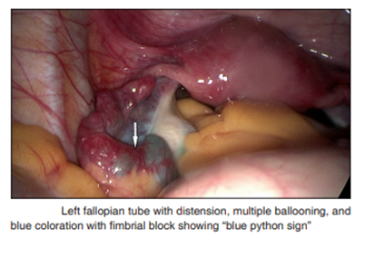

1. ***Sharma, J.B. Sharma’s Kissing Fallopian Tubes Sign: A New Tubal Sign in Female Genital Tuberculosis. J Obstet Gynecol India 67, 227–229 (2017).***

Female genital tuberculosis can cause fusion of fallopian tubes at their fimbrial ends manifesting as Sharma’s Kissing fallopian tube sign on laparoscopy and can be used as a diagnostic test of FGTB.

blue coloration with mbrial blo

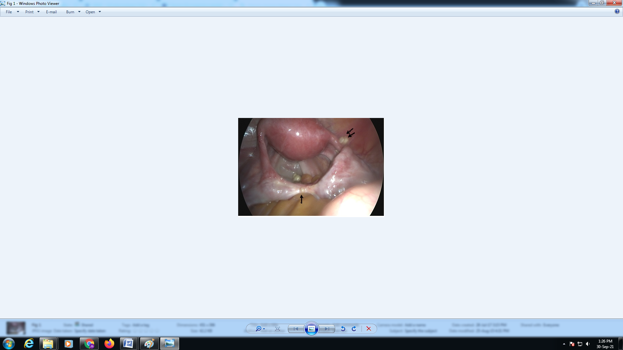

Laparoscopy showing Kissing fallopian tube sign in a proven case of female

genital tuberculosis (arrow). Caseous nodules are also shown (double arrow)

1. ***Sharma JB. Sharma's dried tree branch fallopian tubes sign: A new laparoscopic sign in female genital tuberculosis with infertility. IVF Lite 2016;3:98-103***

Female genital tuberculosis (FGTB) involves fallopian tubes in 95%–100% cases causing various tubal abnormalities. So, the objective was to evaluate the laparoscopic findings in FGTB with special reference to a new dried tree branch fallopian tubes sign. A total of eighty cases of FGTB diagnosed by demonstration of acid‑fast bacilli on microscopy or culture on endometrial or peritoneal biopsy or positive endometrial or peritoneal biopsy or demonstration of epithelioid granuloma on biopsy or positive polymerase chain reaction to Mycobacterium tuberculosis on endometrial biopsy with findings of FGTB on laparoscopy or hysteroscopy were included in this prospective study. Diagnostic laparoscopy was performed in all cases. Definite findings of FGTB such as caseous nodules, tubercles, beaded tubes were seen in 33 (41.2%) cases while probable findings of FGTB such as congested and hyperemic fallopian tubes, hydrosalpinx obstructed tubes, pelvic adhesions, and straw‑colored fluid were observed in rest 47 (58.8%) cases. A new dried tree branch fallopian tubes sign was seen in 7 (8.0%) cases being bilateral in 4 (5%) and unilateral in 3 (3.7%) cases. The new sign Sharma’s dried tree branch fallopian tubes sign appears to be a useful sign in FGTB. However, larger prospective studies are needed before its routine recommendation in clinical practice.

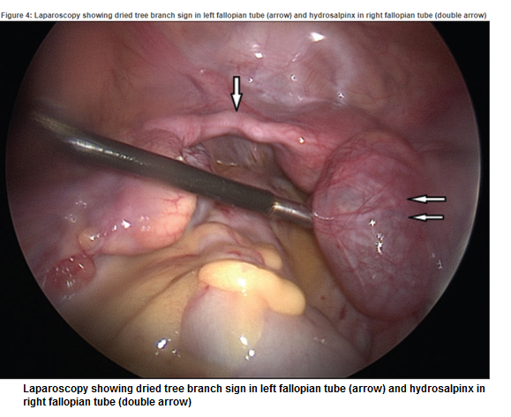

1. ***Sharma JB. Sharma's sigmoid colonic adhesive band – A new laparoscopic sign in female genital tuberculosis, Indian Journal of Tuberculosis, 2020(67) 3,327-332.***

Present study was conducted to observe the prevalence of a new "Sharma's Sigmoid colonic adhesive band "in FGTB on laparoscopy. It was a prospective study in a tertiary referral center as a part of our ongoing tuberculosis project on 148 infertile women found to have FGTB on microbiological or laparoscopic findings over previous 10 years. A new laparoscopic "Sharma's Sigmoid colonic adhesive band" was looked for in these cases on laparoscopy.

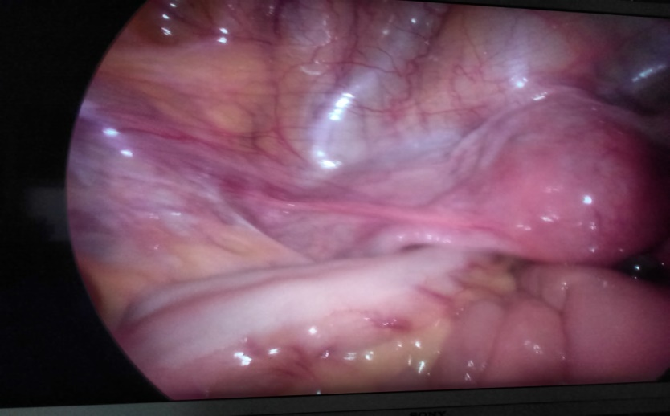

**Laparoscopy showing 3X2 cm “Sharma’s sigmoid colonic adhesive band” (arrow) in a case of FGTB**

1. ***Sharma JB. Sharma's ascending colonic adhesion: A new sign in abdomino pelvic tuberculosis with infertility. IVF Lite 2016;3:18-22***

Abdominal adhesions may occur anywhere at many places We observed a specific 5×4cm large ascending colonic adhesion at junction of lower 2/3rd and upper 1/3rd of ascending colon, below the hepatic flexure, between ascending colon and anterior abdominal wall.

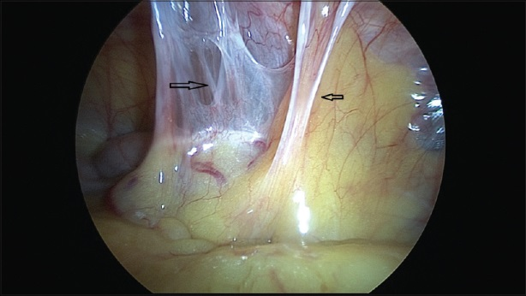

***Laparoscopic findings of Sharma's large ascending colonic adhesion in a proven case of abdominopelvic tuberculosis (arrow)***

1. ***Sharma JB, Singh N, Dharmendra S, Singh UB, Vanamail P, Kumar S, Roy KK, Hari S, Iyer V, Sharma SK. Six months versus nine months anti-tuberculous therapy for female genital tuberculosis: a randomized controlled trial. Eur J Obst Gyne Rep Biol. 2016 (203): 264-273***

To compare six months versus nine months anti-tuberculous therapy in patients of female genital tuberculosis. It was a randomized controlled trial in a tertiary referral center teaching institute on 175 women presenting with infertility and found to have female genital tuberculosis on clinical examination and investigations. Group I women (86 women) were given 9 months of intermitted anti-tuberculous therapy under directly observed treatment short course (DOTS) strategy while Group II (89 women) were given 6 months of anti-tuberculous therapy under DOTS. Patients were evaluated for primary end points (complete cure, partial response, no response) and secondary end points (recurrence rate, pregnancy rate) during treatment. All patients were followed up further for one year after completion of therapy to assess recurrence of disease and further pregnancies. Baseline characteristics were similar between two randomized groups. There was no difference in the complete clinical response rate (95.3% vs 97.7%, p=0.441) between 9-months and 6-months groups. Four patients in 9-months group and two patients in 6-months group had recurrence of disease and required category II anti tuberculous therapy (p=0.441). Pregnancy rate during treatment and up to one year follow up was also similar in the two groups (23.2% vs 21.3%, p=0.762). Side effects occurred in 27(31.4%) and 29(32.6%) in 9-months and 6-months of therapy and were similar (p=0.866). There was no difference in complete cure rate, recurrent rate and pregnancy rate for either 6-months or 9-months of intermittent directly observed treatment short course anti-tuberculous therapy in female genital tuberculosis.

1. ***Sharma JB. In vitro fertilization and embryo transfer in female genital tuberculosis. IVF Lite 2015;2:14-25***

FGTB is in the important cause of infertility being responsible for up to 16% cases of infertility in developing countries while infertility is seen in up to 40-50% cases of genital TB. It can cause destruction of ovaries, tubo-ovarian masses or poor ovarian reserve with poor quality of embryos and need of a high dose of gonadotropins. Endometrial TB causes poor endometrial receptivity, endometrial adhesions, and recurrent implantation failure. Diagnosis is by good history taking, thorough clinical examination and judicious use of investigations especially endometrial sampling for acid-fast bacilli culture, PCR, and histopathological testing. Laparoscopy and hysteroscopy may be helpful in early diagnosis and to see the severity of disease for prognostication for fertility. Medical treatment using DOTS strategy under direct observation and using quality assured drugs in appropriate dosage and for the adequate time is the mainstay of treatment. Surgical treatment is rarely required and should only be done in exceptional circumstances and should be in the form of limited surgeries like laparoscopy, hysteroscopy and drainage of abscess, etc., as surgery in genital and peritoneal TB can be difficult and hazardous.The prognosis for fertility is poor. However, for tubal disease in absence of endometrial disease, ART especially IVF-ET may give good results if performed on time after giving full course of ATT and in fact may be the only hope for such women. There is the role of gestational surrogacy in women with Asherman's is syndrome due to endometrial TB with a viable pregnancy rate of about 50%. Stem cell therapy may play a role in the regeneration of endometrium and tubal mucosa in FGTB in future.

1. ***Sharma JB, Singh UB, Dharmendra S, Hari S, Purwar R. Role of Magnetic Resonance Imaging in evaluation of tuberculous tubo ovarian mass. Ind J Tub. 2021 (Accepted, under press)***

MRI was performed on 33 patients of tuberculous TO mass of female genital tuberculosis (FGTB).

Mean age, BMI, and parity was 27.5 ± 4.2 years, 22.7 ± 3.6 kg/m2, and 0.27 ± 0.13. All patients (100%) had infertility; primary infertility (72.72%) and secondary infertility (27.23%) with mean 5.8 years. Abdominal/pelvic pain 33 (100%) cases, abdominal lump 4 (12.12%), adnexal mass 33 (100%). MRI findings showed pelvic masses 33 (100%), bilateral TO masses 11 (33.33%), cystic lesion 4 (12.12%), solid cystic lesion 3 (9.09%) with bilateral pyosalpinx 1 (3.3%), homogeneous content with ascites 1 (3.03%), rim enhancing lesion abutting pelvic wall in 1 (3.03%). Right adnexal mass 11 (33.33%), right adnexal cyst 2 (6.06%), right adnexal cystic mass in 1 (3.03%), right sided complex TO mass 1 (3.03%), right sided hydrosalpinx in 1 (3.03%) case, right sided TO mass in 4 (12.12%) cases and right sided para-ovarian cyst in 2 (6.06%). Left sided adnexal mass was seen in 11 (33.33%), cystic lesion in 1 (3.03%), ovarian cyst in 3 (9.09%) cases, left sided hydrosalpinx in 2 (6.06%), left ovarian cyst 2 (6.06%) cases,

left sided ovarian cyst with encysted ascites 1 (3.03%) case and with left sided paraovarian cyst 2 (6.06%) case. Miscellaneous finding were generalised ascites (6.06%), encysted ascites (3.03%), pelvic (1; 3.03%) and mesenteric lymphadenopathy 1 (3.03%). Incidental finding were fibroid 3 (9.09%) and adenomyosis 1 (3.03%) case. Hence, MRI appears to be useful diagnostic modality for tuberculous TO masses where differential diagnosis is malignancy but molecular diagnosis remains the gold standard.

1. ***Sharma JB. Sharma's hanging gall bladder sign: A new sign for abdominopelvic tuberculosis: An observational study. IVF Lite 2015;2:94-8***

 Abdominopelvic tuberculosis (TB) involves genital tract, peritoneum, intestines, mesentery, omentum, abdominal lymph nodes, liver, and gall bladder and causes multiple adhesions of intestine and omentum with the anterior abdominal wall. Aim was to study the laparoscopic findings in abdominopelvic TB with special emphasis on new hanging gall bladder sign.  A total of 10 cases of abdominopelvic TB diagnosed by demonstration of AFB on microscopy or culture on endometrial or peritoneal biopsy or positive epithelioid granuloma on biopsy or positive polymerase chain reaction to Mycobacterium TB on endometrial or peritoneal biopsy were included in the study. Laparoscopic visualization was done of all abdominopelvic TB cases. Tubercles were observed in all 10 (100%) cases, caseous nodule in 4 (40%), perihepatic adhesions with a new sign Sharma's hanging gall bladder sign in which gall bladder hangs vertically or stands (instead of lying down position in normal cases) in abdominopelvic TB was observed on 4 (40%) cases. Thus, the new sign Sharma's Hanging Gall Bladder sign appears to be useful in early detection of abdomino-pelvic TB.

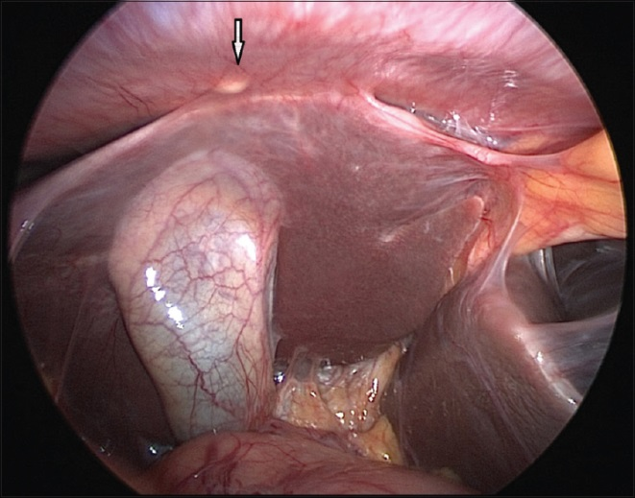

***Laparoscopic view of Sharma's hanging gall bladder sign with caseous nodule of tuberculosis***

1. ***Regmi SK, Singh UB, Sharma JB, Kumar R. Relevance of semen polymerase chain reaction positive for tuberculosis in asymptomatic men undergoing infertility evaluation. J Hum Reprod Sci 2015;8:165-9***

Male partners of infertile women with genital tuberculosis (TB) are often screened for genital TB. We aimed to evaluate the clinical significance of a positive screening semen polymerase chain reaction (PCR) for Mycobacterium tuberculosis test (TB-PCR) in asymptomatic men undergoing infertility evaluation and determine the need for a detailed investigation and treatment for TB. Male partners of 15 infertile women with a diagnosis of genitourinary TB (GUTB) as the cause of infertility, tested positive either on semen PCR for TB (13 cases), or Mycobacterium Growth Indicator Tube-960 test (2 cases). These asymptomatic men underwent infertility evaluation along with evaluation for GUTB. Diagnosis of GUTB was based on standard clinical criteria, which included a high index of suspicion along with clinical, laboratory, and/or radiological evidence of GUTB. Men who had no clinical evidence of GUTB were followed up with clinical evaluation, semen analysis, and repeat semen PCR for TB after 6 months. Fourteen subjects consented for inclusion in the study. One had a history of pulmonary TB 20 years earlier. Another patient was found to have mediastinal lymphadenopathy (tubercular). All except one had a normal semen analysis. None of the patients met the standard clinical criteria for GUTB diagnosis. 8 patients followed up at 6 months with repeat semen analysis, which was similar to the baseline values and no clinical evidence of TB. Thus, asymptomatic men with positive screening semen PCR for TB do not have clinical evidence of TB. Male partners of women with infertility and GUTB should not be screened if they have no symptoms.

1. ***Sharma JB, Sneha J, Singh UB, Kumar S, Roy KK, Singh N, Dharmendra S. Effect of anti-tubercular treatment on ovarian function in female genital tuberculosis with infertility. J Hum Reprod Sci. 2016 Jul-Sep;9(3):145-150***

To evaluate the effect of anti-tubercular therapy (ATT) on an ovarian function such as ovarian reserve, ovarian dimensions, and ovarian stromal blood flow. It’s a Prospective study design with fifty infertile women with female genital tuberculosis (FGTB) without tubo‑ovarian masses diagnosed by positive acid‑fast bacilli culture or epithelioid granuloma on endometrial aspirate or positive polymerase chain reaction with positive findings on laparoscopy or hysteroscopy were recruited. The ovarian function tests were performed on day 2/3 as follicle‑stimulating hormone (FSH) levels and anti‑Mullerian hormone (AMH) levels. Ovarian dimensions (length, width, and depth) were measured using a transvaginal ultrasound. Mean antral follicle count (AFC) and ovarian stromal blood flow (peak systolic velocity [PSV], pulsatility index (PI), and resistive index [RI]) were measured using a transvaginal ultrasound. All women were started on ATT for 6 months by directly observed treatment strategy. After completion of ATT, all the parameters were repeated. There was a significant increase in AMH (2.68 ± 0.97 ng/ml to 2.8 ± 1.03 ng/ml) pre‑ to post‑ATT, nonsignificant increase in FSH (7.16 ± 2.34 mIU/ml to 7.26 ± 2.33 mIU/ml) post‑ATT, significant increase in mean AFC (7.40 ± 2.12–8.14 ± 2.17), PSV in the right ovary (6.015–6.11 cm/s) and left ovary (6.05–6.08 cm/s), PI in the right ovary (0.935–0.951 cm/s) and left ovary (0.936–0.957 cm/s), and RI in the right ovary (0.62 ± 0.01–0.79 ± 0.02) and left ovary (0.65 ± 0.02–0.84 ± 0.01) with ATT. There was no significant change in mean ovarian dimensions (ovarian length, breadth, and width) and summed ovarian volume with ATT. On laparoscopy, tubercles were seen in 27 (54%) women. Caseous nodules and encysted ascites were seen in 8% cases each. Thus, ATT improves the ovarian function (AMH and AFC) and ovarian blood flow in women with FGTB.

1. ***Sharma JB, Dharmendra S, Agarwal S, Sharma E. Genital tuberculosis and infertility. Fertil Sci Res 2016;3:6-18.***

Female genital tuberculosis (TB) is an important cause of significant morbidity, short- and long-term sequelae especially in infertility in which incidence varies from 5 to 15% cases in India. The causative agent is *Mycobacterium tuberculosis*. The fallopian tubes are mainly involved in 90 to 100% cases, endometrium in 60 to 80% cases, ovaries in 30% cases, and cervix in 15% cases of genital TB. Vagina and vulva TB is rare involving 1 to 2% cases. Diagnosis is made by detection of acid fast bacilli on microscopy or culture on endometrial biopsy or on histopathological detection of epithelioid granuloma on biopsy. Polymerase chain reaction (PCR) may be false positive and alone is not sufficient to make the diagnosis. Laparoscopy and hysteroscopy is the gold standard for the diagnosis of the disease. Treatment is by giving daily therapy of rifampicin (R), isoniazid (H), pyrazinamide (Z), and ethambutol (E) for 2 months followed by rifampicin (R) and isoniazid (H) daily for 4 months. Three weekly dosing throughout therapy (RHZE thrice weekly for 2 months followed by RH thrice weekly for 4 months) can be given as Directly Observed Treatment Short Course. Surgery is rarely required only for drainage of abscesses. Role of *in vitro* fertilization and embryo transfer is required in women whose fallopian tubes are damaged but endometrium is healthy. Surrogacy or adoption is needed for women whose endometrium is damaged.

1. ***Sharma JB, Karmakar D, Kumar R, Shamim SA, Kumar S, Singh N, Roy KK, Reddy RM. Comparison of PET/CT with other imaging modalities in women with genital tuberculosis. Int J Gynaecol Obstet. 2012 Aug;118(2):123-8.***

To compare findings with 2-deoxy-2-((18)F)fluoro-D-glucose positron emission tomography combined with computed tomography ((18)F-FDG-PET/CT) with findings obtained using ultrasound (US), magnetic resonance imaging (MRI), and CT in patients with proven tubercular tubo-ovarian masses. Seventeen patients with proven tubercular tubo-ovarian masses underwent (18)F-FDG-PET/CT imaging and the findings were compared with US (for all patients), MRI (for 9 patients), CT (for 4 patients), and laparotomy or laparoscopic findings (for 14 patients). Eleven patients (64.7%) had unilateral tubo-ovarian masses, with activity in 6 masses (35.3%); 4 patients (23.5%) had bilateral tubo-ovarian masses, with activity in all masses; and 2 patients (11.76%) had unilateral space-occupying lesions, with activity in 1 lesion. The detection rates of tubo-ovarian masses with (18)F-FDG-PET/CT were similar to, but the characterization of adnexal masses was less than, those obtained with CT or MRI. Finally, (18)F-FDG-PET/CT was equally accurate as laparoscopy or laparotomy in detecting the presence, laterality, and activity of tubo-ovarian masses. Hence, Imaging with (18)F-FDG-PET/CT is noninvasive and appears to be clinically useful for the diagnosis of tubercular tubo-ovarian masses.

1. ***Sharma JB, Karmakar D, Hari S, Singh N, Singh SP, Kumar S, Roy KK. Magnetic resonance imaging findings among women with tubercular tubo-ovarian masses. Int J Gynaecol Obstet. 2011;113(1):76-80.***

To assess the usefulness of magnetic resonance imaging (MRI) in women with tubercular tubo-ovarian masses. Twenty-four women with a confirmed diagnosis of tubercular tubo-ovarian masses underwent MRI. The findings were compared with laparotomy/laparoscopy results. The mean age was 30.7 years and the mean parity was 1.5. The main symptom in 37.5% of patients was infertility. The MRI findings included unilateral definitive tubo-ovarian masses (n=4 [16.7%]); bilateral definitive tubo-ovarian masses (n=4 [16.7%]); unilateral hydrosalpinx (n=8 [33.3%]); bilateral hydrosalpinx (n=4 [16.7%]); unilateral adnexal cyst (n=4 [16.7%]), tuberculous deposits on the liver (n=1 [4.2%]); and cervical growth (n=1 [4.2%]). Other associated findings were endometriosis (n=2 [8.3%]), inclusion cyst (n=1 [4.2%]), subserous fibroid (n=1 [4.2%]), sacroiliac joint arthritis (n=1 [4.2%]), and enteritis (n=1 [4.2%]). MRI seems to be a useful modality for the diagnosis of tubercular tubo-ovarian masses.

1. ***Sharma, J.B., Jain, S.K., Pushparaj, M. et al. Abdomino-peritoneal tuberculosis masquerading as ovarian cancer: a retrospective study of 26 cases. Arch Gynecol Obstet 282, 643–648 (2010).***

Evaluation of clinical, laboratory, and operative findings in women of abdomino-pelvic tuberculosis undergoing laparotomy for suspected ovarian cancer. It’s a retrospective analysis of 26 women who underwent laparotomy for ovarian cancer and found to have abdomino-pelvic tuberculosis in three hospitals of Delhi. The mean age was 34.65 years. Symptoms were menstrual dysfunction in 12 (46.2%), abdominal distension (8 women, 30.7%), abdominal pain (26 women, 100%), abdominal mass (5 women, 19.2%). Mean and standard deviation (SD) of Ca-125 levels were 594.22 ± 770.07. The mean ± SD of right and left tubovarian mass being 5.82 ± 3.94 cm and 5.81 ± 3.21 cm, respectively. Abdominal hysterectomy was done in 4 (15.4%) cases, right ovariotomy in 5 (19.2%), left Ovariotomy in 6 (23.1%), biopsies from right ovary 11 (42.3%), left ovary 7 (26.9%), omentum 10 (38.5%), peritoneum in 15 (57.7%). Tuberculous granuloma and AFB stain on histopathology were observed in all cases. Hence, peritoneal tuberculosis with abdomino-pelvic masses was difficult to differentiate from ovarian cancer. Anti-tubercular drugs are the treatment of choice and complete surgery being difficult and hazardous should be avoided.

1. ***Sharma JB, Kriplani A, Sharma E, Sharma S, Dharmendra S, Kumar S, Vanamail P, Sharma SK. Multi drug resistant female genital tuberculosis: A preliminary report. Eur J Obstet Gynecol Reprod Biol. 2017 Mar;210:108-115.***

Evaluation of 6 patients presenting with tubo-ovarian mass or infertility with multi drug resistant (MDR) female genital tuberculosis (FGTB). It was an observational study in a tertiary referral centre, India on subjects with MDR FGTB on clinical examination and investigations. All patients were given category IV drugs using kanamycin (intramuscular), levofloxacin, pyrazinamide, cycloserine, ethionamide and ethambutol (or para aminosalicylic acid [PAS] for ethambutol resistant cases) for 6 months intensive phase followed by oral levofloxacin, cycloserine, ethionamide and ethambutol (or PAS for ethambutol resistant cases) for 18 months continuation phase. Patients were evaluated for primary end points (complete cure, partial response, no response, treatment completed) and secondary end points (recurrence rate, pregnancy rate) during treatment. There were 2 (33.3%) primary MDR FGTB patients and 4 (66.6%) secondary MDR FGTB (three pulmonary MDR and one MDR lymphadenitis) patients. Mean age was 23.6 years. Presenting features were menstrual dysfunction in all patients (100%) especially oligomenorrhea in 3 (50%) patients, weight loss in all the patients (100%), cough with expectoration in three patients (50%), tubo-ovarian masses in five (83.3%) patients. Endometrial biopsy showed positive culture for AFB with rifampicin and isoniazid (INH) resistance in both primary MDR FGTB patients and in two secondary MDR FGTB patients who were sexually active. In secondary MDR FGTB, three pulmonary MDR patients had positive sputum AFB smear and culture, while the patient with MDR lymphadenitis had lymph node aspirate for AFB smear and culture positive with all showing resistance to rifampicin and isoniazid. Gene Xpert on endometrial biopsy or sputum was positive in 5 (83.3%) patients. Three (50%) patients (one primary and two secondary) have completed therapy while other 3 (50%) are in continuation phase. All patients are asymptomatic with one having 12 weeks ongoing successful pregnancy. Therefore, MDR FGTB should be thought of in women of FGTB with tubo- ovarian masses who are not responding to first line drugs. Gene Xpert can be used in early diagnosis of MDR FGTB.

1. ***Sharma JB, Roy KK, Pushparaj M, Kumar S. Hysteroscopic findings in women with primary and secondary infertility due to genital tuberculosis. Int J Gynaecol Obstet. 2009 Jan;104(1):49-52.***

To evaluate hysteroscopic findings of infertile women with genital tuberculosis. It’s a retrospective study of the records of 94 women who underwent diagnostic hysteroscopy for infertility at All India Institute of Medical Sciences, New Delhi, India. Genital tuberculosis was diagnosed by laboratory studies of an endometrial biopsy and/or laparoscopic findings. For women with primary or secondary infertility, respectively, the hysteroscopic findings were normal in 15 (20.5%) vs 4 (9%) cases; and adhesions were grade 2 in 11 (15.1%) vs 3 (14) cases, grade 2a in 0 vs 1 (1.4%) cases, grade 3 in 11 (15.1%) vs 9 (42.9%) cases, grade 3b in 6 (8.2%) vs 0 cases, and grade 4 in 28 (38.4%) vs 2 (9.5%) cases. Thus, Genital tuberculosis causes significant pelvic morbidity due to uterine adhesions and infertility.

1. ***Yadav V, Sharma JB, Kachhawa G, Kulshrestha V, Mahey R, Kumari R, Kriplani A. Obstetrical and perinatal outcome in pregnant women with extrapulmonary tuberculosis. Indian J Tuberc. 2019 Jan;66(1):158-162***

Tuberculosis (TB) is a major health problem and a leading cause of illness and death from infectious disease. Tuberculosis in pregnancy has been associated with increased risks of prematurity and small for gestational age (SGA)infants. The present study is aimed to examine obstetrical and perinatal outcomes among women who had extra-pulmonary tuberculosis. It was retrospective study involving patient who presented with extra pulmonary tuberculosis over a period of ten years (2008-2017) was reviewed. Diagnosed women were compared with controls in the ratio of six controls for each case. Data included age, parity and complications in the antenatal, intrapartum and postpartum periods. The mean birth weights of infant and the frequency of small for gestation age, neonatal depression and still births were used for perinatal outcome. During the period of study 30 pregnant women were booked for extra -pulmonary TB. 22/30(73.3%) were diagnosed having extra pulmonary -TB prior to pregnancy and were taking ATT (anti-tubercular therapy) during the pregnancy, in 8/30(26.6%) it was diagnosed during pregnancy. Age, parity were similar in two groups. There was significantly increased incidence of oligoamnios and preterm rupture of membrane (P = 0.001). Mean gestation age of delivery in TB cases was 36.15 ± 1.8 weeks as compared to37.5 ± 0.5 weeks in low risk patients (P = 0.001). The mean birth weight of the infants of mother with extra pulmonary TB was 2324.26 ± 379.5 grams and 2712.3 ± 635.7 for control group(P = 0.001). This study emphasize on the need for early diagnosis and treatment of tuberculosis preferably before pregnancy, regular medical follow up and good perinatal care.