**Project title: Molecular and functional characterization of small molecule inhibitors to evaluate anti-tumor activity in acute myeloid leukemia**

**Introduction:**

Acute myeloid leukemia (AML) is characterized by uncontrolled clonal proliferation of poorly differentiated cells of the myeloid lineage. AML remains a difficult disease to treat with poor survival; therefore, novel therapeutic agents are needed1,2. Recently, high throughput DNA sequencing of AML genomes have revealed a number of potential disease driving genes, such as *NPM1, CEBPA, DNMT3A, TET2, RUNX1, ASXL1, IDH, FLT3, KIT, RAS* and *MLL,* that result in significant changes in disease progression and drug sensitivity3,4. Although a number of these genetic alterations are targetable, very few treatments have been translated to the clinical practice. The main reason behind the failure of targeted treatment is the high level of transcription of genes involved in oncogenesis leading to the defects in the pathways of proliferation and apoptosis. The super enhancers play a major role in the acceleration of general transcription in a cancer cell. Cyclin dependent kinases (CDKs) have an essential role in cell proliferation and their potential as molecular targets for anti-cancer therapies has becoming increasingly recognised5. It has been demonstrated that CDK7 activity in peripheral T-cell lymphoma is necessary to maintain the transcriptional program induced by signal transducer and activator of transcription (STAT) proteins that are activated by extracellular signals. The CDK7-STAT axis controls the transcription of super enhancer associated genes such as *MYC, MCL-1* and *BCL-XL**6*. Therefore, there is a need to rationalise the approach of targeted treatment by incorporating specific inhibitors, which can control the expression of super enhancers in order to modulate the transcription of cancerous cells.

The survival of AML blasts is dependent on the mitochondrial apoptotic pathway involving BCL-2 family of proteins. Most of the agents, regardless of their categorization as ‘cytotoxic’ or ‘targeted’ ultimately function by activating the mitochondrial apoptotic pathway7,8. In 2017, 4 target specific inhibitors received US Food and Drug Administration marketing approval for AML treatment including targeted therapies for mutant *FLT3* (Midostuarin) and *IDH2* (Enasidenib). Promising results also emerged for the BCL-2 inhibitor Venetoclax combined with low-intensity therapy in patients unfit for intensive chemotherapy9. Venetoclax also sensitizes *IDH1* and *IDH2* mutated primary human cells by suppressing cytochrome c oxidase activity to trigger apoptosis10. Although it is active in AML but resistance is emerging due to high expression of MCL-1 in myeloid blasts11. Even in the era of targeted therapies, the structural and functional consequences of inhibiting a target leading to mitochondrial apoptosis and transcriptional regulation pathways are still poorly understood. The purpose of this study is to determine whether a selective and targeted BCL-2 inhibitor (Venetoclax) would cooperate with highly specific CDK7 inhibition *via* novel CRI-256 to kill AML cells, and to elucidate the molecular mechanisms underlying this phenomenon using *in vitro*, *ex vivo* and *in vivo* models of AML.

**Novel CDK7 inhibitor CRI-256:** The Aurigene Discovery Technologies Limited, Bangalore has recently developed a novel CDK7 inhibitor (CRI-256) for multiple myeloma. Since we have been focusing on targeting pathways of proliferation *via* CDK7 we have also included this compound in our study. The preliminary data we obtained from AML patients’ cells and cell lines treated with CRI-256 is very encouraging. CRI-256 targets Cys 312 outside kinase domain and is a covalent inhibitor like THZ1 but CRI-256 is a lot more selective compared to THZ1 as substantiated by kinome panel of both the inhibitors. The binding modes of both the inhibitors are same in the ATP binding pocket but the molecular frame works are different. The hinge binding region of CRI-256 to kinase domain of CDK7 is having features that impart such high selectivity. In case of THZ1, the kinase domain-binding moiety and warhead are more promiscuous resulting in binding to many more kinases.

**Rationale of the study**

The survival of AML cells is regulated by the B-cell leukemia/lymphoma 2 (BCL-2) family of proteins. The BCL-2 family comprises both anti and pro-apoptotic proteins. Anti-apoptotic proteins include BCL-2, BCL-XL, MCL-1, BCL-w and BFL-1 while pro-apoptotic proteins can be divided into two subgroups; (a) multi-domain proteins, like the executioners/death effectors BAX and BAK; (b) BH3-only proteins, like activators BIM, BID and PUMA, or sensitizers including BAD, NOXA, HRK and BMF. The interactions within the BCL-2 family members are complex, and the interplay of anti and pro-apoptotic proteins determines cell fate. The BCL-2 is highly expressed in many hematologic malignancies including leukemia and lymphoma12,13.

The therapeutic potential of directly inhibiting BCL-2/BCL-XL in leukemia was revealed with the development of ABT-263 (Navitoclax). However, ABT-263 induced thrombocytopenia due to BCL-XL inhibition limits the efficacy achievable with this agent. In view of on-target thrombocytopenia caused by BCL-XL inhibition, re-engineering of navitoclax to create a highly potent, orally bioavailable and BCL-2–selective inhibitor, Venetoclax was successfully achieved[14](#_ENREF_14" \o "Souers, 2013 #36). The toxicity of small molecule inhibitors remains a major hurdle in the treatment. However, Venetoclax has an acceptable safety profile15. To date, it has been approved in monotherapy for the treatment of relapsed or refractory chronic lymphocytic leukaemia (CLL) with 17p deletion. Preliminary clinical data combining Venetoclax with monoclonal antibodies, tyrosine kinase inhibitors, hypomethylating agents, and DNA damaging chemotherapy suggest an additive effect on therapeutic efficacy across a spectrum of blood cancers15,16. Pan and colleagues17 have shown that selective, on-target BCL-2 inhibition by Venetoclax had single-agent cytotoxic activity in six of 12 AML cell lines. AML samples with complex cytogenetics, *t*(8;21) and *JAK2* mutations were largely insensitive to Venetoclax. The OCI-AML3 cell line which carries *NPM1* type A mutation was also resistant to Venetoclax. It has been shown that high expression of MCL-1 leads to the resistance to Venetoclax induced apoptosis17-19.

Currently, specific MCL-1 inhibitors for clinical applications in AML are lacking due to high toxicity. However, MCL-1 short half-life feature can be exploited in the setting of cell cycle inhibition which can lead to transcriptional or translational repression of MCL-1 following treatment with cyclin-dependent kinases (CDKs) inhibitors20. MacCallum and colleagues21 have shown that inhibition of CDKs results in decreased levels of MCL-1 and rapid induction of apoptosis in multiple myeloma cells. Most of the known CDK inhibitors are non-covalent and targets many transcriptional CDKs such as CDK7, 8, and 9 simultaneously (pan CDK inhibitors). Following the development of the pan CDK inhibitor flavopiridol more specific CDK inhibitors have been developedwith promising results. Kwiatkowski and colleagues provides the characterization of a CDK7 inhibitor, THZ1, and the mechanistic explanation for its potent anti-proliferative effects on acute lymphoblastic leukemia *via* downregulation of MCL-1. Unlike previously identified CDK inhibitors, THZ1 covalently binds to CDK7 outside of the kinase domain, suggesting a novel approach for designing small molecules to target specific factors in cancer therapies.

Cayrol et al6 have demonstrated that CDK7 induced STAT-signalling pathway is highly vulnerable to THZ1 in peripheral T-cell lymphomas (PTCL). In PTCL, THZ1 decreases the expression of STAT3-regulated anti-apoptotic BH3 family members *MCL-1* and *BCL-XL* sensitizing PTCL cells to VENETOCLAX. The super enhancer-associated genes such as *MYC, MCL-1* and *BCL2L1* (*BCL-XL*) are among the downstream genes transcriptionally regulated by the CDK7-STAT3 axis6. These genes are prominently involved in the biology of AML. CDK7 inhibition causes loss of transcription at super enhancer-associated genes while CDK7 mediated proliferation of cells is controlled by the activation of upstream PI3-AKT pathway. Although THZ1 is highly sensitive to tumor cells but its kinome selectivity data shows that despite being covalent CDK7 inhibitor it may target other kinases such as MAP kinase and serine/threonine protein kinase.

We have observed the potency of CRI-256 in reducing AML blasts proliferation and also established its highly specific CDK7 inhibition. Understanding how to effectively target preferential pathways of uncontrolled survival and proliferation and how to overcome resistance mechanisms could therefore have broad therapeutic applications in AML. Therefore, we propose to identify the mechanisms of restoration of apoptosis and down regulation of proliferation by co-targeting BCL-2 and CDK7 mediated pathways of survival in AML. This mechanism will help to rationalise a novel targeted therapeutic combination of CDK7 inhibitor with BCL-2 inhibitor in AML.

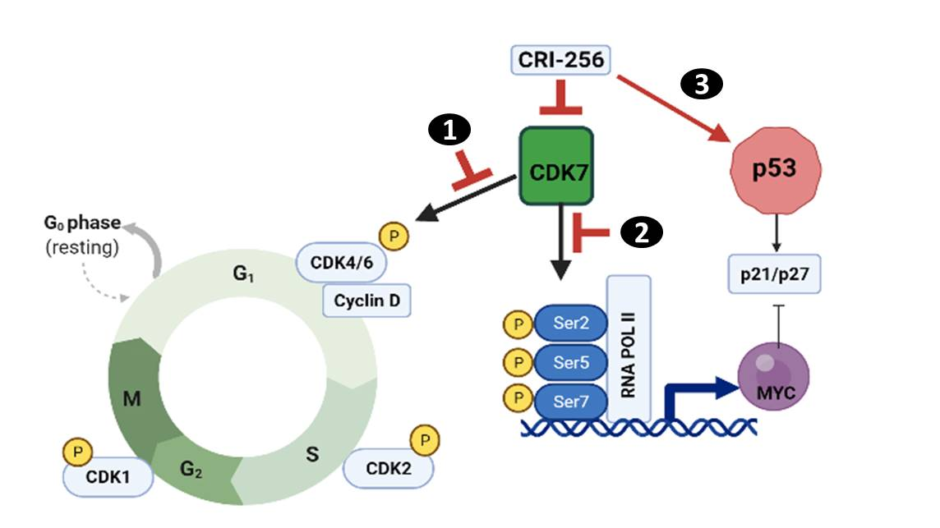

CRI-256 is novel orally bioavailable, covalent and irreversible inhibitor of CDK7. 1) It leads to cell cycle arrest by inhibiting activity of CDK7 to phosphorylate T loops of CDKs. 2) It leads to transcription suppression by decreasing phosphorylation at Ser2/5/7 of RNA pol II which ultimately decreases the transcript of oncogenes such as c-Myc. 3) It stabilizes p53 and activates its downstream targets such as p21/p27

**Objectives:**

1. Evaluation of anti-proliferative activity of CDK7 and BCL-2 inhibitors using different leukemic cell lines and patient derived primary myeloid blasts.
2. To study the functional effects of small molecule inhibitors on the pathways of apoptosis and proliferation in AML.

**Materials and Methods:**

***Cell lines***: Leukemic cell lines OCI AML2 and OCI AML3 were originally procured from European Institute of Oncology (Milan, Italy) and authenticated by short tandem repeat profiling. MOLM13 parental and resistant cells were provided by MD Anderson, USA.

***Patients samples:*** The peripheral blood (PB) from 48 *de novo* AML patients including primary refractory and relapse/refractory from good, intermediate and poor risk groups was collected in BD Vacutainer containing Acid Citrate Dextrose (PB 7ml) and PAX RNA tubes (PB 2.5ml) with informed consent as per institute guidelines. Cytogenetic analyses and mutation detection was done by standard molecular techniques and the next generation sequencing (NGS) using Illumina platform.

Isolation and enrichment of blast cells from AML patients: Following density gradient centrifugation using ficoll-hypaque, peripheral blood mononuclear cells (PBMCs) were isolated from peripheral blood of AML patients. Enrichment of blasts from PBMC was carried out using indirect microbeads based on the magnetic-activated cell sorting (Miltenyi Biotec) standard protocol.

**Antiproliferation assay:**

Cytotoxicity will be assessed using CellTiter-Glo (CTG) assay. Leukemic cells were seeded in sterile 96-well plates and immediately cultured in the presence of small molecule inhibitors (CRI-156, Cytarabine, Venetoclax) with a concentration range of 0.04 to 10 µM in triplicate wells for 72hrs at 37C, 5% CO2. The CTG assay was performed according to the manufacturers’ instructions (Promega). Cell viability at each drug concentration was calculated and the dose-response curve was generated using Graphpad Prism.

**Cell cycle and apoptosis analysis**

Cell-cycle analysis was performed at 24 hours after CRI-256 treatment. Cells fixed in chilled ethanol were incubated with propidium iodide (PI) and RNase Solution (Cell Signaling Technology) for 30 minutes at room temperature. Apoptosis was determined using Dead Cell Apoptosis Kit with Annexin V-FITC and PI by manufacturer's instructions (Life Technologies). Flow cytometric analysis was done on a FACS Attune cytometer and data were analyzed by using Modfit and FlowJo software.

**Western blot analysis**

RIPA buffer was used to lyse the cells containing proteinase and subjected to SDS-PAGE followed by Western blot analysis. Antibodies against the following proteins were used: CDK1,p-CDK1,CDK2, P-CDK2, CDK7, RNAPII, RNAPII S2, RNAPII S5, RNAPII S7, cleaved PARP, cleaved caspase3, MCL1, BCL2, BCLXL, XIAP, p53, p21, p27, p-STAT3(T705), p-AKT(S473), c-MYC, actin, (Cell Signaling Technology)

**RNA sequencing and analysis**

MOLM13 cells were treated with CRI-256 (1µM for 6 hours) or vehicle control. RNA (Two biological replicates per condition) was extracted using RNeasy Plus Mini Kit (Qiagen) according to the manufacturer's protocol. RNA quality was assessed using a Bioanalyzer. Library preparation was done using Prep kit for Illuminia with Collibri (Invitrogen; Cat numbers A39003024 and A 39003096) followed by sequencing using Illumina Hiseq 2500 platform. An adjusted P-value<0.05 was kept for genes which were differentially expressed. Pathway analysis was performed using Reactome and GSEA analysis. **Knockout using CRISPR/Cas9 plasmids and virus infection**

Construction of lenti-CRISPR/Cas9 vectors targeting c-MYC was performed following the protocol associated with the backbone vector (#45, Addgene; ref. 16). The gRNA sequences for c-Myc is:

fwd:CACCGGCCGTATTTCTACTGCGACG;

rv: AAACCGTCGCAGTAGAAATACGGCC

The CDK7 knockout was done using Edit-R All-in-one lentiviral system (Dharmacon).

CDK7 target sequence was: CTTAATGGCGACAATTTGGT

**Tumor xenograft models**

For CRI-256 efficacy studies, MOLM13 cells were subcutaneously injected in the 6-8 weeks old NOD/SCID mice. After 10 days when tumor sizes reached approximately 150 mm3 , mice were divided into three groups of 8 mice in each. Vehicle control group treated with DMSO, other group CRI-256 treated with 60mg/Kg/oral daily and Cytarabine group treated with 20mg/Kg/ intraperitoneal daily) for 8 days. Mice were sacrificed and tumor specimens of mice were decalcified and paraffin embedded followed by slides made and stained with hematoxylin and eosin (H & E) for assessment of tumor necrosis and fibrosis.

**Results:**

**1) Antiproliferative effect of CRI-256 in leukemic cells and patient derived myeloid blasts:**

The antiproliferative effect of CRI-256, Venetoclax and cytarabine using OCI-AML2, MOLM13 and OCI-AML3 cells is shown in Figure 1A. Despite being genetically diverse nature of these cell lines, antiproliferative activity of CRI-256 was found to fall in narrow range of inhibitory concentration (IC50) as compared to Venetoclax or standard of care (Cytarabine). The data from patients derived myeloid blasts revealed the mean IC50 of CRI-256, Venetoclax and cytarabine was 0.3µM, 0.023µM and 0.41µM (Figure 1B). We also analyzed the effect of CRI-256 on peripheral blood mononuclear cells (PBMCs) from fifteen healthy individuals. The mean IC50 using healthy PBMCs was 4.28µM which is significantly higher compared to the data obtained using forty-eight primary myeloid blasts (p<0.001). These findings indicate that CDK7 inhibition does not have a significant antiproliferative effect on healthy mononuclear cells. (Figure 1C).

Furthermore, we analyze the comparative effect of three drugs on primary myeloid blasts, the data from 13 patients was available. Based on Medical Research Council (MRC) risk classification, six out of 13 were in high risk while 4/13 and 3/13 were from intermediate and low risk groups. Consistent with AML cell lines results, the *ex vivo* data from 13 primary AML blasts show that IC50 values of CRI-256 were confined in narrow range as compared to Venetoclax and Cytarabine (Figure 1D). These results suggest that CDK7 inhibition is uniformly effective across different genetic risk groups in AML.

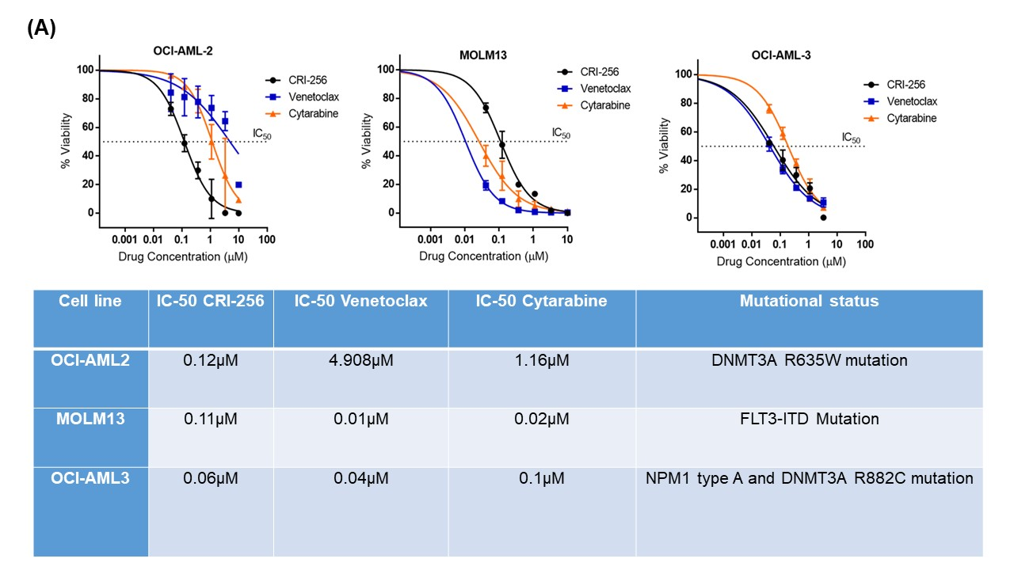

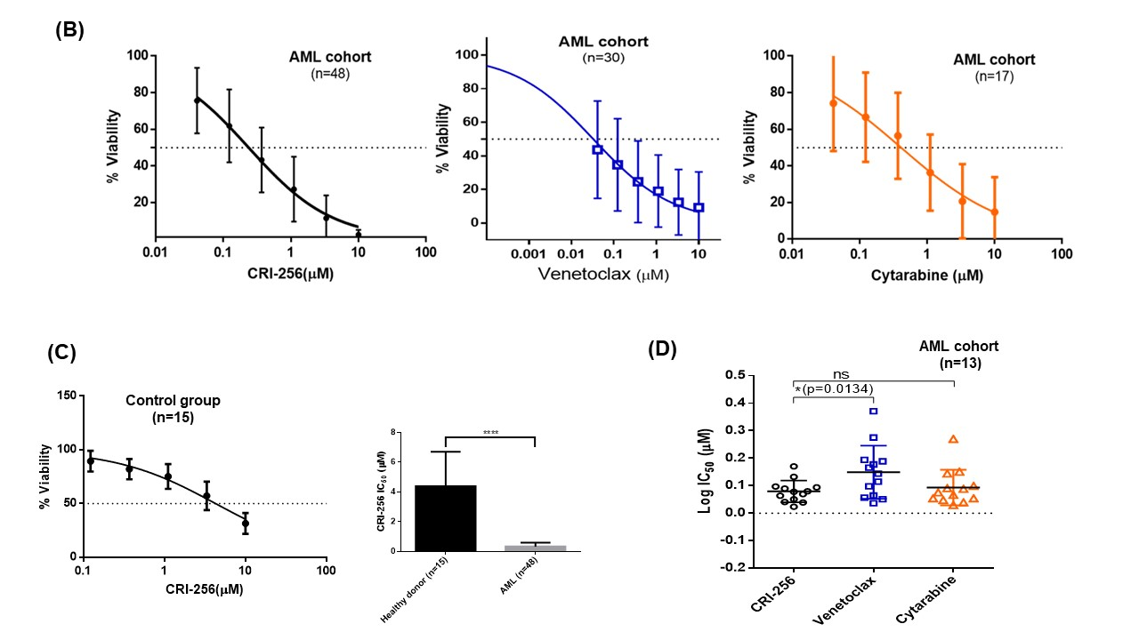

**Figure 1: Antiproliferative effects of CDK7 inhibitor (CRI-256), Venetoclax and Cytarabine in AML** (A) Comparison of IC50 of CRI-256 with Venetoclax and Cytarabine in different leukemic cell lines after 72hrs of drug treatment. (B) Antiproliferative analysis of CRI-256, Venetoclax and Cytarabine in patient derived myeloid blasts. (C) IC50 of CRI-256 in mononuclear cells derived from healthy individuals and comparative analyses of CRI-256 cytotoxicity in AML and controls (D) Comparative IC50 analysis of 3 drugs in patient derived myeloid blasts

**2) The genome-wide impact of CDK7 inhibition by CRI-256 on transcription of leukemic cells:**

Consistent with the reported role of CDK7 inhibitors, CRI-256 led to concentration dependent decrease in phosphorylation of RNA polymerase II CTD domain at Ser2, Ser5, and Ser 7 in AML. The basal levels of RNA polymerase II and CDK7 remains unchanged (Figure 2A).In view of multiple targets inhibited by CDK7 inhibition, high throughput RNA sequencing (RNA-seq) was performed to explore the mechanism of action of CRI-256 in an unbiased manner. RNA-seq results of MOLM13 cells treated with 1µM CRI-256, or vehicle control for 6 hours revealed a global reduction in mRNA levels (Supplemental Figure). Reactome analyses following RNA-seq of CRI-256 treated MOLM13 cells revealed a significant enrichment of genes involved in cell cycle regulation and TP53 mediated transcription pathways (Figure 2B and 2C). The m-RNA levels of the key genes involved in these pathways such as *p21, BTG2, PCNA, AUKB, INKA2, TOP2A, RAD51, E2F1,* and *MYC* were validated using quantitative real-time PCR at 2 6hrs and 24hrs of CRI-256 treatment. (Figure 2D)

CRI-256 stabilizes p53 and downregulates levels of STAT3 phosphorylation in MOLM13 cells:

Interestingly, RNA-seq data revealed an association between CDK7 inhibition and activation of signaling pathway mediated by p53. Although *p53* mutations are present in approximately 5% of patients with newly diagnosed AML, dysregulation of p53 plays significant role in AML pathogenesis irrespective of the mutational status. It has been found that p53 dysregulation such as low expression of p53 can occur through aberrant expression of proteins that regulate p53 stability and function. On functional validation of RNA–seq data of p53 network, we observed dose dependent stabilization of p53 and p21 on CDK7 inhibition (Figure 2E). The precise mechanism underlying p53 stabilization upon CDK7 inhibition remains to be elucidated. However, the preliminary data suggests that CDK7 inhibition can be of therapeutic relevance for non-mutated p53 AML.

Recently Cayrol et. al. have demonstrated that CDK7 activity is necessary to maintain the transcriptional program induced by signal transducer and activator of transcription (STAT3) proteins in peripheral T-cell lymphomas (PTCL). We attempted to explore the effect of CDK7 inhibition by CRI-256 on STAT3/AKT axis. The phosphorylation of STAT3 at Tyr705 and AKT at Serine 473 was determined after 6 hrs treatment with CRI-256 in AML cells. The STAT3 phosphorylation was found to decrease on CDK7 inhibition by CRI-256 as the concentration of CRI-256 increases. The basal levels of STAT3 remained unchanged. Similarly, phosphorylation of AKT decreases and basal level AKT remains same. (Figure 2E). This indicated that STAT3/AKT oncogenic signaling can be targeted in AML through CDK7 inhibition.

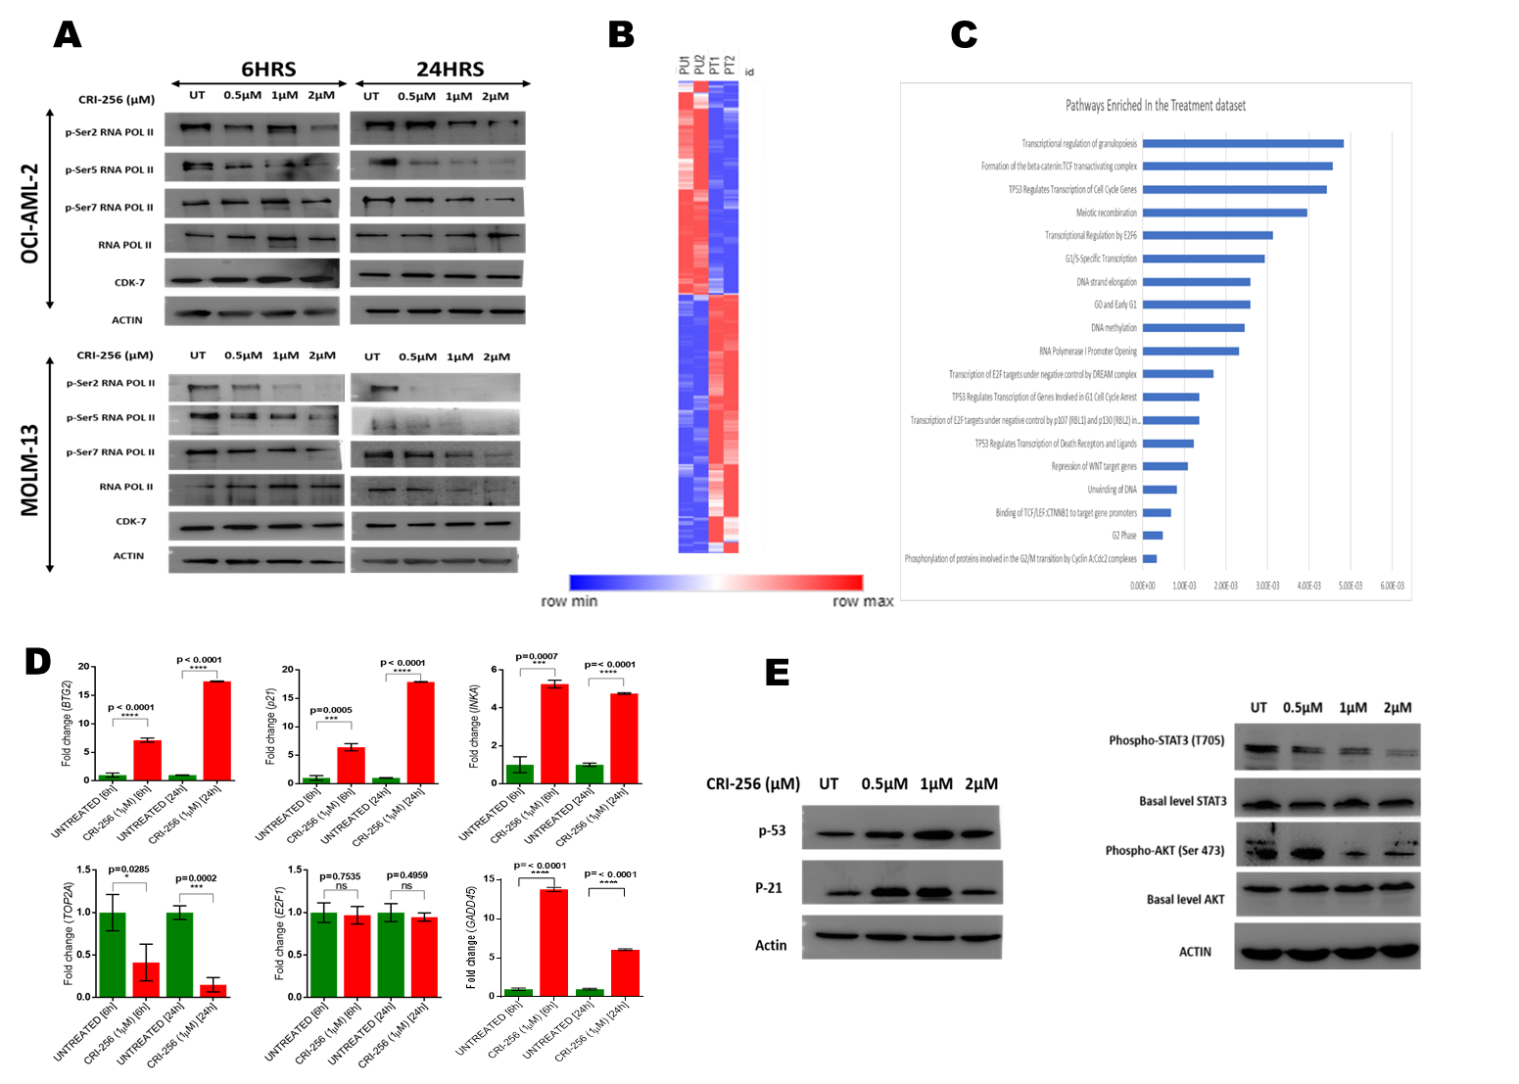

**Figure 2: The impact of CRI-256 on genome-wide gene expression in AML cells.** (A) CRI-256 led to concentration dependent decrease in phosphorylation of RNA polymerase II CTD domain at Ser2, Ser5, and Ser 7 in leukemic cells. (B) RNA-seq derived heatmap of gene expression of MOLM13 cells after 6hrs of 1µM CRI-256 treatment. (C) List of top enriched pathways by Reactome pathway analysis. (D) RQ-PCR validation of enriched genes from RNA-seq data after 6hrs and 24hrs of 1µM CRI-256 treatment (E) Stabilization of p53 & p21 and activation of STAT3/AKT pathway after 6hrs of CRI-256 treatment.

**3) CRI-256 leads to cell cycle arrest by targeting c-MYC**

**i) Cell cycle arrest by CDK7 inhibition**

RNA-seq data derived from AML cells after CRI-256 treatment suggest the underlying mechanism of action of CRI-256 in leukemic cells might relate to the preferential modulation of genes involved in cell cycle and apoptosis. In order to validate those results, we analyzed the effect of CRI-256 on cell cycle and apoptosis in AML. The treatment with CRI-256 showed increase in cells arrested at G1 phase accompanied by reduction in S phase (Figure 3A). Inactive CDKs have presence of large activation loop called T loop emerging from C terminal domain and blocking substrate-binding site. Phosphorylation at conserved threonine residues within this T-loop by CDK-7 is required for cell cycle progression. This phosphorylation of threonine at 161 and 170 positions of CDK1 and CDK2 respectively was inhibited by CRI-256 at 1µM drug concentration. (Figure 3B)

**ii) c-Myc downregulation is associated with CDK7 inhibition, which ultimately leads to cell cycle arrest**

CDK7 is an important positive regulator of super enhancer-mediated transcription, and expression of super enhancer-associated genes such as c-Myc. The c-Myc is frequently dysregulated in AML and plays an important role in leukemogenesis. Therefore, we investigated if c-Myc expression is vulnerable to CDK7 inhibition in primary myeloid blasts and leukemic cell lines. We observed the downregulation of c-Myc at transcript and protein levels in dose dependent manner in two different AML cell lines after 6 and 24 hours of CRI-256 treatment (Figure 3C). To validate the findings, primary blasts from four AML patients were treated with 1µM of CRI-256 for 24hrs. We detected similar effects of CRI-256 on c-Myc protein expression as observed in cell lines (Figure 3D). The c-Myc is known to play crucial role in cell cycle transition from G1 to S phase. In MOLM13, cells by utilizing CRISPR/Cas9 Myc expression was knock out in two clones and the effect on downstream targets such as p21 and cyclin D was analyzed along with cell cycle distribution. As expected, the myc knockout stabilizes the expression of cell cycle inhibitor, p21 and decreases the expression of oncogene cyclin D. The c-MYC knockout also arrested the cells in G1 phase and reduces cell number in S phase (Figure 3E). Thus, CRI-256 induces cell cycle arrest by targeting c-MYC.

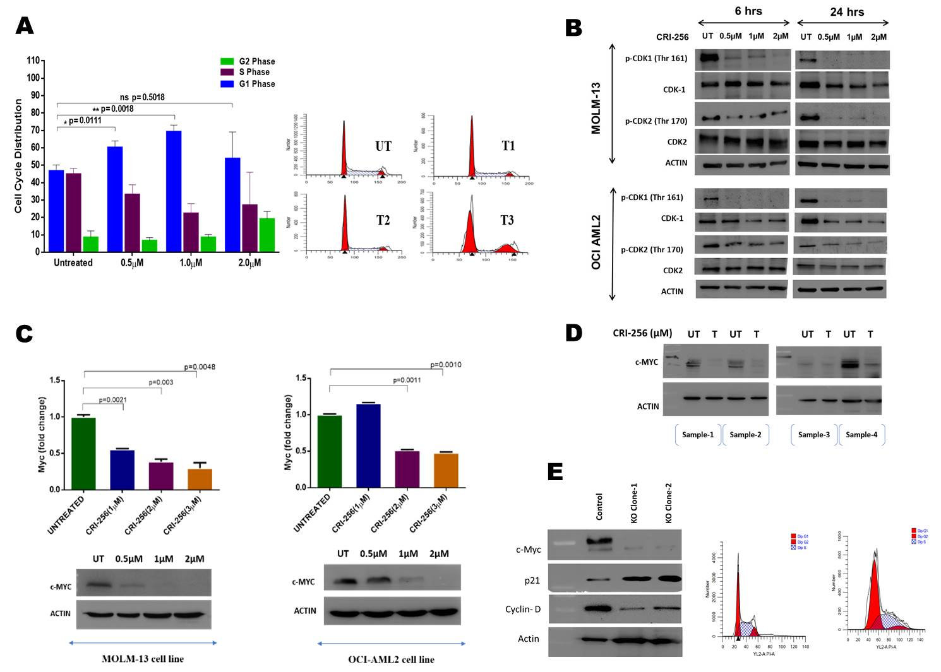

**Figure 3. CRI-256 targets transcription of oncogene c-myc:** (A) Cell cycle analysis using flow cytometry shows increase in population of cells in G1 phase and significant decrease in S phase after CRI-256 treatment for 24hrs.(B) Decrease in expression of p-T161 of CDK1 and p-T170 of CDK2 in OCI AML2 & MOLM13 cells after 6hrs and 24hrs of CRI-256 treatment. (C) Dose dependent decrease in expression of c-myc after 24hrs of CRI-256 treatment in leukemic cells.(D) Decrease in expression of myc in patient derived AML blast cells after 24hrs of 1µM CRI-256 treatment. (E) CRISPR/Cas9 mediated knockout of myc leads to stabilization of p21 and downregulation of cyclin D along with cell cycle arrest.

**4) CRI-256 treatment induces mitochondrial mediated apoptosis in MOLM13 cells *in vitro***

Interruption of the cell cycle in cancer cells by interfering with the action of CDKs induce mitochondria-mediated apoptosis. We tested CRI-256 ability of inducing apoptosis in AML cell lines using annexin-PI (Figure 4A). Mitochondrial apoptotic death is also mediated by the inhibition of the transcriptional kinases. In AML, high expression of MCL-1, BCL-XL, BCL-2 and XIAP plays a significant role in the development of resistance against the current therapeutic regimens. To assess if CDK7 inhibition will modulate the expression these pro-survival proteins, we treated AML cells with CRI-256. As the dose of drug increased the expression of MCL-1 and XIAP was significantly reduced. The levels of BCL-XL were reduced only after 2µM of treatment. The levels of BCL-2 were found to be same as it is reported to be a highly stable protein. The PARP cleavage and Caspase 3 cleavage was observed after 1µM of treatment (Figure 4B). Taken together, the findings suggest that CDK7 inhibition by CRI-256 causes cell cycle arrest and induces mitochondrial mediated apoptosis in cells.

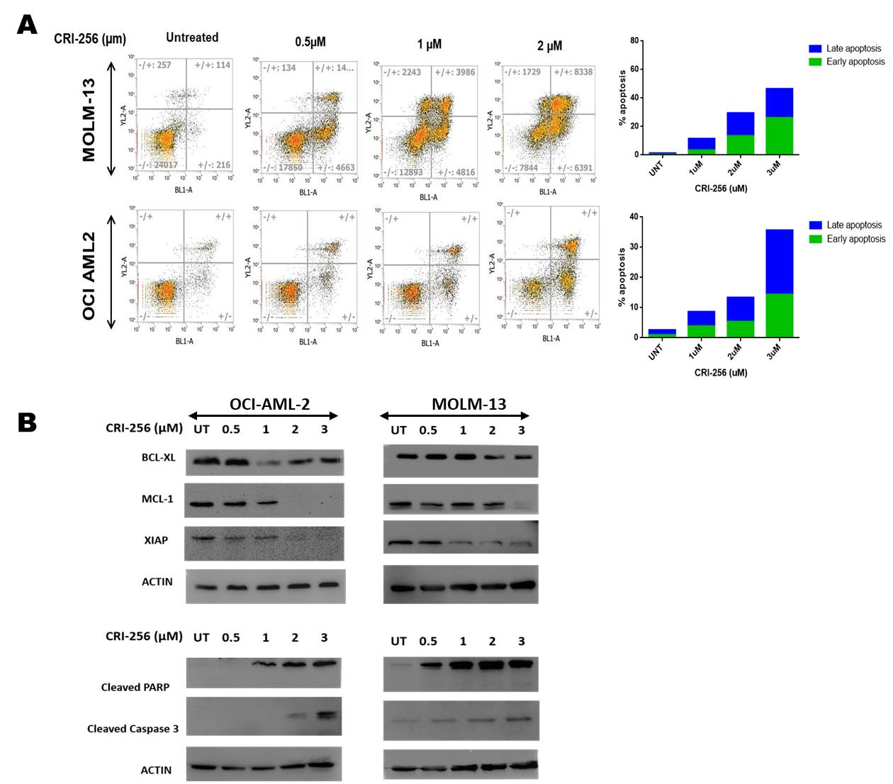

**Figure 4: CRI-256 induces mitochondrial mediated apoptosis: (A)** Apoptosis induction was determined by Annexin-PI after 24hrs of CRI-265 treatment in leukemic cells. (B) Change in expression of antiapoptotic protein after 24hrs of drug treatment in AML cells. Induction of cleaved PARP and cleaved Caspase 3 in dose dependent manner

**5) Targeting CDK7 expression using CRISPR Cas9**

In order to validate these results, the CRISPR/Cas9 technique was used to genetically deplete CDK7 gene in MOLM13 cells. In comparison to control, the knockout cell line displayed dramatic reduction in cell viability and proliferation. The phosphorylation at residue Ser2/5 was decreased in knockout clone in comparison to vector control. Also, the target of CDK7, c-Myc was slightly reduced in clonal population whereas there is stabilization of p27, a cell cycle inhibitor (Figure 5A). CDK7 knockout also caused a substantial accumulation of cells in the G1/S phase of the cell. These results suggest that CDK7 knockout suppresses cell proliferation via induction of cell cycle arrest. (Figure 5B)

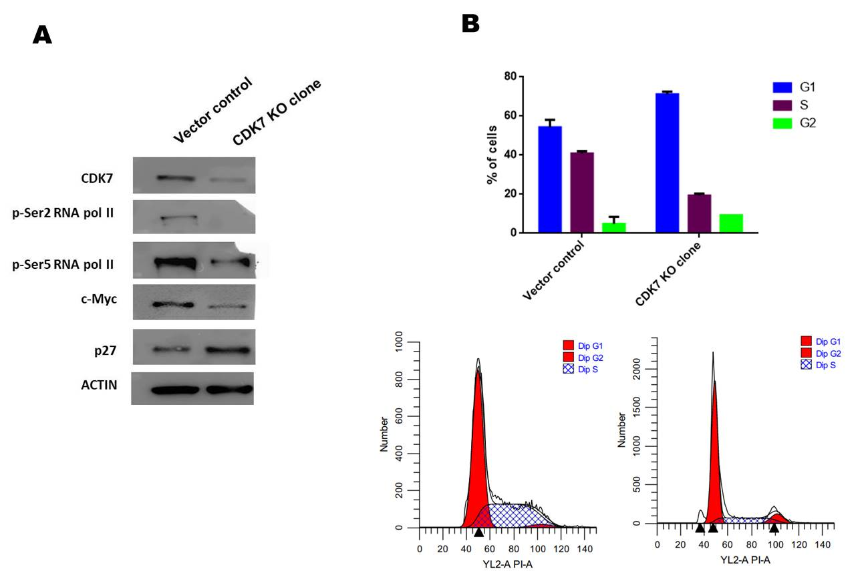

**Figure 5: CDK7 knockout suppresses cell proliferation : (A)** CRISPR/Cas9 mediated knockout decreases the phosphorylation at Ser2/5 of RNA polymerase II as well as c-Myc and stabilized p27 . (B) Cells arrested at G1 phase after CDK7 knockout.

**5) CRI-256 targets AML cells *in vivo***

Based on the efficacy observed for CRI-256 *in vitro*, we next evaluated its anti-leukemic activity using subcutaneous xenografts of AML in NOD/SCID mice. One week after establishing tumor, mice were randomized and treated with CRI-256 (60mg/Kg/oral daily) and Cytarabine (20mg/Kg/intraperitoneal daily) for 8 days. In comparison to vehicle control and cytarabine treated animals, we observed significant tumor reduction in CRI-256 treated mice (Figure 6A-C). All experimental mice were sacrificed for tissue harvest. H&E staining revealed that tumor taken from CRI-256 treated mice showed more apparent disintegrated cells, which signifies induction of necrosis in tumor tissues in comparison to Cytarabine and vehicle control. (Figure 6D). The CRI-256 treatment did not affect in body weight of animals. These results indicates that CRI-256 exert its anti-leukemic effects *in vivo* without any apparent toxicity effects.

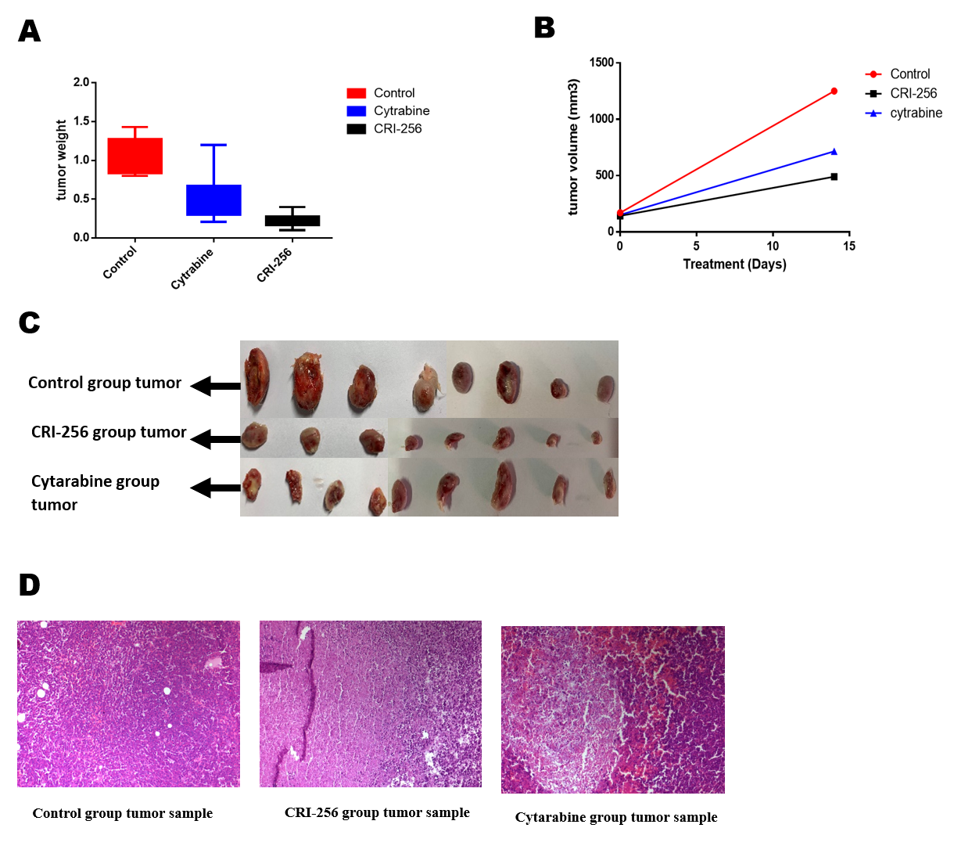

**Figure 6: Efficacy of CRI-256 in-vivo AML model.** (A) Mean tumor weight (in grams) of mice treated with vehicle control, Cytarabine and CRI-256 (n=8 in each group). (B) Mean tumor volume of mice treated with vehicle control, Cytarabine and CRI-256 (C) Tumor excised from each treatment group after 8 days of drug treatment. (D) Representative image of H&E-stained tumor sample from each group after 8 days of drug treatment.

**6) BCL-2 inhibition cooperates with CRI-256 in reducing expansion of myeloid blasts**

Given the modulation of pro-survival proteins by CDK7 inhibition, we aimed to identify synergistic doses between CRI-256 and Venetoclax which is a BCL-2 specific inhibitor. We performed cell viability studies via CellTiter-Glo and generated dose response curves for the combination of CRI-256 and Venetoclax. To assess for any synergistic action, we employed Calsusyn combination index (CI). The CI values derived from OCI-AML2 and OCI-AML3 cells indicated synergistic combination of drugs (Figure 7A). To further demonstrate synergy of CRI-256 and Venetoclax, we treated primary patient AML cells with combination therapy by keeping IC-50 of CRI-256 constant (0.1µM) and varying 5 different concentrations of Venetoclax. Primary myeloid blasts from 10 mutationally diverse AML patients were tested and evaluated for cell viability. We found that combination of CRI-256 and Venetoclax was highly synergistic as the CI value lies below 1 in most cases. (Figure 7B). To verify induction of apoptosis and down regulation of pro survival proteins, we treated MOLM13 cells with Venetoclax or the combination and conducted protein expression experiments. The expression of MCL-1 increases on Venetoclax treatment, however it drastically decreased in combination with CRI-256. The levels of BCL-XL remained unchanged on Venetoclax treatment and it mildly decreases in combination. The enhanced PARP cleavage and Caspase 3 cleavage was observed in combination of both the drugs (Figure 7C).

**7) Combination of CRI-256 and Venetoclax reduces MCL1 expression levels**

Although Venetoclax is effective in inducing apoptosis in AML, upregulated MCL1 is often associated with resistance to treatment with Venetoclax. We tested the effects of CRI-256 in paired Venetoclax sensitive (IC50-0.11µM) and resistant (IC50-0.162 µM) MOLM13 cell lines. We observed that the combination of CRI-256 and Venetoclax was highly synergistic in Venetoclax resistant MOLM13 cells (MOLM13-VR) (Figure 7D). It was found that MCL-1 is slightly upregulated in Venetoclax resistant model. The expression of MCL-1 in both MOLM-13 parental as well as MOLM-13 resistant cells decrease on CRI-256 drug treatment as the concentration of drug increases. (Figure 7E). This suggest that upregulated MCL-1 expression found in Venetoclax resistant cells can be overcome by CDK-7 inhibition.

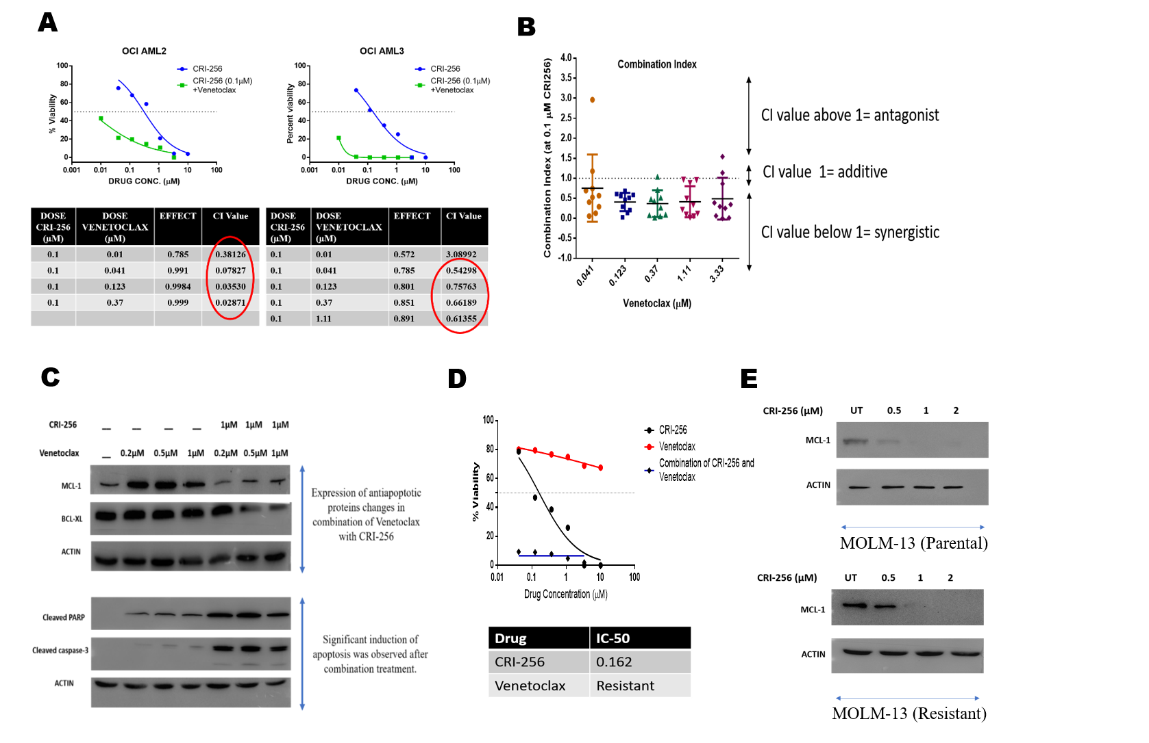

**Figure 7: CRI-256 shows synergy with Venetoclax.** (A) Combination index (CI) values of CRI-256 and Venetoclax in OCI-AML2 and OCI-AML3 cells. (B) Combination index values of 10 AML blast samples. (C) Change in expression of antiapoptotic protein after 24hrs of drug treatment in AML cells. Induction of cleaved PARP and cleaved Caspase 3 in dose dependent manner. (D) IC-50 of CRI-256, Venetoclax and combination of CRI-256 with Venetoclax in MOLM13 Venetoclax resistant model. (E) Decrease in expression of MCL1 in dose dependent manner in MOLM13 parental and resistant cells after 24hrs of CRI-256 treatment.

**Statistical analysis:**

GraphPad Prism version 4.00 (GraphPad Software, San Diego, CA) was used for statistical analysis. Values between groups were compared using one-way analysis of variance (ANOVA), nonparametric test. Paired t-tests were performed to test differences in vehicle and compound treated groups. P values less than 0.05 were considered statistically significant.

**Discussion:**

Although effective molecular targeted therapies exist for chronic myeloid leukemia and acute promyelocytic leukemia but 3+7 cytotoxic chemotherapy and stem cell transplantation continue to be essential means in the treatment of AML. However, current chemotherapy regimens remain inadequate and fail to induce or sustain long-term remissions in AML, due to the emergence of leukemic blasts, which remain resistant to apoptosis following chemotherapy. This resistant leads to relapse and eventually patients die of leukemia. It is well established that apoptotic block and proliferation of undifferentiated cells of myeloid progeny is responsible for the development of AML.

The discovery and development of small molecule cancer drugs has been revolutionized over the last decade. Defects in apoptotic machinery are one of the main mechanisms that cells use to escape cell death. Small molecule inhibitors aiming at restoring apoptosis in leukemic cells have shown encouraging activity in early clinical trials and some of these drugs including Venetoclax are currently being evaluated in randomised controlled trials. The majority of AMLs are genetically diverse. Cell-to-cell variability in apoptosis signaling contributes to heterogenic responses to cytotoxic/targeted stress in AML. Within a clonal cell population, some cells rapidly induce apoptosis, while other cells appear more resistant and continue to proliferate. Thus, improved therapeutic strategies to overcome apoptotic resistance and enhanced proliferation are needed.

Targeting the apoptotic defects by direct inhibition of BCL-2 family proteins and uncontrolled proliferation by CDK inhibitors can restore cell sensitivity to cell death. Therefore, there is a critical need to develop robust in vitro and animal models to study signaling between BCL-2 proteins and cyclin dependent kinases and combining their targeted actions for the improved therapeutic strategies to overcome apoptotic resistance in AML.

In the present study, we describe orally bioavailable non-covalent inhibitor of CDK7 that inhibits leukemic growth in vitro as well as in mouse model. CRI-256 showed antiproliferative activity in different leukemic cell lines as well as patient derived blast cells. As the IC50 of the compound was in a narrow range in comparison to Venetoclax and cytarabine, it suggests that CDK7 inhibition can work effectively in patients of different risk groups. Also, a higher IC50 value of compound in comparison to AML blast in healthy PBMC demonstrated low toxicity in normal cells.

Further transcriptomic data suggested that mechanism of action underlying the efficacy of CRI-256 in leukemic cells might relate to the preferential modulation of gene involved in cell cycle and apoptosis. Several studies have reported c-Myc as a candidate oncogenic driver in different cancer models. Here, we further discovered that a selective CDK7 inhibitor, CRI-256 exerted antineoplastic activity by disrupting c-myc-dependent transcriptional machinery leading to cell-cycle arrest in leukemic cells.

The inhibitor showed antileukemic effect in subcutaneous AML model as a single agent. It was also found to be synergistic in combination with Venetoclax in leukemic cell lines as well as in patient samples. Furthermore, it decreases the expression of MCL-1, which was reported to be the emerging cause of Venetoclax resistance.

In conclusion, we have shown extensive preclinical evidence that novel transcriptional suppressor CRI-256 serves as a promising therapeutic option for the acute myeloid leukemia. Although AML blast display tremendous heterogeneity however it remains exquisitely addicted to oncogenes which are responsible for high transcriptional rates such as c-MYC & MCL-1. The development in molecular characterization of AML, identification of mutations playing role in pathogenesis of disease as well as frustrating clinical outcomes of conventional 7+3 chemotherapy, strongly encouraged the idea of more efficacious targeted therapies, which can be more specific and less toxic. Our study highlights CDK7 inhibition by novel inhibitor, CRI-256 as a new molecular target in combination with Venetoclax as an alternative to conventional chemotherapy.

**Impact of the research in the advancement of knowledge or benefit to mankind**

Acute myeloid leukemia (AML) treatment aims at the eradication of all leukemic cells to achieve remission status. Available treatments produce complete remission (CR) in up-to 80% of patients. However, ~60% of them will relapse. In a three-year prospective study carried out by our group at Tata Memorial Centre (TMC) involving 149 newly diagnosed AML patients, the overall survival was 36.5%. Also, another Indian group from Christian Medical College (CMC) Vellore have shown figures related to the treatment hurdles and survival outcome in AML patients. The group conducted single centre prospective study to address the issues of AML patients in India. Three hundred and eighty *de novo* AML patients were recruited over a period of two years. The overall survival at 1 year was 70·4% ± 10·7%, 55·6% ± 6·8% and 42·4% ± 15·6% in patients aged ≤15 years, 15 ‐ 60 years and ≥60 years, respectively. These results illustrate the challenges faced in treating AML patients in India as the vast majority succumbed to their disease following cytotoxic chemotherapy. The current available curative approach for AML is hematopoietic stem cell transplant. However, the procedure is extremely costly therefore most of Indian patients cannot afford it. Hence, there is a critical need to develop novel strategies, targets and targeted therapy for the management of AML. The reason behind the current treatment failure in AML is the defects in the pathways of proliferation and apoptosis. The survival of AML blasts is dependent on the mitochondrial apoptotic pathway involving BCL2 family of proteins and cyclin dependent kinases (CDKs). Although, some data is available from India in relation to the BCL2 inhibition, MCL-1 expression and cyclin dependent kinase inhibitors, but no systematic study has been undertaken in the context of AML. Therefore, this study can contribute in identifying affordable, efficient and less toxic drug combination strategies to kill leukemia cells, which will ultimately lead to positive impact on the lives of AML patients in India as well as in global scenario.

**Literature References**

1. Dohner H, Gaidzik VI. Impact of Genetic Features on Treatment Decisions in AML. Hematology. 2011;2011(1):36-42. doi:10.1182/asheducation-2011.1.36.

2. Ottone T, Alfonso V, Iaccarino L, et al. Longitudinal detection of DNMT3A R882H transcripts in patients with acute myeloid leukemia. Am J Hematol. 2018;93(5):E120-E123. doi:10.1002/ajh.25061.

3. Welch JS, Ley TJ, Link DC, et al. The Origin and Evolution of Mutations in Acute Myeloid Leukemia. Cell. 2012;150(2):264-278. doi:10.1016/j.cell.2012.06.023.

4. Cancer Genome Atlas Research Network, Ley TJ, Miller C, et al. Genomic and Epigenomic Landscapes of Adult De Novo Acute Myeloid Leukemia. N Engl J Med. 2013;368(22):2059-2074. doi:10.1056/NEJMoa1301689.

5. Buolamwini JK. Cell cycle molecular targets in novel anticancer drug discovery. Curr Pharm Des. 2000;6(4):379-392. http://www.ncbi.nlm.nih.gov/pubmed/10788588. Accessed August 15, 2018.

6. Cayrol F, Praditsuktavorn P, Fernando TM, et al. THZ1 targeting CDK7 suppresses STAT transcriptional activity and sensitizes T-cell lymphomas to BCL2 inhibitors. Nat Commun. 2017;8:14290. doi:10.1038/ncomms14290.

7. Kwiatkowski N, Zhang T, Rahl PB, et al. Targeting transcription regulation in cancer with a covalent CDK7 inhibitor. Nature. 2014;511(7511):616-620. doi:10.1038/nature13393.

8. Deng J. How to unleash mitochondrial apoptotic blockades to kill cancers? Acta Pharm Sin B. 2017;7(1):18-26. doi:10.1016/j.apsb.2016.08.005.

9. Ricciardi MR, Mirabilii S, Licchetta R, Piedimonte M, Tafuri A. Targeting the Akt, GSK-3, Bcl-2 axis in acute myeloid leukemia. Adv Biol Regul. 2017;65:36-58. doi:10.1016/j.jbior.2017.05.002.

10. Konopleva M, Pollyea DA, Potluri J, et al. A Phase 2 Study of ABT-199 (GDC-0199) in Patients with Acute Myelogenous Leukemia (AML). Blood. 2014;124(21). http://www.bloodjournal.org/content/124/21/118/tab-e-letters?sso-checked=true. Accessed August 15, 2018.

11. DiNardo C, Pollyea D, Pratz K, et al. A Phase 1b Study of Venetoclax (ABT-199/GDC-0199) in Combination with Decitabine or Azacitidine in Treatment-Naive Patients with Acute Myelogenous Leukemia Who Are ≥ to 65 Years and Not Eligible for Standard Induction Therapy. Blood. 2015;126(23). http://www.bloodjournal.org/content/126/23/327. Accessed August 15, 2018.

12. Li B, Ni Chonghaile T, Fan Y, et al. Therapeutic Rationale to Target Highly Expressed CDK7 Conferring Poor Outcomes in Triple-Negative Breast Cancer. Cancer Res. 2017;77(14):3834-3845. doi:10.1158/0008-5472.CAN-16-2546.

13. Bogenberger J, Whatcott C, Hansen N, et al. Combined venetoclax and alvocidib in acute myeloid leukemia. Oncotarget. 2017;8(63):107206-107222. doi:10.18632/oncotarget.22284.

14. Walsby E, Lazenby M, Pepper C, Burnett AK. The cyclin-dependent kinase inhibitor SNS-032 has single agent activity in AML cells and is highly synergistic with cytarabine. Leukemia. 2011;25(3):411-419. doi:10.1038/leu.2010.290.

15. Hasan SK, Patkar N, Vishwakarma D, et al. Over-Expression of ERG Predicts Poor Outcome in Acute Myeloid Leukemia. Blood. 2017;130(Suppl 1).

16. Philip C, George B, Ganapule A, et al. Acute myeloid leukaemia: challenges and real world data from India. Br J Haematol. 2015;170(1):110. doi:10.1111/BJH.13406.

17. Basak NP, Banerjee S. Mitochondrial dependency in progression of acute myeloid leukemia. Mitochondrion. 2015;21:41-48. doi:10.1016/j.mito.2015.01.006.

18. Iyer D, Vartak S V., Mishra A, et al. Identification of a novel BCL2-specific inhibitor that binds predominantly to the BH1 domain. FEBS J. 2016;283(18):3408-3437. doi:10.1111/febs.13815.

19. Maji S, Samal SK, Pattanaik L, et al. Mcl-1 is an important therapeutic target for oral squamous cell carcinomas. Oncotarget. 2015;6(18):16623-16637. doi:10.18632/oncotarget.3932.

20. Choudhary GS, Al-Harbi S, Mazumder S, et al. MCL-1 and BCL-xL-dependent resistance to the BCL-2 inhibitor ABT-199 can be overcome by preventing PI3K/AKT/mTOR activation in lymphoid malignancies. Cell Death Dis. 2015;6(1):e1593. doi:10.1038/cddis.2014.525.

21. Joshi KS, Rathos MJ, Joshi RD, et al. In vitro antitumor properties of a novel cyclin-dependent kinase inhibitor, P276-00. Mol Cancer Ther. 2007;6(3):918-925. doi:10.1158/1535-7163.MCT-06-0613.