***Detailed Research Work.***

My laboratory at the National Institute of Immunology has been working towards "**deciphering the role of cell signaling in *Mycobacterium tuberculosis (Mtb) biology****”* & “**investigating the role of phosphorylation events in modulating the functions of nucleoporins**”.

***Role of phosphorylation events in modulating the functions of nucleoporins.***

* A major constituent of the nuclear basket region of the nuclear pore complex (NPC), nucleoporin Tpr, plays role in regulating multiple important processes. We have established that Tpr is phosphorylated in both a MAP-kinase-dependent and independent manner, and that Tpr acts as both a substrate and as a scaffold for ERK2 (***Mol. Cell Biol*.** (2008) 22, 6954-6966).
* Investigations by our group showed that localization of nucleoporin Tpr is essential for Tpr- mediated regulation of the export of unspliced RNA (***Plos One*** (2012) **7**, e29921).
* We reported the identification of S2059 and S2094 as the major novel ERK-independent phosphorylation sites *in vivo* in the Tpr protein. We found that abrogation of S2059 phosphorylation abolishes the interaction of Tpr with Mad1, thus compromising the localization of both Mad1 and Mad2 proteins, resulting in cell cycle defects (***J of Cell Science*** (2014) **127**, 3505).

***­***

***Deciphering the role of cell signaling in Mtb biology***

Tuberculosis has been a long-standing problem in our country and due to the emergence of drug-resistant strains, the search for new drug targets continues. Its complex physiology and ability to survive in hostile environments, coupled with the serious rise in multidrug-resistant (MDR) and extensively drug-resistant (XDR) tuberculosis cases, has necessitated the renewal of efforts to understand the molecular basis of its pathogenesis. To effectively treat tuberculosis, it is imperative to find newer targets, which are important for *in-vivo* bacterial survival and persistence. We work broadly on the following two aspects:

* Phosphorylation based signaling cascades modulated by Eukaryotic like Serine/Threonine Protein Kinases and phosphatase in *Mtb,* transduce extracellular stimuli to a cellular response ensuing pathogen's growth, persistence, and pathogenesis. We are interested in discovering signaling networks in *Mtb* and delineate how the STPKs regulate multiple cellular processes such as; cell division, cell wall synthesis, secretion, transcription, and survival in the host.
* A possible way to overcome the emergence of drug resistance is to combine antibiotic treatment that kills the bacteria with targeting host molecules that are necessary for the sustenance of infection, which is termed adjunct **h**ost**-d**irected **t**herapy (HDT). To identify new possibilities for HDT, we investigated the role of pathogen mediated double-stranded DNA damage and the role of host NAD+ dependent histone deacetylase Sirtuin 2.

***Deciphering STPK mediated regulation of cellular processes in Mtb.***

***Deciphering kinase-mediated signaling networks in Mtb***

Protein phosphorylation has come forth as a preeminent circuitry regulating a vast number of physiological processes in the bacterial kingdom. There are 11 eukaryotic-like STPKs in *Mtb*, and we have worked towards analyzing the functional roles of the phosphorylation events mediated by these kinases.

* Protein kinases A and B, encoded by *pknA* and *pknB* respectively, are part of the operon carrying cistrons coding for protein phosphatase *pstP, rodA* (involved in cell shape control), and *pbpA* (involved in peptidoglycan synthesis). Work from the lab elucidated the roles of RodA and PbpA in regulating *in vitro* growth and *in vivo* survival of pathogenic mycobacteria (***J. Biol. Chem***. (2018) **293**, 6497).
* Using the mouse infection model, we observed that PknA is essential for the survival of the pathogen in the host. Even though PknA and PknB are expressed as part of the same operon, they appear to be regulating cellular processes through divergent signaling pathways (***J Biol Chem*.** (2015) **290,** 9626-9645).
* While there are 11 serine/threonine protein kinases in *Mtb*, only one serine/threonine phosphatase, PstP, has been identified. PstP depletion results in elongated multiseptate cells, suggesting a role for PstP in regulating cell division events. PstP plays an important role in establishing and maintaining infection, possibly via the modulation of cell division events. (***J Biol Chem*.** (2016) **291,** *24215-30).*
* A particular class of receptor-type serine-threonine kinase called PASTA (**P**enicillin-binding proteins **A**nd **S**erine **T**hreonine **A**ssociated) kinase is widespread across Gram-positive firmicutes and actinomycetes. We found that stringent regulation of *Mtb* of the PASTA kinase PknB (PknBMtb) to be necessary for cell survival. While the presence of the carboxy-terminal PASTA domain is dispensable in the avirulent *M. smegmatis*, all four PASTA domains are essential in *Mtb* *(****J. Biol. Chem***. (2014) **289**, 13858-75).
* 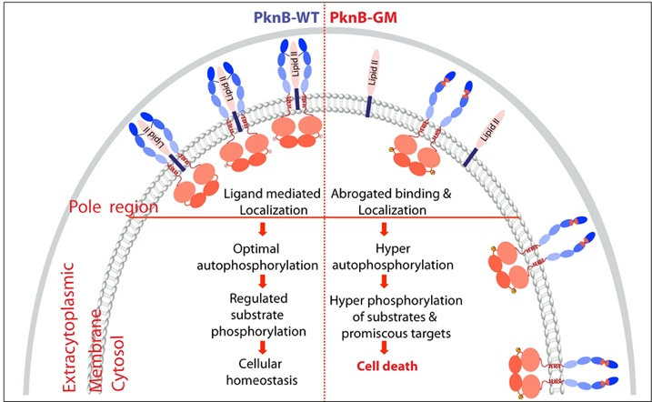With the help of *in silico* molecular simulations, we identified potential ligand-binding residues in the linker regions between PASTA3 and 4 domains. The extracytoplasmic domain interacts with mDAP-containing LipidII, and this is abolished upon mutation of the ligand-interacting residues.

***Figure 1. Model depicting PknB regulation wherein LipidII interacts with a specific region of PASTA 3-4 linker region of PknB and defines its localization to polar/septal niches and regulates the activity to optimal levels and hence maintains cellular homeostasis and cell survival.***

Contrary to the prevailing hypothesis, abrogation of ligand-binding is linked to activation loop hyperphosphorylation, and indiscriminate hyperphosphorylation of PknB substrates as well as other proteins, ultimately causing loss of homeostasis and cell death. (***Nature Communications*** (2019) **10, 1231)**.

* Protein kinase G (PknG), a thioredoxin-fold– containingeukaryotic-like serine/threonine protein kinase, is a virulencefactor in *M. tuberculosis*, required for inhibition ofphagolysosomal fusion. We showed for the first time that the expression of PknG in non-pathogenic mycobacteria allows the continued existence of these bacteria in host tissues (***J Biol. Chem.*** (2009) 284, 27467-27479).
* We unraveled novel functionalfacets of PknG during latency-like conditions. We proposed that PknG probably acts as a modulator of latency-associated signals (***J. Biol. Chem***. (2017) **292,** 16093-16108).
* Recently, we investigated the therapeutic potential of targeting PknG against latent mycobacterium. In the Cornell mouse model of latent TB, the deletion of *pknG* drastically attenuated *Mtb’s* ability to resuscitate post antibiotics treatment. Collectively, the results suggest PknG may be a promising drug target for adjunct therapy to shorten the treatment duration and lower disease relapse (***Antimicrob. Agents Chemother*** (2021).
* We were the first to characterize PknK and show that PknK modulates the activation of transcription from the promoter of mycobacterial monooxygenase operon, through phosphorylation of the transcriptional regulator VirS (***J. Biol. Chem.*** (2009) 284, 11090-11099).
* We showed that deletion of *pknL* causes an increase in the MIC of isoniazid. Collectively our data suggest that PknL plays a role in subverting redox stress and aids in better survival *ex vivo* and *in vivo* (***Tuberculosis (2021)***).

***Substrates of protein kinases.***

***GlmU of Mtb is a promising target for therapeutic intervention.***

* GlmU is an enzyme involved in the synthesis of UDP-GlcNAc, a key metabolite essential for the synthesis of peptidoglycan, disaccharide linker, arabinogalactan and mycothiol. We previously showed that GlmU is phosphorylated on T418 residue and its phosphorylation downregulates its acetyltransferase activity (***J. Mol. Biol*** (2009) 20, 451-64).
* In collaboration with Dr. Balaji Prakash, we determined the structure of GlmUMtb in complex with substrates bound at the acetyltransferase active site, and uncovered unique features in the carboxy terminus of GlmUMtb(***J. Biol. Chem*** (2012) 287, 39524-37).
* The absence of GlmUMtb leads to extensive perturbation of bacterial morphology and substantial reduction in cell wall thickness under normoxic as well as hypoxic conditions. We have developed a novel anti-GlmUMtb inhibitor (Oxa33), identified its binding site on GlmUMtb, and showed its specificity for GlmUMtb. The administration of Oxa33 to infected mice resulted in a significant decrease in the bacillary load. ***Our study suggests that GlmU is a promising target for therapeutic intervention*** (***Plos Pathogens*** (2015) **11**(10), e1005235).
* We delineated the role of *ftsQ*, a terminal gene of the highly conserved division cell wall (dcw) operon, in growth, survival, and cell length maintenance in *Mtb* (***J. Biol. Chem*** (2018) **293,** 12331).
* InhA, the primary target for the first line anti-tuberculosis drug isoniazid, is a key enzyme of the fatty-acid synthase II system involved in mycolic acid biosynthesis in *Mtb*. Our studies revealed that the phosphorylation of InhA by kinases modulates its biochemical activity, with phosphorylation resulting in decreased enzymatic activity (***J. Biol. Chem*** (2010) **285,** 37860).

***Comparative proteomic analyses of avirulent, virulent, and clinical strains of Mtb identified strain-specific patterns***

We performed systematic proteomic analyses of four strains - H37Ra, H37Rv, and clinical isolates BND and JAL, to determine the differences in protein expression patterns that contribute to their virulence and drug resistance. Label-free quantification analysis of the data revealed 257 differentially expressed protein groups. This study revealed that strain-specific variations in protein expression patterns have a meaningful impact on the biology of the pathogen ***(J. Biol. Chem. 291, 14257-73)***.

***Adjunctive host-directed therapy for the treatment of TB***

***Host sirtuin 2 as an immunotherapeutic target against tuberculosis***

*Mtb* employs a plethora of mechanisms to hijack the host defense machinery for its successful survival, proliferation, and persistence. *Mtb* upregulates one of the key epigenetic modulators, NAD+ dependent histone deacetylase Sirtuin 2 (SIRT2), which upon infection translocate to the nucleus and deacetylates histone H3K18, thus modulating the host transcriptome leading to enhanced macrophage activation. Pharmacological inhibition of SIRT2 restricts the intracellular growth of both drug-sensitive and resistant strains of *Mtb* and enhances the efficacy of front-line anti-TB drug Isoniazid in the murine model of infection. SIRT2 inhibitor-treated mice display reduced bacillary load, decreased disease pathology, and increased *Mtb*-specific protective immune responses. This study provides a link between *Mtb* infection, epigenetics, and host immune response, which can be exploited to achieve therapeutic benefits***(eLife*** (2020)***; 9:e55415).***

***Mtb* exploits host ATM kinase for survival advantage through SecA2 secretome**

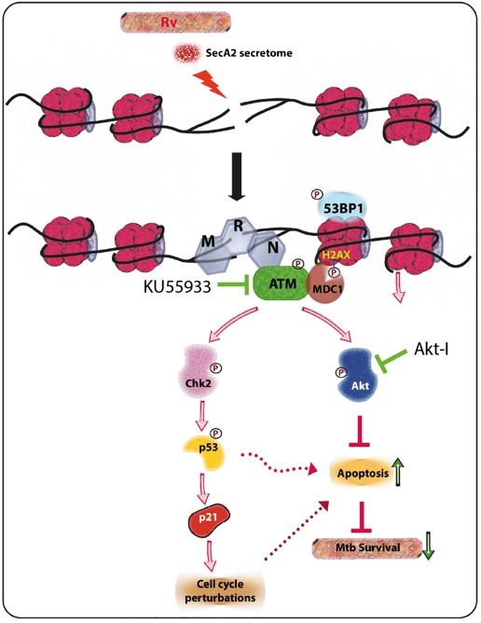In response to the damage, the host activates an intricate and indispensable signaling cascade entitled “**D**NA **d**amage **r**esponse" (DDR) pathway, which not only detects and repairs the damaged lesions in DNA but also regulates the activation of effectors that determine the fate of the cell. Ataxia telangiectasia mutated (ATM), ATM- and Rad3-related protein (ATR), and DNA dependent protein kinase catalytic subunit (DNA-PKcs) are three drivers of DDR Phosphorylation of H2AX at the serine 139 (γH2AX), at the site of damage is considered a marker for DNA damage. The effectors secreted by the SecA2 pathway are necessary and sufficient for inflicting genotoxic stress in the host. *Rv* inflicts DSBs to activate ATM which in turn activates Akt resulting in anti-apoptotic and pro-survival signals which favors *Mtb* survival.

***Figure 2: Rv induces genotoxicity and causes deleterious DSBs in the host genome through SecA2 secretome. Host cell in response to the occurrence of DSBs activate ATM kinase and is recruited at the site of damage by the sensor, MRN complex. pATM in a parallel pathway also activates Akt, which is known to inhibit apoptosis and promote cell survival. Activation of ATM and Akt and subsequent inhibition of apoptosis provides a survival advantage to Rv.***

We showed that a combination of ATM inhibitor + INH treatment resulted in ~1 log fold better clearance compared with INH treatment alone. We believe we have identified a novel survival mechanism utilized by *Mtb*, wherein the pathogen constantly challenges the host genome leading to the activation of pro-survival ATM-Akt signals (Figure 2). We propose the use of ATM inhibitors as an adjunct for HDT in the treatment of tuberculosis **(*eLife*** (2020) **e51466).**

* In a study published in ***Plos Pathogens (2021)*,** we demonstrated that compromised repair in *Mtb* drives greater adaptability and provides a tool for facile identification of drug targets.
* In a study published in ***Journal of Infectious Disease (2021)***, we suggested that the secreted PPiA of *Mtb* interacts with the host integrin receptor, ensuing disease progression through upregulation of host matrix metalloproteinases.
* In a study published in ***Biochem J*** **(2021),** we showed that Methylation of two-component response regulator MtrA in mycobacteria negatively modulates its DNA binding and transcriptional activation
* Recently, we showed that a novel actinomycetes specific transcription factor AosR is critical for detoxifying host-derived oxidative and nitrosative radicals and enhances Mtb survival in the hostile intracellular environment ***EMBO J (2021)***. This study provides the first example of dynamic modulation of an amino acid anabolic pathway in response to changing host microenvironment through a novel transcription factor, AosR.

***Summary***

*Mtb* is an adaptable intracellular pathogen, existing in both dormant as well as active disease-causing states. Thus, work from the lab has increased the understanding of various aspects of *Mtb* cellular processes, and given us significant insights into the role of cell signaling in both mycobacteria and mammalian cells. *Our research on Mtb not only provided insights into different aspects of the pathogen’s physiology but also established strong candidates for the development of newer drugs or for HDT.*