RK University’s First International Conference on Research & Entrepreneurship (ICRE 2016)

A NEW GENERATION OF PAEDIATRIC PATIENT CENTRIC SPRINKLE CAPSULES DESIGNED FOR THE TREATMENT OF MALARIA

Shruti Patel*, Pratik Patel, Lalji Baldaniya, Mukesh Gohel, Vaishali Thakkar, Asha Patel

*Anand Pharmacy College, Opp. Town Hall, Anand-388 001, Gujarat, India.*

*Corresponding author: Shruti Patel (shrutipatel235@gmail.com)

ABSTRACT

The present research work was intended to develop stable formulation of Artemether and Lumefantrine with improved solubility and ease of acceptability to paediatric patient. Formulation of sprinkle pellets was done using ratio of MCC PH 101 and HPMC E5 as binder, MCC PH 101 as spheronozing agent, CCS as disintegrat and Stevia as sweetening agent. Sprinkle formulation were developed by extrusion and spheronization technique. Phase solubility study confirmed 1:1 and 1:2 ratios for the complexation of drug and β-CD. From the 23 factorial design 4% concentration of HPMC E5 was optimized and for RPM and spheronization time, the values were 1200 and 5 min respectively. The preformulation parameters of the powder mixture were found to be within range. The dissolution study showed that both the drugs were released in about 90 min. Comparison with marketed tablet showed *f1*=3.42 value and *f2*=80.94 value.

**SUMMARY**

In the present research work, attempt was made to develop pellets having improved stability as well as solubility by carrying out β-CD complexation and optimization of formulation parameter done by 23 factorial design.

*Keywords: Artemether, Lumefantrine, Pellets, β-CD, 23 full factorial design*

INTRODUCTION

Malaria is caused by parasites which are transmitted to people with the bites of infected mosquitoes (*1*). It is caused by *Plasmodium* parasites. The best available treatment, particularly for P. falciparum malaria, is artemisinin-based combination therapy (ACT). The ACTs combine fast acting artemisinin with another structurally unrelated and more slowly eliminated compound which permits elimination of residual malarial parasites (*2, 3*). ACT is drug of choice. Antimalarial combination therapy (CT) is the simultaneous use of two or more blood schizonticidal drugs with different biochemical targets in the parasites and independent modes of action.

Cyclodextrin is unique compound with lipophilic inner cavity and hydrophilic outer surface that resembles a molecular container which holds non polar, non-ionic guest molecules in its inner cavity. This results the formation of inclusion complex that confers unique property (enhanced solubilization capacity) on guest molecules due to hydrophilic outer surface of molecular container.

**MATERIALS AND METHODS**

**Materials:**

Artemether (Baroque Pharmaceuticals, Khambhat), Lumefantrine (Baroque Pharmaceuticals, Khambhat), Avicel PH101 (Yarrow chem Pvt Ltd., Mumbai), β-Cyclodextrine (Astron chemicals, Ahmedabad), Stevia (Bharat parenteral, Vadodara), CCS (Astron chemicals, Goa), HPMC E5 (Colorcon Asia Pvt. Ltd., Goa).

**Methods:**

*Preparation of Artemether and Lumefantrine sprinkle formulation*

Accurately weighed amount of Artemether and β-CD were mixed in mortar and were uniformly mixed with the help of pestle. Same procedure was also followed in the case of Lumefantrine. Accurately weighed MCC PH 101, CCS and Stevia were added to the physical mixture and mixed uniformly. HPMC E5 was dissolved in water and the binder solution was prepared. Binder solution was added drop by drop to the powder mixture and the mass of desired consistency was obtained. Prepared mass was extruded through the house hold extruder. Then extrudes were air dried.

After the desired drying is achieved. Extrudes are spheronised in the lab scale Spheronised at different RPM for different time period. The prepared pellets were dried in oven for 6-8 hr. and were sieved from different sieve. A prepared dried pellets can be filled in transparent as well as coloured HPMC capsules with different sizes of 00, 0, and 1. House hold extruder and Lab scale Spheronizer are shown in figure 1. Extrudes and pellets are shown in figure 2.

*Factorial design for the optimization of the formulation*

A 23 FFD was used for optimizing the formulation. The factors were studied: the concentration of granulating fluid (X1); the spheronization speed (X2) and time of spheronization (X3). The responses studied were %yield (Y1), Pellet size (Y2). These studied factors along with their levels and the corresponding responses are summarized in Table 1. The QTPP parameters for the pellet preparation are shown in below table 1.

*Micromeritics property of API and API and excipient mixtures (4-6)*

The drug powder and drug excipients blends were evaluated for angle of repose, bulk density, tapped density, Carr’s index and Hausner’s ratio.

*Drug excipient compatibility studies*

Possible interaction of drug with various excipients was checked by using differential scanning calorimetry and Fourier transform infra-red (FTIR).

**Evaluation of Artemether and Lumefantrine pellets:**

*Solubility Determination of Artemether and Lumefantrine*

*(a) Phase solubility:*

An excess amount of drug was placed into 25-mL separate glass flasks containing different concentrations of β-cyclodextrine in 5 ml distilled water. All flasks were stoppered to avoid solvent loss. The content of the suspension was kept for shaking for 48hrs in Orbital Shaking Incubator at 37°C and 100rpm. After attainment of equilibrium of 48 hrs. 1ml of supernant was withdrawn and filtered through whatmann filter paper (No. 1) and analysed using a UV–visible spectrophotometer (SHIMADZU UV-1650PC (E) 230V, Tokyo, Japan) at 254 and 234 nm respectively. All solubility measurements were performed in triplicate. The phase solubility study was done to determine the drug with complexing agent β-CD. The phase solubility of a molar inclusion complex of the drug with β-Cyclodextrine 1:1, 1:2, 1:3, 1:4. The apparent stability constant for artemether and Lumefantrine with the β-Cyclodextrine complex.

*(b) Inclusion complex prepared by physical mixture:*

Accurately weighed quantity of polymer was mixed with sufficient quantity drug to obtain a smooth and homogeneous mixture. The inclusion complex was prepared in the following ratio: Artemether: β-CD in the ratios of 1:1 to 1:4. Lumefantrine: β-CD in the ratios of 1:1 to 1:4.

*(c) Saturated solubility study:*

An excess amount of drug was placed into 25-mL glass flasks containing different concentrations of β-Cyclodextrine in 5 ml distilled water. All flasks were stoppered to avoid solvent loss. The content of the suspension was kept for shaking for 48 hr in Orbital Shaking Incubator at 37°C and 100 rpm. After attainment of equilibrium of 48 hrs. 1ml of supernant was withdrawn and filtered through Whatmann filter paper (No. 1) and analysed using a UV–visible spectrophotometer (SHIMADZU UV-1650PC (E) 230V, Tokyo, Japan) at 254 and 234nm. All solubility measurements were performed in triplicate.

*Size analysis:*

The size distribution of the pellets determined using a mechanical sieve shaker fitted with a Standard Sieves between 500 and 4000 μm. The amount of pellets in the size fractions below 710 μm and above 2 mm were found negligible in most cases.

*Surface characterization by SEM:*

The surface characteristics of the pellets was observed by SEM using a scanning electron microscope.

*Flowability:*

The flow capacities of the pellets to assess whether a homogeneous filling of the gelatine capsules would occur.

*Friability:*

Accurately weighed quantity of pellets was taken from final batch of pellets and placed in a Friabilator (Roche Friabilator).

*Drug Content study:*

Accurately weighed pellets equivalent to 20 mg Artemether and 120 mg Lumefantrine drug were crushed in a dried mortar pestle. Powder of the pellets dissolved up to 100 ml Methanol solution. It was stirred for 15 min and filtered. Appropriate dilutions of solution were prepared subsequently from it and analysed by UV-VIS spectrophotometer (UV-1600, Pharmaspec, Shimadzu Ltd, Japan) at 254 and 338 nm.

*In-vitro Drug Release Study (7, 8)*

The In-vitrorelease of both drugs from the sprinkle pellets was determined using Dissolution Type I apparatus (Electro lab TDT 08L, Mumbai, India). The dissolution test was performed using 900 ml 0.1 N HCl solution at 37 ± 0.5ºC and 1% SLS solution the basket was be rotated at 100 rpm. 5 ml of aliquot was withdrawn at an interval of 10,20,30,40 up to 90 min. from the dissolution medium and it was replaced with fresh medium to maintain the volume as constant. The samples was filtered and diluted to suitable concentrations with 0.1 N HCl solutions. The absorbance of the solutions was measured at 254 and 338 nm for Artemether and Lumefantrine respectively with a UV Visible double beam spectrophotometer.

*Stability study:*

Optimized pellet batch was subjected for the stability studies at 40 ± 2˚C and 75 ± 5% RH for a period of 1 month in a stability chamber. The optimized formulations then wrapped in aluminium foil then kept in humidity chamber with well controlled conditions of temperature and humidity and then the samples were removed after a period of 10, 20 and 30 day and then evaluated for their drug content study and in vitro release characteristics.

*Simulated oral cavity model for Evaluation of extent of Taste-masking study (9-11)*

Design of Simulated oral cavity model apparatus:

The modified apparatus (Shown in figure 3) consist mainly 3 parts;

1. The Artificial salivary fluid reservoir.
2. The simulated oral cavity.
3. Digital monitoring system.

The reservoir contains artificial salivary juice; the liquid was transferred through a tube which control flow rate by regulator. Fluid enters into the oral cavity surrounding the tongue. The simulated oral cavity, which is an adult dental set of lower and upper jaw. It was assembled on the tray which is connected with sampling tube. The artificial spongy tongue was placed at the lower jaw. A tube connected with reservoir was supplying fluid to the tongue at controlled rate, which mimicked the secretion rate of saliva. Previously wetted whatmann filter paper was kept on spongy tongue to facilitate base for formulation retention. The digital monitoring system consists of webcam was used to capture flow of salivary fluid as well as internal view of oral cavity.

Webcam connected to a computer for recording the process as video images. In this modified apparatus the testing can be initiated by putting the three different formulations i.e. pure drug powder, Marketed formulation (LUMETHER®) and Pellet formulation over the artificial tongue.

**B**

**C**

*Evaluation of extent of Taste masking:*

Evaluation of extent of Taste masking study was performed using simulated oral cavity model. This simulated oral cavity model mimic the oral cavity environment. Simulated oral cavity model equipped with reservoir system containing artificial salivary fluid secretion, regulated with 1 ml/min using flow regulator. Pure drug, Marketed formulation and prepared Pellet formulation were placed on pre-wetted Whatmann filter paper one after another. After predetermined time (0 to 10 sec.) formulation was scrapped and removed from tongue. Dissolved drug in the ASF and retained on tongue was collected. Drug content was estimated using UV Spectrophotometer.

**RESULTS AND DISCUSSION**

**Evaluation of prepared pellets:**

All the powder mixture shown excellent flowability as well as angle of repose. The value of Carr’s index was also found in acceptable range. So we can say that the powder mixture possessed good flow property.

*Drug excipient compatibility study:*

*FTIR Study of final mixture*

The IR spectra of Artemether shows characteristic functional peaks at 1381 cm-1, 1453 cm-1, 1033 cm-1, 2948 cm-1 and Lumefantrine shows peaks at 3397 cm-1, 1632 cm-1, 3091 cm-1, 1074 cm-1, 1266 cm-1, 2953 cm-1, 2865 cm-1. The IR spectra of optimized formulation Show characteristic functional peaks at 2948 cm-1, 1584 cm-1. The similarity in the peaks indicated that the compatibility of drug with excipients.

*DSC Spectra of mixture*

The spectra show exothermic peak at 85.60 ˚C which is near to the ideal melting point of Artemether. So, it can be concluded that there was no interaction between drug and excipients.

***Solubility determination of Artemether and Lumefantrine:***

*Phase solubility test:*

As concentration of β-Cyclodextrine increased from1:1 to 1:4 the solubility of both drug increased from 0.0583 mg/ml to 0.0747 mg/ml at 1:2 β-CD 1.28 folds enhancement of solubility of Lumefantrine and was found as that of in distilled water. Table no 2 shows the Solubility and ΔG˚ value of artemether and Lumefantrine using different molar ratio of β-CD.

*Size distribution:*

Formulated pellets were subjected to size distribution study and are represented in figure 4.

*Surface characterization by SEM analysis:*

The morphology of the pellets analysed by scanning electron microscopy is shown in figure 5.

*Drug content study:*

From the preliminary batch F17 gives the highest drug content up to 99.89 ± 0.02 %.

*In-vitro drug release study:*

Dissolution profile of the batches prepared for the optimization of formulation by factorial design, as shown in figure 6. From the dissolution profile, batch A6 showed comparatively higher release than other batches. Batch A6 was prepared with 4% HPMC E5 concentration, 1200 RPM and 5 min of spheronization time. Batch A6 also produced highest % yield as well as maximum amount of pellets in 1.2 mm size. So batch A6 was considered as best amongst all the batches in the design.

*Factorial design for optimization of the formulation:*

Factorial design was applied in the present study to optimize formulation. Concentration Of binder (X1), RPM (X2) and time of spheronization (X3) were chosen as formulation variables and % yield (Y1) and Size (mm) (Y2) were selected as response variables. The responses of these formulations are summarized in table 1. The independent and response variables were related using polynomial equation with statistical analysis through Design-Expert® software 8.0.7.1. Y1 (% Yield)& Y2 (size) showed excellent fit with R-square value of greater than 0.99. The influence of binder concentration and RPM is shown in above Figure, which shows that pellet size was influenced by increasing binder concentration and RPM linearly, but in decreasing order. Desired range of pellet size was 1.2-1.4 mm.

From the dissolution profile, batch A6 showed comparatively higher release than other batches. Batch A6 was prepared with 4% HPMC E5 concentration, 1200 RPM and 5 min of spheronization time. Batch A6 also produced highest % yield as well as maximum amount of pellets in 1.2 mm size. So batch A6 was considered as best amongst all the batches in the design. Polynomial equation were obtain for Y1 and Y2 respectively Y1 = +50.50 + 4.75 X1 + 3.25 X2 + 6.75 X3 + 1.50 X1X2 + 1.00 X1X3 + 2.0 X1X3 and Y2 = +1.40 +0.060 X1 +0.045 X2 + 0.080 X3.Counter plot of size and % yield shown in figure 7 and 8 respectively.

*Drug release kinetic study:*

It showed drug release kinetic of higuchi model. Linearity was observed with the plots, because the correlation coefficient found to be 0.9557 whereas 0.9765, 0.6614 and 0.0445 for Zero order, first order, and Korsmeyer peppas model respectively.

*Stability study:*

The optimized batch of the prepared pellets A6 was kept in the stability chamber for one month at 40±2˚C temperature and 75% RH. The samples were taken at the interval of 10, 20 and 30 days and the drug release was measured. The release is shown in table 3.

*Evaluation of an extent of taste masking:*

The results clearly reveal that pellet formulation has ability to mask effectively the bitter taste of Artemether and Lumefantrine. Hence taste masking could be achieved to a large extent by the use of stevia and β-CD. The formulated product has shown much superiority to the pure drug from the perspective of bitterness. Figure 9 Percentage Drug released from pure drug, Marketed formulation and Pellet formulation in the simulated oral cavity.

*Comparison with marketed formulation:*

Marketed tablet showed similar dissolution profile as prepared pellet formulation. The values of *f1* and *f2* are 3.42 and 80.94.

**CONCLUSION**

Phase solubility studies confirmed ratio of 1:1 and 1:2 for Artemether and Lumefantrine respectively for drug: β-CD. Factorial design confirmed 4% concentration of HPMC E5, 1200 RPM and 5min Spheronization time as optimum parameters for the preparation of the pellets in desired size and %yield. Flow property studies showed good floe property of the powder blend. Dissolution of both the drug showed release in 90 min and zero order kinetic was followed for artemether and higuchi model was best fitted for Lumefantrine. Comparison with marketed formulation was carried out by model dependent approach and *f1* and *f2* values were 3.77 and 77.92 respectively which confirmed similarity between both the formulation and it was also stable. Hence we can conclude that prepared formulation was stable and the solubility was increased with good release profile. Simulated oral cavity method confirmed less amount of drug exposure to oral cavity in the prepared pellets as compared to pure drug and marketed formulation. Relative % bitterness value of prepared pellets was less as compared to marketed formulation and pure drug.

FIGURES

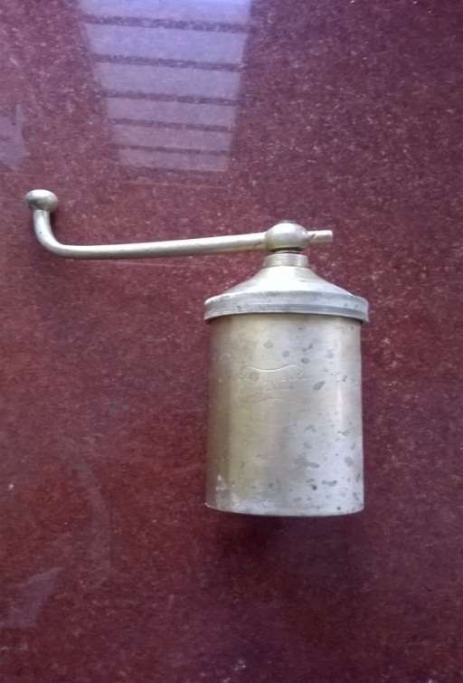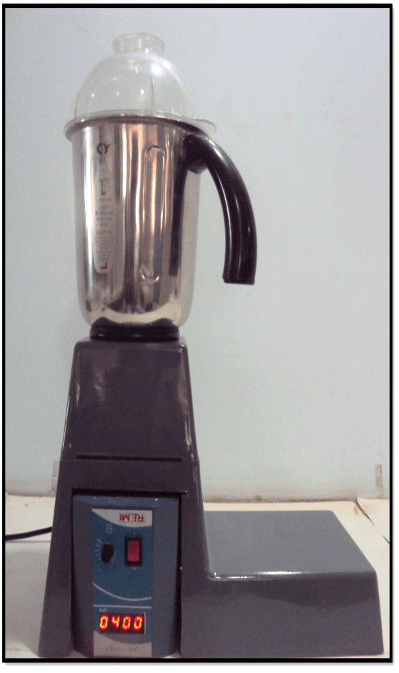

**Fig. 1**. (a) House hold extruder (b) Lab scale Spheronizer

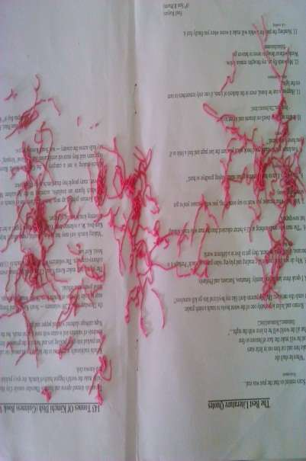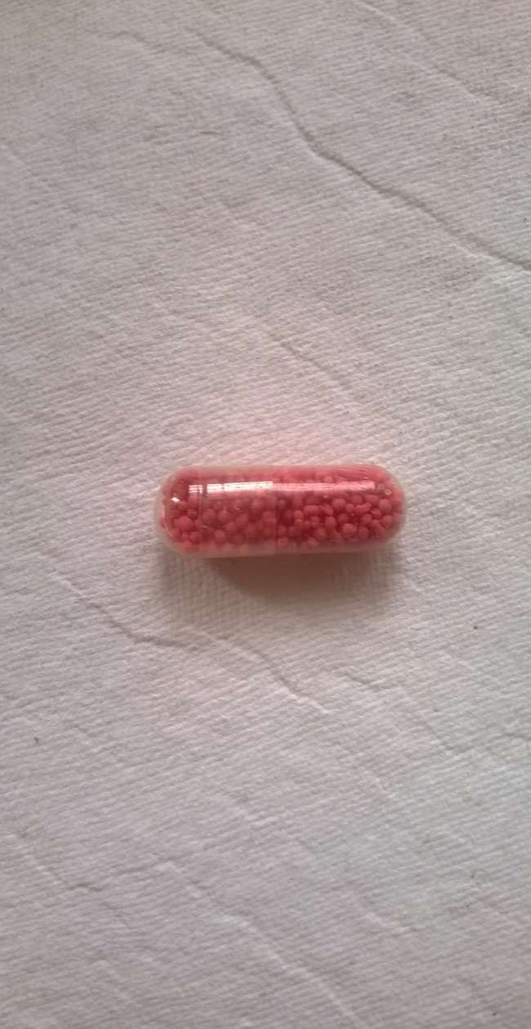

**Fig. 2.** (a) Extrudes (b) pellets filled in HPMC “00” size capsule

Flow Regulator

Reservoir

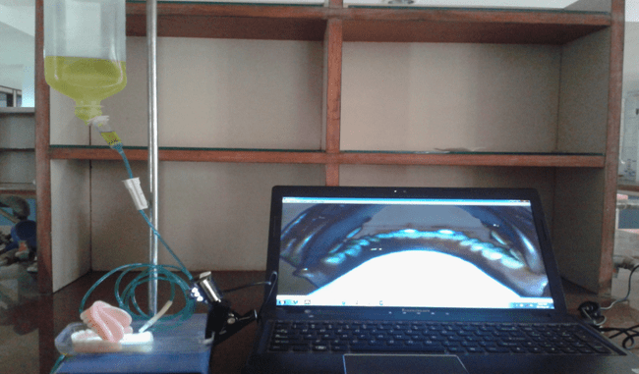

Web camera

Artificial Tongue

Sampling tube

**Fig. 3.** Simulated oral cavity model

**Fig. 4**. Size distribution chart of formulated pellets

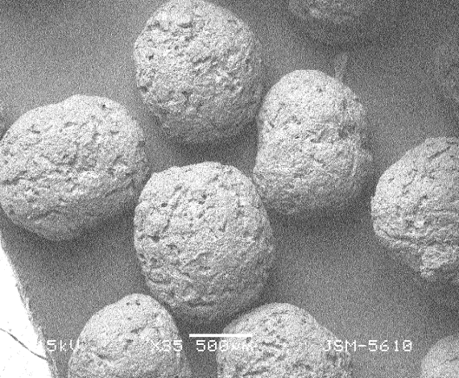 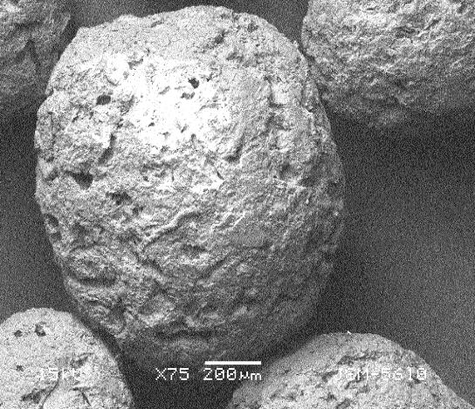

**Fig. 5**. SEM analysis of prepared pellets in 35X and 75X

**Fig. 6.** Dissolution profile of factorial batches

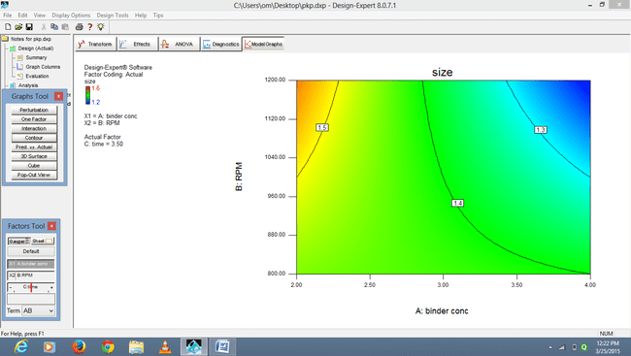

**Fig. 7**. 2D contour plot of size

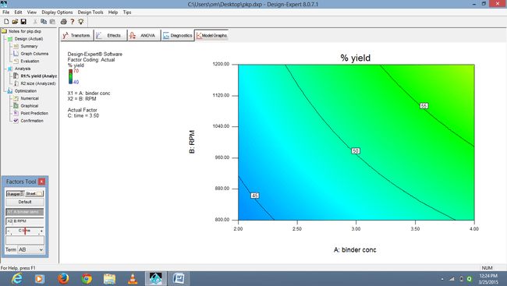

**Fig. 8**. 2D contour plot of % yield

**Fig. 9**. Percentage Drug released from pure drug, marketed formulation and pellet formulation in the simulated oral cavity

**TABLES**

**Table 1.** Factors and levels with coded value, values of dependent variables and QTPP parameters of response variables

|  |  |  |  |  |  |
| --- | --- | --- | --- | --- | --- |
| **Run** | **X1** | **X2** | **X3** | **Y1 (% Yield)** | **Y2 size (mm)** |
| A1 | +1 | -1 | +1 | 56 | 1.4 |
| A2 | +1 | +1 | -1 | 50 | 1.2 |
| A3 | -1 | +1 | +1 | 55 | 1.5 |
| A4 | -1 | +1 | -1 | 40 | 1.6 |
| A5 | +1 | -1 | -1 | 45 | 1.4 |
| A6 | +1 | +1 | +1 | 70 | 1.2 |
| A7 | -1 | -1 | -1 | 40 | 1.5 |
| A8 | -1 | -1 | +1 | 48 | 1.4 |
| **Factor** | | | **low (-1)** | **high (+1)** |
| X1 (Conc. Of binder) (%) | | | 2 | 4 |
| X2 (RPM) | | | 800 | 1200 |
| X3 (Time for spheronization) (min) | | | 2 | 5 |
| **Parameter** | | | **QTPP** | |
| % yield Y1 | | | >60% | |
| pellet size Y2 (mm) | | | 1.2-1.4 | |

**Table 2.** Solubility of Artemether and Lumefantrine using different molar ratio of β-CD

|  |  |  |  |  |
| --- | --- | --- | --- | --- |
| Molar ratio of β-CD | Solubility of Artemether (mg/ml) | ΔG˚ of Artemether | Solubility of Lumefantrine (mg/ml) | ΔG˚ of Lumefantrine |
| 1:0 | 0.0961 | - | 0.0583 | - |
| 1:1 | 0.154 | -1134.03 | 0.0691 | -0.389 |
| 1:2 | 0.145 | -989.4 | 0.0747 | -0.594 |
| 1:3 | 0.143 | -956.1 | 0.0745 | -0.561 |
| 1:4 | 0.142 | -939.46 | 0.0737 | -0.420 |

**Table 3.** Stability study of pellets

|  |  |  |  |  |
| --- | --- | --- | --- | --- |
| Time (days) | Drug content of artemether | Drug content of Lumefantrine | % CDR of Artemether | % CDR of Lumefantrine |
| 7 | 96.16 ± 0.002 | 96.78 ± 0.001 | 96.06± 0.002 | 96.75±0.003 |
| 14 | 96.14 ± 0.002 | 96.78±0.001 | 96.00±0.002 | 96.75±0.001 |
| 21 | 96.14± 0.002 | 96.74± 0.003 | 95.98±0.001 | 96.70±0.001 |
| 30 | 96.13± 0.001 | 96.74±0.002 | 95.98±0.001 | 96.68±0.002 |

ACKNOWLEDGEMENT

Authors would like to thank Anand Pharmacy College for providing instrumentals facility and resource materials for smooth execution of present study. Also, thank Baroque Pharmaceuticals, Khambhat, for providing Artemether and Lumefantrine as a gift sample.

**COPYRIGHT TRANSFER**

The authors of this manuscript hereby transfer all the copyrights and publishing rights to RK University (Rajkot, India). As per the copyright transfer agreement, RK University reserves the right to publish, distribute, upload, or advertise the contents of this manuscript as and when required, without any restrictions. The authors further acknowledge that the content presented in this manuscript is entirely original in nature and not published anywhere else.

REFERENCES

1. Whittaker, A., Currie, A., Turner, M.A., Field, D.J., Mulla, H., Pandya, H.C., Toxic additives in medication for preterm infants. *Archives of Disease Childhood Fetal* Neonatal, 2009, 94, 236–240.
2. Shettigar. R., Damle. A.V., Controlled release pellets of nitrofurantoin. *Indian Journal of Pharaceutical* Science, 1996; 5, 179-85.
3. Gu. L., Liew. C.V., Heng. P.W.S., Wet spheronization by rotary processing-a multistage single-pot process for producing spheroids. *Drug Development and* *Industrial Pharmacy,* 2004; 30, 111-9.
4. Aulton ME, The science of dosage form, Churchill living stone, 2nd edition, 2002, 414-418.
5. Cooper J, Gun C Powder flow compaction. Inc Carter SJ, Eds. Tutorial Pharmacy, New Delhi, hidix CBS Publisher and Distributor, 1986, 211-233.
6. Martin A, Micromeretics, In Martin A, ed. Physical Pharmacy, Baltimores, MD Lippincott Williams and Wilkins, 2001, 423-454.
7. Anand V, Kataria M, Kukkar V, Saharan V, Choudhury PK, The latest trends in the taste assessment of pharmaceuticals‖, *Drug discovery today,* 2007, 12(5-6), 257–265.
8. Lorenz JK, Reo JP, Hendl O, Worthington JH, Petrossian VD, Evaluation of a taste sensor instrument (electronic tongue) for use in formulation development‖, *International journal of pharmaceutics,*. 2009, 367(1-2), 65–72.
9. Woertz K, Tissen C, Kleinebudde P, Breitkreutz J, Taste sensing systems (electronic tongues) for pharmaceutical applications‖ *International journal of pharmaceutics,* 2011, 417(1-2), 256–271.
10. Zimm KR, Schwartz JB, Connor RE. Drug release from multiparticulate pellet system. *Pharmaceutical Development and Technology*, 1996; 1: 37-42.
11. Wan LSC, Lai WF, Factors affecting drug release from drug-coated granules prepared by fluidized-bed coating.‖ *International Journal of Pharmaceutics*, 1991; 72: 163-174.