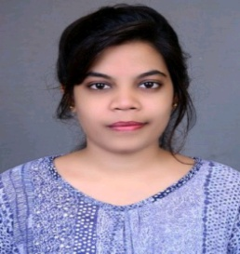**Renjil Joshi** Curriculum Vitae

**PERSONAL DETAILS**

*Address* Village -Tikari, Dist. - Balod [C.G.]

*Birth* 07/11/1995

*Phone* 9074591083

*Mail*  [renjiljoshi48@gmail.com](mailto:renjiljoshi48@gmail.com)

**OBJECTIVES**

I am a dynamic pharmacist and looking for challenging career opportunities in the field of pharmacy.

**ACADEMIC PROFILE**

|  |  |  |  |  |
| --- | --- | --- | --- | --- |
| **S.NO** | **QUALIFICATIONS** | **UNIVERSITY** | **PERCENTAGE** | **YEAR OF PASSING** |
| 1. | Master of Pharmacy | CSVTU, Bhilai | 81.2 | 2019-20 |
| 2. | Bachelor of Pharmacy | CSVTU, Bhilai | 81.7 | 2014-18 |
| 3. | PGDCA | Dr. C.V. Raman University | 71.02 | 2018-19 |
| 4. | 12th | CG Board | 63.4 | 2014 |
| 5. | 10th | CG Board | 73.3 | 2012 |

**SKILLS**

*Languages* Hindi

English

Chhattisgarhi

*Software* MS Office

**TRAINING EXPERIENCE**

* One month Industrial training experience in Peekay Pharma

**PERSONAL SKILLS**

* Adaptability and ability to work under pressure.
* Problem analysis and problem solving.
* Decision making, efficient thinking, organising and planning.

Strong communication skills

**STRENGTH**

* Be polite,
* Be sincere,

**INTRSEST**

* Cooking
* Listening to music
* Travelling

**ACHIEVEMENTS**

* Secured 3rd position in [ e- Poster] sponsored by TEQIP-3 under CSVTU on “ Role of Bioinformatics in Drug Design”, held at Shri Rawatpura Sarkar Institute of Pharmacy, Kumhari, Durg, India, on 20th February 2020
* Secured 2nd position in [ e- Template] organised by Shakti Mahila Vigyan Bharti Samiti, Raipur, Chhattishgarh at Shri Rawatpura Sarkar Institute of Pharmacy, Kumhari, Durg, held on 24th February 2020
* Secured 2nd position in [Oral Presentation] sponsored by International Conference on “New Horizon of Health Science”, held on 4th-5th March, 2020 Organised by School of Pharmacy, Chouksey Engineering College, Bilashpur, Chhattishgarh.
* Presented [e-Poster] in ICMR sponsored National Seminar on “Recent Advance in Modelling and Drug Screening for Neurological Diseases”, held at Rungta college of pharmaceutical sciences & research Bhilai , [CG] on December 11-12, 2017

**CONFERENCE ATTENDED**

* 68th Indian Pharmaceutical Congress Andhra University, Visakhapatnam on 2016
* Indian Pharmaceutical Association Convention held at Pandit Ravishankar University, Raipur on 2016
* Govt. schemes & policies for women”, held at Rungta college of pharmaceutical sciences & research Bhilai, [CG] on 10th Sept. 2016
* Cyber Security for Youth, held at Rungta college of pharmaceutical sciences & research Bhilai , [CG] on 17th Sept.2016

**DECLARATION**

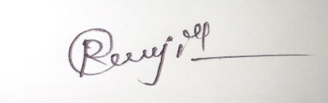 I hereby declare that above mentioned information is correct up to my knowledge and I bear the responsibility for the correctness of the mentioned particulars.

**RENJIL JOSHI**